
State of Kansas
Writing Off a Receivable (Pending) Item
Statewide Management, Accounting and Reporting Tool

Date Created |  | 05/01/2018
Version |  | 1.3
Last Update |  | 06/14/2024
Purpose: |  | Reasons to complete a write-off of a Receivable (Pending) Item may include:  - The Receivable has been deemed uncollectible  - Federal reimbursement has been denied  - A deposit has been created using journal direct instead of pulling the receivable item into the deposit  - The Receivable was created in error  In these situations, a Maintenance Worksheet must be created to write-off the item.  This job aid provides the steps to create a maintenance worksheet to write-off a receivable (pending) item.  The role required to manually enter a receivable (pending) item is:  KAR_Agy_Item_Processor
Navigation: |  | Accounts Receivable Homepage > Customers and Accounts > Item Information > Item List  Or  NavBar: Navigator > Accounts Receivable > Customer Accounts > Item Information > Item List
1. | Document the receivable/ pending item that is to be written off to obtain the revenue account  Customer: Enter the Customer ID for the Pending Item being written off.  Status: All  Select Advanced Search  Item ID: Enter the Item ID for the Pending Item being written off  Search.  Item: Click on the Item ID link.  Select Item Accounting Entries tab  Important: Make note of the revenue account used on the receivable/pending item. It will be needed later in the write off process. | 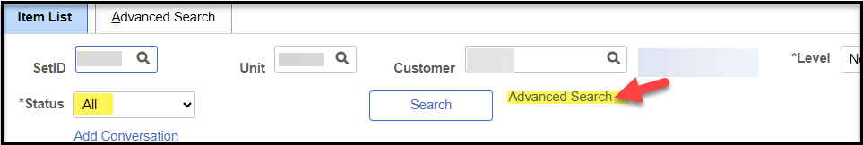  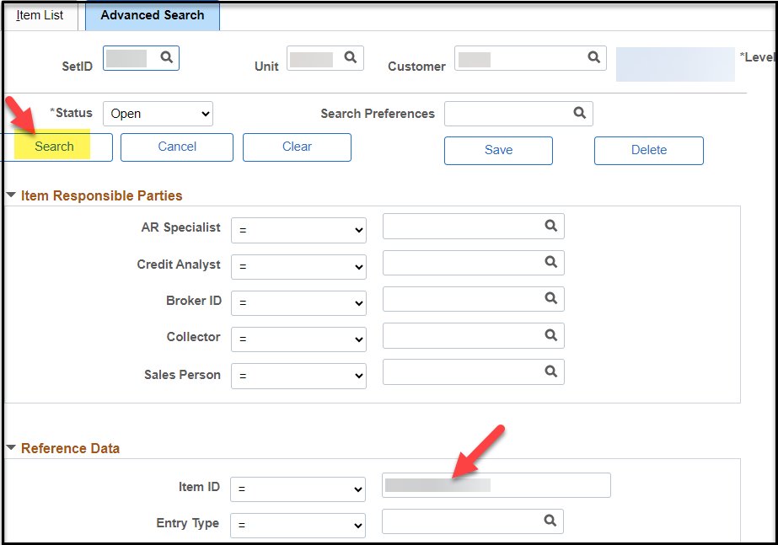  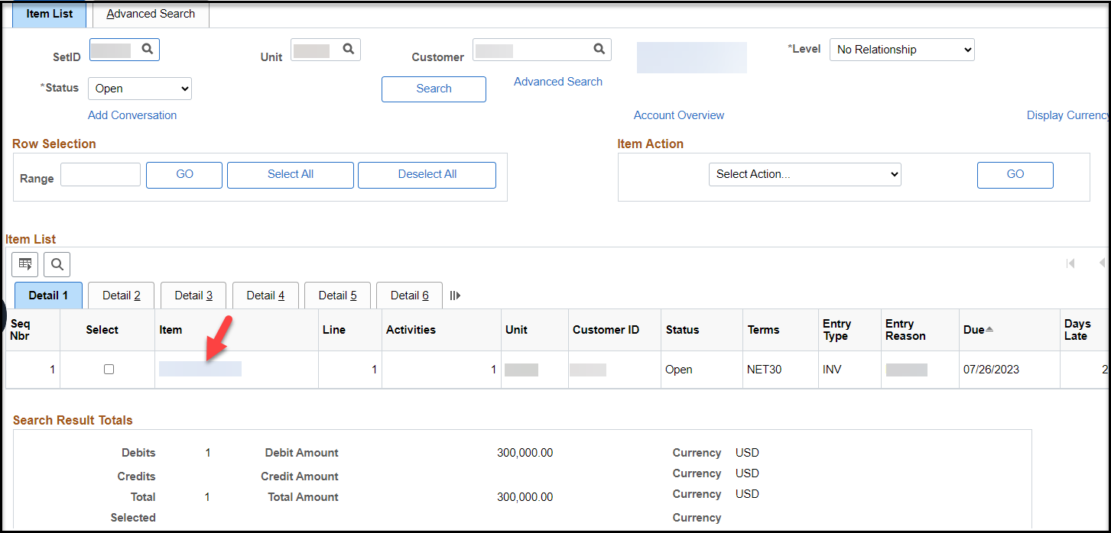  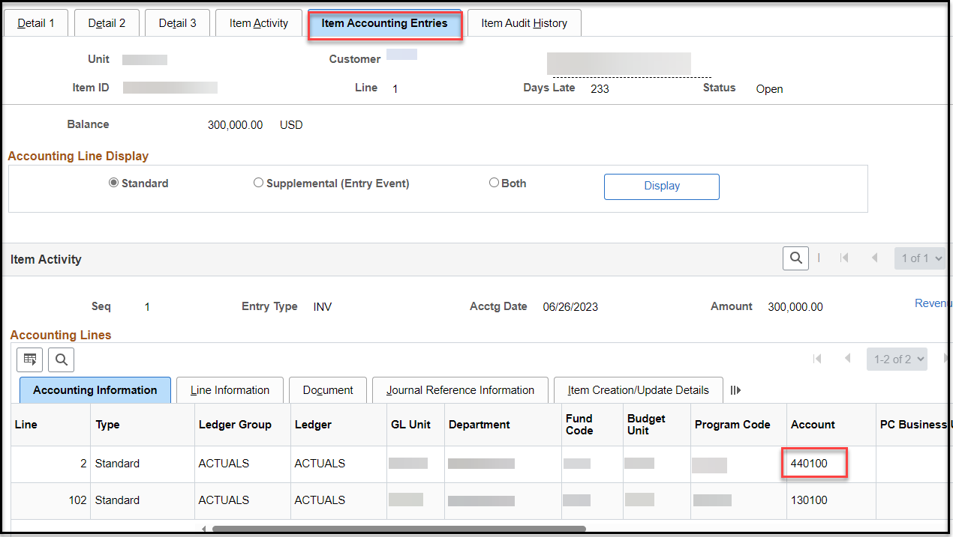
Navigation: |  | Accounts Receivable Homepage> Receivables Maintenance > Create Worksheet > Add a New Value  Or  NavBar: Navigator > Receivables Maintenance > Maintenance Worksheet > Create Worksheet > Add a New Value
2. | Create Worksheet  Worksheet Business Unit = Business Unit  Worksheet ID = Name or number to identify the worksheet (15 characters alpha/numeric)  Select: Add | 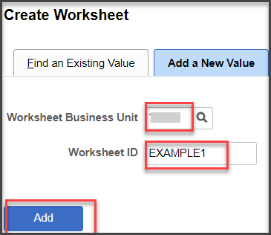
3. | Worksheet Selection  Customer ID: Enter the Customer ID  Worksheet Action: Select Build | 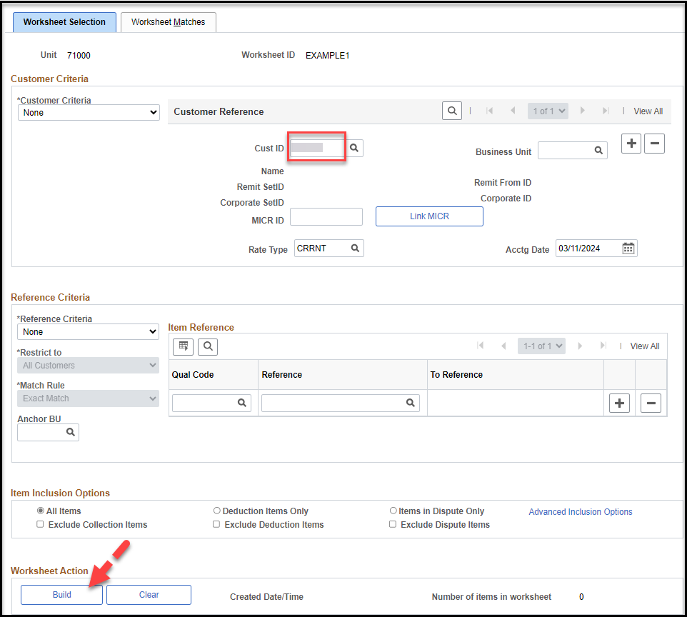
4. | Worksheet Application  Entry Type: Write-off a Debit  Reason: (If defined for BU)  Sel: Select the checkbox for all Item ID lines to be written off.  Type: WOD  Reason: (If defined for BU)  Click Save. | 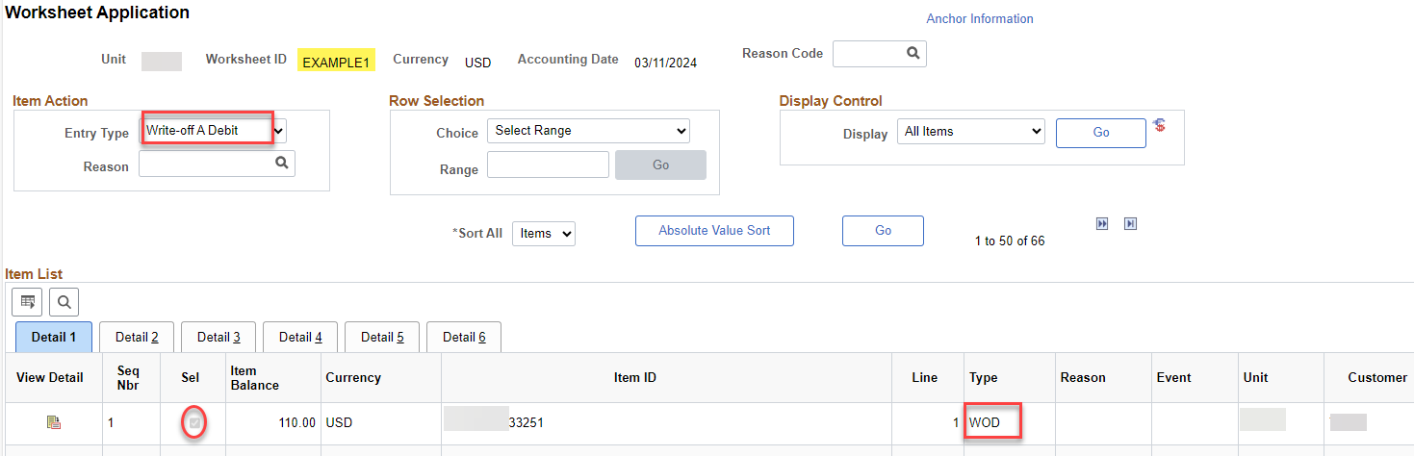  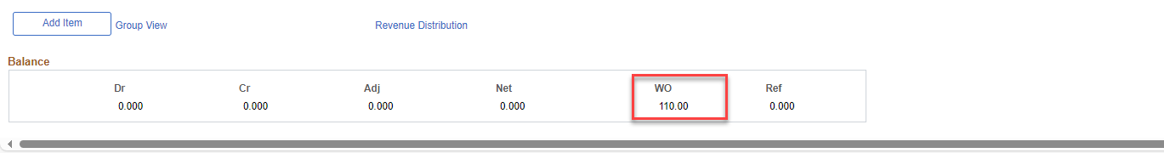  Note: Type must be populated for each line selected to be written off.
5. | Worksheet Application, Balance  Verify WO (Write-Off) amount equals total amount to be written off.  Click Save.  Select Worksheet Action | 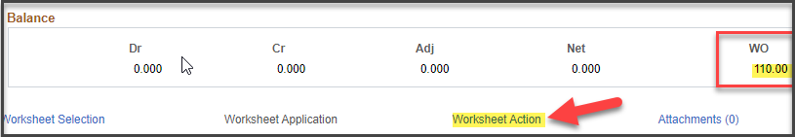  Attachments: Use the hyperlink to attach pending item documents.
6. | Worksheet Action  Accounting Entry Action: Select Create/Review Entries to create accounting entries | 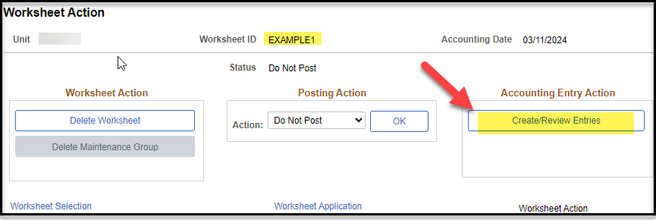
7. | Accounting Entries  Select View All in both the Accounting Entries section and the Distribution Lines section to view all accounting entries.  Verify accounting entries are a reversal of the original Pending Item accounting entries. Generally, a revenue account will be debited and the AR account (130100) will be credited.  Correct the Account chartfield as necessary.  Click Save.  Select Return to Previous Panel to return to Worksheet Action | 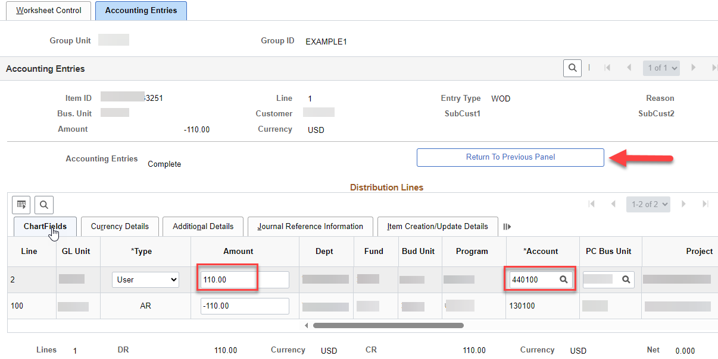  IMPORTANT: Most agencies have a default revenue account set up in the automatic entry type of WOD. Because only one value can be set as the default, it is likely that the revenue account that defaults in may not match the account used on the original receivable/pending item. If the account that defaults in does not match the original item, you must update the revenue account to match that of the original receivable/pending item. (See step 1 of this job aid to view the revenue account on the original receivable.)
8. | Worksheet Action  Posting Action: Set Action to Batch Standard  Click OK and Save. | 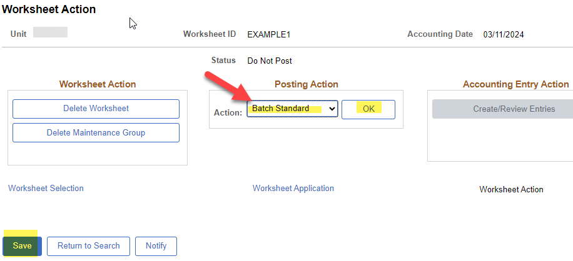  Note: This will post with the next hourly or nightly AR Update batch process.
Navigation: |  | Accounts Receivable Homepage > Customers and Accounts > Item Information > Item List  Or  NavBar: Navigator > Accounts Receivable > Customer Accounts > Item Information > Item List
9. | After hourly or nightly AR Update process has run, verify posting of the Write-off Worksheet  Customer: Enter the Customer ID for the Pending Item being written off.  Status: All  Select Advanced Search  Item ID: Enter the Item ID for the Pending Item being written off  Search | 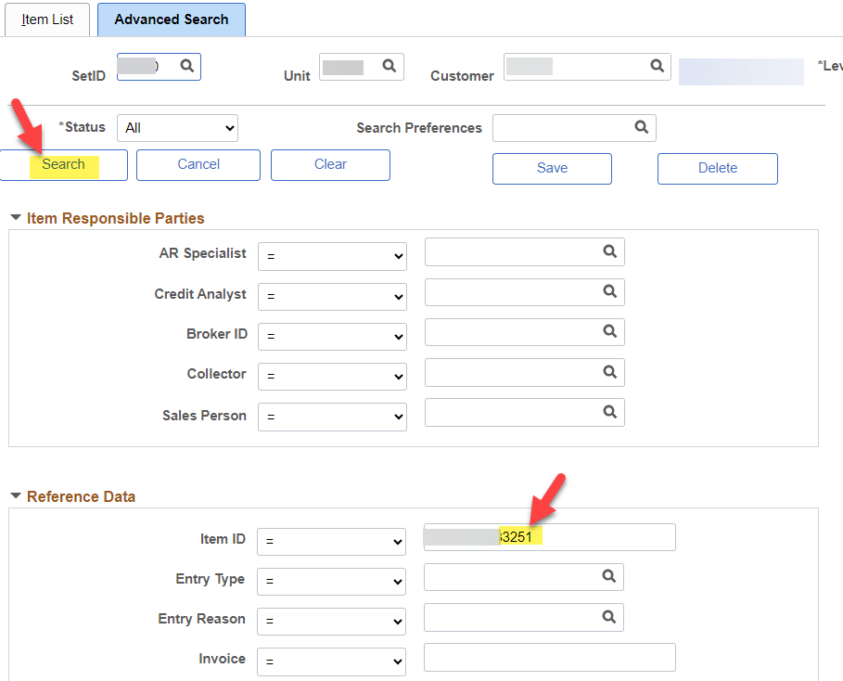
10. | Item List  Click on the Item link.  Item Accounting Entries: Select View All within Item Activity to view both the Entry Type: DR (could also be INV, IF, etc.) that created the pending item, and Entry Type: WOD that created the write off of the pending item | 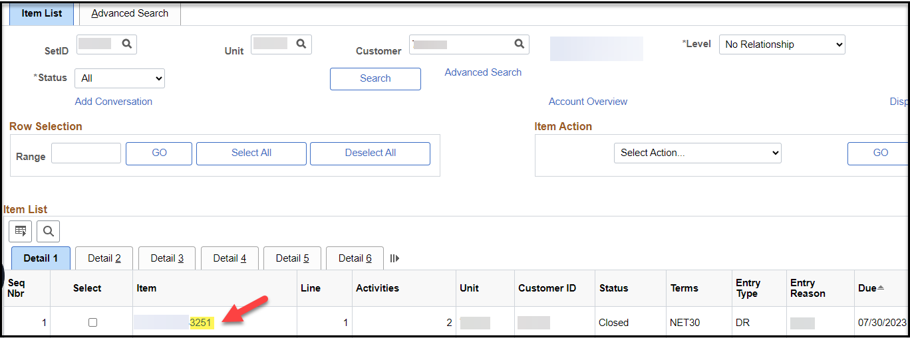  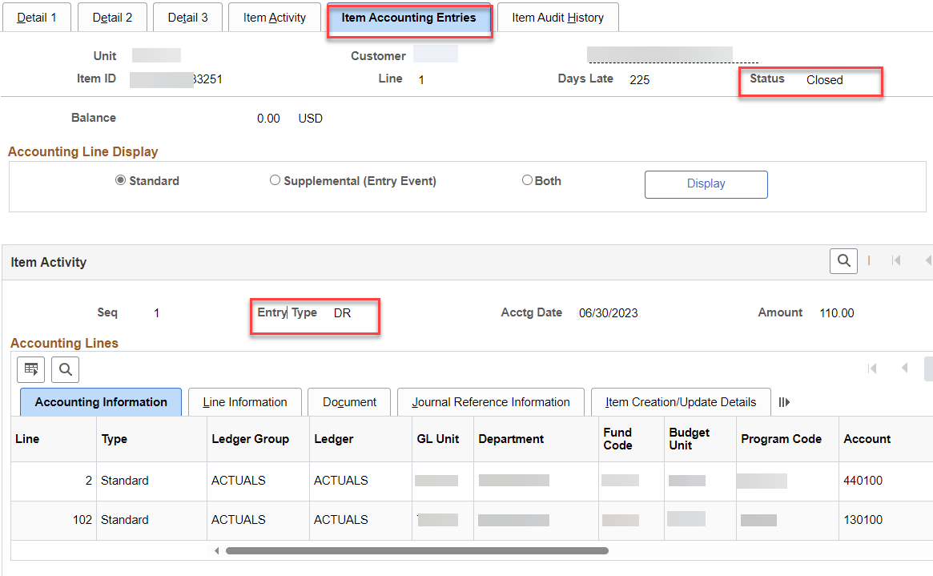  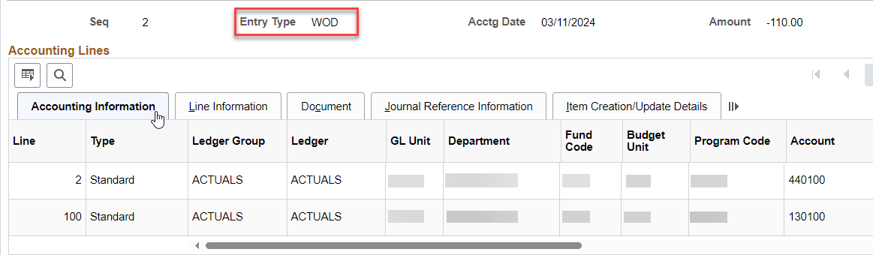
Navigation: |  | Accounts Receivable > Pending Items > Review Items > All Items
11. | After hourly or nightly AR Update process has run, another option to verify posting of the Write-off Worksheet  Group Unit: Business Unit  Group ID: Enter Group ID (Worksheet ID)  Search  Group Control, Totals: Review Posted and Count to verify the worksheet has posted. Posted row should match Control and Entered rows.  If accounting entries have not posted, check for errors on Pending Item 1. | 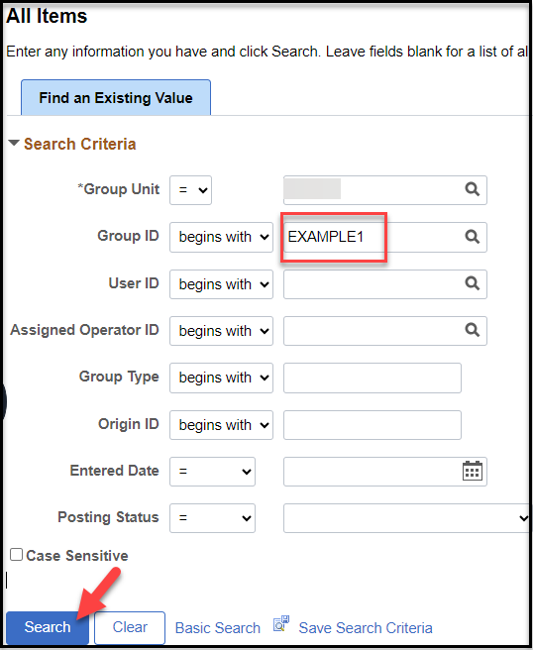  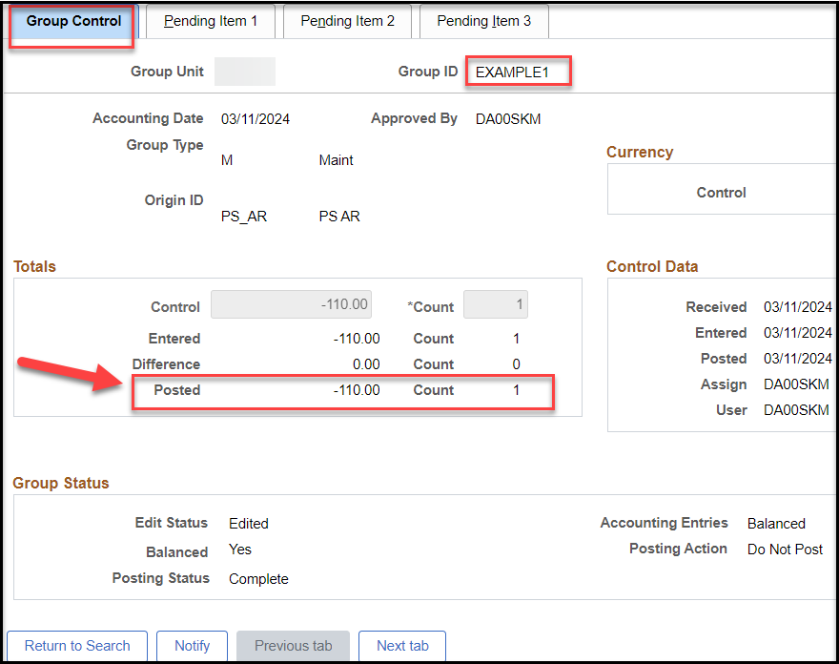
Navigation: |  | Accounts Receivable > Receivables Update > Correct Posting Errors > Worksheet
12. | If errors are found  Pending Item1: Select Error Info  A pop-up message will open. Click OK. | 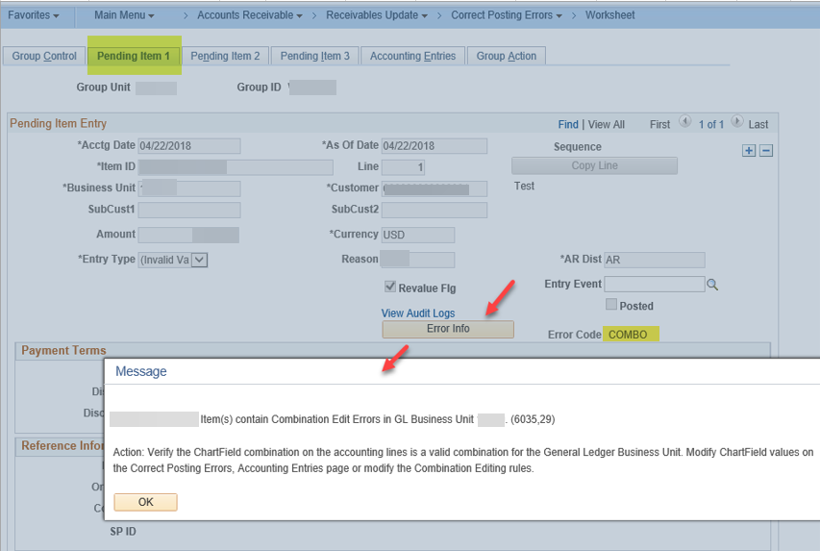
13. | If errors are caused by invalid chartfield values  Go to Accounting Entries.  Update chartfields as needed. (For this example, Account was updated).  Save. | 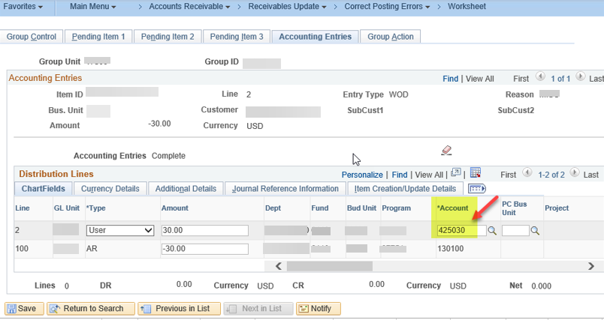
14. | Group Action, Posting Action  Select Batch Standard | 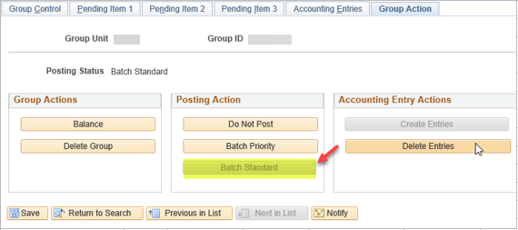  Note: This will post with the next hourly or nightly AR Update batch process.  After AR Update batch process is complete, verify posting of the Write-off Worksheet again with steps 8 – 10.

