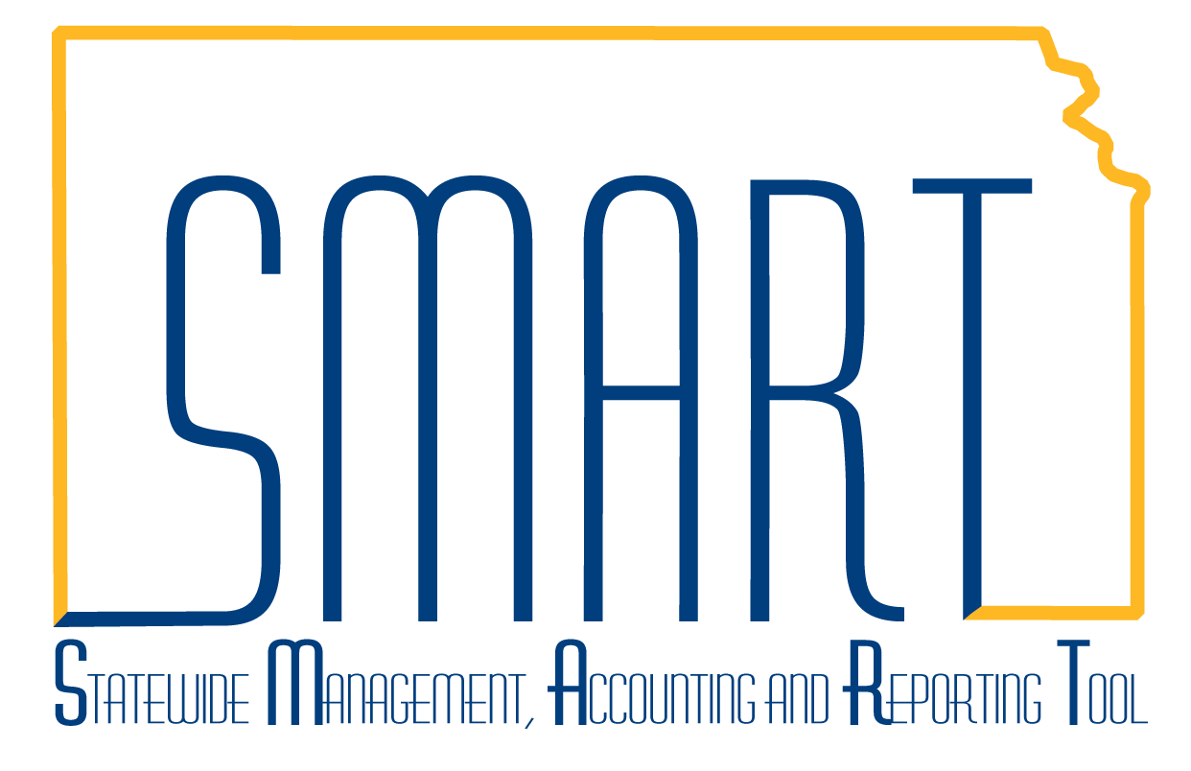
State of Kansas
Using the KS_KK_BP##_IBARS_ACTUALS Queries
Statewide Management, Accounting and Reporting Tool
Date Created: | 08/28/2013
Version: | 4.0
Last Updated Date: | 03/18/2019
Purpose of the Query: | These Queries are designed to extract the Budget Period (BP)## IBARS ACTUALS (Expenditures, Outstanding Encumbrances, and Revenues) from SMART.  These queries were created to assist agencies trying to reconcile their Budget Period (BP)## ACTUALS in IBARS to SMART.
Query parameters: | The Expenditure ACTUALS is the sum of the Budget Period (BP) 20## expenditures and outstanding encumbrances.  This data is found in the:  - ‘CC_IBARS_E’ Ledger Group  - ‘CC_IBR_EXP’ Ledger, and  - ‘CC_IBR_ENC’ Ledger  In addition, the GL Journal Encumbrances are found in the:  - ‘CC_APPROP’ Ledger Group  - ‘CC_APR_ENC’ Ledger  Therefore, a separate query is needed to find the encumbrance journals.  The Revenue ACTUALS is the Budget Period (BP) 20## revenues that are found in the:  - ‘CC_IBARS_R’ Ledger Group, and the  - ‘CC_IBR_COL’ Ledger
Prompt Values: | - Business Unit: Enter agency Business Unit  - Fund: Enter a specific Fund for your Business Unit.  - Budget Period: Enter the Budget Period.
Navigation:  Use this query to find the Expenditure, Outstanding encumbrances and Collected Revenue. | From the SMART Home page in SMART, select the General Ledger/KK page > GL Utilities tile > Query Viewer.  In the Search By field, select ‘Query Name’.  In the ‘begins with’ field, type: ‘KS_KK_BP##_IBARS’  Click on the Excel link to send the results to an Excel spreadsheet.
Enter the desired search criteria.  (Please refer to the ‘Prompt Values’ section above for Ledger guidelines).  Click the “View Results” button.  The Results will display in a new Excel spreadsheet . Keep the spreadsheet open because you will need to add the results from the GL Encumbrance Query. | 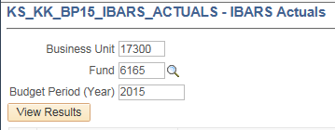  NOTE: The Ledger is set to CC_IBR% to return the Collected Revenue, Expenditures and Outstanding Encumbrances (excluding the GL encumbrances which are only recorded in the CC_APR_ENC ledger.)  Results:  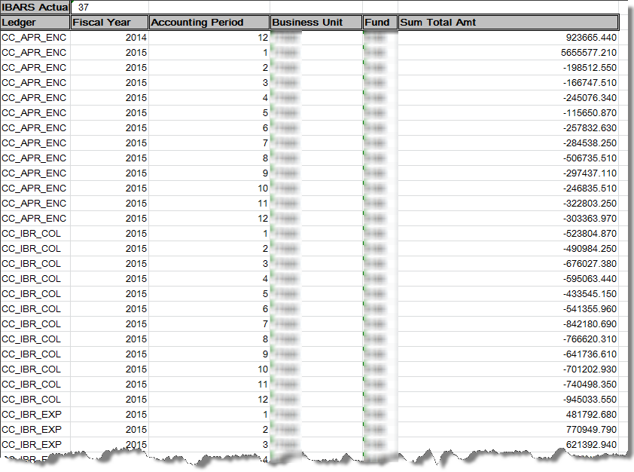
Navigation:  Next, you need to run the GL Encumbrance query | From the SMART Home page in SMART, select the General Ledger/KK page > GL Utilities tile > Query Viewer.  In the Search By field, select ‘Query Name’.  In the ‘begins with’ field, type: ‘KS_GL_ENCUMBRANCES’  (GL encumbrances by journal ID)  Click on the Excel link to send the results to an Excel spreadsheet.
Enter the desired search criteria.  Business Unit: Enter agency Business Unit  Budg Dt: Enter FY end date (i.e., Budget Date 2016 use 6/30/2016)  Click the “View Results” button. | 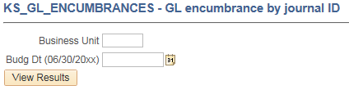  Results:  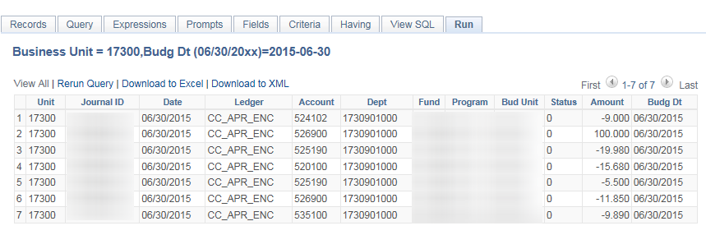  Note: The date that the query is run will determine the balance. You may need to delete adjustments that reduce the encumbrance amount to determine the original amount of the encumbrance. In the example below, the $100 is the original amount and the other amounts are adjusments that should be deleted.
Copy the results of the query (data) into the open Excel spreadsheet. | Note: Some re-formatting will be needed in the Excel spreadsheet, so that the (data) columns line up.
Create a pivot table or sort and subtotal the data in the combined spreadsheet to calculate the ACTUALS. | Summarize the data as needed so Expenditure ACTUALS and Revenue ACTUALS can be calculated. The ledgers with the ACTUALS data are listed below.  Expenditure ACTUALS = CC_IBR_EXP + CC_IBR_ENC + CC_APR_ENC  Revenue ACTUALS = CC_IBR_COL

