State of Kansas
Using the KS_GL_JOURNALS Query
Statewide Management, Accounting and Reporting Tool

Date Created: |  | 01/29/2013
Version: |  | 2.0
Last Updated: |  | 03/21/2019
Purpose of the Query(s): |  | This query is designed to list GL Journals for a specific ChartField value:  - By Department - KS_GL_JOURNAL_BYDEPT  - By Fund - KS_GL_JOURNALS_BYFUND  - By Fund and Budget Unit – KS_GL_JOURNALS_BYFUND_BUDUN  - By Program – KS_GL_JOURNAL_BYPROGRAM  - By Source and Department – KS_GL_JOURNALS_BYSOURCEDEPT
Query Parameters, Prompt Values, and Result Sorts: |  | Query Query Parameters Prompt Values Result Sorts  KS_GL_JOURNALS_BYDEPT Find all journals generated to the General Ledger with a specific Department ID. The data source is the Jrnl_Header and Jrnl_Ln and includes ALL journal statuses. Business Unit = 5 digit Business Unit number Year = Fiscal Year From Date = From Journal Date To Date = To Journal Date Department = Specific Department ID or wildcard (%) Journal ID Date Status Source  Query Query Parameters Prompt Values Result Sorts  KS_GL_JOURNALS_BYFUND Find all journals generated to the General Ledger with a specific Fund code. The data source is the Jrnl_Header and Jrnl_Ln and includes ALL journal statuses. Business Unit = 5 digit Business Unit number Year = Fiscal Year From Date = From Journal Date To Date = To Journal Date Fund = Fund code Journal ID Date Status Source  KS_GL_JOURNALS_BYFUND_BUDUN Find all journals generated to the General Ledger with a specific Fund code and Budget Unit. The data source is the Jrnl_Header and Jrnl_Ln and includes ALL journal statuses. Business Unit = 5 digit Business Unit number Year = Fiscal Year From Date = From Journal Date To Date = To Journal Date Fund = Fund code Bud Unit = Budget Unit Journal ID Date Status Source  Query Query Parameters Prompt Values Result Sorts  KS_GL_JOURNAL_BYPROGRAM Find all journals generated to the General Ledger with a specific Program code. The data source is the Jrnl_Header and Jrnl_Ln and includes ALL journal statuses. Business Unit = 5 digit Business Unit number Year = Fiscal Year From Date = From Journal Date To Date = To Journal Date Program = Program Code Journal ID Date Status Source  KS_GL_JOURNALS_BYSOURCEDEPT Find all journals generated to the General Ledger with a specific Source and Department ID range of values The data source is the Jrnl_Header and Jrnl_Ln and includes all journal statuses. Business Unit = 5 digit Business Unit number Year = Fiscal Year Accounting Period = Accounting Period Source = Journal Source (Please refer to following list of Journal Sources) Greater than Department = From Department ID Less than Department = To Department ID Journal ID Year Period Date Status Source
Prompt Values: |  | Journal Header Status Values:  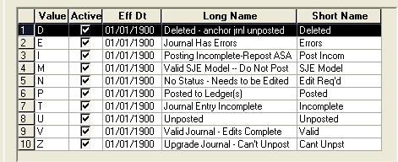  Journal Sources:  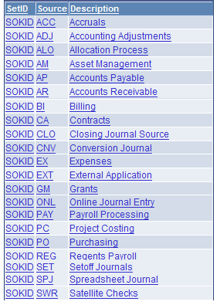
SMART Security Access: |  | - Role Security: GL_Viewer  - BU Security: Business Unit Security is applied. Agencies only have access to journals within their Agency’s business unit.
How to Run the Query:
1 | - Navigation: From the SMART Homepage, click on the ‘General Ledger/KK page’, then click ‘GL Utilities’, then click ‘Query Viewer ‘.  - Select ‘Query Name’ from the *Search By drop down list.  - Enter the ‘Query Name’ into the ‘begins with’ field on the ‘Query Viewer’ page.  - Click the “Search” button.  - In the Query section: Click the “Excel” link. |  | 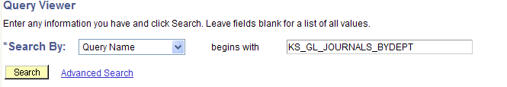  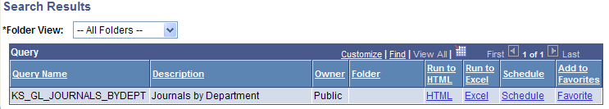
2 | Enter the Prompt Values for the query you are running.  (Please refer to pages 1-3 of this document for the prompt values for each of the KS_GL_JOURNALS queries.)  After you have entered the prompt values, click the “View Results” button. |  | Example:  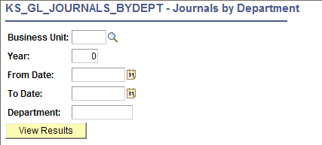
3 | Clicking the ‘View Results’ button prompts SMART to display a ‘File Download’ dialog box.  Click the “Open” button in the File Download dialog box to open the query results. |  | 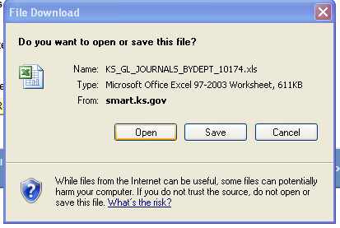
4 | The query results are opened in an Excel spreadsheet (which you can then use to save, sort, etc). |  | 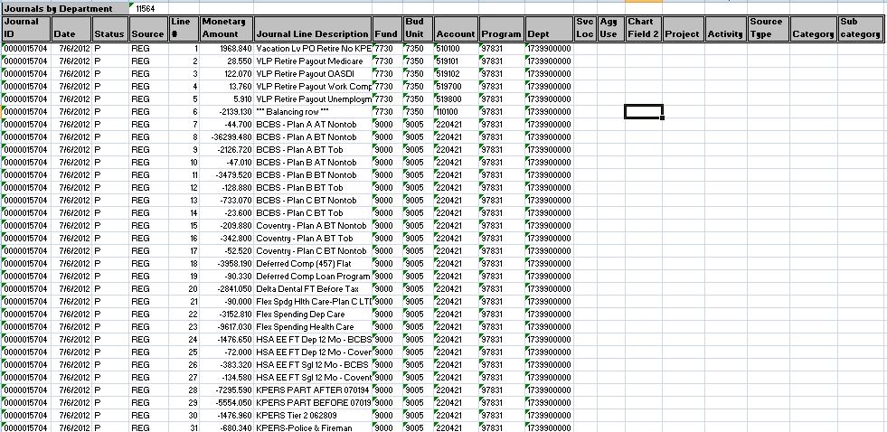
NOTE: |  |  | If desired, you may select the “HTML” link on the Search Results page instead of the “Excel” link in the Query section.  Selecting the “HTML” link displays the query results on-line in a new window in SMART. This on-line query results page does contain an “Excel” link which allows you to then download the results to Excel if you wish to do so.

