
State of Kansas
Using the KGL00005 Trial Balance Report
Statewide Management, Accounting and Reporting Tool

Date Created: | 4/02/2013
Version: | 4.0
Last Updated Date: | 03/21/2019
Purpose of the Report: | This report is designed to give a beginning and ending cash balance. This report reflects activity posted to the General Ledger.  This is a key monthly balancing tool.
Report parameters: | - The report results will be the beginning and ending cash by fund from transactions based on the Accounting Period(s) and Fiscal Year chosen.  Note: The results are the GL cash balances which include activity for multiple budget periods.  - Appropriated funds (Funds 1000,1700,1800, 1900,2000,7000,8001,8100,and 8600) are summarized statewide instead of by agency  - Use the ‘GLS8020 - Budget Status Report’ to review agency Appropriated balances.
Report Prompt Values: | Required Prompt Values:  - Business Unit  - Fiscal Year  - Accounting Period  - Ledger
Report Result Sorts: | The report results are displayed, sorted by:  - Business Unit ID  - Fund

Security Access: |  | - Role Security: Only those individuals assigned the following security access role will receive results from this query :  - GL Viewer  - BU Security: Business Unit Security is applied. Agencies will have access to only the cash associated to their agency’s business unit(s).
1. | Navigation:  From the SMART Homepage, click on the menus as follows: General Ledger/KK page> GL & KK Reports tile > GL Reports> Trial Bal by Fund (KGL00005). | 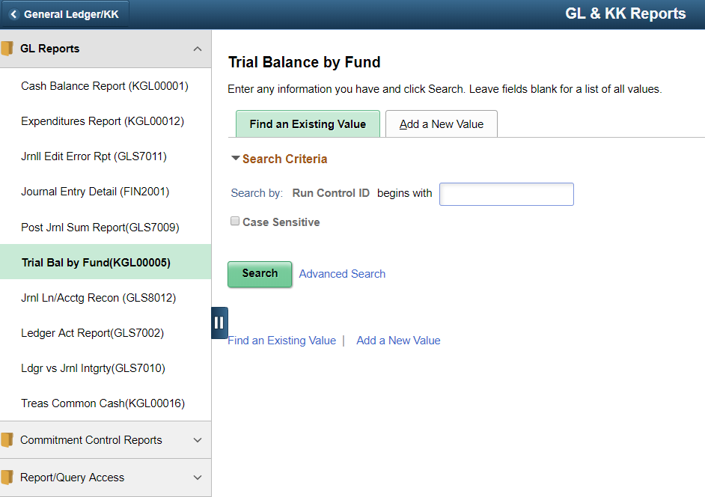
2. | If you have used this report in the past, click on the ‘Find an Existing Value’ tab  Enter/Find the name of the (previously established) Run Control ID into the Run Control ID begins with: field  Click the Search button.  If you have NOT used this report in the past, use the ‘Add a New Value’ tab. Enter a new Run Control ID.  Click the Add button. | 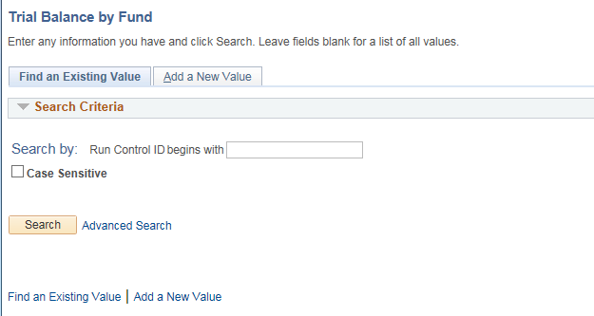  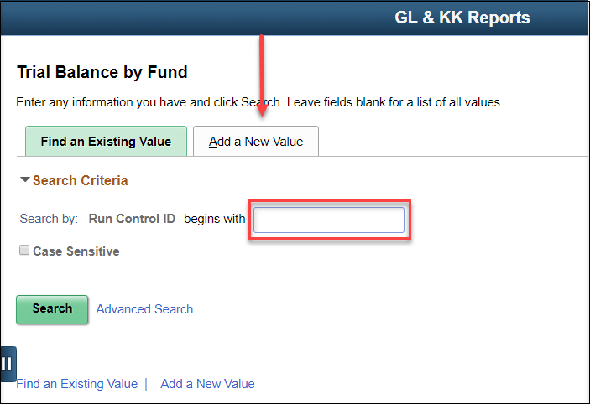
3. | On the Trial Balance by Fund page:  Business Unit: Enter the agency’s Business Unit number. | 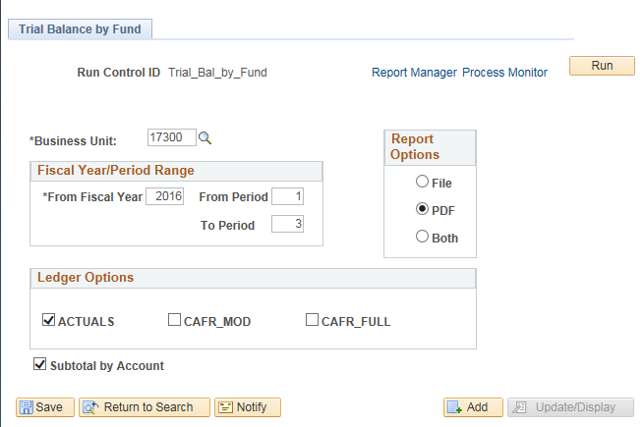
4. | Fiscal Year/Period Range section:  *From Fiscal Year: Enter the desired Fiscal Year.  From Period: Enter the start period for the date range.  To Period: Enter the end period for the date range.
5. | Report Options:  Select the desired report results output method:  File: Provides the report results in a .DAT format, which can then be copied into ‘Excel’ and delimited.  PDF: Provides the report results in a printable format (‘.PDF’ file).
6. | Ledger Options:  Select the desired Ledger(s) for report results:  ACTUALS: Provides the account detail for reporting from the Actuals Ledger (this will be the default for the reports from nightly batch).  CAFR_MOD: Provides the account detail for reporting from the CAFR_MOD Ledger.  CAFR_FULL: Provides the account detail for reporting from the CAFR_FULL Ledger.
7. | Subtotal by Account Option:  Selecting the ‘Subtotal by Account’ checkbox will add subtotaling by the first two digits of the account code.  Click the Save button then click the Run button.
8. | Clicking the “Run” button opens the Process Scheduler Request page.  On the Process Scheduler Request page:  *Type: Select the desired file type.  *Format: Select the desired file output.  Click the “OK” button. Clicking the OK button submits the report (process) to SMART (for the report results to be generated). | 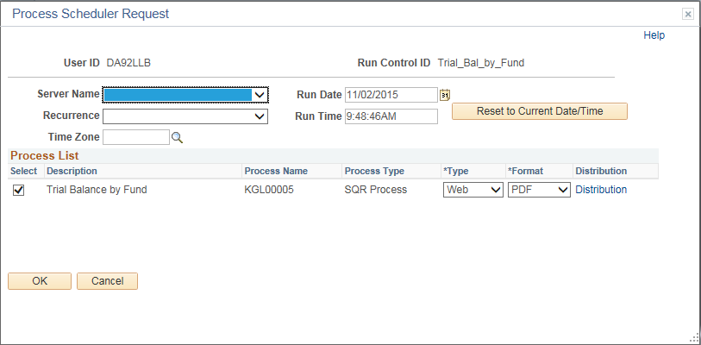
9. | SMART returns you to the Trial Balance by Fund page.  Click the “Process Monitor” link.
10. | On the Process List page:  If the ‘Run Status’ is “Success”, then the report results have been successfully generated.  If the ‘Run Status’ is NOT “Success” you may need to refresh the process results.  Click the “Refresh” button to refresh the process data.  To view the report results, click the “Details” link. | 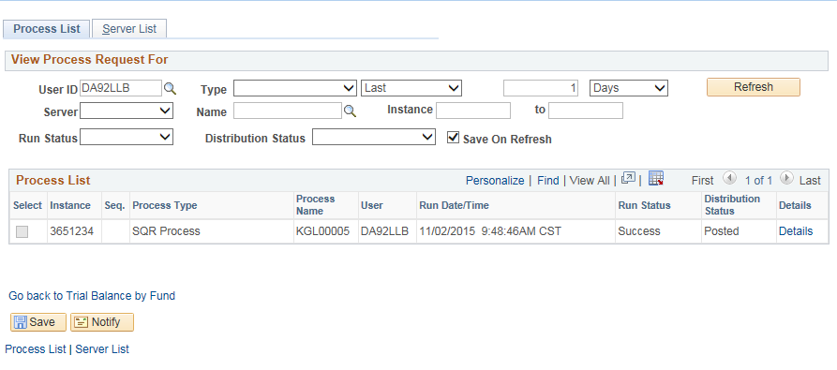
11. | On the Process Detail page:  To view the report results, click the “View Log/Trace” link. | 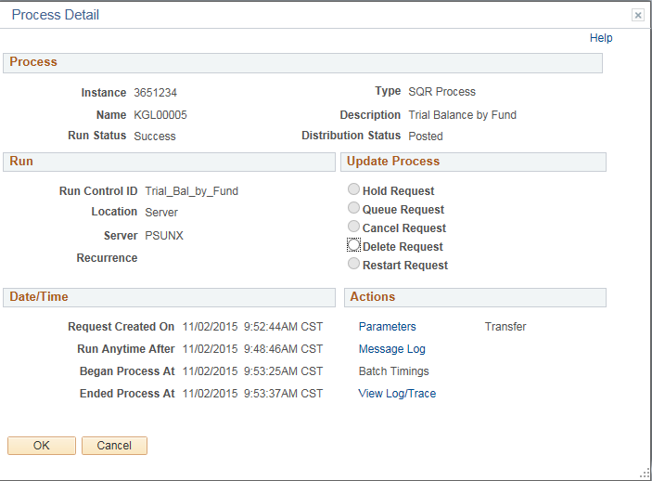
12. | On the View Log/Trace page, File List section: Click the Name link for the desired file output type.  (This is the report results Format that you requested on the Process Scheduler Request page).  In this case, a ‘.PDF’ file was requested. | 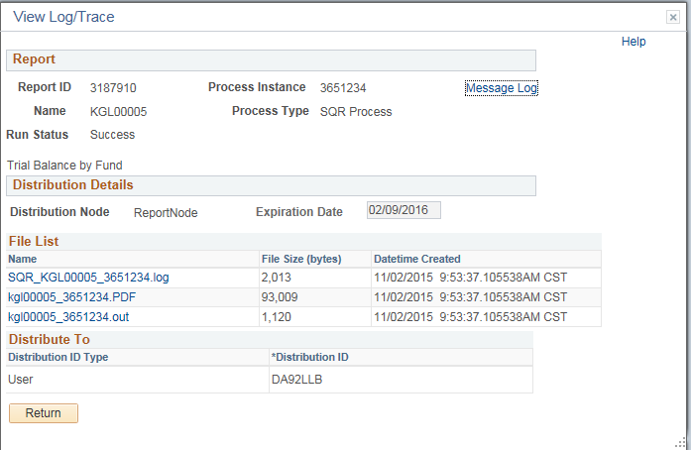
13. | Clicking the file Name link, opens the file in the specified ‘reports results’ Format. | Use the KGL00005 Trial Balance Report results to balance cash by fund by agency.  When the report results appear, you may then save or print the file.

