
State of Kansas
Using the KGL00001 Cash Balance Report
Statewide Management, Accounting and Reporting Tool

Date Created: |  | 11/02/2015
Version: |  | 2.0
Last Updated Date: |  | 03/21/2019
Purpose of the Report: |  | This report is designed to give a beginning and ending ACTUALS ledger cash balances. The results will include totals for the accounting period or range of accounting periods and fiscal year chosen. The details in the report include, Sources of Funds (Receipts), Uses of Funds (Expenses), and Transfers summarized by Account Code tree level 4 or 5. This report reflects activity posted to the General Ledger.  This is a key monthly balancing tool.
Report parameters: |  | The report results will be the beginning and calculated ending cash by fund (and budget unit, if chosen) and Account for GL transactions based on the Accounting Period(s) and Fiscal Year chosen.  Note: The results are the GL cash balances which include activity for multiple budget periods.  When running the report and clicking the Include all Budget Unit box, the Type 1 (Fund level only) funds will show on a separate page with a Fund number and a blank budget unit.  Appropriated funds (Funds 1000, 1700, 1800, 1900, 2000, 7000, 8001, 8100,and 8600) cash balances are tracked statewide instead of by agency. The cash balance for these funds will not be accurate on the Cash Balance Report.  Use the ‘GLS8020 - Budget Status Report’ to review agency Appropriated balances.
Report Prompt Values: |  | Required Prompt Values:  - Fiscal Year  - Accounting Period  - Business Unit  - Fund Code (leave blank to include all agency funds)  - Budget Unit (leave blank and click Include all Budget Units box to include all agency budget units)  - Account Group (summary levels)  - Level 4 is the Account code description summarized to the 2nd digit of the account code (salary and wages, contractual, commodities, capital outlay, etc.  - Level 5 is the Account code description summarized to the 3rd digit of the account code and are listed in alphabetical order (building and improvements, communication, fees – professional services, etc.)
Report Result Sorts: |  | The report results are displayed, sorted by:  - Business Unit ID  - Fund  - Budget Unit (if included)
Security Access: |  | - Role Security: Only those individuals assigned the following security access role will receive results from this query :  - GL Viewer  - BU Security: Business Unit Security is applied. Agencies will have access to only the cash associated to their agency’s business unit(s).
1. | Navigation:  From the SMART Homepage, click on the menus as follows: General Ledger/KK page> GL & KK Reports tile > GL Reports> Cash Balance Report (KGL00001). | 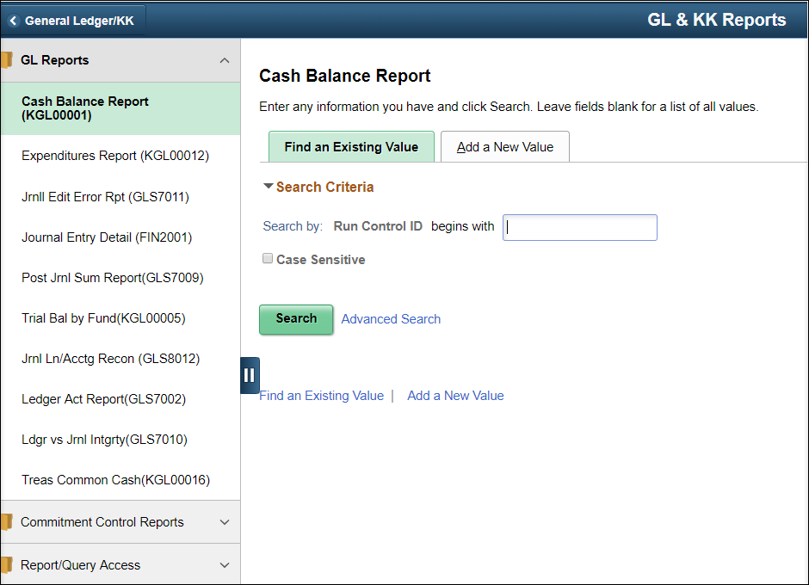
2. | If you have used this report in the past, click on the ‘Find an Existing Value’ tab.  Enter/Find the name of the (previously established) Run Control ID into the Run Control ID begins with: field  Click the Search button.  If you have NOT used this report in the past, use the ‘Add a New Value’ tab.  Enter a new Run Control ID.  Click the Add button. | 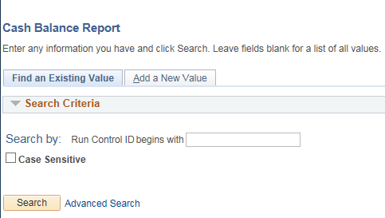  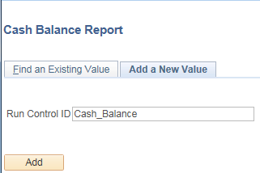
3. | On the Cash Balance Report Run Control page  Business Unit: Enter the agency’s Business Unit number.  Fiscal Year: Enter the desired Fiscal Year.  Range From Accounting Period: Enter the start period for the date range.  Range To Accounting Period: Enter the end period for the date range.  Fund Code: Enter specific Fund or leave blank for all funds  Budget Unit: Enter specific Budget Unit or leave blank and click the  Include all Budget Units box.  If the budget unit field and the box are not populated the results will be at the Fund Level only.  Account Tree section  (pick one by clicking on radio button)  Level 4 Account code description summarized to the 2nd digit of the account code (salary and wages, contractual, commodities, capital outlay, etc.  Level 5 is the Account code description summarized to the 3rd digit of the account code and are listed in alphabetical order (building and improvements, communication, fees – professional services, etc.) | 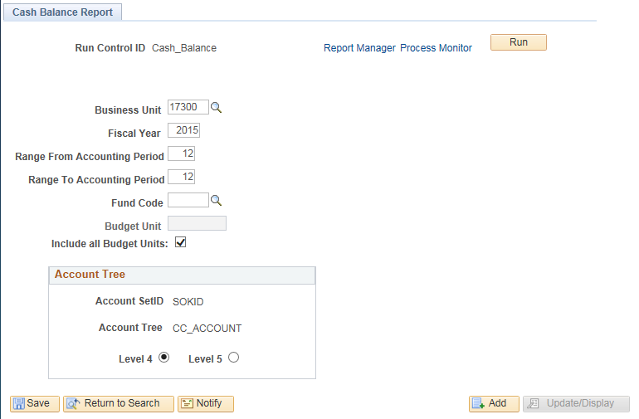
4. | After all parameters are chosen, click the Run button.
5. | Clicking the Run button opens the Process Scheduler Request page. Review the file format choices.  *Type: Select the desired file type.  *Format: Select the desired file output.  Click the “OK” button. Clicking the OK button submits the report (process) to SMART (for the report results to be generated). | 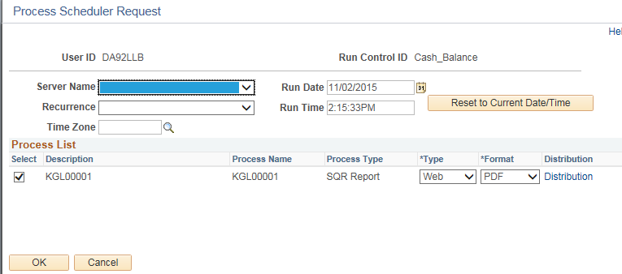
6. | SMART returns you to the Cash Balance Report page.  Click the “Process Monitor” link.
7. | On the Process List page:  If the ‘Run Status’ is “Success”, then the report results have been successfully generated.  If the ‘Run Status’ is NOT “Success” you may need to refresh the process results.  Click the “Refresh” button to refresh the process data.  To view the report results, click the “Details” link. | 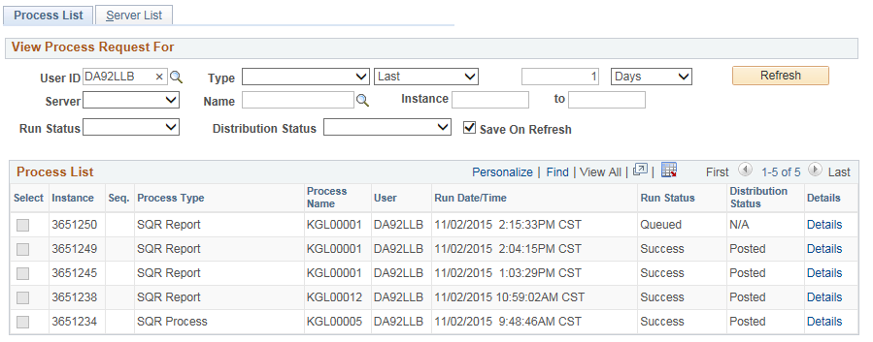
8. | On the Process Detail page:  To view the report results, click the “View Log/Trace” link. | 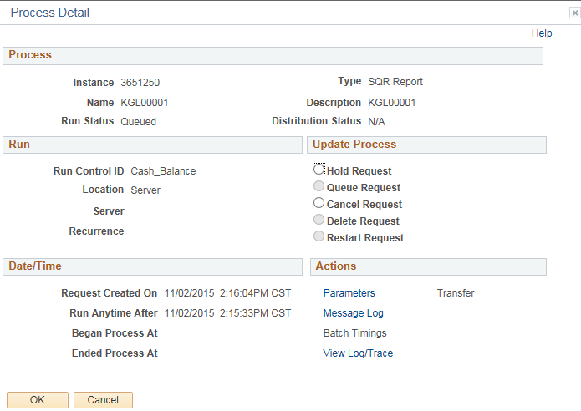
9. | On the View Log/Trace page, File List section: Click the Name link for the desired file output type.  (This is the report results Format that you requested on the Process Scheduler Request page).  In this case, a ‘.PDF’ file was requested. | 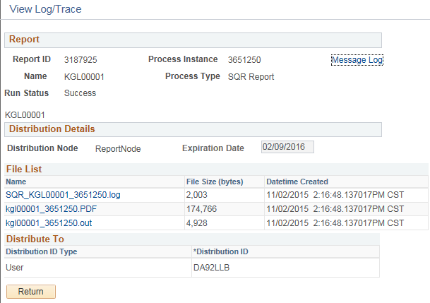
10. | Clicking the file Name link, opens the file in the specified ‘reports results’ Format. | Use the KGL00001 Cash Balance Report results to balance cash by fund/budget unit by agency.  When the report results appear, you may then save or print the file.



