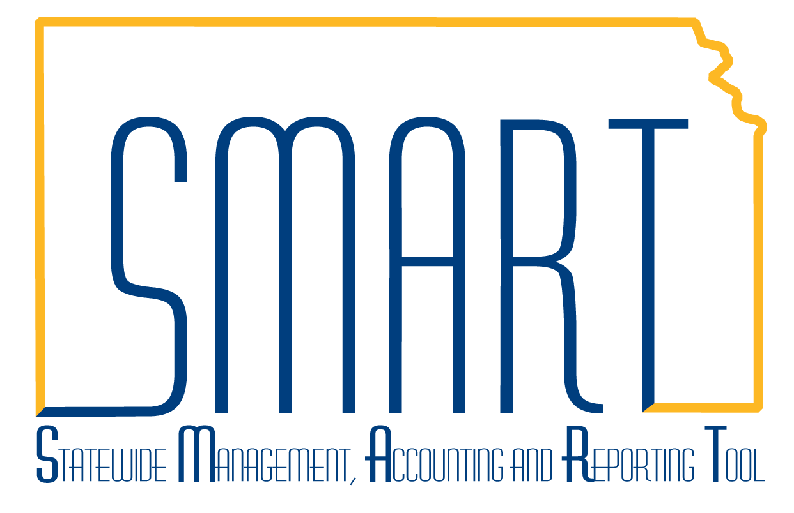
State of Kansas
Updating a Finalized Budget
Statewide Management, Accounting and Reporting Tool

Date Created: | 06/28/2010
Version: | 1.1
Last Updated Date: | 3/8/2019
Process: To modify funding for an existing project that has been generated from a grant.
Step 1. Create an Award Modification in the Grants Module. Navigation: Projects and Grants Homepage > Grants > Creating a Grant > Award Profile > Award Modifications link or Navigator > Grants > Awards > Award Profile > Award Modifications link. | 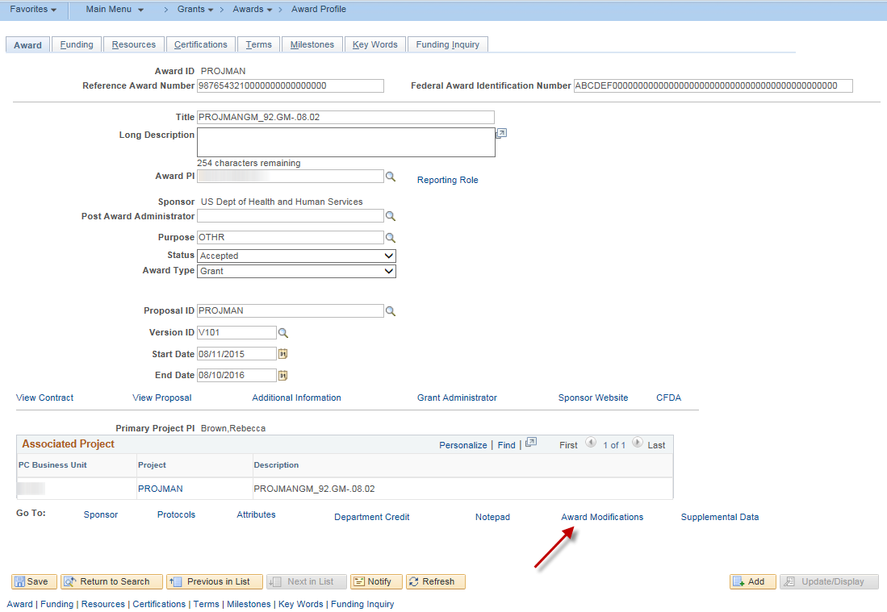
Step 2. On the Award Modifications grid, update the Amount and Total Award Amount. Click the Period icon. | 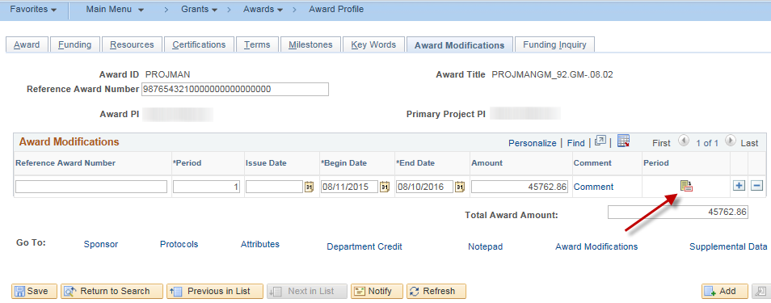
Step 3. In the example, the Award amount has been increased by $2,000.  By selecting the Comments button, additional information pertaining to the modification may be entered. Click OK when comments are completed. | 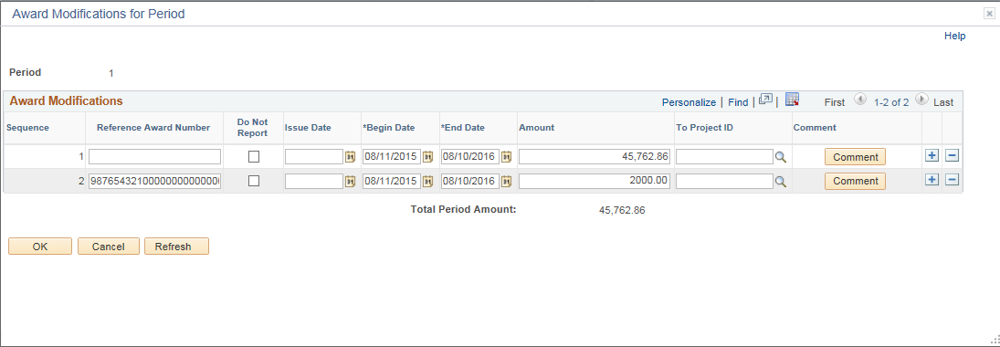  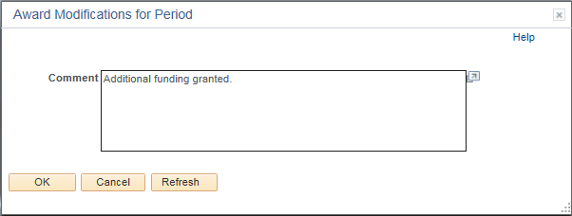
Step 4. Click Refresh, updating the Total Period Amount. Click OK. | 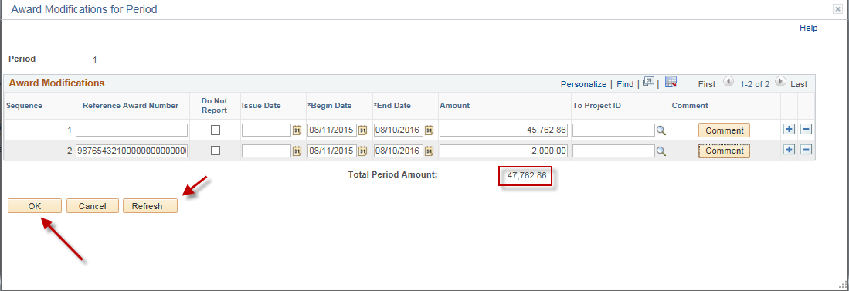
Step 5. The Amount has been updated to reflect the additional funding and the Total Award Amount has updated. Click Save. | 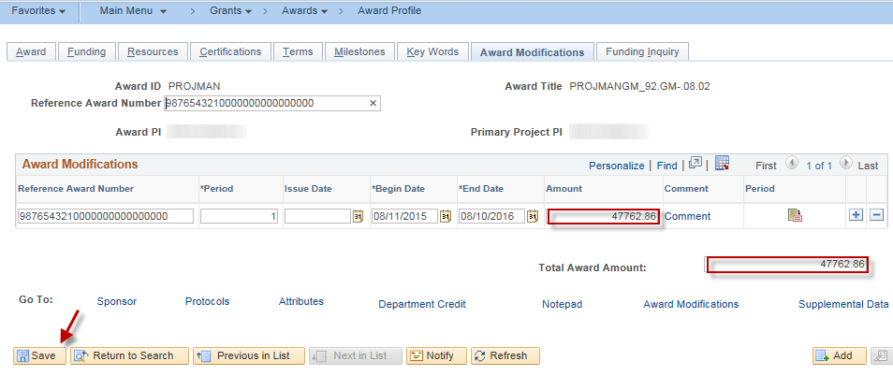
Step 6. Navigation: Projects and Grants Homepage > Grants > Creating a Grant > Project Budgets or Navigator > Grants > Awards > Project Budgets. Search for the Project attached to the Award being updated. Scroll to the right of the page, then use the small scroll on the line to access the + sign to add another row. | 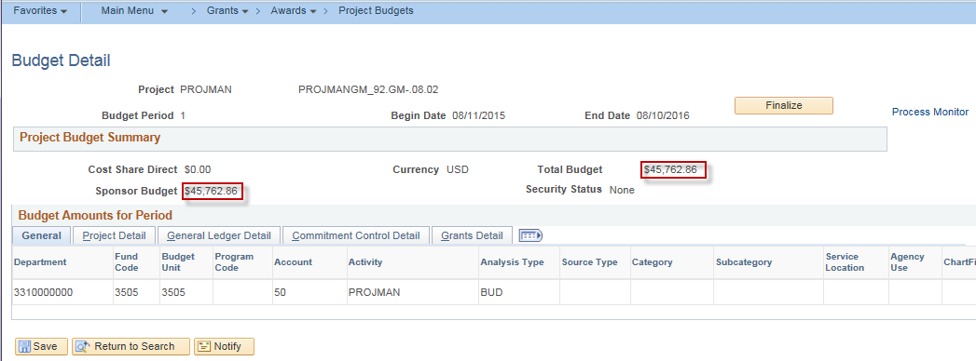
Step 7. Scroll to the right of the page, then use the small scroll on the line to access the + sign to add another row. | 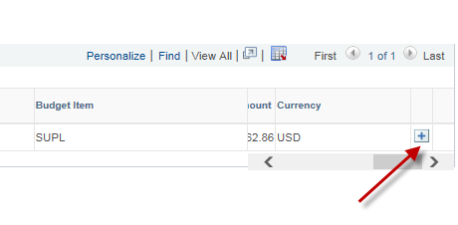
Step 8. Enter the chartfields, Activity, Analysis Type of BUD, and any other applicable information. Enter the Budget Item and Amount. | 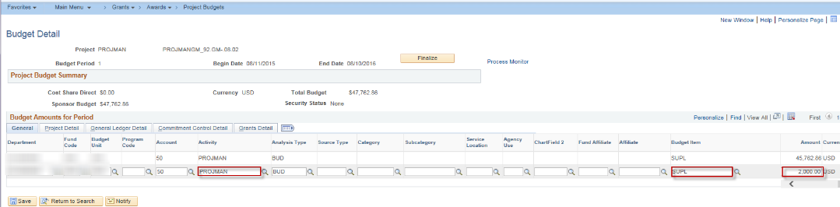
Step 9. Click the Finalize button. Click OK to message that appears. Click the Process Monitor link to view Run Status and Distribution Status. When Success and Posted, select the Return to Project Budgets link. | 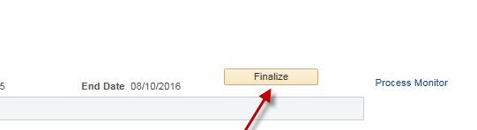
Step 10. Confirm the adjustment by returning to Projects and Grants Homepage > Grants > Creating a Grant > Project Budgets or Navigator > Grants > Awards > Project Budgets. Search for the award. The status on Commitment Control Detail tab for Commitment Control Status will be Distributed and the Total Budget Amount should reflect the changes. | 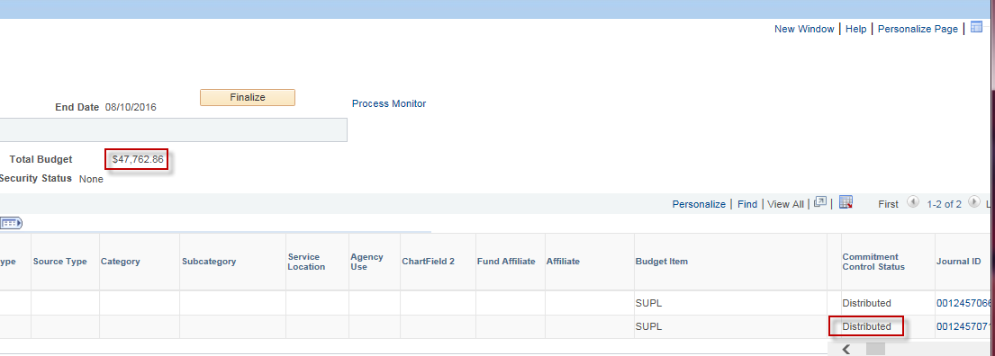
Step 11. Amend the Customer Contract to update the Billing Limit to the new amount. Navigation: Projects and Grants Homepage > Customer Contracts > Customer Contracts > General Information or Navigator > Customer Contracts > Create and Amend > General Information. Search for the Customer Contract associated with the Award. On the General tab, select the Amend Contract button.  Note: The Contracts Workbench (Projects and Grants Homepage > Grants > Manage Grants > Contracts Workbench or Navigator > Grants > Contracts Workbench) is helpful in locating information associated with the Award. | 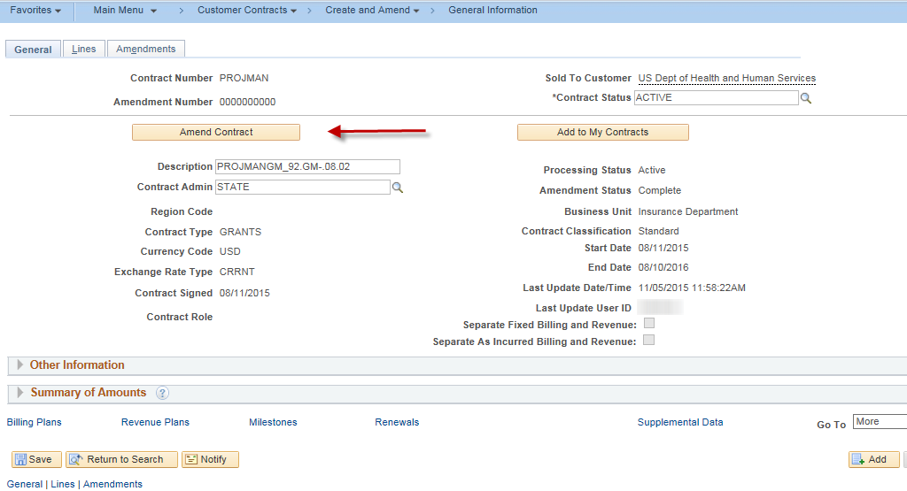
Step 12. When the Amendment tab displays, enter the Amendment Type and Reason. Notes may be added, if desired. Click Save, then select the Amount Allocation hyperlink. | 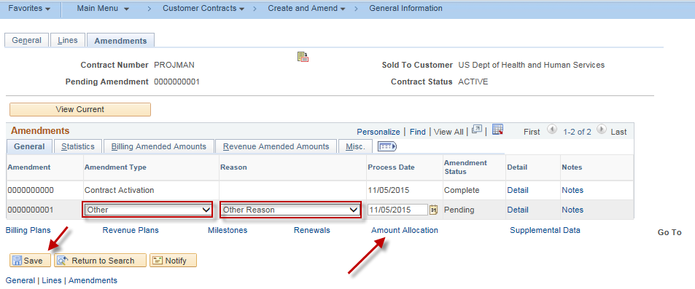
Step 13. The Amount Allocation page will display. Enter the Total Billing Adjustment, in the example is $2,000. Enter the New Billing Limit, in the example $47,762. Click the Recalculate button. Verify the Unallocated Billing amount is 0.00 and the Allocation is now Complete. Click the Save button, then select the Return to General Information hyperlink. | 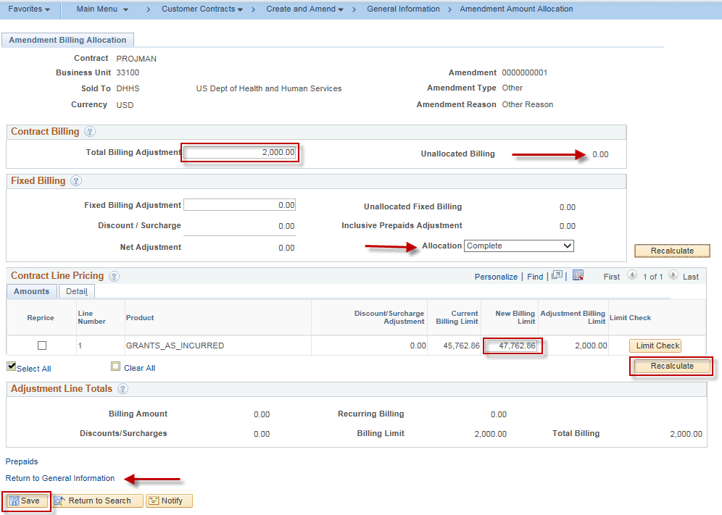
Step 14. On the Amendments tab, select the Detail hyperlink on the line where the adjustment was created. The Amendment Status will be Pending. | 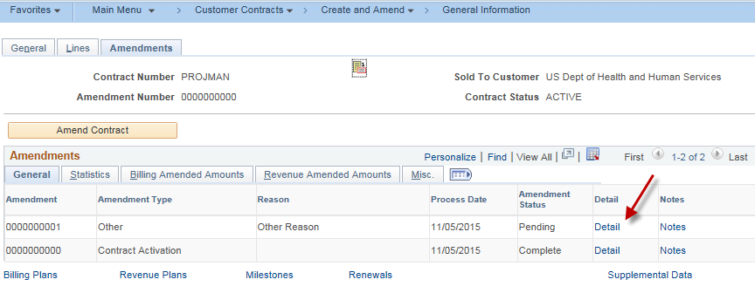
Step 15. The Amendment Details page will display. Toggle the Amendment Status from Pending to Ready. The Process Amendment button will then display. Click the Process Amendment button. Once processed, the Amendment Status will be Complete. Click the Return to General Information hyperlink. | 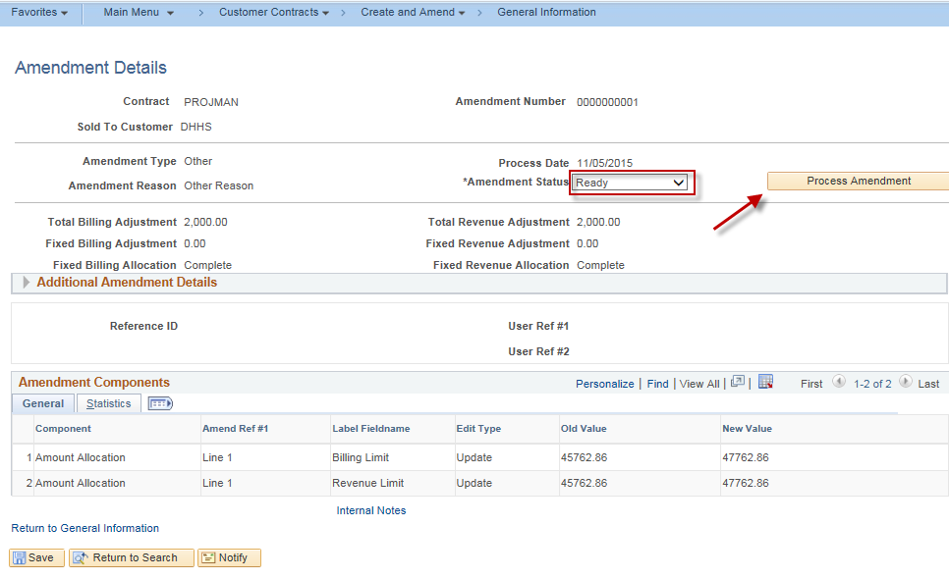
Step 16. The Amendment now has an Amendment Status of Complete.  And the Summary of Amounts on the General tab now reflects the adjusted amounts. | 