Safeguarding Assets
The goal of this document is to provide agencies an overview of utilizing the Asset Management Module to assist in safeguarding assets. Following the SMART processes under the Asset Management Module in conjunction with following the policies described in PM 13,001 will help ensure that adequate controls are in place and that SMART asset records are complete and updated in a timely manner.
Review of Assets per K.S.A. 75-3729
The Office of the Chief Financial Officer’s Audit Services Team will periodically conduct a review of each agency’s assets. The review may cover the following areas, including providing proper supporting documentation for each:
- Asset management processes
- Agency physical verification processes
- Assets purchased during the audit period
- Assets retired and/or transferred during the audit period
- Agency policy to safeguard assets

Date-Specific Reminders
- Each agency should perform a fixed asset inspection by June 30th of each year.
- Form DA-82: Capital Asset Supplemental Information must be submitted to the Department of Administration by August 31st of each year.

Verification Steps Prior to Annual Agency Certification
Step 1. Validate that all financial transactions (additions, adjustments, transfers, and retirements) have been processed in SMART.
a. Use the Asset Management: Agency Month-End Processing checklist to complete these steps. Links to applicable training documents are included in that job aid.
Step 2. Run the Asset Inventory List report (Asset Management > Financial Reports > Asset Inventory List) and validate the following fields for all capital assets (book = CAFR, KPERS, or LOTTERY).
a. Asset Description
i. Be sure a detailed description has been entered for all assets. It should be detailed enough that one could easily identify the asset when reviewing an asset report.
ii. As a rule of thumb, include the Year, Manufacturer Information, and Item in the description field. For example, enter ‘2010 Ford Focus’ instead of ‘Car.’
iii. To update the Description field for an asset, navigate to Asset Management > Asset Transactions > Owned Assets > Basic Add > General Information tab.
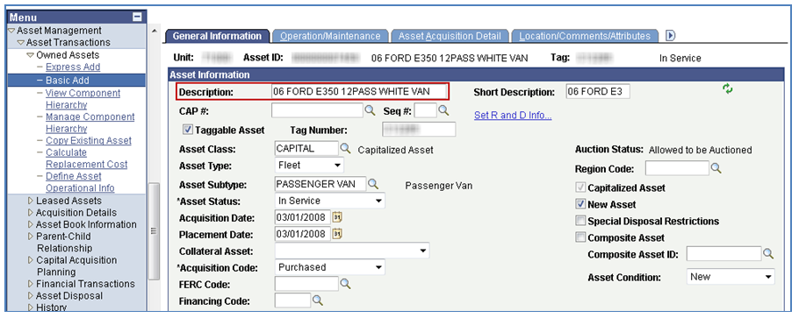

b. Serial Number / VIN
i. The Serial Number/VIN should be entered for all applicable assets (excludes land, buildings, etc).
ii. The Serial Number field is located on the Operation/Maintenance tab in Basic Add.
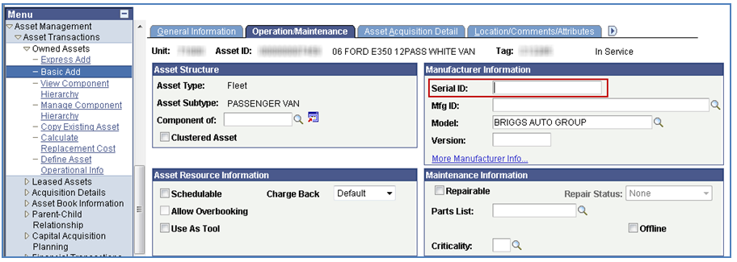

iii. The VIN is located on the Manufacturer/Licence/Custodian tab in Basic Add. It will only be available for assets with an Asset Type of ‘Fleet.’
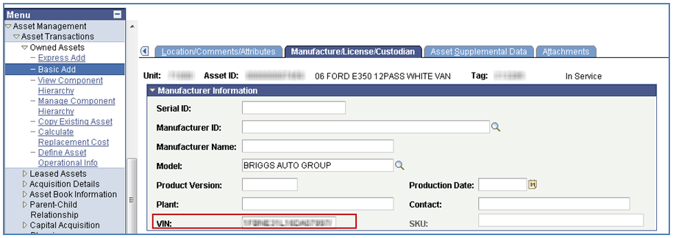

c. Tag Number
i. All applicable assets should have the Tag Number populated in SMART.
ii. The Tag Number field is located on the General Information tab of Basic Add.
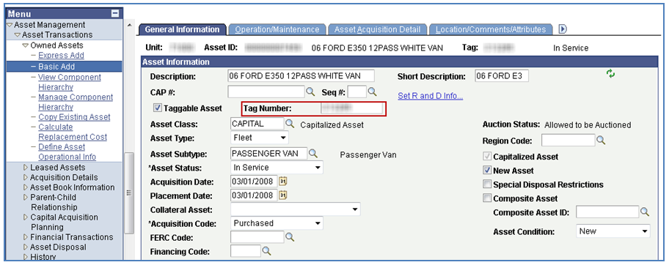

d. In Service Date
i. To update the In Service Date of the asset, correct the Placement Date field. This field is located on the General Information tab in Basic Add.
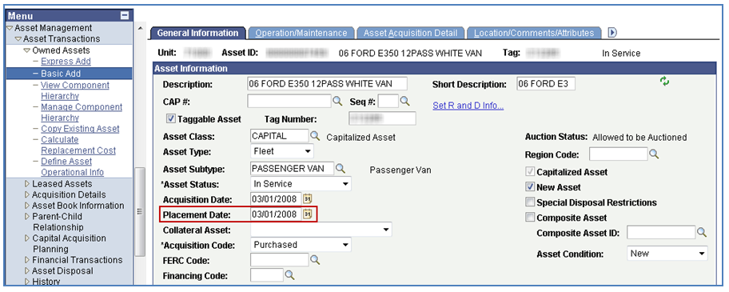

e. Location Code
i. To update the Location Code, see the Updating Locations and Custodians training guide.
ii. For a detailed listing of the Location Code values, see the Location Code Table Values job aid.
iii. The Location Code is located on the Location/Comments/Attributes tab in Basic Add.
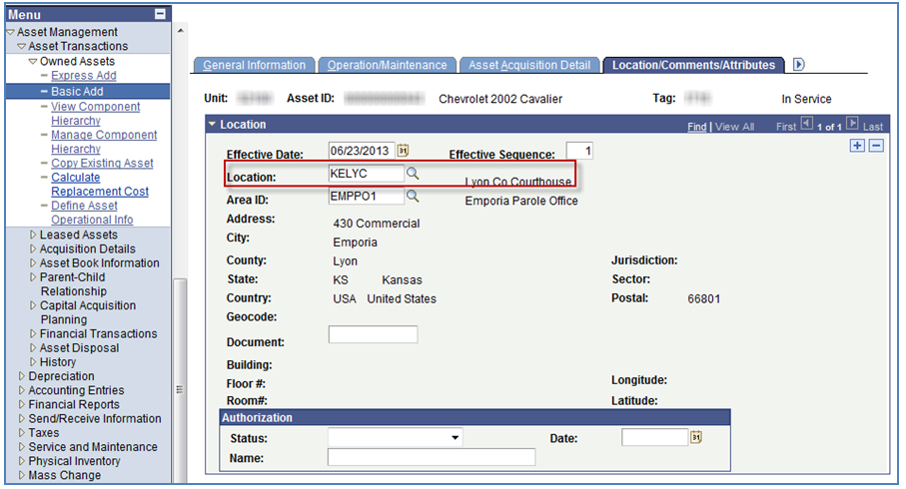

f. Custodian
i. Though not required in SMART, it is best practice to assign a Custodian to each asset. Update the Custodian field in a timely manner when the assigned custodian is no longer applicable (example—retirement).
ii. To update the Custodian, see the Updating Locations and Custodians training guide.
iii. The Custodian is located on the Manufacturer/License/Custodian tab in Basic Add.
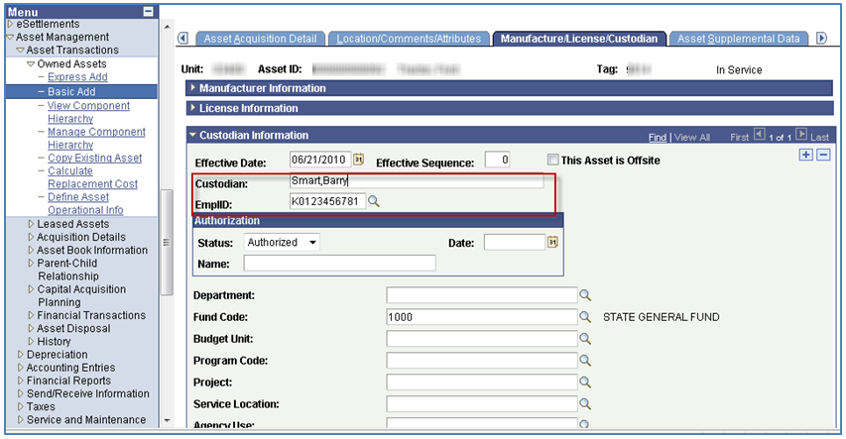

g. Total Cost
i. Validate the Cost is correct for all capital assets. Perform any financial transactions to update the cost if applicable. See Step 1 for more information.

Step 3. Validate that a formal policy exists to safeguard assets. See PM 13001 for more information.

