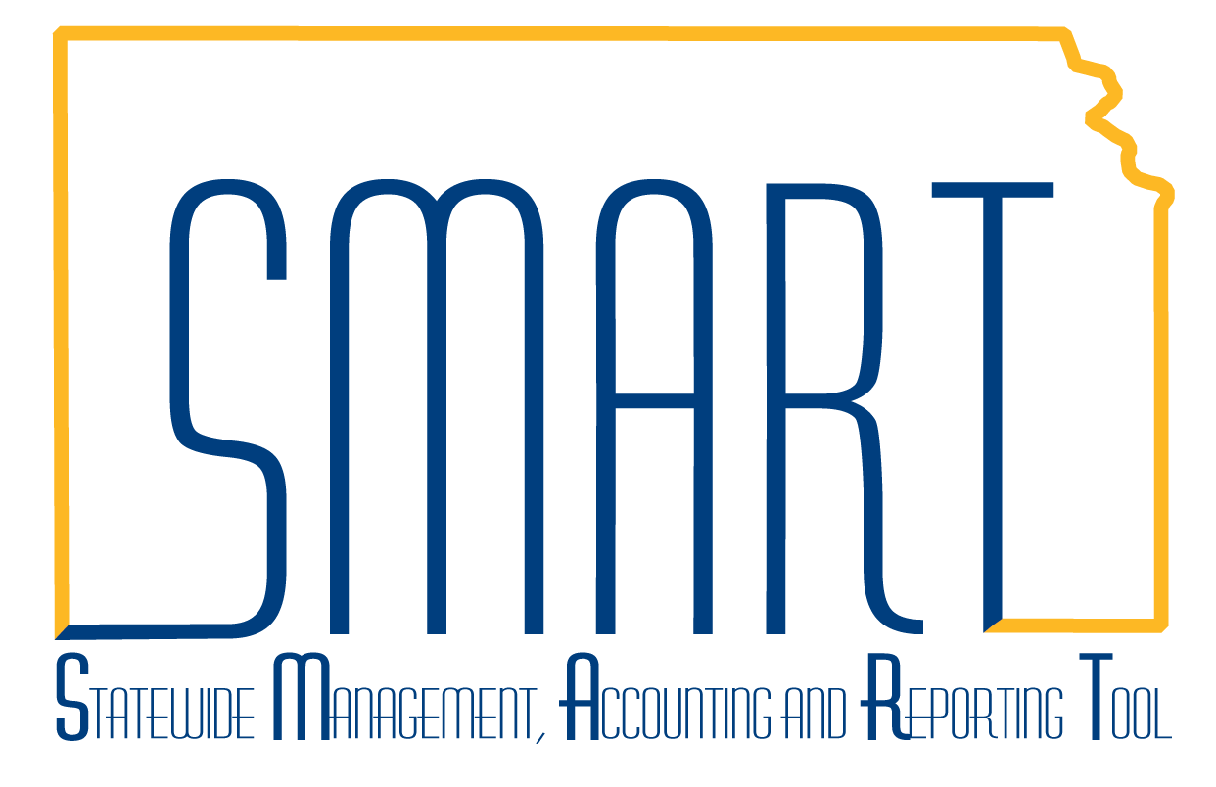
State of Kansas
High-Level Changes from 9.0 to 9.2 in Asset Management:
RF Template on Cost and Depreciation Reports
Statewide Management, Accounting and Reporting Tool
Date Created: | 10/28/2015
Version: | 1.0
Last Updated Date:
Purpose: | This document highlights one of the changes between 9.0 and 9.2 in the Asset Management module.
Security: | - Role Security: The following roles are applicable:  Agency Asset Viewer  BU Security: Business Unit Security is applied. Agencies will only have access to the assets in their Business Unit.
Procedure

Cost and depreciation report enhancements include a new Report Print Option template that enables you to control which fields to print, their order on the report, their labels, and the length of the fields.

In this example, we will run the Cost Activity report and specify that we only wish to see the Beginning and Ending Balances for each asset.

Step | Action
 | Click the Main Menu button.
 | Click the Asset Management menu.
 | Click the Financial Reports menu.
 | Click the Cost and Depreciation menu.

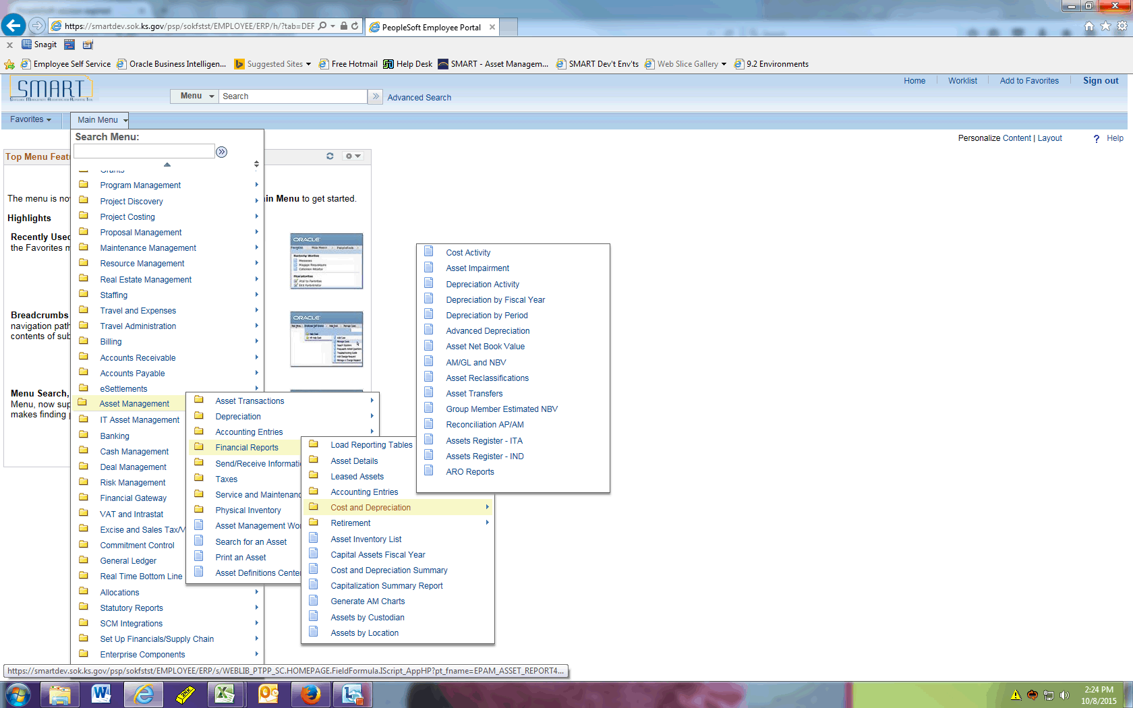

Step | Action
 | Click the Cost Activity menu.
 | Enter the desired information into the Run Control ID field. Enter "RF_TEMPLATE".
 | Click the Add button.

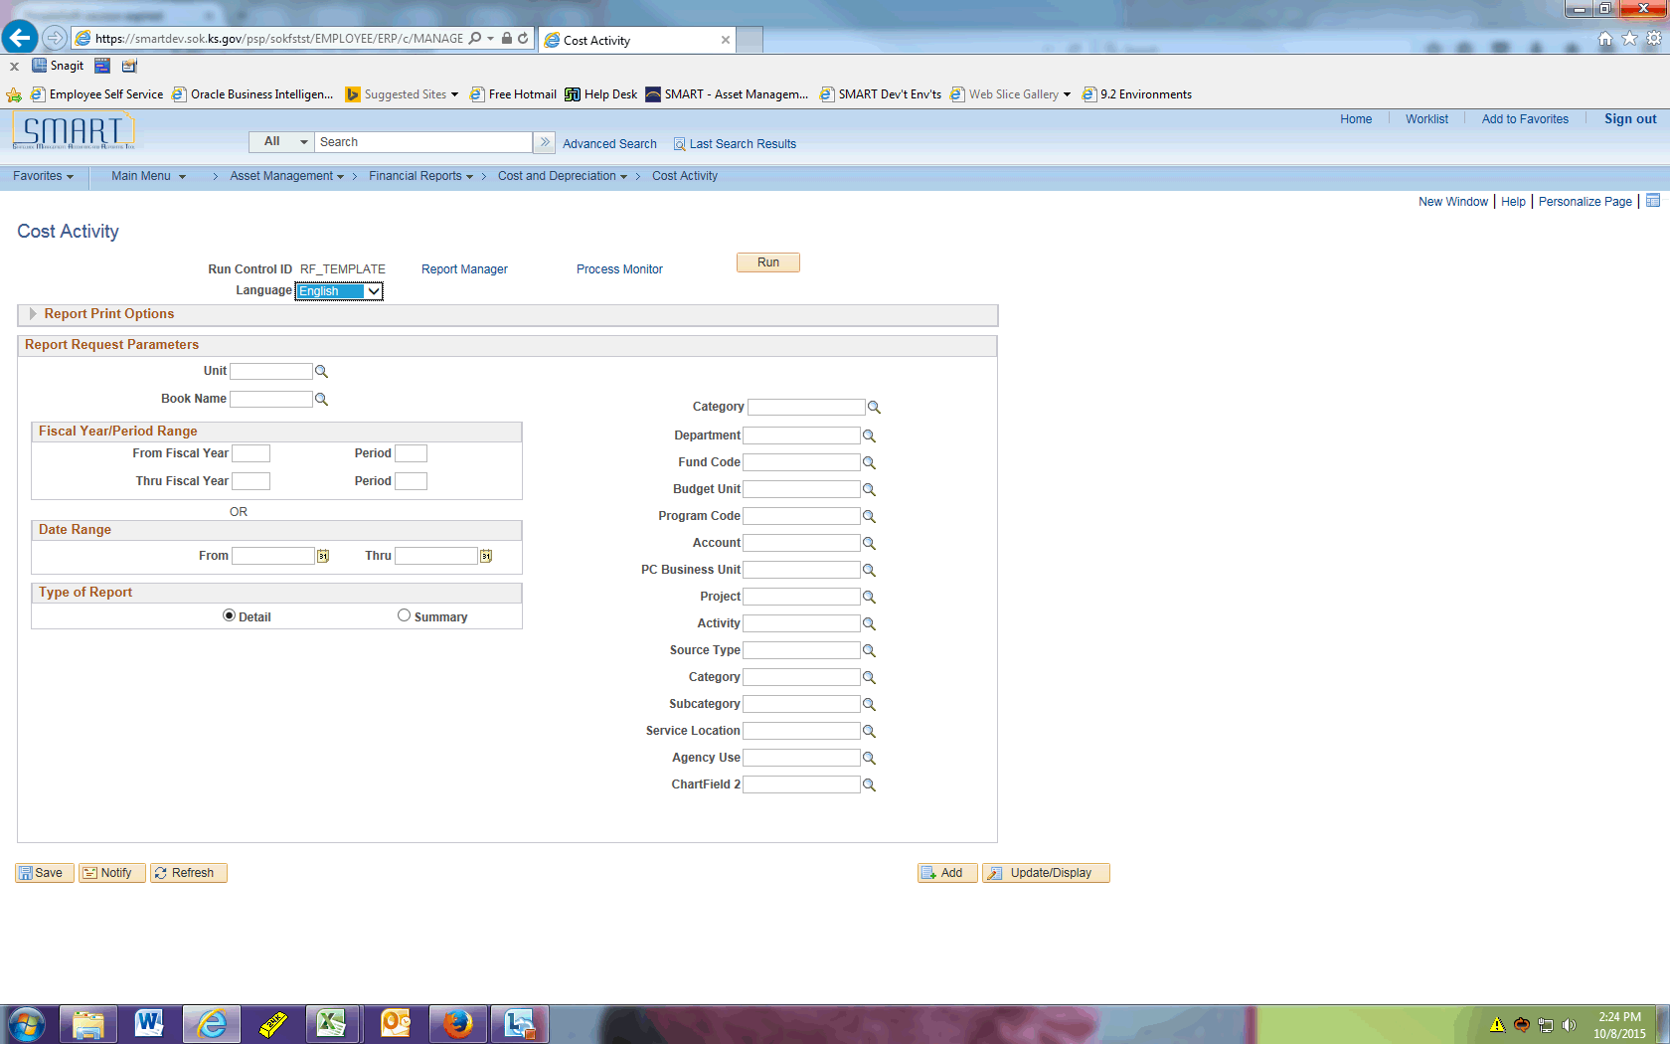

Step | Action
 | Click the Expand section Report Print Options link.
 | Click the Report By list.

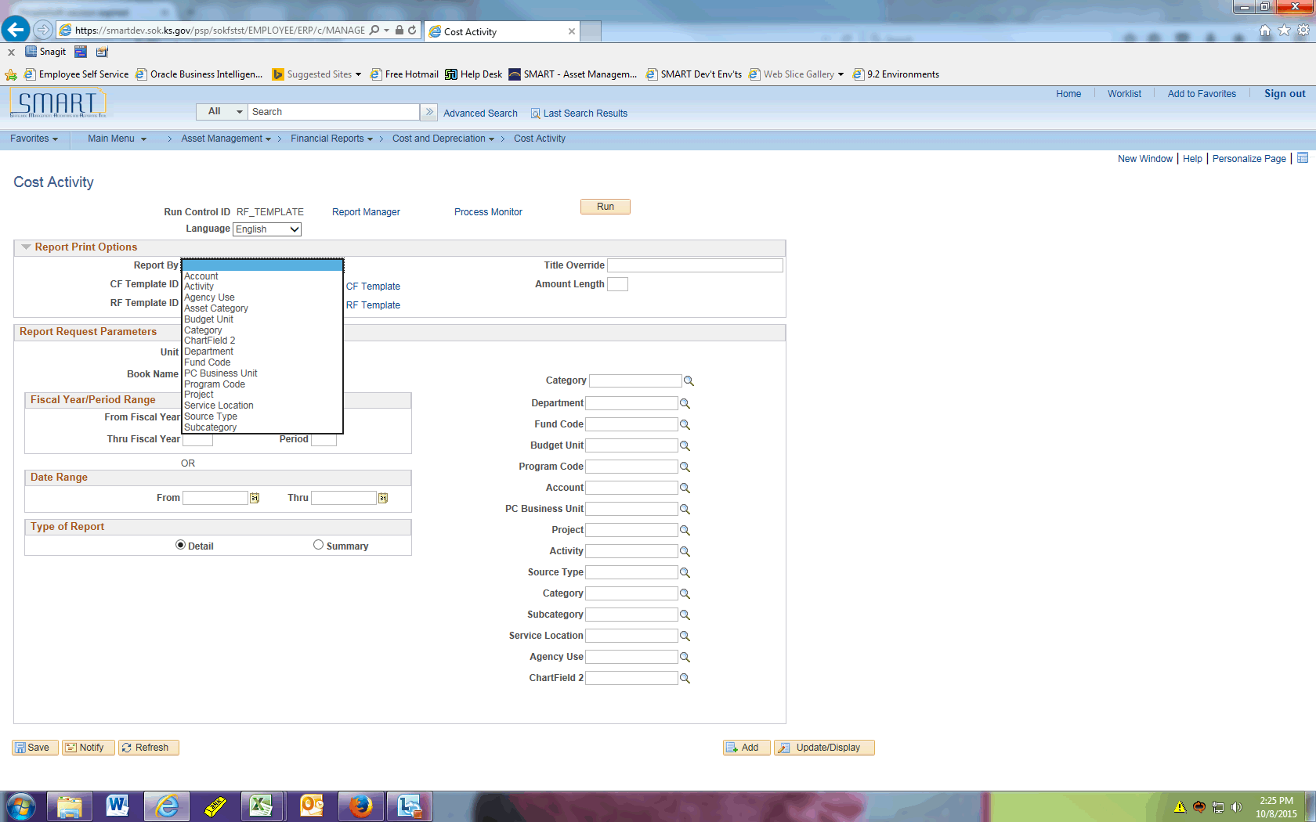

Step | Action
 | Click the Asset Category list item.
 | Click the Update/Add CF Template link.

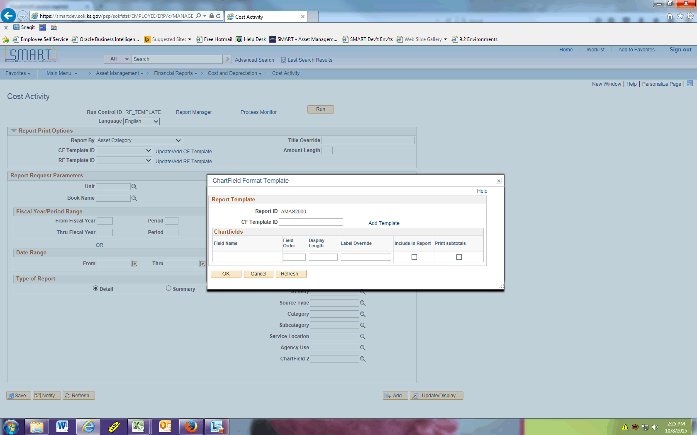

Step | Action
 | Enter the desired information into the CF Template ID field. Enter "AMAS2000.1".
 | Click the Add Template link.

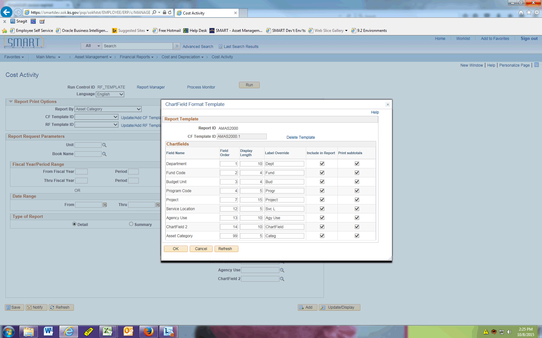

Step | Action
Now you can decide which chartfields to include and subtotal by in this report.

You should deselect any chartfields your agency does not utilize.

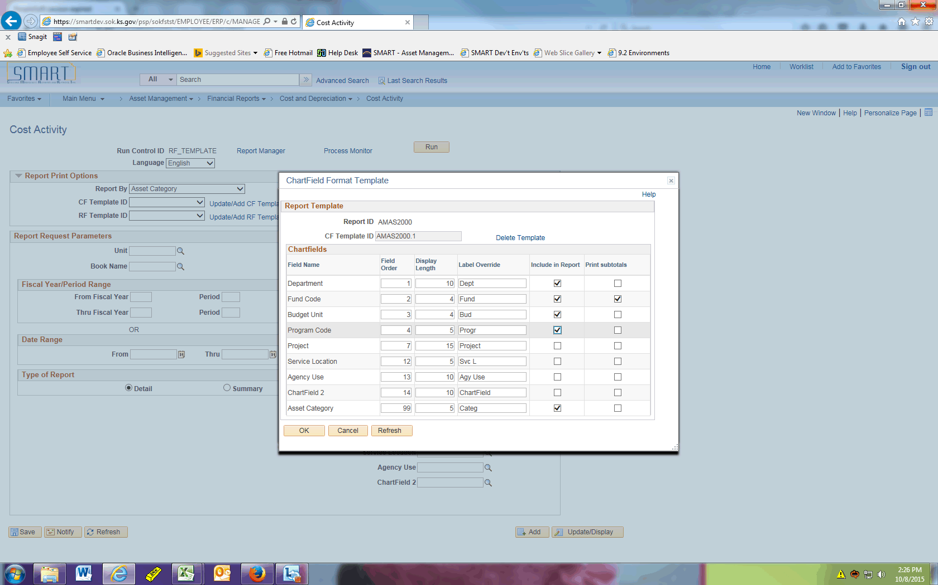

Step | Action
 | Click the OK button.
 | Click the Update/Add RF Template link.

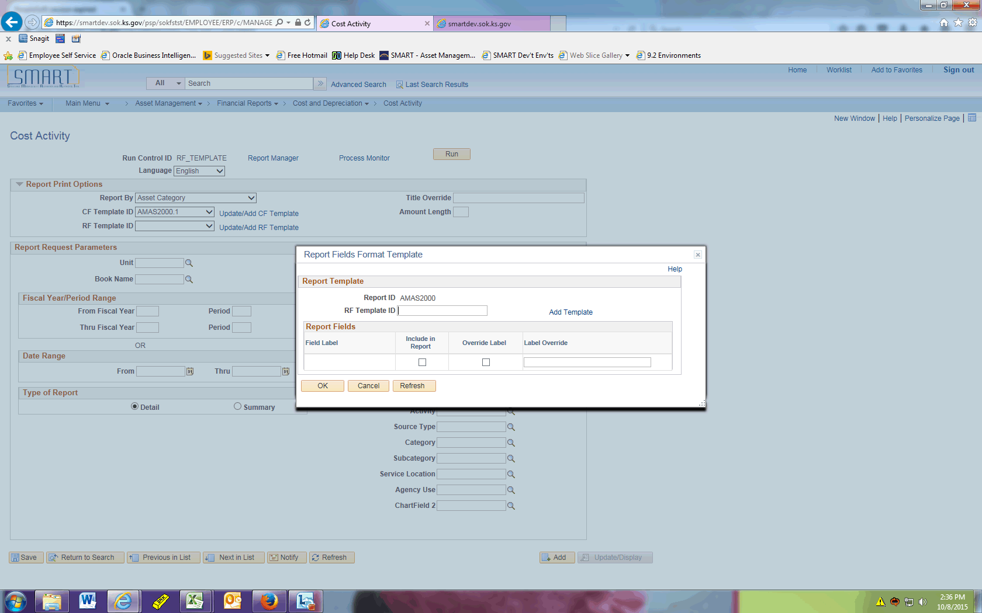

Step | Action
 | Enter the desired information into the RF Template ID field. Enter "AMAS2000.1".
 | Click the Add Template link.

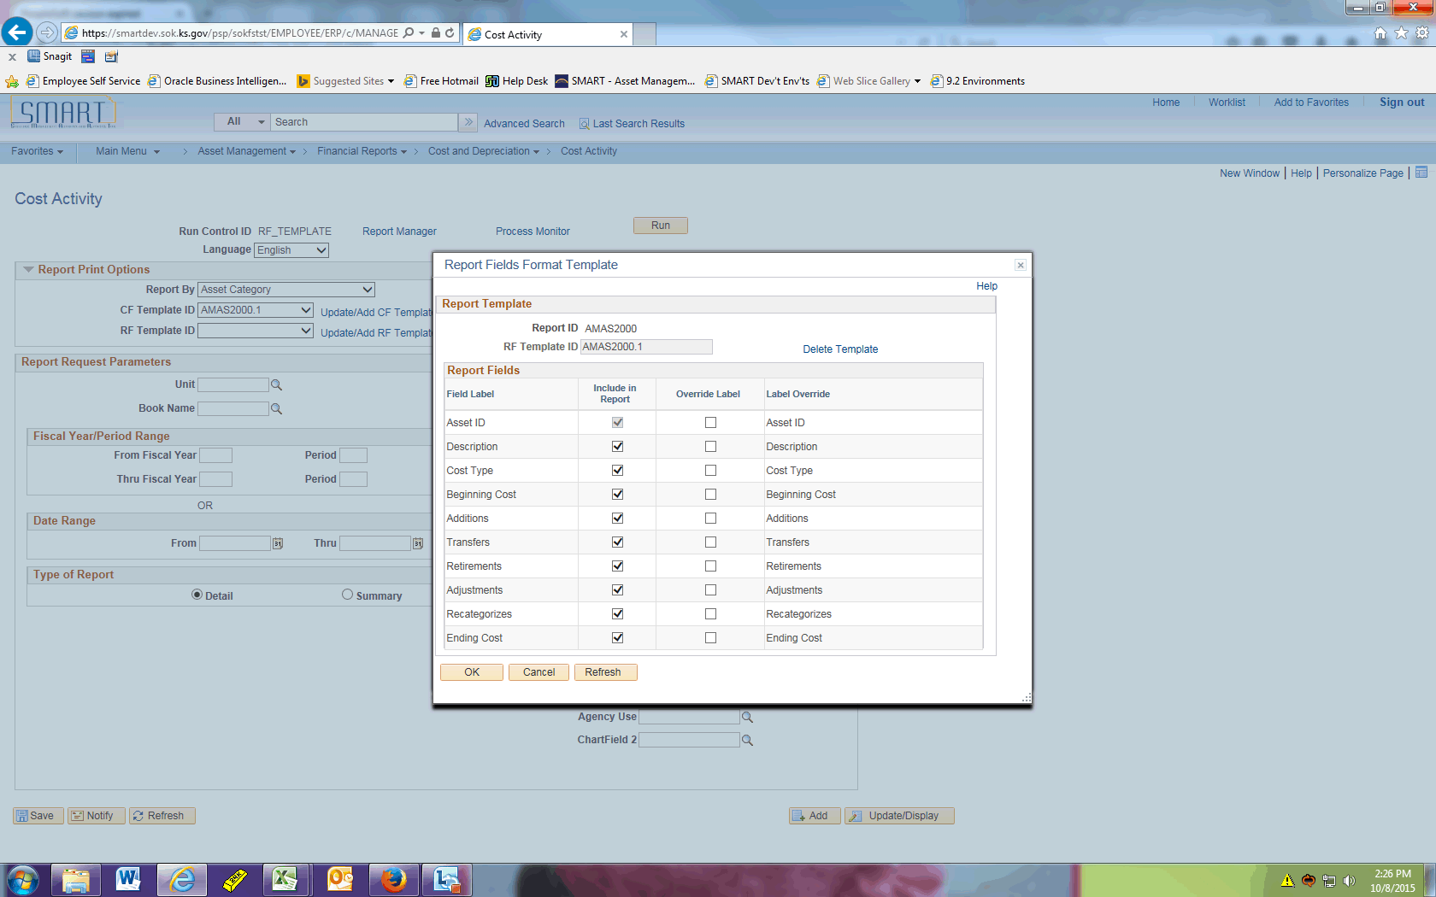

Step | Action
Now you have the option to specify what fields to include in your report. In this example, we only want to see Asset ID, Description, Beginning Cost, and Ending Cost.

Also note you can override the label if needed.
 | Click the Include in Report option.

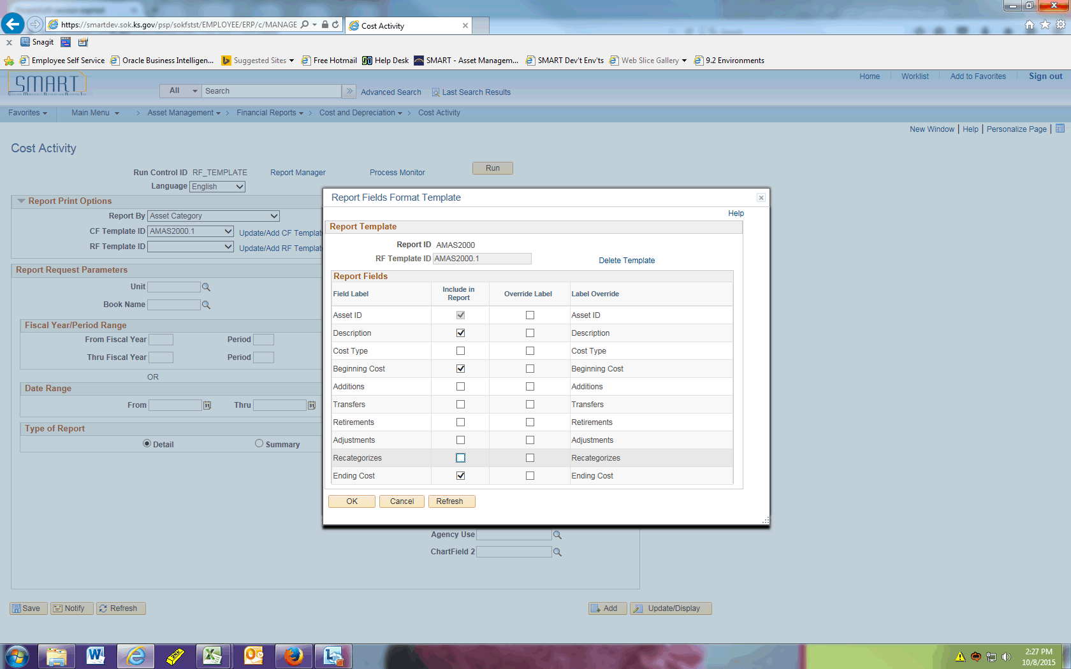

Step | Action
 | Click the OK button.
 | Click the Look up Unit (Alt+5) button.
 | Click the 17300 link.
 | Click the Look up Book Name (Alt+5) button.
 | Click the CAFR link.
 | Enter the desired information into the From Fiscal Year field. Enter "2015".
 | Enter the desired information into the Period field. Enter "1".
 | Enter the desired information into the Thru Fiscal Year field. Enter "2015".
 | Enter the desired information into the Period field. Enter "12".

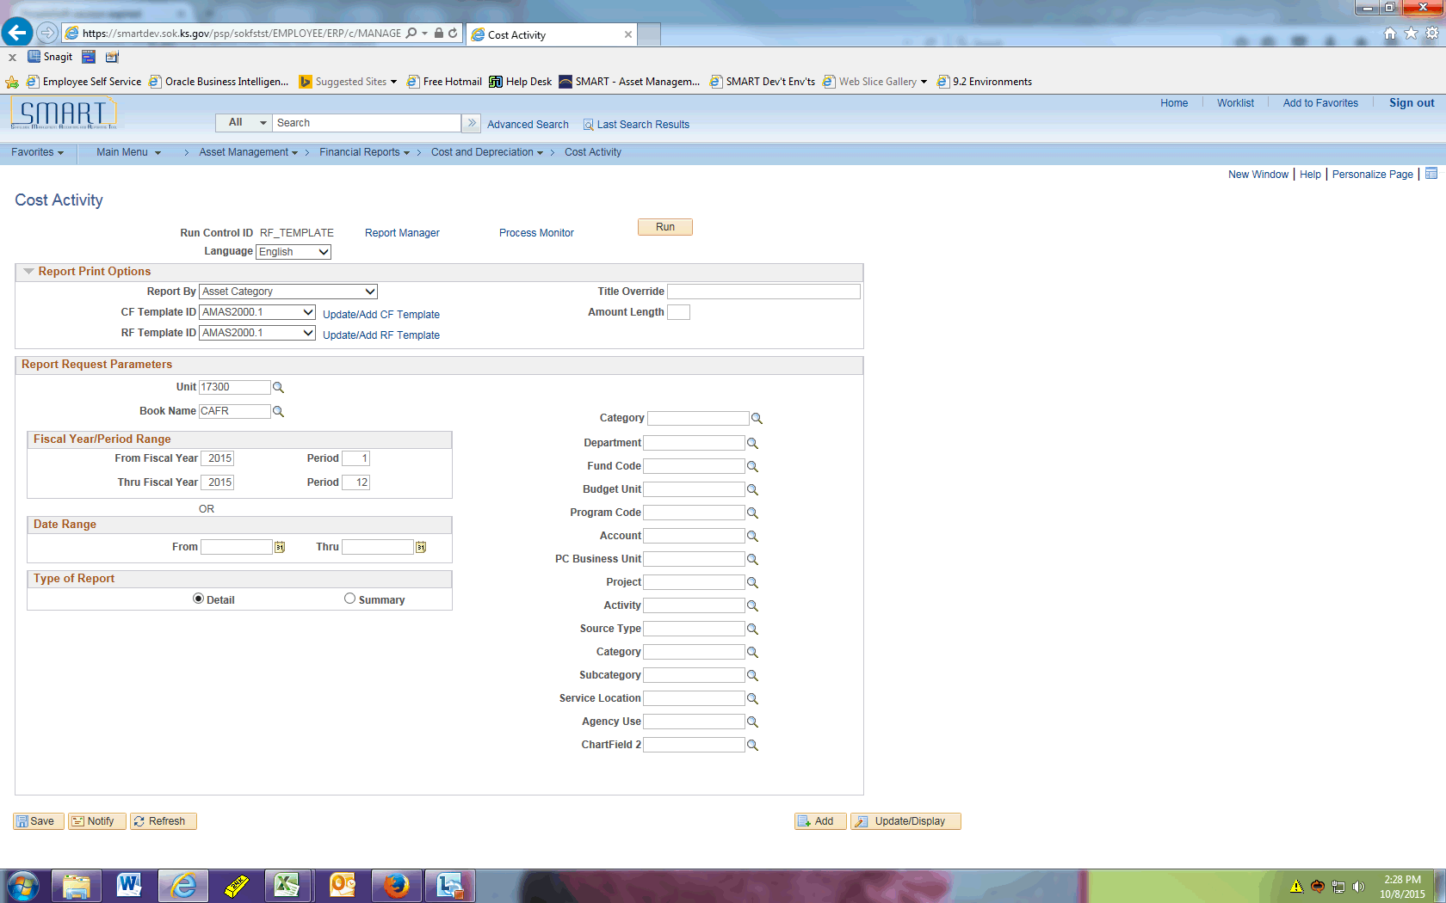

Step | Action
 | Click the Run button.

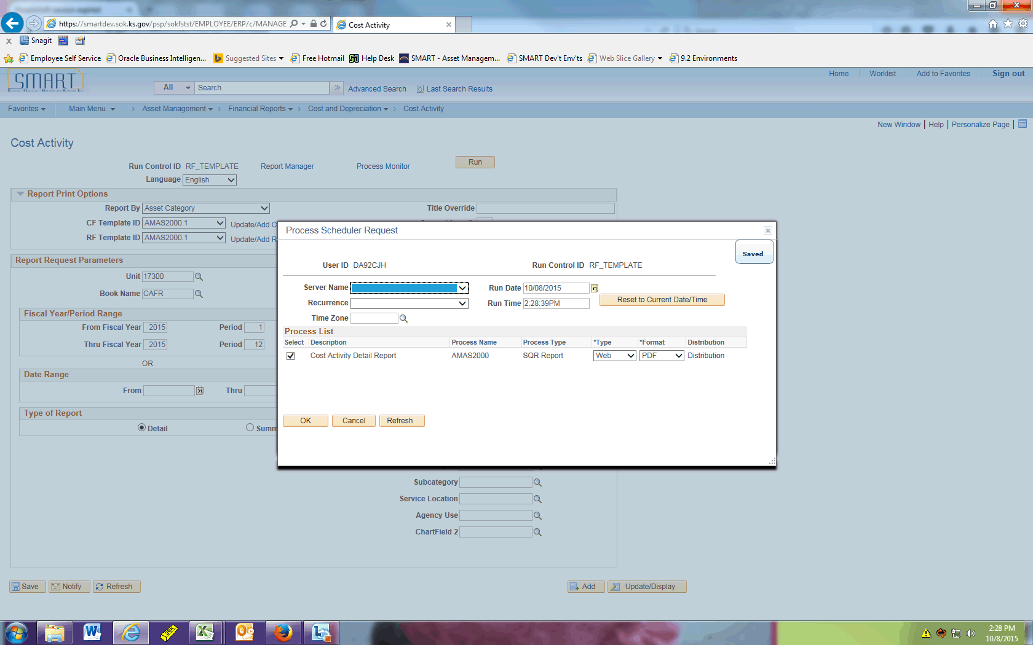

Step | Action
 | Click the OK button.
 | Click the Process Monitor link.
 | Click the Refresh button periodically until the report has a Run Status of Success and Distribution Status of Posted.

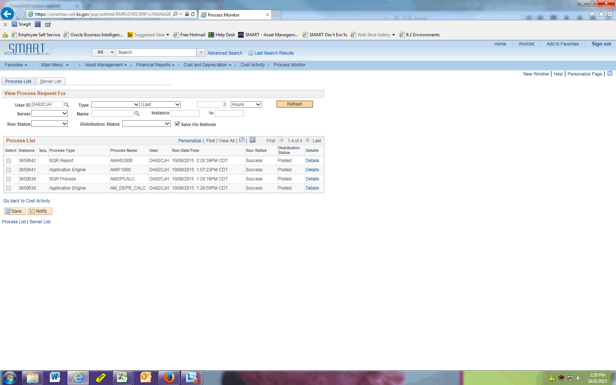

Step | Action
 | Click the Details link.

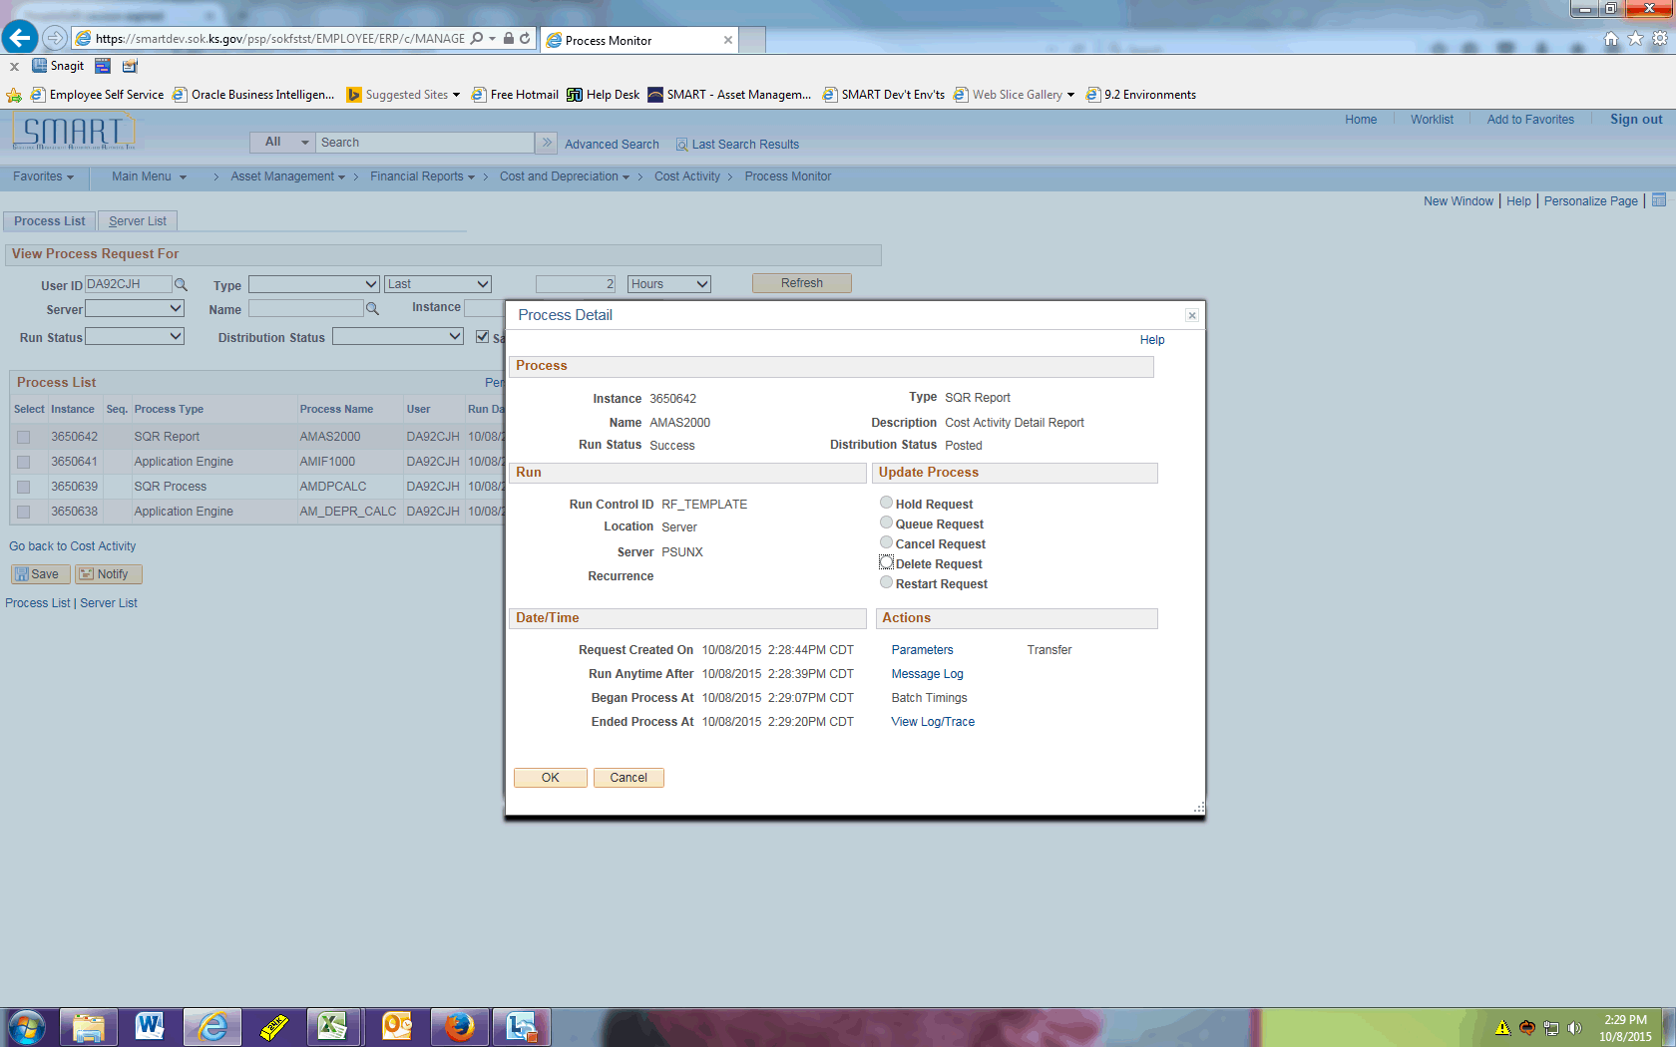

Step | Action
 | Click the View Log/Trace link.
 | Click the amas2000_3650642.PDF link.

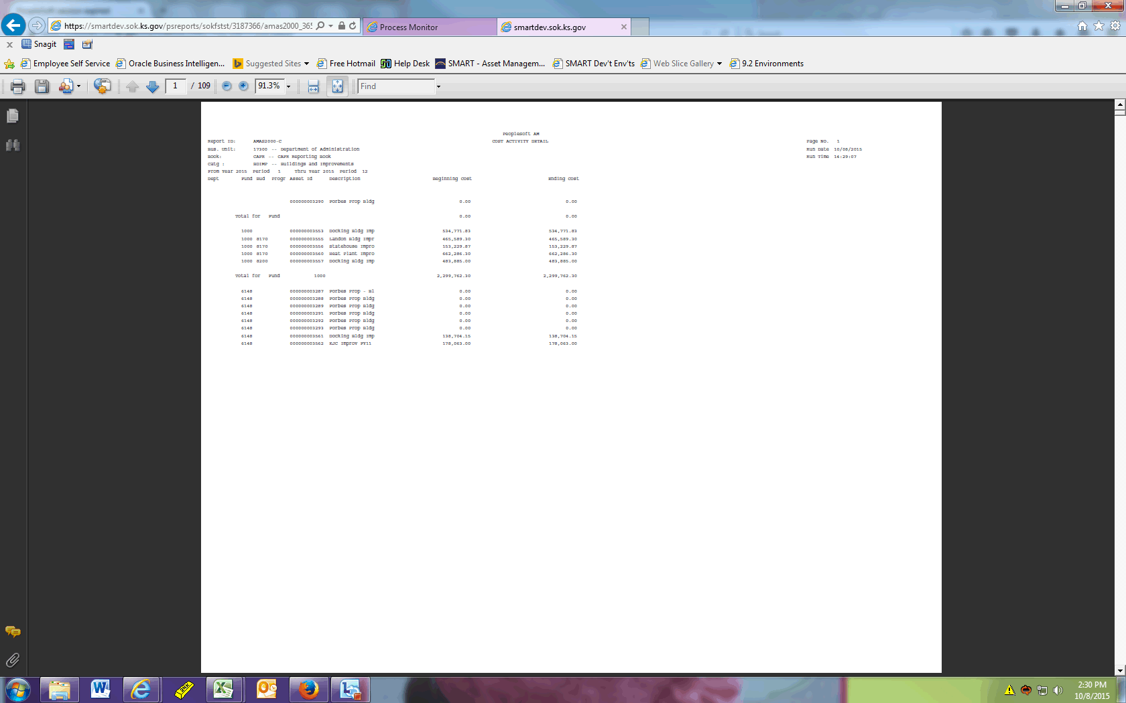

Step | Action
 | The report now shows only the Asset ID, Description, Beginning Cost, and Ending Cost as defined on the RF Template ID. The chartfields specified in the CF Template ID are also displayed.
This concludes the 'AM - RF Template on Cost and Depreciation Reports' topic. Thank you for taking this course.
End of Procedure.

