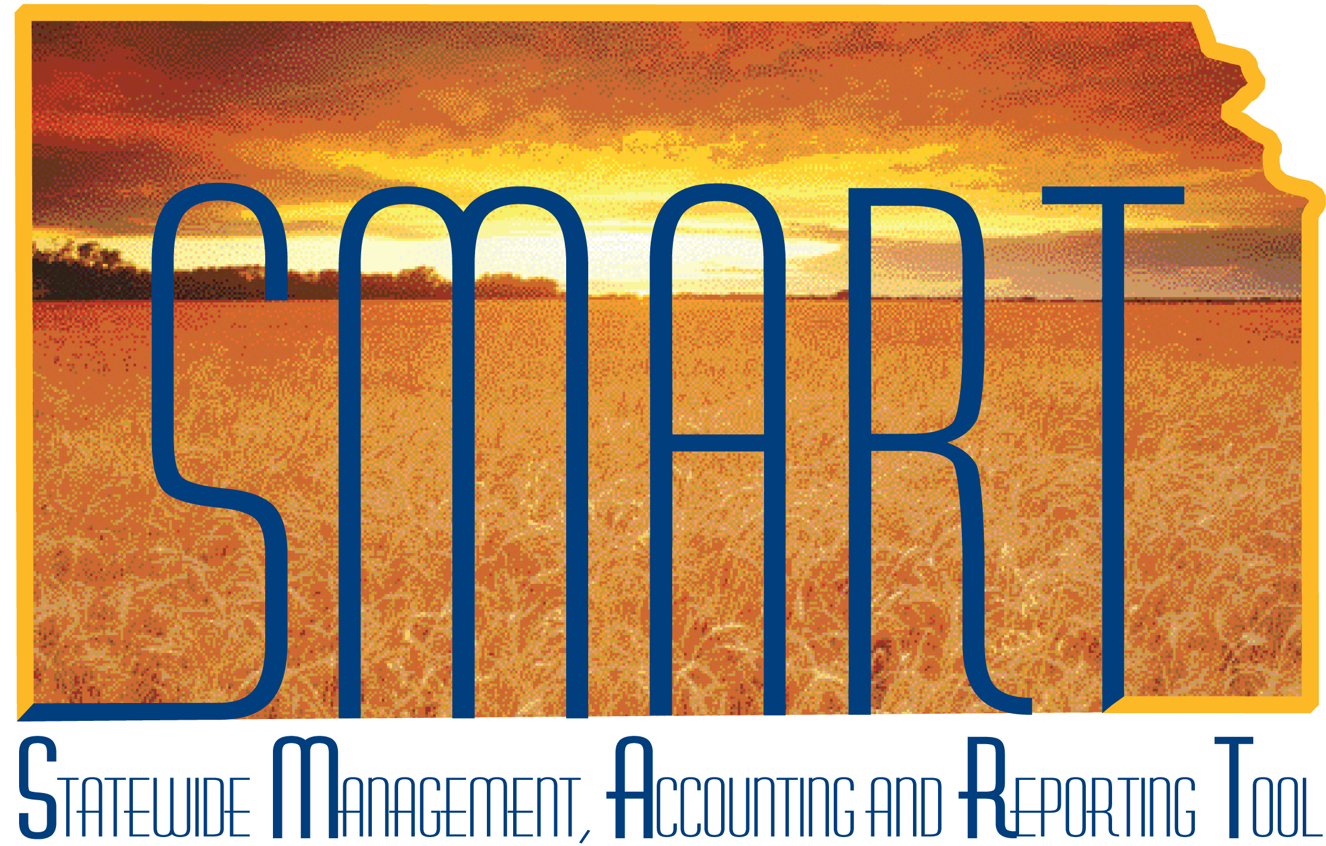
Training Guide – General Ledger
Reviewing Ledger and Journal Entries
State of Kansas

Applicable Role(s):

Kansas GL Processor
Kansas GL Approver
Kansas GL Viewer

Topic 1: Review Journal Status 3
Topic 2: Ledger Inquiry Page 6
Topic 3: Journal Inquiry Page 14

Topic 1: Review Journal Status
- At any time during journal processing, you can view the status of journals and journal line details on the Review Journal Status pages.
Procedure:

- Navigate to Review Journal Status:

Page Name | Path
Review Journal Status | Navigator > General Ledger > Journals > Process Journals > Review Journal Status

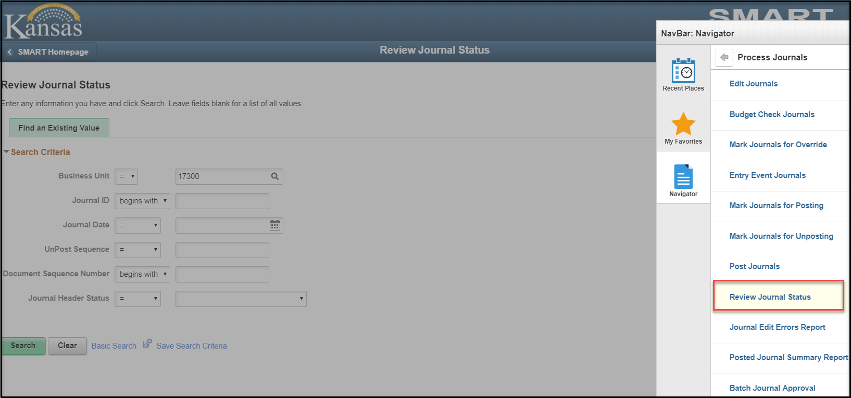
Figure 1. Navigation Menu

- Enter criteria into the Review Journal Status Page.
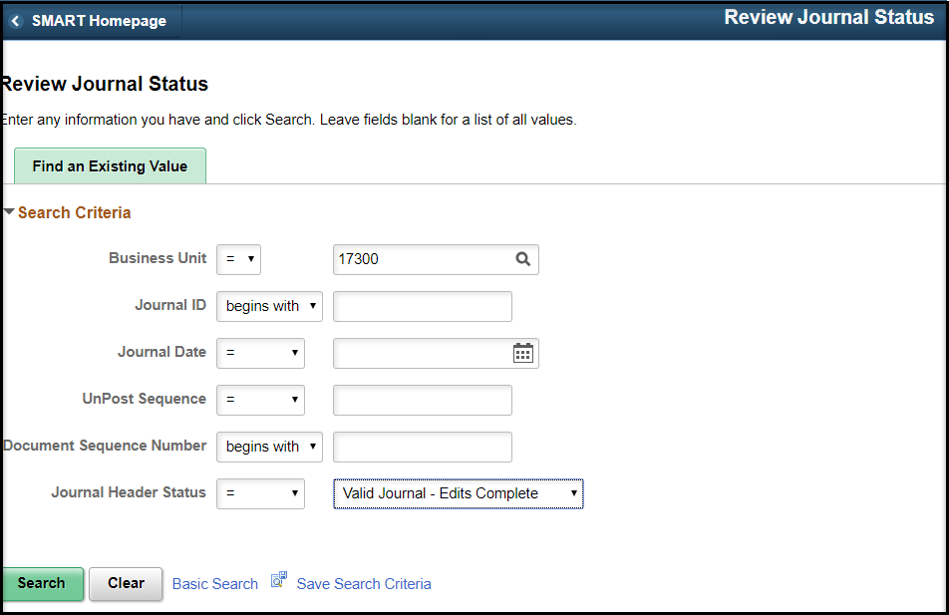
Figure 2. Journal Status Page
- The Journal Header Status page will display. The Journal Header will show the Header Edit Status and Budget Status, Journal Line Totals, and the Commitment Control Amount Type are shown.
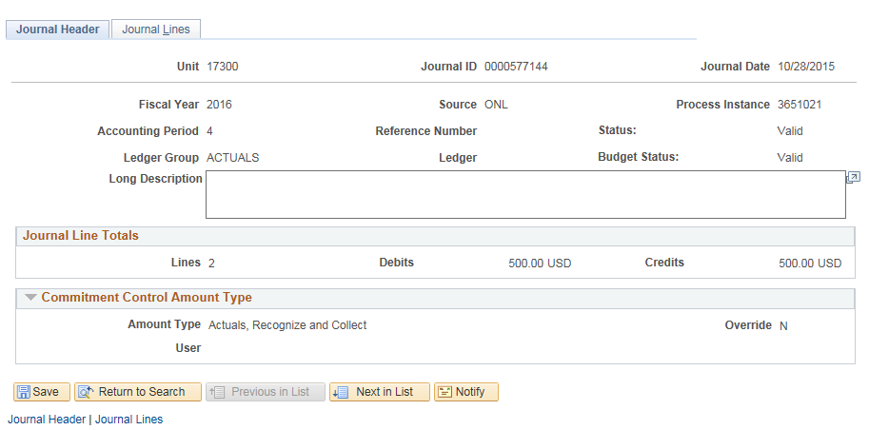
Figure 3. Journal Header Status Page
- Click on the Journal Lines tab. The Journal Lines Status page will be displayed. The Funding, Budget Date, Budget Status and Line Description will be shown.
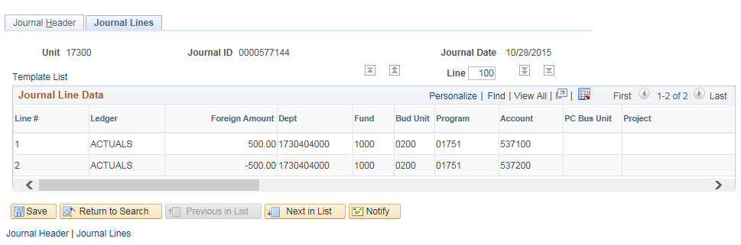
Figure 4. Journal Lines Status Left of Side of Page

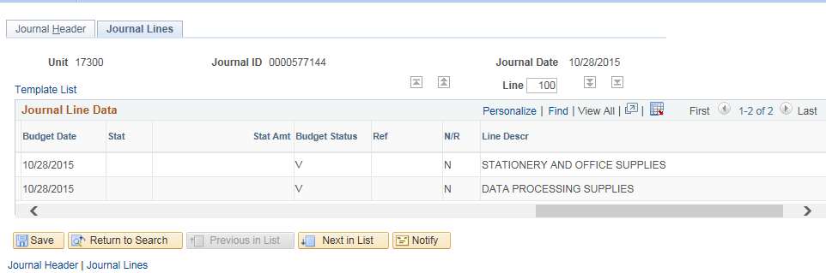
Figure 5. Journal Lines Status Right Side of Page

Topic 2: Ledger Inquiry Page
- SMART provides a series of inquiries that enable you to review ledger summary and detail ledger information based on selected ChartField combinations. These inquiries use several successive views that take you down to journal line details. The ledger inquiry also enables you to drill down across products from account balances in General Ledger to specific transaction entries in other SMART modules
- Commitment control and summary ledgers are not available for ledger inquiry
Procedure:
- Navigate to the Ledger Inquiry page.
Page Name | Description
Ledger Inquiry | SMART Homepage > General Ledger/KK page > General Leger tile > Inquiries > Ledger Inquiry
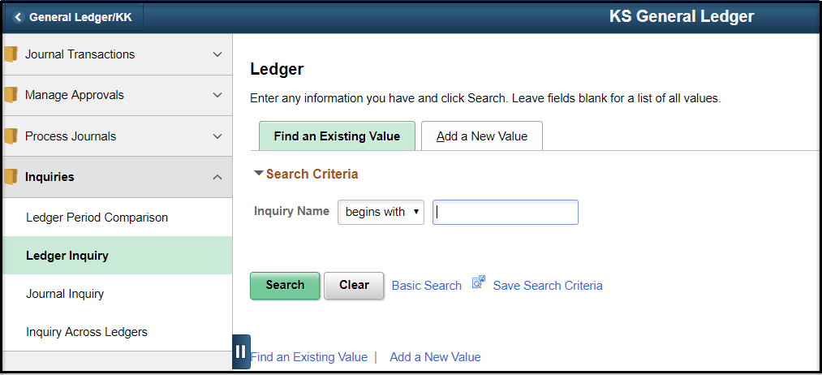
Figure 6. Ledger Inquiry Navigation Page
- Enter criteria into Inquiry page. Click the ‘Show YTD Balance’, ‘Include Closing Adjustments’ and ‘Only in Base Currency’ boxes to summarize the data and limit the columns shown. Enter ChartField Criteria as needed and click the Search button.
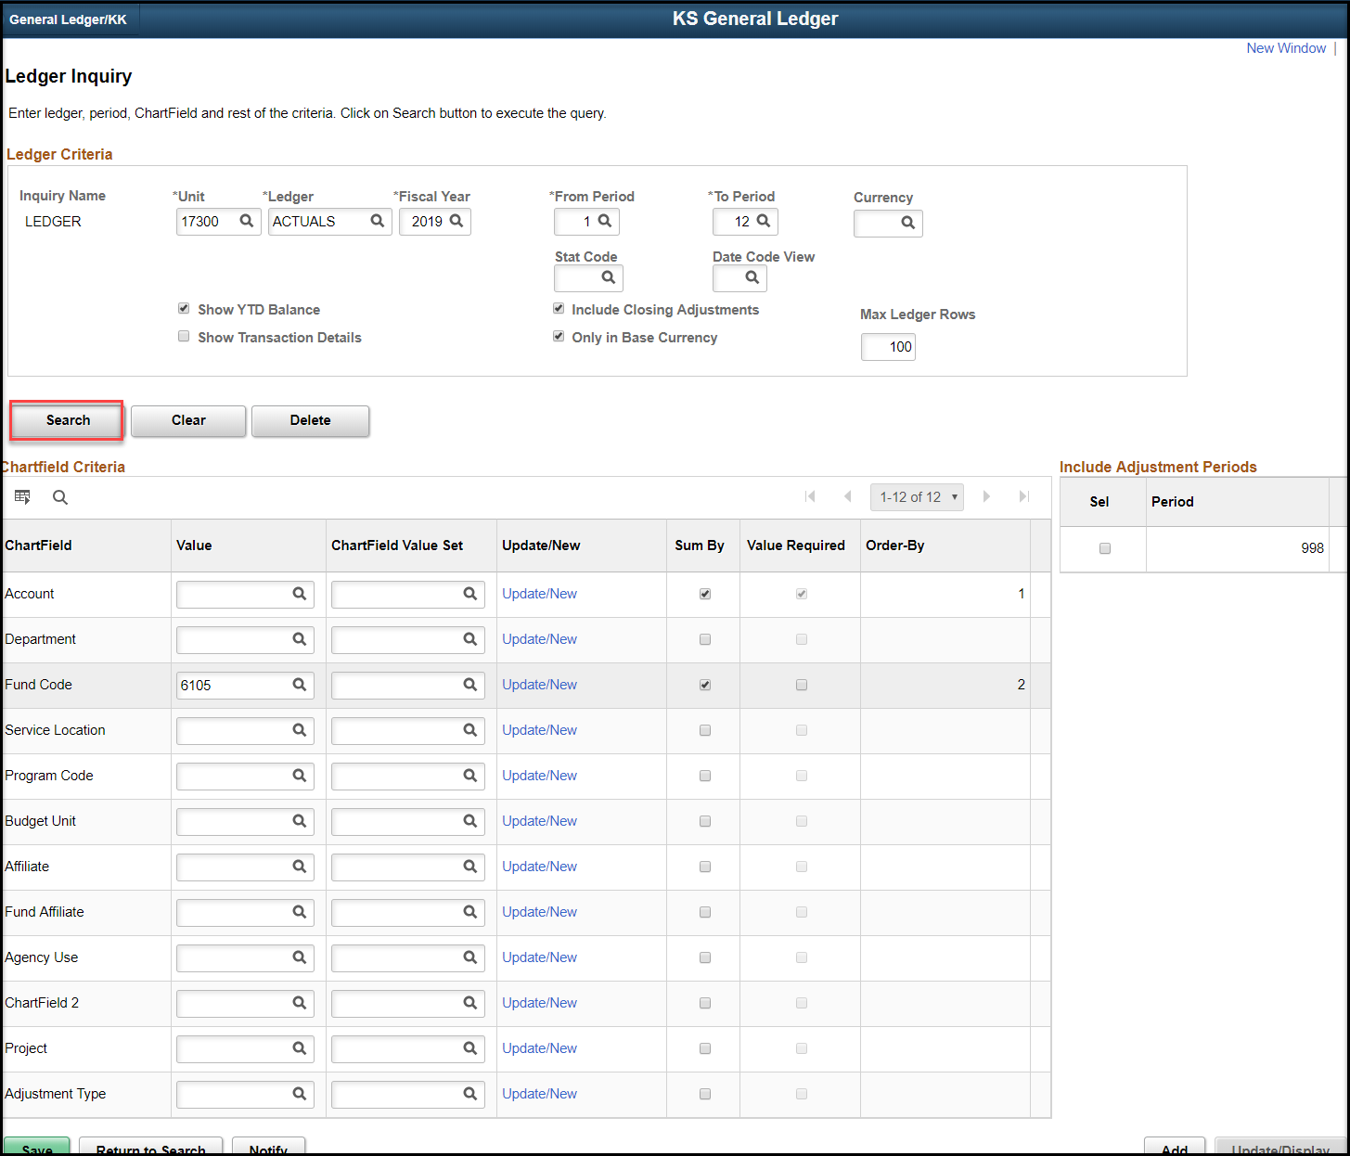
Figure 7. Ledger Inquiry Page
Fields | Description
Show YTD Balance | Select this check box and the inquiry returns year-to-date balances for specified ChartFields for a period. If you do not select this check box and the inquiry returns individual balances for period and account that are displayed in order by period.
Show Transaction Details | Select to see the ledger data along with the journal transactions that contributed to the balance
Include Closing Adjustments | Select this option to include closing balances (period 999) along with the current open period amounts
Max Ledger Rows | Indicates the maximum number of rows to display. You can override the default of “100” with any number <=300 rows of data that you can display in a scroll area.
Delete | Deletes the inquiry, cancels the page, and returns you to a blank Ledger Inquiry
ChartField | Enter a ChartField value for one or more ChartFields to review specific data in a ledger
ChartField Value Set | Select a predefined set of selection criteria for a given ChartField
Sum By | You are required to select at least one ChartField to sum. Account is checked as the default. If you do not, you receive an error message when you select the Search button. Period is always included in the sum by and is always the first column in the inquiry results.  Note: If you select all ChartFields available in the ChartField Criteria for “Sum By” and the “Show Transaction Details” check box is not checked, the result is a display of each row in the ledger that meets your criteria for business unit, ledger, fiscal year, accounting period, currency, and statistics code.
Value Required | Select this check box to filter out ChartFields with blank values. This check box is available only when the Sum By check box is selected. It is also unavailable for selection but is automatically selected by the system if the ChartField Account has Sum By selected.
Order By | Determine the sort order of the ChartFields in the result page by the order in which you select Sum By for each ChartField.
Sel (select) | Select specific adjustment periods by clicking the check box from the list of adjustment periods that are available based on the selected Ledger and Fiscal Year.
Period | Adjustment periods are displayed based on those available for the selected ledger and fiscal year
Table 1. Ledger Inquiry Fields

- The Ledger Summary will be displayed based on the criteria entered. Note the YTD Period Balance is displayed and the data is by Fund, Account, and Period.
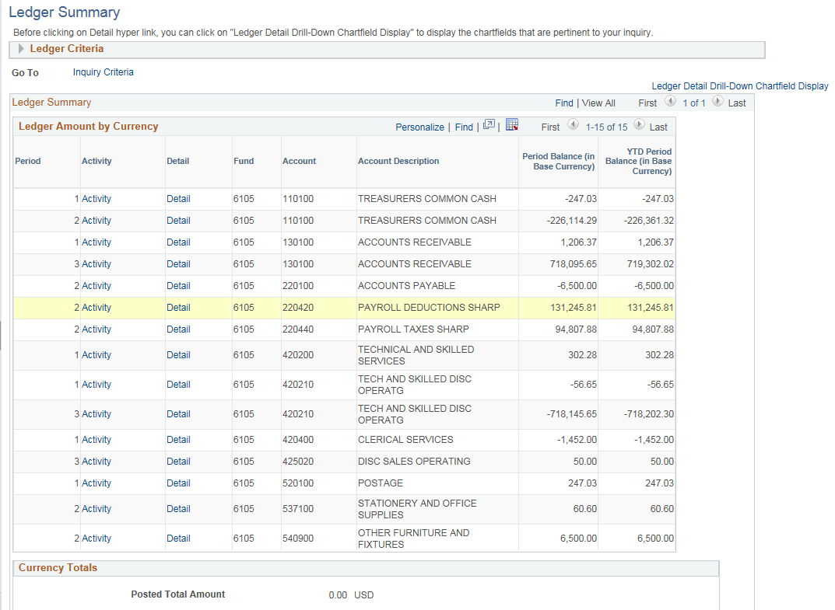
Figure 7. Ledger Summary Page

- Return to the Ledger Inquiry Criteria page. Uncheck the Show YTD Balance and Show Transaction Details. Check the Include Closing Adjustments and Only in Base Currency boxes. Review/enter ChartField Criteria as needed. Click the Search button.

Page Name | Path
Ledger Summary | Search Results from Ledger Inquiry  (“Show YTD Balance” NOT checked)

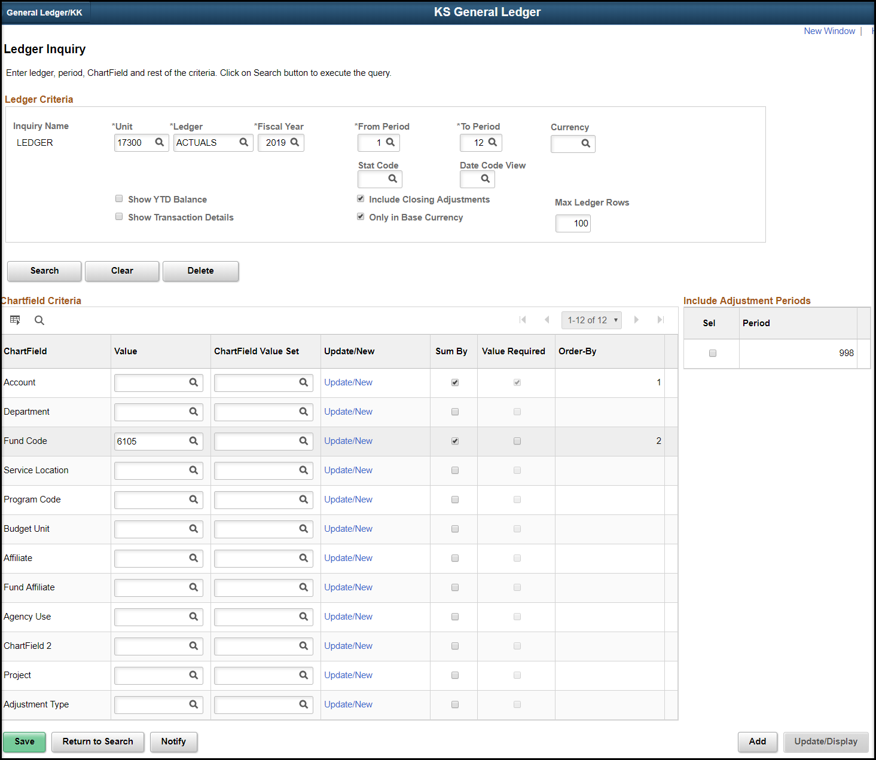
Figure 8. Ledger Inquiry Page

- The Ledger Summary is displayed. Note the YTD Period Balance is not displayed and the data order is by Period, Fund, and Account.
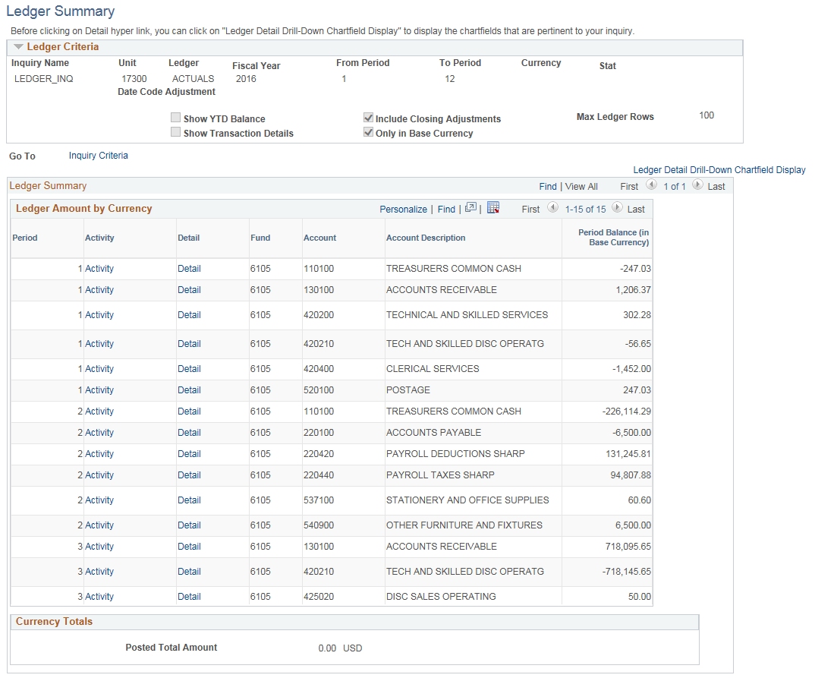
Figure 9. Ledger Summary Page

- Return to the Ledger Inquiry Criteria page. Uncheck the ‘Show YTD Balance’. Check the ‘Show Transaction Details’, ‘Include Closing Adjustments’ and ‘Only in Base Currency’ boxes. Review/enter ChartField Criteria as needed. Click the Search button.

Page Name | Path
Ledger Summary | Search Results from Ledger Inquiry  (“Show Transaction Details” checked)

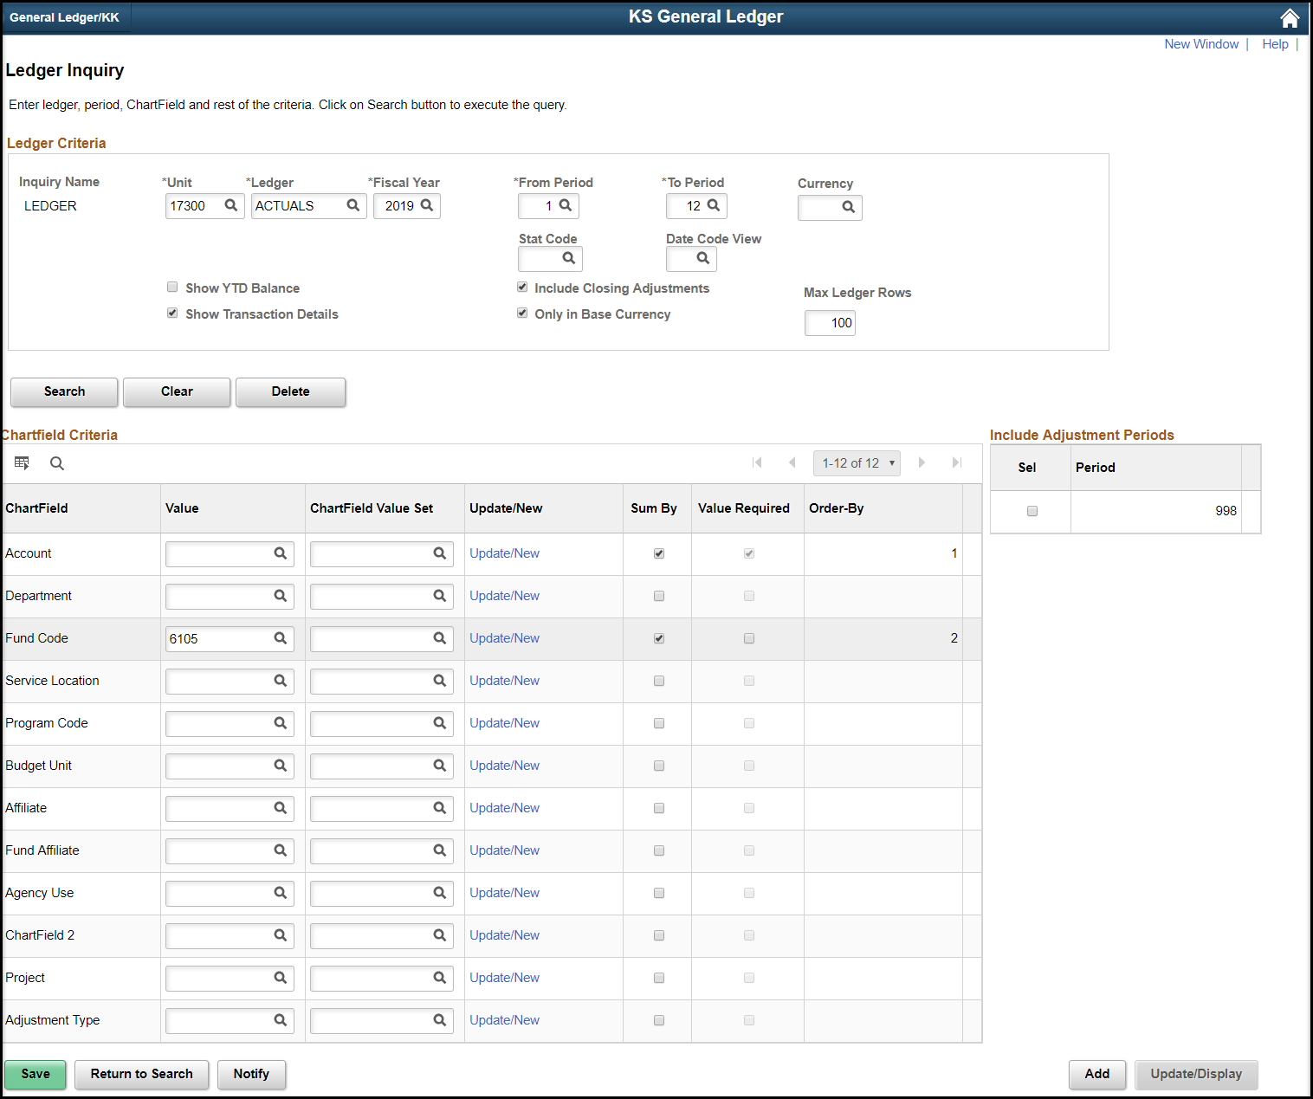
Figure 10. Ledger Inquiry Page

- The Transaction Details are displayed. Note the Transaction Details are displayed by Period, Fund, and Account. No YTD Period Balance is displayed
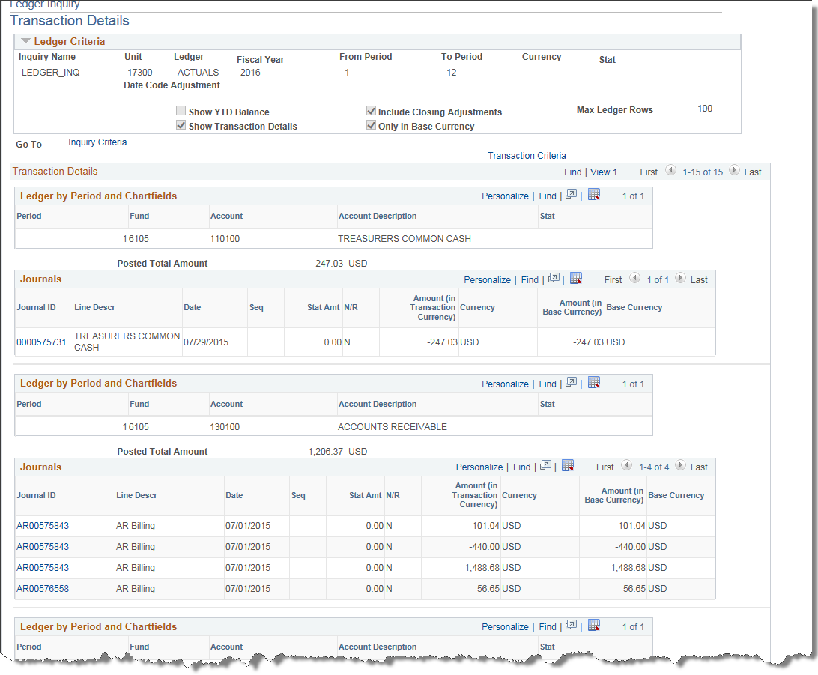
Figure 7. Ledger Summary Page
Fields | Description
Ledger Detail Drill - Down Chartfield Display | Click this link to select the Chartfields that you want to display when you drill into the Ledger Detail
Activity | Click this link to view transaction details on the Ledger Inquiry - Transaction Details page
Detail | Click the link to view ledger details on the Ledger Inquiry - Ledger Details page
Table 2. Ledger Summary Fields

Topic 3: Journal Inquiry Page
- Enables you to review a specific journal or multiple journals within a ledger for a business unit and accounting period.
- Navigate to the Journal Inquiry page.
Page Name | Description
Journal Inquiry | SMART Homepage > General Ledger/KK page > General Leger tile > Inquiries > Journal Inquiry

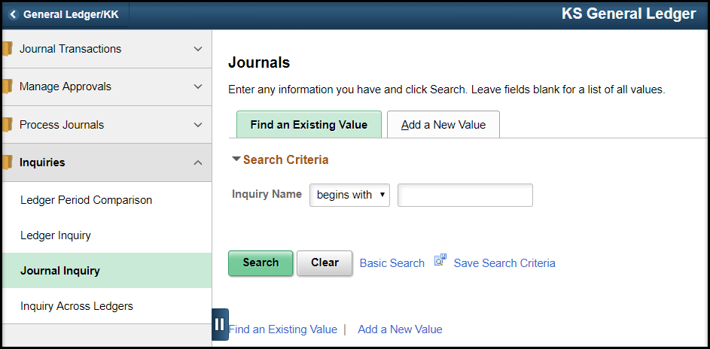
Figure 8. Journal Inquiry Navigation
- Enter the Journal Inquiry criteria.
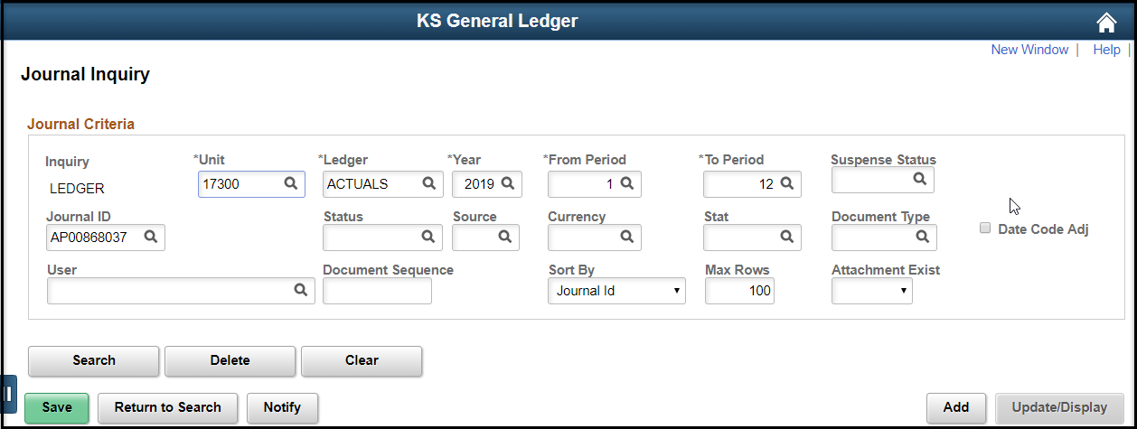
Figure 9. Journal Inquiry Page
Fields | Description
Unit | Enter your Agency Business Unit
Ledger | Enter ACTUALS, CAFR_FULL, or CAFR_MOD
Year | Enter Fiscal Year
From Period/To Period | Enter Accounting Period range
Suspense Status | Not used
Journal ID | Enter specific journal ID, choose from drop down, or leave blank.
Status | Enter Journal status
Source | Enter System Source
Currency | Leave blank or enter USD (US dollar)
Stat | Leave blank or Statistics Code
Document Type | Not used
User | User ID
Document Sequence | Not used
Sort By | Sort results by Journal ID or Journal Date
Max Rows | Change if results are > 100
Table 2. Journal Inquiry Fields

- The Journal(s) will be listed based on the criteria. Click on the Journal ID link to display Journal Line Details.
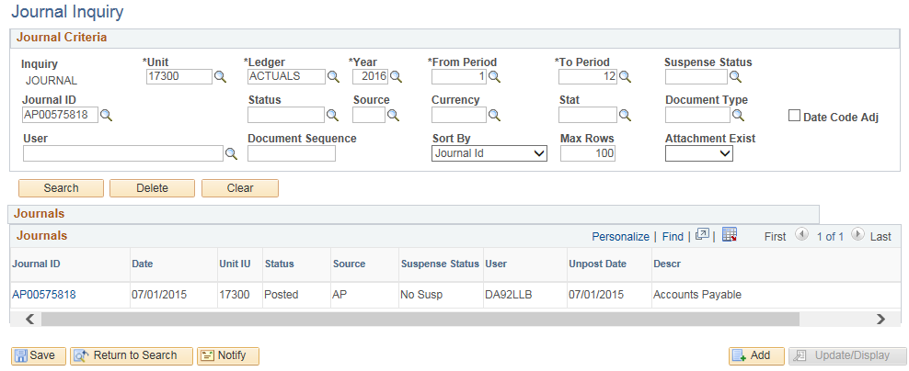
Figure 10. Journal Inquiry Results
- The Drill to Source icon at the beginning of each Journal Line can be clicked to see source document detail. Use the Query Journal Lines criteria to show all journal lines or a selected range of lines.
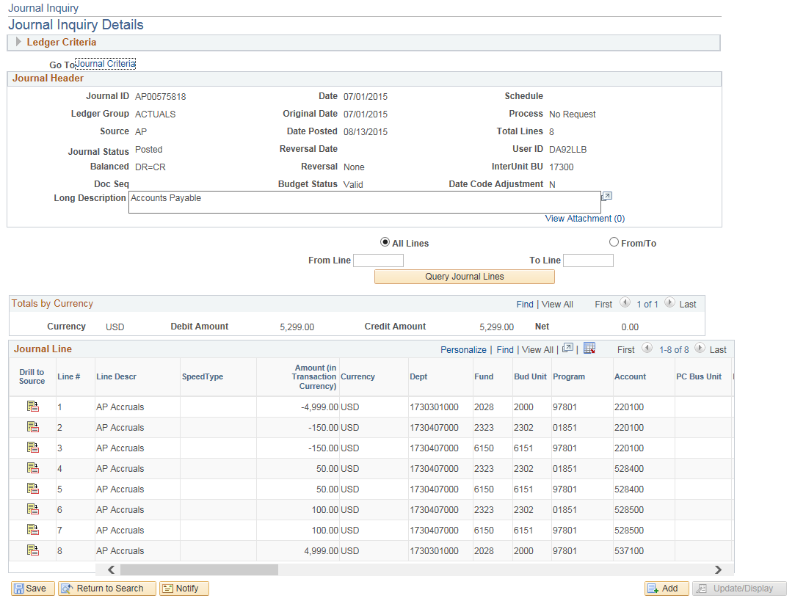
Figure 11. Journal Line Details Left side of page

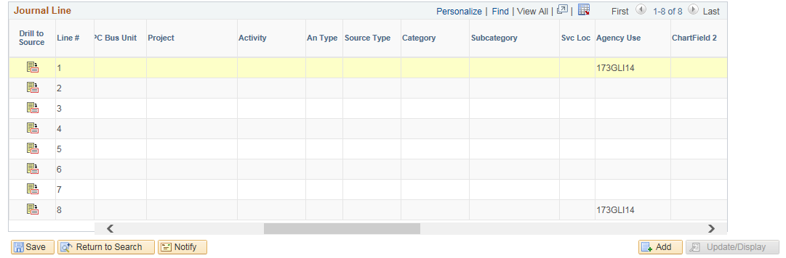
Figure 9. Journal Line Details Center of page

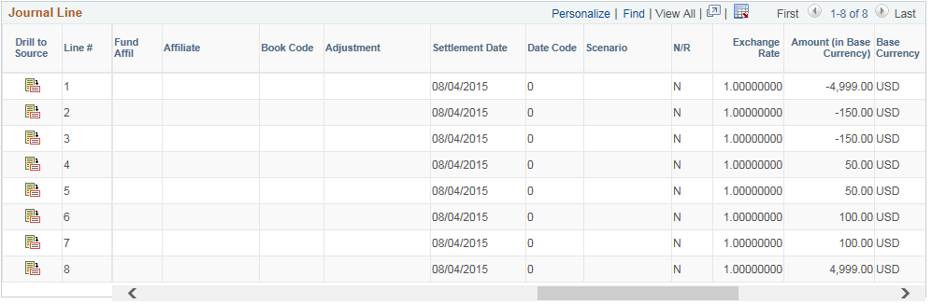 Figure 9. Journal Line Details Right side of page

Fields | Description
All Lines | Select this radio button and click the Query Journal Lines button to see all journal lines.
From/To | Select this radio button and then enter a line number in the From Line and in the To Line fields to display a range of journals and with their information when you click the Query Journal Lines button.
Click the drill to source button to access source of journal lines in the general ledger feeder systems, such as Vouchers or Deposits.
Note: This link is not available on the page if the line was created through an online journal entry rather than through Journal Generator.
Table 3. Journal Inquiry Details Fields

- The Drill to Source page will list the Details of the source transaction(s) including ChartFields, Voucher Information, and Document Information tabs. Click on the Voucher ID to see the Voucher Accounting Entries for the chosen Voucher.
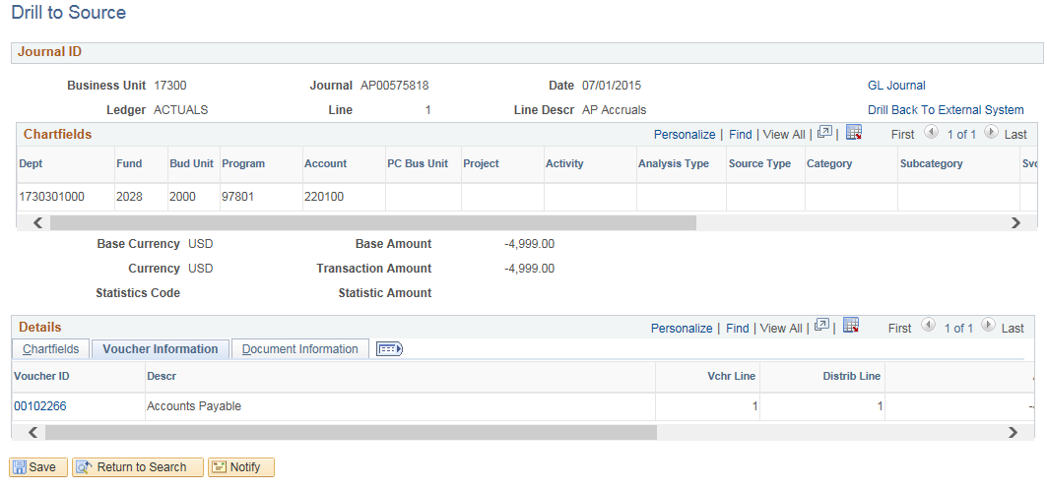
Figure 10. Drill to Source Page

- The Voucher Accounting Entries (or other source document accounting entries) will be displayed. Click the View All link to see all of the Accounting Information and look in each tab to see additional information.
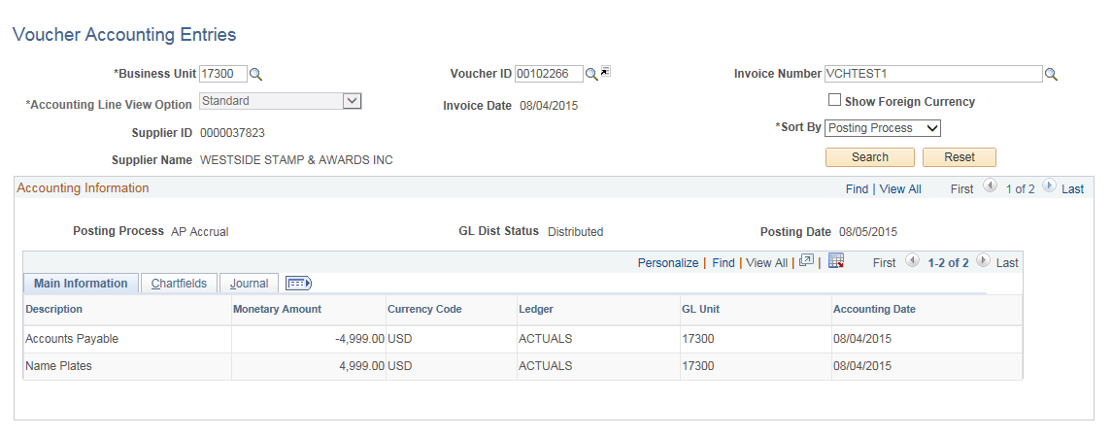
Figure 11. Voucher Accounting Entries Page

