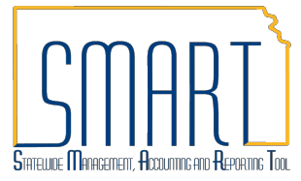
State of Kansas Reviewing Budget Check Exceptions
Statewide Management, Accounting and Reporting Tool

View Budget Check Exceptions for Purchase Orders

Roles: Agency Budget Processor, Agency Budget Approver

Navigate to: Commitment Control > Review Budget Check Exceptions > Purchasing and Cost Management > Purchase Order Enter your agency’s business unit. Select Process Status of Errors Exist from the drop-down menu to view all purchase orders in budget check error. Once you have entered the business unit and process status, click the Search button. The Search Results will appear under the selection criteria. Click on any of the hyperlinks to pull up the budget check exception details.

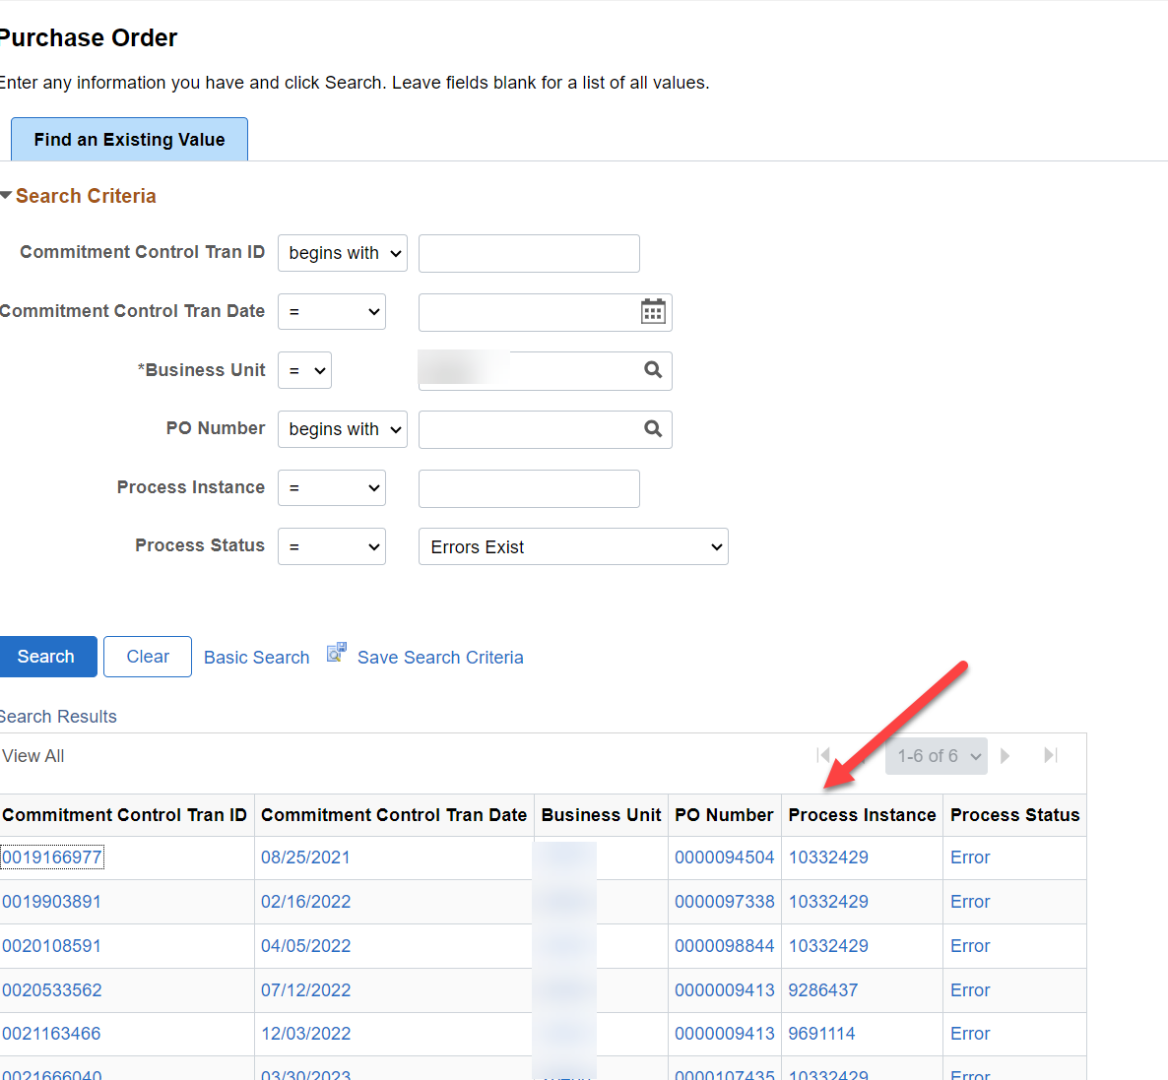

- You can also search by specifying the business unit and PO ID instead of searching for all purchase orders in error. Once you have entered the business unit and PO ID, click the Search button.

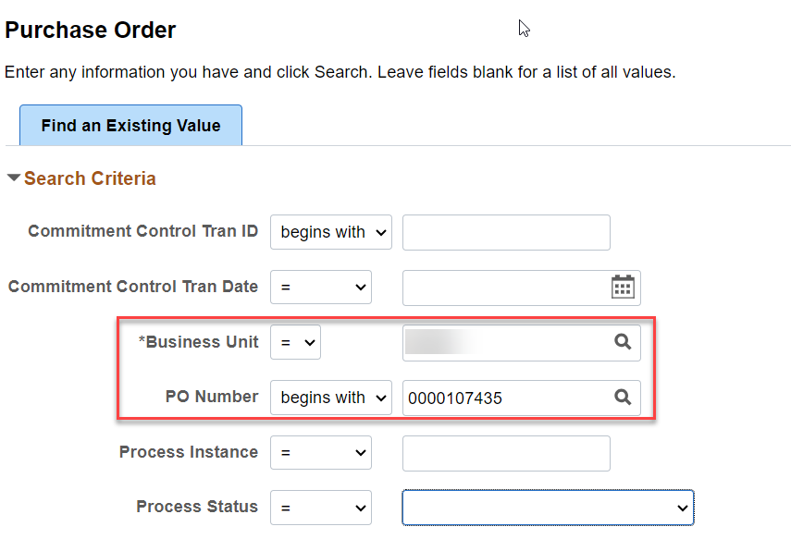

- You will be redirected to the Purchase Order Exceptions details page.

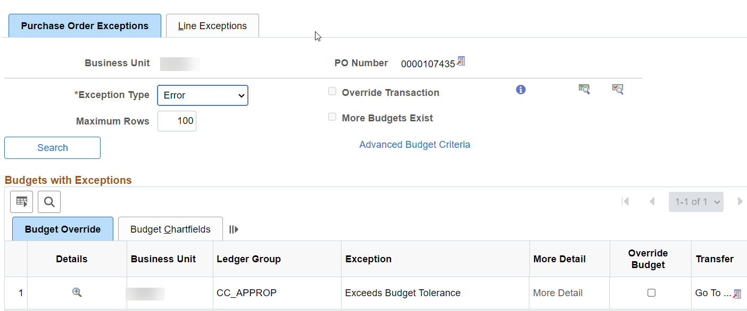

View Budget Check Exceptions for Vouchers

- Navigate to: Commitment Control > Review Budget Check Exceptions > Accounts Payable > Voucher Enter your agency’s business unit. Select Process Status of Errors Exist from the drop-down menu to view all vouchers in budget check error. Once you have entered the business unit and process status, click the Search button. The Search Results will appear under the selection criteria. Click on any of the hyperlinks to pull up the budget check exception details.
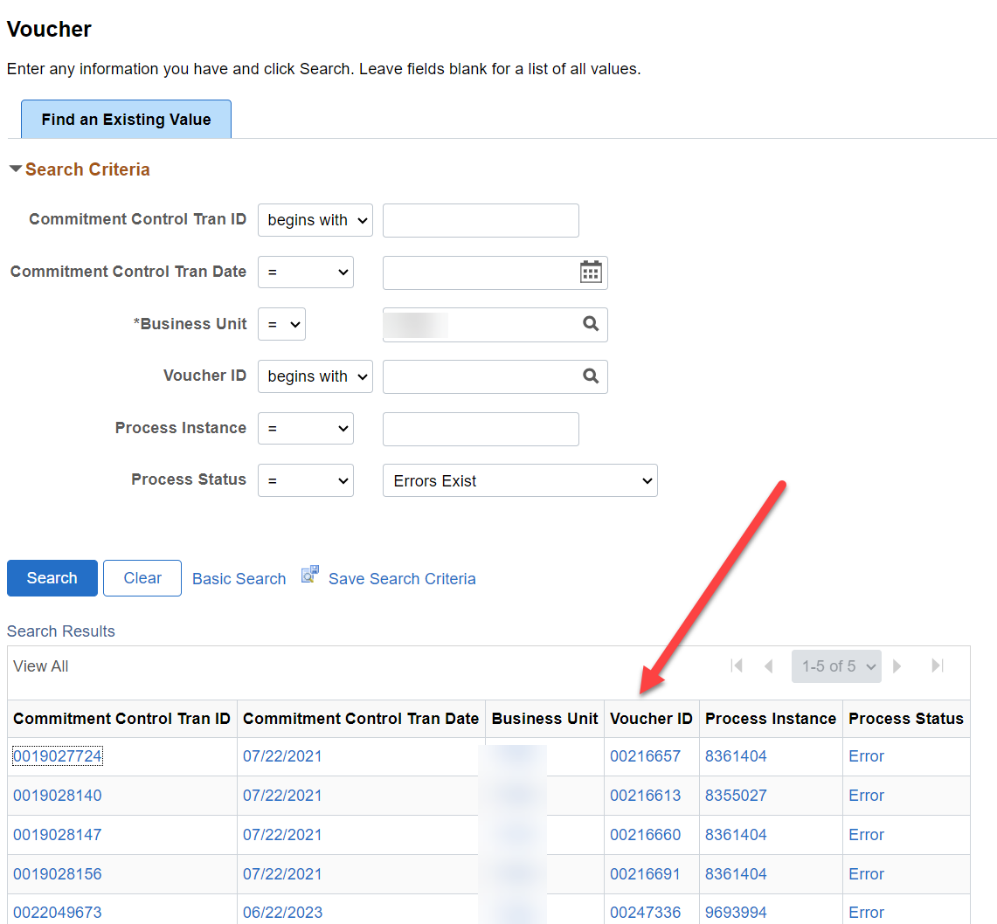

- You can also search by specifying the business unit and Voucher ID instead of searching for all vouchers in error. Once you have entered the business unit and voucher ID, click the Search button.
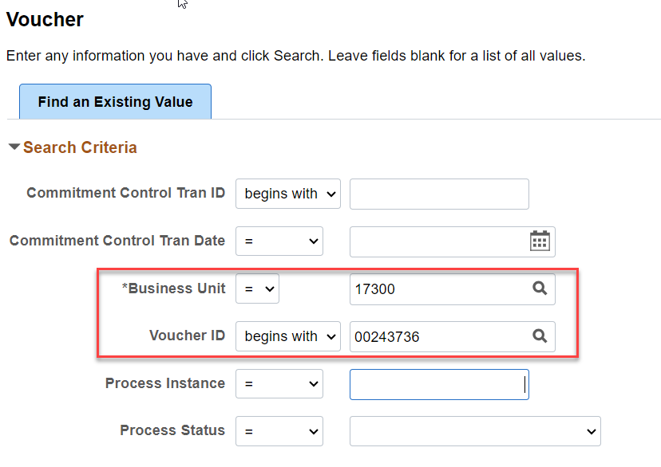

- You will be redirected to the Voucher Exceptions details page.
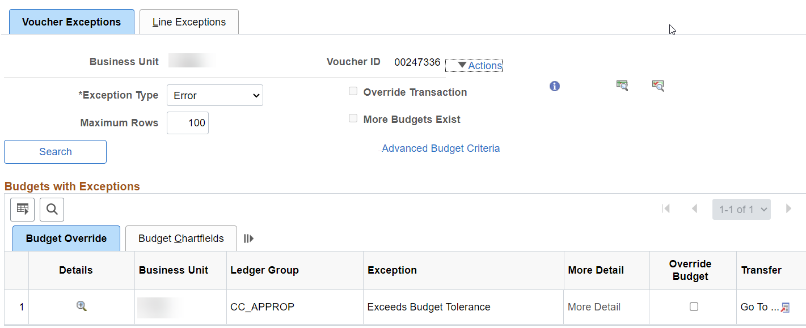

View Budget Check Exceptions for Journals

- Navigate to: Commitment Control > Review Budget Check Exceptions > General Ledger > Journal Enter your agency’s business unit (i.e. 17300). Select Process Status of Errors Exist from the drop-down menu to view all journals in budget check error. Once you have entered the business unit and process status, click the Search button. The Search Results will appear under the selection criteria. Click on any of the hyperlinks to pull up the budget check exception details.

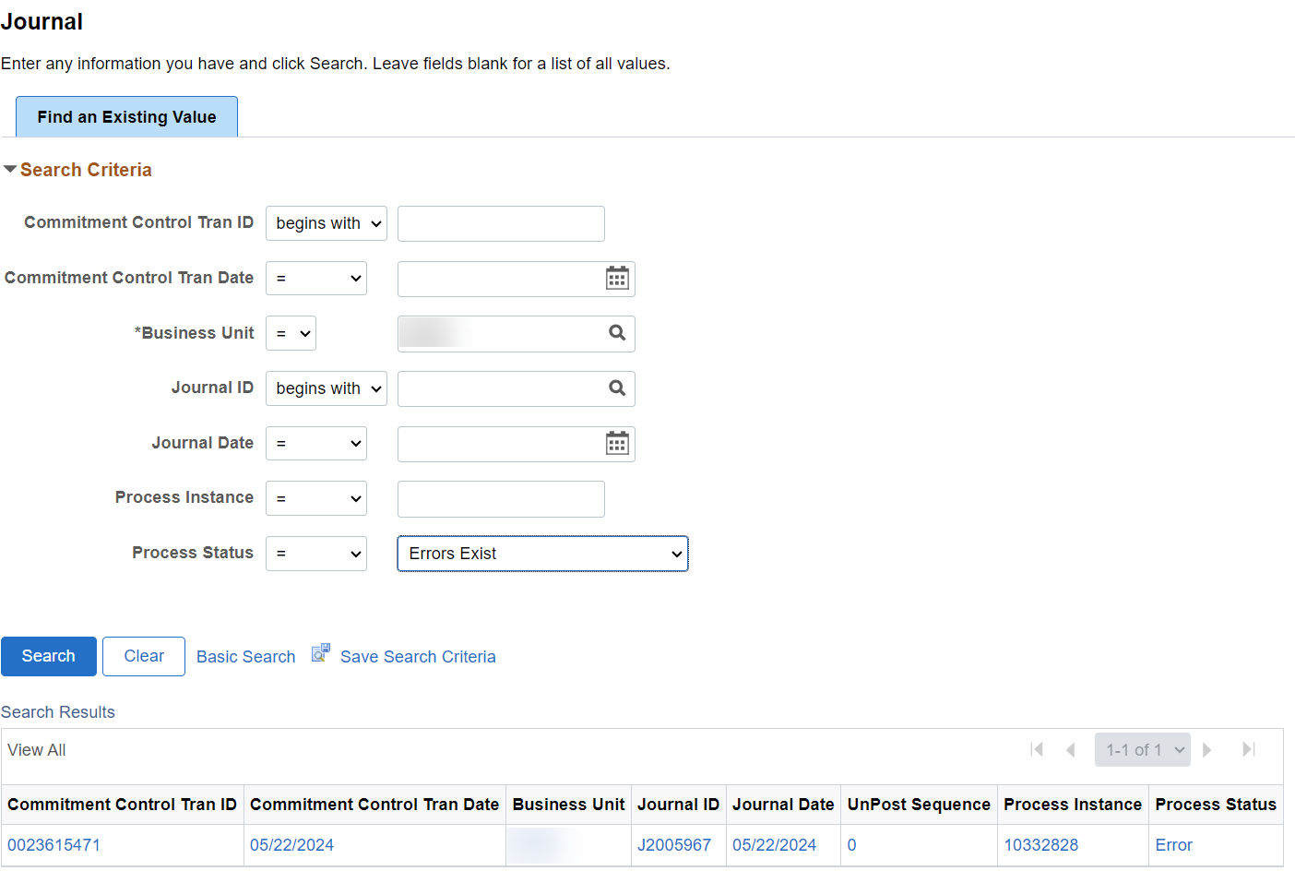

- You can also search by specifying the business unit and Journal ID instead of searching for all journals in error. Once you have entered the business unit and Journal ID, click the Search button.

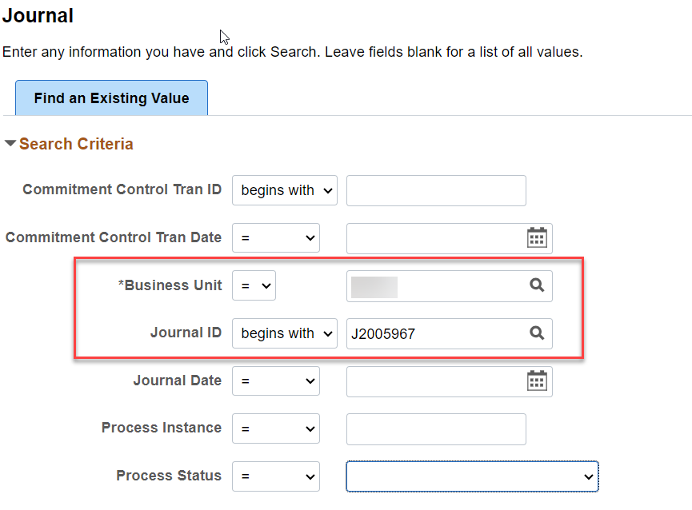

- You will be redirected to the GL Journal Exceptions details page.

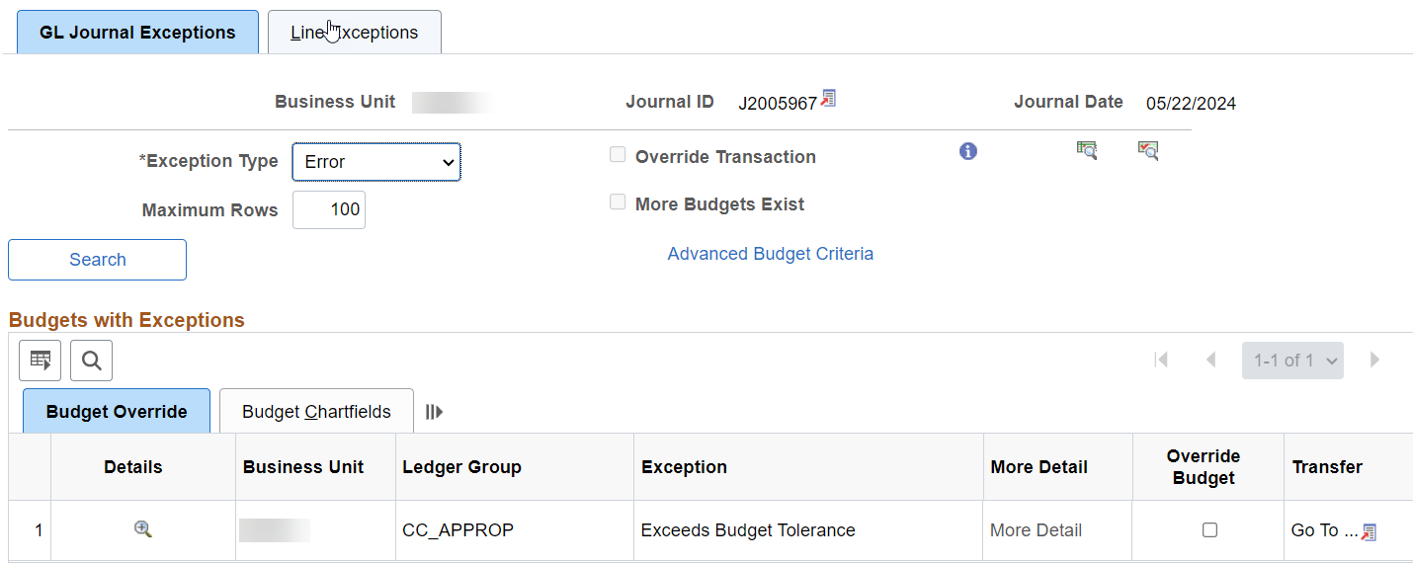

View Budget Check Exceptions for other Expenses:

Expense Reports: Navigate to: Commitment Control > Review Budget Check Exceptions > Travel and Expenses > Expense Sheet Select Process Status of Errors Exist from the drop-down menu to view all expense reports in budget check error.

Travel Authorizations: Navigate to: Commitment Control > Review Budget Check Exceptions > Travel and Expenses > Travel Authorization Select Process Status of Errors Exist from the drop-down menu to view all expense reports in budget check error.

Requisitions: Navigate to: Commitment Control > Review Budget Check Exceptions > Purchasing and Cost Management > Requisition Enter your agency’s business unit. Select Process Status of Errors Exist from the drop-down menu to view all requisitions in budget check error.

Procurement Card: Navigate to: Commitment Control > Review Budget Check Exceptions > Purchasing and Cost Management > Procurement Card Select Process Status of Errors Exist from the drop-down menu to view all requisitions in budget check error.

Additionally, all Budget Check Exceptions can be found at either of the following navigations:

Navigate to: Commitment Control > Review Budget Check Exceptions > Budget Exceptions or General Ledger/KK page > Commitment Control tile > Review Budget Check Exceptions > Review Budget Check Exceptions Enter your agency’s business unit and select the Ledger Group from the drop-down list (i.e. CC_APPROP; CC_CASH; CC_PROJECT, CC_OPERATE, etc.).

