State of Kansas
High-Level Changes from 9.0 to 9.2 in Asset Management:
Related Content – Cost History
Statewide Management, Accounting and Reporting Tool
Date Created: | 10/28/2015
Version: | 1.0
Last Updated Date:
Purpose: | This document highlights one of the changes between 9.0 and 9.2 in the Asset Management module.
Security: | - Role Security: The following roles are applicable:  Agency Asset Processor  KS Assets Viewer  BU Security: Business Unit Security is applied. Agencies will only have access to the assets in their Business Unit.
Procedure

This topic covers the addition of the Cost History Related Content Link to Basic Add. This allows a user to view physical and financial data for the asset at the same time.

Step | Action
 | Click the Main Menu button.
 | Click the Asset Management menu.
 | Click the Asset Transactions menu.
 | Click the Owned Assets menu.

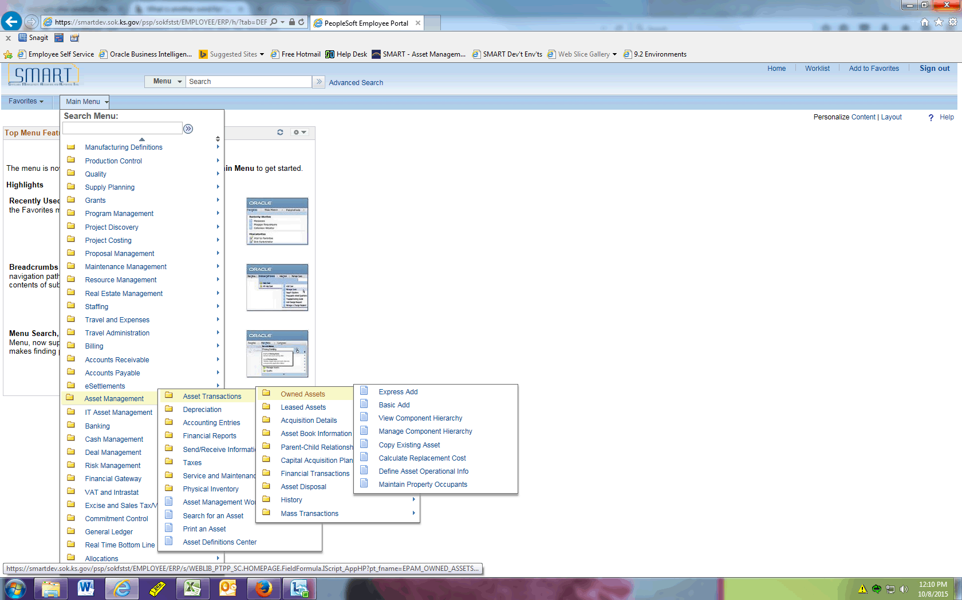

Step | Action
 | Click the Basic Add menu.
 | Click the Search button.
 | Click the asset you wish to open.

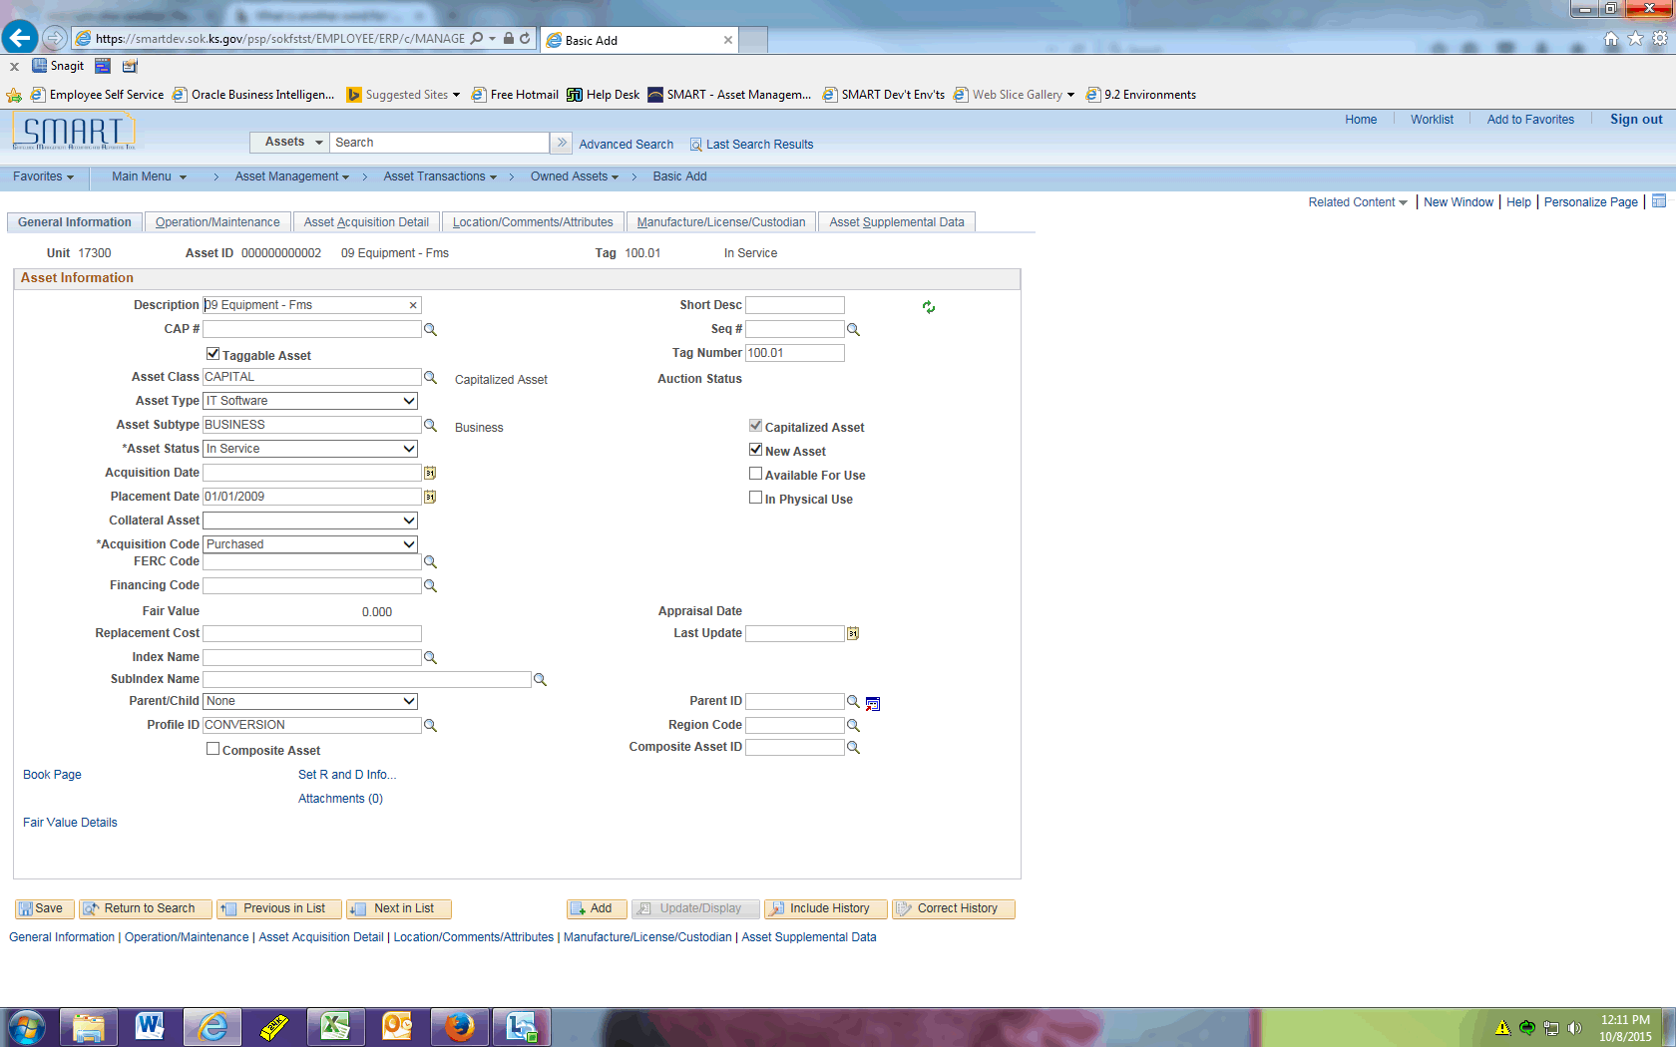

Step | Action
 | The General Information tab of Basic Add will open and looks the same as 9.0. The next slide will display the new feature that allows you to view physical and financial data at the same time.

Step | Action
 | Click the Related Content object in the upper right corner.

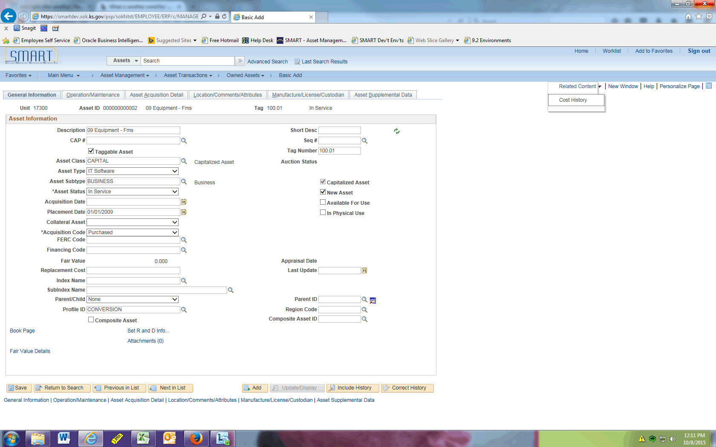

Step | Action
 | Click the Cost History menu.

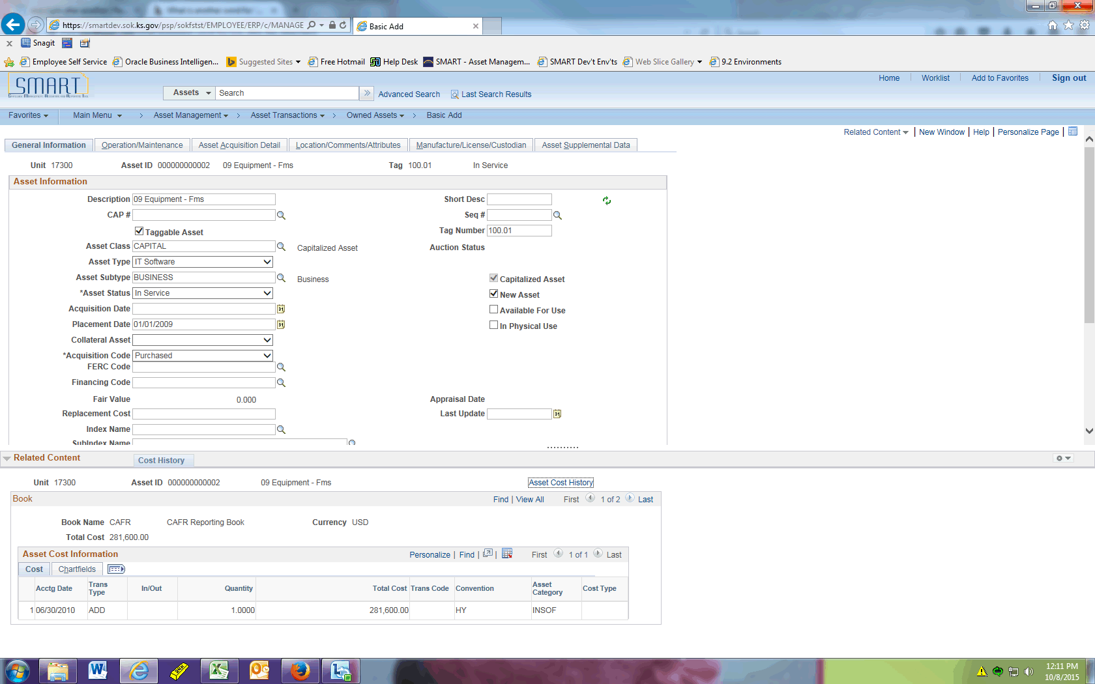

Step | Action
Above the Related Content section, you will see a ..... that displays a double arrow when you hover over it. Click and hold the ..... to drag the Cost History section vertically so it is more visible.

You can now view the financial transactions associated with this asset, as well as the chartfields used (on the Chartfields tab). This information is alternately shown here: Asset Management > Asset Transactions > History > Review Cost.
This concludes the 'AM - Related Content--Cost History' topic. Thank you for taking this course.
End of Procedure.

