Project Costing: Agency Month-End Processing

1 | Run the query KS_PC_PROJ_ELIGIBLE_TO_CLOSE using the current month/last day of month/current year – (minus) 7 years (MM/DD/YYYY) format. Download the query results.
2 | Determine which of the projects should be closed.
3 | Cleanup may be necessary before closing a project. For each project selected for closure, consideration should be directed to the following areas:  - Purchase Orders –The Req and PO Budgetary Activity Report uses Project ID as criteria. All purchase orders associated with the project should be in Complete status.  - Accounts Payable – Any outstanding vouchers should be posted, and processing completed for the transaction.  - General Ledger – Any GL activities should be completed.  - Accounts Receivable Pending Items – Pending Items should be written off.  - Asset Management – The query KS_PC_BU_ASSETS_BY_PROJECT is available to confirming asset status. If a project has an asset that is “I” (In Service), do not close the project. The project status should be changed to “X” (Asset Processing Only). If the project is currently in “X” (Asset Processing Only) status, verify the project should remain in this status.  - Billing Worksheets – Use the KS_PC_NEW_BILLING_WKST_DTL query to locate any unprocessed Billing Worksheets. The Job Aid “How to Write-Off Billing Worksheet Transactions” https://www.smartweb.ks.gov/training/accountsreceivable#Billing_Header is helpful for any old billing worksheets needing written-off.  - Customer Contracts – For projects associated Customer Contracts, consider closing the Customer Contract. This option does not allow cleanup without central intervention. Only use this option if all cleanup is complete and there is no chance that any further processing is necessary.  Another option is to change the Billing and Revenue Plans to ‘Completed’ status. This option allows transactions to be processed though to Project Costing without potentially creating a billing worksheet. If necessary, the Billing and Revenue Plans can be changed back to ‘In Progress’ status.  Business processes for your agency may have changed in the last 7 years, so each area should be verified. All issues should be resolved before closing the project. If assistance is needed, please enter a ManageEngine Service Desk ticket for the appropriate module area to resolve any issues.
4 | Update the project status, using the following instructions:
5 | Click the current Project Status hyperlink at the following navigation: Projects & Grants > Project Costing > General Information  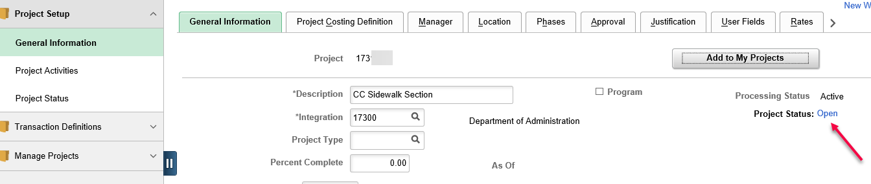
6 | Click the Include History button on the bottom right. 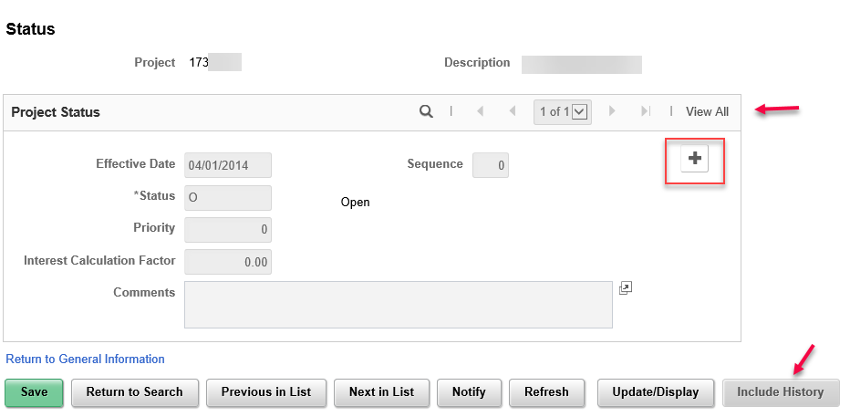
7 | Click the + button. Click the View All link on the Project Status grid.  The Effective Date defaults in as the current date. This will need to be updated.  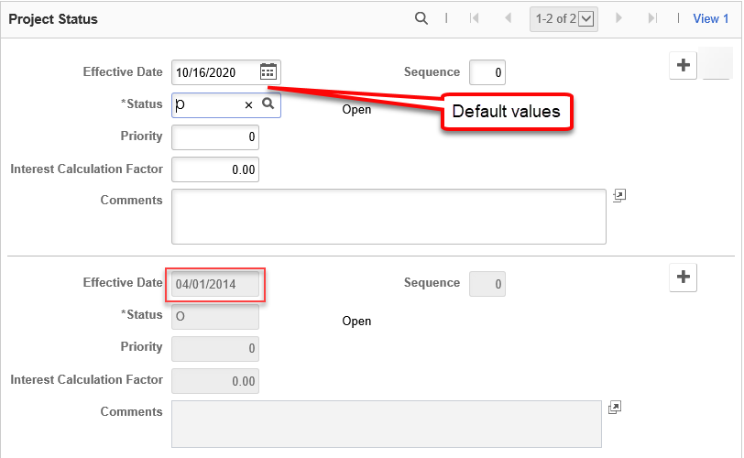
8 | Best practice is to change the effective date on the new status row to either the day after the most recent status row so there are no gaps in dates, or to enter the same date as the previous status row and use the Sequence field to make the row unique. Sequence numbering begins with 0; therefore, if using the same date, enter the Sequence as 1 or the next number. Update the Status to C (Closed) or X (Asset Processing Only. Click Save.  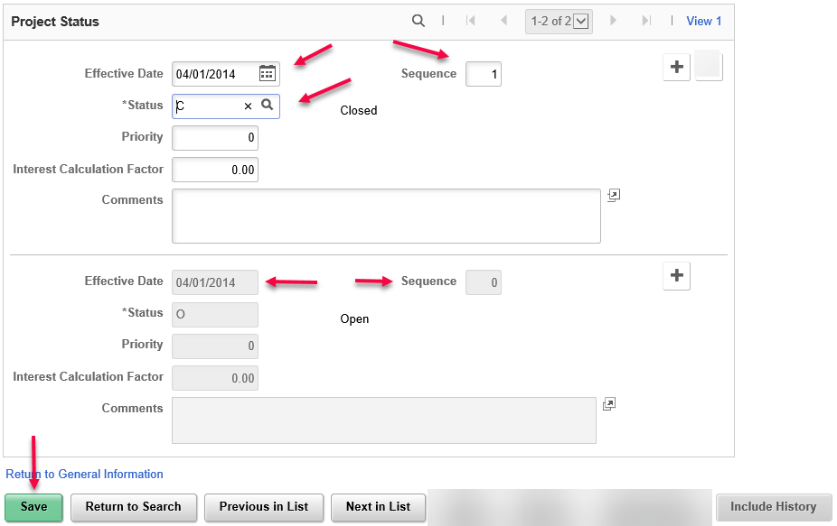
9 | If the project can be compressed during the next archive cycle, enter a ManageEngine Service Desk ticket informing the PC Analyst of the projects that have been closed and are now eligible for compression. Provide the Business Unit, Project ID and Effective Date of the last Closed status row. PC Compression will be run annually.

