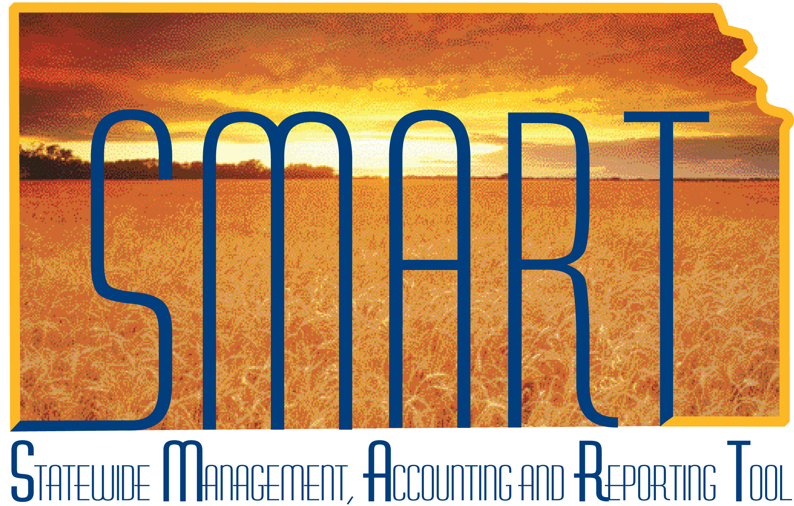
Training Guide – General Ledger
Processing Journal Entries
State of Kansas

Applicable Role(s):

Kansas GL Processor
Kansas GL Approver
Kansas GL Viewer

TABLE OF CONTENTS
Topic 1: Journal Edit Process 3
Topic 2: Errors in Journal Processing 9
Topic 3: Correcting Journal Errors 13
Topic 4: Approving Journals to Post 16

Topic 1: Journal Edit Process
- After a journal is entered in SMART, it must be edited and submitted before it can be approved and posted.
- Journal Edit ensures that:
  - the ChartField values are valid,
  - the combination edits are valid,
  - debits equal credits are equal, and
  - Journal entries are ready for approval and posting to the SMART general ledger.
- SMART has automatic batch processes that run as follows:
- Budget Checking runs hourly
- Submit Journal (approvals) run bi-hourly
- Edit ChartFields runs bi-hourly.
- All the processes run during nightly batch.
- The best practice is to save a journal and allow the scheduled batch processes to run.
- Budget checking also occurs as part of the edit process.
- If errors occur during the editing process, the journal must be corrected before it can move forward into the SMART posting process.
- In rare circumstances, the hourly and nightly batch processes need bypassed and manual journal edit may need to be performed.
  - If the journal entry is comprised of less than two hundred lines, you can use the online journal Lines page process drop-down list to process the journal.
  - If a journal entry is larger than two hundred lines, you need to run a manual batch process to edit the journal.

Procedure:

- Navigate to the Edit Journal process page.
Page Name | Navigation
Edit Journals Request | SMART Homepage> General Ledger/KK page > General Ledger tile >Process Journals>Edit Journals

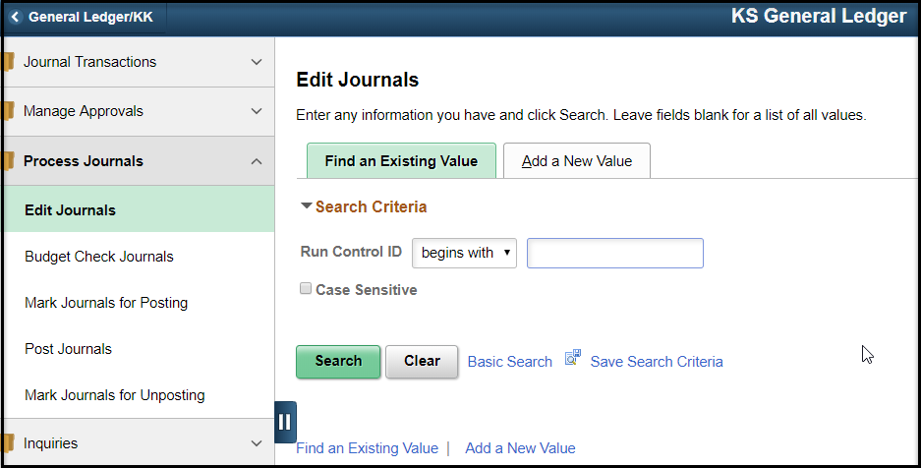
Figure 1. Edit Journals Page Navigation

- Click the Add a New Value tab and enter a Run Control ID. Click on the Add button.
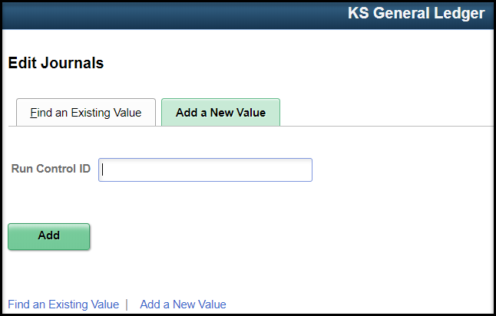
Figure 2. Edit Journals – Add a New Value Page
OR

Click on the Find and Existing Value tab, click on Search. Choose a saved Run Control ID.

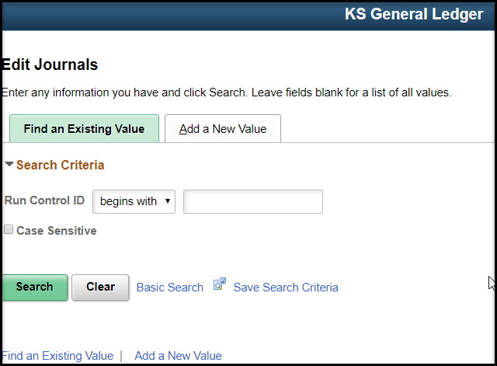
Figure 3. Edit Journals – Find an Existing Value Page

- Enter the required fields . Save and click the Run button.

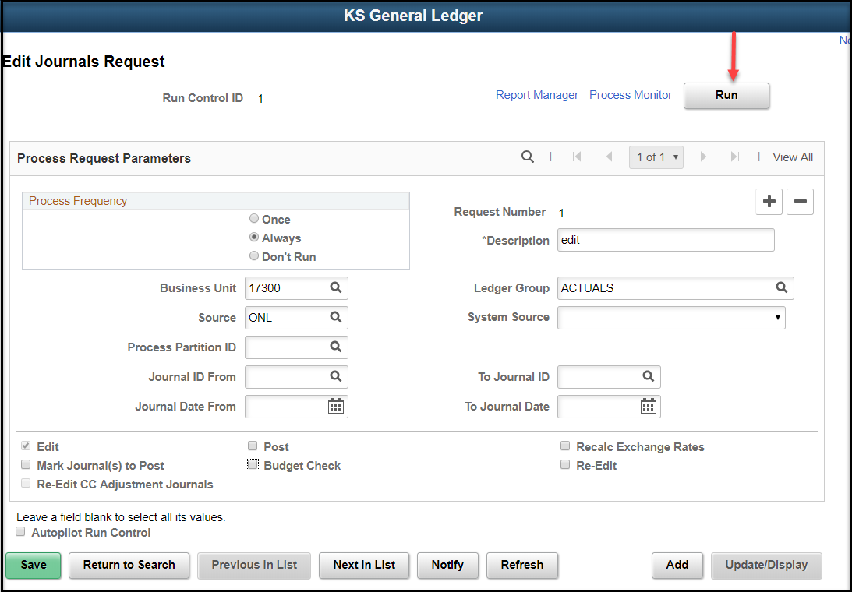
Figure 4. Edit Journals Request Page

Fields | Description
Process Frequency | The radio buttons in the Process Frequency group box determine how often a request is processed. You want the request to be processed each time editing is initiated. Therefore, you need to select the Always radio button.
Description | Use this field to enter the reason for the process request
Business Unit | Your agency Business Unit defaults. Based on your security access, you may change the Business Unit. NEVER leave this field blank.
Journal ID From/To | Use these fields to specify a range of journal IDs to be edited. If you are processing one journal, enter the journal ID in both the Journal ID From and the Journal ID To fields.
Journal Date From/To | Use these fields to specify a range of journal dates to be edited. If you are processing for one date, enter the date in both the Journal Date From and the Journal Date To fields.
Edit | This check box is automatically selected
Budget Check | Select to ensure that the journal entry passes through the budget check process
Table 1. Edit Journals Request Page Fields

- On the Process Scheduler Request page, check the box next to the Process you want to run. Both choices run the PS/GL Journal Edit process. The first choice will create an error report, as needed. Click the OK button.
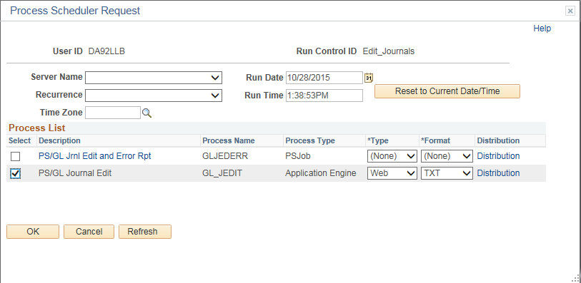
Figure 5. Process Scheduler Request Page

- On the Edit Journals Request page, click on the Process Monitor hyperlink.
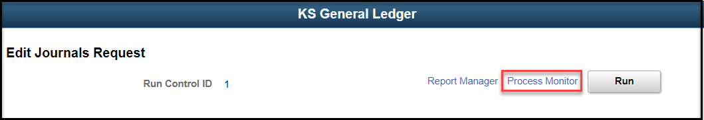
Figure 6. Edit Journals Request Page
- On the Process List page, click on the Refresh button until the Process Instance is in Success and Posted status. Journal entries should now be edited and budget checked.
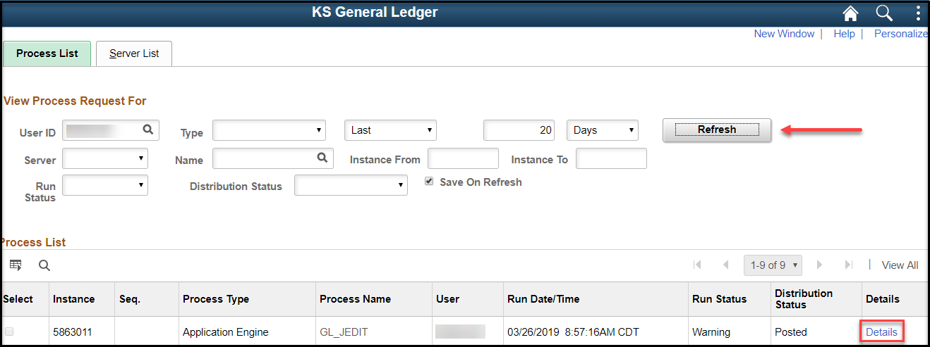
Figure 7. Process List Page

- If there is a Warning, click on the Details link and open the Message Log to check for Header or Line errors. See Topic 2 on how to review Errors.
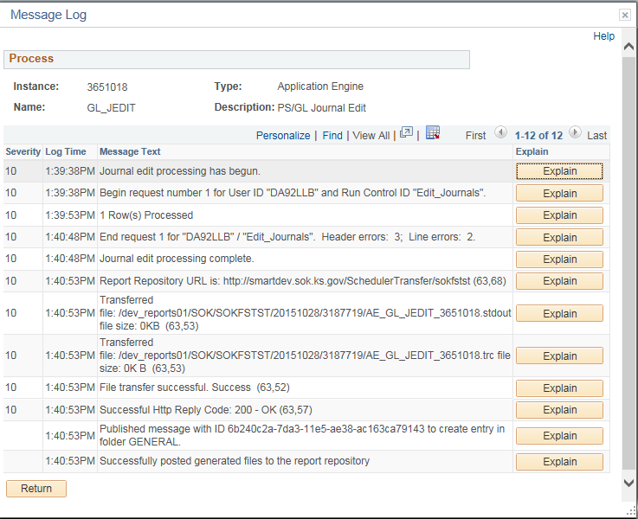
Figure 8. Message Log Page

Topic 2: Errors in Journal Processing
- In SMART, agencies will inquire to see which journals have errors. A journal must have a valid Edit and Budget check status before it can be routed for approval.
- A journal entry cannot be posted if one or more of the following conditions are true:
  - The accounting period is not currently open
  - Total debits do not equal total credits (not balanced)
  - Any control totals entered with the journal header do not match the actual totals for the journal
  - One or more journal lines use inactive or invalid ChartFields as of the journal date
  - Any of the combination edits are not valid
  - There are Budget Check errors.

To review Edit errors:

Procedure:

- Navigate to the Create/Update Journal Entries page:

Page Name | Navigation
Journal | SMART Homepage> General Ledger/KK page > General Ledger tile > Journal Transactions >Journal Entries

- Enter the Search Criteria as shown below:
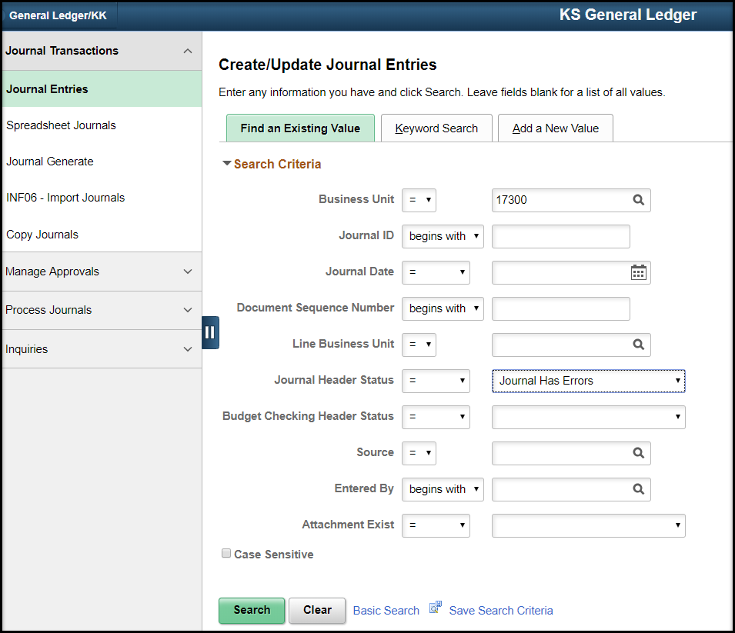
Figure 9. Create/Update Journal Entries Page

Fields
Business Unit | Enter agency Business Unit
Journal ID | Leave blank
Journal Date | Leave blank
Document Sequence Number | Leave blank
Line Business Unit | Leave blank
Journal Header Status | Pick “Journal has Errors” from dropdown
Budget Checking Header Status | Pick Leave blank
Source | Leave blank
Table 2. Create/Update Journal Entries Page Fields
- Choose a journal from the Search Results. If there is only one journal in error, it will open. When the journal opens, click on the Errors tab to review errors
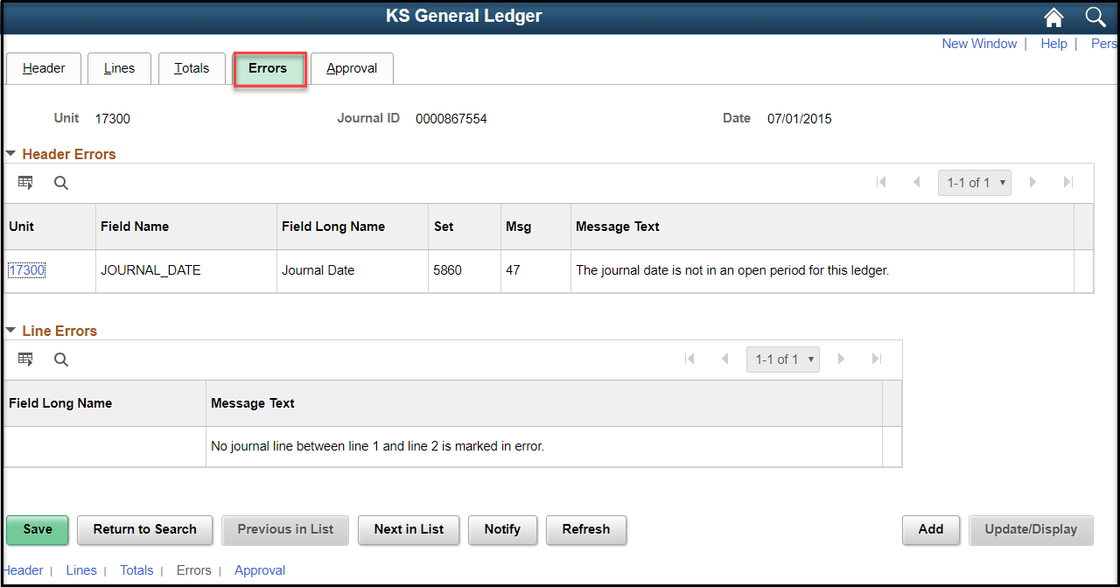
Figure 10. Errors Page

Fields | Description
Field Name | Displays the field in error
Message Text | Provides information regarding the error
Unit | Click to access the Header page to correct the error
Line # | Click to access the Lines page to correct the error
Table 3. Errors Page Fields

To review Budget Check Errors

Procedure:
- Navigate to the Create/Update Journal Entries page

Page Name | Navigation
Journal | SMART Homepage> General Ledger/KK page > General Ledger tile > Journal Transactions >Journal Entries

- Enter the Search Criteria as shown below:
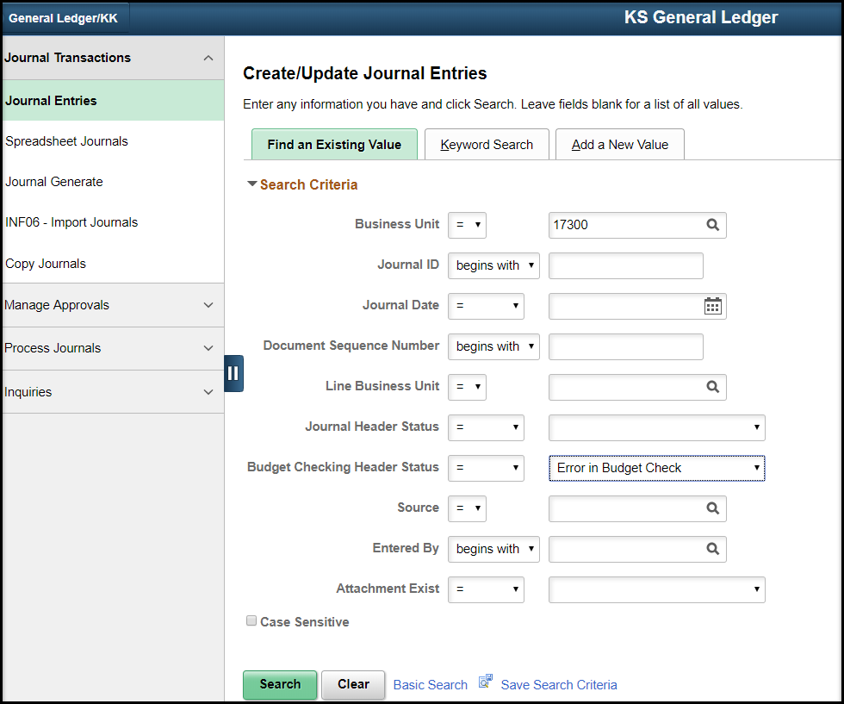
Figure 11. Create/Update Journal Entries Page

Fields
Business Unit | Enter agency Business Unit
Journal ID | Leave blank
Journal Date | Leave blank
Document Sequence Number | Leave blank
Line Business Unit | Leave blank
Journal Header Status | Leave blank
Budget Checking Header Status | Pick Error in Budget Check
Source | Leave blank
Table 4. Create/Update Journal Entries Page Fields

- Choose a journal from the Search Results. If there is only one journal in error, it will open. When the journal opens, click on the Lines tab. Click on the ‘E’ under Budget Status.
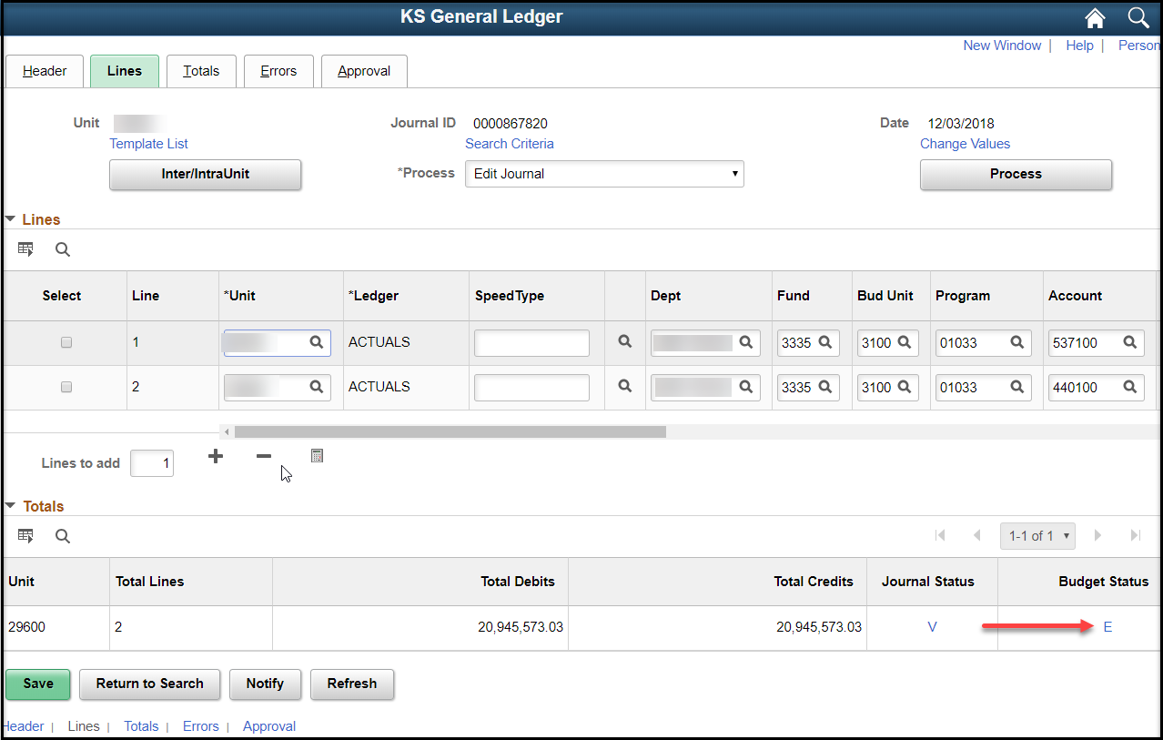
Figure 12. Journal Lines Tab
- The GL Journal (Budget) Exceptions tab will be displayed. Click on the Lines Exceptions tab to see the Journal Lines with budget exceptions. To see additional detail:
  - Expand the tabs under Budget with Exceptions to see ChartFields,
  - under Details drill down to see additional information, and
  - Click the icon under Transfer to open the Budget Exceptions or Budget Inquiry.
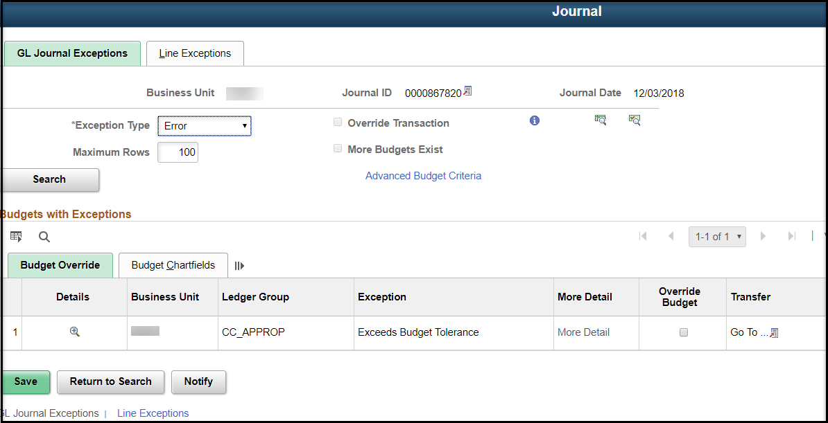
Figure 13. GL Journal Exceptions Page

Topic 3: Correcting Journal Errors
- When General Ledger encounters errors during editing, it marks the journal lines and suspends the journal. It saves the journals but will not post them until you correct the errors. Common errors are listed below:

Error | Troubleshooting Steps
Failed Budget Checking | Work with Agency Budget Approver to determine next steps
Invalid Combination Edits | Verify the ChartFields and ChartField combinations.
Accounting Period Closed | Choose a current accounting period
Total Debits do not equal Total Credits | Review entries for data entry mistake. Fund/Budget Unit Debits MUST EQUAL Credits.
Control Totals do not match Actual Totals | Review entries for data entry mistake
Inactive or invalid ChartField | Verify the ChartFields entered
Table 5. Fixing Journal Errors
Procedure:
- To correct errors, navigate to the Create/Update Journal Entries page
Page Name | Navigation
Journal | SMART Homepage> General Ledger/KK page > General Ledger tile > Journal Transactions >Journal Entries

- Enter the Search Criteria as shown below:
Figure 14. Create/Update Journal Entries Page

Fields
Business Unit | Enter agency Business Unit
Journal ID | Enter Journal ID
Journal Date | Leave blank
Document Sequence Number | Leave blank
Line Business Unit | Leave blank
Journal Header Status | Pick “Journal has Errors” from dropdown
Budget Checking Header Status | Pick Leave blank
Source | Leave blank
Table 6. Create/Update Journal Entries Page Fields

- The Journal will open. Make changes on the Lines tab depending on the error.
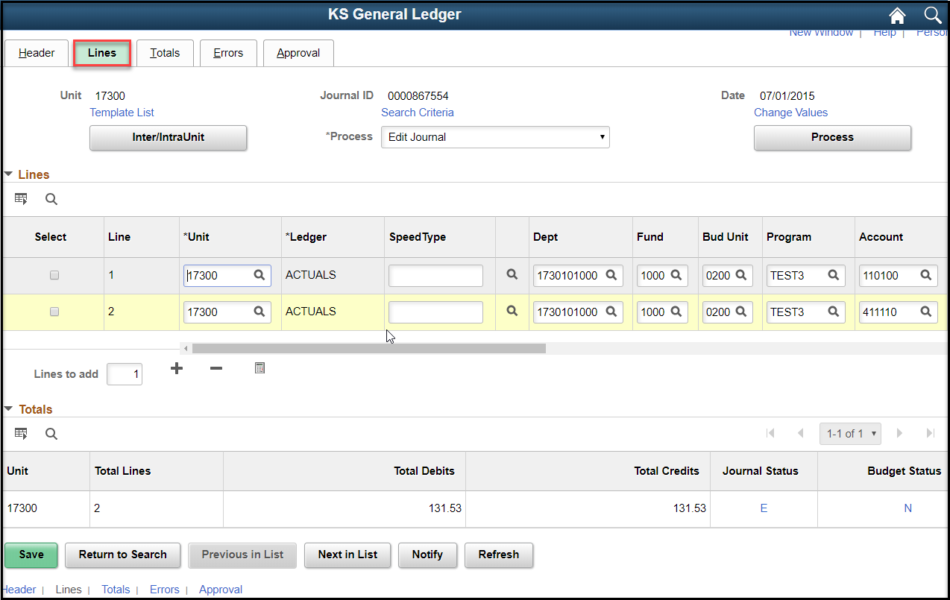
Figure 15. Journal Lines Tab

Error | Correction
Failed Budget Checking | Follow guidance from Agency Budget Approver. You may need to change the funding on the journal or wait until additional funds are deposited to cover the expenditure.
Invalid Combination Edits | Change the combination or request the combination be added to the SMART table.
Accounting Period Closed | Copy the Journal and change the Journal Date to the open accounting period.
Total Debits do not equal Total Credits | Fix the Line causing the journal to be out of balance.
Control Totals do not match Actual Totals | Change control totals or change the amounts on the Journal Line(s)
Inactive or invalid ChartField | Use a different ChartField value or add/reactivate the ChartField.
Table 7. Journal Errors

Topic 4: Approving Journals to Post
- Approving a journal entry is defined as the process of evaluating that the journal entry is correct and approving the transaction. This evaluation includes budget checking and error checking. Following the approval and systematic checks, the journal will post to the appropriate ledger. Once you run the edit process and the Journal is in Valid Journal Status and Valid Budget Status, click the Approval tab.
- All journals need to be approved at the agency level and by Central Responsibilities Team. There may be multiple levels of agency approval.
- An Approval Status effectively marks a journal for posting. Journal posting runs as a batch process at night. If a journal needs to be posted before the batch process runs, contact the Central Responsibilities Team for assistance.
- See the WorkFlow Training Guides and Job Aids on SMARTWeb for detailed instructions on the Journal Approval Process.

