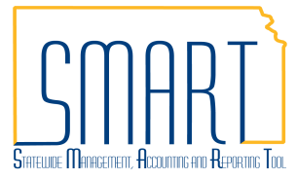
State of Kansas
Print Statement – Report AR32000
Statewide Management, Accounting and Reporting Tool

Date Created: | 10/29/2015
Version: | 1.1
Last Updated Date: | 03/26/2019
Purpose of the Job Aid: | To assist SMART User in printing a statement.
Security: | - Role Security: Only those individuals with one of the following roles will have access to print a statement: Agency AR Maintainer  BU Security: Business Unit Security is applied. Agencies will only have access to the print statements for their agency’s business unit.
Process | - Navigate to: NavBar>Navigator>Accounts Receivable>Customer Interactions>Statements>Print Statements
 | - Select the 'Add a New Value' tab and enter a Run Control ID; Click 'Add' button.
 | - Select the Statement Number to be printed.
 | - Select the Customer ID or enter ‘%’ in the Customer ID box.
 | - Click Run.
 | - Put a check in 'Customer Statement Print ' (ARX32000) box and click OK.
 | - Click on the 'Process Monitor' link. Click the 'Refresh' button until the 'ARX32000-' job runs to 'Success'.
 | - Navigate to the Accounts Receivable Homepage>Utilities>Report Manager then click on the ARX32000S.pdf report link to view the report.

