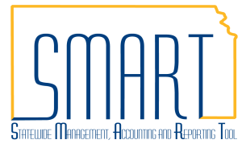
State of Kansas
PO Accounting Entries
Statewide Management, Accounting and Reporting Tool
Date Created: | 02/28/2013
Version: | 2.0
Last Updated Date: | 11/13/2020
Classic Navigation: NavBar > Navigator > Purchasing > Purchase Orders > Review PO Information > Po Accounting Entries
Purpose: | Use the PO Accounting Entries page to view the PO encumbrance amount versus Voucher encumbrance reversal amounts.
NOTE: Use the *Ledger Group of CC_APPROP to pull the information for the agency’s appropriate budget which is stored in the Commitment Control module. The *GL Unit will also need to be provided be results will pull back.
Enter the desired search criteria into the Selection Criteria page and select OK. | 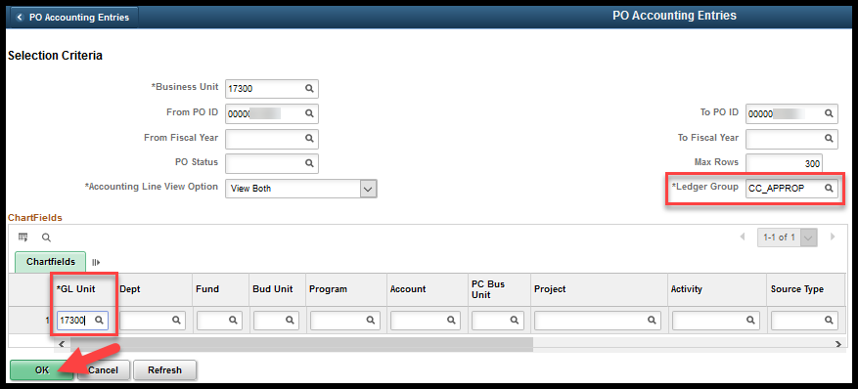
The search results are displayed.  NOTE: Notice that the PO Accounting Entries page tracks encumbrances and reversals at the Distribution Line level and contains many of those fields. | 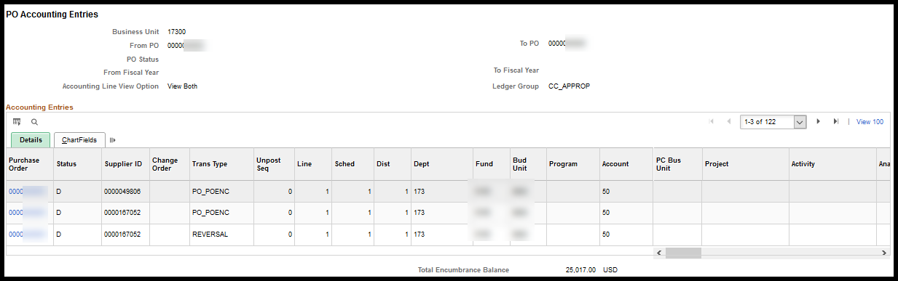

In addition to Distribution Line level fields this page also contains:
- Supplier ID  - Trans Type  - Unpost Seq  - Closed Value  - Budget Period  - Fiscal Year | - Journal ID – this is the Budget Journal ID number from KK  - Tran ID  - Reference Reversal ID – this is the Voucher ID number from Accounts Payable for the Reversal
NOTE: When a Voucher Line is created against a PO Line the PO encumbrance is liquidated (released) ONLY if they share the SAME Fund and Budget Unit Chartfield combination.
NOTE: Once a Voucher Line has been created against a PO Line, the distribution information (Chartfields / Funding) is locked on the PO Line and can no longer be changed.
Example 1 – PO & Voucher ChartField Info Not Matching
Purchase Order – PO Line 1
PO Line 1 Amount: $100.00 (encumbrance).
PO Line has 2 Distribution Lines:
Distribution Line 1 = $25.00 – Fund 6148 / Budget Unit 4200
Distribution Line 2 = $75.00 – Fund 1000 / Budget Unit 3210

Voucher - Line 1 = $100.00
Voucher Processor pulls PO Line 1 into Voucher Line 1
Voucher Distribution Line 1 Amount = $25.00 - Fund 6148 / Budget Unit 4200 (Reversal)
Voucher Distribution Line 2 Amount = $75.00 - Voucher Processor manually edits to: Fund 1200 / Budget Unit 1430

Result:
Purchase Order Line 1, Distribution Line 1 = $25.00 Release of monies: Fund 6148 / Budget Unit 4200
The PO Accounting Entries page shows a Reversal amount of $25.00 from Voucher Line 1, Distribution Line 1
Purchase Order Line 1, Distribution Line 2 = $0.00 Release of monies for Fund 1000 / Budget Unit 3210. Therefore, the reversal amount from Voucher Line 1, Distribution Line 2 = $0.00 (because the Voucher Processor changed the funding information for the Fund / Budget Unit when creating Voucher Line 1, Distribution Line 2)

The PO Accounting Entries page shows:
PO Line 1, Distribution Line 1 = PO_POENC = 25.00 for Fund 6148 / Budget Unit 4200
Voucher Line 1, Distribution Line 1 = REVERSAL = -25.00 for Fund 6148 / Budget Unit 4200

PO Line 1, Distribution Line 2 = PO_ENC = 75.00 for Fund 1000 / Budget Unit 3210
Voucher Line 1, Distribution Line 2 = REVERSAL = 0 for Fund 1200 / Budget Unit 1430
NOTE: Budget Activity of $75.00 occurred against unencumbered monies (live budget) for Fund 1200 / Budget Unit 1430. Budget Activity against unencumbered monies does NOT show on the PO Accounting Entries page. To view budget activity against unencumbered monies, use the Budget Details Overview page in the Commitment Control module.
Example 2 – Vouchered Amount Exceeding PO Amount
Purchase Order – PO Line 1
PO Line Amount: $100.00
PO Line has 1 Distribution Line:
Distribution Line 1 = $100.00 – Fund 6148 / Budget Unit 4200

Invoice from Vendor
Invoice Amount: $120.00
The Voucher is created and is associated with PO Line 1. The Voucher Processor manually increases the Voucher dollar amount on the Voucher Line from the encumbrance amount of $100.00 to $120.00 (to equal the vendor invoice dollar amount).

Result:
The Voucher does NOT experience a ‘Budget Exception’ as long as there are available funds (additional unencumbered funds for the extra $20.00) available in the agency’s live budget for the Chartfield combination of ‘Fund’ 6148 and ‘Budget Unit’ 4200

The PO Accounting Entries page shows:
The PO Accounting Entries page displays only a $100.00 Reversal because the PO Line encumbered only $100.00
NOTE: SMART draws the additional $20.00 funding from unencumbered monies in the agency’s live budget (using the unencumbered funds allocated to the Chartfield combination of ‘Fund’ 6148 and ‘Budget Unit’ 4200)

