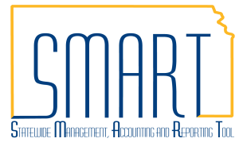
State of Kansas
PO Activity Summary Page
Statewide Management, Accounting and Reporting Tool
Date Created: | 07/12/2012
Version: | 2.0
Last Updated Date: | 11/23/2020
Fluid Navigation: POs & Receiving > Purchase Orders > Review Purchase Orders > Activity Summary
Classic Navigation: NavBar > Navigator > Purchasing > Purchase Orders > Review PO Information > Activity Summary
Purpose: | Use the Activity Summary page to review summary information pertaining to purchase orders, receipts, vouchers, payments, matching information, and RTV (Return to Vendor) information.
Enter the desired search criteria into the Selection Criteria page and select Search. | 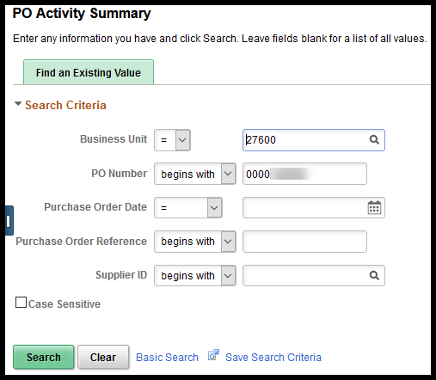
The search results are displayed on the Activity Summary page. | 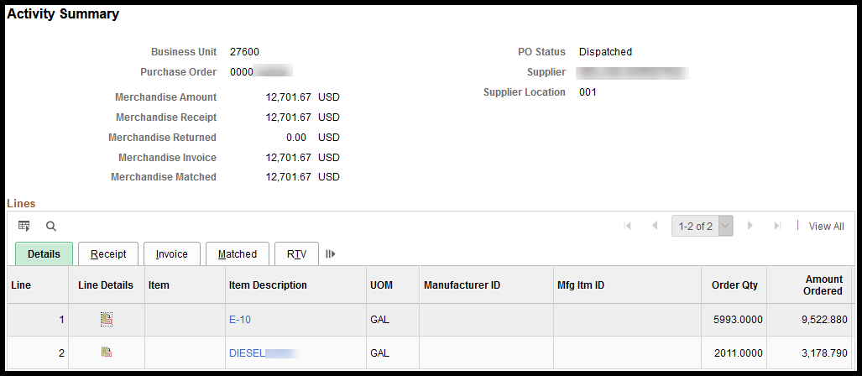
Included on the Details tab are:
- Line Details icon - Allows the user to see all details, for all tabs, for the line on one vertical page
- Order Qty - Displays the quantity of items/services that were ordered on the purchase order
- Amount Ordered - Displays the dollar amount for the items/services that were ordered on the purchase order
- Amount Only checkbox - This checkbox indicates whether the Amount Only checkbox was selected on the purchase order line or not
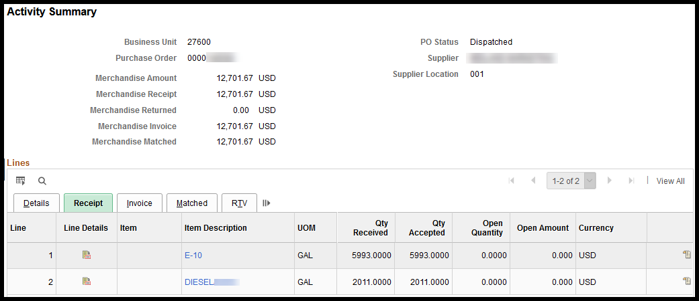
Included on the Receipt tab are:
- Qty Received - Displays the amount of items that have been received on receipt(s) for the PO
- Qty Accepted - Displays the amount of items that have been accepted on receipt(s) for the PO
- Open Quantity - Displays the amount of items that have not yet been received on a receipt for the PO
- Open Amount - Displays the dollar amount for items that have not yet been received on a receipt for the PO
Use the Receipt icon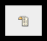on the right side of the Receipt tab to view the details of the receipt lines(s) for the PO Line: | 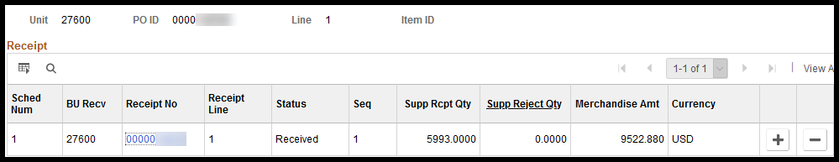
- Receipt No - Displays the receipt number(s) for each receipt(s) that have been created against the PO line and is a link to the Receipt page and information.
- Receipt Line- Displays the receipt line number
- Status - Displays the status of the Receipt Line(s)
- Supp Rcpt Qty - Displays the quantity of item(s) received on the receipt line
- Supp Reject Qty - Displays the quantity of item(s) that have had an RTV (Return to Vendor) created for them against the receipt line and PO line
- Merchandise Amt - Displays the dollar amount for the received item(s) on the receipt line
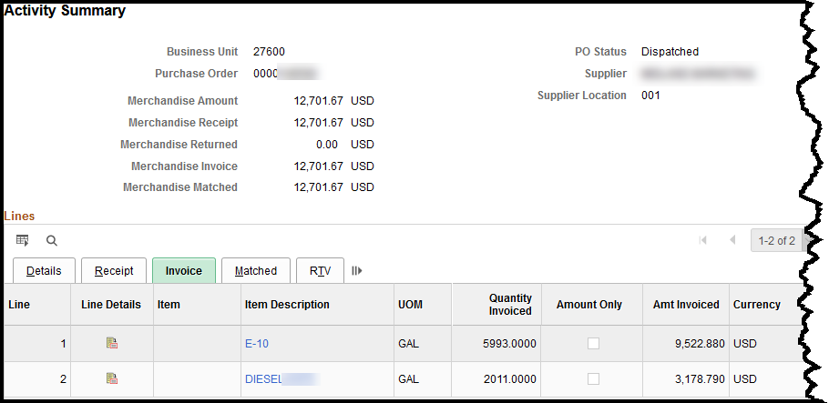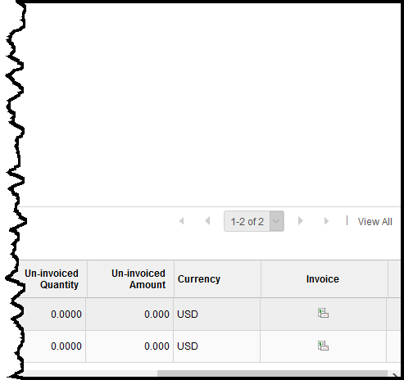
Included on the Invoice tab are:
- Quantity Invoiced - Displays the quantity that has been entered in to voucher(s), against the PO
- Amount Only checkbox - Displays whether the Amount Only checkbox was selected for the PO line
- Amt Invoiced - Displays the dollar amount that has been entered in to voucher(s), against the PO
- Un-invoiced Quantity - Displays the quantity of item(s) that have not been entered in to voucher(s), against the PO
- Un-invoiced Amount - Displays the dollar amount for item(s) that have not been entered in to voucher(s), against the PO

Use the Invoice icon 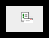 on the right side of the Invoice tab to view the details of the invoices (vouchers) associated to this PO Line: | 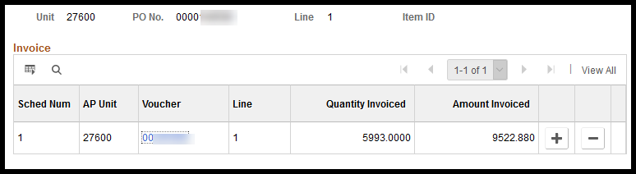
- Voucher - Displays the Voucher number and is a link to access and review the voucher information in a new window
- Line - Displays the voucher line number
- Quantity Invoiced - Displays the quantity that has been entered in to voucher(s), against the PO line
- Amount Invoiced - Displays the dollar amount that has been entered in to voucher(s), against the PO line
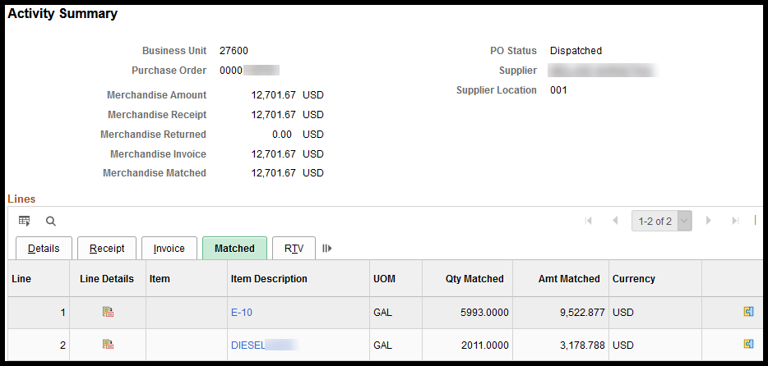
Included on the Matched tab are:
- Qty Matched - Displays the quantity that has been matched (on the PO and on the voucher)
- Amt Matched - Displays the dollar amount that has been matched (on the PO and on the voucher)
Use the Matched icon 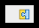 on the right side of the Matched tab to view by Voucher: | 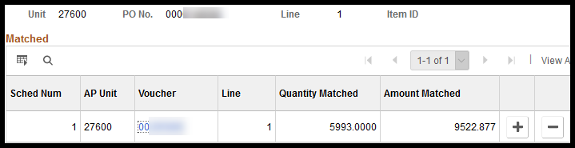
- Voucher = Displays the Voucher ID number and is a link to voucher details in a new window
- Qty Matched = Displays the quantity that has been matched (on the PO line and on the voucher line)
- Amt Matched = Displays the dollar amount that has been matched (on the PO line and on the voucher line)
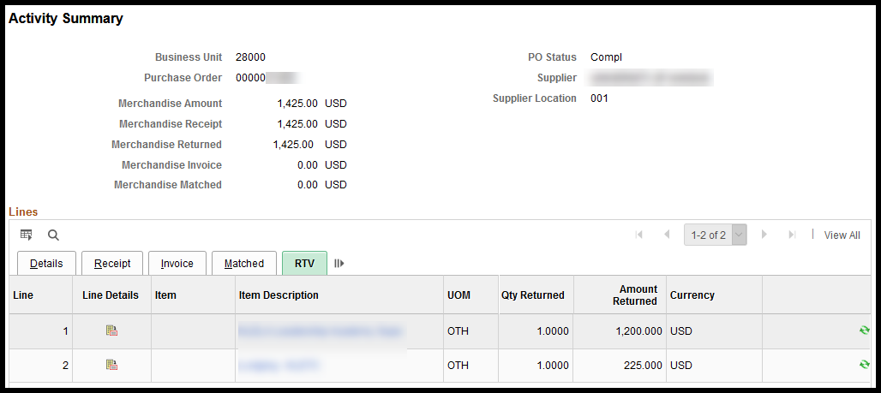
Included on the Matched tab are:
- Qty Returned - Displays the quantity of items returned on RTV(s), against the PO Line
- Amount Returned - Displays the dollar amount of items returned on RTV(s), against the PO Line
Use the RTV icon  on the right side of the RTV tab to view the details of the RTV line(s) that have been created against the PO Line: | 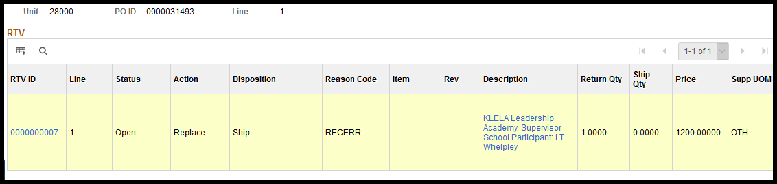
- RTV ID - Displays the RTV ID number and is a link to the RTV details in a new window
- Line - Displays the RTV Line number
- Status - Displays the status of the RTV Line
- Action - Displays the Action option that was selected when the RTV was created: (Based on contact/conversation with supplier before the RTV was created):
- Credit – Supplier will issue a credit for the item
- Replacement – Supplier will send the same item again, as a replacement for the original item that was ordered
- Exchange – Supplier will send a different item to replace the original item that was ordered
- Disposition - Displays the option that was selected when the RTV was created: (Based on contact/conversation with supplier before the RTV was created):
- Ship – Item must be shipped back to the supplier (per supplier’s request)
- Destroy – Supplier has given permission for the item to be field destroyed/disposed of (not sent back to supplier)
- Reason Code - Displays the option that was selected for the reason why the RTV is being created:
- RECERR – Received in Error
- TOO MANY – Too many items were received
- DAM – Item was damaged (shipping damage)
- DEF – Item is defective (Item does not work – not shipping damage, manufacturing fault)
- Rev - Displays the quantity of items that have been received on the receipt(s)
- Description - Displays the description of item and links to view the full description details
- Return Qty - Displays the number of items that were entered on the RTV to be destroyed
- Ship Qty - Displays the number of items that were entered on the RTV to be shipped back to the supplier
- Price - Displays the price of the item per unit of measure
- Supp UOM – Supplier Unit of Measure – Displays the quantity (unit of measure) in which the supplier sells the item
Examples: EA = each, BG = Bag, DOZ = Dozen.

