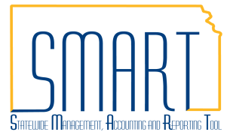
State of Kansas
Closing a Contract PO Not Used in Full
Statewide Management, Accounting and Reporting Tool

Date Created: | 11/22/2016
Last Updated: | 3/22/2021
Reason for the Job aid: | For a Purchase Order (PO) associated to a contract, create a Change Order to accurately update the contract amount calculations, or contract spend, on a contract when the entire PO amount will not be used.  For a PO not associated to a contract, the use of the Finalize option on the voucher and the PO Close process will release the encumbrance without the need for a Change Order.
PO Change Order Decision Tree
When must a PO be Canceled or the PO Lines modified prior to Closing the PO?
Have any partial payments been made on the PO line(s)?
Does Purchase Order have a Contract ID on the PO Line(s)?
NO
THEN
Close PO
Cancel PO
NO
Adjust PO Line(s) Amount or Quantity to the value of what has been vouchered.
YES
YES
Content Hyperlinks: | Creating Change Orders:  - Determine if PO to be released is associated to a contract.  - Determine if a PO is set up as ‘Amount Only’ or ‘Quantity’.  - Determine if the PO has multiple Distribution Lines.  - PO Accounting Entry Inquiry; for ‘Amount Only’ POs  - KS_KK_PO_ACTIVITY_IN_KK Query; for ‘Amount Only or ‘Quantity’ POs  - Change Order for a PO with a SINGLE Schedule and Distribution Line per PO Line.  - Change Order for a PO with MULTIPLE Schedule and/or Distribution Lines per PO Line.  To Be Aware Of:  - Investigate all Match Status Exceptions.  - Receipts - Receive at Distribution Line level.
Roles: | KPO_KS_Buyer  KPO_KS_Super_Buyer (OPC and KDOT use only)
Creating Change Orders:
- How to determine if a PO with a remaining encumbrance balance to be released is associated to a contract.
Fluid Navigation: | SMART Homepage > POs & Receiving > Purchase Orders > Add/Update Purchase Orders > Find an Existing Value
Classic Navigation: | Main Menu > Purchasing > Purchase Orders > Add/Update POs > Find an Existing Value
Search for the PO.  In this example, the PO has a remaining encumbrance balance of $50.00 that will not be used. | 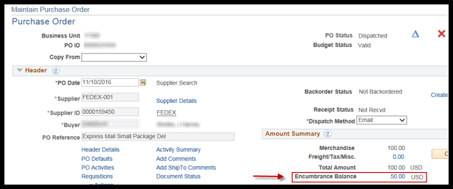
Select the Contract tab in the Lines section of the PO. Check to see if the Contract ID field is populated.  If there is NO contract: normal finalize procedures may be used. If there IS a contract: a Change Order must be created. | 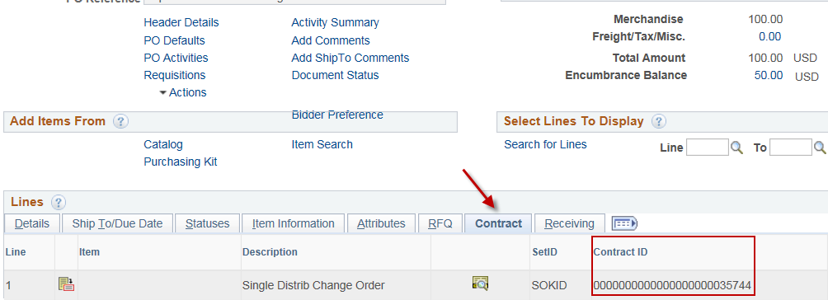
- How to determine if the PO was set up as ‘Amount Only’ or ‘Quantity’ at the PO Line level.
Select the Attributes tab in the Lines section of the PO. Check to see if the Amount Only checkbox is selected. | 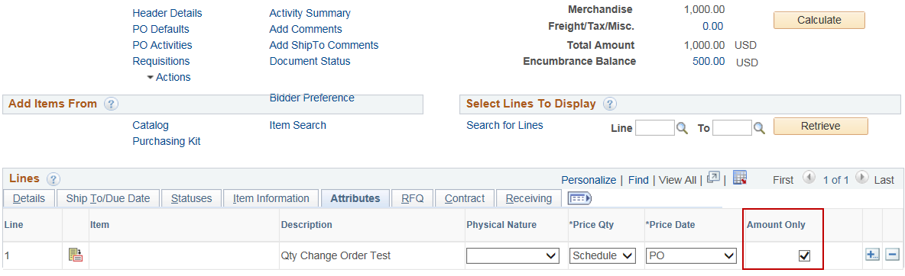
If the Amount Only box is checked, Distribute By: Amount will default in for all distribution lines. This causes the PO to apply to a voucher using the dollar amount, and there is no quantity that needs to be taken into consideration when creating a Change Order. | 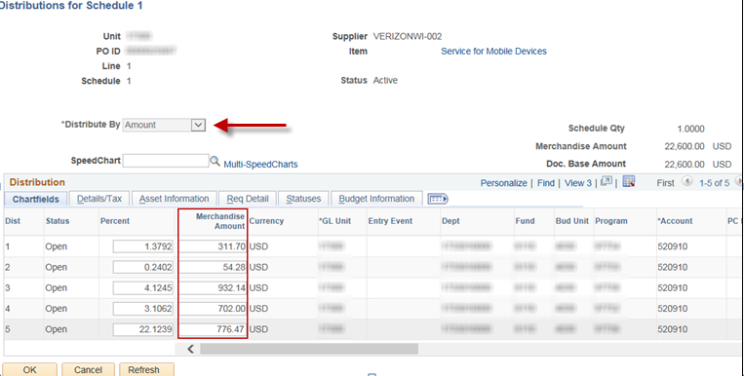
When the Amount Only box is not checked, the PO is set up for ‘Quantity’ at the PO Line level. | 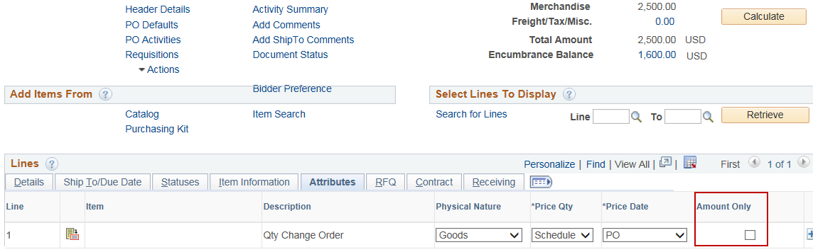
This quantity at the PO Line level must be taken into consideration when creating a Change Order. | 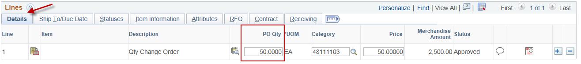
In addition, when the Amount Only check box is not selected and a PO is set up for ‘Quantity’ at the PO Line level, an agency can choose for the associated Distribution Lines to apply to the voucher by quantity (Distribute By: Quantity). | 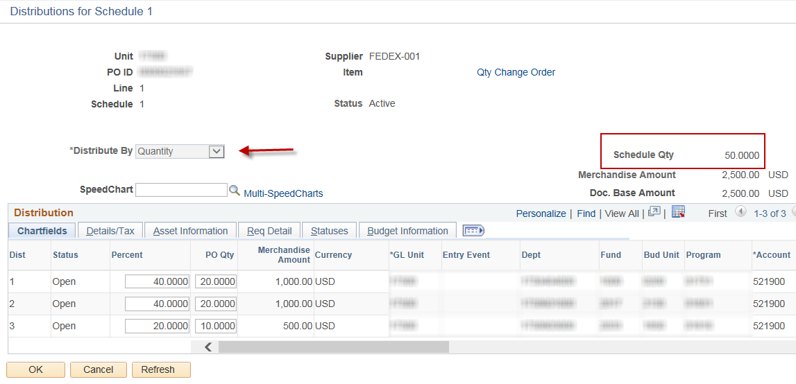
Or, the agency can choose the ‘Quantity’ PO Line’s associated Distribution Lines to apply to the voucher by amount (Distribute By: Amount). | 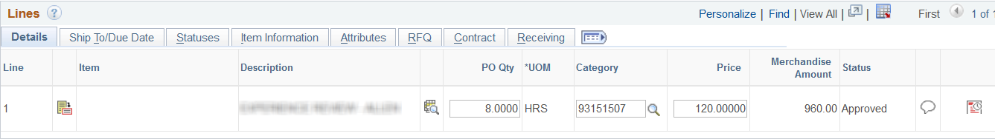  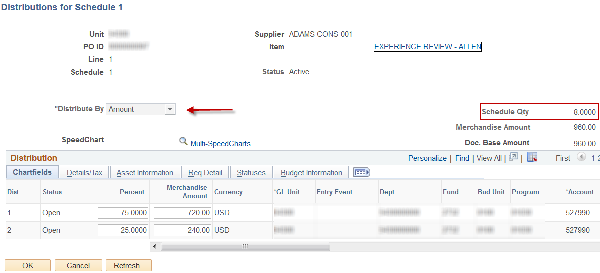
- How to determine if the PO has multiple distribution lines, and if so, how to determine amount or quantity already applied to voucher(s) for each Distribution Line.
Two methods of obtaining this information are: | - PO Accounting Entry Inquiry  - KS_KK_PO_ACTIVITY_IN_KK Query
How the methods differ in what they provide: | - Provides less detailed chartfield information, and can only be used if the PO is ‘Amount Only’.  - Provides more detailed chartfield information, and can be used if the PO is either ‘Amount Only’ or ‘Quantity’.

        - PO Accounting Entry Inquiry
Classic Navigation: | Main Menu > Purchasing > Purchase Orders > Review PO Information > PO Accounting Entries
Search by Business Unit and From PO ID/To PO ID using the Appropriation Ledger Group (CC_APPROP). | 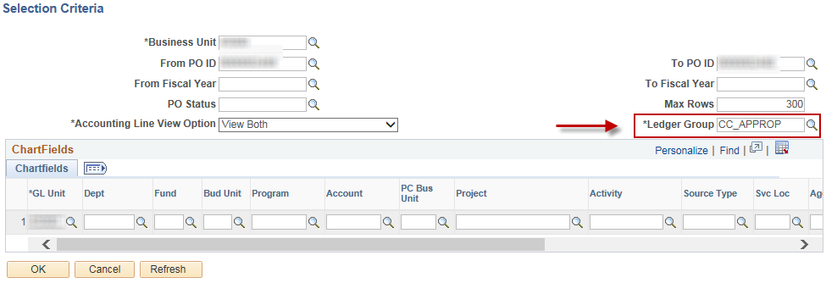
If there is only one Schedules Line (Sched) and one Distribution Line (Dist) per PO Line (Line), skip ahead to section 4 ‘How to process a Change Order for a PO with a SINGLE Schedule and Distribution Line per PO Line’. | 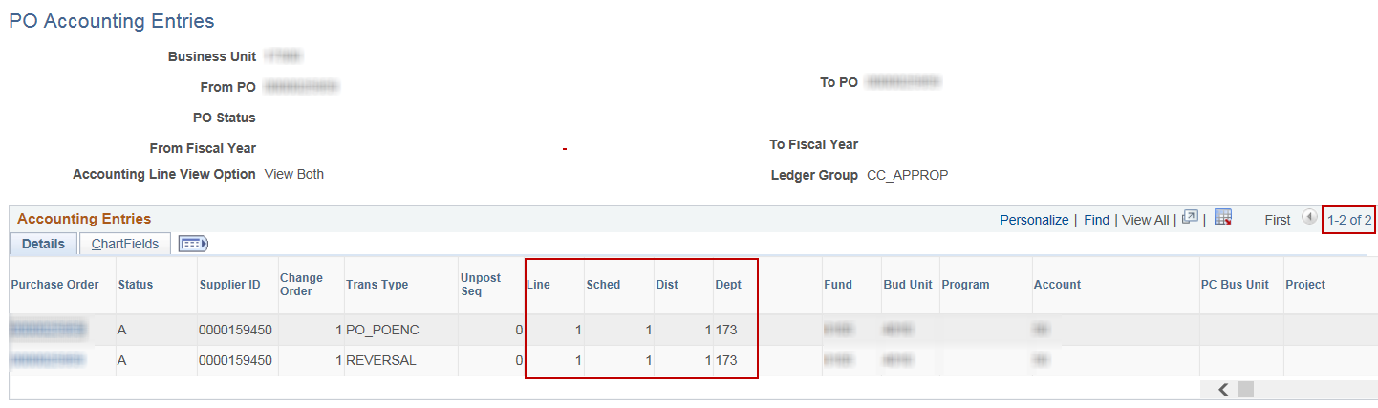
If there are multiple Schedules Lines (Sched) and/or Distribution Lines (Dist) per PO Line (Line), export search results to Excel only if the PO is ‘Amount Only’.  If the PO uses ‘Quantity’ for distribution, skip to section 3b ‘KS_KK_PO_ACTIVITY_IN_KK Query’. | 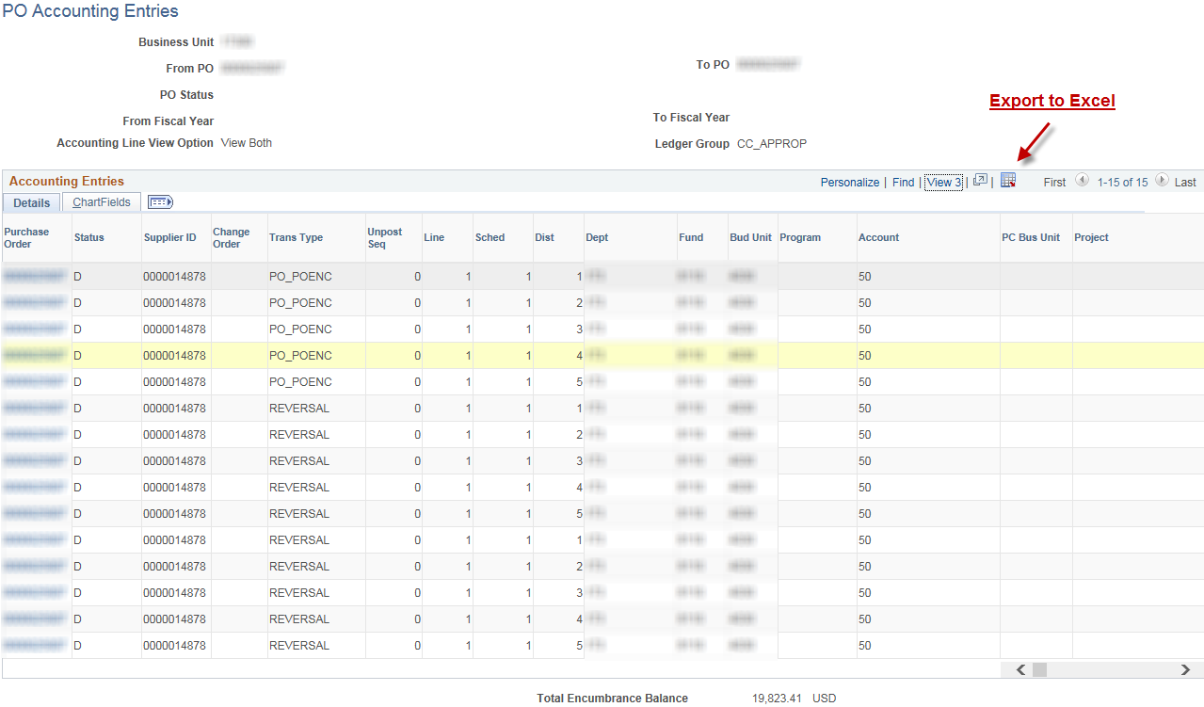

In Excel, a Pivot Table can be applied to the exported data to assist in calculating the remaining encumbrance on PO/Schedules/Distribution Lines.  Pivot tables allow for easy summarization of complicated data. | 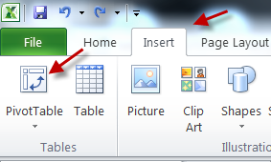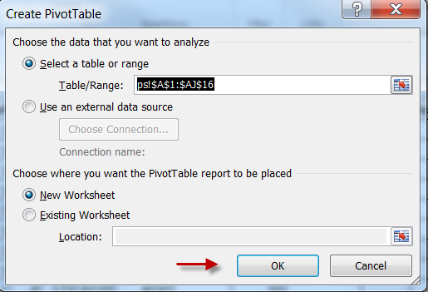  Navigation: Insert tab > PivotTable icon > select all cells containing inquiry data
A simple display for viewing the PO amounts by Distribution Line can be obtained by dragging and dropping the following fields into the designated areas:  Row Labels:  - Purchase Order  - Line  - Sched  - Dist  Column Labels:  - Trans Type  Values:  - Monetary Amount | 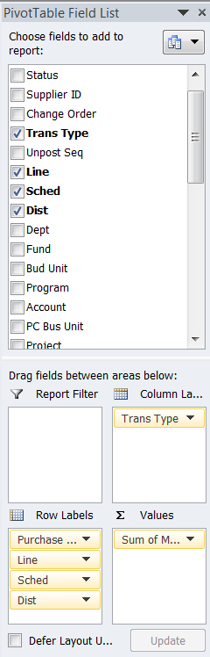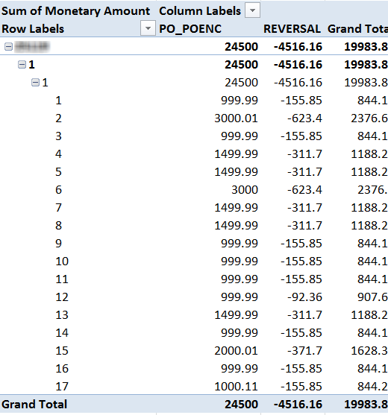  How the data will display.

A rounding issue can occur that displays results in a manner such as, 3.04112E-12. To resolve this, highlight the column and format the cell using Number, Currency, or Accounting.  Skip to section 5 ‘How to process a Change Order for a PO MULTIPLE Schedule and/or Distribution Lines per PO Line’. |  | Before: After:  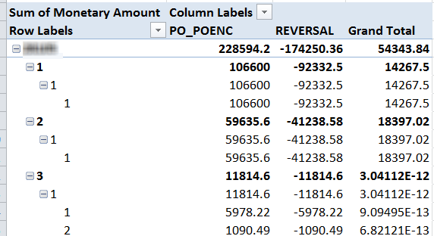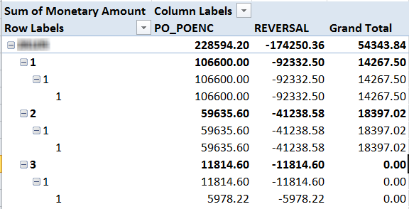  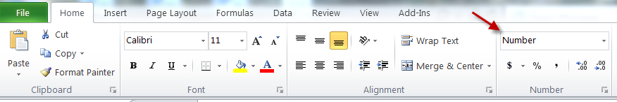
        - KS_KK_PO_ACTIVITY_IN_KK Query
Navigation for query: |  | Main Menu > Reporting Tools > Query > Query Viewer
Search for query KS_KK_PO_ACTIVITY_IN_KK and select the Excel hyperlink under Run to Excel. |  | 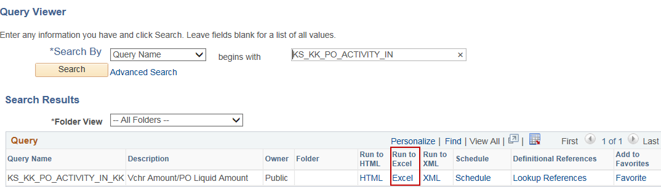
Search by Business Unit and PO No. |  | 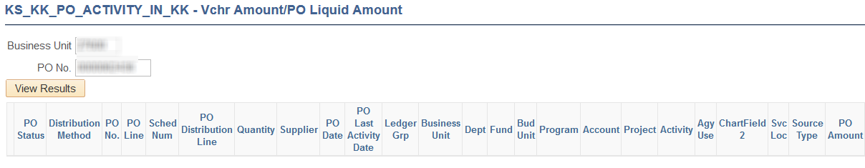
If there is only one Schedules Line (Sched) and one Distribution Line (Dist) per PO Line (Line), skip ahead to section 4 ‘How to process a Change Order for a PO with a SINGLE Schedule and Distribution Line per PO Line’. |  | 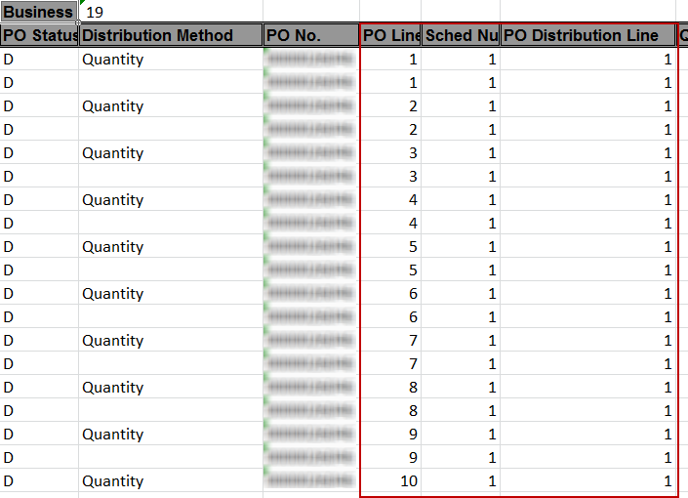
If there are multiple Schedules Lines (Sched) and/or Distribution Lines (Dist) per PO Line (Line), apply a Pivot Table.  As with the inquiry data, a Pivot Table can be applied to the exported data in Excel to assist in calculating the encumbrance on PO/Distribution Lines. Pivot tables allow for easy summarization of complicated data. |  | Navigation: Insert tab > PivotTable icon > select all cells containing query data
A simple display for viewing the PO amounts by Distribution Line can be obtained by dragging and dropping the following fields into the designated areas:  Row Labels:  - PO No.  - PO Line  - Sched Num  - PO Distribution Line  - PO Quantity  - Vouchered Quantity  Values:  - PO Amount  - Liquidated Amount |  | 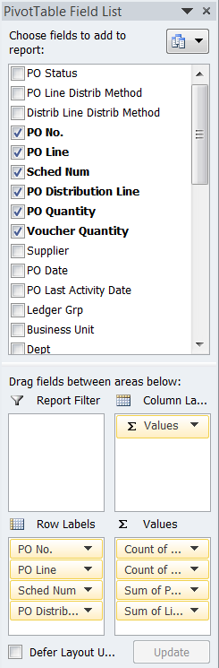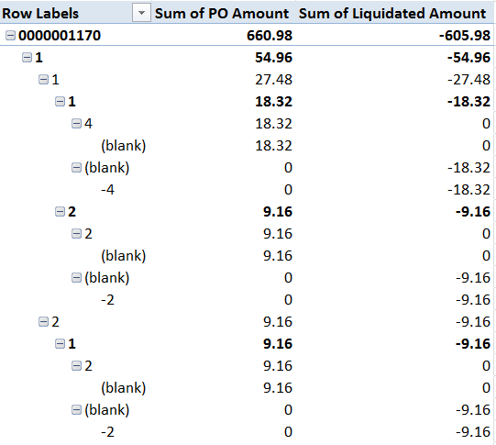  How the data will display.
A rounding issue can occur that displays results in a manner such as, 3.04112E-12. To resolve this, highlight the column and format the cell using Number, Currency, or Accounting. |  | Before: After:
Note: A custom report is currently being designed to produce this same information without the manual manipulation. A SMART Blast will go out and this job aid will be updated as soon as the report has been made available.
Note: Agencies also have the ability to search for all agency POs associated to a specific contract over a defined time period:
See query KS_KK_PO_ACTIVITY_BY_CONTRACT

Fluid Navigation: SMART Homepage > POs & Receiving > Utilities > Query Viewer

Classic Navigation: Main Menu > Reporting Tools > Query > Query Viewer

This query is run by From/To Budget Period (Year), which may return a high volume of results; therefore, scheduling the query may be a good option to improve run times. In addition, the Contract ID is set as ‘equal to’, so the full contract number must be used including leading zeros or suffix letters.
- How to process a Change Order for a PO with a SINGLE Schedule and Distribution Line per PO Line.
Fluid Navigation: |  | SMART Homepage > POs & Receiving > Purchase Orders > Add/Update Purchase Orders > Find an Existing Value
Classic Navigation: |  | Main Menu > Purchasing > Purchase Orders > Add/Update POs > Find an Existing Value
Search for the PO.

Select the blue triangle to initiate a Change Order.
On the Details tab, manually adjust the PO Qty field downward, if the PO Line was set up to distribute by quantity. |  | Before:  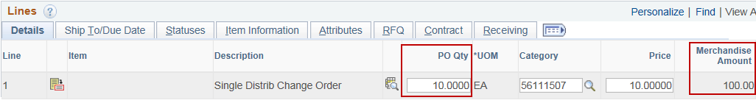  After:  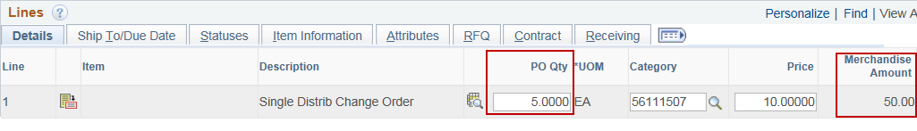
Or, manually adjust the Merchandise Amount field downward, if the PO Line was set up to distribute by amount. |  | Before:  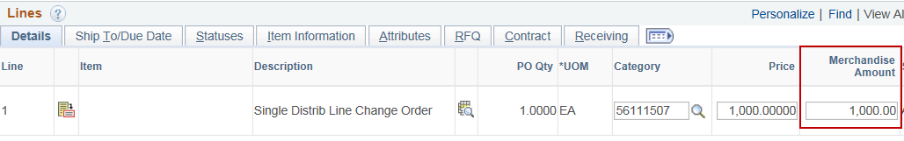  After:  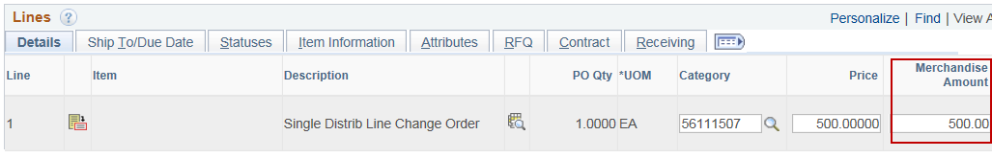
Once a Change Order is approved and budget checked it will go through the hourly Dispatch Batch process. Be aware of what the Dispatch Method is set to. If you do not want the supplier to receive the Change Order on the PO, set the Dispatch Method to Print. |  | 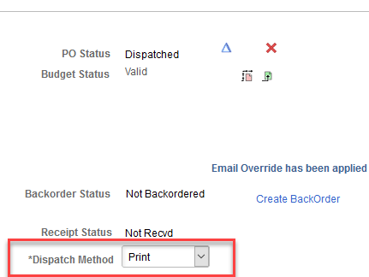
The Change Order must then be Saved, Approved and Budget Checked. |  | Approve:  Budget Check:
- How to process a Change Order for a PO with MULTIPLE Schedule and/or Distribution Lines.
Fluid Navigation: | SMART Homepage > POs & Receiving > Purchase Orders > Add/Update Purchase Orders > Find an Existing Value
Classic Navigation: | Main Menu > Purchasing > Purchase Orders > Add/Update POs > Find an Existing Value
Search for the PO. | 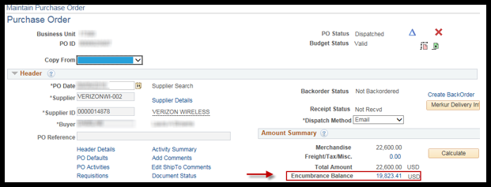
Select the blue triangle to initiate a Change Order.
Select the Schedule icon on the Details tab in the Lines section of the PO. | 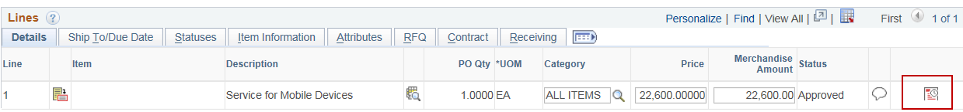
Select the Distributions / Chartfield icon on the Details tab in the Schedules section. | 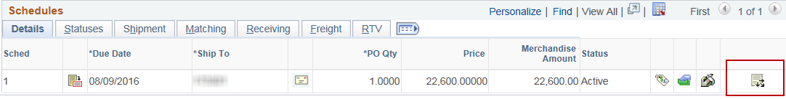
The Distributions for Schedule # page is displayed.  The Merchandise Amount per Distribution Line is equal to PO_POENC from the inquiry and Sum of PO Amount from the query. | 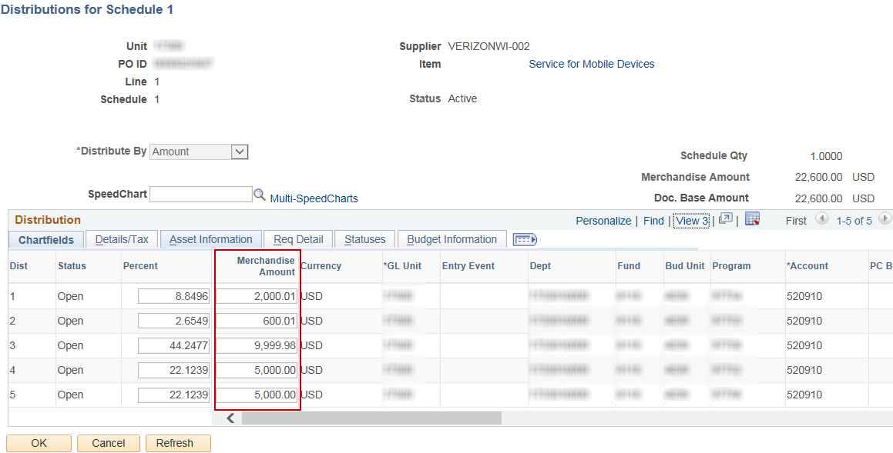
To release the encumbrance for an ‘Amount Only’ PO or a ‘Quantity’ PO that is set to Distribute By: Amount, enter the REVERSAL from the inquiry or Sum of Liquidated Amount from the query into the Merchandise Amount per Distribution Line.
These amounts should only be reduced down to what was applied to voucher(s). | 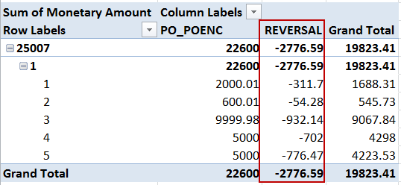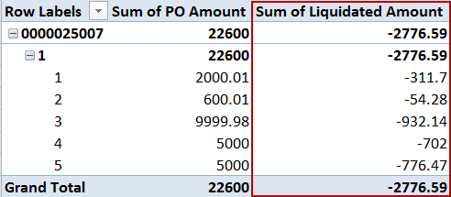  KS_KK_PO_ACTIVITY_IN_KK Query  PO Accounting Entry Inquiry
To release the encumbrance for a ‘Quantity’ PO that is set to Distribute By: Quantity, enter the Row Labels difference from the query into the PO Qty per Distribution Line. | 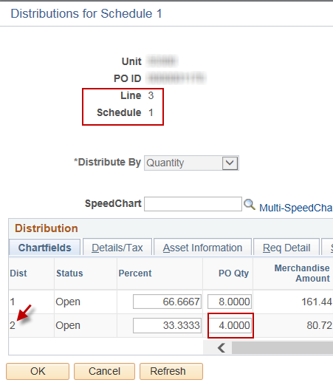
These amounts should only be reduced down to what was applied to voucher(s).  In this example, of the quantity of 4 (4.0000) the PO was originally created for, 2 (-2.0000) have been vouchered. | 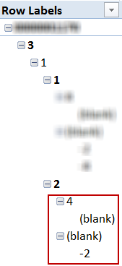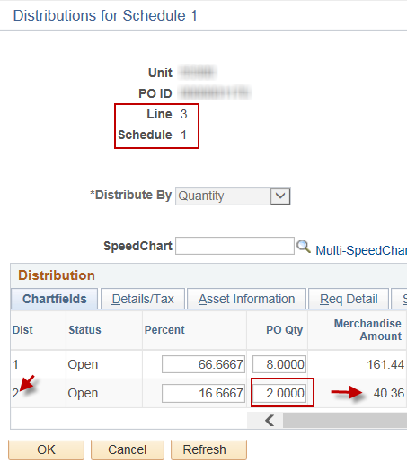  KS_KK_PO_ACTIVITY_IN_KK Query
Once back on the Maintain Purchase Order page, the total Price or PO Qty amount on the PO Line needs to be adjusted, as appropriate to match the new total after Distribution Line Changes. | 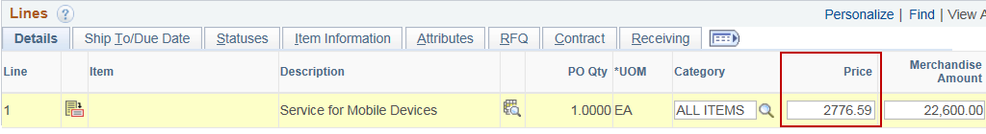
Once a Change Order is approved and budget checked it will go through the hourly Dispatch Batch process. Be aware of what the Dispatch Method is set to. If you do not want the supplier to receive the Change Order on the PO, set the Dispatch Method to Print.
The Change Order must then be Saved, Approved and Budget Checked. When Saving, Approving, and Budget Checking the Change Order, a warning may appear letting you know that you will not be able to source the requisition to a PO again without taking additional action. Click ‘OK’ on this message. | 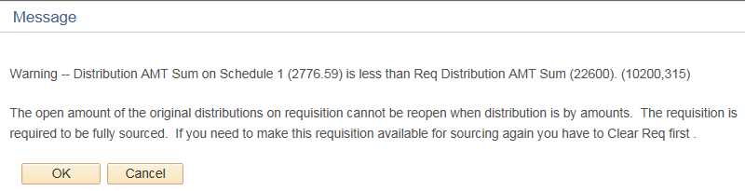
Once the Change Order is Budget Checked, the PO encumbrance balance will have been released and the Merchandise Amount field will have been reduced to the amount applied to voucher(s). | 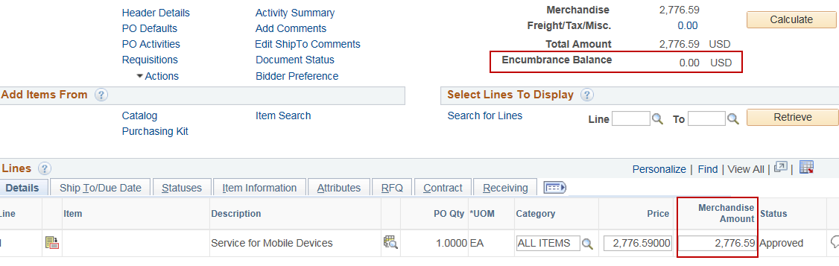
The Merchandise Amount field on the PO is utilized by SMART in the Released Amount (contract amount) calculations on a contract.  Navigation: Main Menu > Supplier Contracts > Create Contracts and Documents > Contract Entry > Find an Existing Value tab | 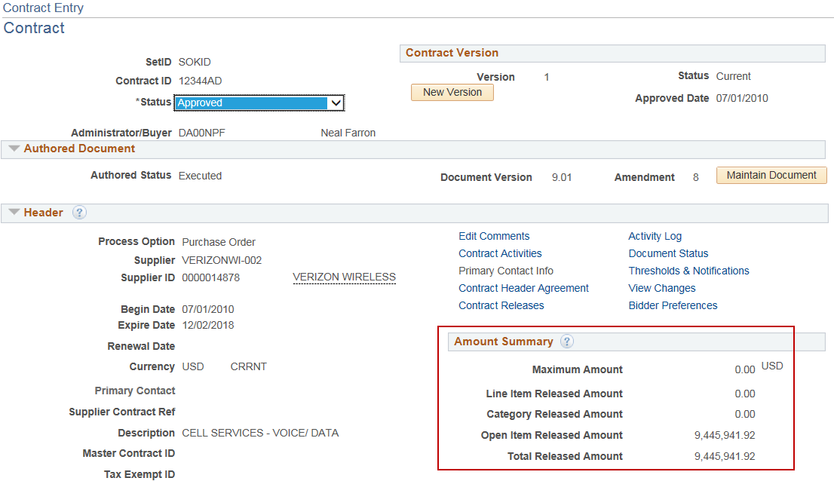
If a Maximum Amount is applied to a contact, the Released Amount is used to determine the remaining amount that could still be applied to the contract. | 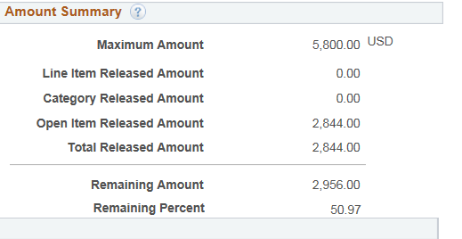
To Be Aware Of:
- Investigate all Match Status Exceptions.
If a PO is created with the intention of making multiple payments that reduce the PO each time, the Amount Only checkbox MUST be selected.

If the Amount Only check box is not selected and the PO is used on a payment for less than the PO Line was created for, a Match Status: Exceptions warning will occur.  An ‘Exceptions’ warning indicates there is an inconsistency between the PO and voucher, or between the PO, Receipt, and voucher. |  |  | 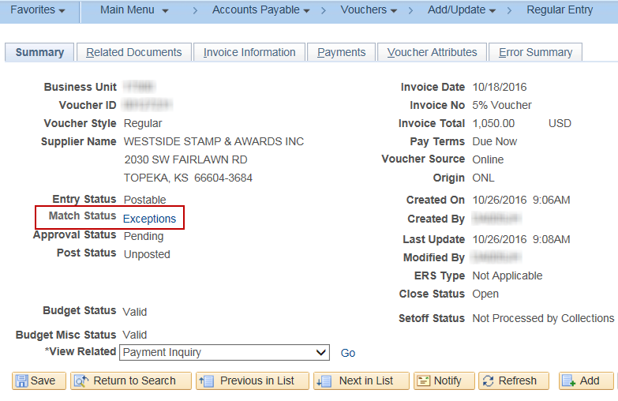
If this status is ‘Overridden’ and the voucher proceeds to payment without fixing the PO by selecting the Amount Only checkbox, SMART will not allow a Change Order to be created against that PO Line. |  |  | 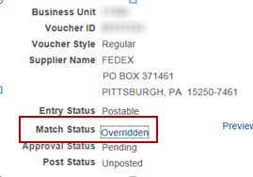
The reason this occurs is because without the Amount Only check box being selected, SMART will match not only the amount against the PO, but also the quantity. Since a PO that is intended to be used as ‘Amount Only’ is ususally only created with a quantity of 1 and that quantity of 1 was applied to the voucher, SMART allocated 100% of that PO Line’s quantity to a voucher and will not allow a Change Order. |  |  | This is the error that will be received if attempted:  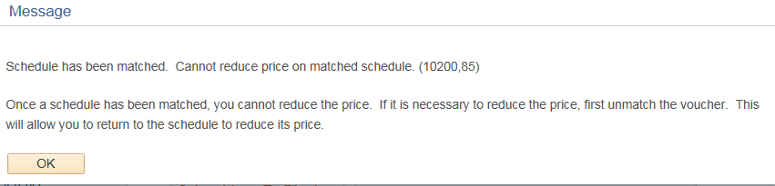

- Receipts - Receiving must be done at the Distribution Line level.
If receiving is used on a PO that is associated to a contract, all receipts MUST be created with the quantity or amount applied at the Distribution Line level. Otherwise, SMART allocates receiving that occurs at the Line level using First-In, First-Out logic, which is not necessarily the same way payments are made. The following steps will outline how to receive at the Distribution Line level.
Role: | KPO_Agy_Receiver
Fluid Navigation: | SMART Homepage > POs & Receiving > Purchase Orders > Add/Update Purchase Orders > Add a New Value
Classic Navigation: | Main Menu > Purchasing > Receipts > Add/Update Receipts > Add a New Value tab
The Business Unit search field defaults based on your agency number.  Click the ‘Add’ button. A ‘Select Purchase Order Search Criteria’ window appears. | 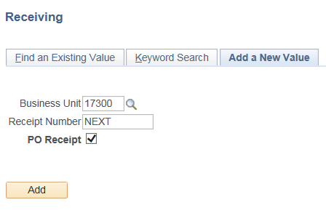
Enter the search critira and select ‘Search’.  Select the PO line(s) from the ‘Retrieved Rows’ table, and select ‘OK’. | 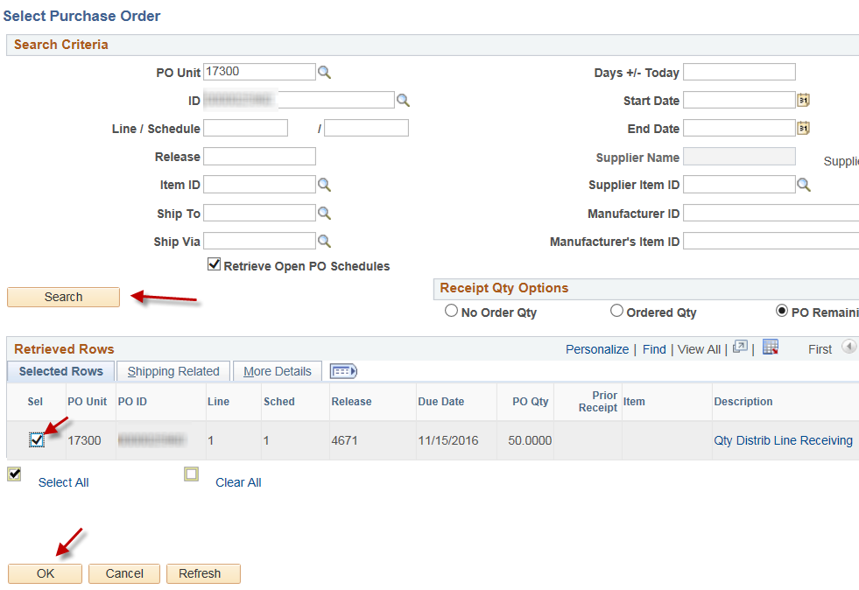
Select the Distrib icon on the Links and Status tab in the Receipt Lines section. | 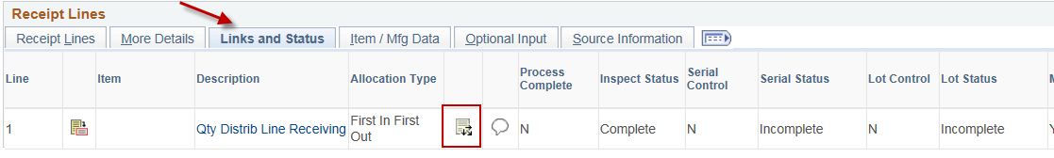
On the Receipt Distributions page select the Allocation Type dropdown and select Specify. | 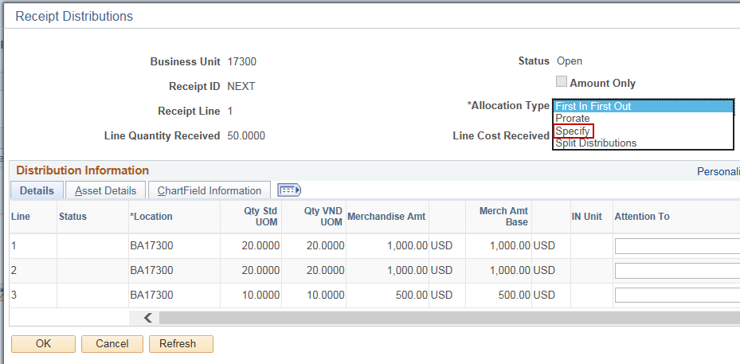
Change the Qty Std UOM to what should be received for each Distribution Line and select ‘OK’. | 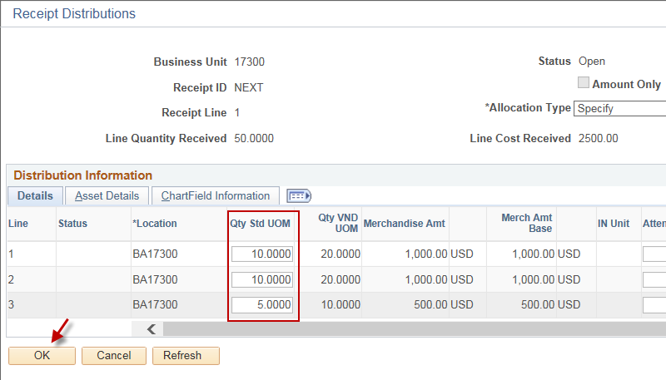
On the Receipt Lines tab change the Receipt Qty to the total of what was received on the Distribuition Lines. In this case, it would be 25 (10+10+5). | 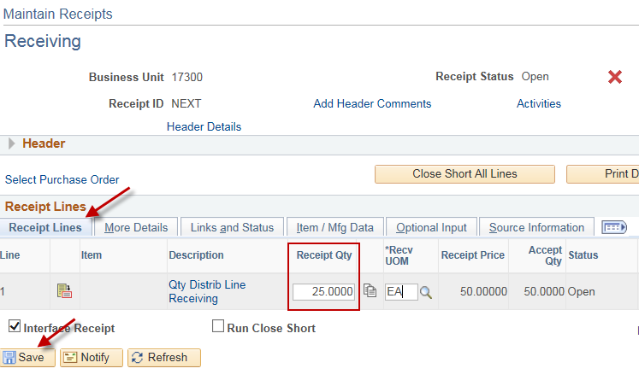
Caution:
When a PO that is associated with a contract is set up as ‘Quantity’ at the PO Line level and Distribute by: Amount at the Distribution Line level, DO NOT USE RECEIVING if there is any chance the PO will not be used in full and a Change Order may be required.

Receiving is directed by the Amount Only checkbox at the PO Line level. If that is not selected it tells SMART that receiving will be conducted by quantity, even if the Distribution Lines are set to distribute to the voucher by amount.

