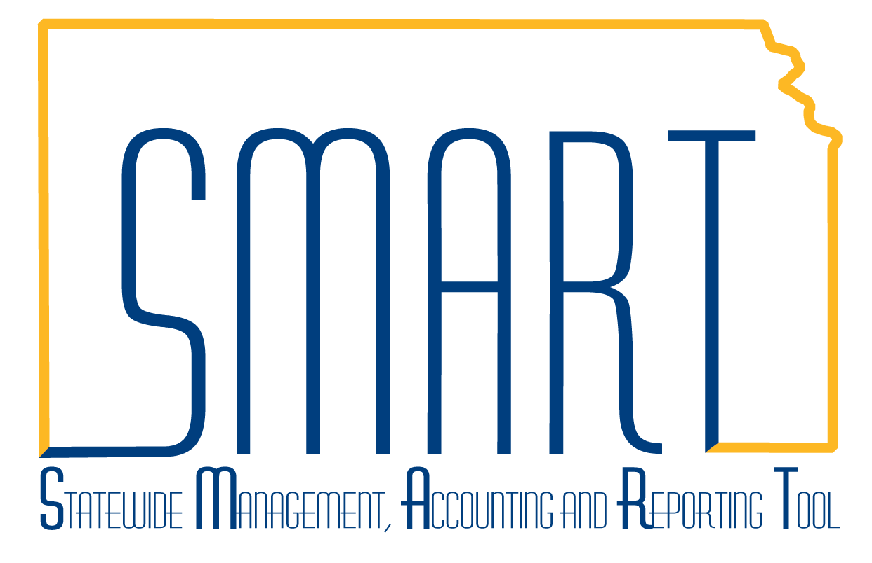
State of Kansas
Opening Closed Projects
Statewide Management, Accounting and Reporting Tool

Date Created: | 03/01/2019
Version: | 1.1
Last Updated Date: | 03/01/2019
Process: | Projects can be changed between any status at any time by someone with the Agency Projects Manager role. So, if a project was Closed by mistake and needs to be re-opened, the agency has access to do this.
Step 1. Navigation: Projects and Grants Homepage > Project Costing > Project Setup > General Information or Navigator > Project Costing > Project Definitions > General Information. Search for the Project ID you wish to re-open. Once you are on the project’s General Information tab, click on the Project Status link that says “Closed”. | 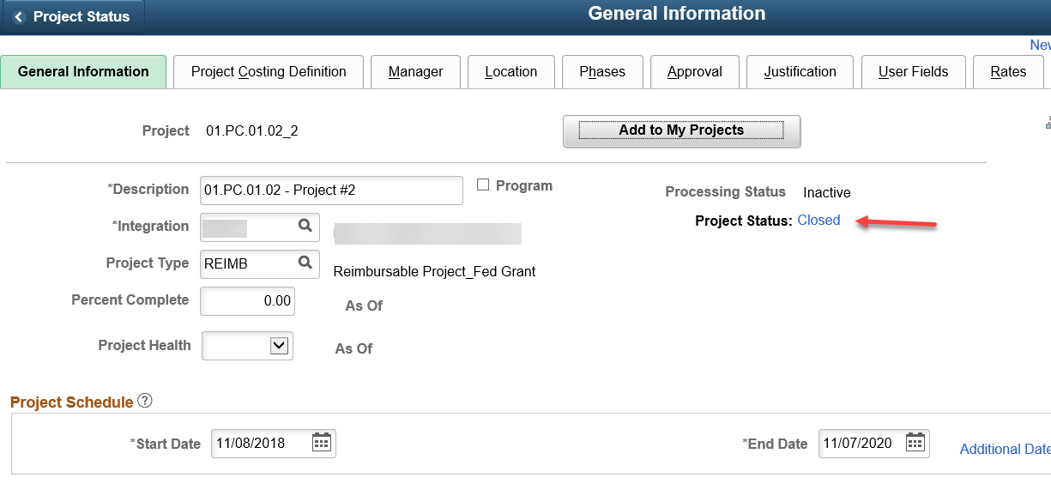
Step 2. This land on the Status page where you can add a new effective-dated row to change the project status from Closed to Open by clicking the Plus button.  Note: Click the Include History button. There are 2 existing rows, 1 for the original “Open” status and 1 for the change to “Closed”. | 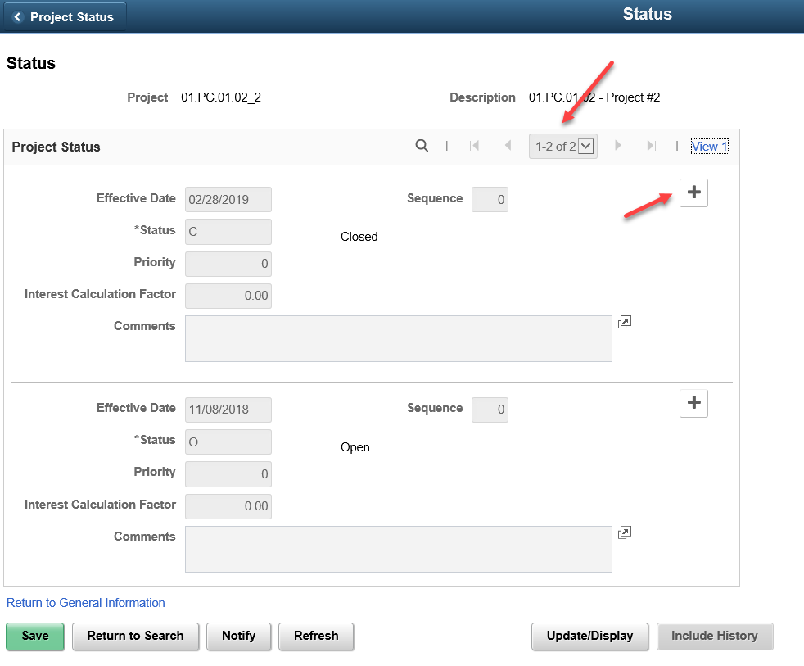
Step 3. Clicking the plus button. Change Status to ‘O’ for Open. Enter the Effective Date, after consideration of the notes below. Click Save.  Note: If you are re-opening the project so pending transactions may post, then you will need to change the Effective Date field on the Status page to reflect the earliest Transaction Date that needs to post.  To prevent potentially creating a gap between when the project was closed & when it was re-opened, the recommendation is to use the same Effective Date on the new “Open” row as was used on the most recent “Closed” row. When creating multiple rows with the same effective date, use the “Sequence” field to number the order in which the status changes occurred. | 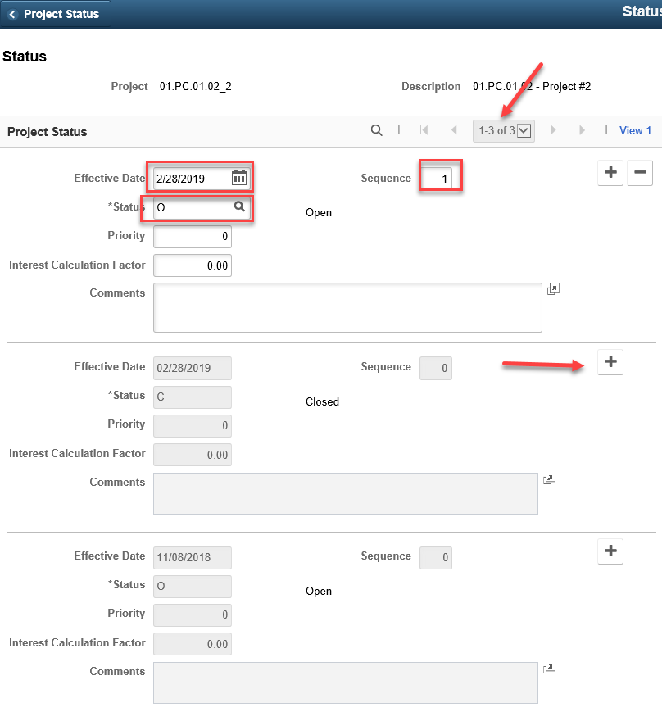
Step 4. If you accidentally Save the new Open row with a gap in the dates between closure and opening, the only way the row can be removed is through technical assistance from the SMART Team. A ManageEngine Service Desk ticket is required.

