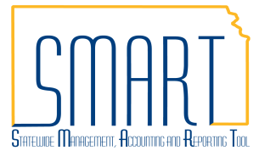
State of Kansas
Maintaining Notification Contacts
for Interfunds
Statewide Management, Accounting and Reporting Tool

Date Created: |  | 2/16/2018
Version: |  | 2.0
Security: |  | - Role Security: Only those individuals with the following role will have access to update Interfund Notifications:  - Agency Customer Creator (KAP_Agy_Customer_Creator)  - BU Security: Business Unit Security is applied. Agencies will only have access to the Customer Contacts associated to their agency business unit.
Navigation |  | Customers > Contact Information
1. | Notification for voucher reciprocation on an Interfund  - Key your Agency Business Unit into the SetID field and click search.  - Select the appropriate Contact ID to verify. | To verify the notification settings for interfunds that you will be creating a voucher for, please review your agency’s Contact Information.  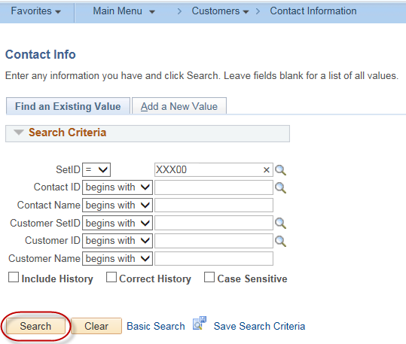  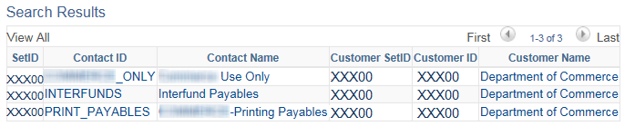

 | - Ensure that the Contact is active and has the appropriate email address and settings for notifications of vouchers for interfunds.  - If changes are needed, click the ‘plus sign’ to create a new page. Make changes as necessary on the new page.  - Note that today’s date will populate into the Effective Date field on this new page.  - Review the updates and click the ‘Save’ button. | 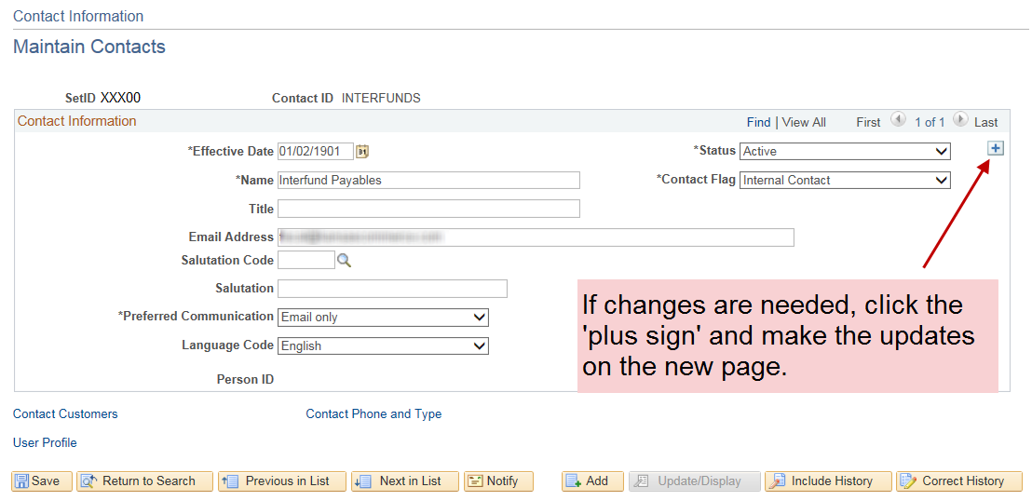  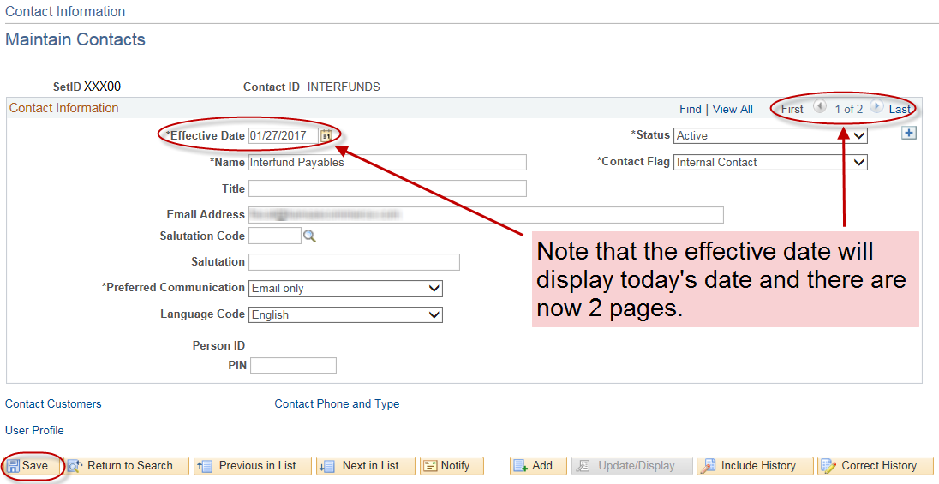
Navigation |  | Suppliers > Supplier Information > Add/Update > Review Suppliers
2. | Notification for deposit reciprocation on an Interfund  - In the Supplier ID field key your agency’s 5-digit Business Unit then click the ‘Search’ button.  - Using the Actions dropdown menu in the search results section, select ‘Review Supplier Contact’.  This will display the contact information for interfund notifications. | To verify the notification settings for interfunds that you will be creating a deposit for, please review your agency’s Business Unit Supplier ID contact information.  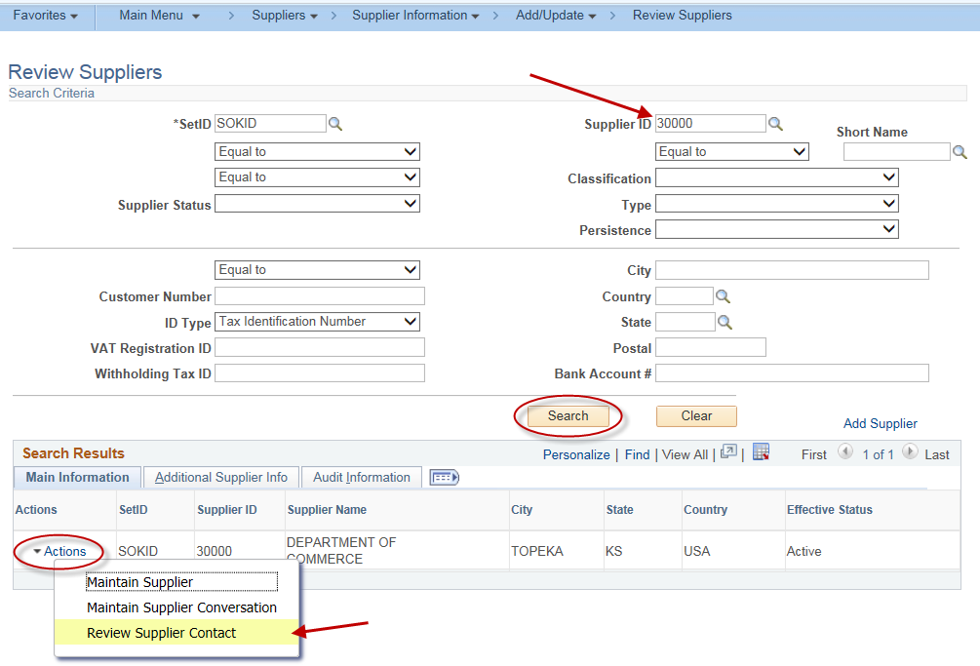
 | - If changes are needed, please submit a Service Desk Ticket requesting the appropriate changes be made to the Supplier ID. | 