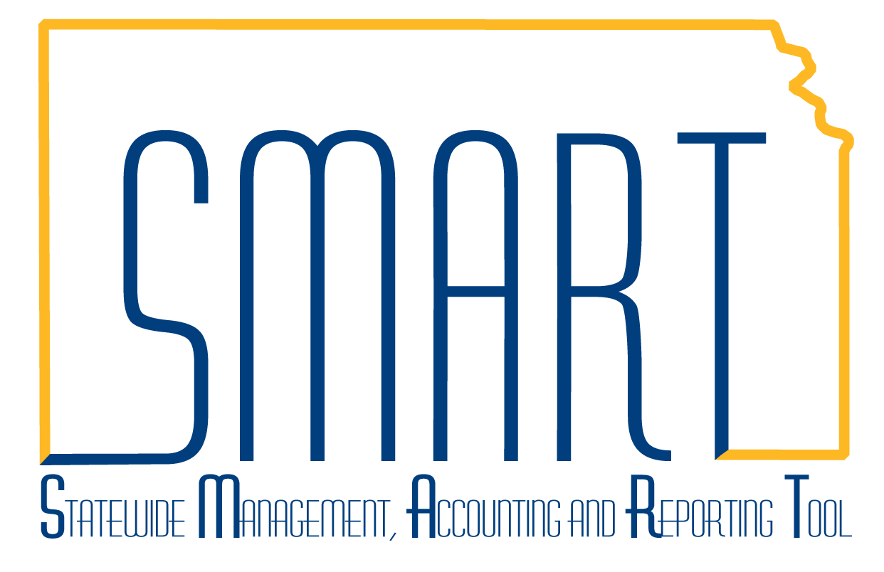
State of Kansas
Entering Non-Owned Assets
Statewide Management, Accounting and Reporting Tool
Created: 05/20/2010
Updated: 08/12/2019
Version #3

Non-owned assets are assets that need to be tracked in SMART but are not owned by the agency. An example is land, that is not owned by an agency, that has a building on it, owned by the agency. The non-owned land asset record is necessary in order to associate the building to the land. Another example is when an agency has custodianship over assets that do not belong to the agency but the custodians of those assets need to be tracked.

The following sections outline non-owned land and non-owned equipment asset entry into SMART.

Non-Owned Land Asset Entry

- Navigate to either Asset Management Homepage > Asset Transactions > Express Add or NavBar: Navigator > Asset Management > Asset Transactions > Owned Assets > Express Add.
- Validate the Business Unit and accept the default ‘NEXT’ as the Asset ID.
- Click Add.
- Select a non-capitalized Land Profile, for example, ‘543190’.
- Enter a description beginning with ‘Owner’ followed by the agency that owns the land. Then enter further descriptive information, for example, “Owner 27600, Weigh Stat #345.”
- Select the Location Code.
- Do not enter a cost in the Cost field. Assets that are classified as ‘non-owned’ will not have costs associated with them.
- Select a Fund in the Asset Cost Information section.
- Click the Default Profile button and note only the STATE book is in the Asset Cost Information section.
- Select an Asset Subtype in the Asset Additional Information box.
- Click Save.

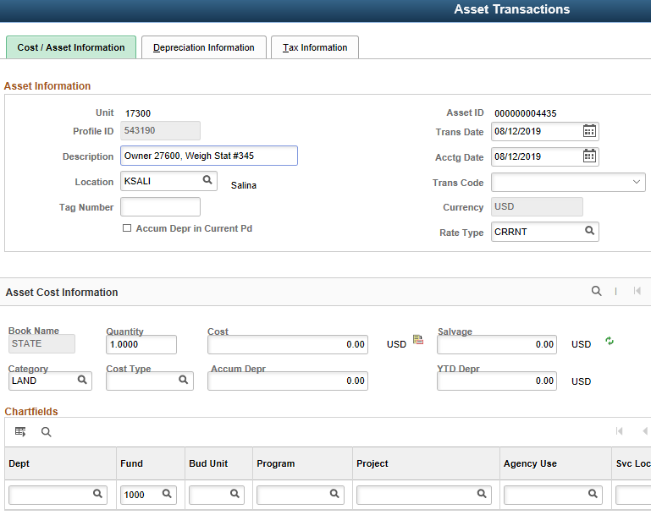

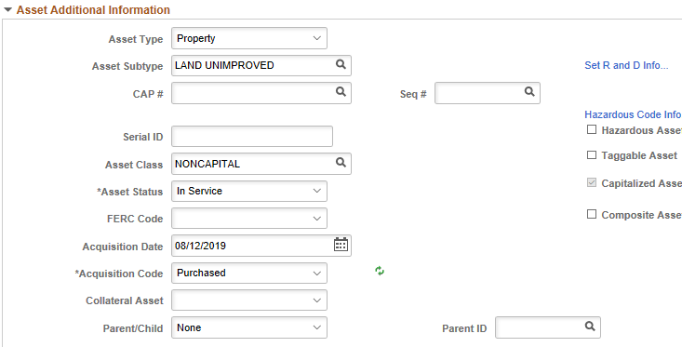

- Click the Basic Add navigation on the left. The non-owned land record just created will be displayed. Optionally, navigate to either NavBar: Navigator > Asset Management > Asset Transactions > Owned Assets > Basic Add or Asset Management Homepage > Asset Transactions > Basic Add. Fill in the applicable search information for the asset.
- Click the Operation/Maintenance tab.
- Check the ‘Non-Owned Asset’ box in the Other Information section.

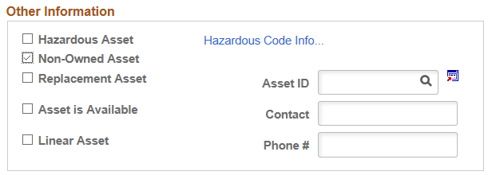

- Select the Asset Property tab. Use the ‘Show following tabs’ arrow in the upper right corner to view the tabs on the right.
- Select ‘Site’ in the Property Class field.
- Enter a Property Name and Description, for example, ‘Owner 27600, Weigh Stat #345, I-70 mile marker 252’.
- Enter ‘1’ in the Total Area field.
- Select ‘ACR’ in the Space Unit of Measure field.

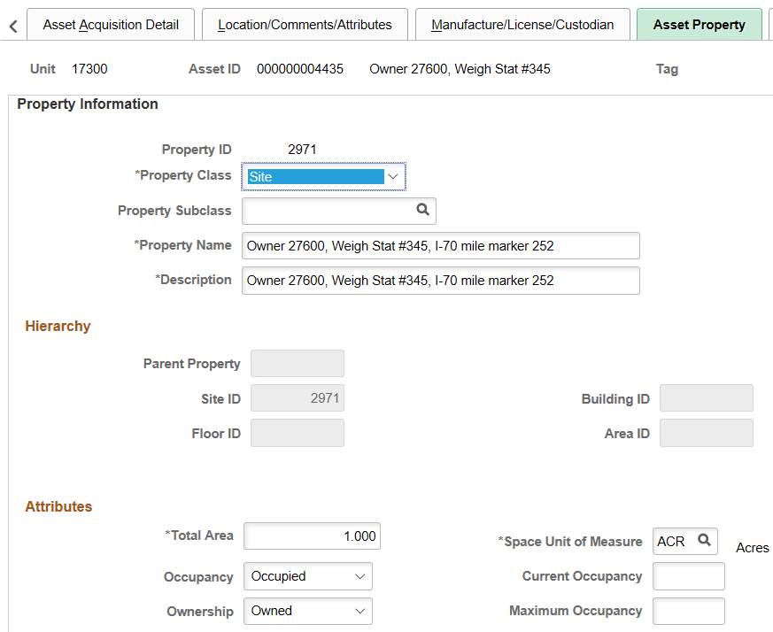

- Click Save. The system will auto-assign a Site ID. Once a Site ID is created, the building Asset ID can be associated with this Site ID on the Asset Property tab. For additional information on how to create the property asset relationship, please review the “Property Assets and Related Improvements” Training Guide.

Non-Owned Equipment Asset Entry

- Navigate to either Asset Management Homepage > Asset Transactions > Express Add or NavBar: Navigator > Asset Management > Asset Transactions > Owned Assets > Express Add.
- Validate the Business Unit and accept the default NEXT as the Asset ID.
- Click Add.
- Select a non-capitalized equipment profile, for example, 546490 – Radio Equip Portable Non Cap.
- Enter a description beginning with ‘Owner’ followed by the agency that owns the land. Then enter further descriptive information, for example, ‘Owner 27600, Radio #5.’
- Select the Location Code.
- Do not enter a cost in the Cost field. Assets that are classified as ‘non-owned’ will not have costs associated with them.
- Select a Fund in the Asset Cost Information section.
- Click the Default Profile button and note only the STATE book is in the Asset Cost Information section.
- Select an Asset Subtype in the Asset Additional Information box.
- Click Save.

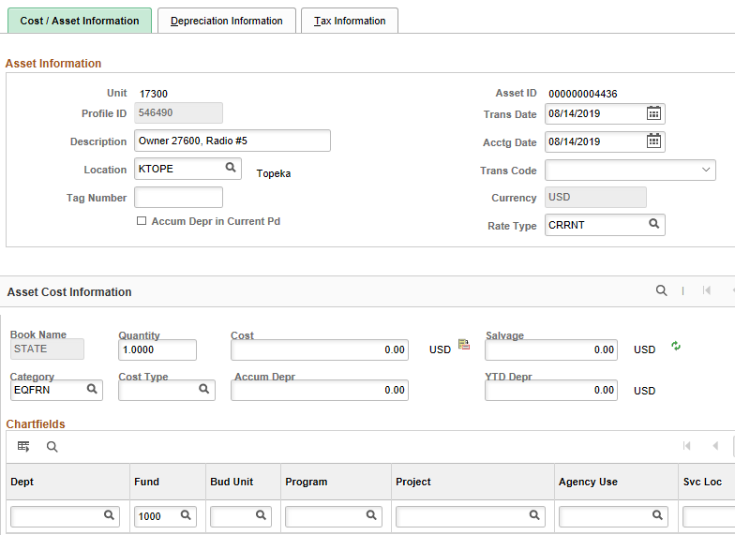

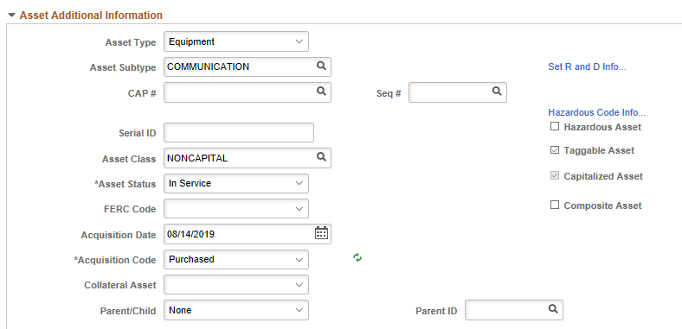

- Click the Basic Add navigation on the left. The non-owned equipment record just created will be displayed. Optionally, navigate to either NavBar: Navigator > Asset Management > Asset Transactions > Owned Assets > Basic Add or Asset Management Homepage > Asset Transactions > Basic Add. Fill in the applicable search information for the asset.
- Click the Operation/Maintenance tab.
- Check the ‘Non-Owned Asset’ box in the Other Information section.

- Click Save. A custodian can now be assigned on the Manufacture/License/Custodian tab.

