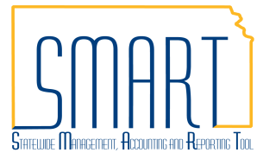
State of Kansas
New Reporting System Date Parameter
Statewide Management, Accounting and Reporting Tool

Date Created: | 2/01/2016
Version: | 1.0
Last Updated Date: | 2/01/2016
Purpose of the Job Aid: | To communicate the new AR reporting ‘system date’ parameter that can be used to generate aging and customer statements. This enables users to set a recurrence for processes and have them run for the current date without any user intervention.
Security: | - Role Security: Only those individuals with one of the following roles will have access to print a statement: Agency AR Maintainer  BU Security: Business Unit Security is applied. Agencies will only have access to run aging and statement reports for their agency’s business unit.
Process | - Navigate to: Accounts Receivable>Customer Interactions>Statements>Create Customer Statements to set parameter on a statement.
 | - Select the 'Add a New Value' tab and enter a Run Control ID; click 'Add' button.
 | - Notice the ‘Use System Date’ field. When selected, the ‘As of Date’ field will be greyed out.
 | 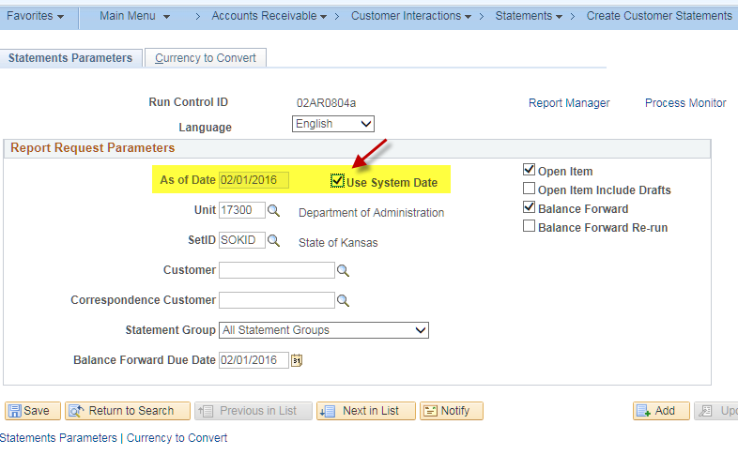
 | - Navigate to: Accounts Receivable>Receivables Analysis>Aging>Aging Summary by Unit Rpt to set parameter on an aging report.
 | - Notice the ‘Use System Date’ field. When selected, the ‘As of Date’ field will be greyed out.
 | 