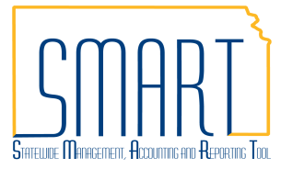
State of Kansas
Modifying 1099 Information on a Voucher
Statewide Management, Accounting and Reporting Tool

Date Created: |  | 11/01/2016
Version: |  | 2.0
Security: |  | - Role Security: Only those individuals with the following role will have access to create a voucher:  - Agency AP Processor (KAP_Agy_AP_Processor)  - BU Security: Business Unit Security is applied. Agencies will only have access to the vouchers associated to their agency business unit.
Navigation |  | Accounts Payable > Vouchers > Add/Update > Regular Entry
1. | Create a Voucher OR Navigate to an Existing Voucher.  - Create Voucher: Use the ‘Add a New Value’ tab and populate the fields as necessary for your voucher creation. You can choose to populate these fields now or after you have clicked the ‘Add’ button.  - Navigate to an Existing Voucher: Use the ‘Find an Existing Value’ tab and populate the Voucher ID field then click the ‘Search’ button. | 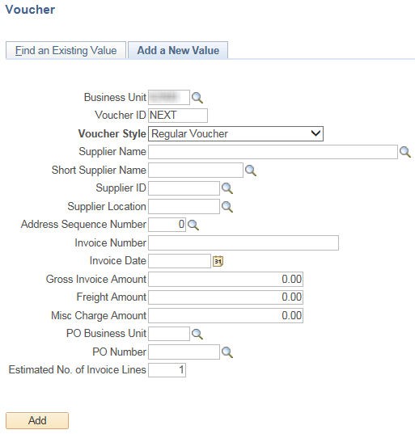  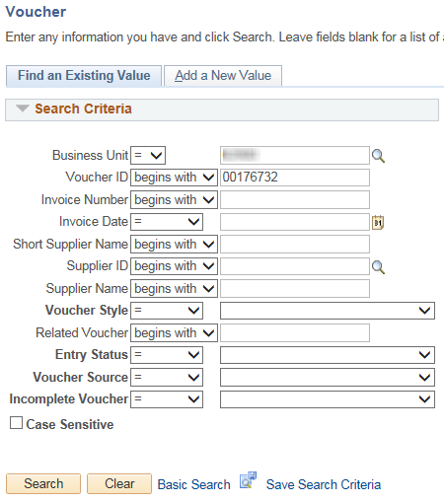

2. | View Withholding Details  Click the ‘Withholding’ hyperlink to view details for the voucher’s supplier.  The Withholding details may be changed from this page if necessary.  The Withholding Applicable checkbox defaults to selected if the supplier was set up as being Withholding Applicable. This indicates that the payment for this voucher line will be included on the 1099 statement that is issued for this supplier. | 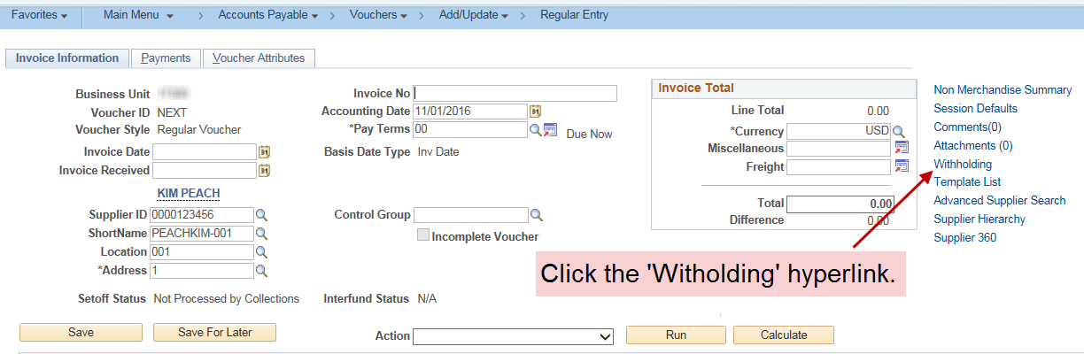  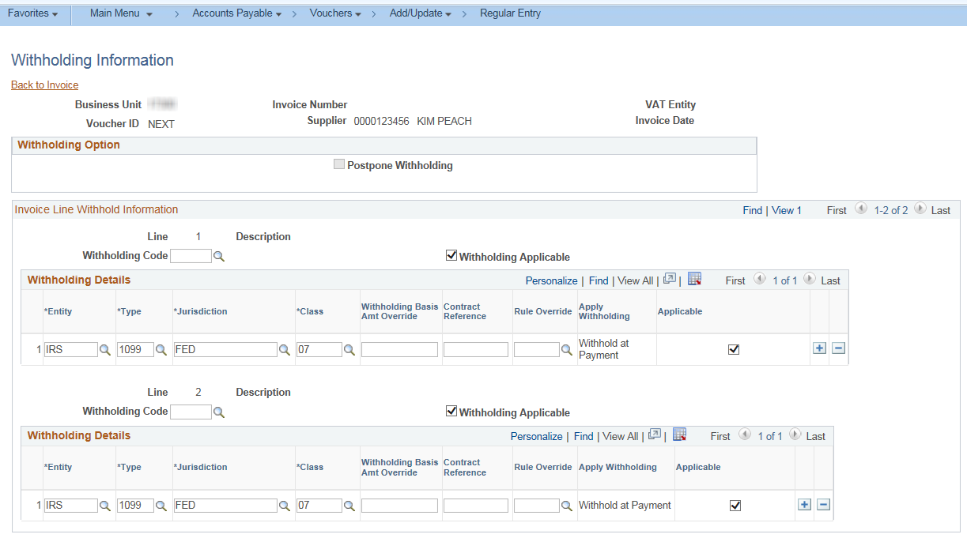
3. | Modify the Withholding Status on a Voucher  - If the payment is not reportable deselect the Withholding Applicable checkboxes in the Withholding Code section and the Withholding Details section. Withholding can be modified separately for each line on the voucher if one is applicable and one is not.  See the SMART 1099 and Withholding Information Training Guide for details. | 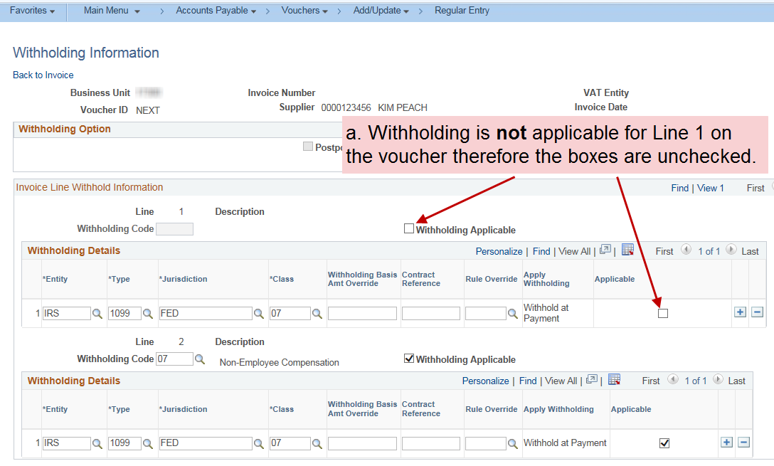  *The Withholding Applicable checkbox should be deselected only in those cases where the agency has determined the payment to be non-reportable in accordance with IRS regulations.

 | - If the payment is reportable the withholding boxes should remain checked.  - Populate the appropriate Class in the field. If you need a new Class added to the supplier please submit a Service Desk Ticket.  Leave the Withholding Code field blank.  - Once all modifications are made, click the ‘Back to Invoice’ hyperlink to return to the voucher.  Save the voucher once you have exited out of the Withholding Information page. | 