State of Kansas
Match Exceptions on Vouchers
Statewide Management, Accounting and Reporting Tool

Date Created |  | 07/25/2017
Version |  | 2.1
Last Update |  | 04/26/2019
Security |  | - Role Security: Only those individuals with the following roles will have access to review match exceptions on a voucher:  - Agency AP Processor (KAP_Agy_AP_Processor)  - Agency AP Maintainer (KAP_Agy_AP_Maintainer)  - BU Security: Business Unit Security is applied. Agencies will only have access to the vouchers and POs associated to their agency business unit.
Navigation |  | - Accounts Payable Homepage > Vouchers > Add/Update > Regular Entry  - NavBar: Navigator > Accounts Payable>Vouchers>Add/Update>Regular Entry
1.1 | Review Match Exceptions on a Voucher  On the Summary tab of the Voucher view the Match Status. Click the ‘Exceptions’ hyperlink to be taken to the Match Workbench to view details about the Exceptions.  Match Exception details can also be viewed on the the Error Summary tab of the voucher. This tab will show the Match Rules that are in error. | 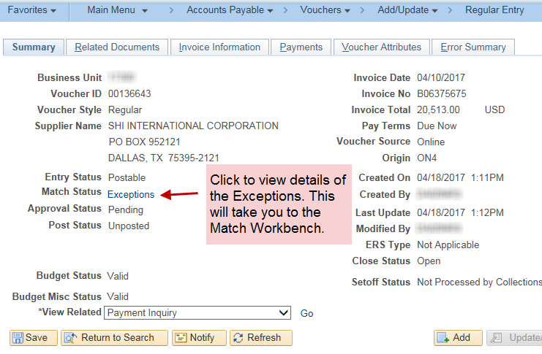  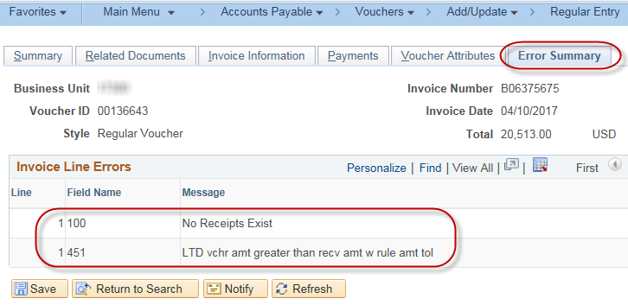

Navigation |  |  |  | - Accounts Payable Homepage > Vouchers > Match Workbench  - NavBar: Navigator > Accounts Payable > Review Accounts Payable Info > Vouchers > Match Workbench
1.2 | Access the Match Workbench directly to review Match Exceptions.  Search Criteria:  Business Unit – Enter your agency’s business unit.  Match Status – Select ‘Match Exceptions Exist’ from the drop-down menu.  Voucher ID – Select ‘equal to’ from the drop-down menu. Enter the Voucher ID in the open field.  Click the ‘Search’ button.  In the Results section click the ‘Match Exceptions Exist’ hyperlink .  The Match Workbench shows details about the Match Exception(s) including:  - Match Exception Summary – shows the Match Rules which are in error.  - Document Details – shows Associated Document Information such as voucher, PO, and receiver attributes for all lines.  - Line Document Details – shows Associated Document Information such as voucher, PO, and receiver attributes for a specific line.  - View Document ‘Go’ hyperlink – opens up the associated PO in a separate tab. |  |  | 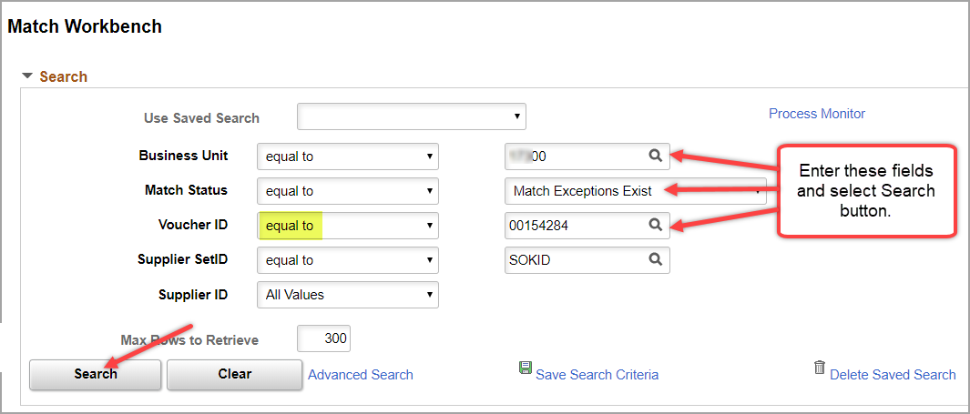  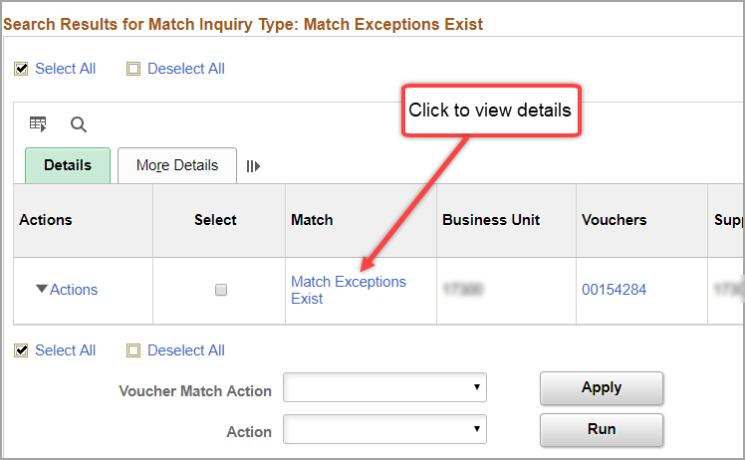  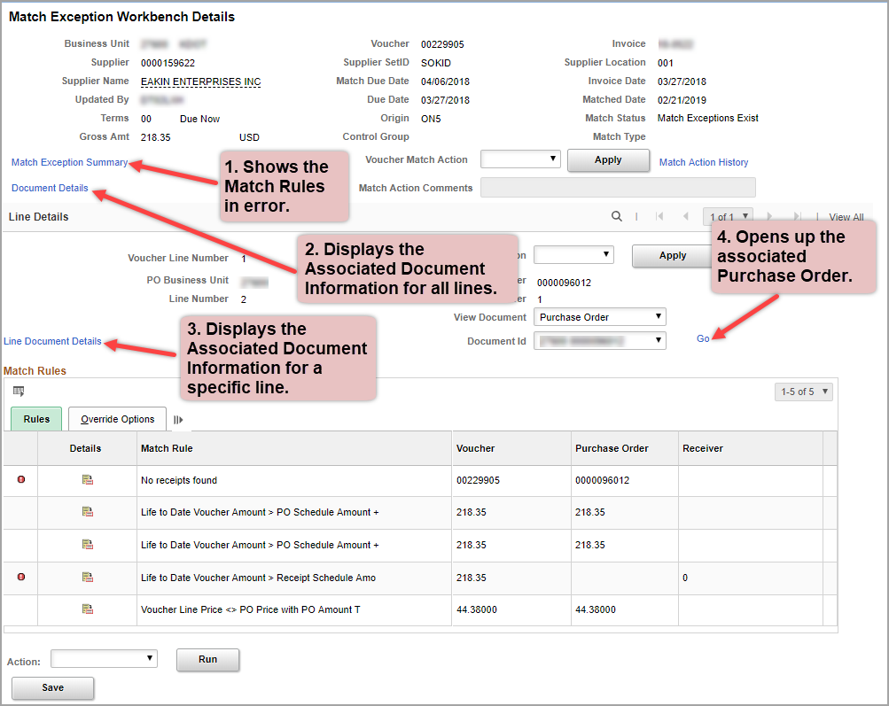
 | 1. Match Exception Summary  In this example the Match Exception Summary is showing that the Match Rules impacted are 100 & 451. These both have to do with the receiver.  2. & 3. Document Details – Associated Document Information  The Associated Document Information page shows that there is no Receiver associated with the voucher but Receiving is Required (Match Rule 100). This is also causing the voucher amount to be greater than the receiver amount (Match Rule 451).  4. View Document – Purchase Order  Viewing the details on the Purchase Order may help to determine from where the Match Exceptions are stemming. If a change order needs to be processed, the voucher will likely need to be deleted to do this.  Correct the Match Exceptions by modifying the Voucher, PO, or Receipt. See the next page for Match Rules. This table has details on how to correct exceptions for each Match Rule. | 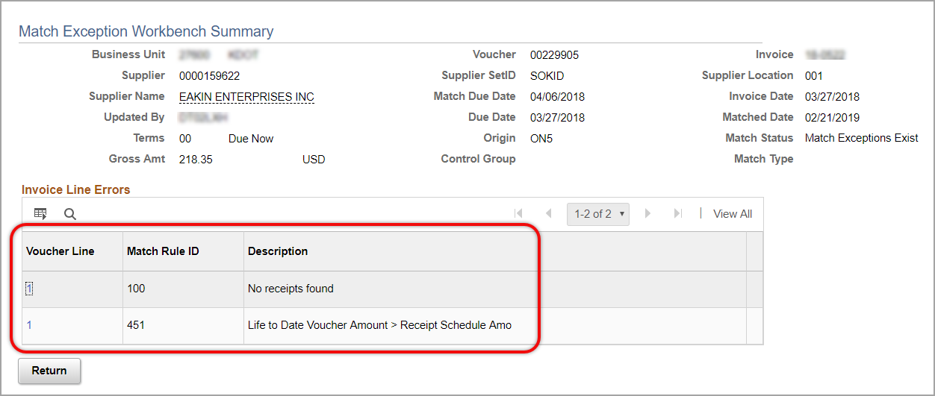  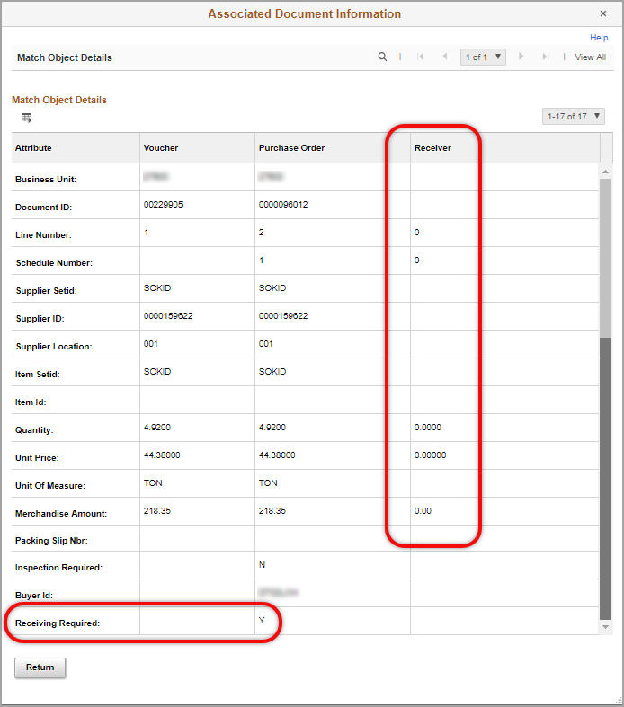  To get to the PO, either use the ‘Go’ link on the Match Workbench page or navigate to:  - POs & Receiving Homepage>Purchase Orders>Review Purchase Orders>Review Purchase Orders  - NavBar: Navigator>Purchasing >Purchase Orders>Review PO Information>Purchase Order  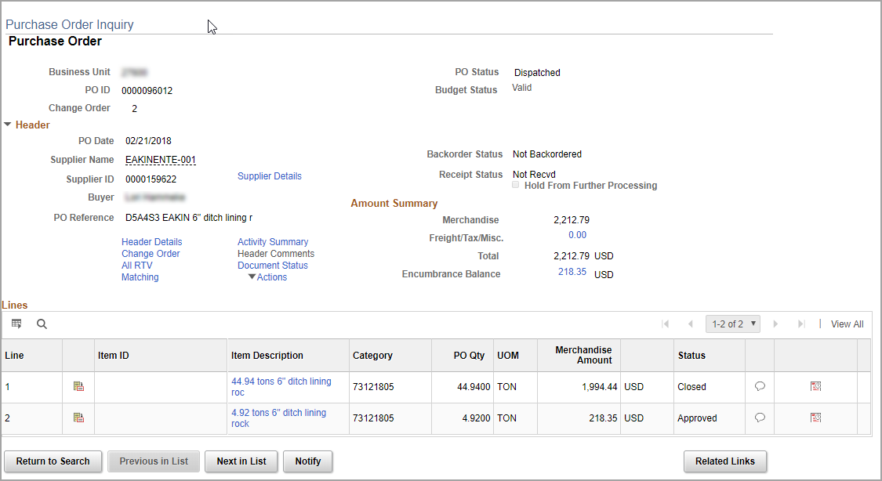
2. Use the Match Rules Table to determine how to correct the Match Exceptions.
*For Match Rules 340 and 350, please use the information in section 3 to gather information.
Match Rule | Description | How to Fix
Match Rule 100: No Receipts Exist | Receiving is required on the PO but no available receipts (not matched, not on hold, and not canceled) are associated to the voucher line. | If necessary, contact the designated receiver to receive the item(s). The designated receiver should enter the receipt for the referenced voucher/purchase order line items. Once the system matching job runs, the receipt will associate to the voucher.
Match Rule 131: Supplier not = PO Supplier | The supplier on the voucher does not equal the supplier on the purchase order. | Change the supplier on the voucher to match the purchase order supplier. Contact your agency's purchasing department if needed.
Match Rule 340: LTD vchr amt greater than PO amt with PO amt tol | The current voucher line amount plus previously matched voucher line amounts, if any, is greater than the PO line schedule amount. Include amount and percent tolerances from the PO, if any, when comparing the values.  *The available amount left on the PO line is being exceeded on the current voucher. Use section 3 to find the PO distribution line available amount. | A change needs to be made to the voucher total or the purchase order total, depending on which one is incorrect. If the purchase order total is changed, a change order is created and the purchase order must be dispatched again. This will require that the current voucher gets deleted before the change order can be processed. Attention must be paid to the dispatch method on the purchase order. If the voucher total is incorrect and needs to be changed, the voucher processor must change the voucher.  Possible solutions for this match rule:  - If the amount on the invoice is different than the amount on the purchase order, contact the supplier for a resolution.  - Correct voucher to reflect the amount listed on the purchase order.  - Contact your agency's purchasing department to have the purchase order adjusted.
Match Rule 350: LTD vchr amt greater than PO amt with PO % tol
Match Rule 451:  LTD vchr amt greater than recv amt w rule amt tol | Current voucher line amount or quantity plus previously matched voucher line amounts or quantity, if any, greater than receipt line amount or quantity.  *The available Receipt amount or quantity is being exceeded on the current voucher. | Review the voucher and receipt to identify any amount or quantity discrepancies.  Possible solutions for this match rule:  - If the amount/quantity on the invoice is different than the amount/quantity on the receipt, contact the supplier for a resolution.  - Correct voucher to reflect the amount/quantity listed on the receipt.  - Contact your agency's purchasing department to have the receipt adjusted.
Match Rule 470: Line price not = PO price with PO price amt tol | Compare voucher price with PO price. Include price amount tolerances, if any, from the PO when comparing the values.  *The PO is NOT set up as ‘Amount Only’ and the voucher line amount is not equal to the PO line amount. | A change needs to be made to the voucher line price or the purchase order line price, depending on which one is incorrect. If the purchase order line price is incorrect, a change order is created and the purchase order must be dispatched again. This will require that the current voucher gets deleted before the change order can be processed. Attention must be paid to the dispatch method on the purchase order. If the voucher line price is incorrect and needs to be changed, the voucher processor must change the voucher.  Possible solutions for this match rule:  - If the line price amount on the invoice is different than the line price amount on the purchase order, contact the supplier for a resolution.  - Correct voucher to reflect the line price amount listed on the purchase order.  - Contact your agency's purchasing department to have the purchase order line price amount adjusted.

3. | Find the Available Balance for each PO distribution line.  *This should be done for errors on Match Rules 340 and 350.  - Determine the PO ID associated with the Match Exception. Find this from the Match Workbench or by viewing the Error Summary tab and Invoice Line on the Voucher.  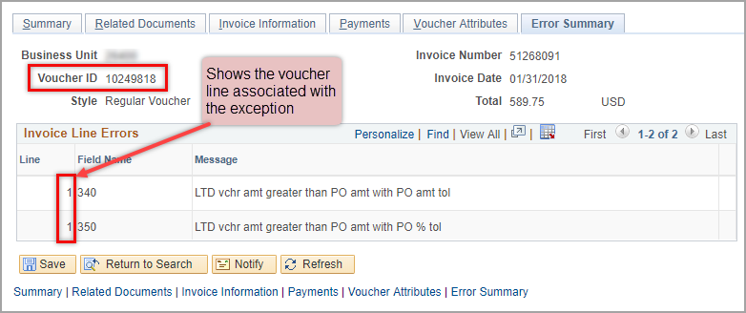  View the correlated Invoice Line on the Invoice Information tab of the voucher.  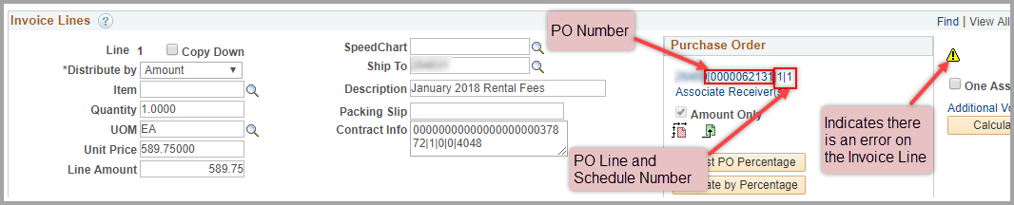
Navigation |  |  | NavBar: Navigator > Purchasing > Purchase Orders > Review PO Information > PO Accounting Entries
- Go the the PO Accounting Entries page. Enter the values then click “OK”.
Business Unit – in the Business Unit field and the GL Unit field.
From PO ID – enter the PO ID (the ‘To PO ID’ field will auto-fill).
Ledger Group – Enter ‘CC_Detail’ in the field.

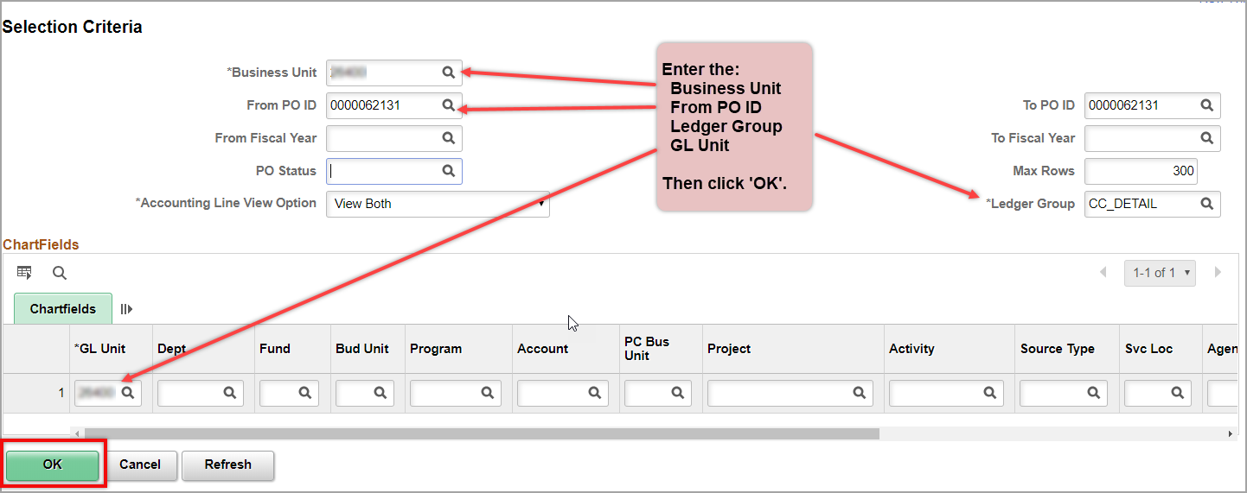

- Download the PO Accounting Entries into Excel so the PO Distribution Line Available Balance can be found.
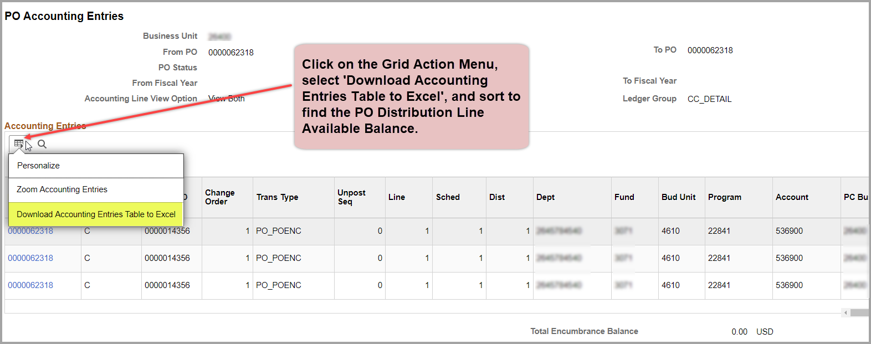

- Once the data is in Excel you may hide columns as preferred and sort to find the transactions for the specific line that is associated with the Exception.
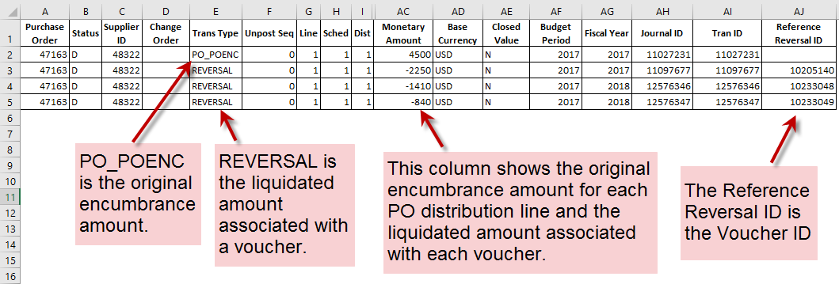
*This example shows that the PO has 3 vouchers associated with it. Voucher 10205140 has already paid. Voucher 10233048 is also in match exception status but the amount on the PO Accounting Entries and the voucher Invoice Line are a match. Voucher 10233049, shows as using only $840.00 of the encumbrance (as seen on the PO Accounting Entries above), while the amount on the voucher Invoice Line is $1,730.60. The PO distribution line is being overspent causing a Match Exception. Either the PO needs to be modified to accommodate the excess amount, which would require deleting voucher 10233049 to process a change order, or the amount on the voucher Invoice Line must be reduced to $840.00 to get the voucher out of Match Exception status. Either of these actions will also clear up the Match Exceptions on voucher 10233048.

