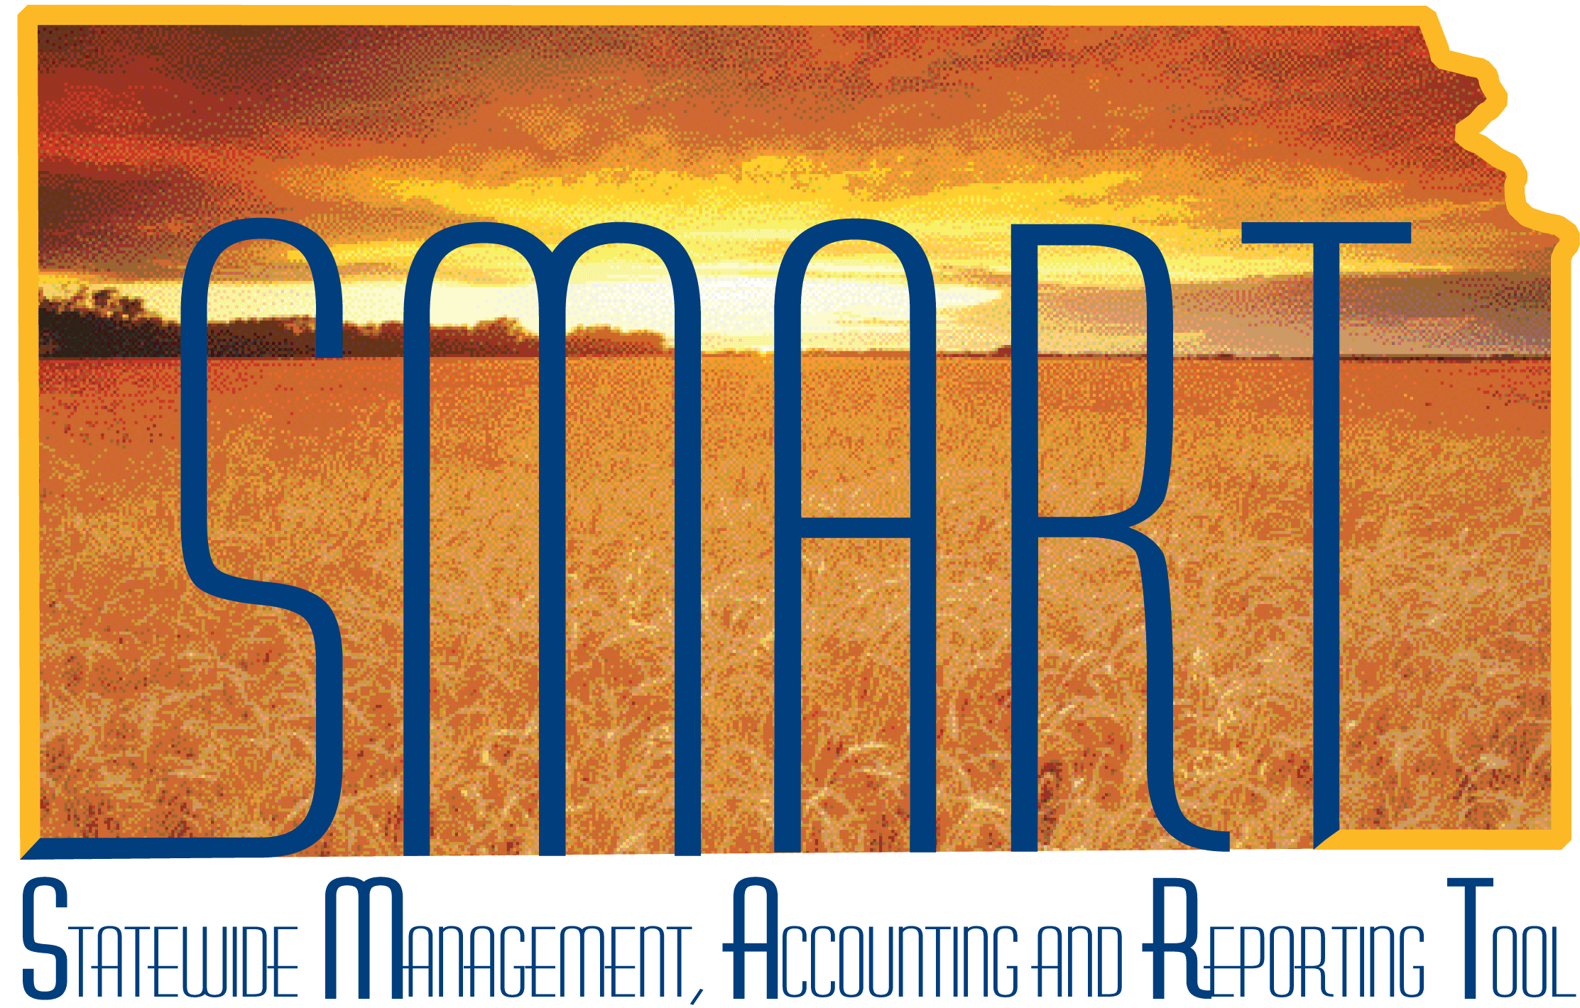
Training Guide – Project Costing
Managing Projects

State of Kansas

Applicable Role(s):
Agency Projects Manager
Kansas Projects Viewer
Agency Tree Manager
Agency Projects Maintainer

Table of Contents
Overview 3
Lesson 1: Understanding Projects 4
Key Terms 4
Topic 1: Key Concepts for Project Costing 5
Topic 2: Understanding Projects Processes 6
Lesson 2: Entering and Updating Projects 8
Topic 1: Understanding Project Creation 8
Topic 2: Creating Projects 9
Topic 3: Creating Project Activities 20
Topic 4: Understanding Project Transactions 21
Topic 5: Closing Projects 21
Lesson 3: Analyzing Projects 22
Topic 1: Understanding Project Analysis 22
Topic 2: Understanding Project Trees 22
Topic 3: Viewing the Project Transaction Summary and Project Costs 22
Lesson 4: Integrating Projects with other SMART Modules 24
Topic 1: Capitalizing Project Assets (AM) (Optional) 24
Topic 2: Understanding Project Allocations (GL) (Optional) 25
Topic 3: Understanding Actual Costs Collection from Journal Entries (GL) 25
Topic 4: Understanding Committed Costs Collection from Purchasing (PO) 25
Topic 5: Understanding Actual Costs Collection from a Voucher (AP) 26
Topic 6: Understanding Actual Costs Collection from an Expense (EX) 26
Topic 7: Understanding Labor Costs Collection (TL) 26
Lesson 5: Additional Resources 27

Overview

The use of the Project Costing module can be as simple or as complex as needed to meet an agency’s needs. The Project Costing functionality can be utilized singularly to simply track expenditures at a more granular level. Project Costing and Customer Contracts modules allow the tracking of expenditures and automating the sponsor draw down process by utilizing the Billing module. The sections below will be noted below as “Optional” when functionality reaches beyond the basic level.

Note: Before beginning to use the Project Costing module, please submit a ManageEngine Service Desk ticket. Configurations are required based on how Project Costing will be used and whether additional functionality will be utilized.

The information contained in this Training Guide provides the user with the knowledge to complete the following:

- Enter and maintain projects
- Analyze projects
- Understand and explain the integration of projects with other SMART modules

Lesson 1: Understanding Projects

Key Terms

- Project – An organized endeavor for which costs are incurred that has a defined beginning and ending date for which costs need to be accumulated and reported
- Activity – The SMART field that defines tasks or subcomponents associated with a project that represents a breakdown of collected costs. At least one activity must be defined for each project.
- Source Type – Optional Project Costing ChartField that is assigned to individual
transactions to identify its purpose
- Category – Optional Project Costing ChartField that further defines its purpose for more detailed reporting and analysis
- Subcategory – Optional Project Costing ChartField used to further define its purpose to increase flexibility and granularity for tracking and analyzing costs
- Analysis Type – 3 letter code assigned to individual transactions by the system to identify different types of transactions, such as, budgeted amounts, actual costs, and billed costs
- Project Resource Table – A table within the Project Costing module that lists all transactions that have occurred against a specific project, including committed costs, actual costs, budgeted costs, and billed amounts. Table includes BIL (Billable Amount) rows that have not yet been billed and BLD (Billed Amount) rows for transactions that have been billed in the past.
- Project Tree – A hierarchical structure that defines how projects are related to
one another and is used to achieve the desired level of detail when tracking and reporting costs

Topic 1: Key Concepts for Project Costing

- Project Costing is a central repository for project-related financial, distribution, and operational data
- Projects can be grant-funded or non-grant funded
- For some projects assets will be added during the life of the project. Express Capitalization enables you to automate the process of capturing project costs and capitalizing them into assets.
- Through integration with other SMART modules, Project Costing accumulates a
large amount of resource transaction data. Each resource transaction contains a cost and a quantity, as well as identifiers for the cost. The value of Projects is
that it can reflect costs in meaningful ways. The two primary features of Project
Costing are:
o Project-based billing - Project Costing sends billing information for rate- based contract lines to Billing. Billing then generates invoices for the contract lines and sends information regarding the invoices back to Project Costing.
o Operational analysis and reporting - Project Costing allows you to view the activities of your project for analysis, view transaction summaries by project or transactions in progress. Additionally, the Project Summary
Report can be run to project specific data including budget vs. actual costs, provided budget journals have been entered into Commitment Control for the project.

Topic 2: Understanding Projects Processes

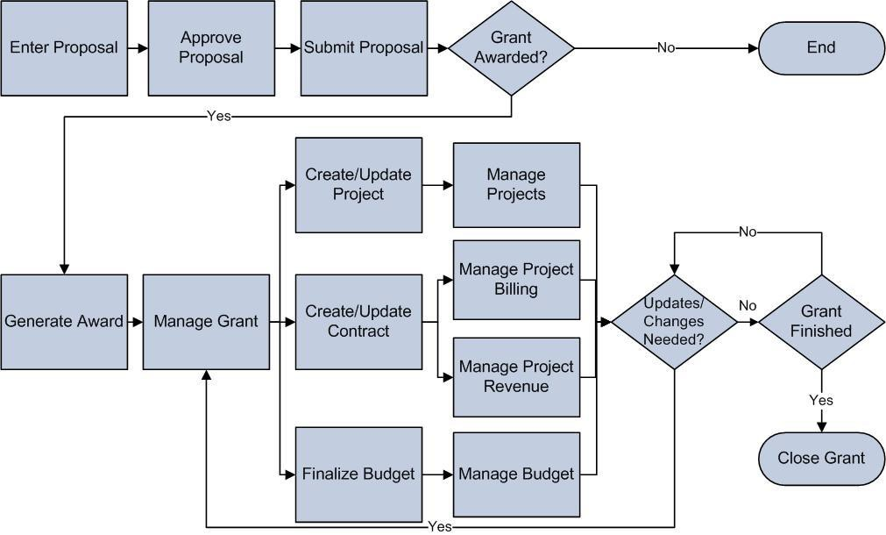
Figure 1. End-to-End Projects/Contracts/Grants Process (Optional)

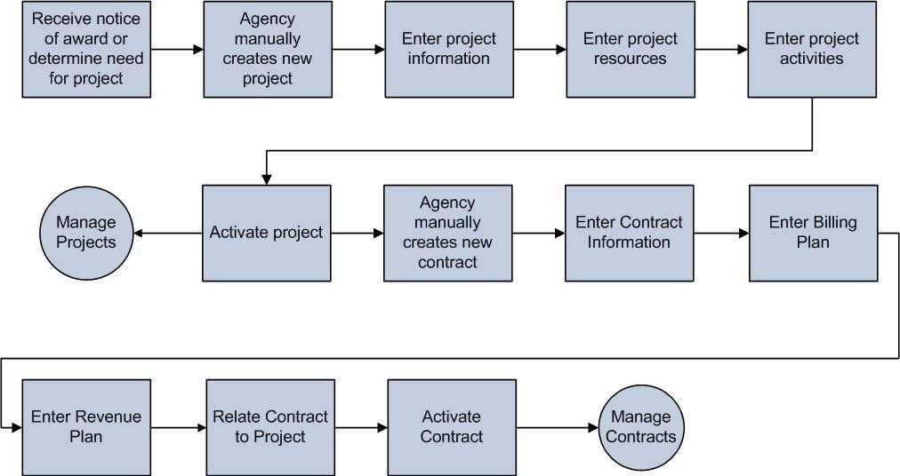
Figure 2. Project Costing Lifestyle (Optional)

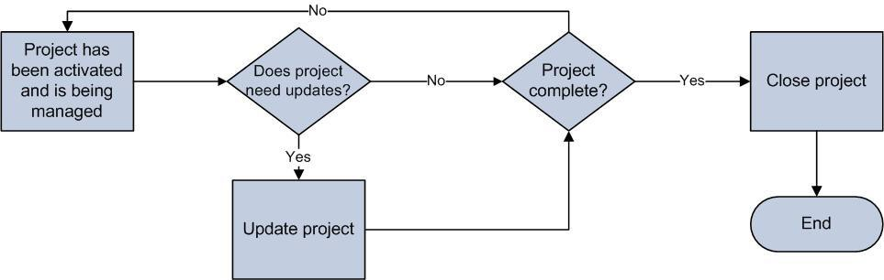
Figure 3. Manage Projects Process

- The Manage Contracts piece of the Project Costing Lifecycle is covered in the Managing Customer Contracts participant guide.
- There are four roles involved in Managing Projects.

Role | Description
Agency Projects Manager | This role will be responsible for entering, reviewing, and analyzing projects. This role will also be responsible for understanding the integration with other SMART modules.
Kansas Projects Viewer | This role will be responsible for viewing project information only
Agency Tree Manager | This role will be responsible for creating and updating project trees
Agency Projects Maintainer | Maintains configurations to agency-maintained  Project Costing tables, such as Source Type, Category and SubCategory values
Table 1. Roles

Lesson 2: Entering and Updating Projects

Topic 1: Understanding Project Creation

- When you create a project, you define the structure to which activities and resources are added. You must set up a project before you can attach any activities or resources to it.
- Employees that work on a project can be added as a resource to the project during project creation. Employee information comes over from SHARP and includes the Employee ID. NOTE: Employee ID is considered a confidential data element. (Optional)
- A project can also be associated with a grant. A project in Grants is a subset of a proposal; proposals may be associated with multiple projects. (Optional)
- Reimbursable and non-reimbursable projects – By assigning a project to a customer contract, the project will be invoiced, billed, and thus reimbursable. (Optional)
- Non-reimbursable projects are not assigned to a contract; however, Project
Costing is used to track the costs related to the project.
- Once the project creation has begun, it is assigned a status and a corresponding Processing Status Type. You can charge cost transactions from feeder systems to projects with an active processing status, but not to projects with a pending or inactive processing status.
- A Project Status of ‘Pending Close’ will allow existing costs in the system to process but not new costs
- Activity Status needs to match Project Status when creating a project and activity. The agency defaults to “Active”, but can be changed manually set the Activity Status after creation.
- Once you set the project to an “Inactive” status, both the project and its activities cannot have transactions posted against them.
- Users can change between any project status at any time to provide maximum transactional flexibility and control at the agency. Project status rows are effective-dated.

Status Type | Processing Status Type
Proposed (P) | Pending (P)
Open (O) | Active(A)
Closed(C) | Inactive(I)
Frozen(F) | Inactive(I)
Pending Close(z) | Active(A)
Table 2. SMART Project Status Types

Topic 2: Creating Projects

Page Name | Navigation
General Information | Projects and Grants Homepage > Project Costing > Project Setup > General Information
 | NavBar
General Information | Navigator > Project Costing > Project Definitions > General Information

- When creating a project, do not use spaces or special characters for the Project ID except for hyphen or underscore. This will cause problems in processing and reporting. Project names can only be used once within the entire state.

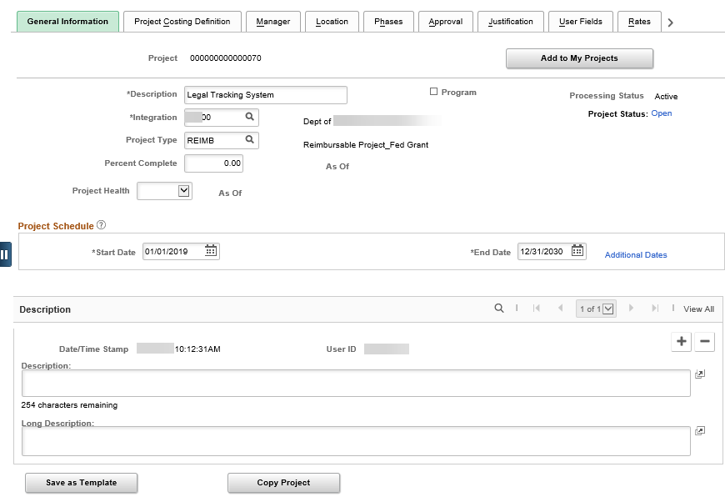
Figure 4. General Information page

Fields | Description
Description | Use to enter a description of the project
Integration | Based on the business unit and is used to  integrate the project with other modules in SMART
Project Status | Defaults to "Active" when a new project is created. After you save the project, the status appears as a link to the Project Definitions - Status page where you can update the status.
Project Type | Select a Project Type to group similar projects for reporting and analysis.  The Project Type also integrates with the Accounting Rules for further transaction processing. Note: This field may be used for SEFA reporting purposes.
Start Date | Use to enter the date that the project is scheduled to begin. The start date cannot be after any of the project's activity start dates.
End Date | Use to specify the date the project ends. The end date cannot be before any of the project's activity end dates.
Long Description | Use this field to enter more detailed information about the project
Table 3. General Information

- Project Type is for both agency use and, in the future, to capture project information for the Schedule of Expenditures of Federal Awards Report (SEFA). See the list of Project Types on the SMART website under Project Costing Job Aids.
- Three project types that identify the project as a federally funded project:
  - Research & Development (RD prefix project types) – which is determined by the federal funding
  - Indirect Awards (IN prefix project types) – the state receives federal flow- through funding from another pass-through organization, rather than receiving the funding directly from the federal government
  - IR prefix project types – projects which includes both Research & Development and Indirect funding

Page Name | Navigation
Location | Projects and Grants Homepage > Project Costing > Project Setup > General Information > Location tab
 | NavBar
Location | Navigator > Project Costing > Project Definitions > General Information > Location tab

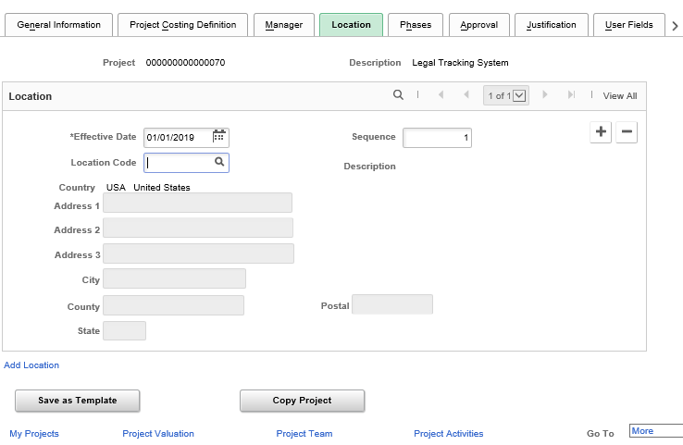
Figure 5. Location page

Fields | Description
Effective Date | Use this field to specify when the project is scheduled to begin at the selected location. By default, this date is carried over from the General Information page.
Location Code | Use this field to indicate the location of the project. SMART and SHARP share a common table of locations across the State, including cities, buildings, and floor/rooms within buildings (Optional)
Address Information | Address information defaults based on the location code chosen. Submit a Service Desk ticket to update location code information or to create a new location code.
Table 4. Location page

Page Name | Navigation
Phases | Projects and Grants Homepage > Project Costing > Project Setup > General Information > Phases tab
 | NavBar
Phases | Navigator > Project Costing > Project Definitions > General Information>Phases

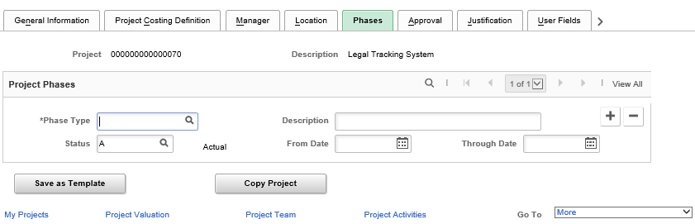
Figure 6. Phases page

Fields | Description
Phase Type | Use this field to select a phase type to track the time spent on different stages of a project and, for exception reporting, to view the projects that are on schedule. Phase Types are maintained at the agency level, and can be added in SMART when necessary. Note - this is a statewide shared table and values used by all agencies will display in the lookup. Only Agency Project Maintainers will have access to create or change but use caution as the values may be used by another agency. (Optional)
Description | Enter a description of each individual phase
Status | Indicate whether a phase is active or inactive
From Date | Indicate the start date for each phase
Through Date | Indicate the end date for each phase
Table 5. Phases page

- When creating an activity, do not use spaces or special characters for the Activity ID except for hyphen or underscore. This will cause problems in processing and reporting. Activity names can be used more than once so it is important to name them similar to the project ID.

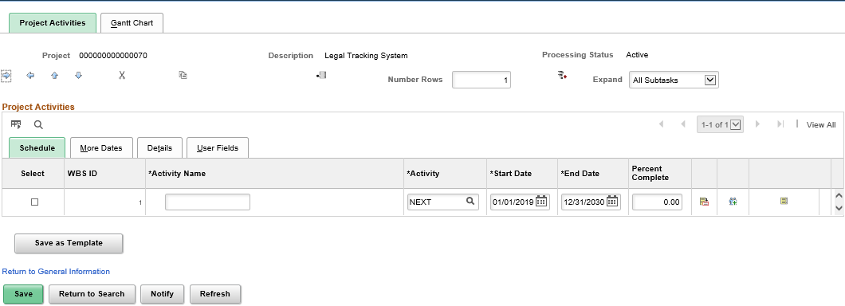
Figure 7. Project Activities – Schedule tab

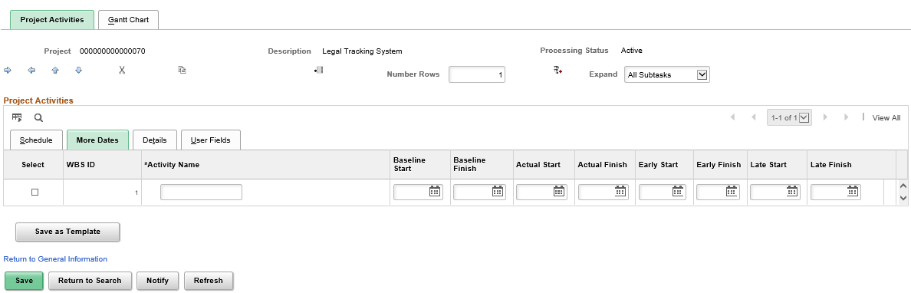
Figure 8. Project Activities – More Dates tab

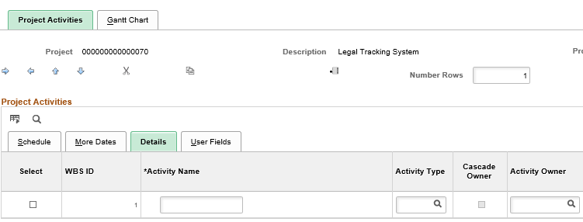
Figure 9. Project Activities – Detail tab, left side of page

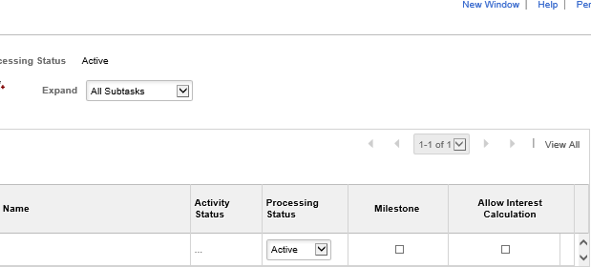
Figure 10. Project Activities – Detail tab, right side of page

Fields | Description
Activity Name | Enter a description of the activity
Activity | Enter the ID code for the activity
Start Date | Defaults to the project start date. Update to the  activity start date, if different.
End Date | Defaults to the project end date. Update to the  activity end date, if different.
More Dates | Use this tab to maintain activity dates, including  baseline, actual, early and late begin and end dates
Activity Owner | Enter the employee ID of the person responsible for this activity (Optional)
Name | The employee name defaults based on the employee ID
Processing Status | Use this field to update the activity status
Milestone | Do not use this checkbox. The State of Kansas does not use project milestones
Table 6. Project Activities – Detail tab

Page Name | Navigation
Activity Definition | Projects and Grants Homepage > Project Costing > Project Setup > General Information > Project Activities hyperlink > Activity Definition icon
 | NavBar
Activity Definition | Navigator > Project Costing > Project Definitions > General Information > Project Activities hyperlink > Activity Definition icon

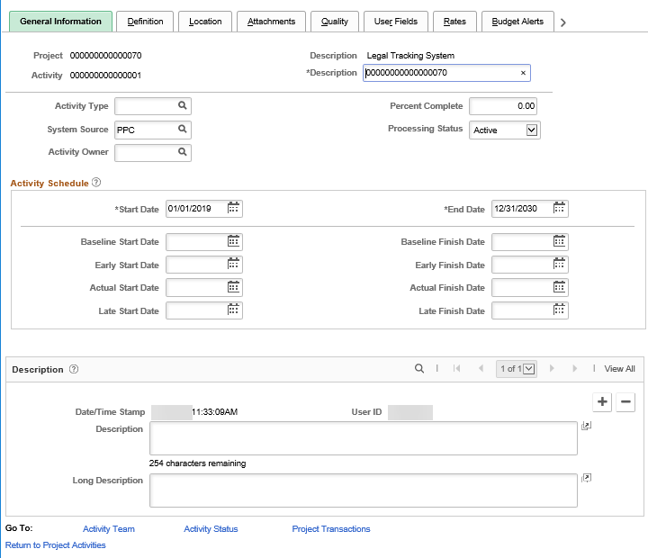
Figure 11. Project Activity – General Information page

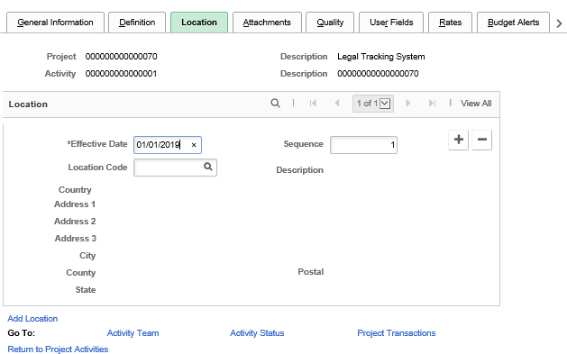
Figure 12. Project Activity – Location page

- In order to add team members to an activity team, you must first add them to the project team. (Optional)
- Adding teams to a project or activity is optional, you can designate a Project
Manager or other roles to employees working on the project using this tab

Page Name | Navigation
Team Detail | Navigator > Project Costing > Project Definitions > Team > Team  Detail

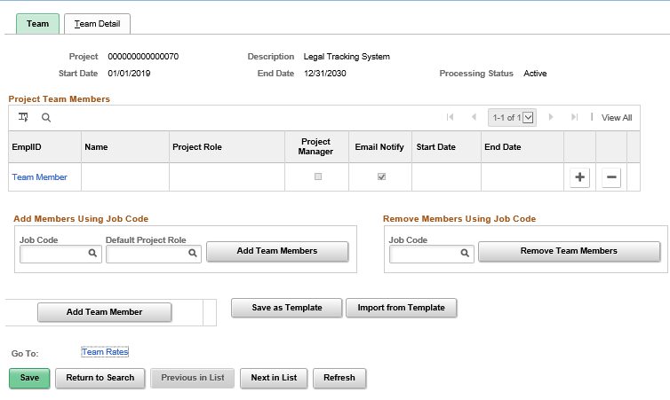
Figure 13. Team page

Fields | Description
Employee ID | Enter employee ID of employee assigned to  Project (Optional)
Email ID | Enter employee’s email address
Project Role | Enter employee’s role on the project
Start Date | Defaults to the project start date.
End Date | Defaults to the project end date.
Table 7. Team page

Page Name | Navigation
Team | Projects and Grants Homepage > Project Costing > Project Setup > General Information > Project Activities hyperlink > Activity Definition icon > Activity Team hyperlink
 | NavBar
Team | Navigator > Project Costing > Project Definitions > General Information > Project Activities hyperlink > Activity Definition icon > Activity Team hyperlink

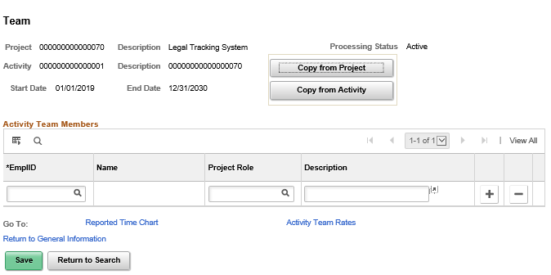
Figure 14. Team page

Fields | Description
EmplID | Use this field to record the employee who is  working on this activity (Optional)
Name | Employee Name defaults based on the employee ID
Project Role | Use this field to denote the role the employee will have on the project
Description | Enter additional description of the employee’s role  on the project
Table 8. Team page

Topic 3: Creating Project Activities

- Project activities are the specific tasks that make up a project.
- Project transactions are tracked at the activity level.
- At least one activity should be entered when you create a project. Additional activities can be added to your project at any time.
- At minimum, the description, start date, and end date fields are required to create
a project activity.
- There are two types of activities, summary and detail:
  - Summary activities group together detail activities. A project can include one or more levels of summary activity.
  - Detail activities are used to store project costs and other transactions
- The Work Breakdown Structure (WBS) is a visual representation of the hierarchical and sequential order of project activities (Optional)
  - Indent and outdent activities to create summary and detail activities.
  - Move activities up and down, to indicate sequencing.
  - Activities can be indented up to nine levels.
  - Only the lowest level activity can have transactions charged against it.

Topic 4: Understanding Project Transactions

- Transactions can only be entered for projects with a status of “Active”.
- Transactions are the lowest level that costs can be tracked and reported on, including costs, BIL and BLD rows, budgeted amounts, commitments, and employee hours.
- Most project transactions are brought into a project automatically through
integration with Purchasing, Accounts Payable, Travel and Expense, General
Ledger, Commitment Control and Time and Labor
- As an example, on voucher transactions: if you are paying a voucher for grant
and non-grant purchases, you will have at minimum two lines on the voucher with different Fund ChartFields, one with the Federal Fund and one with the State Fund. You may or may not have Project chartfields for the non-grant funded line, depending upon whether or not you have set up a Project to track it with. You can still track non-grant projects with the Project Costing module:
  - You will have a Project and Activity for the grant line.
  - If you have a Grant that requires State match, you will have two funding lines because of the different Fund ChartField. The State match line will use the same Project ID as the federal line. If you are using the functionality of the Grants module, you can use the same Activity ID for the State match component, or alternatively, you can use a different Activity ID (but same Project ID).

Topic 5: Closing Projects

- Closing a contract requires you to close the project and its related project activities.
- Change the project status from “Active” to “Closed” using an effective-dated row.

Lesson 3: Analyzing Projects

Topic 1: Understanding Project Analysis

- Project Analysis - The process of analyzing internal or external projects to measure factors such as actual vs. budgeted costs, billed vs. unbilled costs, etc.
- The Project Summary Report will be available in SMART to review budgeted costs vs. actual cost by project and activity. Filtering will also be available by Department and Fund.

Topic 2: Understanding Project Trees

- The structure of a project tree determines how costs are reported. (Optional)
- At the top of a project tree, you can create a single program into which all of the projects for the entire tree can be rolled up. This type of project is called a program or summary project.
- Project trees are created and maintained through SMART Tree Manager or added to trees directly from a project. You should add projects and activities to a project tree after defining them through the project and activity pages.

Topic 3: Viewing the Project Transaction Summary and Project Costs

- Analysis Types – Assigned to individual transactions by the system to identify different types of transactions. They control background processes within the system. There are many different analysis types used in SMART, a complete listing and explanation of analysis types is on the SMART website.

Page Name | Navigation
Transaction List | Projects and Grants Homepage > Project Costing > Transaction Definitions > Transaction List
 | NavBar
Transaction List | Navigator > Project Costing > Transaction  Definitions > Transaction List

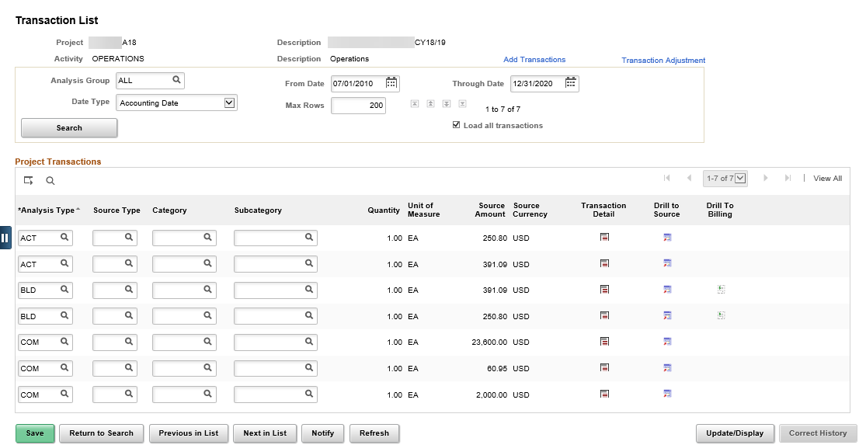
Figure 15. Transaction Summary list

Fields | Description
Analysis Group | Enter the analysis group that contains the type of transactions that you want to view
From Date | Enter search criteria for the transactions that you want to view
Through Date | Enter search criteria for the transactions that you want to view
Date Type | The default value for the Date Type field is Acct  Date (Accounting Date). Other options are Journal Date, Posted Date, and Transaction Date.
Table 9. Transaction Summary List

Lesson 4: Integrating Projects with other SMART Modules

Topic 1: Capitalizing Project Assets (AM) (Optional)

- Project Costing enables you to capitalize the assets of a particular project by sending information to Asset Management. Before the assets can be sent to Asset Management, the assets are approved in Project Costing. Project Costing uses the express capitalization process.
  - Use the Express Asset Definition pages to define assets and their attributes and to relate those assets to projects and activities.
  - Use the Express Capitalization Process function to define the Asset
Processing Destination.
  - Once the Process Scheduler is run and is successful the asset has been capitalized in Asset Management.
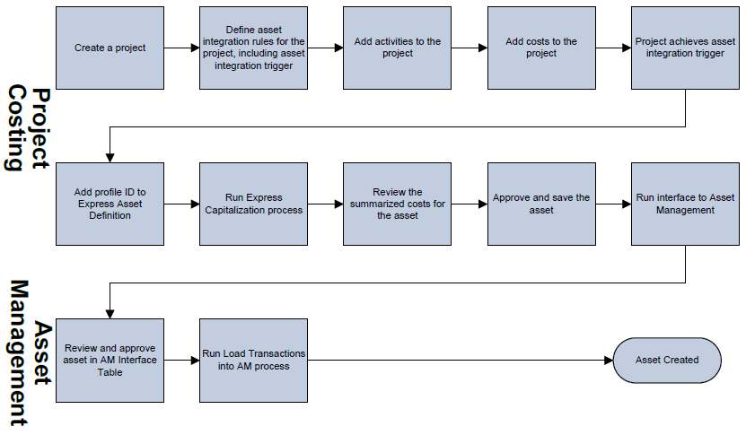
Figure 16. Express Add and Capitalization

Topic 2: Understanding Project Allocations (GL) (Optional)

- In Project Costing (PC), you can perform allocations to distribute amounts and statistical quantities. Agencies will provide the information to Central, who will enter the allocations. The two types of allocations are:
  - GL-to-PC: Accounts in General Ledger (GL) to projects – Amounts from accounts in GL are allocated to one or more projects in PC.
  - PC-to-PC: One or more projects to other projects – Quantities and amounts are distributed from one project or projects to another project or projects. Project-to-project allocation that allocates dollars from one project to other projects may have different GL ChartFields, such as Fund. This project allocation allows PC and GL to be in balance with each other.

Topic 3: Understanding Actual Costs Collection from Journal Entries (GL)

- Allocations enable you to distribute amounts from the general ledger to projects.
The General Ledger interface creates project transactions from general ledger journal entries.
- In order for journal entries to be interfaced to Project Costing, the entry must
include a valid Project ID and be in a Posted status.
- A nightly process will run and each transaction will be sent to the Project Transaction Table. The analysis type for a journal entry can only be selected from the GL analysis group which is GLE (General Ledger Expense).

Topic 4: Understanding Committed Costs Collection from Purchasing (PO)

- Purchase orders that are created in the purchasing module create transactions sent to Project Costing as committed cost lines (aka encumbrances), when the Project Chartfields are used on the Purchase Order.
- Any valid budget checked and dispatched Purchase Order with a valid Project ID will be collected and sent to the Project Transaction table as COM (Committed Costs) analysis type in a nightly process. These transactions do NOT create BIL rows since no actual cost has been incurred yet.

Topic 5: Understanding Actual Costs Collection from a Voucher (AP)

- Project information entered on distribution lines of vouchers, and the project information that you capture on vouchers are available to Project Costing.
- Additionally, Project Costing can retrieve the Project Costing Business Unit, Project ID, Activity ID, and Resource Type from the voucher. These fields are found on the distribution line of the voucher.
- Any valid budget checked, posted vouchers that have a valid Project ID will be collected and brought over to Project Costing into the Project Transaction Table with an analysis type of ACT (Actual Cost) through a nightly process. If using the Grants module and cost sharing is activated, the analysis type will be CAC (Cost Sharing Actual). These rows will not be billed but will be tracked against the project.
- Any ACT rows that have a customer contract setup of that project will have an additional row created and is reimbursable. The analysis type will be BIL
(Billable Amount) and that information will be sent to Billing.

Topic 6: Understanding Actual Costs Collection from an Expense (EX)

- You can collect costs, tracked in Expenses, and pull them into Project Costing.
These costs can then be used for project reporting and analysis, or included in customer bills.
- Any valid budget checked expense reports where the liabilities have been posted with a valid Project ID are brought over in a nightly process. These expenses come over as ACT analysis types and will create a BIL row, if the project the expense is associated with, is attached to a Customer Contract.

Topic 7: Understanding Labor Costs Collection (TL)

- The Time & Labor distribution process will multiply the rate by the hours worked from a finalized timesheet and add the related payroll costs (i.e. fringe) and sent to payroll. The payroll process will send the summarized dollar amounts to the General Ledger. If the payroll information is tied to a valid Project ID, this information will be sent to the Project Transaction table as the analysis type LBR (General Ledger Labor Cost). If the project is tied to a contract, the LBR rows will also create a BIL row.
- Time & Labor will send labor hours to Project Costing as analysis type PAY (Labor Hours) rows. Labor hours will be stored by date worked by employee ID in the Project Costing Transaction List. They are included in the Project Costing
Query report in SMART.

Lesson 5: Additional Resources

- SMARTWeb > Training > Projects & Grants – Projects/Grants material
- OMB Uniform Guidance (Super Circular)
- Department of Administration Policies and Procedures
- GAAP Policy & Procedures Manual

