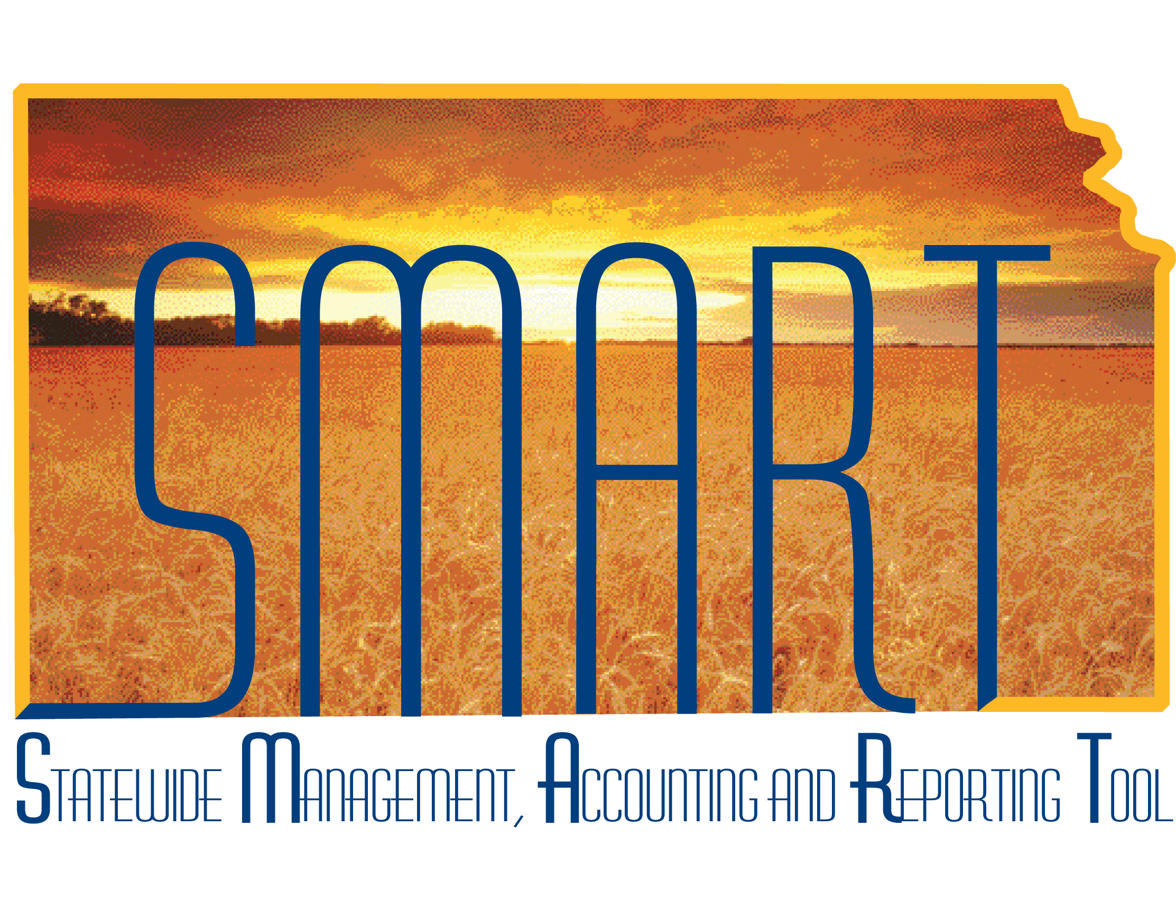

Training Guide –

Managing Grants

State of Kansas

**TABLE OF CONTENTS**

Course Overview 3

3

Course Objectives 3

Agenda 3

Lesson 1: Understanding Grants 4

4

Objectives 4

4

Topic 1: Understanding Grants Processes 6

Topic 2: Understanding Grant Roles 7

Lesson Review 8

Lesson 2: Creating Grants 9

9

Objectives 9

Topic 1: Creating Grant Proposals and Proposal Budgets 9

Topic 2: Copying Existing Proposals 34

Topic 3: Submitting Proposals 37

Topic 4: Creating Awards 39

Lesson Review 41

Lesson 3: Managing Grants 42

42

Objectives 42

Topic 1: Understanding Award/Grant Management 42

Topic 2: Updating Awards 43

Topic 3: Reviewing Award Projects 47

Topic 4: Reviewing Award Project Activities 50

Topic 5: Updating Award Budgets 51

Topic 6: Reviewing Cost-Shared Amounts 56

Topic 7: Updating and Activating Award Contracts 58

Topic 8: Understanding Grant Closure 60

Topic 9: Running Federal Grant Reports 61

Lesson Review 61

# Course Overview

## Course Objectives

Upon completion of the course, you will be able to:

* Create and manage grants
* Close grants
* Integrate the Grants module with other SMART modules

## Agenda

Today, we will cover the following topics:

* Defining Key Terms for Grants
* Understanding Grants Processes
* Creating a Grant Proposal and Proposal Budget
* Copying an Existing Proposal
* Submitting a Proposal
* Creating an Award
* Understanding Award/Grant Management
* Updating Awards
* Reviewing Award Projects
* Reviewing Award Project Activities
* Updating Award Contracts
* Updating Award Budgets
* Understanding Grant Closure
* Running Federal Grant Reports
* Reviewing Cost-Shared Amounts

# Lesson 1: Understanding Grants

## Objectives

Upon completion of this lesson, you will be able to:

* Define basic grants terms, including: grant, proposal, award, project, activity, customer contract, institution, sponsor, sub-recipient, professional, facilities and administrative (F&A) costs, cost sharing, pre-award spending, grants budgeting, and CFDA
* Explain the end-to-end process for grants and describe how grant management fits into the end-to-end process for Project Costing, Customer Contracts, and Grants
* List roles involved in the grants process and describe tasks performed by each role

|  |  |
| --- | --- |
| **Key Terms** |  |

* **Grant** – An award of money from a Sponsor for a project. It is often separated into 2 phases: pre-award and post-award
* **Proposal** – The pre-award side of a grant. A document, submitted to a sponsor or funding source, that describes how a Grantee intends to utilize grant money, if awarded/funded
* **Award** – The post-award side of a grant. An executed agreement between an institution (the Grantee) and a sponsor (the Grantor)
* **Project** – An organized endeavor for which costs are incurred that has a defined beginning and ending purpose for which costs need to be accumulated and reported. Grant award expenditures are tracked via projects/activities in Project Costing
* **Activity –** Individual tasks or subcomponents associated with a project that represent a more detailed breakdown of collected costs. At least one activity must be defined for each project.
* **Customer Contracts** – The SMART module that defines how the Grantee bills and recognizes revenue from a Sponsor. Creates a link between Project Costing and Billing for reimbursement processing.
* **Institution** – A State of Kansas agency that receives funding from a Sponsor for a grant or project
* **Sponsor** – An external entity or source that funds programs, research, and other projects. This entity could be a Federal government agency, a private foundation, etc.
* **Sub-Recipient** – Organizations or individuals that receive flow-through grant funds from the State of Kansas under a primary award
* **Professional** – An individual who is included in a grant proposal as a grant-funded employee, for workflow purposes, or both
* **Facilities and Administrative (F&A) Costs** – Overhead costs associated with the grant, also known as indirect costs
* **Cost Sharing** – Component of a grant budget that represents the part of the project that the sponsor does not fund (Cost sharing is synonymous with the term ‘match’ or ‘matching funds’ and includes both hard-dollar and in-kind contributions)
* **Pre-Award Spending** – Money spent for a project (against a grant) prior to the formal award of the proposal by the sponsor
* **Grants Budgeting** – The process of capturing budget line details to support both a pre-award (proposal) budget and a post-award (award) budget
* **CFDA (Catalog of Federal Domestic Assistance number)** – The number used by the Federal government to track its funding programs when issuing grant awards

## Topic 1: Understanding Grants Processes

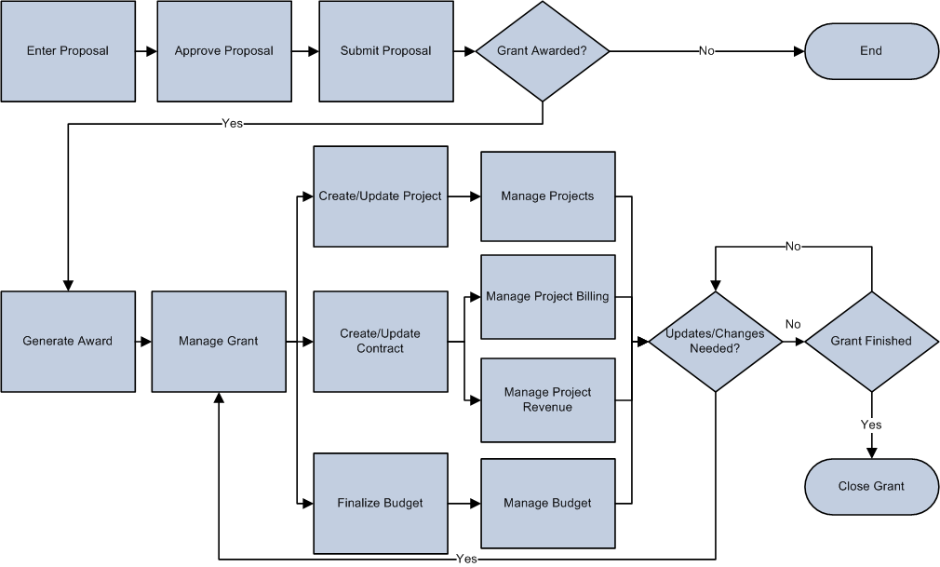

*Figure 1. End to End Grants Process*

* Grants leverages functionality that is delivered within Customer Contracts, Project Costing, General Ledger, and Billing to provide a fully integrated grants management solution



*Figure 2. Grants Integration Process Flow*

## Topic 2: Understanding Grant Roles

* There are three roles involved in Managing Grants

| **Role** | **Description** |
| --- | --- |
| Agency Grants Manager | Enter, reviews and analyzes proposals and awards and understands the integration with other SMART modules |
| Agency Grants Approver | Approves proposals and understands the integration with other SMART modules. **Note:** This role is optional and only for agencies using workflow. |
| Agency Grants Maintainer | Maintain configurations to agency-maintained grants tables |

*Table 1.Grants Roles*

## Lesson Review

In this lesson, you learned to:

* Define the key terms and roles for managing grants
* Explain Grants processes
* List roles involved in the Grants process and understand tasks associated with each role

The following are additional resources that provide more detail about the topic we have covered:



**Additional Resources**

* SMART Website – Projects/Grants materials
* OMB, Omni Circular, “OMB Uniform Guidance: Administrative Requirements, Cost Principles, and Audit Requirements for Federal Awards”
* Grant Award Agreements

# Lesson 2: Creating Grants

## Objectives

Upon completion of this lesson, you will be able to:

* Create and submit a grant proposal with a proposal budget
* Create a new grant proposal by copying information from a previous proposal
* Create an award
* Define pre-award spending for a grant

## Topic 1: Creating Grant Proposals and Proposal Budgets

* A proposal is a document that contains all the programmatic and budgetary details for a grant and is used by the sponsor to evaluate the merits of the request and make the decision whether to award funding
* Each proposal requires at least one project with one budget (i.e. activity) be established for post-award expenditure tracking upon award.
* After creating a proposal, you can view the proposal data and any subsequent changes via the **Proposal Audit Logs**. The audit trail is accumulated automatically and tracks changes (add, delete, or modify) to important data elements in the proposal.
* The proposal budget captures budget line details
* The proposal budget includes direct costs (such as personnel, equipment and supplies), cost sharing, and facilities and administration costs



*Figure 3. Entering a Grant Process*

|  |  |
| --- | --- |
| **Page Name** | **Navigation** |
| Proposal | Projects and Grants Homepage > Grants > Creating a Grant > Maintain Proposal > Proposal tab |
|  | **NavBar Navigation** |
| Proposal | Navigator > Grants > Proposals > Maintain Proposal > Proposal tab |

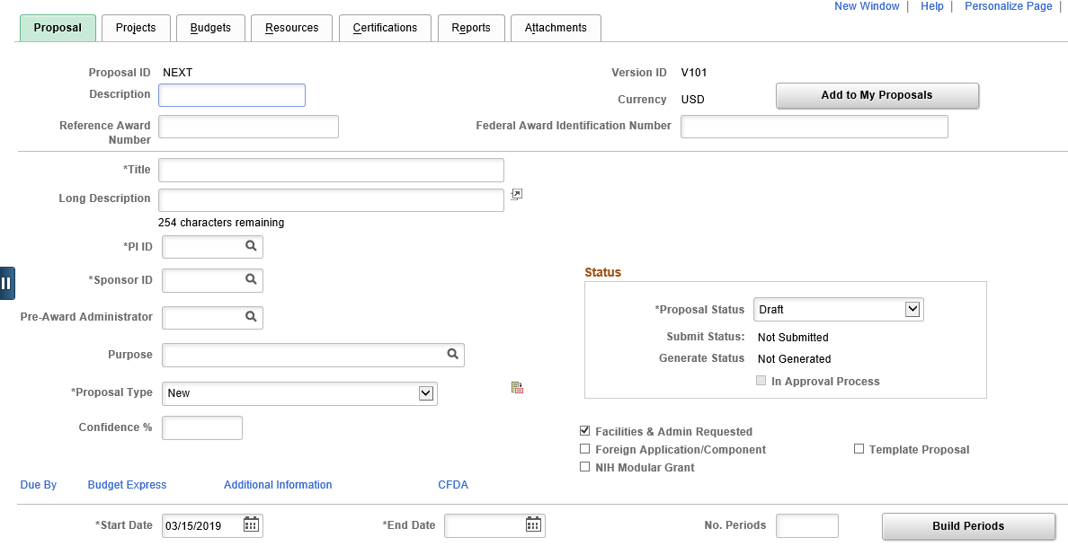

*Figure 4. Proposal Top of Page*

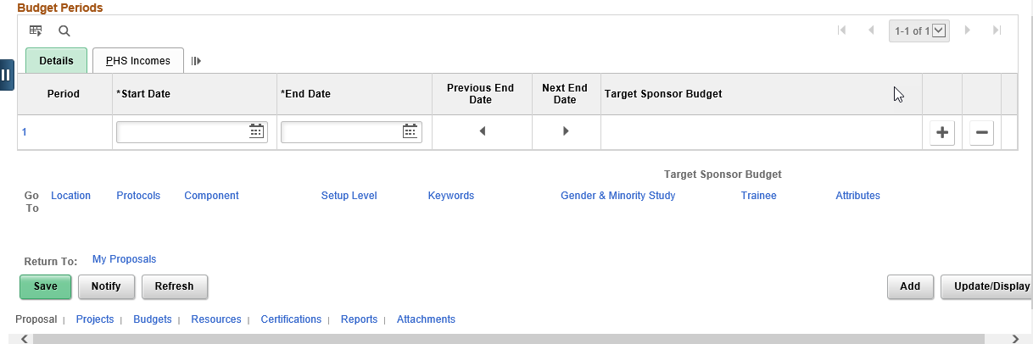

*Figure 5. Proposal Bottom of Page*

| **Fields** | **Description** |
| --- | --- |
| Description | Enter a long description for the proposal |
| Reference Award Number | With the 9.2 Upgrade, this field was added to provide more identifying information. A Reference Award Number appears on some of the Grants invoice formats when you process your billing information. |
| Federal Award Identification Number | The U.S. government requires Federal agencies to assign a unique FAIN to each award. When you enter the FAIN and Reference Award Number on the proposal, they will automatically populate on the award pages after the award generation process. |
| Title | Enter a title for the proposal. The title entered in this field is used by SMART during the **Generate Award** process to populate the description field for the award/contract. To enter a longer title than the Title field allows, click the **Description** link. |
| PI ID | Enter the employee ID for the principle investigator for the proposal.  **Note:** Only employees who have the **Eligible PI** check box selected on the **Employee Data** page appear in this drop down box. |
| Sponsor ID | Select the ID of the organization that is sponsoring the grant. Sponsors are stored on the SMART Customer table. |
| Purpose | Select a proposal purpose from a list of entries |
| Proposal Type | Select a proposal type from the available options |
| CFDA | Enter the CFDA number that relates to the proposal. This field is a link to the CFDA page, where you can enter one or more CFDA numbers. One CFDA must be selected as the Primary by using the checkbox found via the CFDA link.  Note: CFDA is a ChartField Attribute of Fund for both transactions and reporting |
| Facilities and Admin Requested | Select to indicate that the institution is requesting indirect cost recovery and would like SMART to automatically calculate this amount when budgeting and transacting based on a percentage defined by the institution.  **Note:** If you leave this option blank, SMART resets the F&A amounts in the budget to zero and deletes the F&A rates. |
| Start Date and End Date | Enter the start date and end date for the proposal. SMART automatically creates the overall grant budget with the same dates. |
| Number of Periods | Enter the number of periods for the budget. A budget period typically equals 1 year, but the periods are defined by the user. |
| Build Periods | Click the **Build Periods** button to create the budget periods for the proposal |

*Table 2. Proposal Fields*

|  |  |
| --- | --- |
| **Page Name** | **Navigation** |
| Projects | Projects and Grants homepage > Grants > Creating a Grant > Maintain Proposal > Projects tab |
|  | **NavBar Navigation** |
| Projects | Navigator > Grants > Proposals > Maintain Proposal > Projects tab |

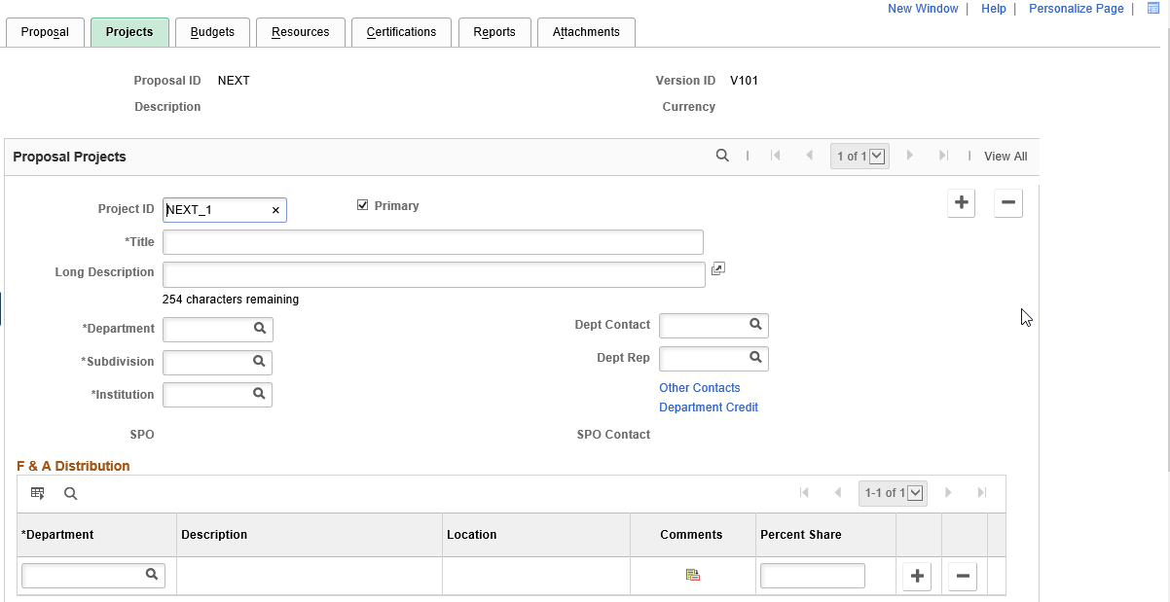

*Figure 6. Projects Page*

| **Fields** | **Description** |
| --- | --- |
| Project ID | Displays the Project ID field, which you can edit. This will be the Project ID in Project Costing if the grant is awarded.  When you first create a draft proposal, SMART automatically creates the first project and budget header with ID of *Next_1.* Although you can accept the default Project ID, it is recommended that you change the Project ID to reflect the Grant Proposal ID. |
| Primary | Select to indicate that this is the primary project in the proposal, if there will be multiple projects created from this 1 grant. |
| Title | Displays the proposal title, which you can change |
| Department | Choose the department value that is responsible for the proposal. |
| Subdivision | Choose the department value that is responsible for the proposal. |
| Institution | Choose the institution value based on the agency submitting the proposal. |
| Dept Contact | Select the name of the individual who is the department contact. Only people added as department contacts in the **Department Contact** setup page will be listed on the prompt table. This field is optional. |
| Dept Rep | Select the name of the department representative. This field is optional. |
| *F & A Distribution section* | |
| Department | Select the department that is collaborating on the project. If more than one department exists for the project, add a row for each department participating. |
| Location | Displays the location that is associated with the department. |
| Comment | Click to add comments to explain departmental collaborations. This field is optional |
| Percent Share | Enter the respective percentage share of the F&A return for each department that is included in the project. The total percentage must equal 100 percent. |

*Table 3. Projects Fields*

|  |  |
| --- | --- |
| **Page Name** | **Navigation** |
| Location | Projects and Grants Homepage > Grants > Creating a Grant > Maintain Proposal > Location link/tab |
|  | **NavBar Navigation** |
| Location | Navigator > Grants > Proposals > Maintain Proposal > Location link/tab |

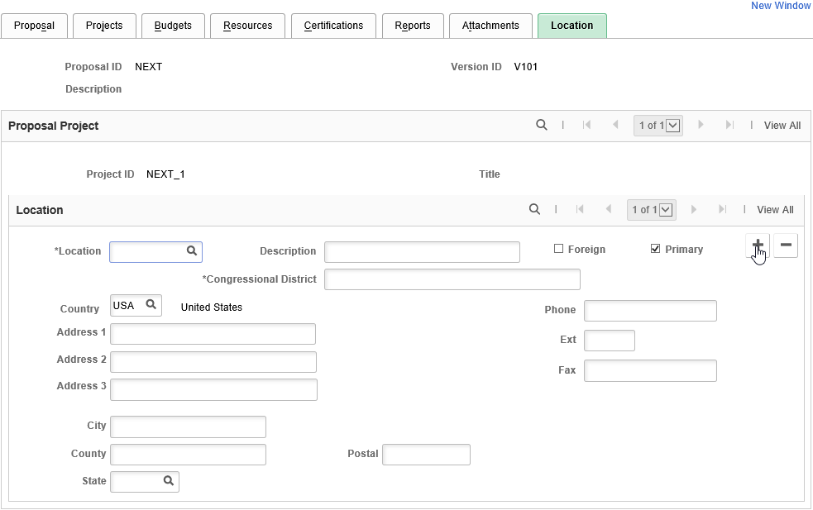

*Figure 7. Location Page*

| **Fields** | **Description** |
| --- | --- |
| Location | If no value defaults, select a value for this field from the location table. When you select a site, the system populates the address information fields. You can also add new locations and enter information in the specific address and phone fields.  Note: all agencies have a general Business Address location code that begins with *BA* and is followed by the agency number. |
| Primary | Select to indicate that this location is the primary location for the proposed grant work. Each proposal can have only one primary location. The primary location exists on the primary project. The system sets the first location on the primary project as the primary location. |

*Table 4. Location Fields*

|  |  |
| --- | --- |
| **Page Name** | **Navigation** |
| Budgets | Projects and Grants Homepage > Grants > Creating a Grant > Maintain Proposal > Budgets tab |
|  | **NavBar** |
| Budgets | Navigator > Grants > Proposals > Maintain Proposal > Budgets tab |

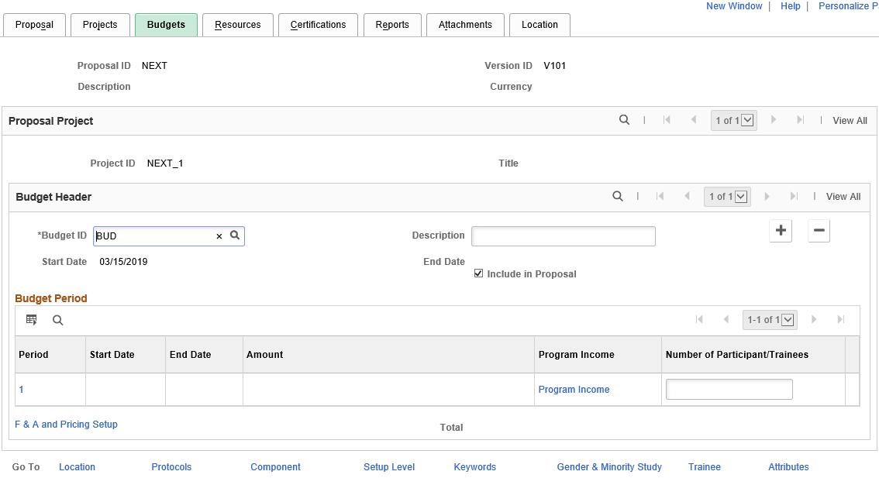

*Figure 8. Budgets Page*

| **Fields** | **Description** |
| --- | --- |
| Budget ID | Displays the default Budget ID of each project. This becomes the Activity ID in Project Costing, if the grant is awarded. |
| Description | Displays the proposal title description |
| Start Date and End Date | Displays the start and end dates that you entered on the **Projects** page. These can be changed if there are multiple activities and the individual activities do not last the entire duration of the project. |
| Include in Proposal | Select to include budget header data in the proposal |
| F&A and Pricing Setup(facilities and administration and pricing setup) | Click to access the **F&A and Pricing Setup** page to enter F&A setup for the institution, sponsor, and budget. **Note:** this page is only needed if your agency is using the Grants module to auto-calculate F&A. |
| Total | Displays the grand total for all budget periods within a project |

*Table 5. Budget Fields*

|  |  |
| --- | --- |
| **Page Name** | **Navigation** |
| F & A and Pricing Setup | Projects and Grants Homepage > Grants > Creating a Grant > Maintain Proposal > Budgets > F & A and Pricing Setup link |
|  | **NavBar** |
| F & A and Pricing Setup | Navigator > Grants > Proposals > Maintain Proposal > Budgets > F & A and Pricing Setup link |

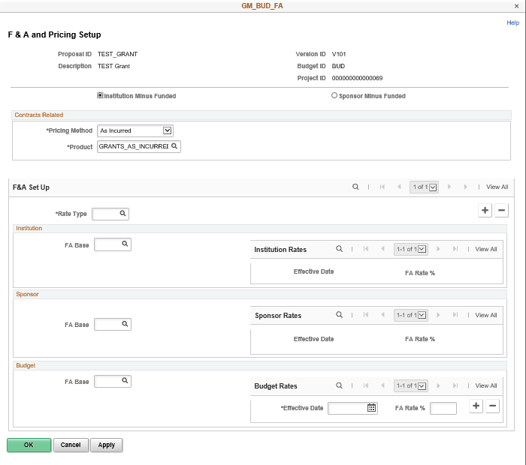

*Figure 9. F & A Pricing Setup Page*

| **Fields** | **Description** |
| --- | --- |
| Institution minus Funded | Select to use the institution's F&A rate for calculating unrecovered F&A as part of agency cost-share |
| Sponsor Minus Funded | Select to use the sponsor’s F&A rate for calculating unrecovered F&A as part of agency cost-share |
| Pricing Method | Select either *As Incur* or *Fixed* to indicate the type of contract that will be created in the Customer Contracts module, if the grant is awarded.  Most grants will use the default pricing method of As Incur. |
| Product | Select the product for the contract line. You can identify a distinct product within each activity.  Most grants will use the default product of GRANTS_AS_INCURRED. |
| Rate Type | Choose the rate type that is associated with the project. The rate type is associated with the percentage of F&A that will be assessed on the grant. You must choose a rate type your agency has defined for its F&A rates.  Note: the look-up table contains value for all agencies state-wide. |

*Table 6. F & A Pricing Setup Fields*

* Enter the Budget Item **FACADM** for Facilites and Administration on the **Enter Budget Detail** page if your agency is not using the Grants module to auto-calculate F&A and would prefer to include the F&A as a direct line item in the budget.
* To bill for F&A costs when not using system-calculated F&A, users must split-fund each project transaction to include the F&A percentage on the transaction and use the designated F&A account code (773200).
* The SFA (Sponsor Funded F&A) Analysis Type should not be added directly in Project Costing because it is reserved for system-calculated F&A processing

|  |  |
| --- | --- |
| **Page** | **Navigation** |
| Enter Budget Detail | Projects and Grants Homepage > Grants > Creating a Grant > Maintain Proposal > Budgets > Period Link |
|  | **NavBar** |
| Enter Budget Detail | Navigator > Grants > Proposals > Maintain Proposal > Budgets > Period Link |

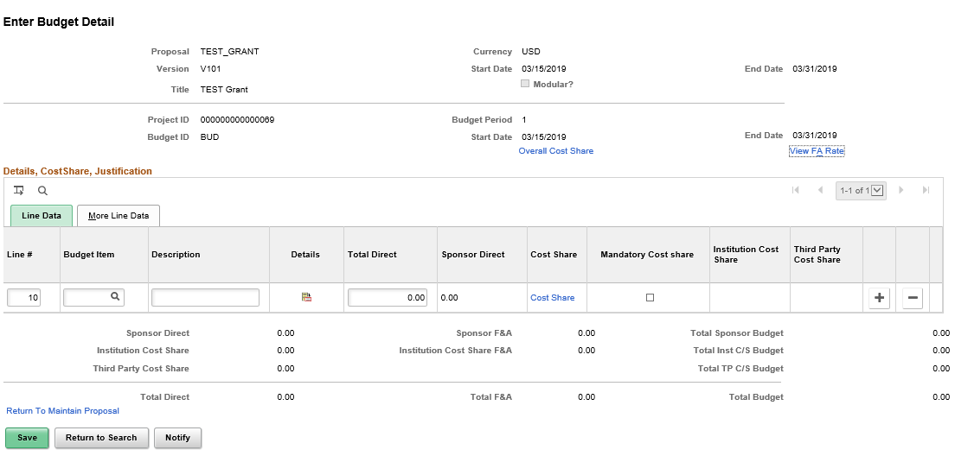

*Figure 10. Enter Budget Detail Page*

| **Fields** | **Description** |
| --- | --- |
| Budget Item | Select each budget item |
| Description | Displays the Budget Item description, which you can change |
| Details | Enter detailed information about each budget item (unit cost, quantity, etc.) |
| Total Direct | Enter the total direct budget amount for each budget item, or let the system calculate if you entered a quantity and unit cost on the Details page |

*Table 7. Enter Budget Detail Fields*

|  |  |
| --- | --- |
| **Page Name** | **Navigation** |
| Budget Detail | Projects and Grants Homepage > Grants > Creating a Grant > Maintain Proposa l> Budgets > Period Link > Details icon |
|  | **NavBar** |
| Budget Detail | Navigator > Grants > Proposals > Maintain Proposa l> Budgets > Period Link > Details icon |

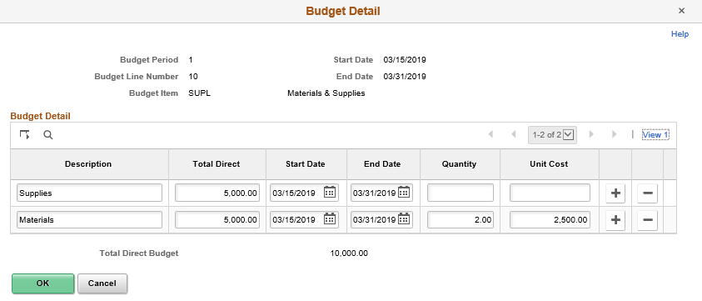

*Figure 11. Budget Detail (CONST Budget Item) Page*

|  |  |
| --- | --- |
| **Page Name** | **Navigation** |
| Personnel Detail | Projects and Grants Homepage > Grants > Creating a Grants > Maintain Proposal > Budgets > Period link > Details icon |
|  | **NavBar** |
| Personnel Detail | Navigator > Grants > Proposals > Maintain Proposal > Budgets > Period link > Details icon |

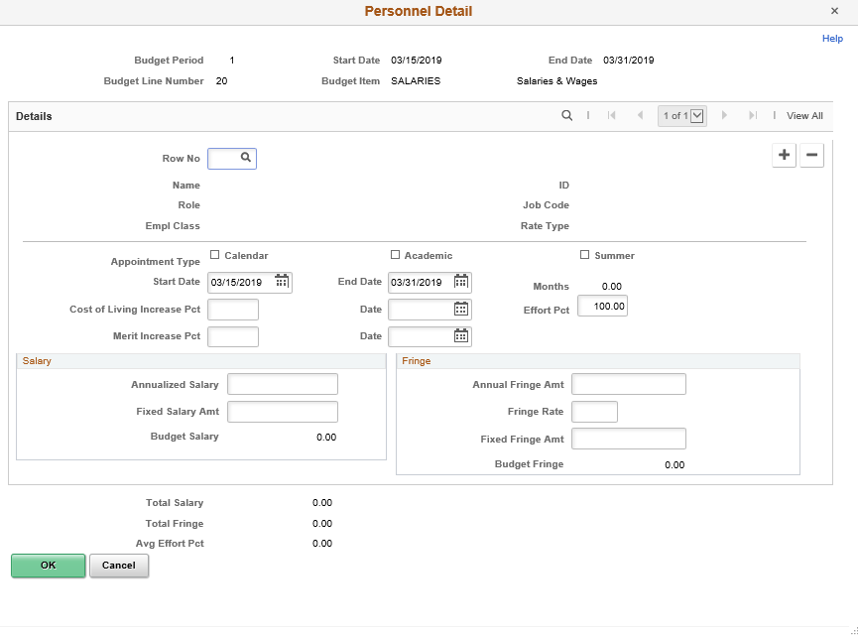

*Figure 12. Personnel Detail (Salaries Budget Item) Page*

* By using the Personnel Detail page employees may be added to a proposal budget. Note: they must be added on the Resources tab in the *Professional* section before they become available for selection in the budget. Fringe benefits may be added as a single budget line item for all employees in one lump sum.
* Or, the Personnel Detail page can be used to auto-calculate fringe costs for individual employees based on salary and fringe rate.

|  |  |
| --- | --- |
| **Page Name** | **Navigation** |
| Overall Cost Sharing | Projects and Grants Homepage > Creating a Grant > Maintain Proposal > Budget tab > Period Icon > Overall Cost Sharing link |
|  | **NavBar** |
| Overall Cost Sharing | Navigator > Grants > Proposals > Maintain Proposal > Budget tab > Period Icon > Overall Cost Sharing link |

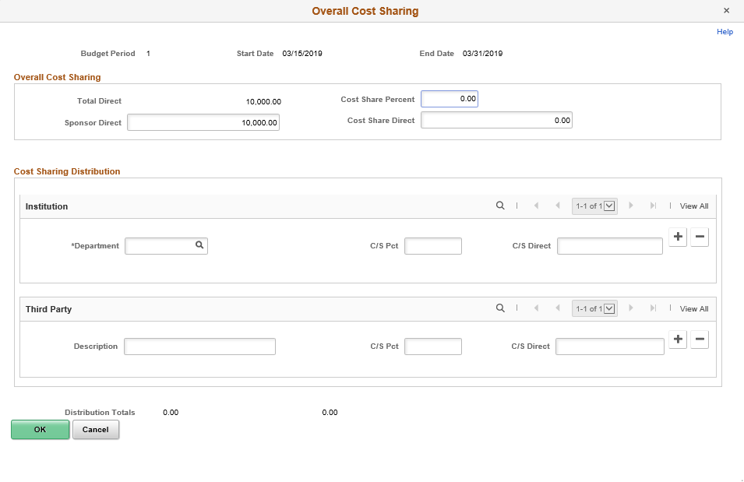

*Figure 13. Cost Share Page*

| **Fields** | **Description** |
| --- | --- |
| Cost Share Percent | Select percent of Institution cost share out of the total budget |
| Department | Select Department for cost share |
| C/S Percent | Select percent for Department out of the total cost share. Multiple departments may be selected as long as C/S Percent amounts total 100% |

*Table 8. Cost Share Fields*

|  |  |
| --- | --- |
| **Page Name** | **Navigation** |
| Resources | Projects and Grants Homepage > Grants > Creating a Grant > Maintain Proposal > Resources tab |
|  | **NavBar** |
| Resources | Navigator > Grants > Proposals > Maintain Proposal > Resources tab |

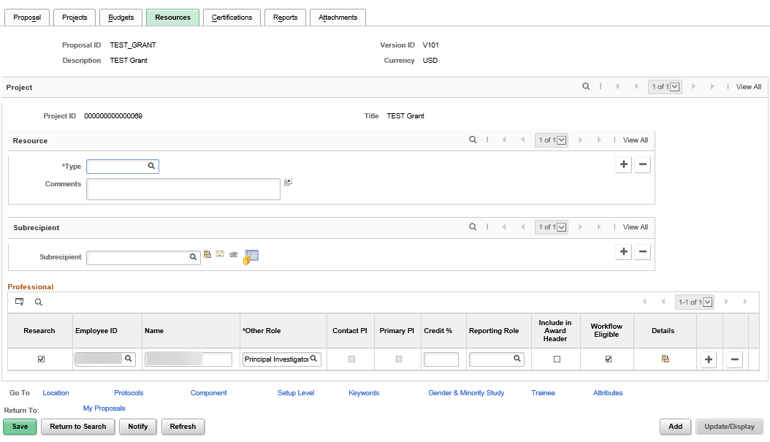

*Figure 14. Resources Page*

| **Fields** | **Description** |
| --- | --- |
| Type | Select a resource type |
| Subrecipient | Select the subrecipient to add to the proposal. Subrecipients are stored on the SMART Vendor table. |
| Agreement Details | Click the **Agreement Details** button to go to the Agreement **Details** page to enter details about the subrecipient. |
| Location Details | Click the **Get Location Details** button to go to the **Subrecipient Location** page to enter subrecipient location and address information. |
| Contact Details | Click the **Get Contact Details** button to go to the **Subrecipient Contact** page to enter subrecipient contract information. |
| Supplier Budget | Click the **Supplier Budget** button to go to the **Subrecipient Budget** page to enter subrecipient budget information.  Note: this information is for reference only. It does not create a way for agencies to track detailed subrecipient expenditures in SMART. |
| Research | Select this option if you are listing a person whose name appears on the form and is part of the project team during the project generation process. Clear this option if you are listing a person only for workflow approval process. If unselected, you can add the same person with multiple workflow roles.  Note: Grants workflow has been turned off due to defects in the functionality. |
| Employee ID | Select the ID of a professional to add to the proposal |
| Name | Displays the name of the professional who is associated with the ID you selected in the ID field |
| Other Role | Select the professional's role in the project. Options are in Table 9 below. |

*Table 9. Resources Fields*

| **Role** | **Description** |
| --- | --- |
| AUTH | Authorized Personnel |
| AWPI | Award PI |
| DHD | Department Head |
| DPTC | Department Contact |
| DPTR | Department Representative |
| FNAP | Final Approver |
| GMM | Grants Manager |
| GPP | Grants Preparer |
| IO | Institutional Officer |
| KEY | Key Personnel |
| OTH | Other |
| PAA | Pre-Award Admininstrator |
| PI | Principal Investigator |
| SPO | Sponsored Projects Official |
| WADM | Grants Administrator |
| WCPI | Award Co-PI |

*Table 10. Grants Role Types*

* Select the **Workflow Eligible** checkbox if your agency is using Workflow for the approval process. Note: How ever many approval roles your agency has designated for your approval process those roles must be added to individuals listed in the **Professional** section of the **Resouces** tab before you can submit the proposal. A Principal Investigator (defaults and comes from Proposal page) and Pre Award Admininstrator (can be designated on the proposal page) must be included as a minimum for the workflow process to be triggered.

Note: Grants workflow has been turned off due to defects in the functionality.

* If this checkbox is selected, the proposal must be approved by each individual listed after the **Start Approval Process** button is selected

|  |  |
| --- | --- |
| **Page Name** | **Navigation** |
| Certifications | Projects and Grants Homepage > Grants > Creating a Grant > Maintain Proposal > Certifications tab |
|  | **NavBar** |
| Certifications | Navigator > Grants > Proposals > Maintain Proposal > Certifications |

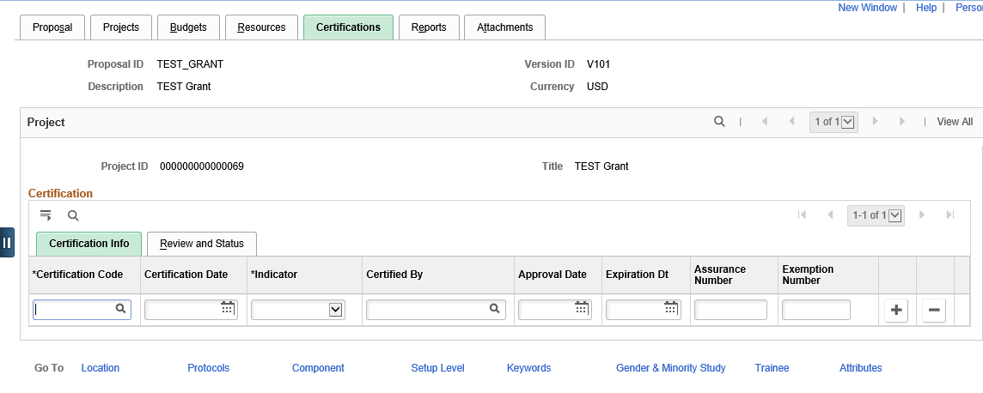

*Figure 15. Certifications Page_Top*

| **Fields** | **Description** |
| --- | --- |
| **Certification Code** | Select the certification codes that are associated with the proposal |
| **Certification Date** | Select the certification date for each code |
| **Indicator** | Select the certification indicator. Values are *N/A,* *No,* *Pending,* and *Yes* |
| **Certified By** | Select the name of the person who authorized the certification |
| **Approval Date** | Select the date on which the certification was approved |
| **Expiration Date** | Select the date upon which the certification expires. The generate process brings this date forward to the award |
| **Assurance Number** | Enter the assurance number that is associated with the certification, if applicable |
| **Exemption Number** | Enter the exemption number that is associated with the certification, if applicable |

*Table 11. Certification*

|  |  |
| --- | --- |
| **Page Name** | **Navigation** |
| Reports | Projects and Grants Homepage > Grants > Creating a Grant > Maintain Proposal > Reports |
|  | **NavBar** |
| Reports | Navigator > Grants > Proposals > Maintain Proposal > Reports |

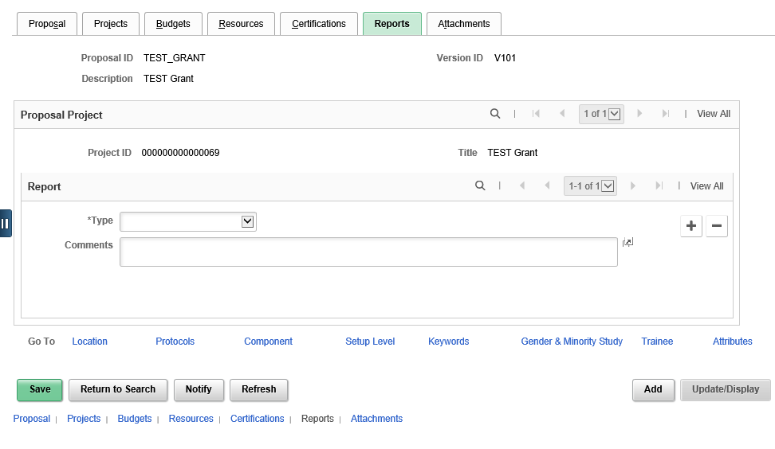

*Figure 17. Reports Page*

| **Fields** | **Description** |
| --- | --- |
| Type | Select type of report |
| Comments | Enter any comments regarding the report |

*Table 12. Reports*

* Use the Attachments tab to attached documentation related to your grant. This functionality is used to store the Statement of Work, Grant Application/Guidelines, and Award documentation associated with the grant. You should NOT attach invoices or copies of invoices in this tab.

|  |  |
| --- | --- |
| **Page Name** | **Navigation** |
| Attachments | Projects and Grants Homepage > Grants > Creating a Grant > Maintain Proposal > Attachments |
|  | **NavBar** |
| Attachments | Navigator > Grants > Proposals > Maintain Proposal > Attachments |

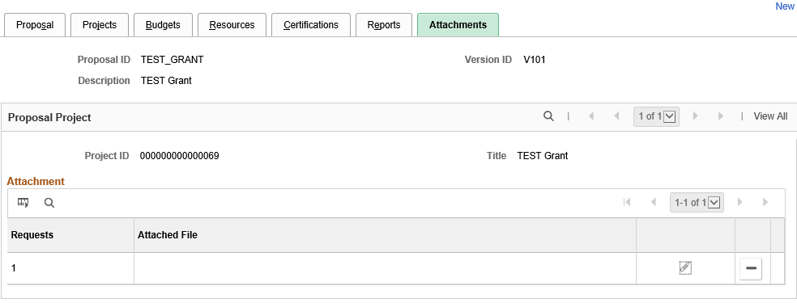

*Figure 18. Attachments Page*

| **Page Name** | **Navigation** |
| --- | --- |
| **Page Name** | **Navigation** |
| Upload Attachment | Projects and Grants Homepage > Grants > Creating a Grant > Maintain Proposal > Attachments > Add Attachments Link |
|  | **NavBar** |
| Upload Attachment | Navigator > Grants > Proposals > Maintain Proposal > Attachments > Add Attachments Link |

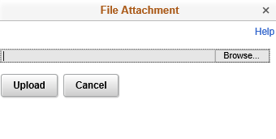

*Figure 19. Upload Attachment*

| **Fields** | **Description** |
| --- | --- |
| Add Attachment | Click the Add Attachment button to attach a document to the proposal  **Note:** The system does not track changes to external documents. |
| Browse | Click to search for the document that you want to attach to the proposal. This button appears after you click the Add Attachment button. |
| Upload | Click to attach the file to the proposal and return to the Documents page. This button appears after you click the Add Attachment button. |
| Delete Attachment | Click the Delete Attachment button to delete a document. This button appears only after you attach a document to the page. |
| View Attachment | Click the View Attachment button to view the attachment. This button appears only after you attach a document to the page. |

*Table 13. Attachments*

|  |  |
| --- | --- |
| **Page Name** | **NavBar Navigation** |
| Review Proposal Audit Log | Navigator > Grants > Proposals > Review Proposal Audit Logs |

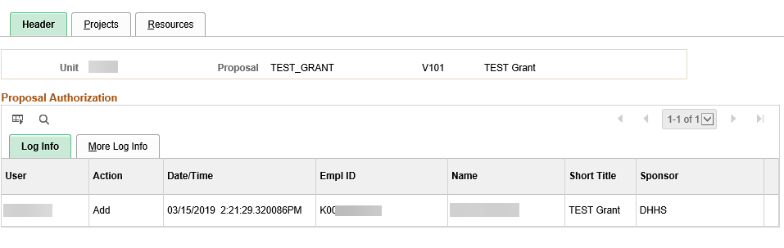

*Figure 20. Proposal Audit Log*

## Topic 2: Copying Existing Proposals

* Create new proposals from existing proposals for different proposal date ranges
* You can copy a Proposal ID, a version ID, any number of its child projects, and selected proposal budgets and periods from one proposal to another without re-entering data
* This feature saves you time by avoiding entering duplicate information
* The copy becomes an editable version of the original proposal under either a new version ID or an entirely new Proposal ID, depending on your needs



*Figure 21. Copy Existing Proposal Process*

|  |  |
| --- | --- |
| **Page Name** | **NavBar Navigation** |
| Copy Proposal | Navigator > Grants > Proposals > Copy Proposal |

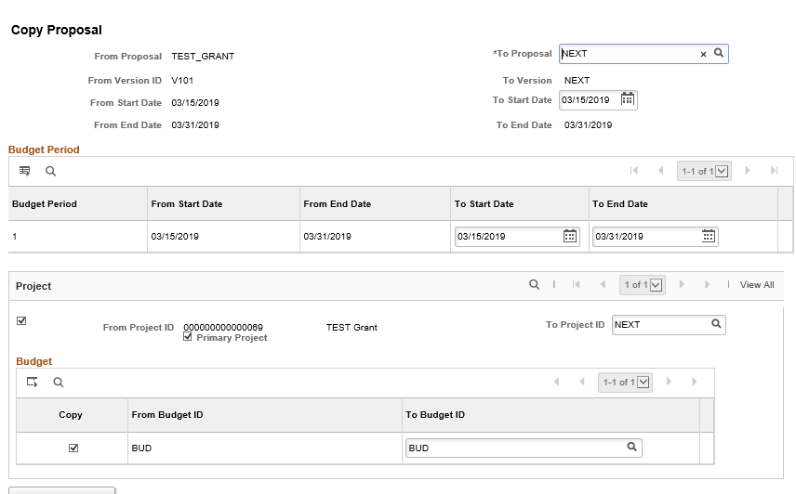

*Figure 22. Copy Proposal Page*

| **Fields** | **Description** |
| --- | --- |
| To Proposal | **NEXT** appears by default. When you click **Copy**, SMART generates the next Proposal ID that is available. You are able to name your Proposal ID, Project ID, and Budget ID on this page if you choose to. It is recommended that you update these fields to an agency-defined value.  Remember that Budget ID becomes Activity ID in Project Costing, if the grant is awarded. |
| To Start Date and To End Date | By default, SMART populates the start and end dates of the proposal from which you are copying; however, you can change these values. If you change the start and end dates on the target proposal, the copy process changes the start and end dates for all of its projects and activities. |

*Table 14. Copy Proposal Fields*

## Topic 3: Submitting Proposals

* After you complete the proposal, the next step is to take the proposal through the approval and submission process
* You can assign approvers to a proposal before sending to the sponsor, if your agency is using workflow. Job Aid “Workflow Approvals” contains the process for workflow agencies.

|  |  |
| --- | --- |
| **Page Name** | **Navigation** |
| Submit Proposal | Projects and Grants Homepage > Grants > Creating a Grant > Proposals > Submit Proposal |
|  | **NavBar** |
| Submit Proposal | Navigator > Grants > Proposals > Submit Proposal |

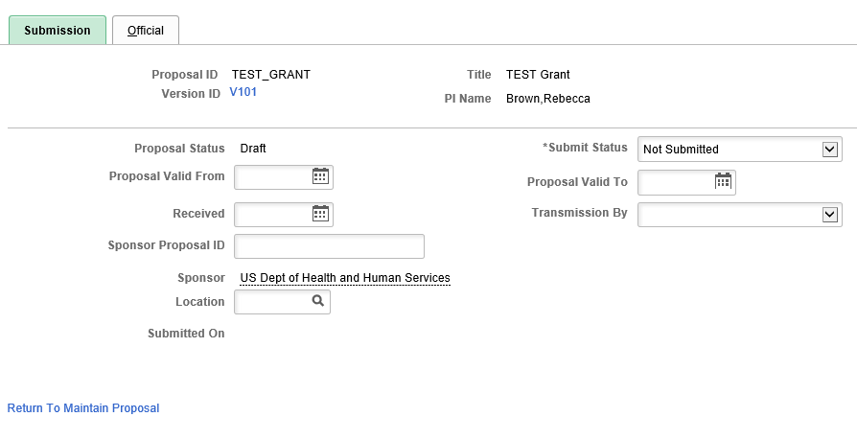

*Figure 23. Proposal Submission Page*

| **Fields** | **Description** |
| --- | --- |
| Submit Status | Select status of “Submitted”. After you mark a proposal version as “Submitted”, you can no longer modify any of the proposal information for that version. To make any modifications to a proposal after it has been submitted, you must create a new version of the proposal using the *Copy Proposal Version* menu option. |

*Table 15. Proposal Submission Fields*

## Topic 4: Creating Awards

* The award generation process is an automated process that creates the SMART award infrastructure for you. This allows better management of your grant award by housing key information related to the grant in one place.
* Only proposals with a status of “Submitted” are available for selection when you run the **Generate Award** process
* This process also creates a project with activities, a customer contract, project budget and the necessary setup to manage the award transactions
* You can run this process before the grant is approved by the sponsor if pre-award spending is necessary by checking the pre-award spending checkbox. This creates the project and activities along with the budget, but not the customer contract which manages the reimbursement process. In most cases, this process is run after the sponsor issues the formal grant award.

|  |  |
| --- | --- |
| **Page Name** | **Navigation** |
| Generate Award | Projects and Grants Homepage > Grants > Creating a Grant > Generate Award |
|  | **NavBar** |
| Generate Award | Navigator > Grants > Proposals > Generate Award |

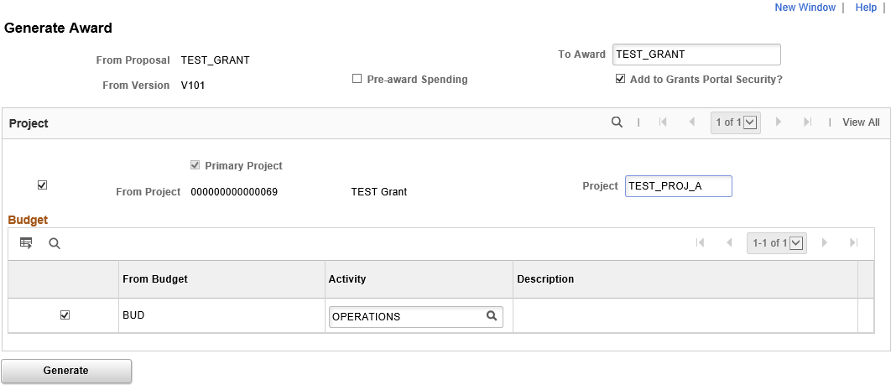

*Figure 24. Generate Award Page*

| **Fields** | **Description** |
| --- | --- |
| Pre-Award Spending | Select to create an award that has pre-award spending. If you are generating an award that was already created for pre-award spending, this field will be unavailable.  To initiate pre-award spending:   1. Run the process with the Pre-award Spending check box selected to bring over the project and budget level information to SMART Project Costing. 2. When the proposal officially becomes an award, run the award generation process again to finalize the proposal as an award and create the Customer Contract to allow for billing of the project costs. |
| To Award | Enter an Award ID the first time that you run the award generation process. SMART creates certain key fields on the first run even though the award records do not yet exist. This field is display-only the second time that you access the page, preventing you from changing the award name.  It is recommended that the Award ID match the Proposal ID and/or Project ID for ease of use. |
| From Project | Select to specify which proposal projects or project budgets should map to the award |
| Generate | Click to run the award generation process. This process creates information in the award pages from the proposals pages.   * At least one proposal project must be within the proposal that you are moving. If not, SMART displays an error message. * The Budget ID in Grants is the Activity ID in Project Costing * You must select at least one Budget ID within a proposal for every selected project. If you do not, SMART displays a warning message indicating you must select a Budget ID. |

*Table 16. Generate Award Fields*

## Lesson Review

In this lesson, you learned:

* How to create a grant proposal and proposal budget
* How to copy an existing proposal to another
* How to submit a completed proposal
* How to generate an award

The following are additional resources that provide more detail about the topic we have covered:



**Additional Resources**

* SMART Website – Projects/Grants materials
* OMB, Omni Circular, “OMB Uniform Guidance: Administrative Requirements, Cost Principles, and Audit Requirements for Federal Awards”
* Grant Award Agreements

# Lesson 3: Managing Grants

## Objectives

Upon completion of this lesson, you will be able to:

* Update award information for award profiles and budgets
* Review the projects and activities created by the award generation process
* Activate the customer contract created from the award
* Understand grant closure
* Run federal grant reports

## Topic 1: Understanding Award/Grant Management

* The information that you create and maintain in the award profile establishes an award. An award is associated with one business unit, one billing sponsor, and one award sponsor. Each award must have at least one project, which also includes at least one activity, which is created along with the customer contract during the Generate Award process. The bulk of this award setup information appears by default when you run the Generate Award process, saving you from unnecessary data re-entry.
* After running the Generate Award process, use the components within the Awards Pagelet to validate the award information and finalize the budget, which sends the information to Commitment Control as project budget journals.
* You can confirm the “Active” status for the project and activity in Project Costing from a pagelet within the Grants module
* The contract status must be set to “Active” after award generation in order to process billing and revenue recognition. The default contract status is “Pending.”
* The statuses of the billing and revenue recognition plan are tied to the contract status. Once the contract is activated the related billing and revenue recognition plan will be in “Ready” status as well.

## Topic 2: Updating Awards

* After running the Generate Award process, use the **Award Profile** pages to change or add information about the grant including funding, resources and terms.
* This information populates from the proposal. Updates are only needed if information has changed or is missing.
* Enter the sponsor award number in the **Reference Award Number** field. This value populates on some of the Grants invoice formats and prints on the Sponsor Draw Down Report. Reference Award number also ties the grant to the Federal Financial Report.
* If you receive additional funding for an award in progress, it must be manually updated before the project budget is finalized. The process for updating the project budget after it has been finalized is provided in the Job Aid “Updating a Finalized Budget”



*Figure 25. Updating a Grant Process*

|  |  |
| --- | --- |
| **Page Name** | **Navigation** |
| Award Profile | Projects and Grants > Grants > Creating a Grant > Award Profile |
|  | **NavBar** |
| Award Profile | Navigator > Grants > Awards > Award Profile > Award |

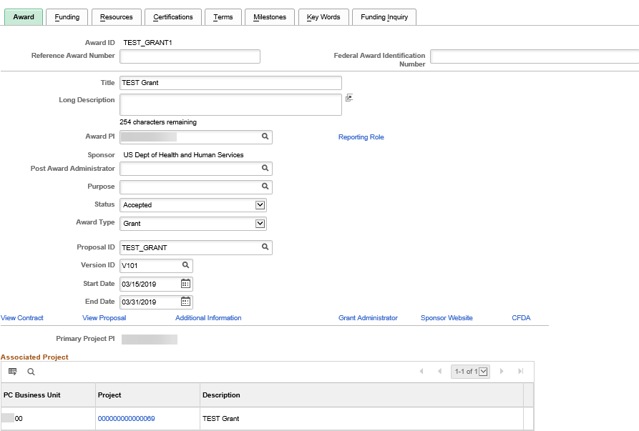

*Figure 26. Award Page*

| **Fields** | **Description** |
| --- | --- |
| View Contract | Takes you into the customer contract created by the generate award process |
| View Proposal | Takes you into the proposal that was used to create the award |
| Grant Administrator | Enter administrative contact information for the grant |
| Sponsor Website | Enter the URL link for the sponsor |

*Table 17. Award Fields*

* The **Funding** page maintains funding periods and amounts for each project. Use the **Show Next Row** buttons for each project, as an award can have multiple projects with multiple budget periods. You may also select **View All** to view all projects associated with the award.
* Remember that we define this data on the **Proposal** and **Budget** pages in the proposal. All of the fields that are on this page appear by default when you run the Generate Award process.

|  |  |
| --- | --- |
| **Page Name** | **Navigation** |
| Funding | Projects and Grants Homepage > Grants > Creating a Grant > Award Profile > Funding tab |
|  | **NavBar** |
| Funding | Navigator > Grants > Awards > Award Profile > Funding tab |
|  |  |

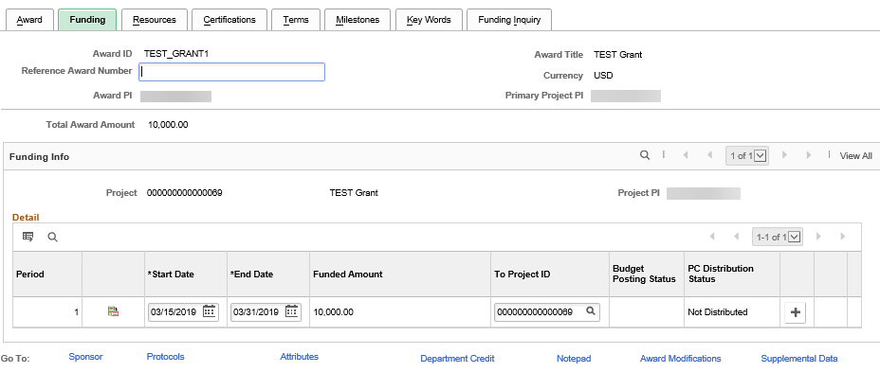

*Figure 27. Funding Page*

* The **Resources** page brings forward the resources information defined on the grant proposal

|  |  |
| --- | --- |
| **Page Name** | **Navigation** |
| Resources | Projects and Grants Homepage > Grants > Creating a Grant > Award Profile > Resources tab |
|  | **NavBar** |
| Resources | Navigator > Grants > Awards > Award Profile > Resources tab |

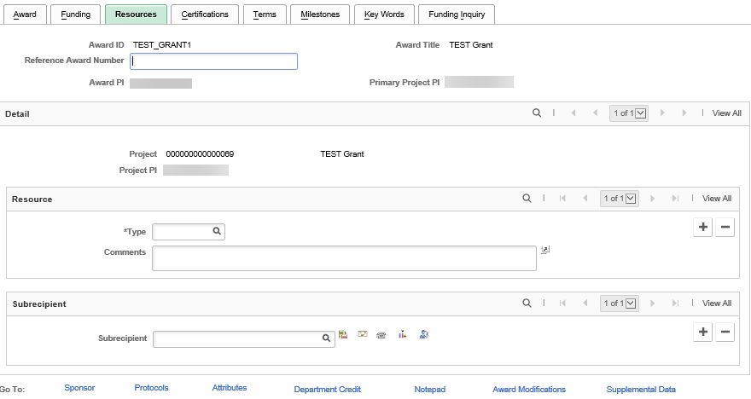

*Figure 28. Resources Page*

## Topic 3: Reviewing Award Projects

* After the award generation process is complete, you can view the project profile information
* Similar to the award profile, most of the project profile information is populated during the award generation process
* Information can be viewed here, through the Grants>Awards>Project navigation, as well as through the Project Costing navigation Project Costing>Project Definitions>General Information

|  |  |
| --- | --- |
| **Page Name** | **Navigation** |
| General Information | Projects and Grants Homepage > Grants > Creating a Grant > Award Project |
|  | **NavBar** |
| General Information | Navigator > Grants > Awards > Project > General Information |

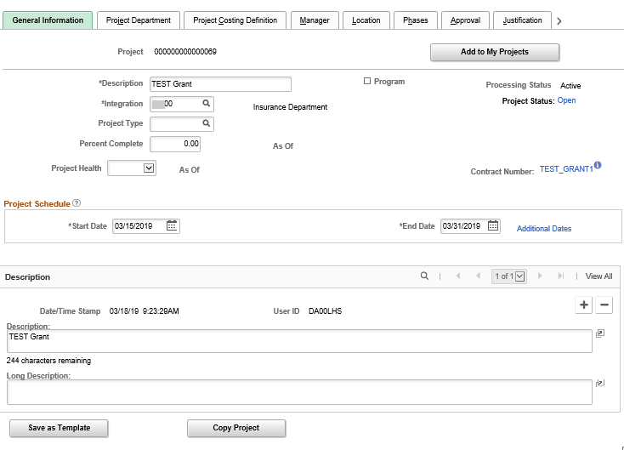

*Figure 29. General Information Page*

| **Fields** | **Description** |
| --- | --- |
| **Description** | Description of the project |
| **Program** | Select to designate this project as a program or summary project. When this option is selected, the system prevents you from adding activities to the program, because only projects can have activities. If you try to select this option for a project that already has activities, a message appears indicating that the project cannot be changed to a program because it has activities associated with it, and you must either remove the activities from the existing project or create a new program.  Programs are used to group transactional projects for reporting purposes. The association of projects to a program is done via a project tree. |
| **Processing Status** | SMART uses the processing status to restrict incoming transactions. Processing Status is automatically set based on the Project Status field value. |
| **Integration** | Enter the integration template that is used to associate this project with other SMART modules, specifically General Ledger and Asset Management.  For most agencies, this will be your agency ID. |
| **Project Status** | Enter the project's status when you are in add mode. After you save the project for the first time, the Project Status field becomes read only on this page and appears as a link to the **Project Definitions - Status** page so you can update the status using effective-dated rows. |
| **Project Type** | Displays the type of project that is being conducted. In the future, the Project Type field will be leveraged in producing the annual Schedule of Expenditure of Federal Awards (SEFA) report. |
| **Percent Complete** | State of Kansas does not use this field |
| **As of** | State of Kansas does not use this field |
| **Project Health** | State of Kansas does not use this field |
| **As of** | State of Kansas does not use this field |
| **Work Order Managed** | State of Kansas does not use this field |
| **Additional Dates** | Click to access the Additional Dates page, where you can enter or view project baseline start and finish dates, early start and finish dates, actual start and finish dates, and late start and finish dates  These additional dates are optional. |
| **Description** | Description of the project |
| **Long Description** | Displays additional project data, as entered by the agency |

*Table 18. General Information*

## 

## Topic 4: Reviewing Award Project Activities

* All transactions associated with an award must be linked to a project and an activity to process the transactions against the award funding.
* When you run the **Generate Award** process, Activity IDs are automatically created based on the Budget IDs entered on the proposal.
* During post-award processing, you can specify any additional activity information that was not already populated by the application
* Information can be viewed here through Grants>Awards>Project Activity, as well as on the project activity page accessed through the Project Costing navigation Project Costing>Activity Definitions>General Information

|  |  |
| --- | --- |
| **Page Name** | **NavBar Navigation** |
| Award Project Activities | Navigator > Grants > Awards > Project Activity |

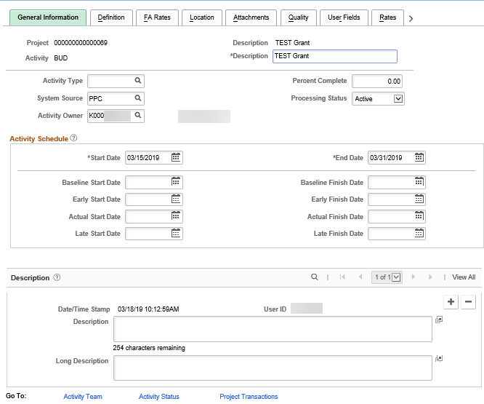

*Figure 30. Project Award Activities Page*

| **Fields** | **Description** |
| --- | --- |
| Activity Status | Status of activity |
| Start Date | The activity start date |
| End Date | The activity completion date |
| Project Transactions | Click to access the Transaction List page to view transactions for this activity |

*Figure 31. Project Award Activities*

## Topic 5: Updating Award Budgets

* The final step to prepare an award for processing is to establish the award budget and submit it to Commitment Control.
* When you run the Generate Award process, SMART populates the **Project Budgets** page in the Awards pagelet with summarized budget information.
* At this point make any additions or modifications, such as updating any amounts, prior to finalization of the budget
* You must add the required ChartFields Department (defaults from proposal, but can be changed here), Fund Code, Budget Unit, Program Code and Account (F&A will default, if applicable)
  + The Account Code must be a ‘budgetary only’ account so any account value that falls within that budgetary category can be used on transactions
  + It is recommended that the agency-level Department be used to allow any department at the agency to charge to the project, unless it is certain only a specific department should transact
* Only after the budget is finalized can transactions be applied against it

|  |  |
| --- | --- |
| **Page Name** | **Navigation** |
| Budget Details | Projects and Grants Homepage > Grants > Creating a Grant > Project Budgets |
|  | **NavBar** |
| Budget Details | Navigator > Grants > Awards > Project Budgets |

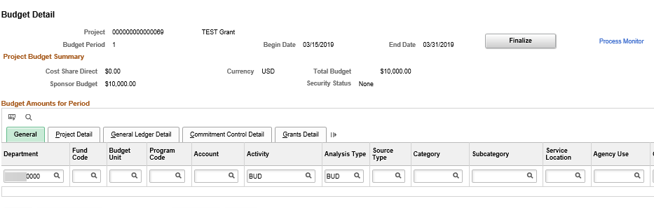

*Figure 32. Budget Detail*

* For cost sharing funds, use the **General Ledger Detail** tab to validate and/or update the budget structure. The budget items will have an analysis type of **BUD (Total Cost Budget)** and **CBU (Cost Sharing Budget).** This can also be viewed using the **Project Budget Inquiry** link in the **Awards** component.
* Use a **Cost Sharing** fund code to allow transactions to be split according to what your agency has set up.
* When a voucher is budget checked, posted and sent from Accounts Payable to Project Costing for award expenditure tracking, you will see an **ACT (Actual Cost)** row which will have an associated **BIL (Billable Cost)** row, if the customer contract has been activated. The BIL row is what is reimbursable from the grant sponsor. And, there will be a **CAC (Cost Sharing Actuals)** for the remaining cost shared amount which will not be billable – this will all be in the Project Costing Transaction List for reporting.

|  |  |
| --- | --- |
| **Page Name** | **Navigation** |
| General Ledger Detail | Projects and Grants Homepage > Grants > Creating a Grant > Project Budgets > General Ledger Detail tab |
|  | **NavBar** |
| General Ledger Detail | Navigator > Grants > Awards > Project Budgets > General Ledger Detail tab |

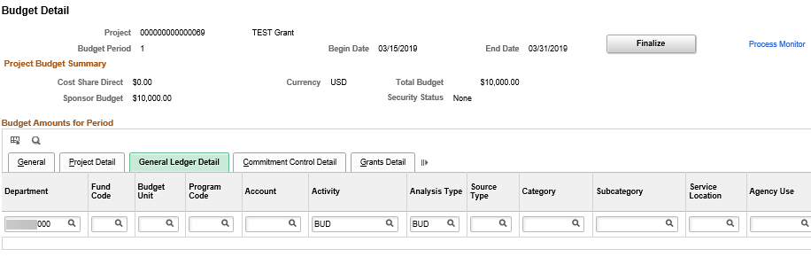

*Figure 33. Budget Detail_General Ledger Detail*

* Click **Finalize** after making any changes and adding the ChartFields to an active budget period. The system finalizes the plan by picking up the rows only for a budget period and not the entire plan. This allows agencies to update and finalize their budgets period by period.
* After finalizing the budget, check Commitment Control for any errors that may have occurred in the Budget Line(s). Update any necessary ChartFields, and click the Finalize button from the Budget Detail page.

|  |  |
| --- | --- |
| **Page Name** | **Navigation** |
| Review Commitment Control | Projects and Grants Homepage > Grants > Creating a Grant > Commitment Control Errors |
|  | **NavBar** |
| Review Commitment Control | Navigator > Grants > Awards > Commitment Control Errors |

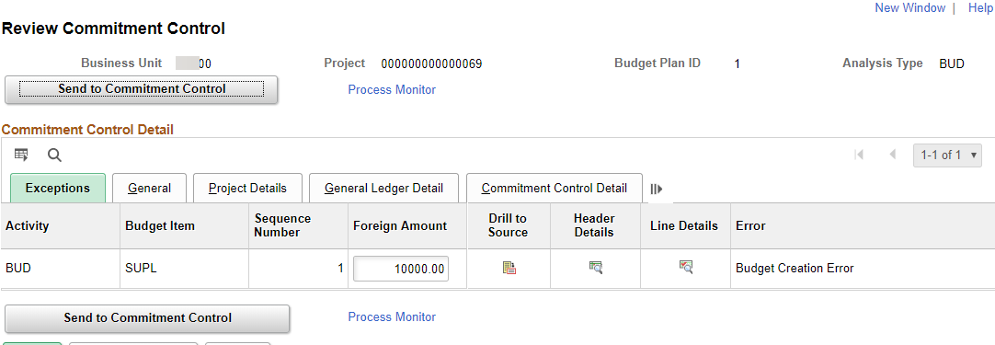

*Figure 34. Review Commitment Control page*

|  |  |
| --- | --- |
| **Page Name** | **Navigation** |
| PC Budget Exceptions | Projects and Grants Homepage > Grants > Creating a Grant > Commitment Control Errors > Commitment Control Detail tab |
|  | **NavBar** |
| PC Budget Exceptions | Navigator > Grants > Awards > Commitment Control Errors > Commitment Control Detail tab |

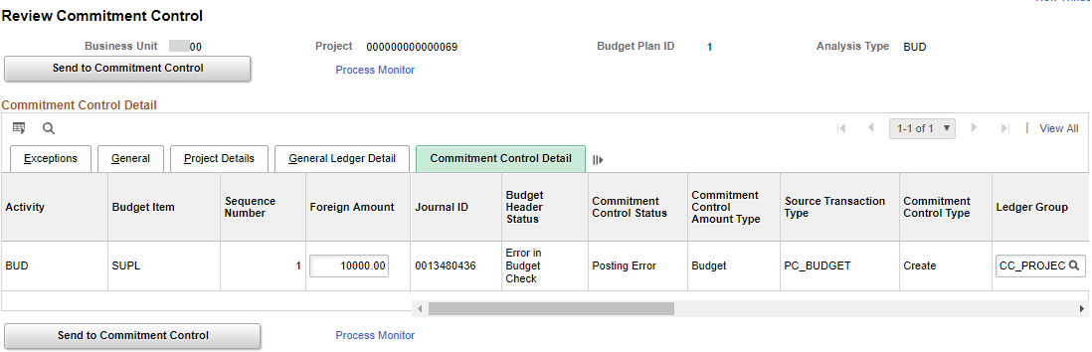

*Figure 35. PC Budget Exceptions page*

## Topic 6: Reviewing Cost-Shared Amounts

* Cost sharing setup up is usually incorporated in the proposal creation. Cost sharing information can be viewed at any time using the **Project Budget Inquiry** page. Cost shared lines will show twice on the Budget Inquiry page, the **CBU** row is the amount the agency pays, the **BUD** row is paid by the sponsor.

|  |  |
| --- | --- |
| **Page Name** | **Navigation** |
| Budget Inquiry | Projects and Grants Homepage > Grants > Creating a Grant > Project Budget Inquiry |
|  | **NavBar** |
| Budget Inquiry | Navigator > Grants > Awards > Project Budget Inquiry |

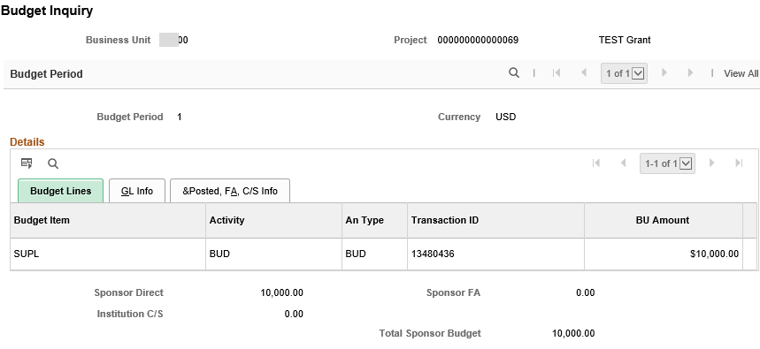

*Figure 37. Budget Inquiry Page*

* Access the **Lines** page of the contract to review the Billing and Revenue Plans status. They both must be set to “Pending” in order for the contract to be set to “Active” (this should be the default).
* If your sponsor has a **Letter of Credit ID (LOC Doc ID),** it must be entered on the **Lines** page of the contract before the contract can be activated. The **LOC ID** on the Go To Billing Options page must also be entered. The LOC Doc ID allows the award information to be included on the Sponsor Drawn-Down Report. If your agency does not have this configured, the box will not be avaliable for this ID.

|  |  |
| --- | --- |
| **Page Name** | **Navigation** |
| Lines | Projects and Grants Homepage > Grants > Creating a Grant > Award Profile > View Contract link |
|  | **NavBar** |
| Lines | Navigator > Grants > Awards > Award Profile > View Contract link |

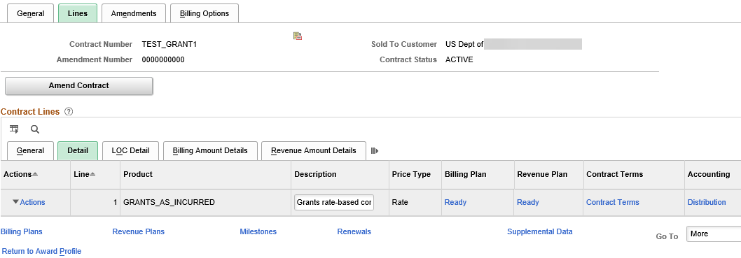

*Figure 38. Lines Page*

## Topic 7: Updating and Activating Award Contracts

* The status of the customer contract created by the Generate Award process defaults to “Pending” and must be set to “Active” in order to begin billing and recognizing revenue for reimbursable project-related expenditures
* Changes here (Grants>Awards>Award Profile>View Contract link) are also reflected on the contract page accessed through the Customer Contracts navigation (Projects and Grants Homepage > Customer Contracts > Customer Contracts > General Information or Navigator > Customer Contracts > Create and Amend > General Information.

|  |  |
| --- | --- |
| **Page Name** | **Navigation** |
| View Contract | Projects and Grants Homepage > Grants > Creating a Grant > Award Profile > View Contract link |
|  | **NavBar** |
| View Contract | Navigator > Grants > Awards > Award Profile > View Contract link |

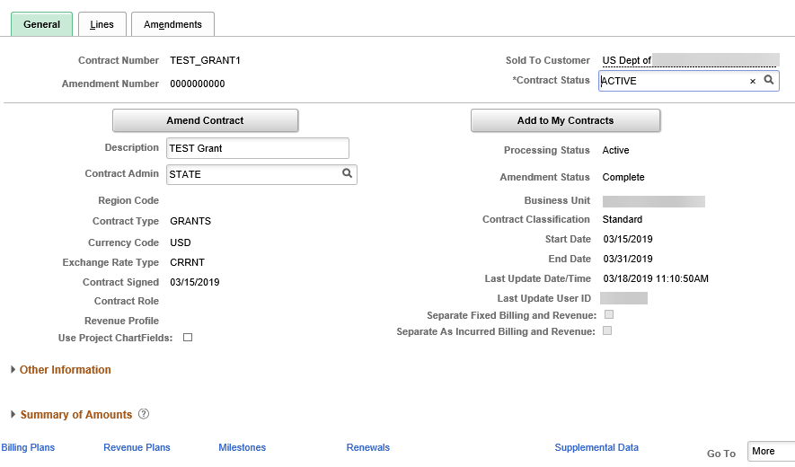

*Figure 39. View Contract Page*

| **Fields** | **Description** |
| --- | --- |
| Contract Status | Status of the contract. Set to Active to activate the award contract. |

*Table 19. View Contract Fields*

## Topic 8: Understanding Grant Closure

* Once an award reaches completion, the final step in the grants management process is to close out the award
* There are several steps required to complete the award close out process, including:
  + Closing the grant-related projects and activities in Project Costing
  + Closing the grant-related contract, including the billing and revenue plans in Customer Contracts
* Access to the pages for closing the project/activities along with billing plan/revenue plan and the contract requires the Project Manager and Customer Contracts Manager roles, respectively. If an end user only has the Grants Manager or Grants Approver role, they must work with their agency’s Project and/or Customer Contracts Manager to complete these activities.



*Figure 40. Close a Grant Process*

## Topic 9: Running Federal Grant Reports

* With the 9.2 Upgrade, the Federal Financial Report was delivered. The reports may be found on the Projects and Grants Homepage > PC & GM Reports > PC Reports > Federal Financial Report. This report may be run using the Award Modifications or Contracts Billing Limit as a base.
* Federal Cash Transactions Report (SF-272) & Financial Status/Interim Outlay Report (SF-269a) have been combined as the Federal Financial Report. This report captures information from the **Reference Award Number** entered on the projects page. This report is located: *KS > KS PC > Federal Financial Report.*
* The Sponsor Draw-Down Report for reimbursable expenditures associated with grants is located: *Customer Contracts > Reports > Sponsor Draw Down Report*

## Lesson Review

In this lesson, you learned:

* How to update award profile information
* How to review project profile and project activity information for an award
* How to update and finalize budget information for an award
* How to review cost sharing amounts
* How to update customer contract information and activate an award
* The closing of a grant process
* The explanation of Federal Reports

The following are additional resources that provide more detail about the topic we have covered:



**Additional Resources**

* SMART Website – Projects/Grants materials
* OMB, Omni Circular, “OMB Uniform Guidance: Administrative Requirements, Cost Principles, and Audit Requirements for Federal Awards”
* Grant Award Agreements