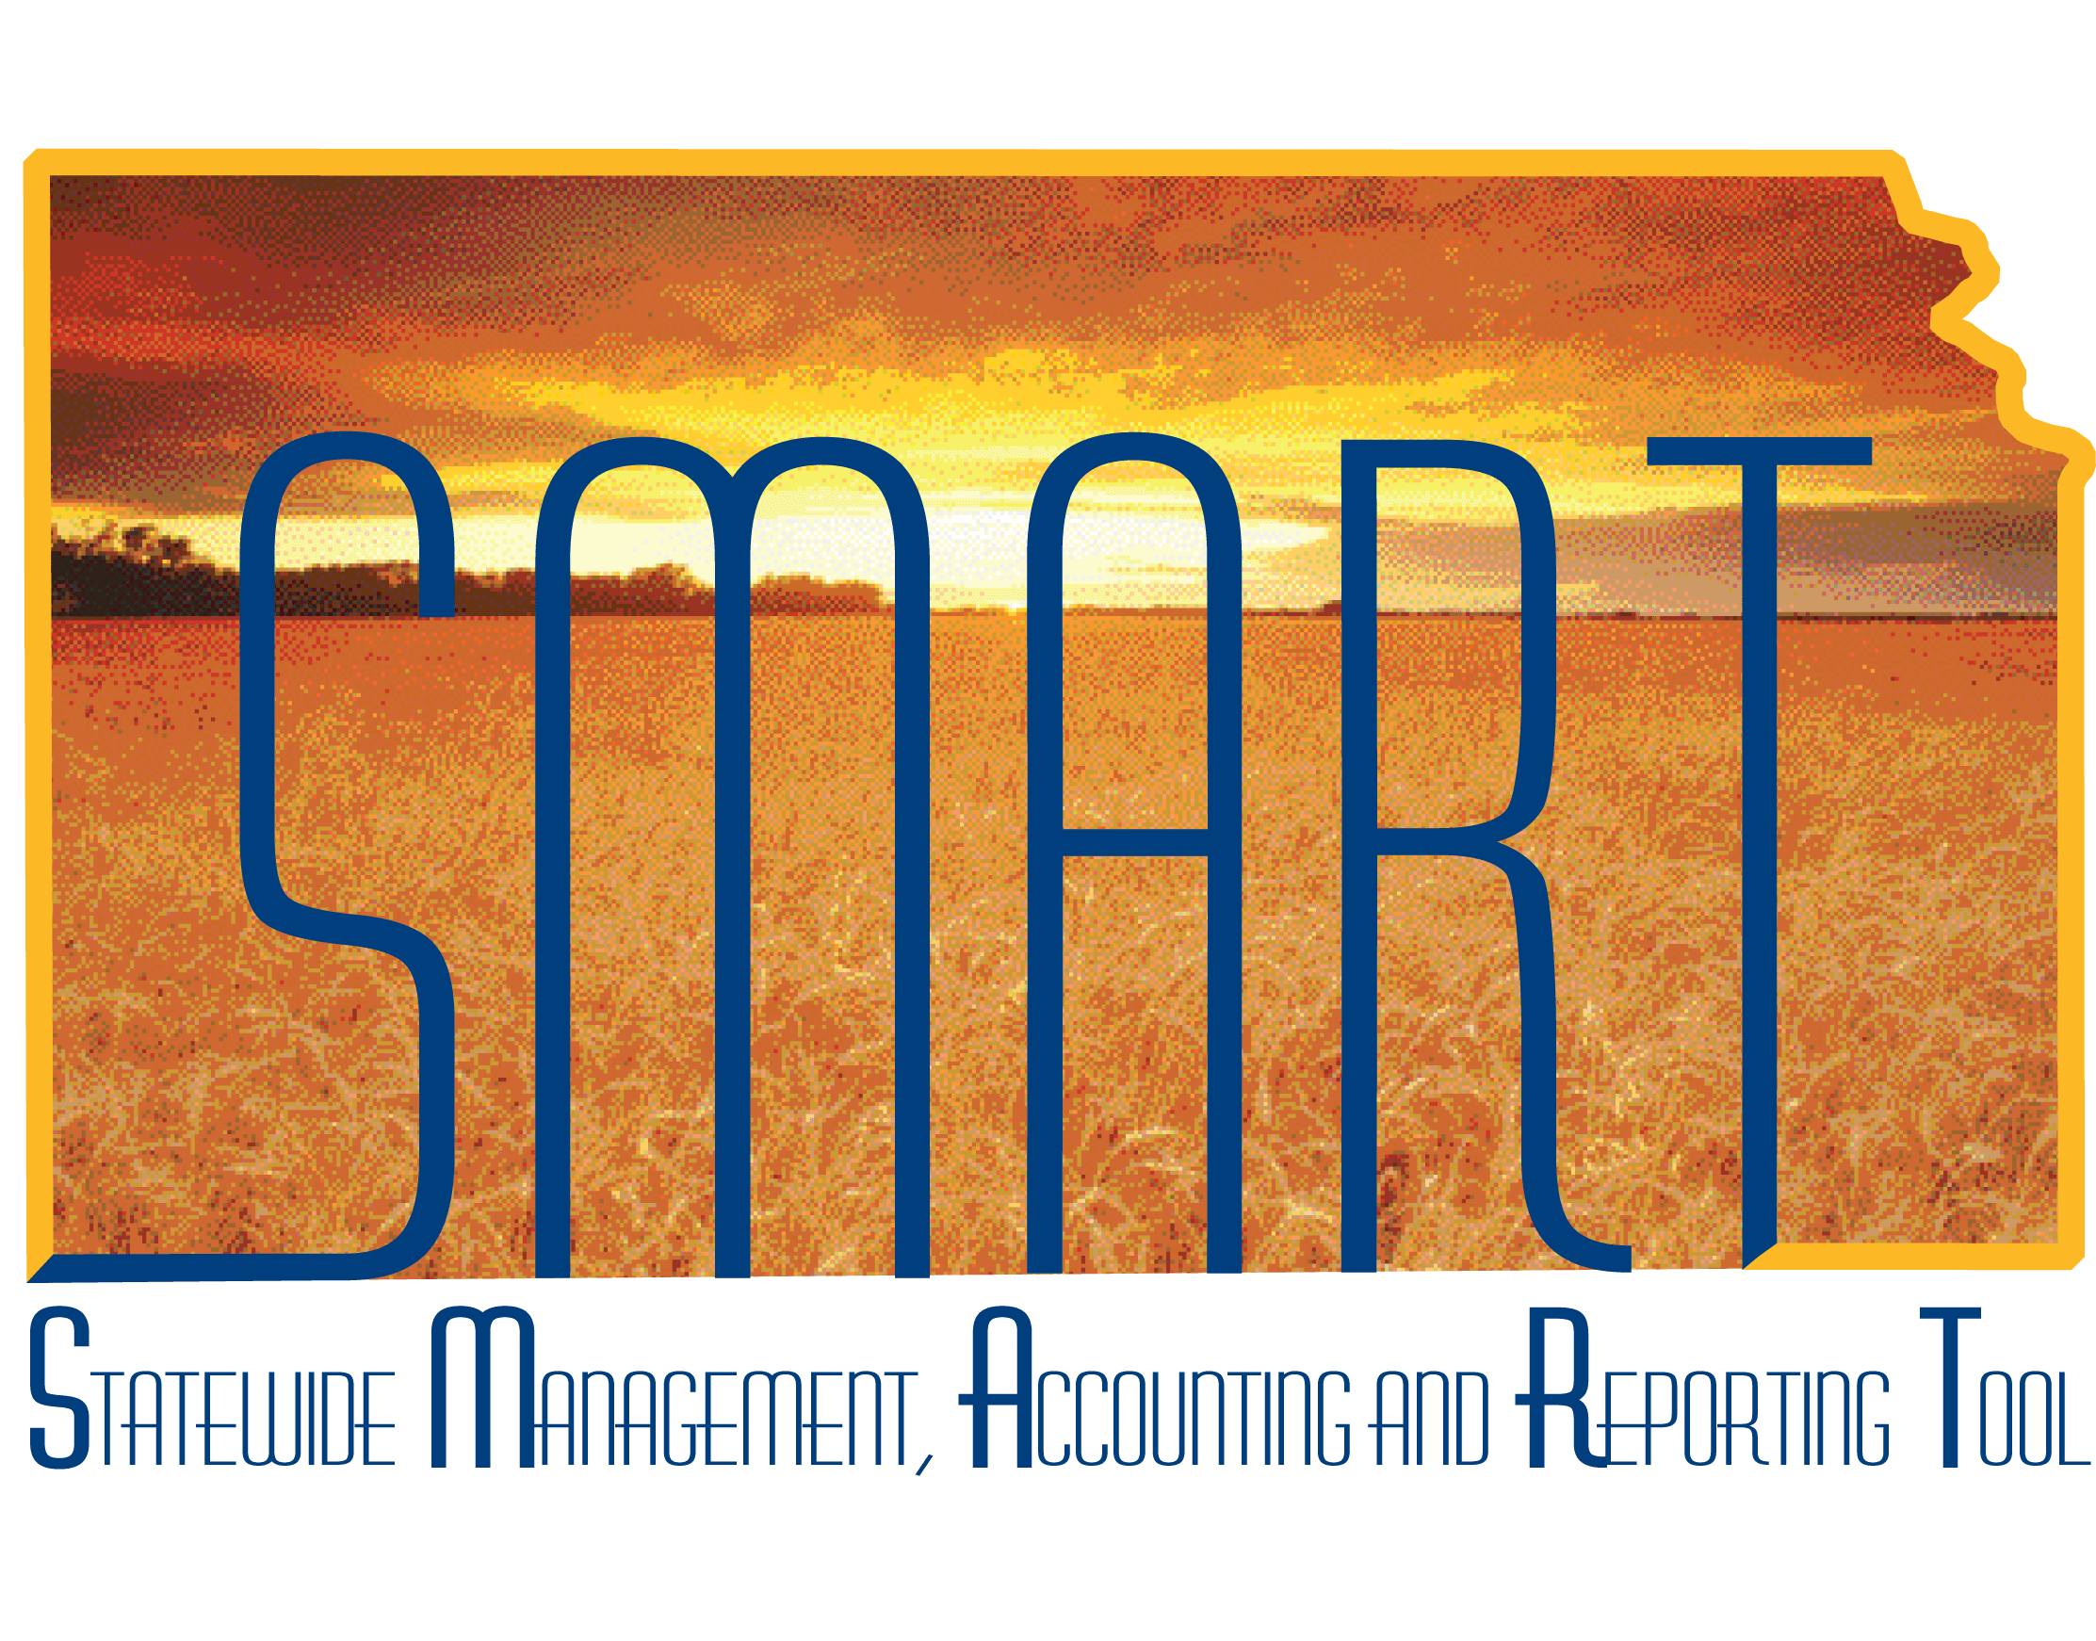

Training Guide – Managing Customer Contracts

State of Kansas

**Associated Roles:**

Customer Contracts Manager

Customer Contracts Viewer

**Table of Contents**

Lesson 1: Understanding Contracts 3

Topic 1: Defining Key Terms for Contracts 3

Topic 2: Understanding Contracts Processes 5

Lesson 2: Creating and Maintaining Contracts 8

Topic 1: Understanding Contracts, Milestones, and Amendments 8

Topic 2: Creating a Contract 9

Topic 3: Activating a Contract 16

Topic 4. Creating and Updating Milestones (Amount Based Contracts Only) 19

Topic 5: Creating an Amendment 24

Topic 6: Closing a Contract 29

Lesson 3: Integrating Contracts with other SMART Modules 31

Topic 1: Integrating Contracts with Projects and Billing 31

Topic 2: Understanding the Contracts/Billing Interface 31

# Lesson 1: Understanding Contracts

## Topic 1: Defining Key Terms for Contracts

* **Contract** – The document related to a grant that defines how the grantee/funding recipient bills and recognizes revenue from a Sponsor (i.e. non-State funding source for a project)
* **Product** – The method by which billing and revenue recognition is processed on a contract. There are 2 main types of products in Customer Contracts:
* **Amount-Based Products** – This type of product allows the user to define when to bill/recognize revenue manually. After you define your contract, the next step is to allocate the contract's fixed price amount across any eligible amount-based contract lines. Amount-based contracts can have multiple contract lines to allow different amounts to be billed at different rates.
* **Rate-Based Products** – This type of product uses an As Incurred method, whereby project costs are sent to Billing and revenue recognition entries are booked to the General Ledger as those costs are incurred. Rate-based contract lines are priced using SMART Project Costing rate sets and rate plans. The agency rate set or rate plan defaults onto the rate-based contract at a 1:1 ratio (i.e. 100% of the cost is assumed to be reimbursable and is sent to the billing worksheet for processing). Rate- based contracts typically only have 1 contract line and all project costs attached to the contract use the same “as incurred” method.
* **Note**: The State of Kansas predominantly uses Rate-Based contracts. If

you are unsure which type of Product to select, please log a Kansas Service Desk ticket and the SMART Projects/Grants analyst will contact you to discuss.

* **Billing Plan** – Stores the timing of when billing occurs, how bill lines should

appear, and what notes should relate to the bill. You can assign contract lines with similar billing requirements to the same billing plan. Each contract has at least one billing plan and a contract may have more than one billing plan. Billing plans default onto the contract when a Product is selected.

* **Milestone** – An activity, the completion of which marks an important event in a

project. Achieving a milestone can result in sending a bill or recognizing revenue. Milestones are only used with Amount-Based contracts.

* **Revenue Plan** – When Customer Contracts manages revenue for a contract line,

you associate each contract line with a revenue plan. The revenue plan contains a list of events defining when revenue is recognized for each contract line assigned to that revenue plan. Revenue plans default onto the contract when a Product is selected.

* **Amendment** – A contract amendment is any change made to an active contract where you are altering certain obligations and entitlements of the contract. This could include modifications to the data contained in the contract entry component and limit changes. Using amendment processing, Customer Contracts enables you to maintain an audit trail, as well as a historical record, of certain changes made to the contract throughout its life cycle.
* **Contract Status** – Provides you with a visual indicator of where your contract is within the contract life cycle and it designates when a contract is available for lookup and processing.

## Topic 2: Understanding Contracts Processes

* Contracts can be created manually using Customer Contracts link or

automatically via the Grants module’s *Award Generation* process. We will review creating a contract manually. Updates may be made to a contract while the contract is still pending. Once the contract is “Active”, updates are made using the Amendment process.

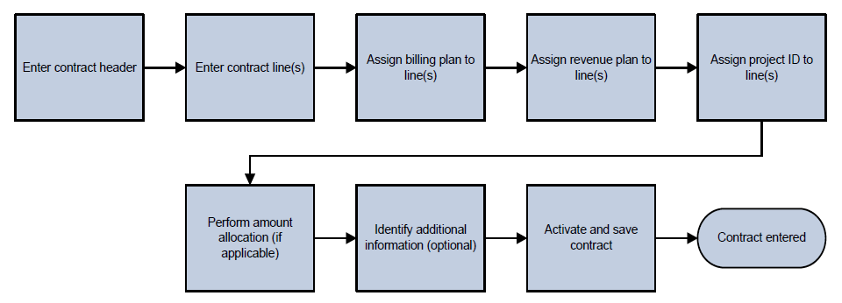

*Figure 1. Entering a Contract Process*

*Note: The billing/revenue plans will default onto the contract based on the Product selected on*

*the contract line(s). The “Perform Amount Allocation” step is only for Amount-Based contracts.*

* Billing plans store the timing of when billing occurs, how bill lines should appear, and what notes should relate to the bill.
* Revenue plans enable you to define, administer, and maintain accounting schedules and rules for the products and services that you offer under a contract.

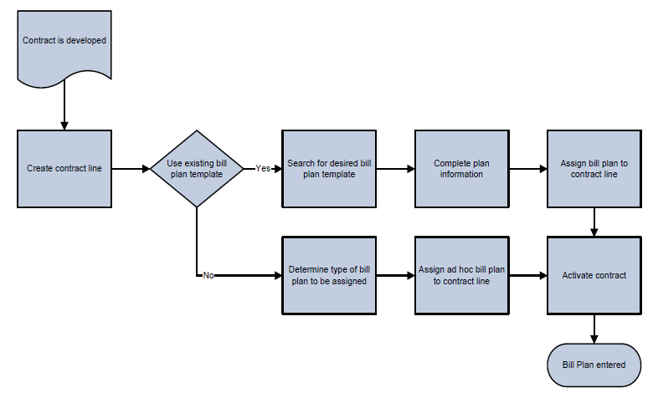

*Figure 2. Creating a Billing Plan Process*

*Note: Typically, agencies do not create new Billing Plans. There are pre-configured values available for selection.*

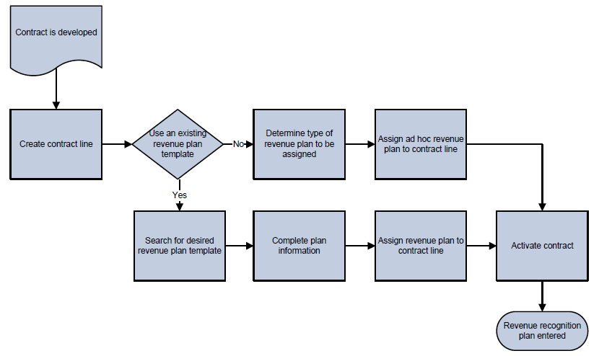

*Figure 3. Entering a Revenue Recognition Plan Process*

*Note: Typically, agencies do not create new Revenue Plans. There are pre-configured values available for selection.*

* Customer Contracts is designed to fully integrate with Project Costing, Billing, General Ledger, and Grants.

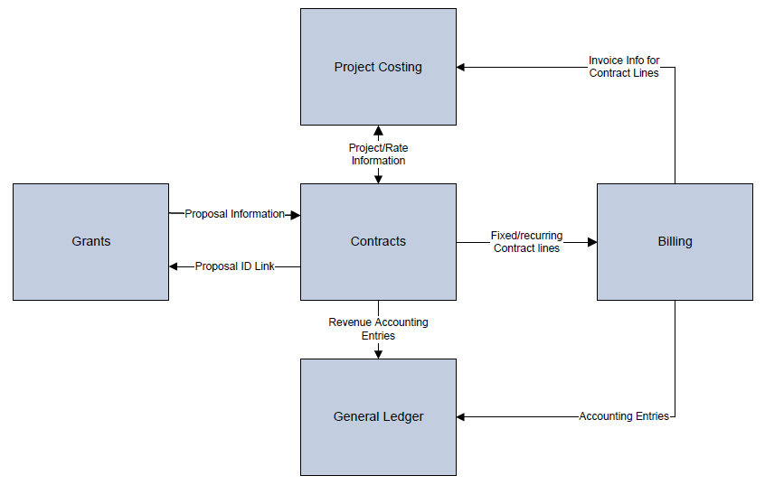

*Figure 4. Integrating Customer Contracts Process*

* There are two roles associated with Customer Contracts

|  |  |
| --- | --- |
| **Role** | **Description** |
| Customer Contracts  Manager | This role is responsible for entering,  reviewing, and analyzing customer contracts. This role is also responsible for understanding the integration with other SMART modules. |
| Customer Contracts  Viewer | This role views customer contracts information only |

# Lesson 2: Creating and Maintaining Contracts

## Topic 1: Understanding Contracts, Milestones, and Amendments

* A contract consists of two components, the contract header (General tab) and the contract lines (Lines tab)
* The contract header contains information relevant to the entire contract
* A contract line corresponds to an individual product

o For rate-based contract lines, you associate the contract line with project and activity IDs and a rate set or plan and the project costs are processed for reimbursement as they are incurred

o For amount-based contract lines, the system processes billing/revenue recognition for the contract line based on the amount that you manually established on the contract and on the reimbursement schedule you selected



* Contracts can have a status of “Pending”, “Active”, “Closed”, and “Cancelled”
* A milestone is a significant event in the life of an amount-based contract.
* You can use milestones to control billing or revenue recognition in

Customer Contracts. To do that, you need to create and then link the

relevant milestones to your contract.

* You must set the milestone status field to “Ready” before the system can perform any processing against it. After the system processes a “Ready” milestone and confirms that the required conditions are met, the system changes the milestone status from “Ready” to “Completed” and no longer enables changes. When you enter a milestone, the milestone status is “Pending” by default.
* A contract amendment is a change made to an active contract whereby you modify the original terms and conditions of the contract

o You make amendments to a contract by using the Amendment Processing feature. This feature enables you to create a new version of an active contract that you can edit and modify. In addition, you can maintain a historical record of the original document

o Reasons for amending a contract may include the addition or subtraction of overall contract and contract line amounts, addition of new lines to the contract, and modification of billing and revenue events in “Pending” status

* Amendments can have a status of “Pending”, “Ready”, “Complete”, or

“Cancelled”.

## Topic 2: Creating a Contract

* The contract header serves two primary functions in Customer Contracts:
* To capture agreement information for a specific contract

o To provide a simple and flexible format that enables you to tailor the structure of your contracts to match your business model

* Add contract lines, which correspond to the individual products for which you are requesting reimbursement
* Use the **Amount Allocation** page to allocate negotiated amounts to contract Amount-based Contracts manages the accounting distribution for the unbilled accounts receivable (AR) accounts for each contract line distinguished by chartfield combination
* After adding a contract line, you must select the appropriate chartfield combination on the **Accounting Distribution page** for the Revenue and Unbilled AR sections for an amount-based contract

▪ The **Unbilled AR** section must have a valid Fund/Budget Unit entered for rate-based contracts to pass the Edit process. However, the chartfields used to book the revenue recognition accounting entries will be carried forward from the originating expenditure transaction.

* Because billing and revenue recognition can be managed independently, an account is needed to collect transactions that have not yet been billed or revenue that has not yet been recognized
* The system creates an entry to unbilled AR when revenue is generated and then relieves this account when the invoice is finalized in Billing
* A **billing plan** stores the schedule of billing events (when to bill) and the corresponding bill lines (what to bill) for these events. Each contract line product is tied to a billing plan, and you can associate contract lines with similar billing requirements with the same billing plan.
* The billing plan is defaulted based upon the product that is chosen for the

contract line

|  |  |
| --- | --- |
| **Billing Plan Status** | **Description** |
| Pending | Default status when you define a new billing plan |
| Ready | Status when the contract is in Active status |
| In Progress | Status when the contract is in Active status |
| **Billing Plan Status** | **Description** |
| Action Required | Contract line amendment is processed or event is reversed |
| Cancelled | Entire contract is terminated or contract line  dropped |
| Completed | For rate-based contracts, the user must manually set the billing plan to ‘Completed.’  For amount-based contracts, the system sets the status to ‘Completed’ once all billing plan events are completed. |
| Recycled | Once the billing event status is marked Recycled |
| Reversal in Progress | When you initiate the reversal of a billing plan |
| Reversed | After completing the reversal process |

*Table 1. Billing Plan Status*

* A revenue recognition plan lets you define, administer, and maintain accounting schedules and rules for the products and services under a contract
* The revenue recognition plan is defaulted based on the product chosen for the contract line

|  |  |
| --- | --- |
| **Page Name** | **Navigation** |
| General Information | Projects and Grants Homepage > Customer Contracts > Customer Contracts > General Information > General tab |
|  | **NavBar** |
| General Information | Navigator > Customer Contracts > Contracts Center > General tab  Information>General |

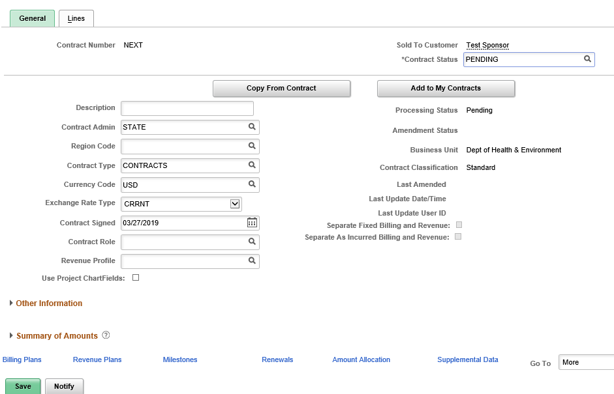

*Figure 5. General page*

|  |  |
| --- | --- |
| **Fields** | **Description** |
| Description | Enter a description for the contract |
| Contract Type | Used to categorize types of contracts. Contracts entered online will default to ‘CONTRACTS’.  Contracts created by the Grants *Award Generation* process will default to ‘GRANTS’. |
| Contract Status | Displays a value that provides a visual indicator of where the contract is within the contract life cycle |

*Table 2. General page*

|  |  |
| --- | --- |
| **Page Name** | **Navigation** |
| General Information | Projects and Grants Homepage > Customer Contracts > Customer Contracts > General Information > Lines tab |
|  | **NavBar** |
| General Information | Navigator > Customer Contracts > Contracts Center > General Information > Lines tab |

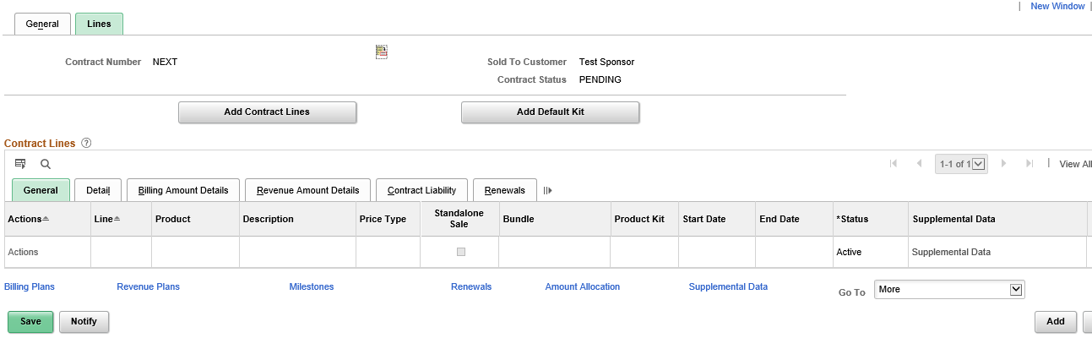

*Figure 6. Lines page*

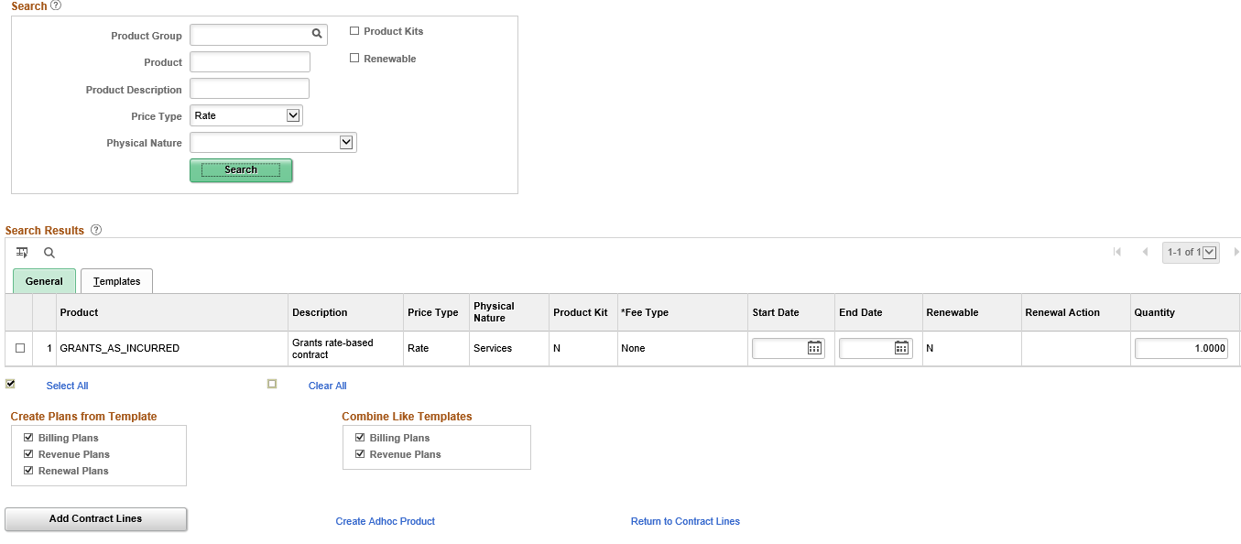*Figure 7. Add Contract page – Search Results*

|  |  |
| --- | --- |
| **Fields** | **Description** |
| Product Group | Select a product group. Product groups are optional but provide a logical grouping of products. |
| Price Type | Select a price type of Amount, Rate or Percent.  ‘Amount’ and ‘Percent’ are both amount-based products. |

*Table 3. Lines tab – Add Contract page*

|  |  |
| --- | --- |
| **Fields** | **Description** |
| Start Date | Enter a start date for the contract line. The value that you enter here populates onto the Contract – Lines page. |
| End Date | Enter an end date for the contract line. The value that you enter here populates onto the Contract – Lines page. |
| Quantity | Displays the quantity for the product. The system populates this field with 1. If you wish to specify a different quantity, you can enter a new value here. |
| UOM | Enter the Unit of Measure (UOM) here for the product, or leave it blank. |

*Table 4. Add Contract*

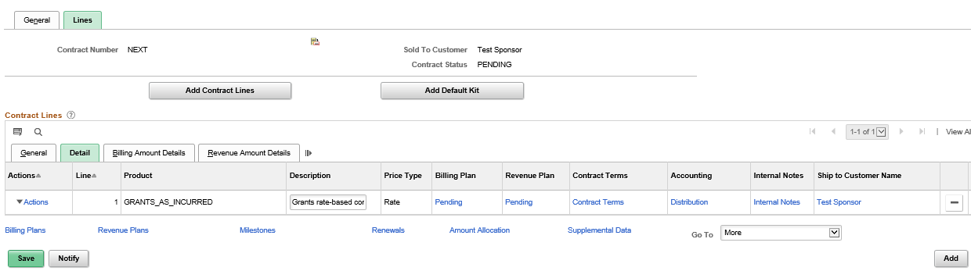*Figure 8. Contract Lines – Details tab*

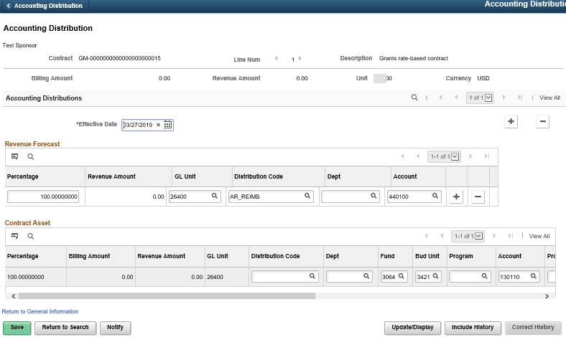

*Figure 9. Accounting Distribution page*

*Note: Before updating the values on this page, the user must scroll to the right*

*and click the “Correct History” button.*

|  |  |
| --- | --- |
| **Fields** | **Description** |
| Distribution Code | The default value in this field will clear out when chartfield values are entered. |
| Account | The default value in this field will clear out when chartfield values are entered. |
| Fund | Enter a valid value.  For rate-based contracts, this value must entered to activate the contract.  For amount-based contracts, this value will be used when the revenue and unbilled AR accounting entries are written to the General Ledger. |
| Budget Unit | Enter a valid value.  For rate-based contracts, this value must entered to activate the contract.  For amount-based contracts, this value will be used when the revenue and unbilled AR accounting entries are written to the General Ledger. |
| Department | Only required for amount-based contracts. |
| Program | Only required for amount-based contracts. |
| Account | Only required for amount-based contracts. |

*Table 5. Accounting Distribution*

**Note**: With the 9.2 Upgrade, functionality was introduced allowing the “Sold To Customer” to be modified while the Contract status is still in **Pending status**. Please see the *Modify Sold to Customer* job aid under Training > Projects & Grants > Customer Contracts on SMART*Web.*

## Topic 3: Activating a Contract

* Activating a contract indicates that all data for the contract has been entered into the system and has passed system data validation
* A contract must be in “Active” status for any contract element to be available for billing/revenue processing
* Before the processing status for a contract can be set to “Active”, you must perform these activities:

o For an amount-based contract, set the **Allocation** field to “Complete” on the Amount Allocation page (if rate-based you do not set Allocation to complete)

o Billing and revenue plans are “Pending” and set to “Ready at Activation”

(this is the default setting)

o Complete all required fields in the **Contract General Information**

component

|  |  |
| --- | --- |
| **Page Name** | **Navigation** |
| General Information | Projects and Grants Homepage > Customer Contracts > Customer Contracts > General Information > General tab > Amount Allocation link (This link is only available while the customer contract is in Pending status.) |
|  | **NavBar** |
|  | Navigator > Customer Contracts > Contracts Center > General Information > General tab > Amount Allocation link |

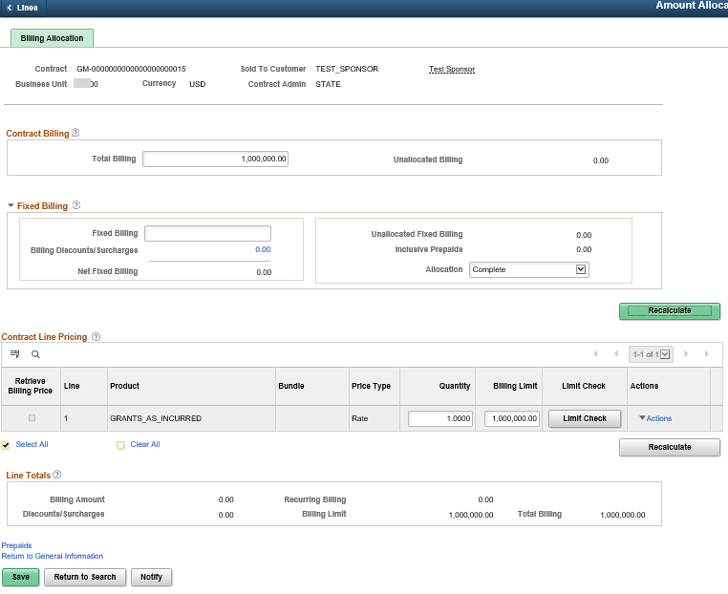

*Figure 10. Amount Allocation page*

|  |  |
| --- | --- |
| **Fields** | **Description** |
| Allocation | Set Allocation to “Complete” in order activate the Contract  Note: Enter the Total Billing and Billing Limit on the Contract Line Pricing amounts. Click the Recalculate button. The Allocation should display as “Complete” and “Unallocated Billing” should be 0.00. |

*Table 6. Amount Allocation Page*

|  |  |
| --- | --- |
| **Page Name** | **Navigation** |
| General Information | Projects and Grants Homepage > Customer Contracts > Customer Contracts > General Information > Lines tab > Contract Lines - Detail tab |
|  | **NavBar** |
| General Information | Navigator > Customer Contracts > Contracts Center > General Information > Lines tab > Contract Lines - Detail tab |

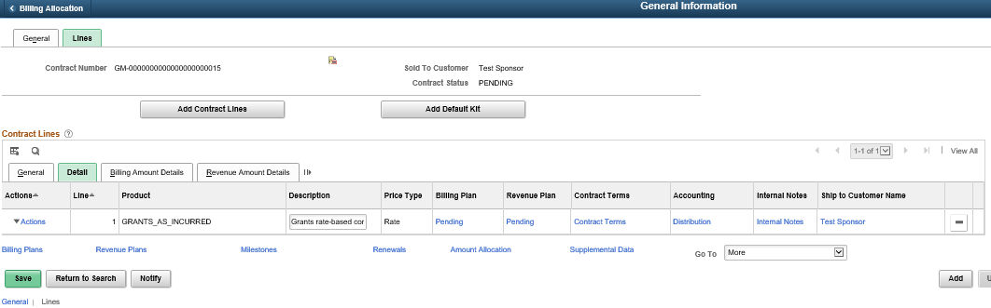

*Figure 11. Lines page – Contract Lines Detail tab*

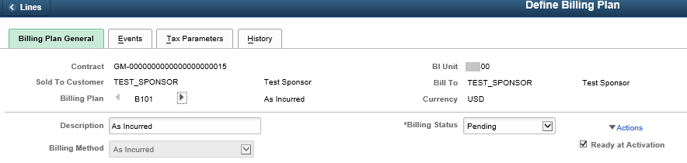

*Figure 12. Billing Plan General tab*

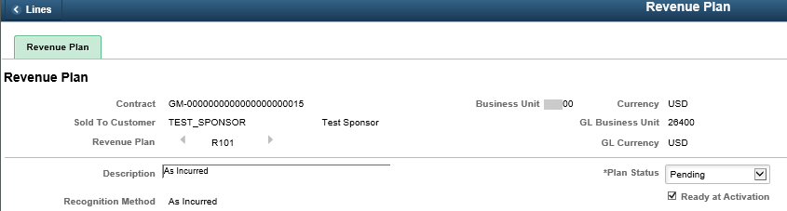*Figure 13. Revenue Plan page*

## Topic 4. Creating and Updating Milestones (Amount Based Contracts Only)

* Milestones can be added to an amount-based contract to trigger billing or revenue recognition.
* There are several types of Milestone templates to select:

|  |  |
| --- | --- |
| **Milestone Template** | **Description** |
| DATE1 | Date Type Milestone |
| DESIGN | Design Complete |
| ENHANC | Enhancements Complete |
| GOLIVE | System Go Live |
| INSTAL | Installation Complete |
| MILE1 | Milestone Type Milestone |
| START | Contract Work Started |
| UPGRAD | Upgrade Complete |
| SHIP01 | Product Shipped |
| INST01 | Product Installation |

*Table 7. Milestone Templates*

* The Milestone Processing Application Engine runs as a batch process and updates milestone condition statuses from “Ready” to “Completed” for Milestone Date.

|  |  |
| --- | --- |
| **Page Name** | **Navigation** |
| Create Milestones | Navigator > Customer Contracts > Create and Amend > Create Milestones |

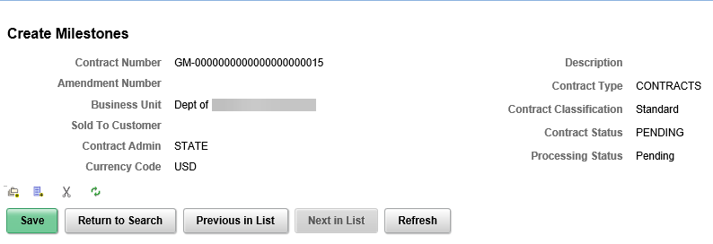*Figure 14. Create Milestones*

*Note: The State of Kansas currently does not use Milestones. If interested in this*

*Functionality, a Service Desk ticket must be submitted.*

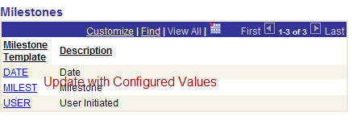

*Figure 15. Create Milestone templates*

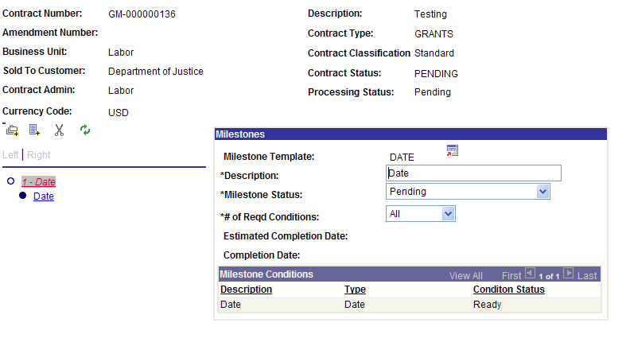*Figure 16. Milestone page*

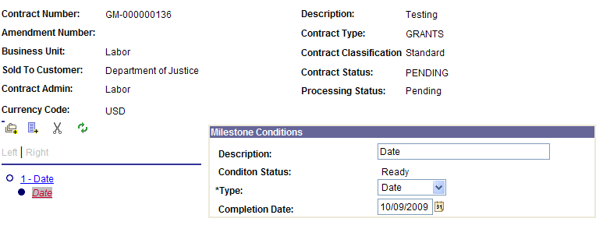*Figure 17. Milestone Conditions page*

| **Fields** | **Description** |
| --- | --- |
| Add Milestone | Click the Add Milestone button to add a milestone template to the contract. The milestone template populates the Milestone page with predetermined values and milestone conditions for the contract. You can change the values, conditions |
| Add Condition | Click the Add Condition button to add a milestone condition to the selected milestone. You must have an existing milestone to add a milestone condition. |
| Delete | Click the Delete button to delete the selected milestone or milestone condition |
| Refresh | Click the Refresh button to refresh the Milestone page. If you have changed any milestone templates, refreshing the page updates the names of milestone and milestone conditions in the milestone tree. |
| Description | Accept the default description or enter a contract- specific description. This enables you to easily take a generic milestone description and make it specific |
| Milestone Status | Select a milestone status. Values are:  ***Pending*** *-* Milestones are not processed by the Milestone Processing Application Engine  ***Ready*** *-* Milestones are eligible for processing by the Milestone Processing Application Engine  ***Completed*** *-* The Milestone Processing Application Engine updates the milestone status to *Completed* after its conditions are met  ***Cancelled*** *-* Cancel a milestone by manually setting the milestone status to cancelled |
| **Fields** | **Description** |
| Type | Select a milestone condition type of *Date, Milestone,* or *User Initiated* |
| Completion Date | For *Date* milestone condition types, enter the completion date. The milestone condition is complete when the system date (i.e. current date) reaches the completion date.  For *User Initiated* milestone condition types, the completion date is an optional field. The milestone condition is complete when you click the **Mark Complete** button. If you do not specify a completion date prior to selecting the Mark Complete button, when you select Mark Complete, the system records the completion date as the current date. |
| Estimated Completion Date | (Optional) Enter an estimated completion date. This date has no effect on milestone processing. The field is available for milestones with *User Initiated* milestone condition types. |
| Mark Complete | Click to manually set the status of a *User Initiated* milestone condition type to *Completed.* This field is available only for *User Initiated* milestone condition types. |

*Table 8. Milestones and Conditions pages*

## Topic 5: Creating an Amendment

* A contract amendment is a change made to an active contract where you modify the original terms and conditions of the contract
* Use the Amendments page to enter the initial amendment details when you first begin an amendment
* Use the Amendment Amount Allocation page to allocate the amended negotiated change amounts for amount-based contracts to the amended contract lines



* After you finish entering amendment data, set the amendment status to “Ready”
* If the amendment’s Process Date is less than or equal to the amendment processing run date (i.e. current date), the amendment is eligible to be applied by the Amendment Processing engine
* When an amendment is processed, the system sets the amendments status to

‘Completed’, and the values that you specified for that amendment become the current, active values.

|  |  |
| --- | --- |
| **Amendment Type** | **Description** |
| CANC | Cancellation |
| RNEG | Renegotiation |
| SCHG | Scope Change |
| OTHR | Other |
| ACTV | Contract Activation |

*Table 9. Amendment Types*

|  |  |
| --- | --- |
| **Amendment Reason** | **Description** |
| ADD | Additional Purchase |
| CSSN | Concession |
| ERR | Data entry error |
| SCOP | Scope Change |
| OTHR | Other Reason |

*Table 10. Amendment Reasons*

|  |  |
| --- | --- |
| **Page Name** | **Navigation** |
| Amendments | Projects and Grants Homepage > Customer Contracts > Customer Contracts > General Information > General tab |
|  | **NavBar** |
| Amendments | Navigator > Customer Contracts > Create and  Amend > Amendments |

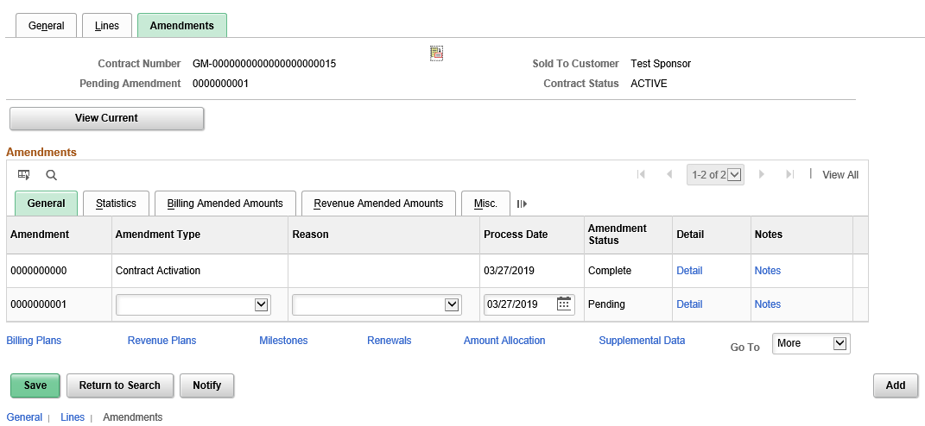*Figure 18. Amendments page*

|  |  |
| --- | --- |
| **Fields** | **Description** |
| Amendment Type | Displays an amendment type, which is a high-level indicator that enables you to create categories of amendments.  **Note:** This field is informational only. No processing is driven by it. |
| Reason | Displays an amendment reason, which provides viewers with a quick reference as to why an amendment was initiated.  **Note:** This field is for informational purposes only. No processing is driven by it. |
| Detail (Link) | Takes you to the Amendment Details page |

*Table 11. Amendments page*

|  |  |
| --- | --- |
| **Page Name** | **Navigation** |
| Amendments Details | Projects and Grants Homepage > Customer Contracts > Customer Contracts > General Information > Amendments > Details link |
|  | **NavBar** |
| Amendments Details | Navigator > Customer Contracts > Create and  Amend > Amendments > Details link |

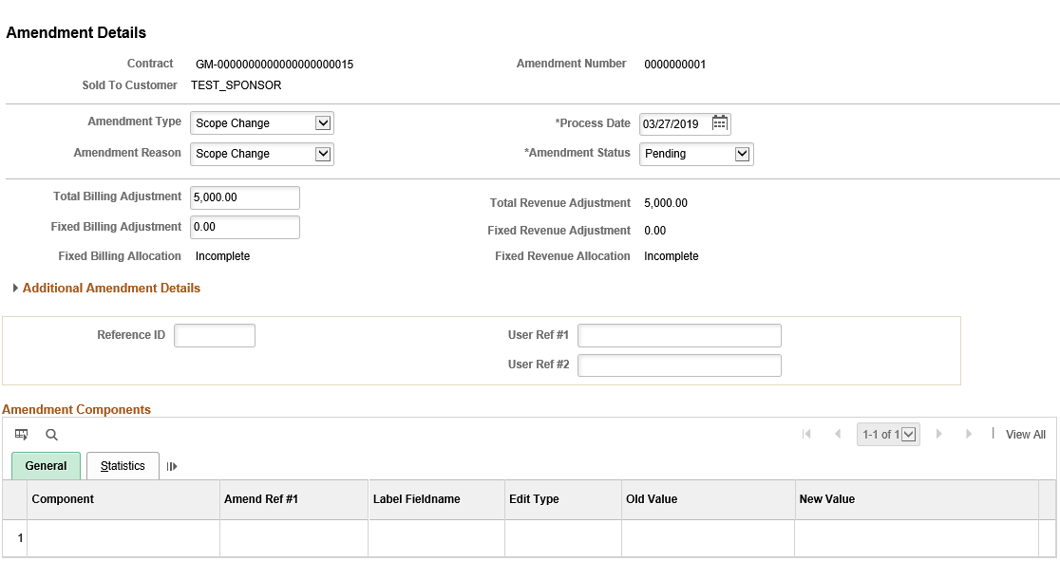*Figure 19. Amendment Detail page*

|  |  |
| --- | --- |
| **Fields** | **Description** |
| Amend Status | Displays the current amendment status |

*Table 12. Amendment Detail page*

|  |  |
| --- | --- |
| **Page Name** | **Navigation** |
| Amendments Amount Allocation | Projects and Grants Homepage > Customer Contracts > Customer Contracts > General Information > Amendments > Details link > Amendment Amount Allocation link |
|  | **NavBar** |
| Amendments Amount Allocation | Navigator > Customer Contracts > Create and Amend > Amendments > Details link > Amendment Amount Allocation link |

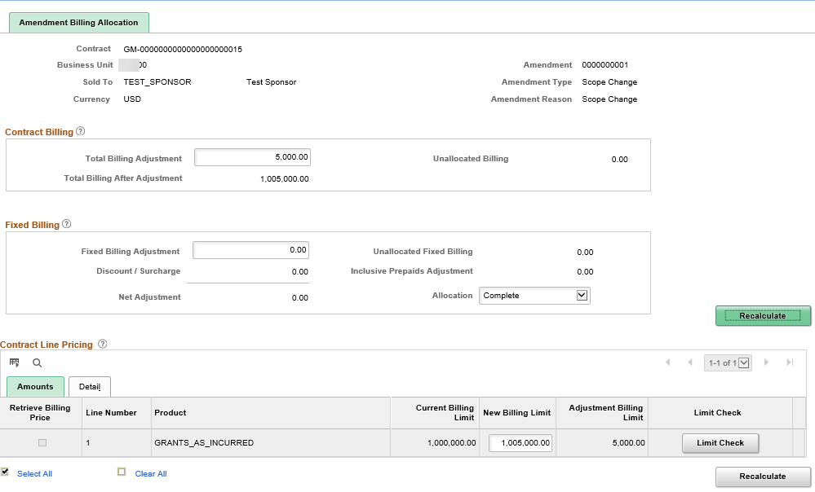*Figure 20. Amendment Amount Allocation page*

|  |  |
| --- | --- |
| **Fields** | **Description** |
| Adjustment Amount | Displays the total amendment amount. This total can be an amount increase or decrease. The amount in this field must equal the sum of the Adjustment Amount values for all contract lines before you can select *Complete* in the Allocation field. |
| New Billing Limit | Update the New Billing Limit to reflect the amount of increase or decrease. |
| Recalculate Button | When you click Recalculate, the Unallocated Billing should be 0.00. |

*Table 13. Amendment Amount Allocation*

**For steps to amend a Rate-based Contract, please see the “Increasing the**

**Billing Limit On an As Incurred Contract” job aid on the SMART website.**

## Topic 6: Closing a Contract

* Closing a contract requires you to close both the related revenue recognition and billing plans by manually changing the status to “Completed.”
* Then from the contract General tab, change the Contract Status to “Closed”.

|  |  |
| --- | --- |
| **Page Name** | **Navigation** |
| Billing Plan General | Projects and Grants Homepage > Customer Contracts > Customer Contracts > General Information > Lines tab > Contract Lines – Detail tab > Billing Plan Status link |
|  | **NavBar** |
| Billing Plan General | Navigator > Customer Contracts > Schedule and Process Billing > Define Billing Plan |

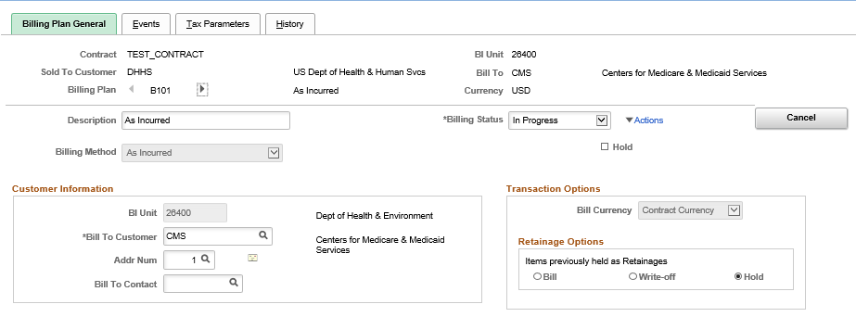

*Figure 21. Billing Plan General page*

|  |  |
| --- | --- |
| **Page Name** | **Navigation** |
| Revenue Plan | Projects and Grants Homepage > Customer Contracts > Customer Contracts > General Information > Lines tab > Contract Lines – Detail tab > Revenue Plan Status link |
|  | **NavBar** |
| Revenue Plan | Navigator > Customer Contracts > Schedule and Process Revenue > Define Revenue Plan |

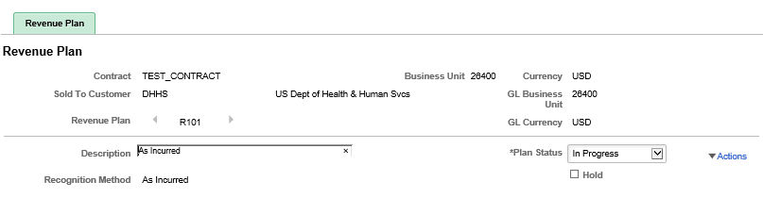

*Figure 22. Revenue Plan General page*

# Lesson 3: Integrating Contracts with other SMART Modules

## Topic 1: Integrating Contracts with Projects and Billing

* Customer Contracts integrates with Billing and Project Costing, enabling you to generate invoices for all of the project costs linked to your contract lines.
* Customer Contracts sends billing information for amount- and rate-based contract lines to Billing,
* Billing processing generates invoices for the contract lines and sends information regarding the invoices back to Customer Contracts and Project Costing.
* Contract Managers must enter revenue received from billings as deposits within the Accounts Receivable module. This training is provided in the Accounts Receivable area of the SMART website.

## Topic 2: Understanding the Contracts/Billing Interface

* Once costs are collected into Project Costing during the nightly batch process, BIL (billable) rows are created for all reimbursable project-related expenditures for projects that are tied to a contract line.
* An Interface ID is created and used by the billing interface to process the bills

into temporary tables and are sent to the billing worksheet.

* The temporary bills in the billing worksheet must be reviewed and approved by the agency before they can be generated into an actual invoice and sent through the downstream billing processes in SMART.
* Bills can be approved at a header or line level. Any price changes are done at the line level.
* If a price is updated and once the bill is approved, the price difference is recorded by the system as a BAJ (Billing Adjustment). The ACT (Actual Cost) and BIL lines will be for the original invoiced amount and BAJ makes up the

corrected amount.

|  |  |
| --- | --- |
| **Page Name** | **Navigation** |
| Worksheet Headers | Billing Homepage > Process Billing Worksheets > Update Billing Worksheet |
|  | **NavBar** |
| Worksheet Headers | Navigator > Billing > Manage Billing Worksheet > Update Billing Worksheet |

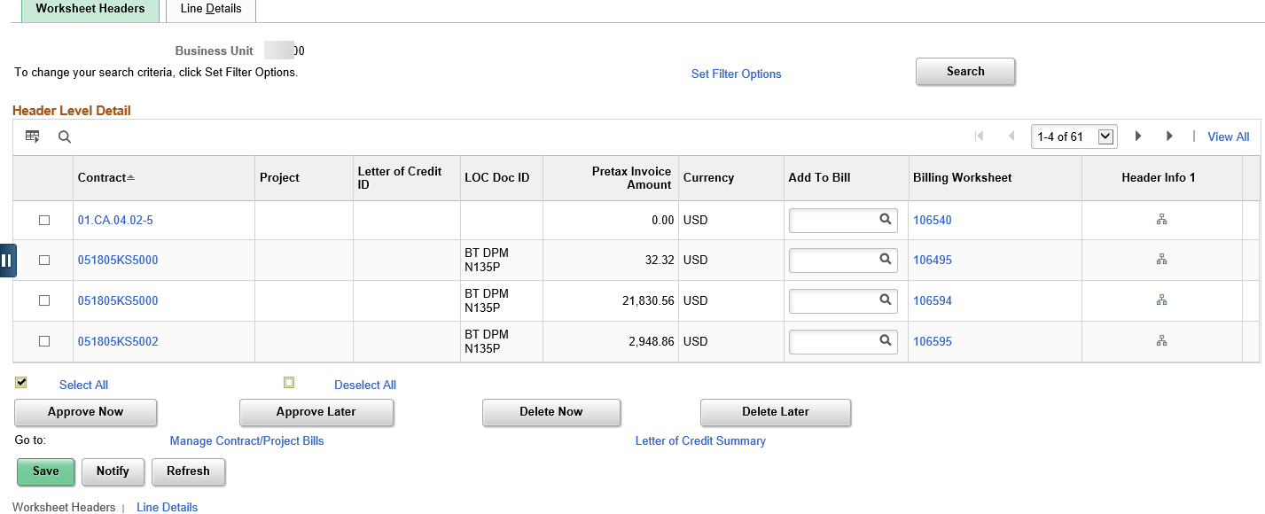

*Figure 23. Worksheet Headers page*

|  |  |
| --- | --- |
| **Fields** | **Description** |
| Approve Now | Click this button to approve the selected billing  worksheets and to create a regular invoice |
| Approve Later | **Do not use this button** |
| Delete Now | **Do not use this button** |
| Delete Later | **Do not use this button** |

*Table 14. Worksheet Header*

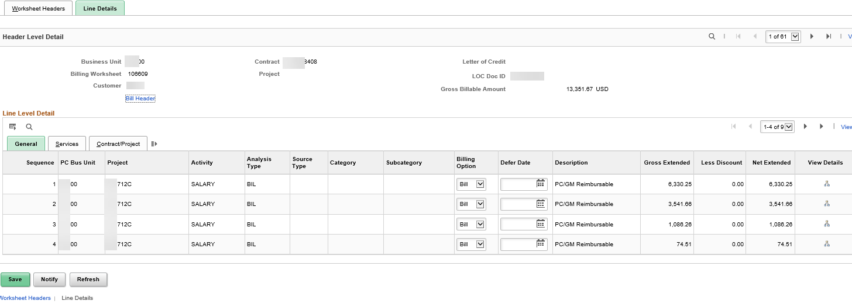

*Figure 24. Line Level Details*

|  |  |
| --- | --- |
| **Fields** | **Description** |
| Billing Option | Choose how to handle the billable transaction. Bill, Defer, Mark as Over the Limit, or Write Off.  Do not use the Delete option. |
| Defer Date | Date that the bill is deferred to. Upon this date, the billable transaction will re-appear on a new billing worksheet for processing. |
| View Details Link | Click this button to navigate to the Standard Billing - Line Worksheet page, where you can review the detailed bill line information and make changes |

*Table 15. Line Level Details*

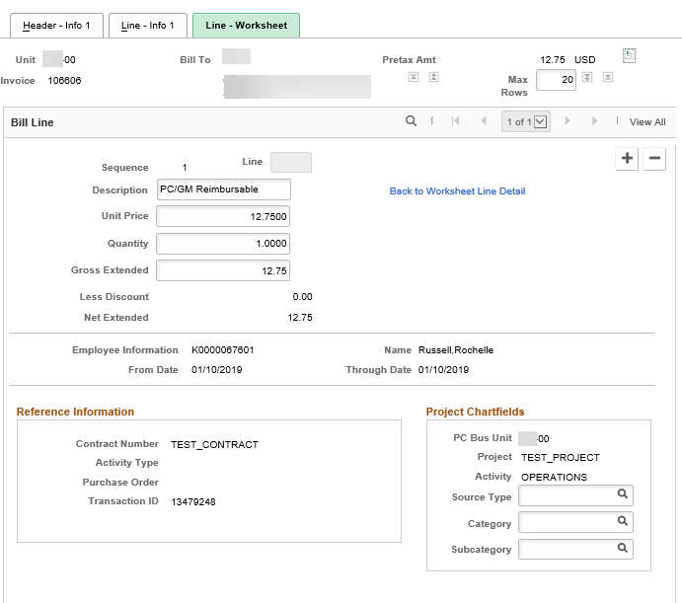*Figure 25. Line Level*

|  |  |
| --- | --- |
| **Fields** | **Description** |
| Gross Extended | Displays the total gross extended amount for the bill line. Make any updates to the price in this field. |

*Table 16. Line Level Information*