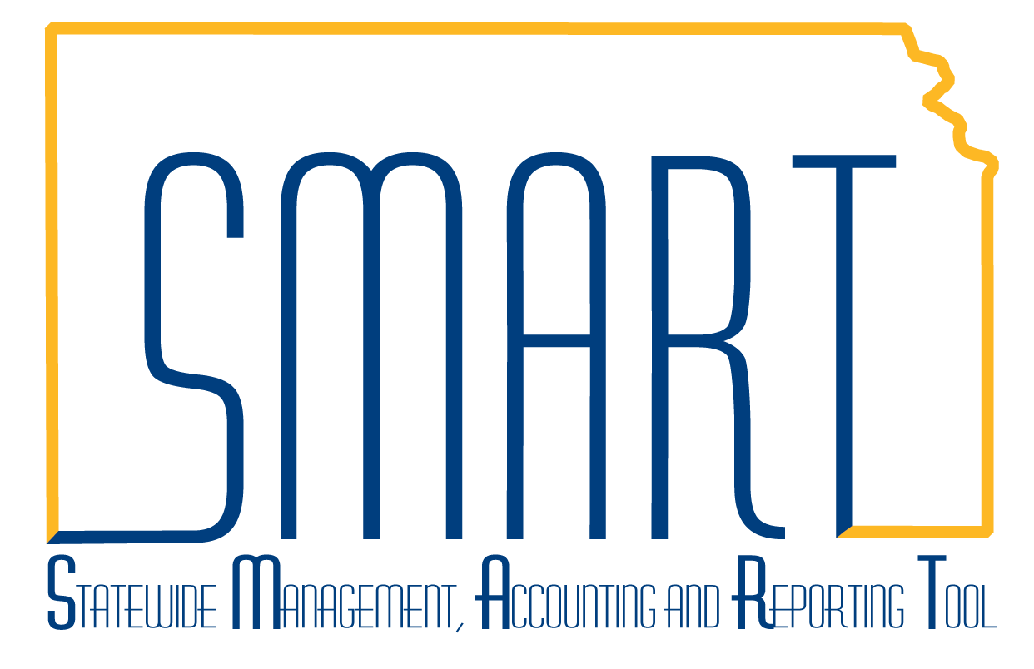
State of Kansas
Manager Transaction Review
Statewide Management, Accounting and Reporting Tool

Date Created: | 11/11/2015
Version: | 1.0
Last Updated Date: | 3/4/2019
Process: | Manager Transaction Review is a useful tool for tracking costs, billing, and revenue for a project. The Search criteria include Project, Activity, Contract, Analysis Type, Employee ID, Revenue and Billing Distribution Status, and Dates. This job aid will cover several scenarios.  Note: The functionality of using the Adjust button has not been tested. The use of this button is discouraged.
Scenario 1: | What costs were written off the Billing Worksheet?
Step 1-1. Navigation: Projects and Grants Homepage > Project Costing > Manage Projects > Manager Transaction Review or Navigator > Project Costing > Interactive Reports > Manager Transaction Review. Enter the following information:  Business Unit  Project  Activity  Analysis Type – WTO  Click the Search button. | 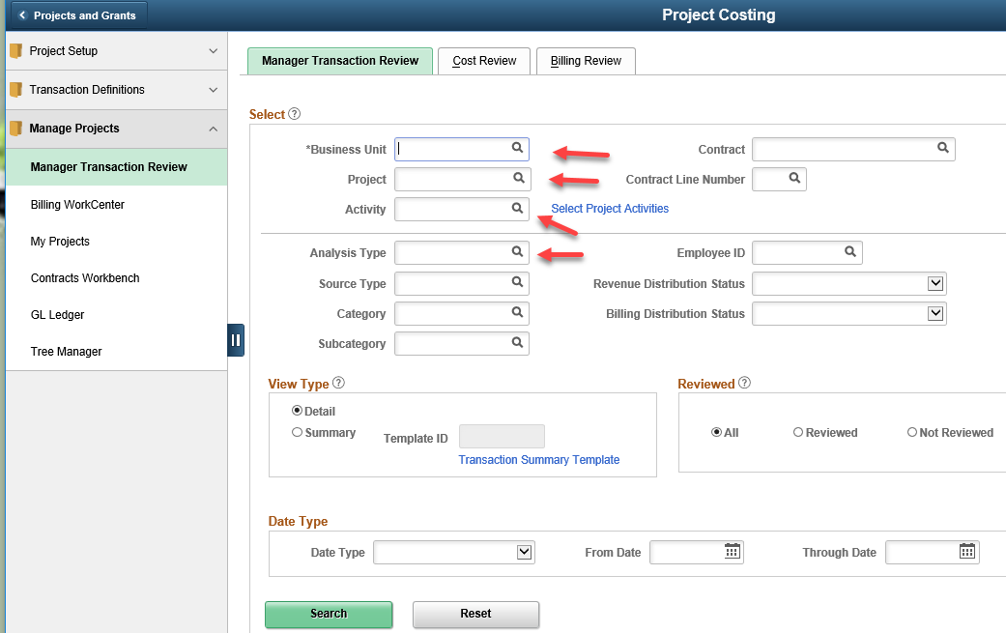
Step 1-2. The Search will land on the Cost Review page, but since the WTO rows would be neither Cost or Billing transactions, select the Review Revenue tab. | 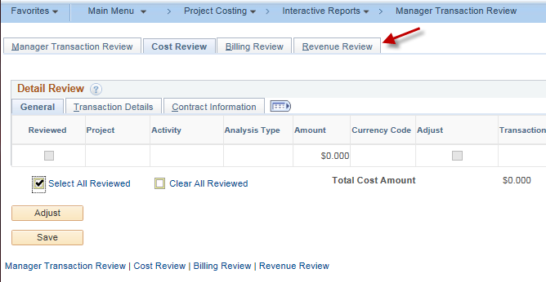
Step 1-3. The Review Revenue page displays all rows with the Analysis Type of WTO. In our example, there are 141 rows associated with the project that have been written off. The date range could be used in the Search criteria to further narrow down the results. | 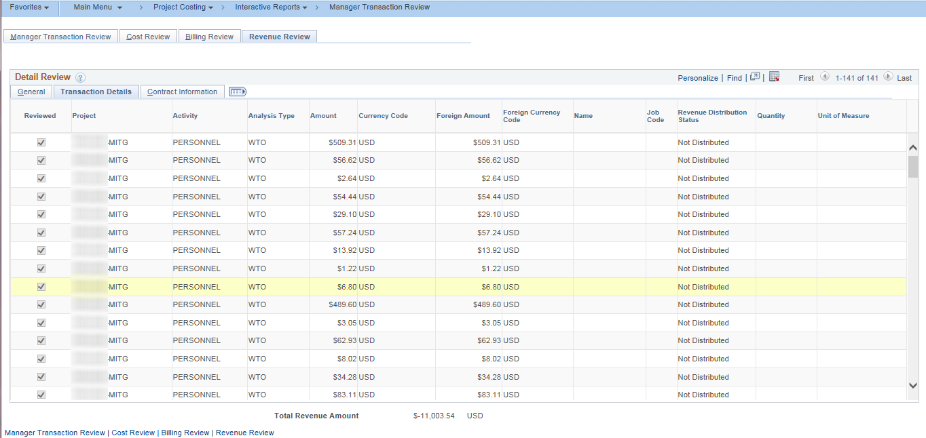
Scenario 2: | An employee expense transaction was originally paid out of a default fund, but after payment a determination was made this should have been a project cost. While the default is a billable transaction, the original transaction was toggled to nonbillable. The Manager Transaction Review is the only location where this type of error can be corrected without more invasive Service Desk intervention.
Step 2-1. The journal will need to be completed first for the transaction to be pulled into Project Costing. Once the transaction is pulled in, Search for the Project in Manager Transaction Review.  Navigation: Projects and Grants Homepage > Project Costing > Manage Projects > Manager Transaction Review or Navigator > Project Costing > Interactive Reports > Manager Transaction Review. Enter the following information:  Business Unit  Project  Activity  and/or Contract  Click the Search button.  When the search pages display, select the Transaction Details tab in the Detail Review grid. In the example the Project would have a row(s) with Billing Status of Nonbillable. For the transaction to process, toggle the row to Billable. Click Save.  Note: A Service Desk request will need to be entered for the row to be processed since the transaction has not completed the nightly batch processes. Reference the How to Fix Travel & Expense costs that are not making it to the Billing Worksheet job aid for more information. | 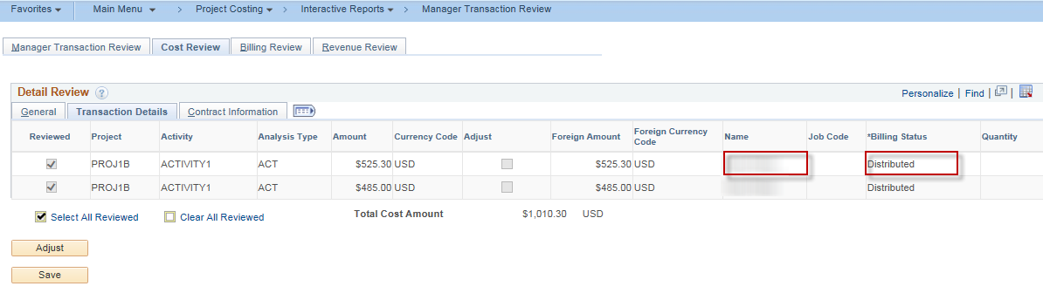  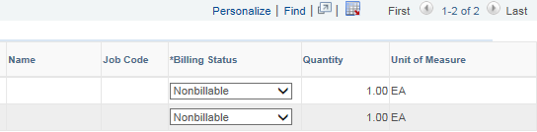
Scenario 3: | The project manager needs to view all transactions that were charged to a particular project during the month. While there are many ways of viewing this information in the system by using queries, reports, and other inquiry pages in SMART, the Manager Transaction Review provides a quick resource for viewing both transaction detail (Cost Review) and what has processed through the Billing module (Billing Review)
Step 3-1. Navigation: Projects and Grants Homepage > Project Costing > Manage Projects > Manager Transaction Review or Navigator > Project Costing > Interactive Reports > Manager Transaction Review. Enter the following information:  Business Unit  Project  Activity  and/or Contract  Note: Rows with the Analysis Type of PAY are Time and Labor Actuals, bringing into SMART the hours for projects. The rows with the Analysis Type of LBR are General Ledger Labor Costs. In this simulation the Analysis Type of LBR was entered into the Search criteria. | 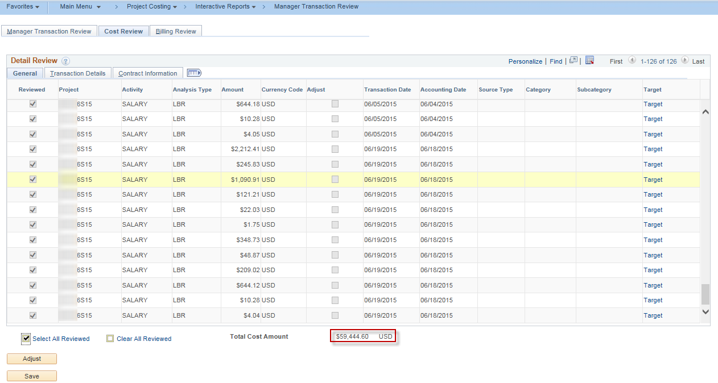
Step 3-2. The second search for BLD rows provides information on the Billing Review tab. In this scenario, it can be determined that all LBR costs have all been billed to the customer.  Note: Project – Job Aids SMART Web > Training > Projects & Grants > Projects > Project – Job Aids provides a document on Analysis Types. | 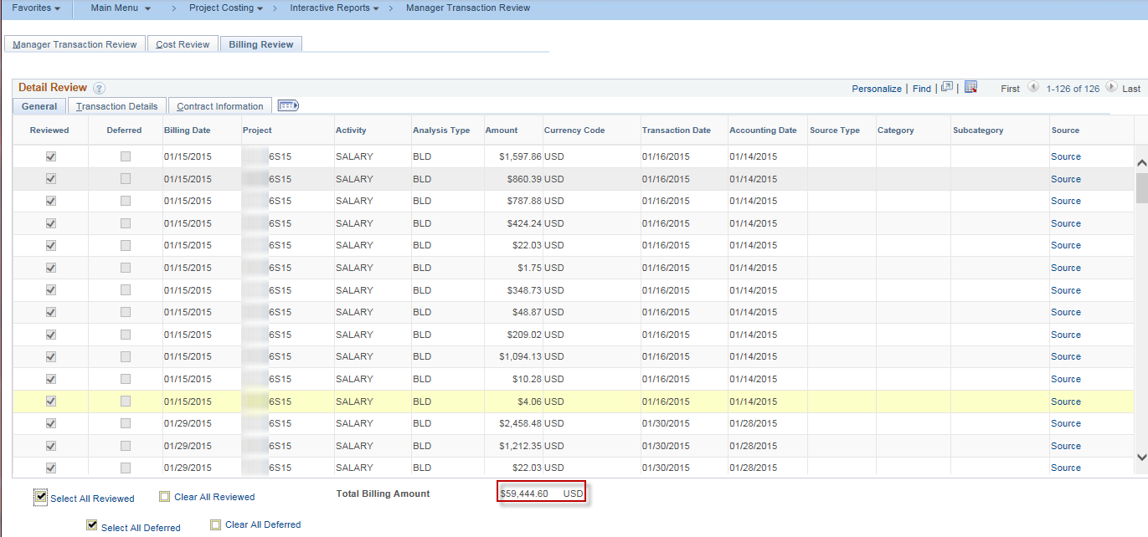
Scenario 4: | Where do I find information on where the transaction originated – voucher, journal, expense,
Step 4-1. Navigation: Projects and Grants Homepage > Project Costing > Manage Projects > Manager Transaction Review or Navigator > Project Costing > Interactive Reports > Manager Transaction Review. Enter the following information:  Business Unit  Project  Activity  And/or Contract  Click the Search button.  On the General tab, select the Target hyperlink on a line being questioned. | 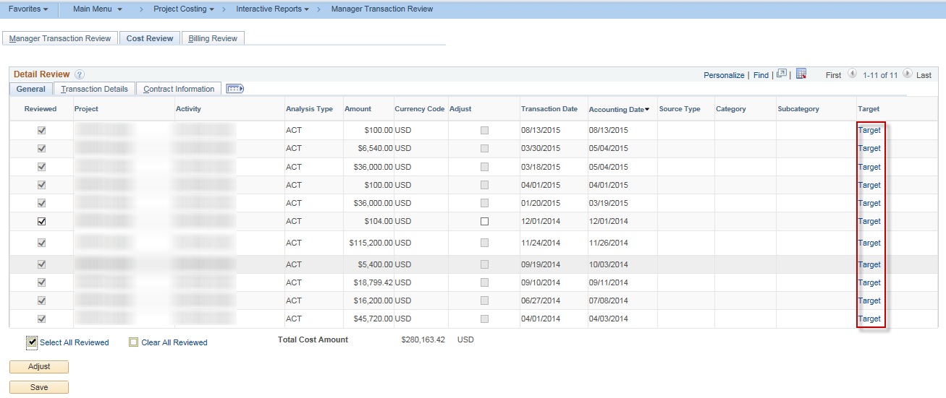
Step 4-2. The Target Transaction Review page displays. In the example, the determination can be made that this is an ACT (Actuals) transaction, processed through the Batch AP processing (BAP), and the transaction has already completed the Billing process with the Analysis Type of BLD (Billed). | 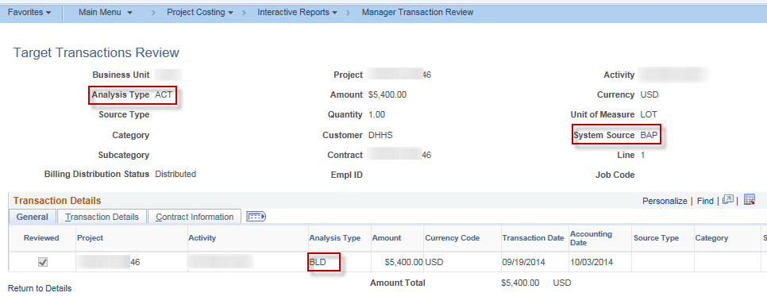
Step 4-3. The example project contained some rows that are questionable. Select the Transaction Details tab on the Detail Review grid on the Cost Review tab. The first and second red highlighted boxes are showing rows that have been Priced, which indicates the overnight batch processes have run, and these rows should be on the Billing Worksheet.  The third highlighted box showing Billable would indicate that the transaction has not been processed overnight and requires further action. | 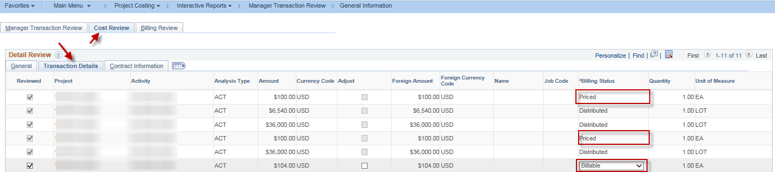
Step 4-4. Verification on the Billing Review tab of the Manager Transaction Review indicates there are two rows with a BIL Analysis Type and there is not a BIL transaction row for the one marked as Unbillable. | 