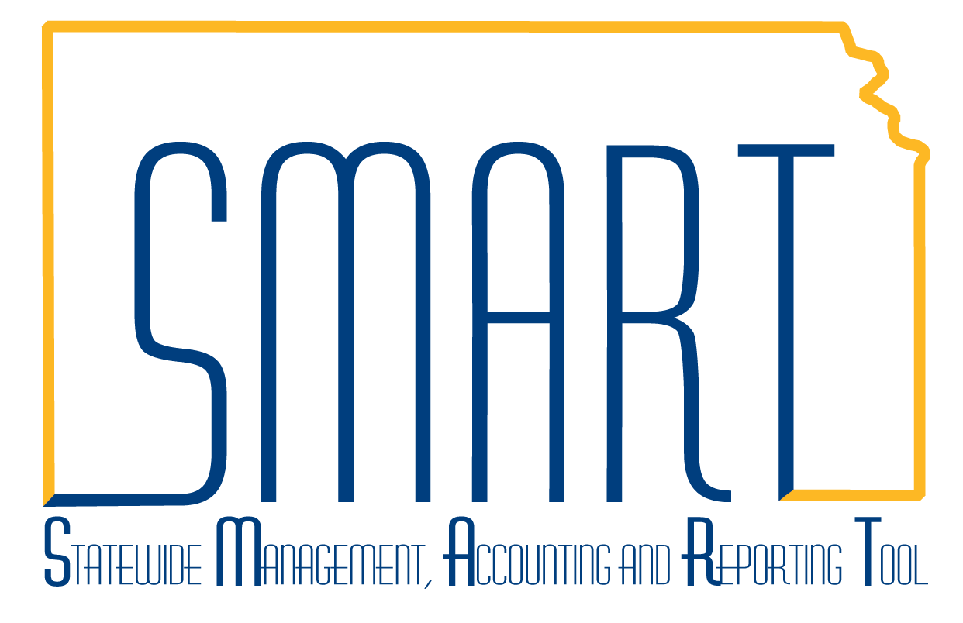
State of Kansas
Maintaining Source Type, Category,
and SubCategory Values
Statewide Management, Accounting and Reporting Tool

Date Created: | 8/14/2013
Version: | 1.2
Last Updated Date: | 3/5/2019
Process: | ROLE: AGENCY PROJECTS MAINTAINER  Project Costing uses transactions to track, analyze, and report on actual and planned project costs. You assign Source Types to individual transactions to identify the transaction's purpose. Source types can be as general or as specific as needed. For example, you can use a Salary source type to track total project Salary costs. Source Types are mostly used for reporting purposes within SMART. Source Types are optional.  Categories and Subcategories further define Source Types. Although defining Categories and Subcategories is optional, using them provides greater flexibility and granularity for tracking and analyzing costs.  Source Types, Categories, and Subcategories are keyed under the agency-specific SETID, so each agency will have its own values. All are limited to 5 characters.
Source Types  Step 1. Navigation: Project Costing Homepage > Manage Projects > Source Types or Navigator > Set Up Financials/Supply Chain > Product Related > Project Costing > Transaction Options > Source Types  Here you can find an existing Source Type if the agency has any set up. | 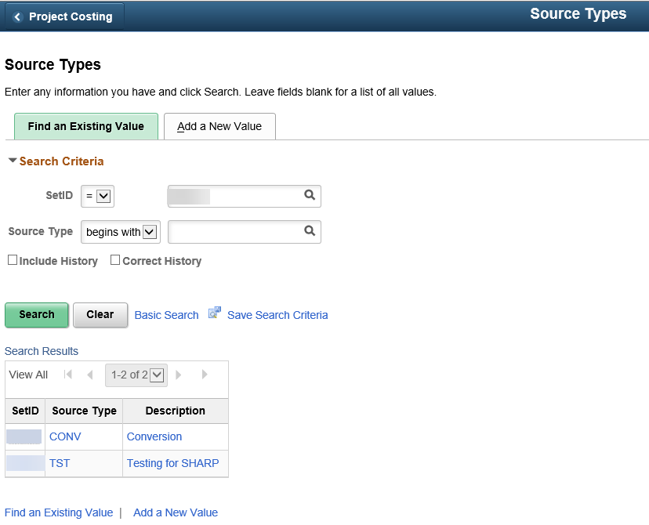
Step 2. You may add additional Source Types using your agency’s SetID (i.e. your agency number).  Click the Add a New Yalue tab and enter the SetID and Source Type, as defined by your agency. Click Add. | 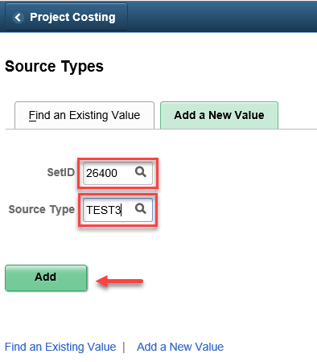
Step 3. The Effective Date will default to the current date. Update as necessary. If adding a new Source Type, retain the Active Status. In the Description field, provide a short description. Click Save.  Note: If inactivating a current Source Type, the other Status is Inactive, which would be approriate as well as an appropriate effective date on which the change should be effective. | 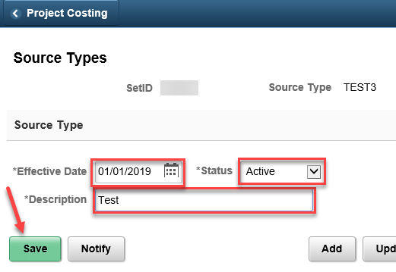
Categories  Step 1. Navigation: Project Costing Homepage > Manage Projects > Categories or Navigator > Set Up Financials/Supply Chain > Product Related > Project Costing > Transaction Options > Categories.  Here you can find an existing Categories, if the agency has any set up. | 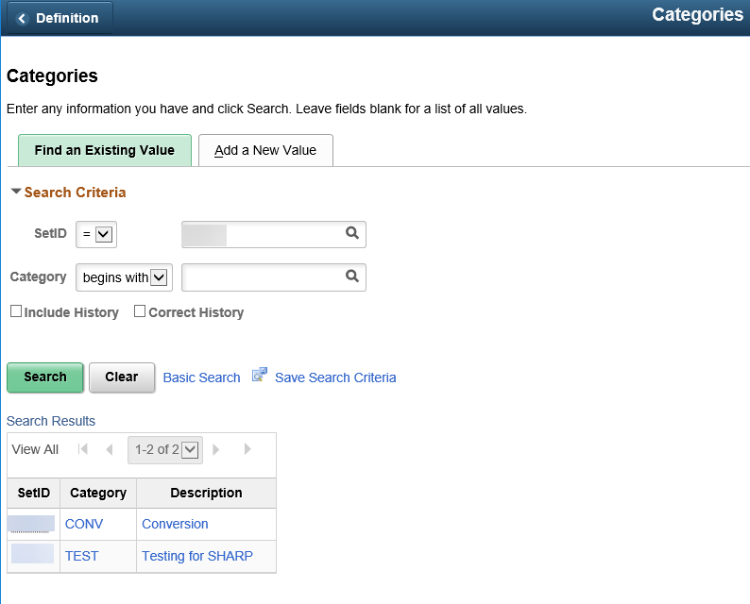
Step 2. You may add additional Categories using your agency’s SetID (i.e. your agency number).  Click the Add a New Yalue tab and enter the  SetID and Category, as defined by your agency.  Click Add. | 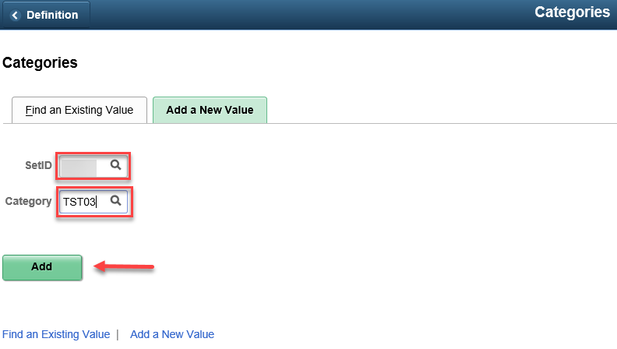
Step 3. The Effective Date will default to the current date. Update as necessary. If adding a new Category, retain the Active Status. In the Description field, provide a short description. Click Save.  Note: If inactivating a current Category, the other Status is Inactive, which would be approriate as well as an appropriate effective date on which the change should be effective. | 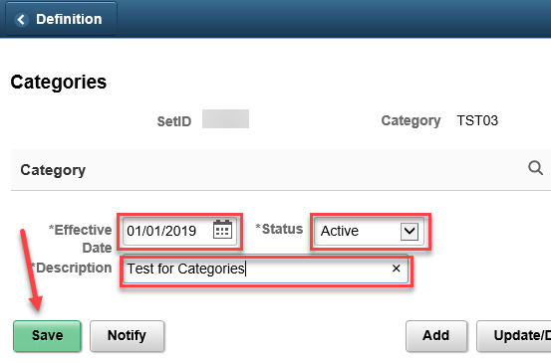
Subcategories  Step 1. Navigation: Project Costing Homepage > Manage Projects > Subcategories or Navigator > Set Up Financials/Supply Chain > Product Related > Project Costing > Transaction Options > Subcategories  Here you can find an existing Subcategories, if the agency has any set up. | 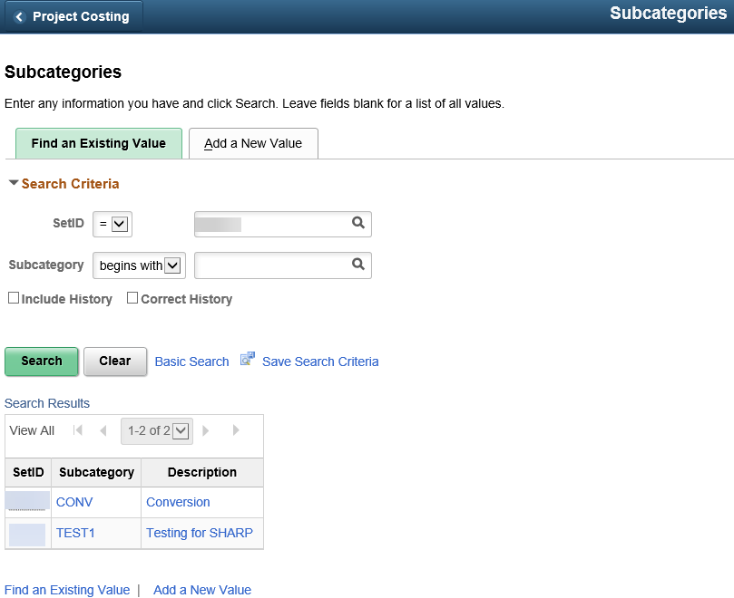
Step 2. You may add additional Subcategories using your agency’s SetID (i.e. your agency number).  Click the Add a New Yalue tab and enter the  SetID and Subcategory, as defined by your agency. Click Add. | 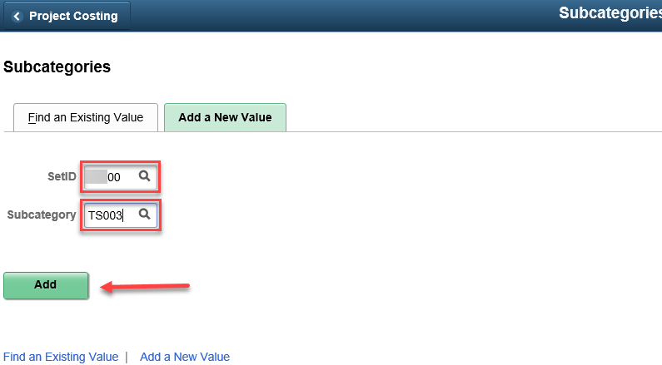
Step 3. The Effective Date will default to the current date. Update as necessary. If adding a new Subcategory, retain the Active Status. In the Description field, provide a short description. Click Save.  Note: If inactivating a current Subcategory, the other Status is Inactive, which would be approriate as well as an appropriate effective date on which the change should be effective. | 