

Training Guide – Accounts Receivable
Interfund Processing

State of Kansas

Applicable Role(s):

KAR_Agy_Interfund_Processor, KAR_Agy_Interfund_Approver, Agency AP Interfund Processor and Agency AP Interfund Approver
Table of Contents
Interfund Processing Overview 3
Interfund Process and Roles 4
Interfund Basics 6
Using the Interfund Details Search Page 6
Navigating the Interfund Details Page 7
Adding and Linking Interfund Transactions 13
Adding Initiating Interfund Deposits 13
Adding Reciprocating Interfund Deposits 15
Linking Deposits to an Interfund 17
Deleting Interfund Deposits 19
Adding Initiating Interfund Vouchers 20
Adding Reciprocating Interfund Vouchers 22
Linking Existing Interfund Vouchers 23
Deleting Interfund Interfund Vouchers 24
Approving and Managing Interfunds 25
Approving Interfund Deposits 25
Approving Interfund Vouchers 26
Sending Interfund Notifications 28
Interfund Updates 30

Interfund Processing Overview

The Interfund process is the method of recording payment and receipt transactions in or between state business units in SMART. It is the systematic movement of funds for the payment of goods/services within or between state agencies that have purchased from or provided goods or services to one another.

Key Terms:
- Interfund – Expense and revenue transactions between and within state agencies
- Initiating – The first of two transactions that make up an Interfund
- Reciprocating – The responding or second of two transactions that make up an Interfund
- Deposit Types – A category that describes the nature of the deposit transaction
  - I (Initiating) – SMART assigns this deposit type when there is not a matching voucher. This deposit is the first transaction for the Interfund.
  - R (Reciprocating) – SMART assigns this deposit type when a matching voucher with origin “I” exists. This deposit is the second transaction for the Interfund.
- Voucher Origin – A value used to identify the source of a voucher. In this case, the source is Interfund transactions.
  - I (Initiating) – SMART assigns this origin when there is not a matching deposit. This voucher is the first transaction for the Interfund.
  - R (Reciprocating) – SMART assigns this origin when a matching deposit with deposit type “I” exists. This voucher is the second transaction for the Interfund.

Interfund Process and Roles
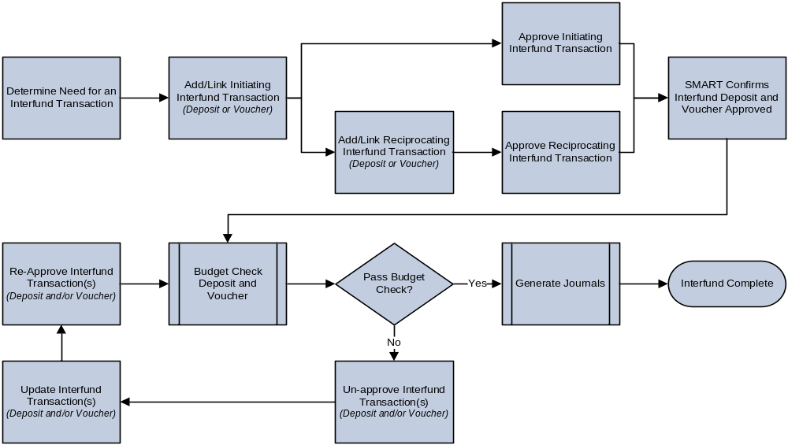
End-to-End Interfund Process
- An Interfund consists of two sides, a deposit and a voucher, and can be initiated by either side.
  - Enter initiating Interfund transaction, including any applicable comments.
    - Notify the reciprocating agency that there is a pending Interfund transaction (optional).
    - Notify the approver of the pending Interfund transaction (optional).
  - Approve the initiating Interfund transaction.
  - Reciprocating agency enters reciprocating Interfund transaction, including any applicable comments.
    - Notify the initiating agency that the reciprocating Interfund transaction is complete (optional).
    - Notify the approver of the pending Interfund transaction (optional).
  - Approve the reciprocating Interfund transaction.
- Once both sides of the Interfund are approved, it is released for processing.
- SMART verifies that the deposit and voucher amounts are equal and that both the deposit and voucher are approved.
- Budget check runs. Budget checking occurs only after both sides of the Interfund transaction are entered and approved.
    - If the voucher fails budget check, it should be unapproved, corrections should be made then the voucher should be reapproved.
    - If changes to the deposit are also necessary, remove approval on the deposit, make corrections and then reapprove the deposit.
Note: The deposit can only be unapproved while the voucher is also “Not Approved”. Interfund deposits that have budget check errors are identified and addressed by the SMART Team.
    - If the voucher passes budget check, the budget status will be ‘Valid’. If the deposit passes budget check, the budget status will be ‘Valid’.
- Accounts Receivable and Accounts Payable journals are generated and posted to the GL.
The following roles are involved in Interfund Processing:
Process Area |  | Role |  | Central / Agency? |  | Description
AR |  | KAR Interfund Processor |  | Agency |  | This role will be responsible for entering and updating Interfund deposits, correcting Interfund deposit errors, and entering Interfund comments. This role will also delete the deposit associated with an Interfund transaction, as needed, but not the Interfund transaction record.
AR |  | KAR Interfund Approver |  | Agency |  | This role will be responsible for approving Interfund deposits. This role will also delete Interfund transaction records, as needed, after the corresponding transactions (deposit and voucher) have been deleted.
AP | KAP Interfund Processor |  | Agency |  | This role will be responsible for entering and updating Interfund vouchers, correcting Interfund voucher errors, and entering Interfund comments.
AP | KAP Interfund Approver |  | Agency |  | This role will be responsible for approving Interfund vouchers. This role will also delete Interfund transaction records, as needed, after the corresponding transactions (deposit and voucher) have been deleted.
SMART User Role Definitions

- Processes:
  - The Office of the Chief Financial Officer (OCFO) does not approve Interfund transactions. The OCFO audits Interfund transactions after completion.
  - Interfund vouchers are released through pay cycle processing without the need for a check or electronic file.
  - To place an order in SMART, the voucher side of Interfund can be initiated and notes included in the comments section.
  - In SMART, each side of an Interfund transaction is visible on the Interfund page to both Accounts Receivable and Accounts Payable once it is entered.

Interfund Basics

Using the Interfund Details Search Page
- Interfund Details search page – Provides key fields to search for an Interfund, Interfund Deposit, or Interfund Voucher. Search fields include Interfund ID, Deposit Unit (AR Business Unit), Deposit ID, Customer ID, AP Business Unit, Voucher ID, Supplier ID, Approval Status for both the deposit and voucher, Creation Date for both the deposit and voucher or any combination of these.
- Interfund ID – A system generated value that ties the deposit and voucher together. Agencies will not be able to enter their own Interfund ID or edit the system-generated value.
- Use the Find an Existing Value tab to search for an existing Interfund deposit or Interfund voucher before entering a reciprocating Interfund transaction.
- Use the Add a New Value tab to generate an Interfund ID and open the Interfund page.

Page Name | Navigation
Interfund Details Page | Accounts Receivable or Accounts Payable Homepage > Interfunds  or  NavBar > Navigator > Accounts Receivable or Accounts Payable > Interfund Details

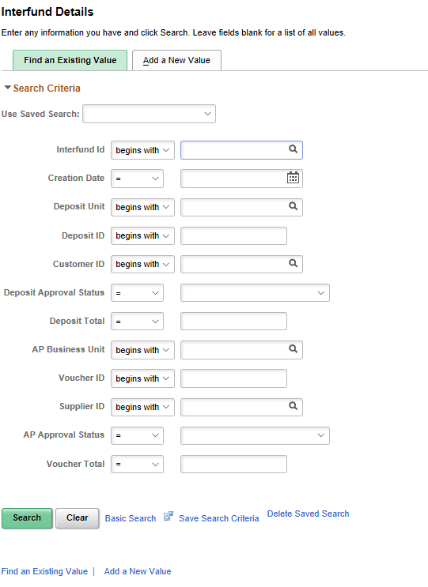
Interfund Details Search Page
Navigating the Interfund Details Page
- This page is used to enter, update, link, review and approve Interfund deposits and vouchers.
- Consists of three main sections: 1) Accounts Receivable Transactions 2) Accounts Payable Transactions 3) Comments
- Key Fields/Buttons
  - Interfund ID – Identifies the unique value assigned to the Interfund record located at the top of the page.
  - Delete button – Used to delete the Interfund record, located at the top of the page. Note: An Interfund cannot be deleted until both the associated deposit and the voucher are removed.
  - Notify button – Used to send notifications to Interfund contacts for the deposit and voucher.
- Accounts Receivable transaction section
  - Hyperlinks are provided to add/update/view a deposit, find an existing deposit to match with an initiating voucher, or remove the existing deposit.
  - Includes details of the deposit, including AR distribution lines
  - AR Interfund Approval box used to approve the Interfund deposit and review approval details (Approved By and Approval Date).
  - Contact information can be selected based on the customer.
  - Approved By and Entered By fields are hyperlinks that display the user’s name, work email, and work phone (if available).

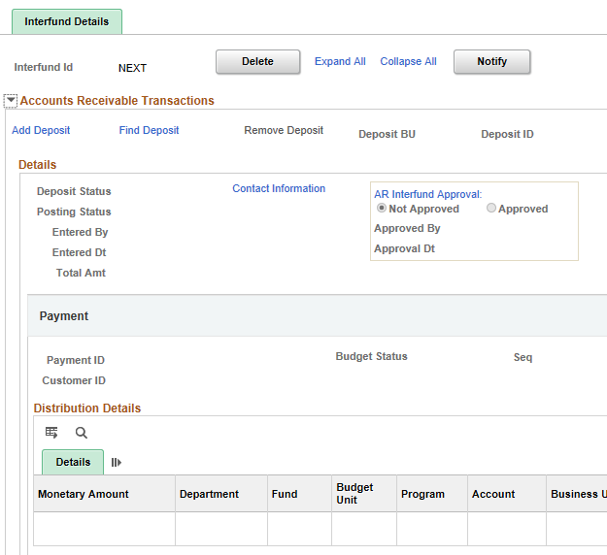
Interfund Details Page – Accounts Receivable Transaction section
Field | Description
Add/Update/View Deposit | Select to add a new Interfund deposit or update an existing Interfund deposit. If the Interfund has been approved on both sides, the deposit can only be viewed.
Find Deposit | Select to add a reciprocating deposit that has been uploaded.
Remove Deposit | Select to remove existing Interfund deposit. The deposit must be unapproved and the accounting entries must not be marked ‘Complete’ to remove the deposit.
Deposit BU | The AR business unit of the Interfund deposit
Deposit ID | Deposit ID for the Interfund deposit
Deposit Status | Status of the Interfund deposit
Posting Status | Posting status of the Interfund deposit
Entered By | User who entered the Interfund deposit
Entered Dt | Date Interfund deposit was entered
Total Amt | Total amount of the Interfund deposit
AR Interfund Approval | Options are ‘Not Approved’ or ‘Approved’. Defaults to ‘Not Approved’ and can only be changed by the AR Interfund Approver.
Approved By | User who approved the Interfund deposit
Approval Dt | Date the Interfund deposit was approved
Payment ID | Payment ID entered on the Interfund deposit
Customer ID | Customer ID of the Interfund deposit
Budget Status | Budget Status of the Interfund deposit
Accounting Entries | Link to Accounting Entries page where accounting entries are added/updated/completed
Distribution Details | ChartField details from the Interfund deposit
Interfund Details Page – Accounts Receivable Transaction section fields
- Accounts Payable Transaction section
  - Hyperlinks are provided to add/update/view a voucher, find an existing uploaded voucher to match with an initiating deposit and remove the existing voucher
  - Includes details of the voucher, including AP distribution lines.
  - AP Interfund Approval box used to approve the Interfund voucher and review approval details (Approved By and Approval Date)
  - Contact can be selected based on the Supplier.
  - Approved By and Entered By fields are hyperlinks that display the user’s name, work email and work phone (if available).
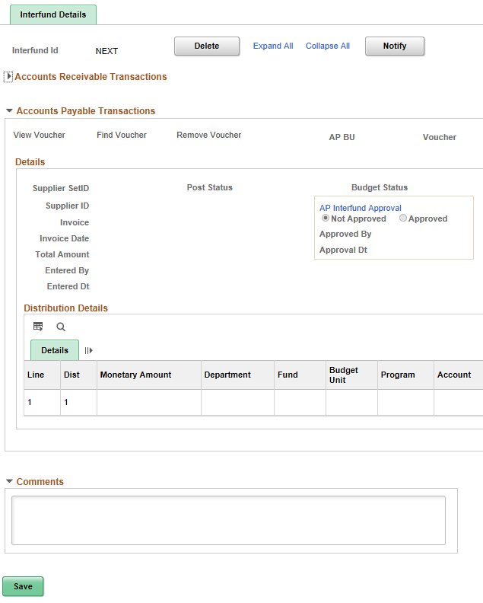
Interfund Details Page – Accounts Payable Transaction section

Field | Description
Add/Update/View Voucher | Select to add an Interfund voucher or update an existing Interfund voucher. After both sides of the Interfund are approved, the voucher can be viewed.
Find Voucher | Select to add a reciprocating voucher that has been uploaded.
Remove Voucher | Select to remove an existing Interfund voucher. The voucher must be unapproved to remove the voucher from the Interfund.
AP BU | The AP Business Unit of the Interfund voucher
Voucher | Voucher ID
Supplier Set ID | Set ID of the supplier. Always SOKID.
Post Status | Posting Status of the Interfund voucher
Budget Status | Budget Status of the Interfund voucher
Supplier ID | Supplier ID of the Interfund voucher
Invoice | Invoice of the Interfund voucher
Invoice Date | Invoice Date of the Interfund voucher
Total Amount | Total Amount of the Interfund voucher
Entered By | User who entered the Interfund voucher
Entered Dt | Date the Interfund voucher was entered
AP Interfund Approval | Options are ‘Not Approved’ or ‘Approved’. Defaults to ‘Not Approved’ and can only be changed by the AP Interfund Approver.
Approved By | User who approved the Interfund voucher
Approval Dt | Date the Interfund voucher was approved
Distribution Details | ChartField details from the Interfund voucher
Interfund Details Page – Accounts Payable Transaction section fields
- Comments field - Field located at the bottom of the Interfund page, used by Accounts Receivable and Accounts Payable to provide relevant information regarding the Interfund. This a free form field with a limit of 2,000 characters. The initiating side should always add reference information regarding purpose of the Interfund and a contact for questions. This field is optional for the reciprocating side.

Adding and Linking Interfund Transactions

This section covers the following in SMART:
- Adding and updating the deposit on an Interfund transaction
- Adding and updating the voucher on an Interfund transaction
- Searching for and finding an existing Interfund deposit or Interfund voucher
- Linking a deposit or a voucher to an Interfund transaction
- Deleting an Interfund transaction

Adding Initiating Interfund Deposits
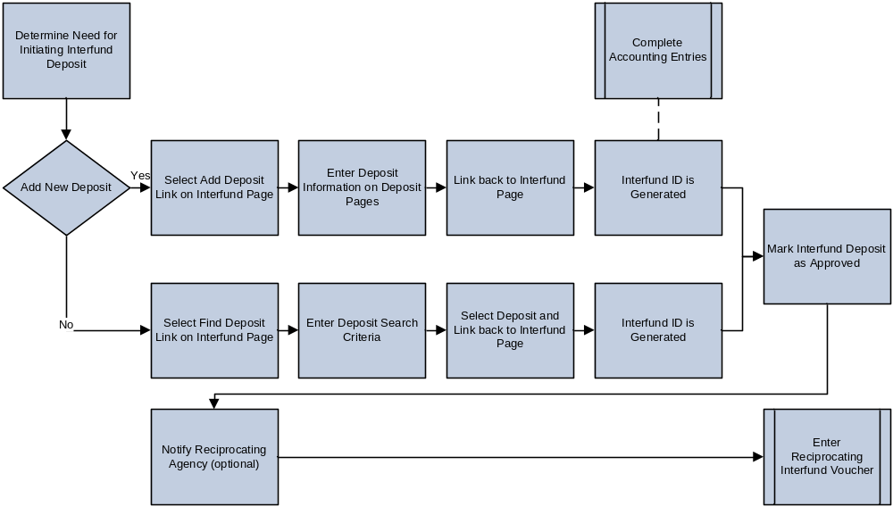
Adding an Initiating Interfund Deposit Process
- Use the Add a New Value tab on the Interfund Details search page when you need to enter an initiating deposit for an Interfund transaction.
- On the Interfund page, use the Add Deposit link to create a new deposit.
Note: The deposit is automatically created with a deposit type ‘I’ (Initiating).
- Updates are made to deposits by opening an existing Interfund and selecting the Update Deposit link from the Accounts Receivable Transactions section of the Interfund page.

Note: Initiating Interfund deposits can also be created automatically when deposits with deposit type ‘I’ are interfaced or uploaded to SMART.

Page | Navigation
Interfund Details Page | Accounts Receivable or Accounts Payable Homepage > Interfunds  or  NavBar > Navigator > Accounts Receivable or Accounts Payable > Interfund Details

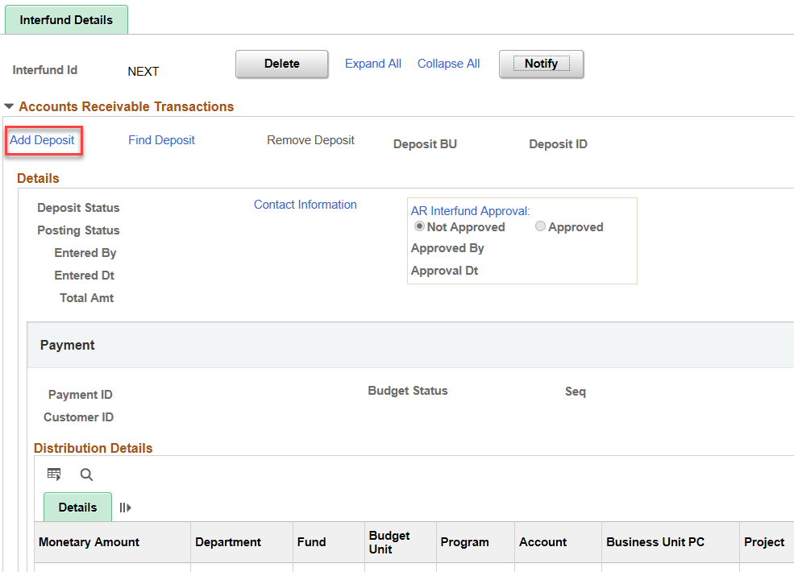
Interfund Details - Add Deposit

- The Customer ID field is required for all Interfund deposits. When entering the initiating deposit, you must include a Customer ID on the Payments page of the deposit.
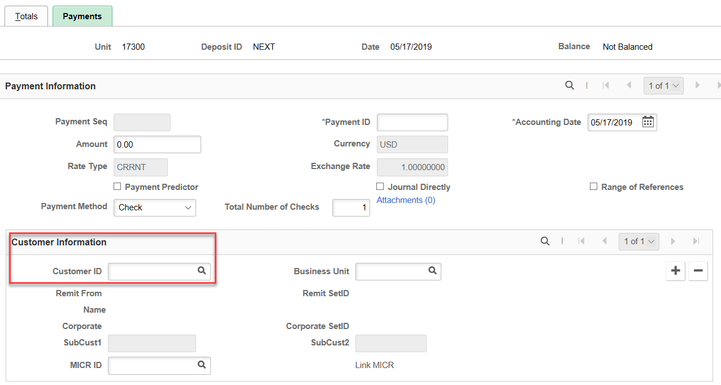
Customer ID field for Interfund Deposits

Adding Reciprocating Interfund Deposits
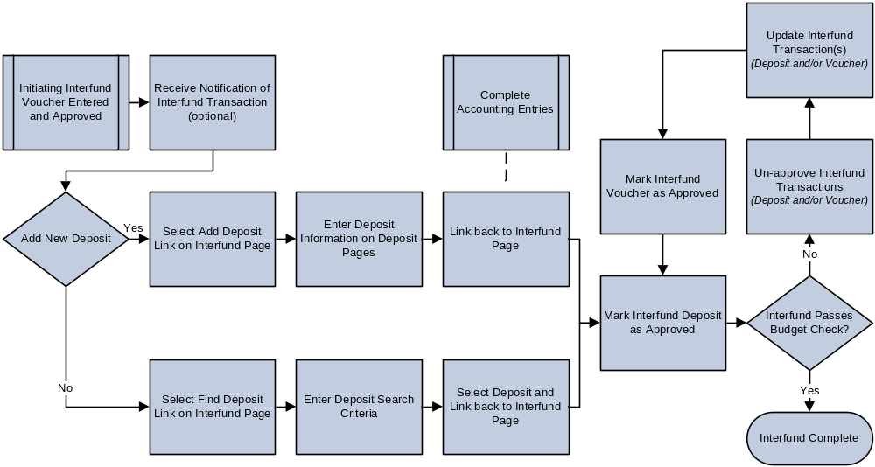
Add Reciprocating Interfund Deposit Process
- Use the Find an Existing Value tab from the Interfund Details search page to find an existing Interfund.
- On the Interfund page, use the Add Deposit link to create a new deposit.
Note: The deposit is automatically created with a deposit type ‘R’ (Reciprocating). Reciprocating Interfund deposits can also be created when deposits with deposit type ‘R’ are interfaced or uploaded to SMART.

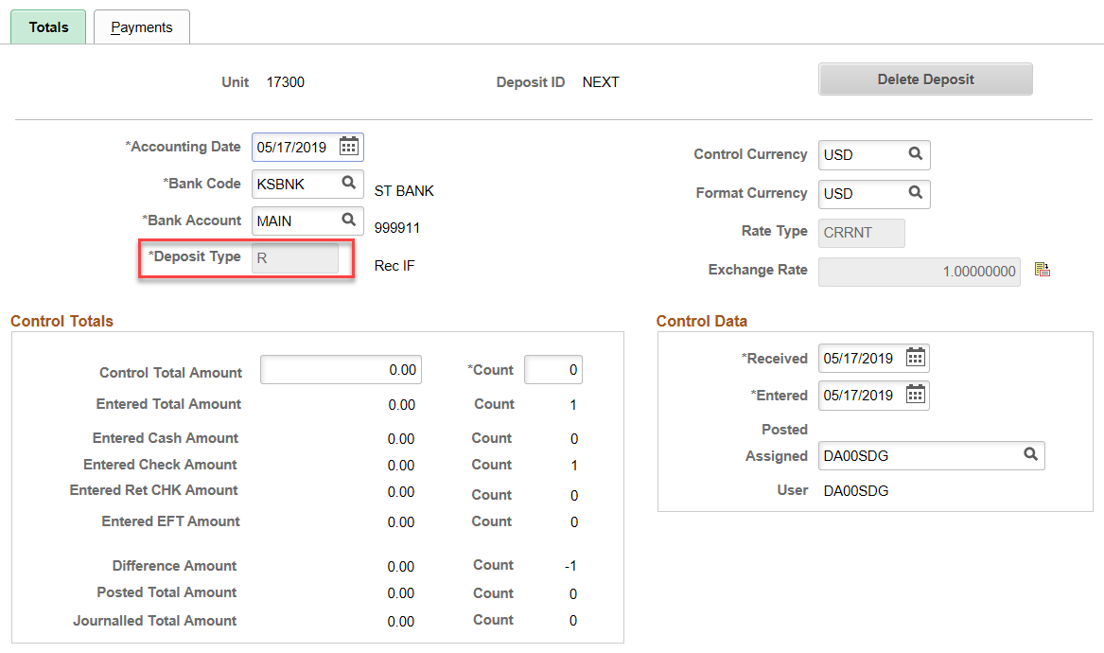
Deposit Totals Page

Updates are made to deposits by opening an existing Interfund and selecting the ‘Update Deposit’ link from the Accounts Receivable Transactions section of the Interfund page.

Linking Deposits to an existing or new Interfund
- Search for existing Interfund or create new Interfund.
- Once on the Interfund Details page, use the Find Deposit link to search for and link an interfaced or Excel uploaded reciprocating deposit for an Interfund transaction.
- Click ‘Search’ to see the deposits available for linking.
Note: You cannot manually enter a deposit in SMART then add it to an Interfund using the Find Deposit link.

Page | Navigation
Interfund Details | Accounts Receivable or Accounts Payable Homepage > Interfunds  or  NavBar > Navigator > Accounts Receivable or Accounts Payable > Interfund Details

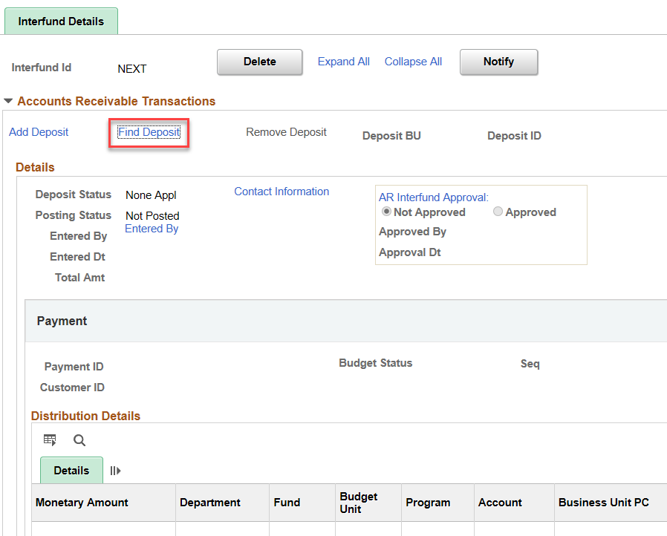
Interfund Details – ‘Find Deposit’ link on new Interfund
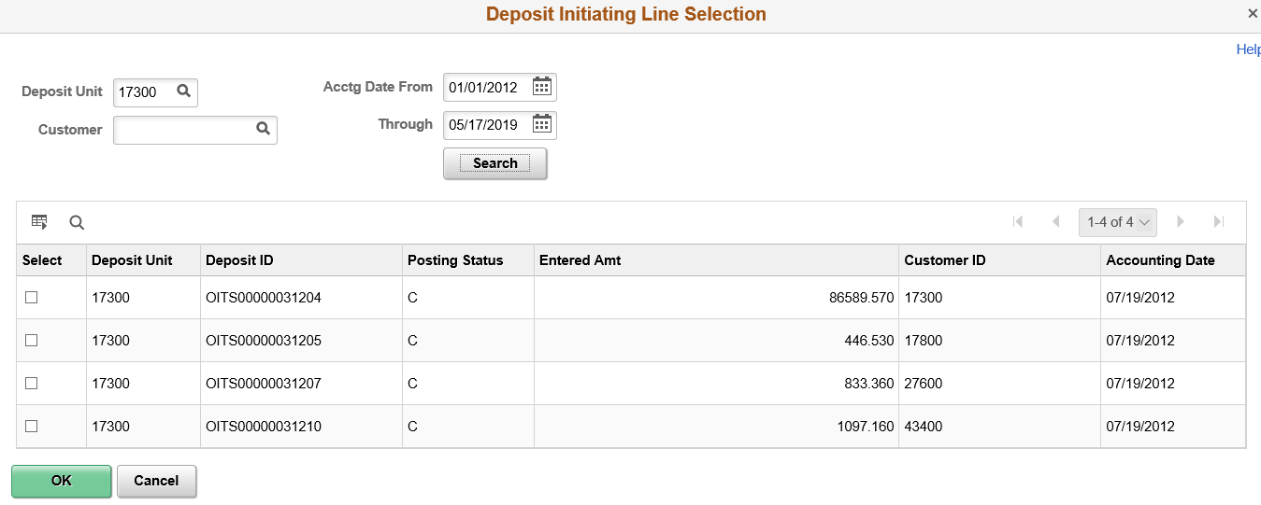
Deposit Initiating - Line Selection page
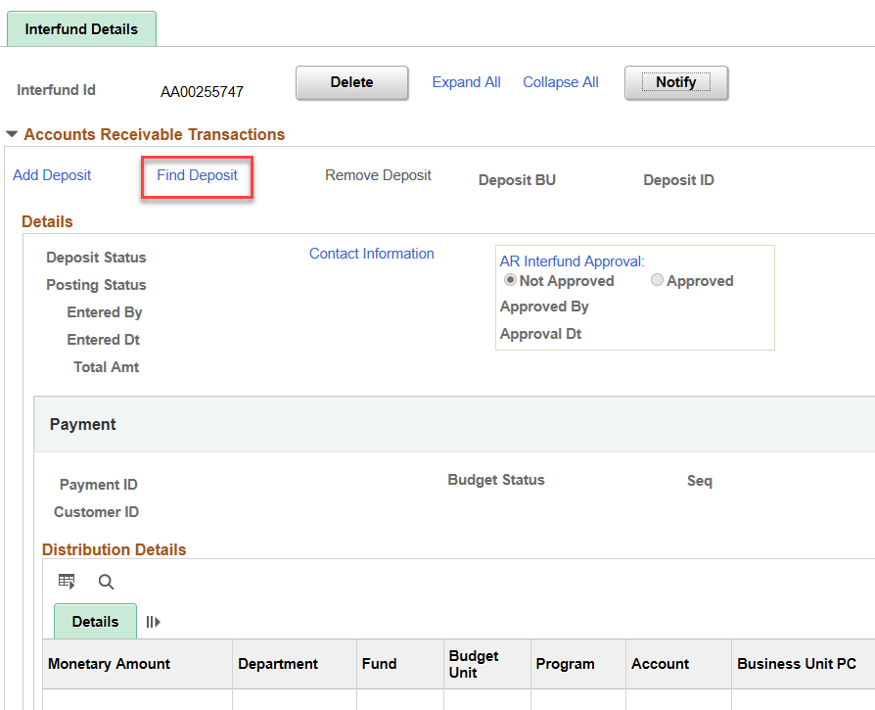
Interfund Details – ‘Find Deposit’ link on existing Interfund
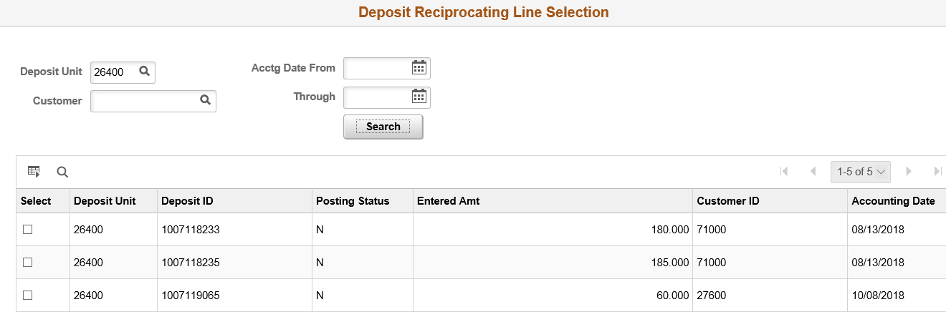
Deposit Reciprocating - Line Selection page

Deleting Interfund Deposits
See the Delete Interfund Deposit job aid for detailed instructions.

- A deposit can be removed from an Interfund before or after removing the voucher. This can be done by the AR Interfund Processor or AR Interfund Approver.
- If the Interfund deposit was approved, the following roles are required to delete it: KAR_Agy_Interfund_Approver
KAR_Agy_Admin
- If the Interfund deposit was not approved, only the KAR_Agy_Admin role is required to delete it.
- Removing the deposit from the Interfund transaction does not delete the deposit from SMART.
- Removing the deposit, deleting the Interfund and deleting the deposit must all take place before the next hourly batch. A deposit with an ‘I’ or ‘R’ deposit type will create a new interfund in hourly batch.
- The deposit can be removed and deleted if there is a voucher associated, only if both sides of the Interfund are not approved. Once both sides of the Interfund are approved, neither side of the Interfund can be edited.

Adding Initiating Interfund Vouchers
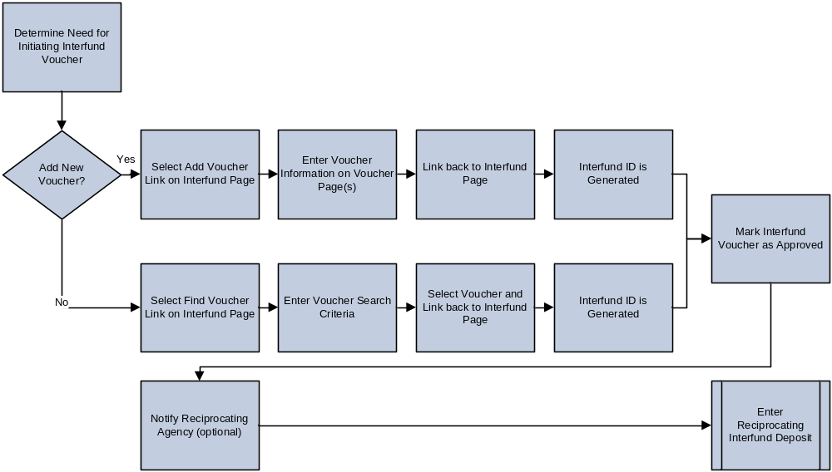
Adding Initiating Interfund Voucher Process
- Use the Add a New Value tab from the Interfund Details search page when you need to enter an initiating voucher for an Interfund transaction.
- On the Interfund Details page, use the Add Voucher link to create a new voucher.
Note: The voucher is automatically created with voucher origin ‘I’ (Initiating).
- Updates are made to vouchers by opening an existing Interfund and selecting the Update Voucher link from the Accounts Payable Transactions section of the Interfund page.
Note: Initiating Interfund vouchers as well as the Interfund record can also be created automatically when vouchers with voucher origin ‘I’ are interfaced or uploaded to SMART.

Page | Navigation
Interfund Details | Accounts Receivable or Accounts Payable Homepage > Interfunds  or  NavBar > Navigator > Accounts Receivable or Accounts Payable > Interfund Details

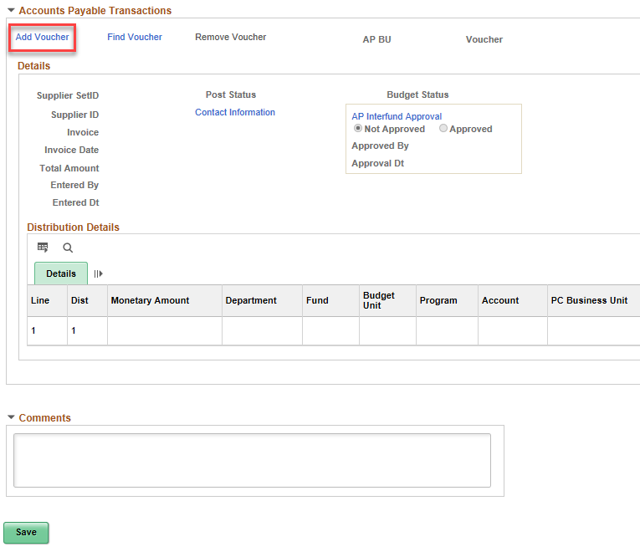
Interfund Details - Add Voucher link

Adding Reciprocating Interfund Vouchers
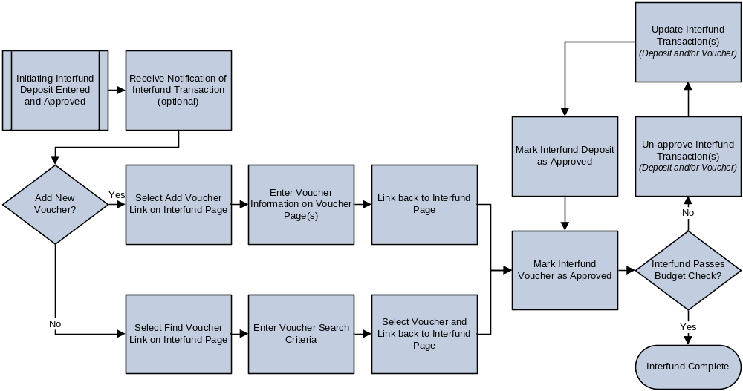
Adding Reciprocating Interfund Voucher Process
- Use the Find an Existing Value tab from the Interfund Details search page to find an existing Interfund.
- On the Interfund page, use the Add Voucher link to create a new voucher.
Note: The voucher is automatically created with voucher origin ‘R’ (Reciprocating).
- Updates are made to vouchers by opening an existing Interfund and selecting the Update Voucher link from the Accounts Payable Transactions section of the Interfund page.
- Reciprocating Interfund vouchers can also be created automatically when vouchers with voucher origin ‘R’ are interfaced or uploaded to SMART.
Linking Existing Interfund Vouchers

- Use the Find an Existing Value tab from the Interfund Details search page to find an existing Interfund.
- On the Interfund Details page, use the Find Voucher link to search for and link an interfaced or Excel uploaded reciprocating voucher for an Interfund transaction.
- Click ‘Search’ to see the vouchers available for linking.

Page | Navigation
Interfund Details | Accounts Receivable or Accounts Payable Homepage > Interfunds  or  NavBar > Navigator > Accounts Receivable or Accounts Payable > Interfund Details

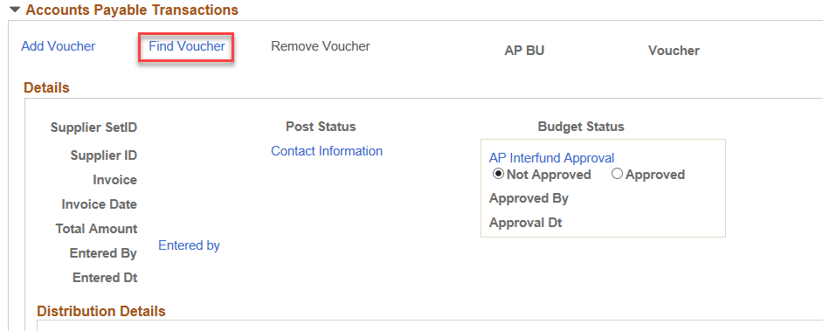
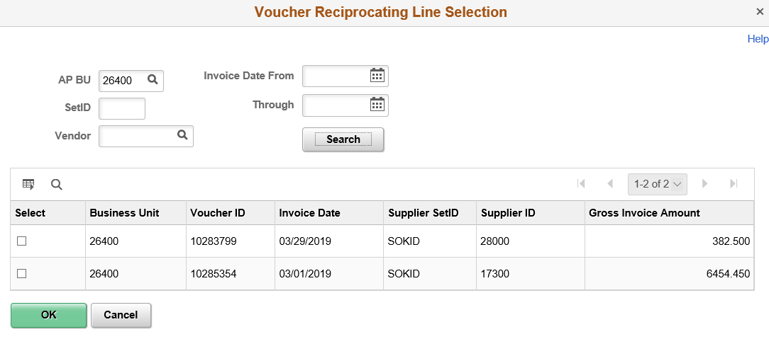
Voucher Reciprocating Line Selection

Deleting Interfund Vouchers
- Remove the deposit from an Interfund before or after removing the voucher. This can be done by the AR Interfund Processor or AR Interfund Approver.
Note: Removing the deposit from the Interfund transaction does not delete the deposit from SMART.
- Remove the voucher from an Interfund before or after removing the deposit. This can be done by the AP Interfund Processor or AP Interfund Approver.
Note: Removing the voucher does not delete the voucher from SMART.
- Delete the Interfund after both the deposit and the voucher have been removed from the Interfund transaction record.

Page | Navigation
Interfund Details | Accounts Receivable or Accounts Payable Homepage > Interfunds  or  NavBar > Navigator > Accounts Receivable or Accounts Payable > Interfund Details

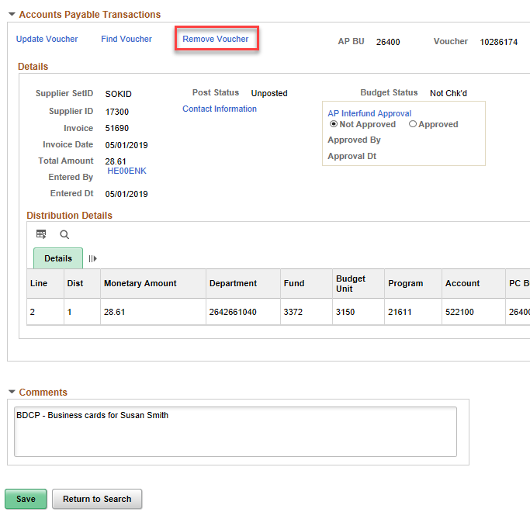
Interfund Details - Remove Voucher
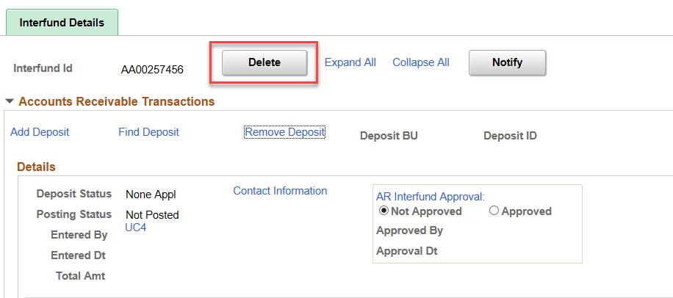
Interfund Details - Delete button

Approving and Managing Interfunds

Approving Interfund Deposits
- The AR Interfund Approver is notified by the AR Interfund Processor when an Interfund deposit is ready for approval. The AR Interfund Approver can be notified by one of the following methods:
  - A manual process outside of SMART (e.g. agency email or phone call).
  - The ‘Notify’ button and manually adding the AR Interfund Approver’s email in the To: or cc: lines on the Send Notification page. Note that both agencies must have contact information updated for the ‘Notify’ feature to work. Please see the ‘Maintaining Notification Contacts for Interfunds’ job aid for more details.
- The AR Interfund Approver reviews the details of the deposit and verifies the amount.
- If a corresponding voucher is present, the AR Interfund Approver verifies that the amount of the deposit and amount of the voucher are equal.
- AR Interfund Approver selects the Approved radio button in the AR Interfund Approval section of the Interfund Details page and then saves. This approves the Interfund deposit side of the Interfund transaction.
  - If this is the first of two approvals, SMART does not require the Interfund voucher to be added or for the voucher and deposit amount to equal, but a warning message appears.
  - If this is the second of two approvals, SMART requires the voucher and deposit amounts to be equal. The approval cannot be saved if the deposit and voucher amounts do not match.

Page | Navigation
Interfund Details | Accounts Receivable or Accounts Payable Homepage > Interfunds  or  NavBar > Navigator > Accounts Receivable or Accounts Payable > Interfund Details

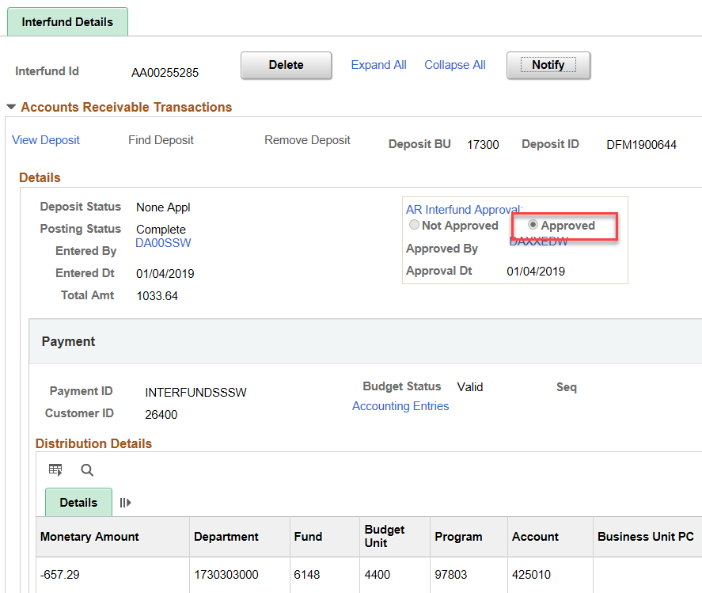
Approved Interfund Deposit

Approving Interfund Vouchers
- Interfund vouchers must be approved on the Interfund page.
- AP Interfund Approver is notified by AP Interfund Processor when an Interfund voucher is ready for approval. The AP Interfund Approver can be notified using one of the following methods:
  - A manual process outside of SMART (e.g. agency email or phone call)
  - The Notify button and manually adding the AR Interfund Approver’s email in the To: or cc: lines on the Send Notification page.
- AP Interfund Approver accesses the Interfund page, reviews the details of the Interfund voucher, and verifies that the amount of the voucher is accurate
- If a corresponding deposit is present, the AP Interfund Approver verifies that the amount of the deposit and amount of the voucher are equal.
- AP Interfund Approver selects the Approved radio button in the AP Interfund Approval section of the Interfund page. This approves the Interfund voucher for the Interfund transaction.
  - If this is the first of two approvals, SMART does not require the Interfund deposit to be added or for the voucher and deposit amount to be equal, but you will receive a warning message.
  - If this is the second of two approvals, SMART requires the voucher and deposit amounts to be equal. Otherwise, you will not be able to save the approval. Upon the second approval, you will receive a message notifying you that the Interfund will be released for processing. This is the last opportunity to make changes. Select ‘No’ if changes need to be made.
- Once both sides of an Interfund transaction are approved, no changes can be made to the Interfund transaction unless it fails budget check.
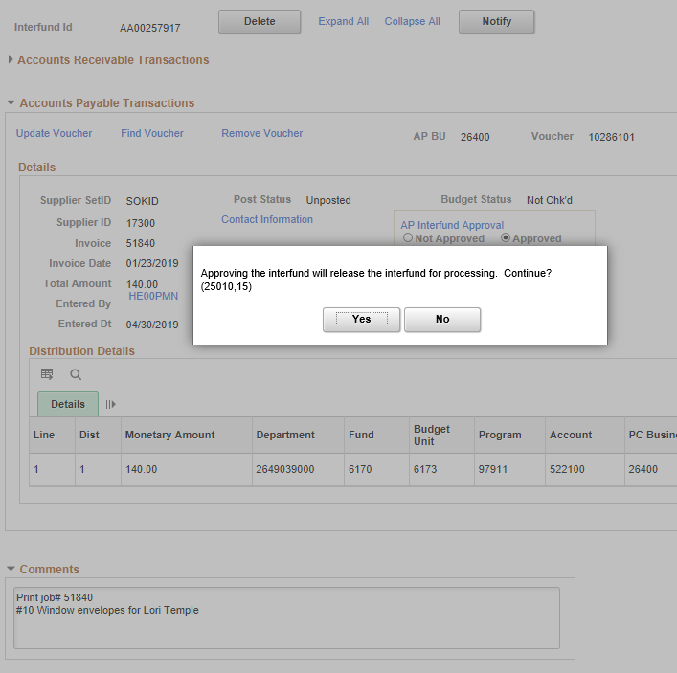
Approved Interfund Voucher

Sending Interfund Notifications
- Use the Contact Information link to look up and select the desired contact(s) for deposit and voucher Interfund notifications.
- Contact information for notifications is set up on the supplier and customer pages. See the ‘Maintaining Notification Contacts for Interfunds’ job aid for details.
- Each customer/vendor can have multiple contacts.
  - Use the Select checkboxes on the Contact Information page to choose one or more contacts to receive the Interfund notification. If a selection is not made in the contact list, clicking the Notify button has no affect.
  - Selected contact email addresses are automatically populated into the To: field on the Send Notification page. Open this page by clicking the Notify button on the Interfund Details page.
- When required, manually add additional emails to the Interfund notification using the To: and cc: fields on the Send Notification page. Separate emails using a semicolon. Email addresses are not validated in SMART or Microsoft Outlook.
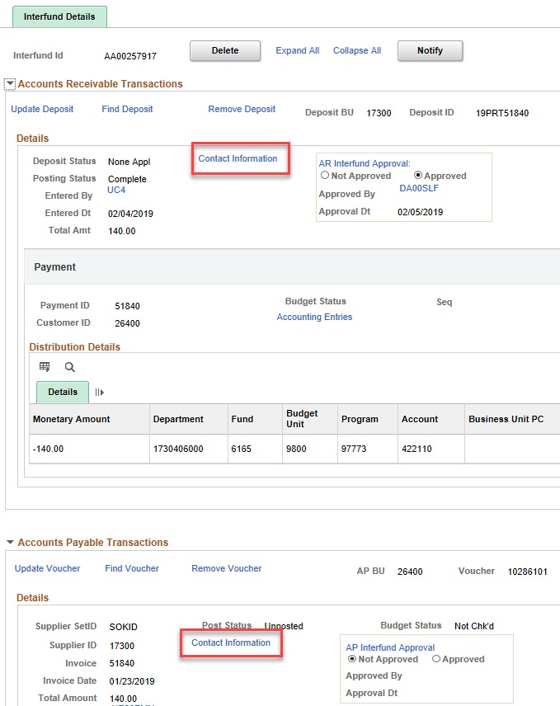
Interfund Details Contact Information link
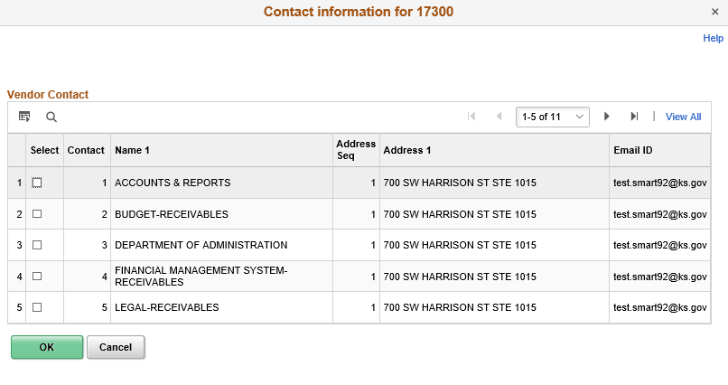
Contact Information page
The screen below appears after clicking the ‘Notify’ button if a contact has been selected.

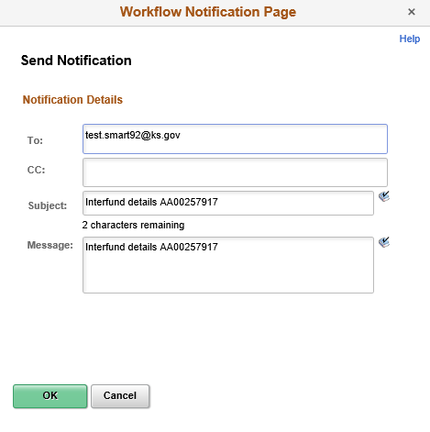
Send Notification page
Field | Description
To: | This field is automatically populated with the email(s) selected on the Contact Information page.  Note: When adding additional emails, separate each email with a semicolon (;).
CC: | Use this field to enter additional email addresses to copy on the Interfund notification.
Subject | Do not change the content of this field.
Message | Do not change the content of this field.
Send Notification page fields

Interfund Updates
- Refer to the End-to-End Interfund Process for timeline of voucher and deposit budget checking.
- The Interfund cannot be approved by the second approver if the amounts of the deposit and voucher are not equal.
- Vouchers
  - If the voucher budget check status is ‘Error’, Interfund voucher corrections must be performed before processing can continue.
  - When making updates to an Interfund voucher, the approval status on the Interfund page must be ‘Not Approved’.
  - Changes to the Interfund voucher are made on the voucher transaction pages by clicking the “Update Voucher” link on the Interfund page.
  - After updating and saving the changes to the Interfund voucher, the AP Interfund Approver must reapprove the Interfund transaction before voucher budget check can run again and Interfund processing can continue.
  - See AP job aids for more detail on specific transactions and scenarios.
- Deposits
  - When making changes on an Interfund deposit, the approval status of the deposit on the Interfund page must be ‘Not Approved’.
  - The deposit approval cannot be changed to ‘Not Approved’ if the voucher is approved.
  - Do not remove the deposit from the Interfund when making changes to the deposit.
  - See AR job aids for more detail on specific transactions and scenarios.
  - The steps on the following pages detail how to make changes on an interfund deposit.

Making changes to an approved Interfund deposit

Navigate to the Interfund:
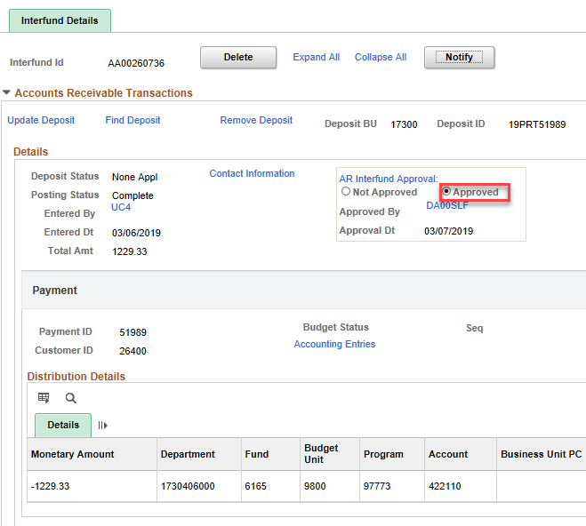

If ‘Approved’, change to ‘Not Approved’ and Save. Click ‘Yes’ on the warning message.
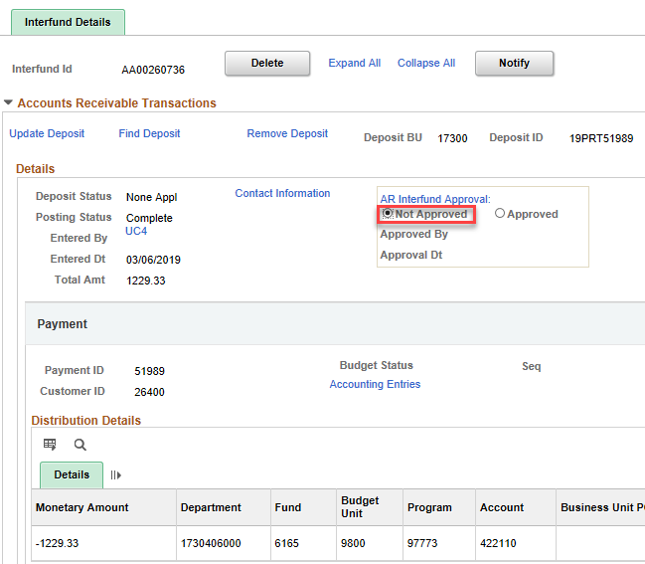

Click the ‘Update Deposit’ link and select ‘Yes’ on the warning message. Verify that the ‘Agency Deposit Approval’ is set to ‘Not Approved’.

Make note of the Interfund Deposit ID (upper right corner of Interfund).

Navigate to: Accounts Receivable Homepage > Payments > Direct Journal Deposits > Modify Accounting Entries.

Search for the Deposit ID.

Click the ‘Complete’ box to deselect. Click ‘OK’ on the warning message. Save.

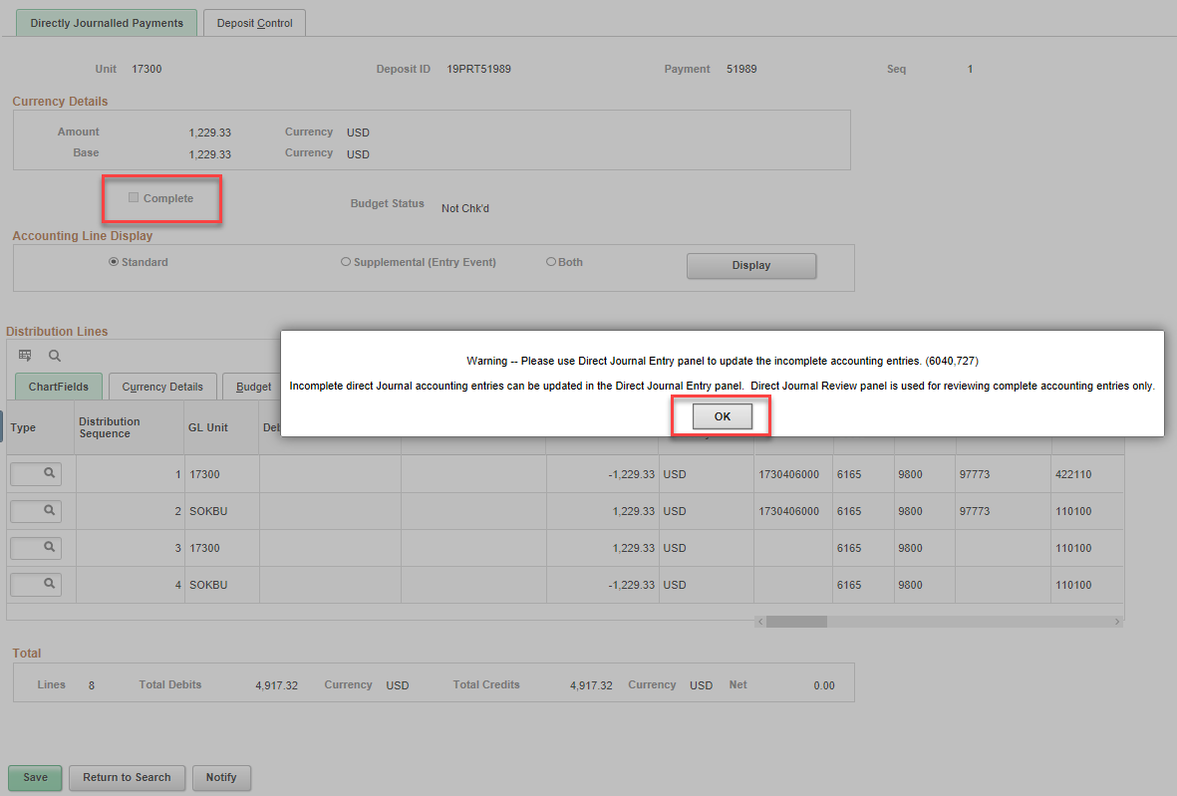

Navigate to: Accounts Receivable Homepage > Interfunds then search for the Interfund.

Click the ‘Accounting Entries’ link on the Interfund.

Click the Delete icon (the box with the red ‘x’ next to the lightning bolt) on the Payment Sequence that needs to be changed. Once the accounting entries are deleted, the Distribution Line will become editable.
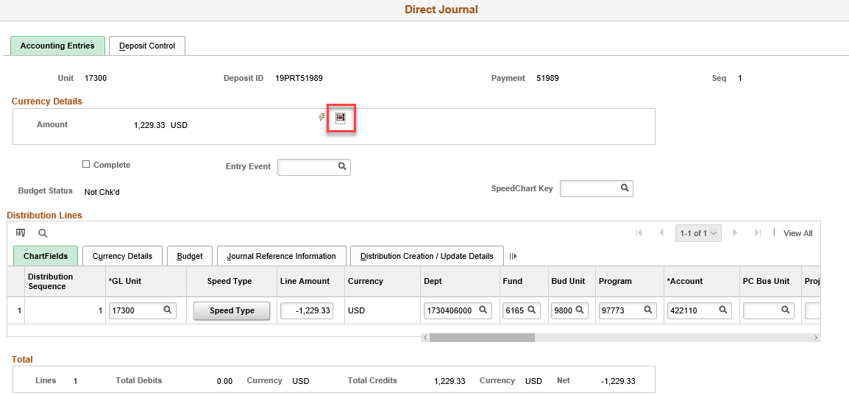

After the Distribution Line is corrected, click the Create icon (the lightning bolt) to create new accounting entries. Mark the Complete box.

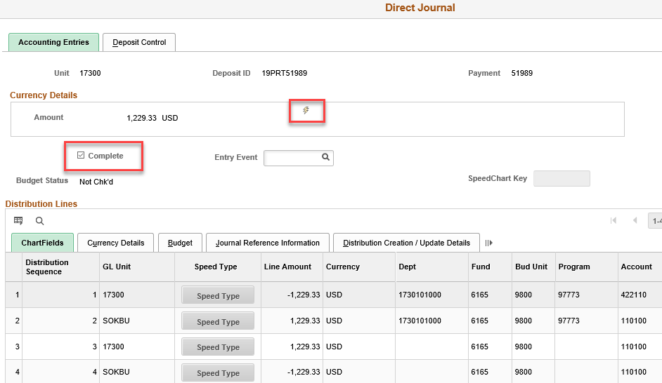

Click the OK button to return to the Interfund page, then Save. The Interfund is ready to be approved.

If the Interfund deposit total needs to be changed:

Follow the steps above. In addition to deleting the cash lines on the Modify Accounting Entries page, scroll to the far right and delete the distribution line(s) using the ‘-‘. Save.

Click OK to return to the Interfund Detail page then click on the ‘Update Deposit’ link to make changes on the Totals and Payments pages. Save and return to the Interfund Details page.

Use the Accounting Entries link to create and complete the accounting.

