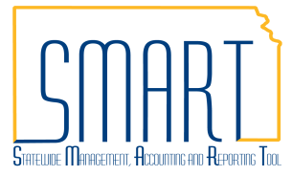
State of Kansas
Incomplete Interfunds
Statewide Management, Accounting and Reporting Tool

Date Created |  | 2/16/2018
Version |  | 2.1
Last Update |  | 05/10/2019
Security |  | - Role Security: Only those individuals with the following roles will have access to view the interfunds associated to their agency business unit:  - Agency AP Interfund Processor (KAP_Interfund_Processor)  - Agency AR Interfund Processor (KAP_Agy_Interfund_Processor)  - BU Security: Business Unit Security is applied. Agencies will only have access to the interfunds associated to their agency business unit.
Details
This job aid will assist agencies in searching for interfunds that need reciprocating as well as find incomplete interfund vouchers. The initiating side of an interfund is the first of two transactions that make up an interfund. The reciprocating side is the responding side of the two transactions.
The Deposit Type of an interfund deposit will be I (Initiating) or R (Reciprocating). The Voucher Origin of an interfund voucher will be either I (Initiating) or R (Reciprocating).
It is optional for the initiating agency to notify the reciprocating agency when transactions are pending and it is optional for the reciprocating agency to notify the initiating agency when transactions are complete. Therefore, it is important to regularly search for interfunds that have been placed in SMART for your agency to reciprocate.
Using Queries in Query Viewer to Find Incomplete Interfunds
Navigation |  | - Accounts Payable Homepage > Utilities > Query Viewer  - NavBar: Navigator > Reporting Tools > Query > Query Viewer Reporting Tools > Query > Query Viewer
1. | The query results provide a listing and details for interfunds that are incomplete which are associated with your agency on either the deposit or voucher side. | Use a Query to Find all Pending Interfunds  KS_APAR_PENDING_INTRFNDS  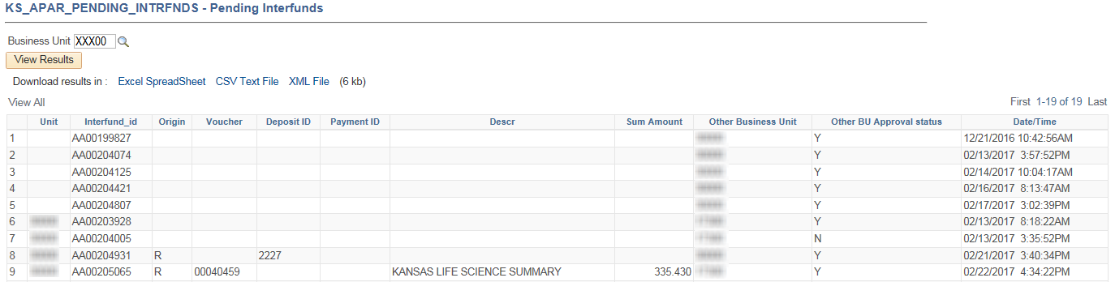
2. | The query results provide a listing of interfund vouchers that have not fully processed. Included are the associated interfund IDs and deposit IDs. The query also includes Interfund vouchers that are not attached to an Interfund. | Use a Query to Find all Incomplete Interfund Vouchers  KS_AP_UNPROCESSED_INTRFND_VCHR  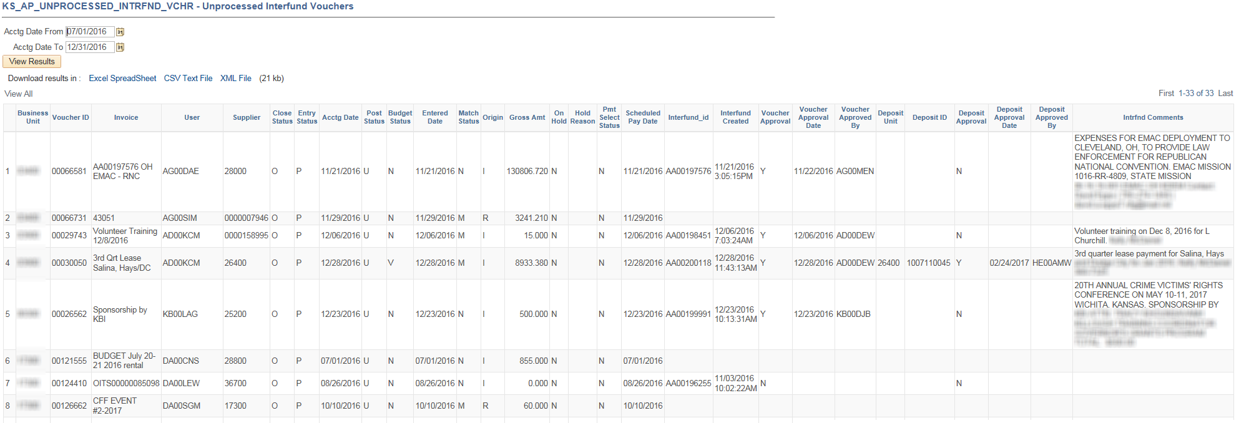
3. | The query results include information for interfunds associated with your agency on either the deposit or voucher side in which at least one of the following is true:  - Voucher is not posted  - Payment is not posted  - Deposit is not posted | Use a Query to Find all Unposted Interfunds that are approved  KS_INTRFNDS_APPR_NOT_POSTED  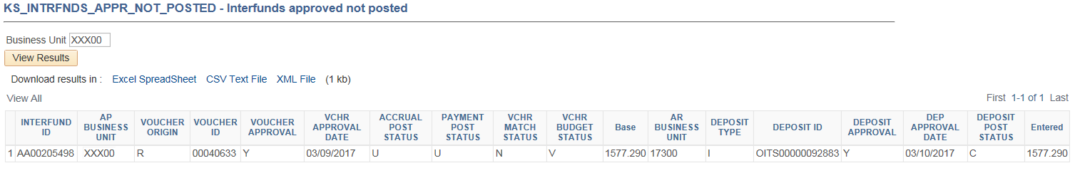  Depending on when you run the query, the list may include interfunds that were approved in the current day’s activity that have not yet posted in the nightly batch. If the deposit or voucher approval date reflects the current or previous day’s date, you can likely ignore it.
Searching for Interfunds that need Reciprocation using the Interfund Details page
Navigation |  | Use any of the following navigations to access the Interfund Details Page:  - Accounts Receivable Homepage > Interfund Details  - NavBar: Navigator > Accounts Receivable > Interfund Details  - Accounts Payable Homepage > Interfund Details  - NavBar: Navigator > Accounts Payable > Interfund Details
1. | a. To find interfunds that need the deposit added or approved by your agency:  1. Deposit Approval Status, select ‘Unapproved’ from the dropdown menu.  2. Supplier ID, key your 5-digit agency business unit in the field.  b. To find interfunds that need the voucher added or approved by your agency:  1. AP Approval Status, select ‘Unapproved’ from the dropdown menu.  2. Customer ID, key your 5-digit agency business unit in the field. | 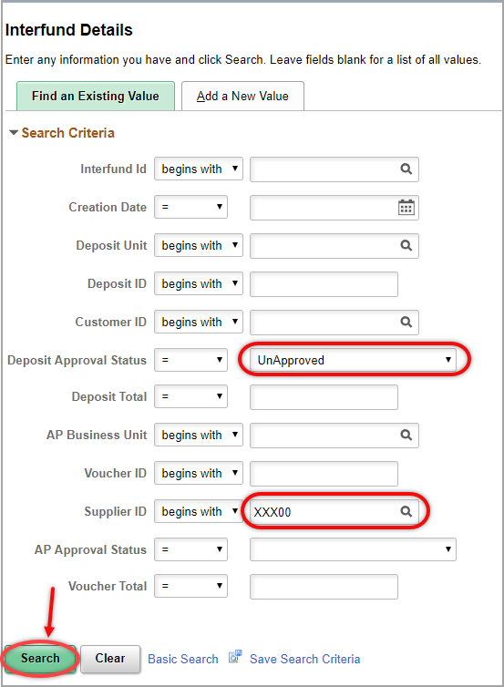  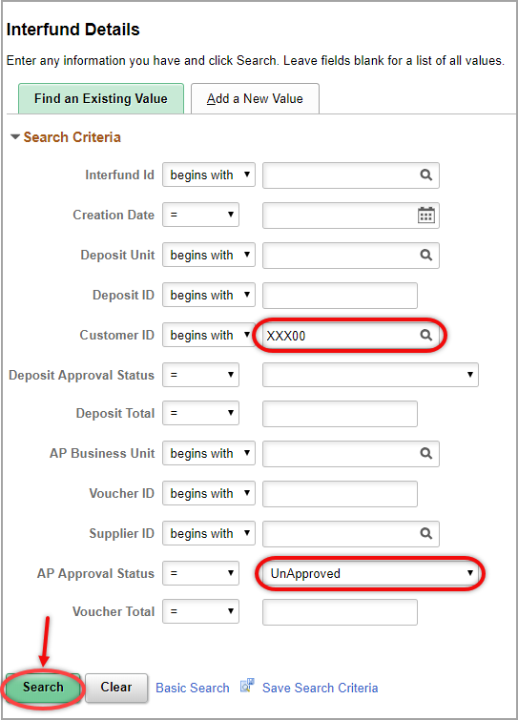
2. | Save Search Criteria for easy future access  a. Enter the Search Criteria then click the ‘Save Search Criteria’ hyperlink.  b. Enter a name for the Search and click the ‘Save’ button.  c. To use the saved search select it from the dropdown menu on the Interfund Details page. | 