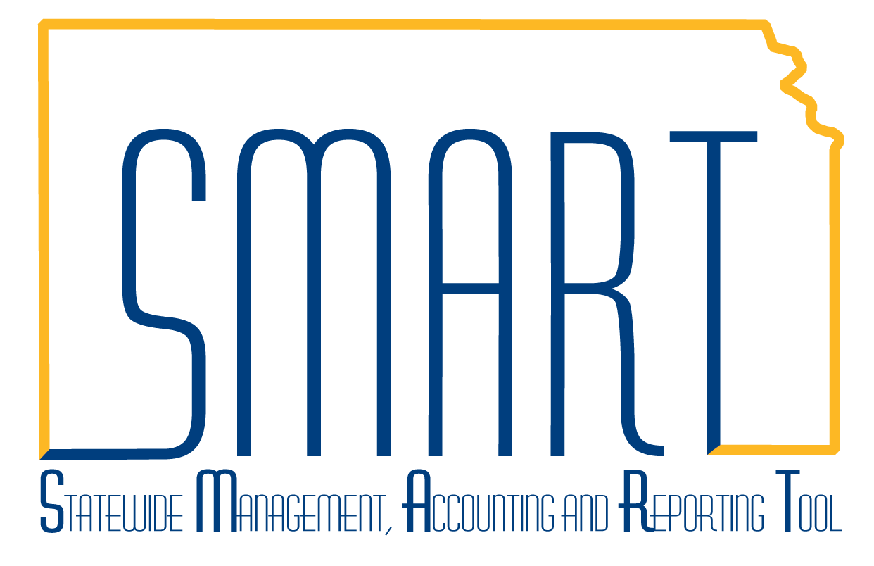
State of Kansas
How to Write-Off Billing Worksheet Transactions
Statewide Management, Accounting and Reporting Tool

Date Created: |  | 01/18/2013
Version: |  | 1.0
Last Updated: |  | 2/28/2019
Scenario: |  | Writing-off billing worksheet lines will prevent those transactions from generating an invoice in the Billing module and then passing into Accounts Receivable to create a pending item. It also reverses out the revenue that was recognized from the Customer Contracts module when the transaction was incurred and sent to Billing. Agencies may need to write-off billing worksheet transactions for various reasons, including transactions that were accidentally attached to a contract and should not have been; or, transactions that should have been cost-share/match, but the award profile was never created in the Grants module to identify the transaction as cost-share by use of the Fund.
1. | Navigation: Billing Homepage > Non-Consol Invoice Processing > Update Billing Worksheet or Navigator > Billing > Manage Billing Worksheet > Update Worksheet and click the Search button to view your agency’s billing worksheets.  Billing worksheets group transactions by Contract number and by Transaction Date. This grouping occurs because the processes to produce Billing Worksheets are run every night from the transactions created that day. This is why you may see multiple worksheets for the same Contract number.  Search for the Contract number associated with the project transactions you want to write-off and click that Billing Worksheet number. | 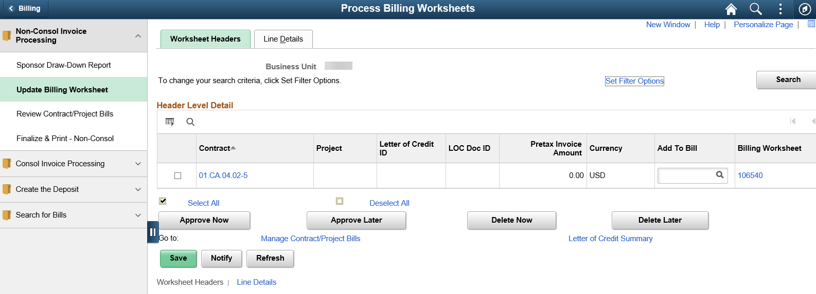
2. | The detailed list of individual transactions charged to the projects tied to that Contract number/Transaction Date will display (note, if you have more than 5 transactions, you will need to click the View All link to see the full list). | (left side of page)  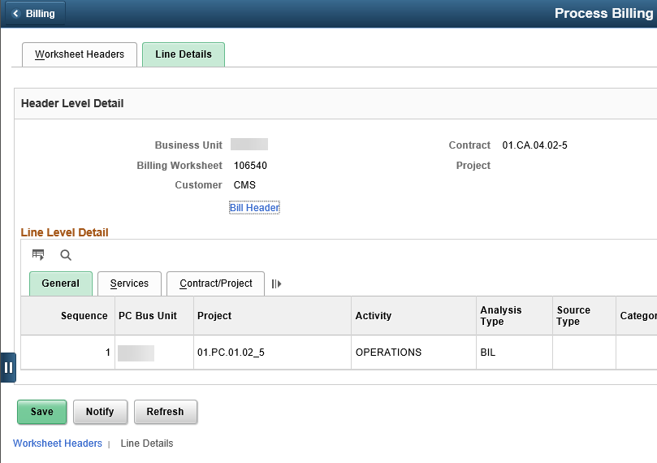  (right side of page)  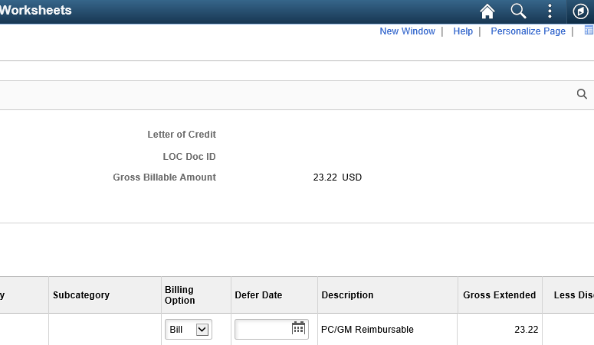
3. | The “Billing Option” column is where you tell the system how you want it to process that particular transaction. The default is “Bill” but you will need to change it to “Write-off” on those transaction lines you want to write-off.  Important Note: In order to process the write-off & reverse out the revenue that was recognized from the original billable transaction, you have to Approve the entire Billing Worksheet those transactions reside on. If you don’t want to write-off every transaction on that billing worksheet, but don’t yet want to process billing for the remaining transactions, you will need to change “Bill” to “Defer” and enter a Defer Date, which is the date you want these billable transactions to re-appear on the billing worksheet for you to process. Our recommendation is to use a Defer Date of the next business day. | 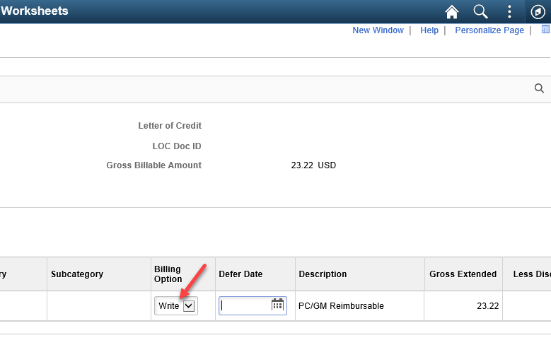  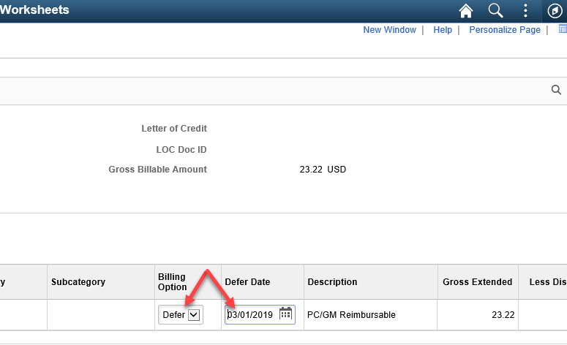
4. | Once every transaction line on that particular billing worksheet has the appropriate Billing Option selected to identify how you want each line to process, you will click the Worksheet Headers tab at the top.  Note: The Pretax Invoice Amount will be reduced by the dollar total amount of the lines you chose to write-off or defer. | 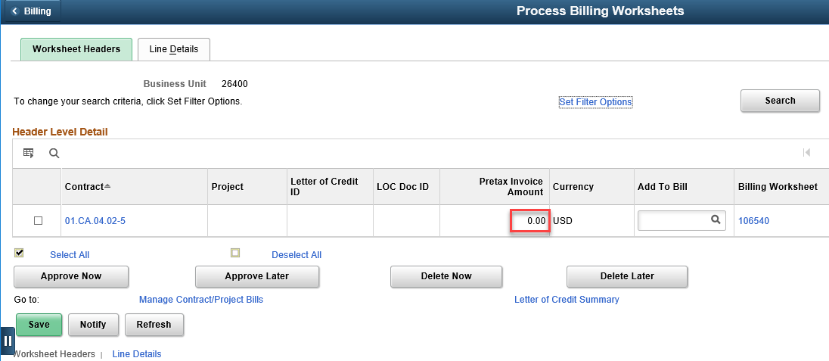
5 | Select the billing worksheet for the transactions that been set to Write-Off or Defer status. Select Approve Now. | 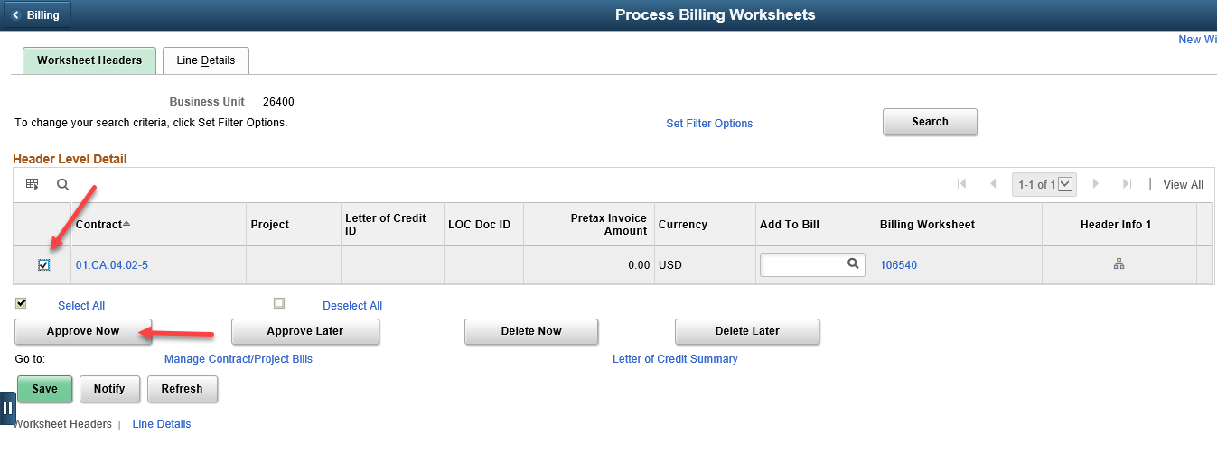
6. | Then, when the billing and revenue processes run overnight, the BIL row that was in Project Costing for $23.22 will become a WTO row and the BIL row being deferred will become a DEF row. Also, a journal will be created in the General Ledger that reverses out the original recognized revenue associated with the WTO rows. The deferred transactions from the approved billing worksheet will re-appear on a new billing worksheet on the date you specified as the Defer Date.

