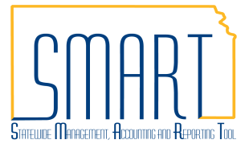
State of Kansas
How to Locate an Asset IF from a Requisition ID
Statewide Management, Accounting and Reporting Tool

Date Created: | 08/02/2016
Version: | 1.0
Last Updated Date:
Process
1. Navigate to: Purchasing > Requisitions > Review Requisition Information > Document Status
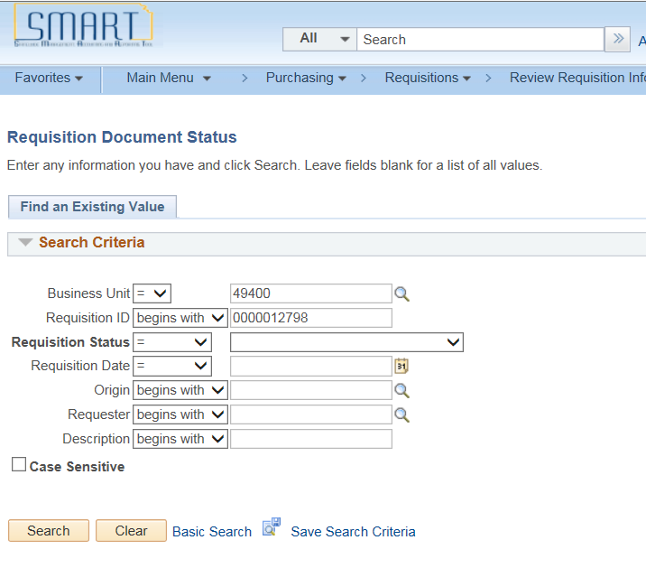
Enter the Business Unit & Requisition

The Document Status page shows the list of transactions from the Requisition to the Voucher related to your Requisition ID, including the PO ID:
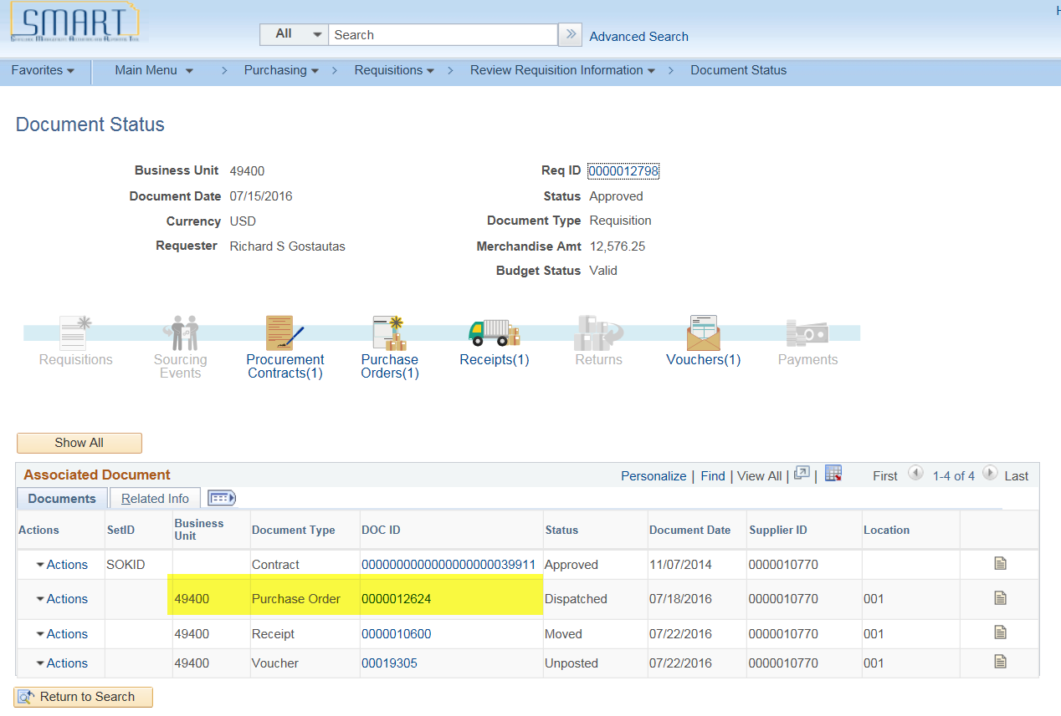

2. Navigate to Asset Management > Search for an Asset page:

Enter the highlighted fields, Unit, PO Unit and PO No & CLEAR OUT the Asset Status field.

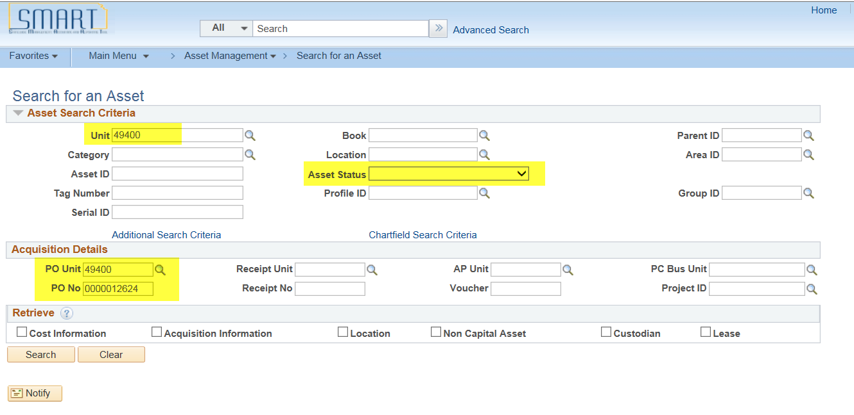

Click the Search button & the Asset ID displays in the results:

