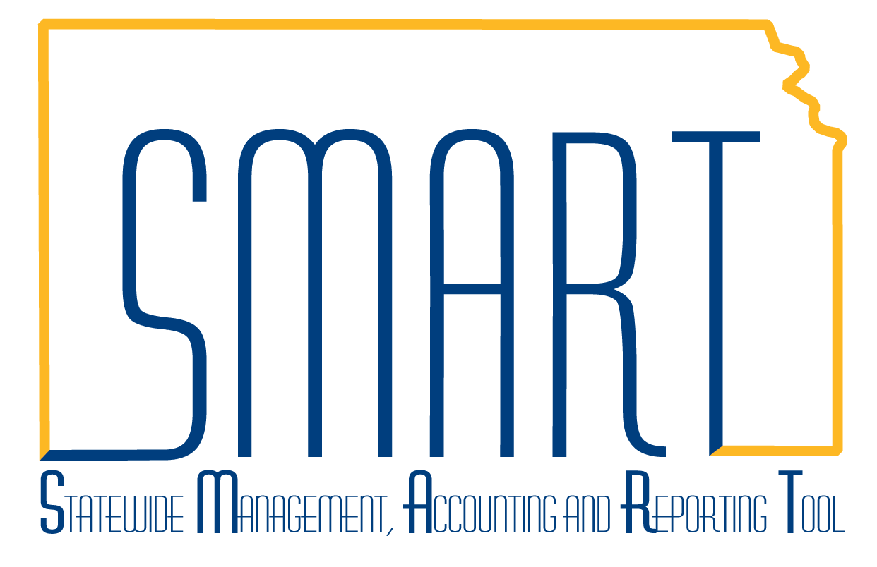
State of Kansas
How to Generate an Award
Statewide Management, Accounting and Reporting Tool

Date Created: |  | 02/06/2013
Version: |  | 1.0
Last Updated: |  | 3/12/2019
Scenario: |  | When a submitted grant proposal is awarded, the Generate Award process must be run in SMART. This process does several things:  - Creates an Award Profile in the Grants module where information such as Terms & Conditions can be stored.  - Creates an award budget in the Grants module that, when finalized, creates Budget Journals in the Commitment Control module.  - Creates Projects and Activities in the Project Costing module, based on the proposal set-up.  - Creates a pending Contract in the Customer Contracts module that can be activated if reimbursement processing is desired.
1. | Navigation: Projects and Grants Homepage > Grants > Creating a Grant > Generate Award or Navigator > Grants > Proposals > Generate Award.  Enter the search criteria for the proposal to be awarded and click Search. | 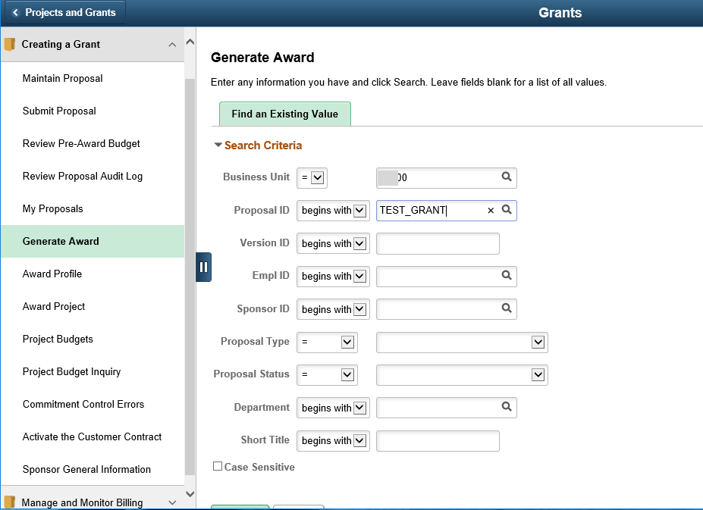
2. | Review the various IDs that will be used in the award generation process. Make any updates, as needed to the editable IDs. Then, click the Generate button.  Note: the Pre-award Spending checkbox is available if the award notification has not been received, but the agency needs to begin spending. This will create the required Projects/Activities, but not the Contract. The award generation process must be run a second time to create the contract, when needed. | 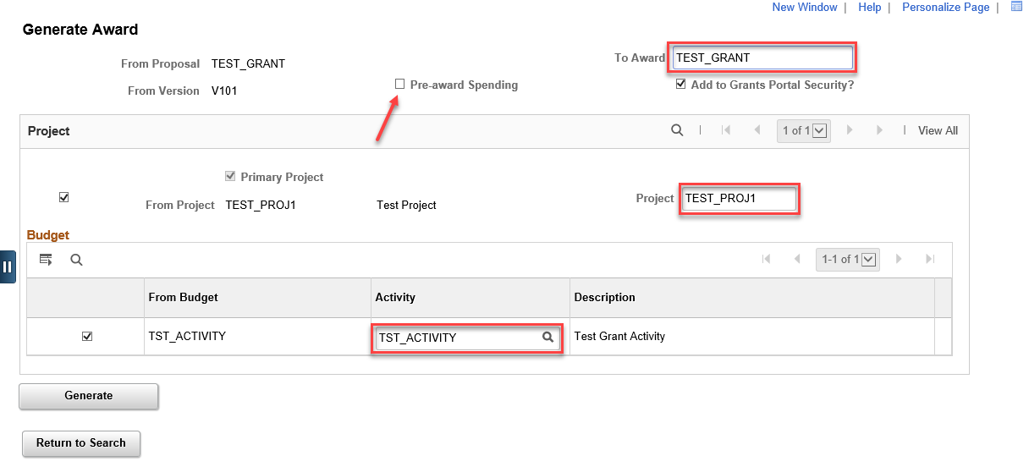
3. | Once the process is complete, the Generate button will turn gray. The user can validate the process ran successfully by searching for the award profile at Projects and Grants Homepage > Grants > Creating a Grant > Award Profile or Navigator > Grants > Awards > Award Profile. | 