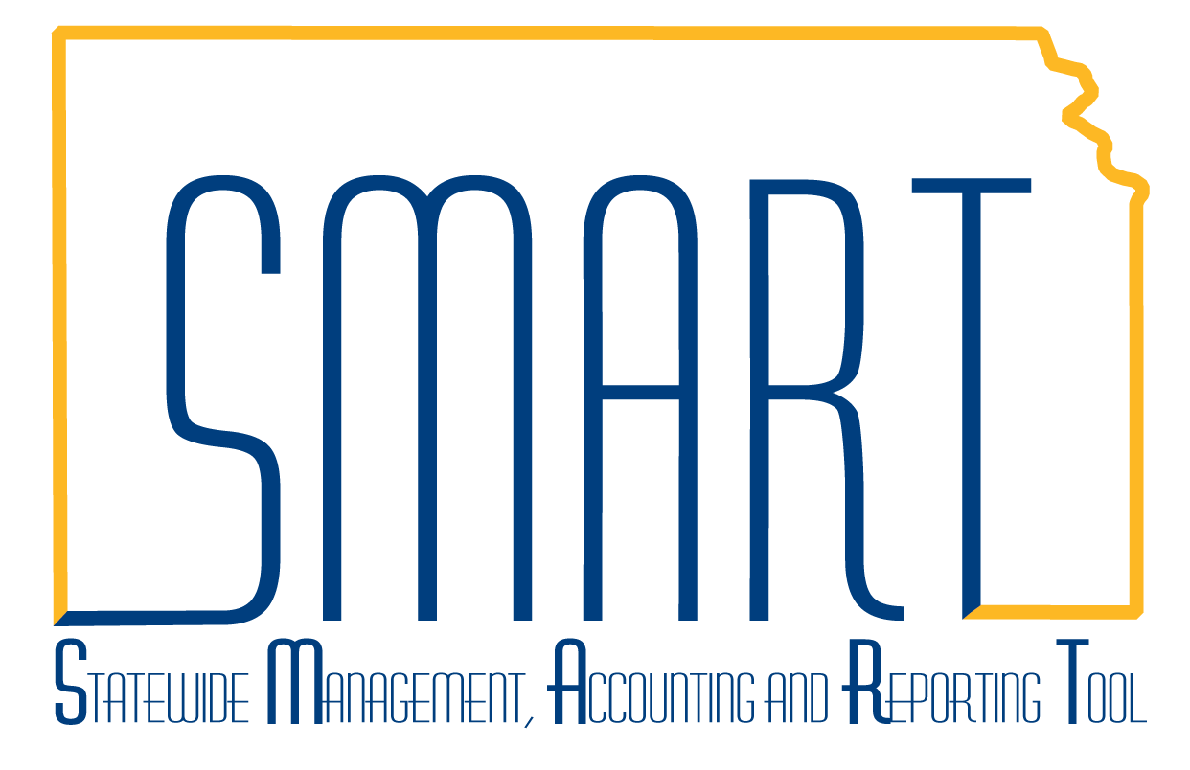
State of Kansas
How to Create a Project
Statewide Management, Accounting and Reporting Tool

Date Created: |  | 2/15/2019
Version: |  | 1.1
Scenario |  | Project Costing is designed to allow users to track expenditures against a particular project to get a lower level of detail than the basic General Ledger chartfields. Projects can be broken down into multiple Activities for even greater reporting capability.  This job aid demonstrates how to create a new project and associated activities.
1. | Navigate to: Project and Grants homepage > Project Costing tile > General Information or Navigator > Project Costing > Project Definitions > General Information.  Click on the Add a New Value tab. The Business Unit should default based on user security. Enter the Project ID in the Project field and click the Add button. | 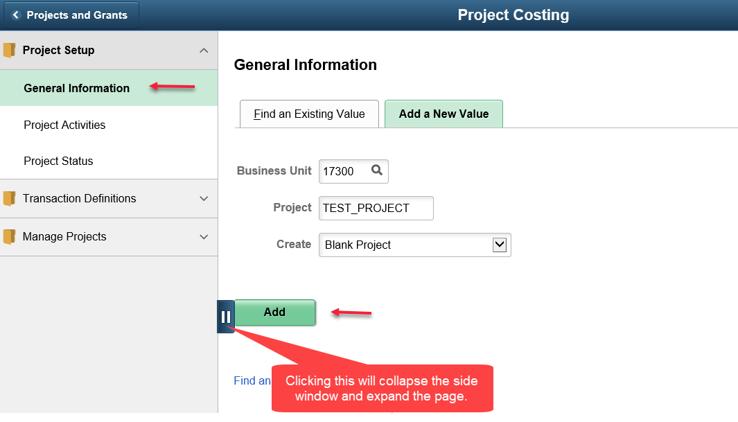  Note: The Project ID field has a 15 character limit. There should be no spaces. The only allowable special characters are dashes and underscores.
2. | On the General Information tab, enter data into the following fields, then click Save:  Description  Integration (should default)  Project Type  Start Date  End Date  Note: The Project Type field will eventually be used to aid in the state-wide Schedule of Expenditure of Federal Award report. Please visit the SMART website for a full list of the Project Type values. | 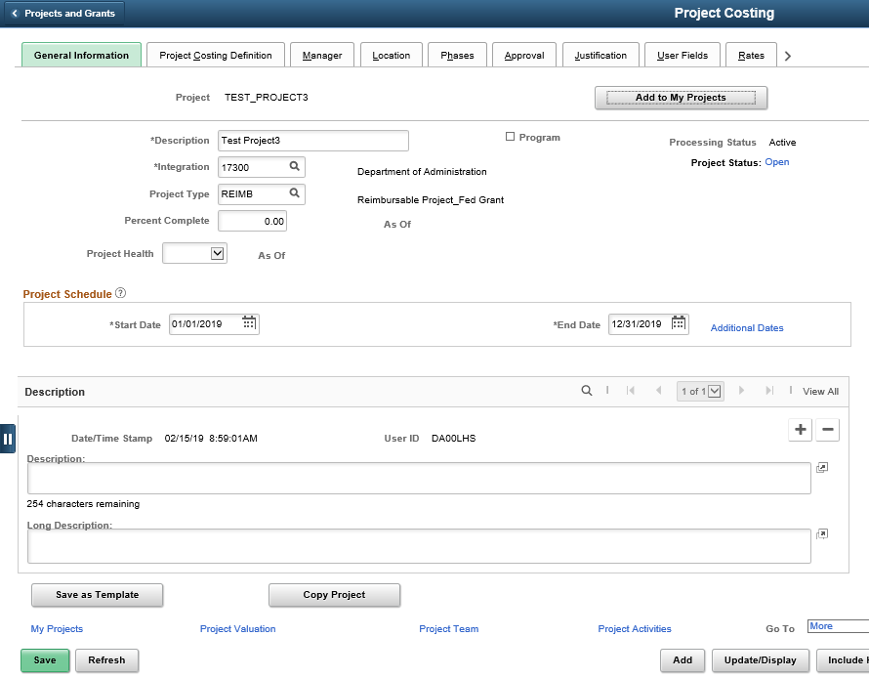
3. | Click on the Project Activities link at the bottom of the page. On the Project Activities tab, enter data into the following fields, then click Save:  Activity Name  Activity (this is the Activity ID)  Start Date  End Date | 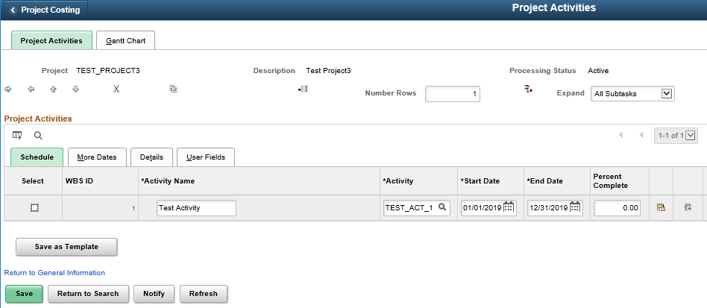  Note: The Activity field has a 15 character limit. There should be no spaces. The only allowable special characters are dashes and underscores.  The Start Date and End Date fields will default based on the Project dates. The user may update them, as needed.
4. | To add more activities, check the box next to the Activity row beneath which the new row should be inserted.  Then, enter the number of rows to add in the Number Rows box and click the  icon to add new rows. | 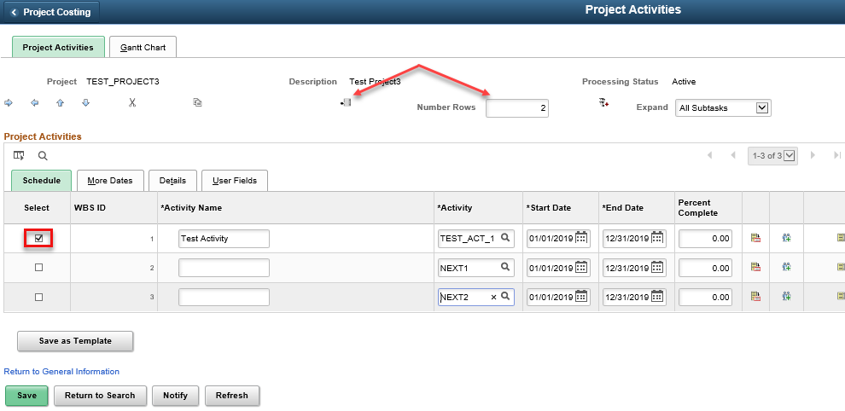
5. | Enter values in the Activity Name and Activity field for each new row. Also update the Start Date and End Date fields, if appropriate. Then, Click Save. | 