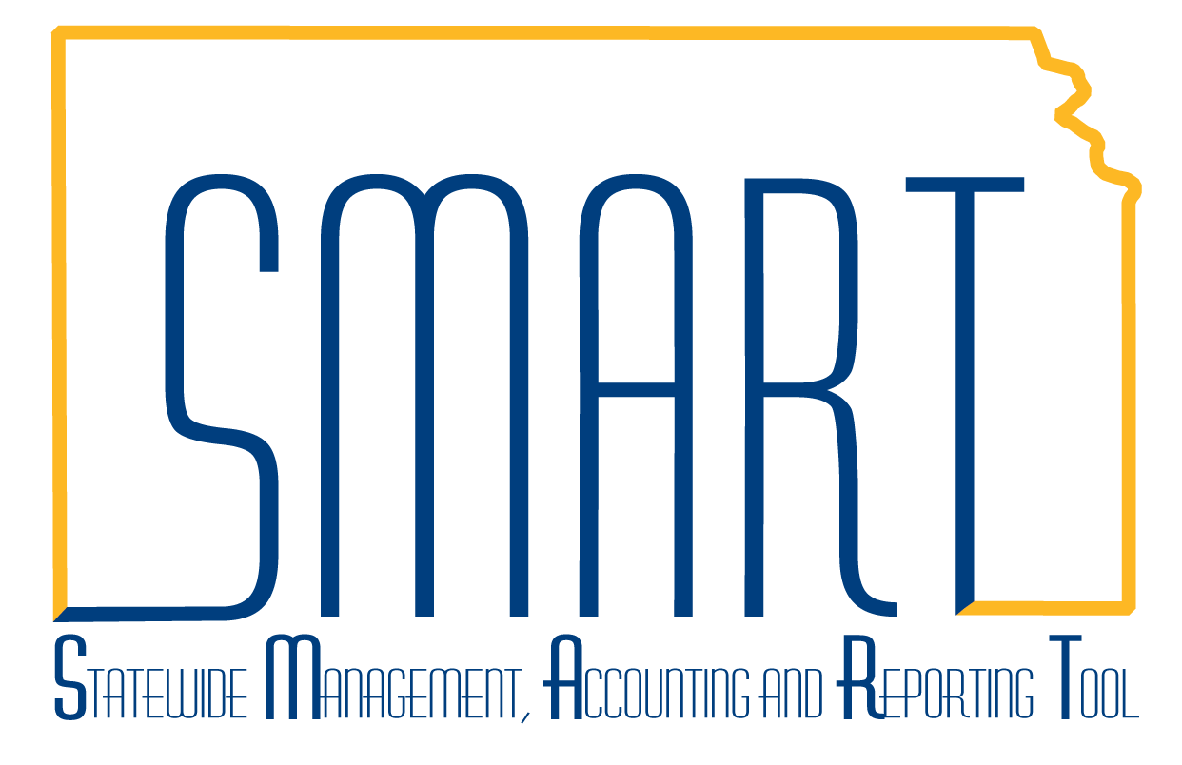
State of Kansas
How to Create a Grant
Statewide Management, Accounting and Reporting Tool

Date Created: |  | 02/06/2013
Version: |  | 1.0
Last Updated |  | 3/11/2019
Scenario: |  | The Grants module manages the pre-award side of the grants process. Specifically, it stores proposal and award information, including budget data. This job aid demonstrates how to create a grant.  Note that grant expenditure tracking occurs in the Project Costing module, and reimbursement process occurs via attaching a project to a contract in the Customer Contracts module. The 3 modules work together to manage end-to-end grant processing.
1. | Navigation: Projects and Grants Homepage > Creating a Grant > Maintain Proposal or Navigator > Grants > Proposals > Maintain Proposal.  Click on the Add a New Value tab. The Business Unit should default based on user security. Enter the Proposal ID in the Proposal ID field and click the Add button. | 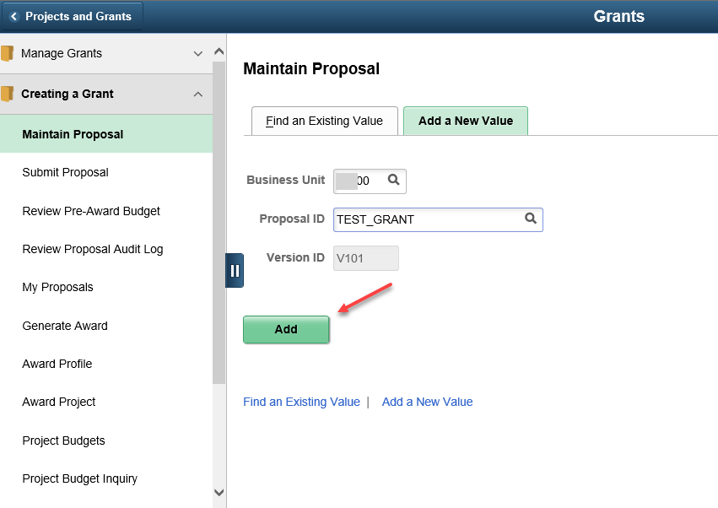  Note: The Proposal ID field has a 15 character limit. There should be no spaces. The only allowable special characters are dashes and underscores.
2. | On the Proposal tab, enter data into the following fields:  Description  *Title  *PI ID  *Sponsor ID  *Start Date  *End Date  *No. Periods  Click the Build Periods button to create budget periods for your grant period. | 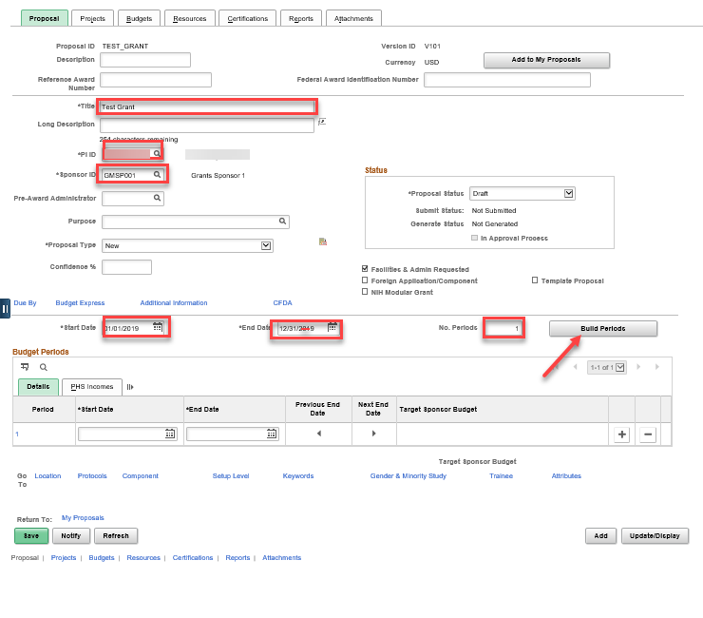
3. | Click on the Location link at the bottom of the page. Enter the location code for the physical location where the grant work will be taking place. | 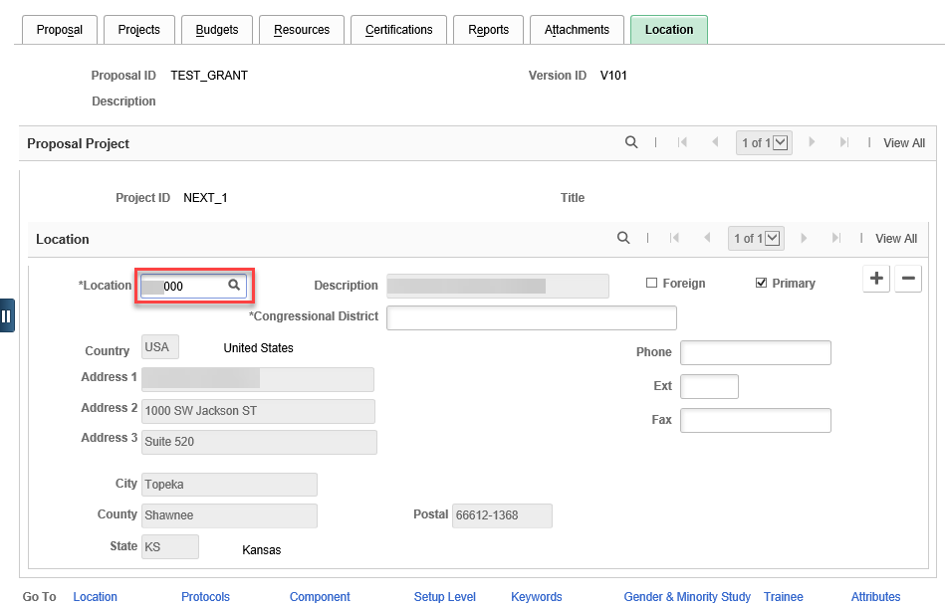
4. | Click on the Projects tab. Enter data into the following fields:  Project ID  Department  Subdivision (same as Department)  Institution  F&A Distribution section:  Department | 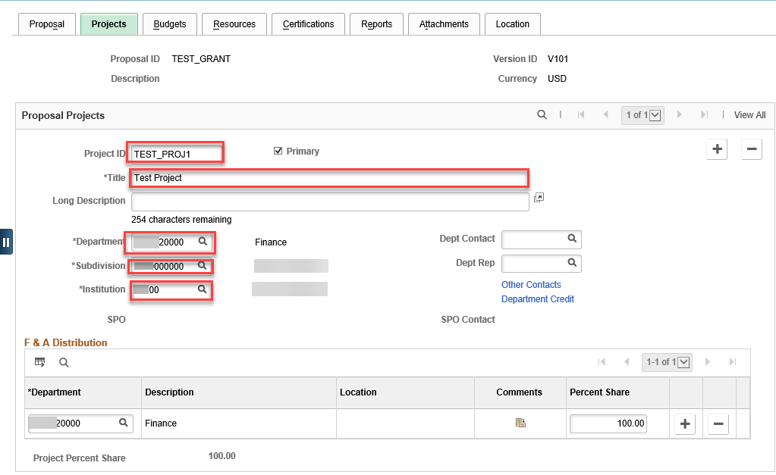  Note: The Project ID field has a 15 character limit. There should be no spaces. The only allowable special characters are dashes and underscores.
5. | Click on the Budgets tab. Enter data into the following fields, then click Save:  Budget ID  Description | 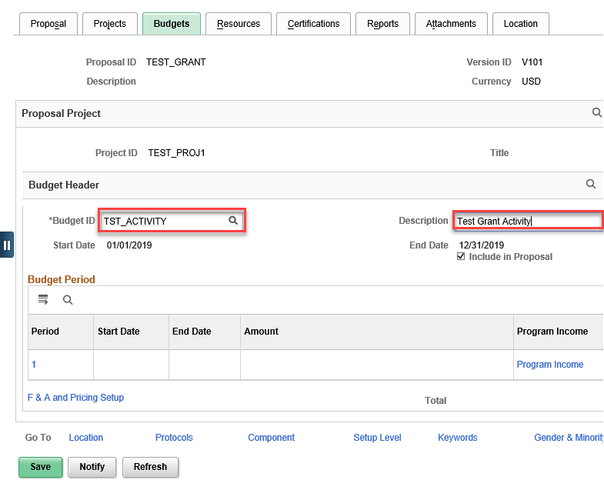  Note: The Budget ID becomes the Activity ID in Project Costing when the grant is awarded. It can be re-named at the time of award, if needed.
6. | If the agency wishes to use the auto-F&A calculation, click on the F&A and Pricing Setup link beneath the Budget Period box. Enter data into the following fields, then click Apply, then OK:  Rate Type  FA Base (in the Institution, Sponsor and Budget sections)  Click OK. | 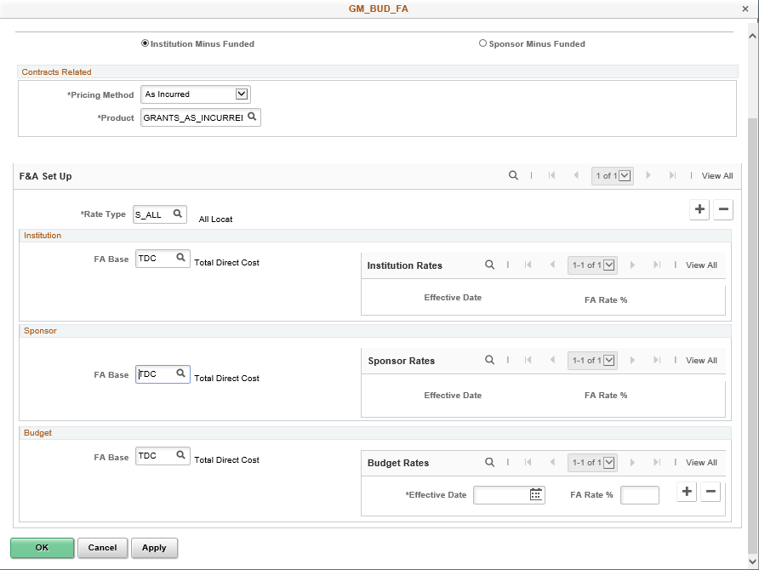Note: if the F&A rate % to be used on this proposal differs from the percentage that defaults into the Budget Rates box, the user may change the value.
7. | Click on the 1 link in the Period box to enter budget detail for the first budget period.  Enter Budget Item values and Total Direct amounts for each line. Use the icon to add rows, as needed. | 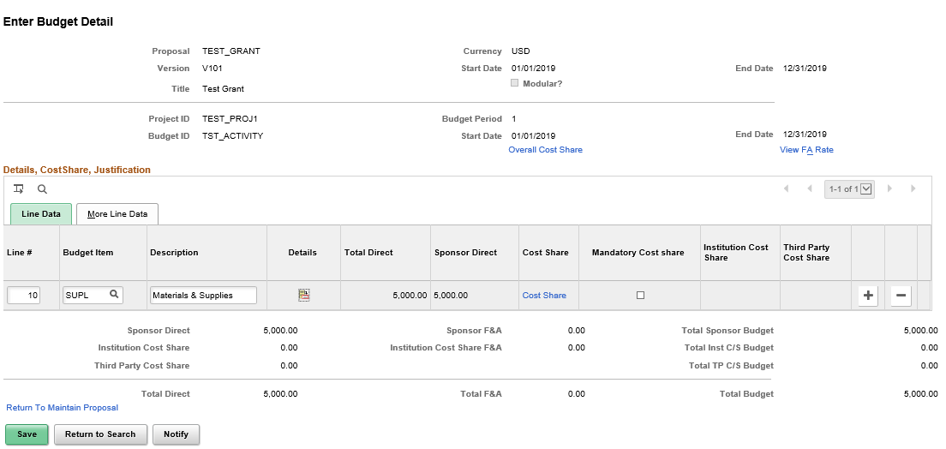  Note: clicking on the Details icon for any line will display a screen where additional item details can be entered (e.g. per item cost, quantity, etc.)
8. | When selecting the SALARIES budget item, the Details icon allows the user to identify specific individuals working on the grant and uses their actual salary rate when budgeting, based on the Appointment Type and Effort Pct entered. Click OK. | 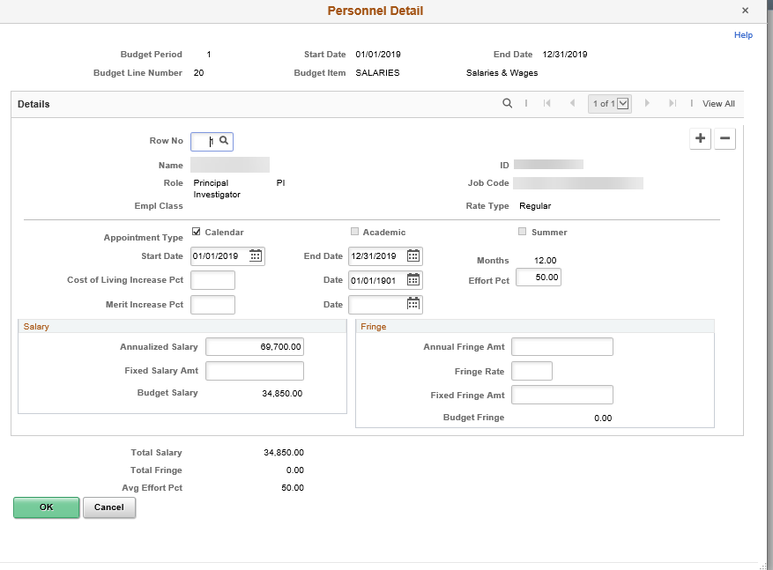Note: The Row No. field corresponds to individuals listed on the Resources tab of the proposal in the Professional section. Individuals must be listed here before they can be selected in the budget.
9. | If Cost Share is appropriate, click the Cost Share link on the budget line and enter data in the following fields, then click OK:  Cost Share Percent  Institution box:  Department  C/S Pct | 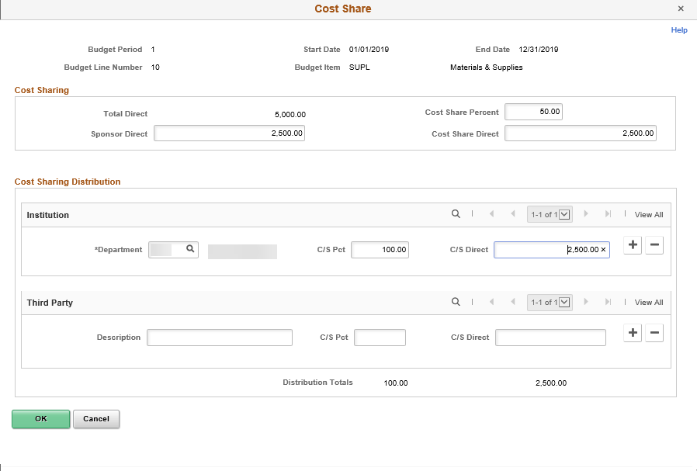  Note: Use the highest level Department ID value (representing the agency). If there is any Third Party cost share, enter it in the appropriate box.
10. | As Budget Items and Cost Share are entered, the system keeps a running total at the bottom of the Budget Detail page. Click Save. | 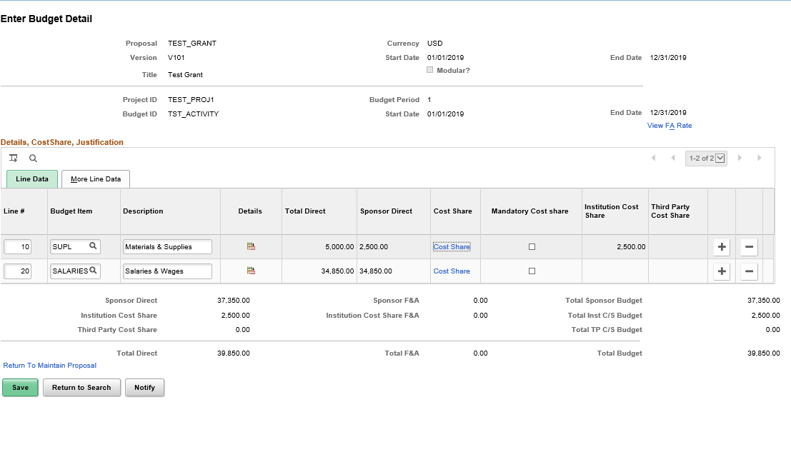
11. | Click the Return to Maintain Proposal link to return to the Budgets tab.  Note: Only the Sponsor requested amount of the budget displays on this page.  All required proposal information has been entered at this point. | 