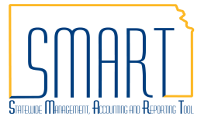
State of Kansas
GL Encumbrance Journals
Statewide Management, Accounting and Reporting Tool
Date Created: | 03/13/2019
Version: | 4.0
Scenario: | General Ledger (GL) Encumbrance Journals (non-supplier specific encumbrances) obligate budget at fiscal year-end. GL encumbrances shall be used for:  - A bid event for procurement that is not complete by fiscal year end, i.e. the supplier not yet known. Once the supplier is identified, the GL Encumbrance journal is liquidated and a Requisition (REQ) is created.  - Anticipated travel at fiscal year-end and the traveler is not yet known.  The GL encumbrance process involves three steps:  - Request the GL encumbrance journal  - Find and Liquidate the GL encumbrance journal  - Create a Requisition or GL Journal to utilize the prior budget period funds.

Request the GL Encumbrance Journal
1 | Complete the GL Encumbrance Request Form and attach it to a ManageEngine Service Desk Request. Refer to the Year-end Informational Circular for the submission deadline.  The GL Encumbrance Request Form (Form # GL_F016) is located in the Document Center on the Department of Administration website at the following link: https://view.officeapps.live.com/op/view.aspx?src=https%3A%2F%2Fadmin.ks.gov%2Fmedia%2Fdocuments%2Fglf016glencumbrancerequestform_A68C_D29DF9F7BF703.xlsx&wdOrigin=BROWSELINK
2. | In ManageEngine Service Desk, click on the “Requests” tab and choose the “New Incident” button. Fill in the Requester Details and make sure to select the Category of General Ledger and Sub-Category of GL Encumbrance. Provide a description of the obligation AND either: the reason the supplier is not known, OR, the reason the Purchase Requisition/Purchase Order/Travel Authorization process is not practical for encumbering budget.  Make sure you click the “Add request” button when you have finished the request. ManageEngine Service Desk Requests will be routed to the Division of the Budget (DoB) for approval.  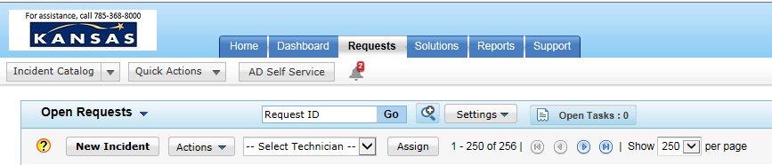

The completed SD ticket:
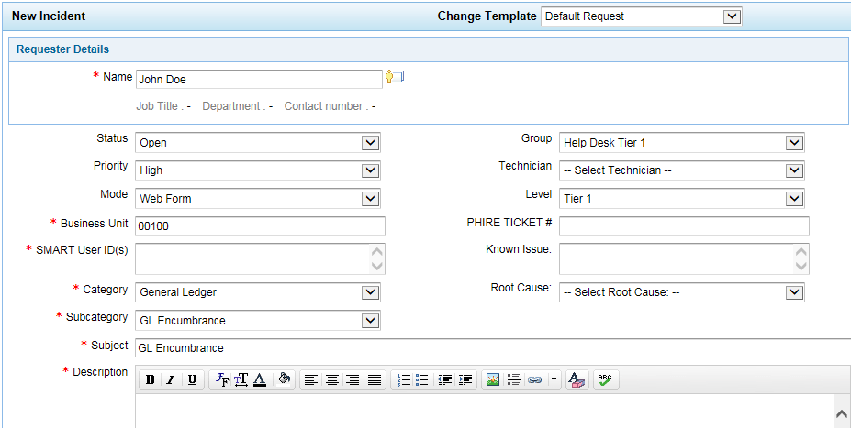
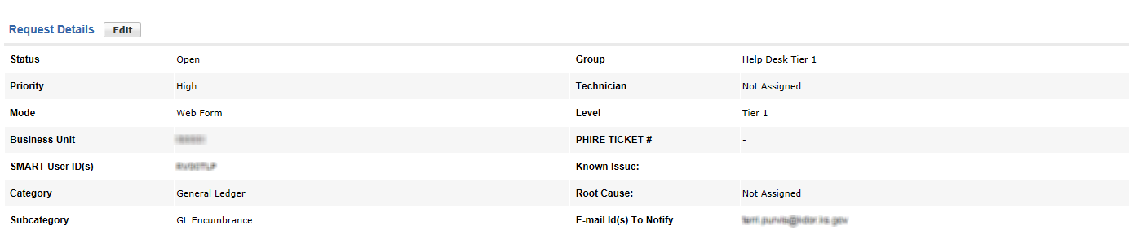
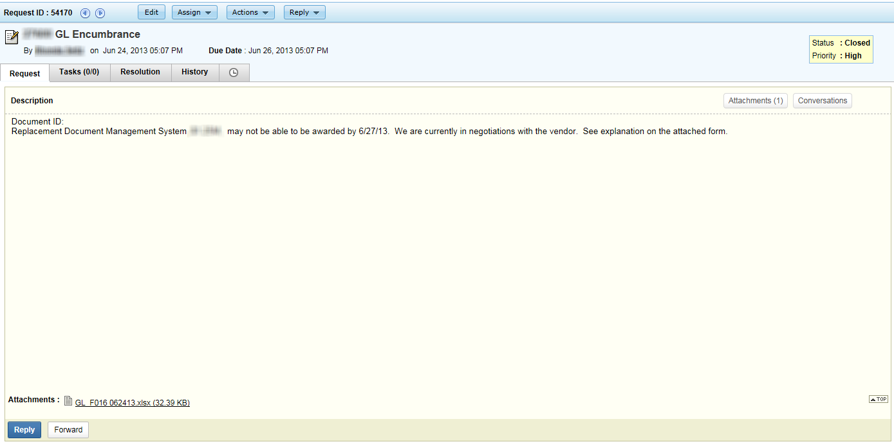
3. | GL Encumbrance Journals may be keyed by the Office of Accounts and Reports (OAR) Central Responsibilities Team into SMART, prior to receiving DoB approval (in order to give each agency the opportunity to review the document and its effects in SMART prior to fiscal year-end close). Agencies will receive the GL Encumbrance Journal ID number(s) via the ManageEngine Service Desk Request.  Note: The ManageEngine Service Desk Request ID from the GL encumbrance journal request will be keyed in the GL encumbrance journal Header Long Description. The Service Desk Request ID shall be entered on all Purchase Requisitions and GL journals to create an audit trail between the GL encumbrance journal and the Purchase Requisitions or GL Journals funded with the GL encumbered funds.  SMART GL Journal Header  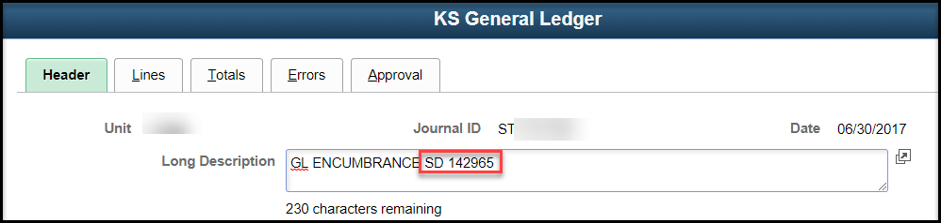
4. | DoB will use the ManageEngine Service Desk Request to notify agencies if the GL Encumbrance Journal request is denied. The journal will be deleted from SMART by the OAR Central Responsibilities Team.
5. | To determine the outstanding GL Journal Encumbrance amounts by Journal ID, Fund, and Budget Unit, run the KS_GL_ENCUMBRANCES query from SMART Homepage> General Ledger/KK page > GL Utilities tile > Query Viewer. Enter your agency Business Unit and a Budget Period end date (i.e. 2016 = 06/30/2016)  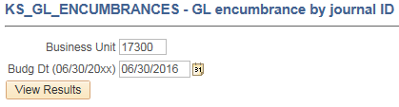
6. | The query results will list all of the GL encumbrance journal lines for the Budget Period chosen. The results can be downloaded into Excel and summarized to determine the available funding.  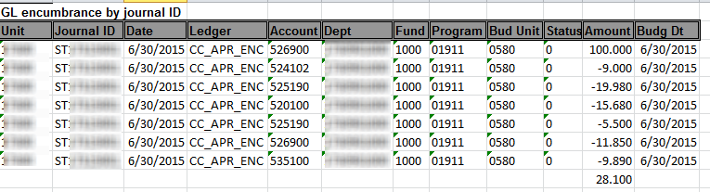
Find and Liquidate the GL Encumbrance Journal
1. | Navigate to: SMART Homepage > General Ledger/KK page> General Ledger tile > Journal Transactions > Journal Entries > Create/Update Journal Entries> Find an Existing Value. Clear the parameters then enter the Business Unit and Journal ID begins with: ST and click the Search button.  The Search Results will list all of the GL Encumbrances for your agency.
2. | Select a Journal to determine if any funding is available on the journal.  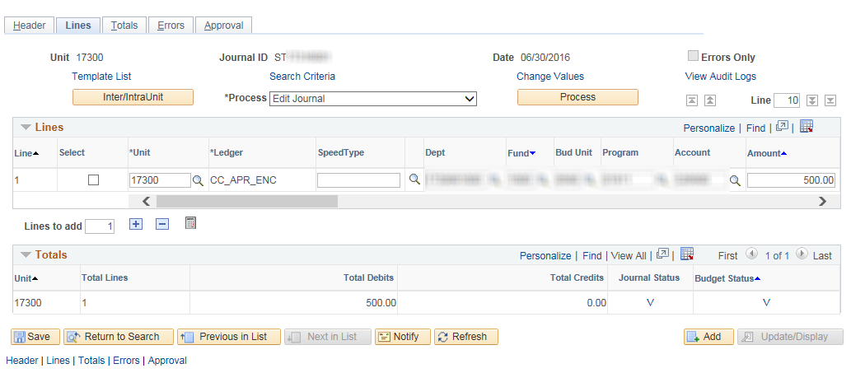
3. | To liquidate a line of the encumbrance, add a line to the journal by clicking on the “+” sign. This will copy the line from above. Verify/enter the ChartFields from the line you are liquidating and verify the amount is a negative (-). Repeat process for each GL journal line to be liquidated. Please note: The sum of the amounts for any budget unit cannot be less than zero. The GL encumbrance journal should NOT be deleted even if all lines are liquidated. This maintains the audit trail in SMART.  Click the ‘Save’ button. This will save the journal and update the Journal Status and Budget Status. Choose “Edit Journal” in the Process box then click the “Process” button. After processing, the Journal Status must be “V” (valid) and Budget Status must be “V” (valid). The budgeted funds are now available to create a prior budget period purchase requisition or a GL journal for travel and expense expenditures.  Journal Line page  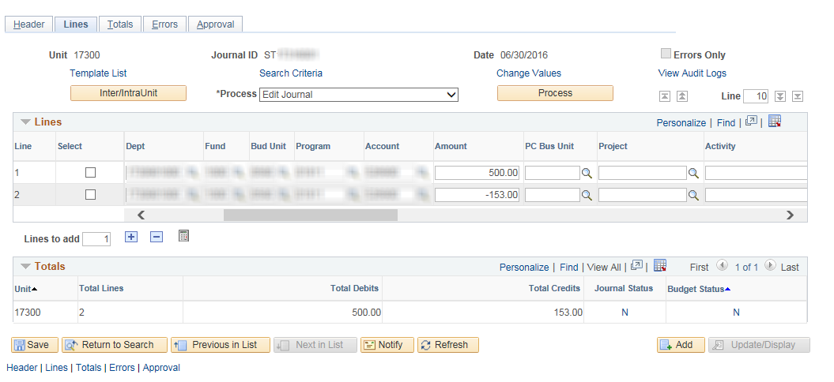  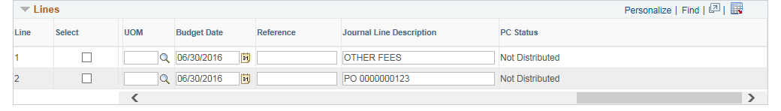
Encumber/Expend available prior budget period funds
1. | Prior Budget Period funds will be available after the GL encumbrance journal is successfully edited and budget checked. The available funds should be encumbered or expended as soon as possible so other obligations do not use the funds inadvertently.
2. | Purchase Requisitions  When the supplier for a procurement bid event that did not complete by fiscal year-end is identified, the GL Encumbrance Journal is liquidated and a Purchase Requisition is created.  - Enter a Requisition (REQ). Here is a link to the related job aid: http://smartweb.ks.gov/docs/default-source/po---reqs---job-aids/entering-requisitions-training-guide.docx?sfvrsn=4.  - You shall enter the ManageEngine Service Desk Request ID from the request for the GL Encumbrance into the Purchase Requisition. (See the Request the GL Encumbrance Journal section, step 3 above). Enter the Service Desk Request ID in the ‘Additional Information’ section on the Create Requisition page in SMART (see screen print below).  You must select the ‘Save for Later’ button until the budget date is changed on the Requisition.  Create Requisition page  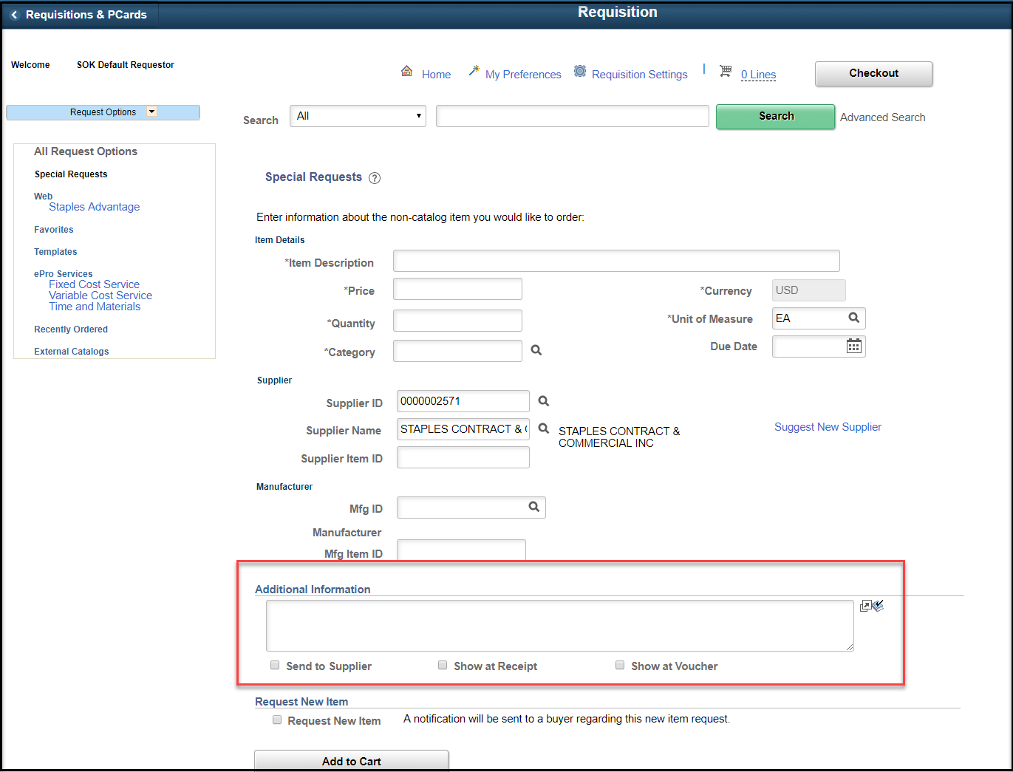  - Complete a Budget Date Change Request form located in the Document Center on the Department of Administration website at the following link: https://www.admin.ks.gov/docs/default-source/osm---accounting-forms/gl-f026-budget-date-change-request-form.xlsx?sfvrsn=d89581c7_  - Submit a ManageEngine Service Desk ticket using the ‘Budget Date Change – Req’ template to request the budget date be changed to a prior year on the Requisition (This is not the GL Encumbrance Journal). You shall attach the Budget Date Change Request GL-F026 to the template to expedite the changes.  ManageEngine Service Desk New Incident, ‘Budget Date Change – Req’ template  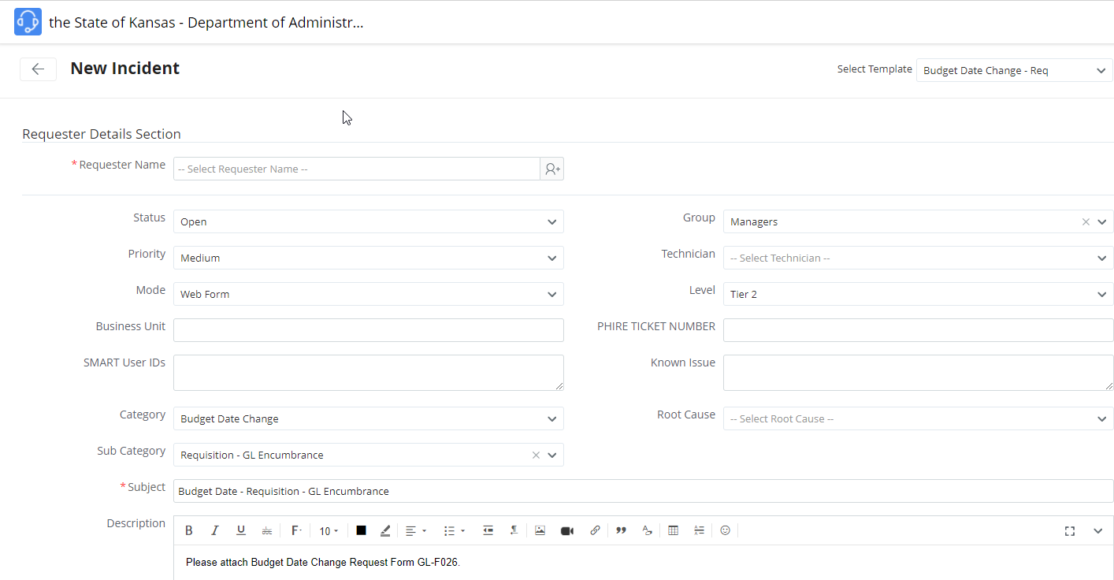  - After the budget date has been changed on the Purchase Requisition, the ManageEngine Service Desk Request will be CLOSED. If not completed already, the ‘Save and submit’ button in the Requisition should be clicked to submit the requisition into the workflow process for approvals.  - The Requisition will be sourced to a Purchase Order with the correct budget date.
3. | Travel and Expense Expenditures  When a prior year travel and expense expenditure is identified, the expense is paid with current budget period funds and then GL journaled to the prior budget period.  - Create a GL journal entry. Here is a link to the related job aid: http://smartweb.ks.gov/docs/default-source/general-ledger/online-journal-entries-training-guide.docx?sfvrsn=4.  You shall enter the ManageEngine Service Desk Request ID from the GL encumbrance request into the GL journal (See the Request the GL Encumbrance Journal section, step 3 above). Enter the ManageEngine Service Desk Request ID in the ‘Long Description’ section on the Journal Entry Header page in SMART (see screen print below).  You must place the journal on hold by checking the ‘Save Journal Incomplete Status’ box on the journal header until the budget date is changed.  Journal Entry Header page  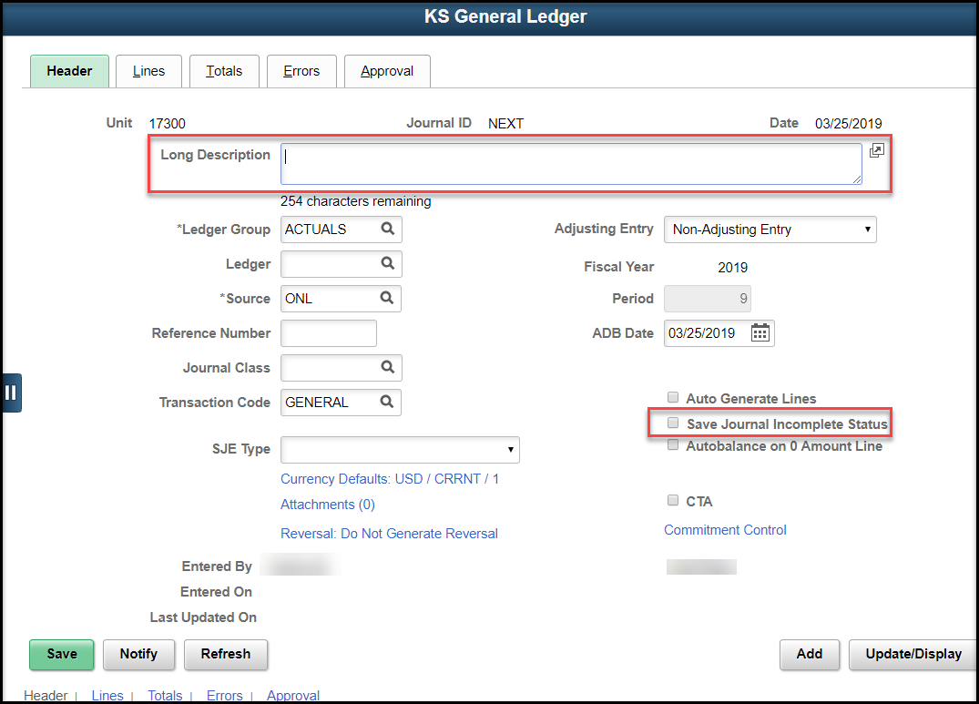  - Submit a ManageEngine Service Desk ticket using the ‘Budget Date Change – T&E’ template to request the budget date be changed on the GL journal entry (This is not the GL Encumbrance journal). You shall attach the Budget Date Change Request Form GL-F026 to the template to expedite the changes.  ManageEngine Service Desk New Incident, ‘Budget Date Change – T&E’ template  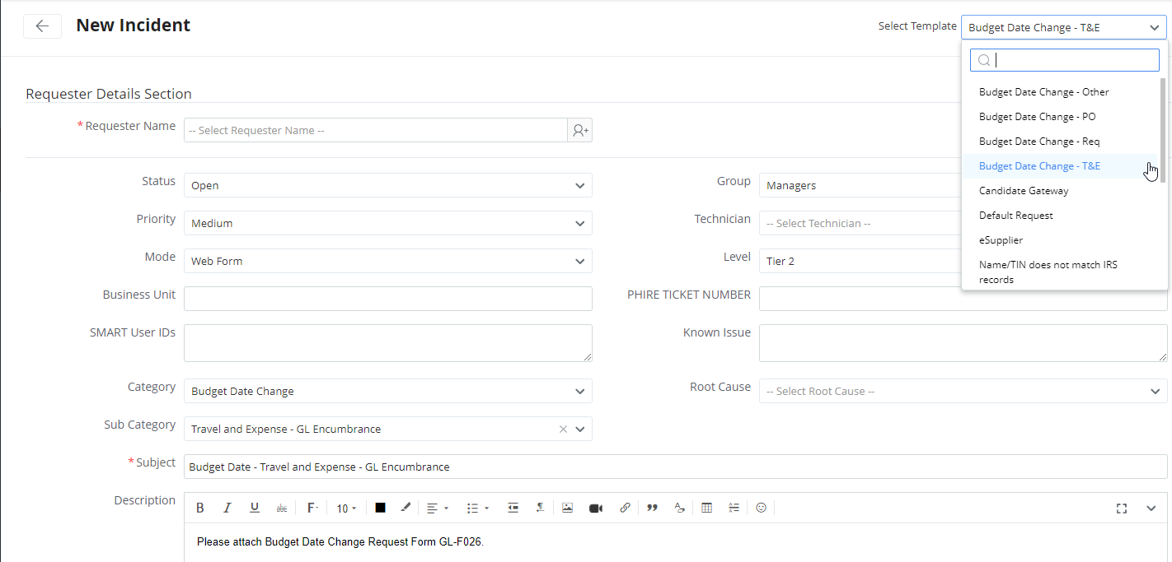  - After the GL journal entry budget date is changed, the ManageEngine Service Desk ticket will be CLOSED. If not completed already, remove the hold from the GL journal entry by un-checking the ‘Save Journal Incomplete Status’ box on the journal header page and click ‘Save’.  - Hourly and nightly batch processes will edit and budget check the GL journal entry so it is recorded in Commitment Control and posted in the GL.

