State of Kansas
High-Level Changes from 9.0 to 9.2 in Asset Management:
Fund Requirement for Capital Assets
Statewide Management, Accounting and Reporting Tool
Date Created: | 10/28/2015
Version: | 1.0
Last Updated Date:
Purpose: | This document highlights one of the changes between 9.0 and 9.2 in the Asset Management module.
Security: | - Role Security: The following roles are applicable:  Agency Asset Processor  BU Security: Business Unit Security is applied. Agencies will only have access to the assets in their Business Unit.
Procedure

Fund is now a required chartfield for all capital assets. In 9.0, it was possible to enter an asset without a fund code. The SMART team would then inform the user of the error and require an IntraUnit Transfer be processed to correct the fund. In 9.2, the system will generate a Combination Edit Error if a fund code is not entered.

This example shows the error message if fund is missed in Express Add. The same error message would generate on the Cost Adjust/Transfer Asset page if fund was not entered there.

Step | Action
 | Click the Main Menu button.
 | Click the Asset Management menu.
 | Click the Asset Transactions menu.
 | Click the Owned Assets menu.

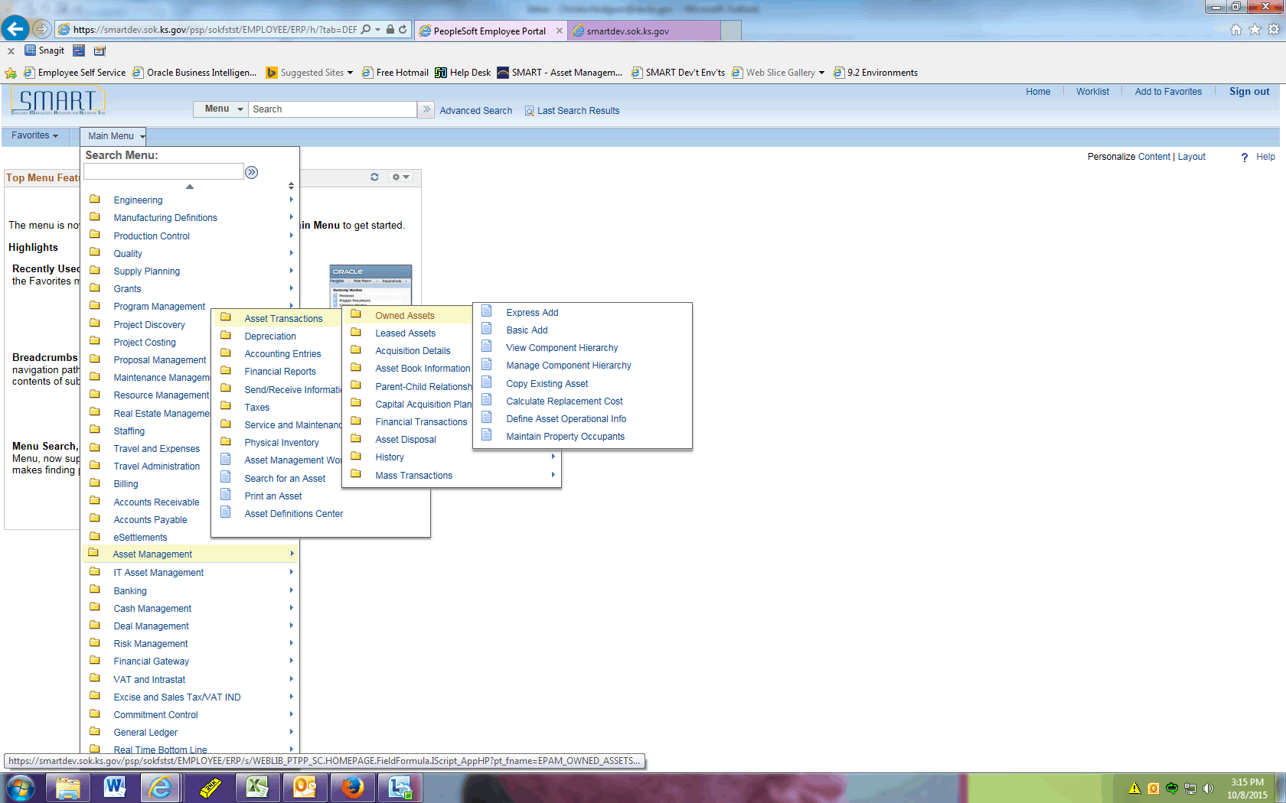

Step | Action
 | Click the Express Add menu.
 | Click the Add button.

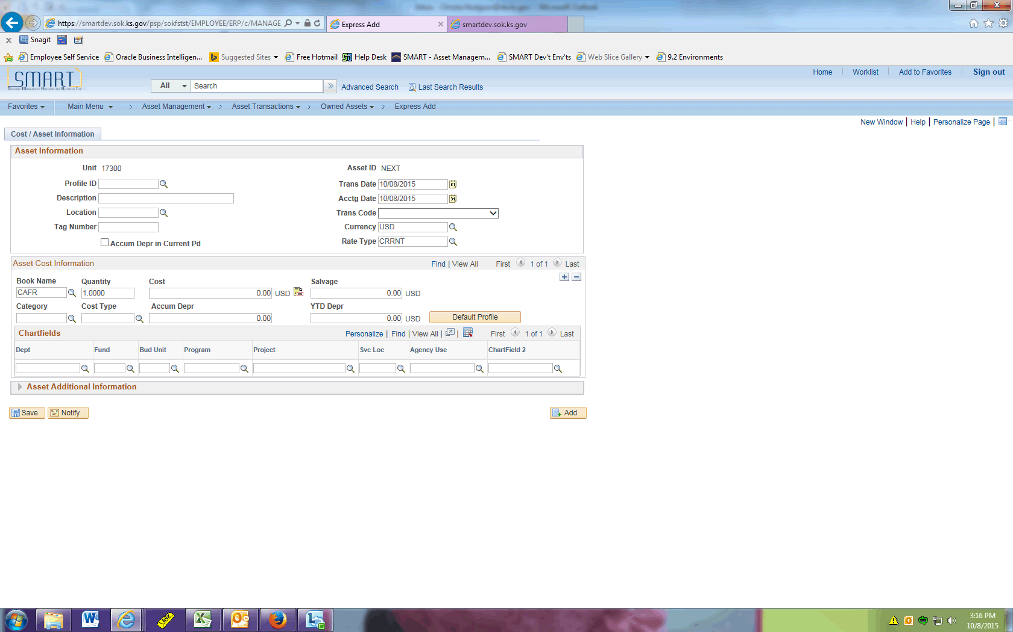

Step | Action
 | Click the Look up Profile ID (Alt+5) button.
 | Click the 540100 link.
 | Enter the desired information into the Description field. Enter "FUND REQUIRED".
 | Click the Look up Location (Alt+5) button.
 | Enter the desired information into the Location Code field. Enter "KT".
 | Click the button.
 | Click the KT112 link.
 | Enter the desired information into the Tag Number field. Enter "12345".
 | Enter the desired information into the Cost field. Enter "45000".
 | Click the Look up Dept (Alt+5) button.
 | Click the 1730101000 link.

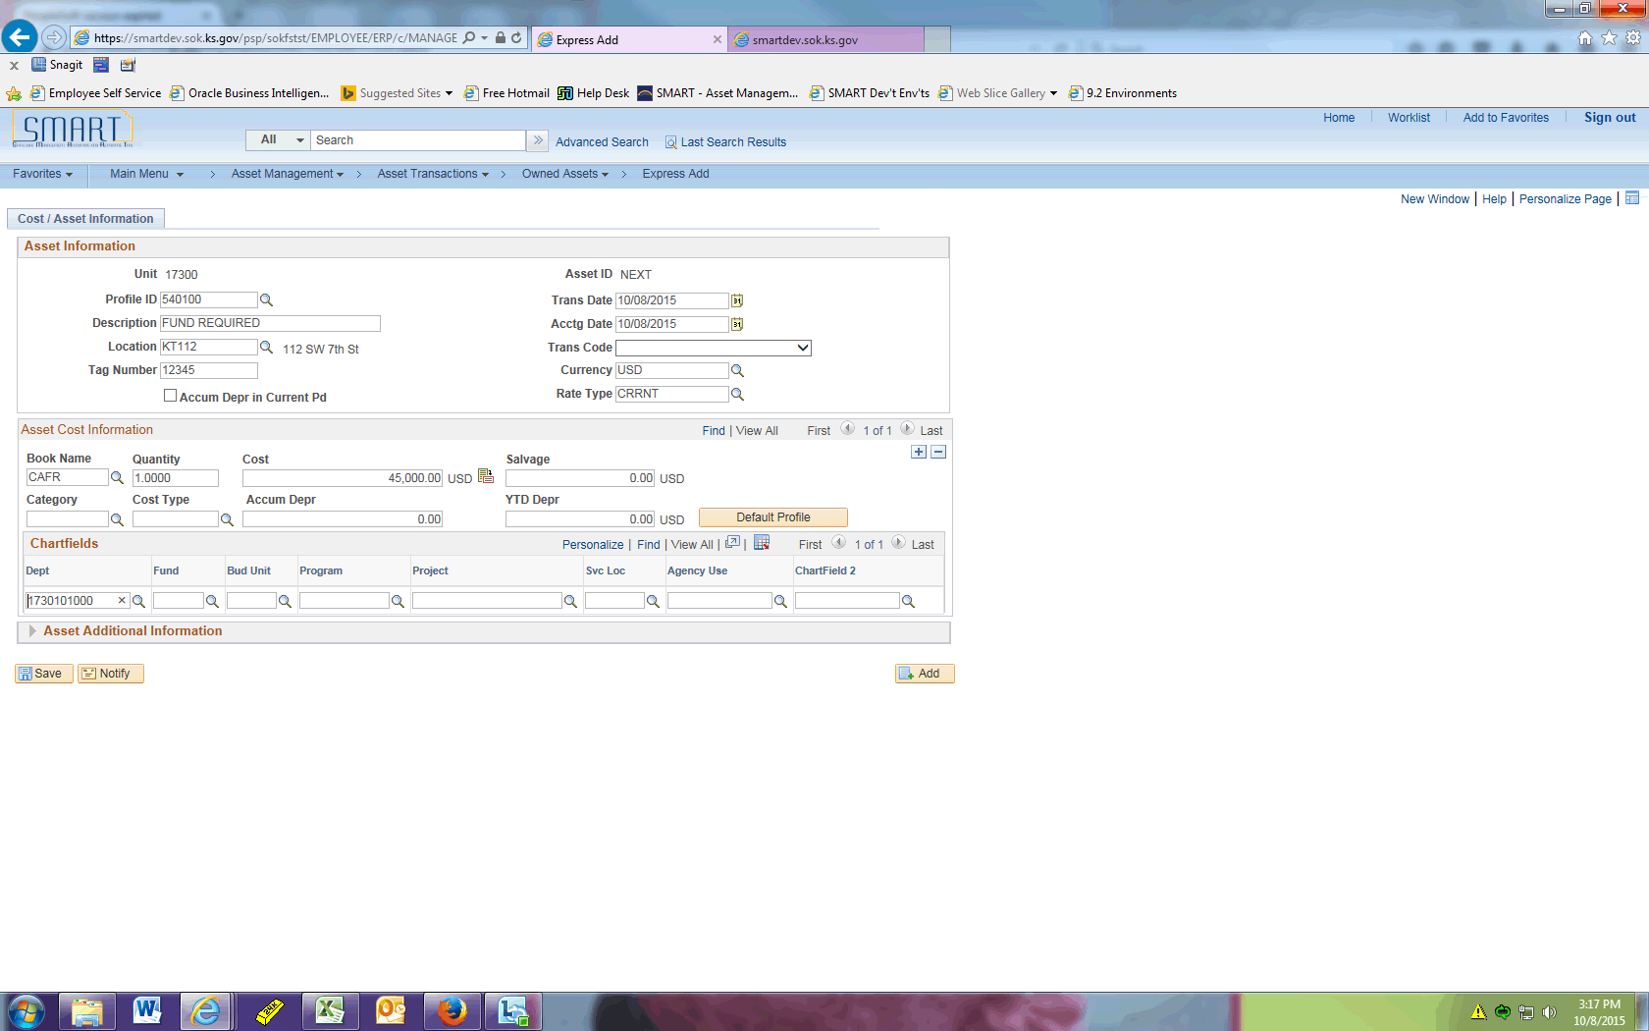

Step | Action
 | Normally a user would select a Fund Code after the Department. To illustrate the error message generated if Fund Code is left blank, we will intentionally leave this field blank now.

Step | Action
 | Click the Default Profile button followed by the Save button.

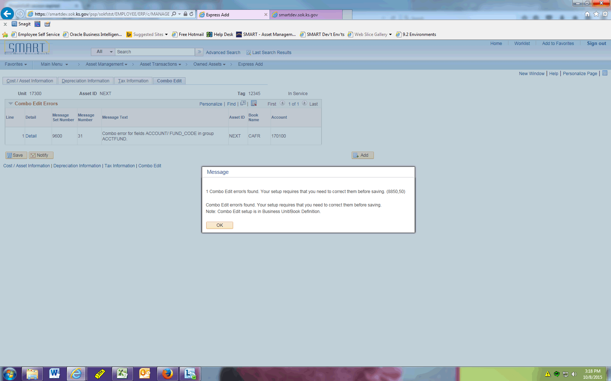

Step | Action
This error message will generate indicating you need to enter a fund code.

Click OK.
 | Click the Cost / Asset Information tab.

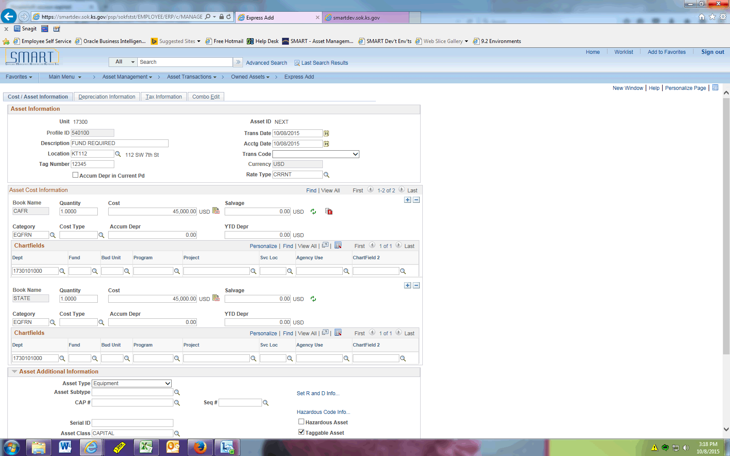

Step | Action
The fund must be added to all books.

Enter the desired information into the Fund field for the CAFR book. Enter "1000".

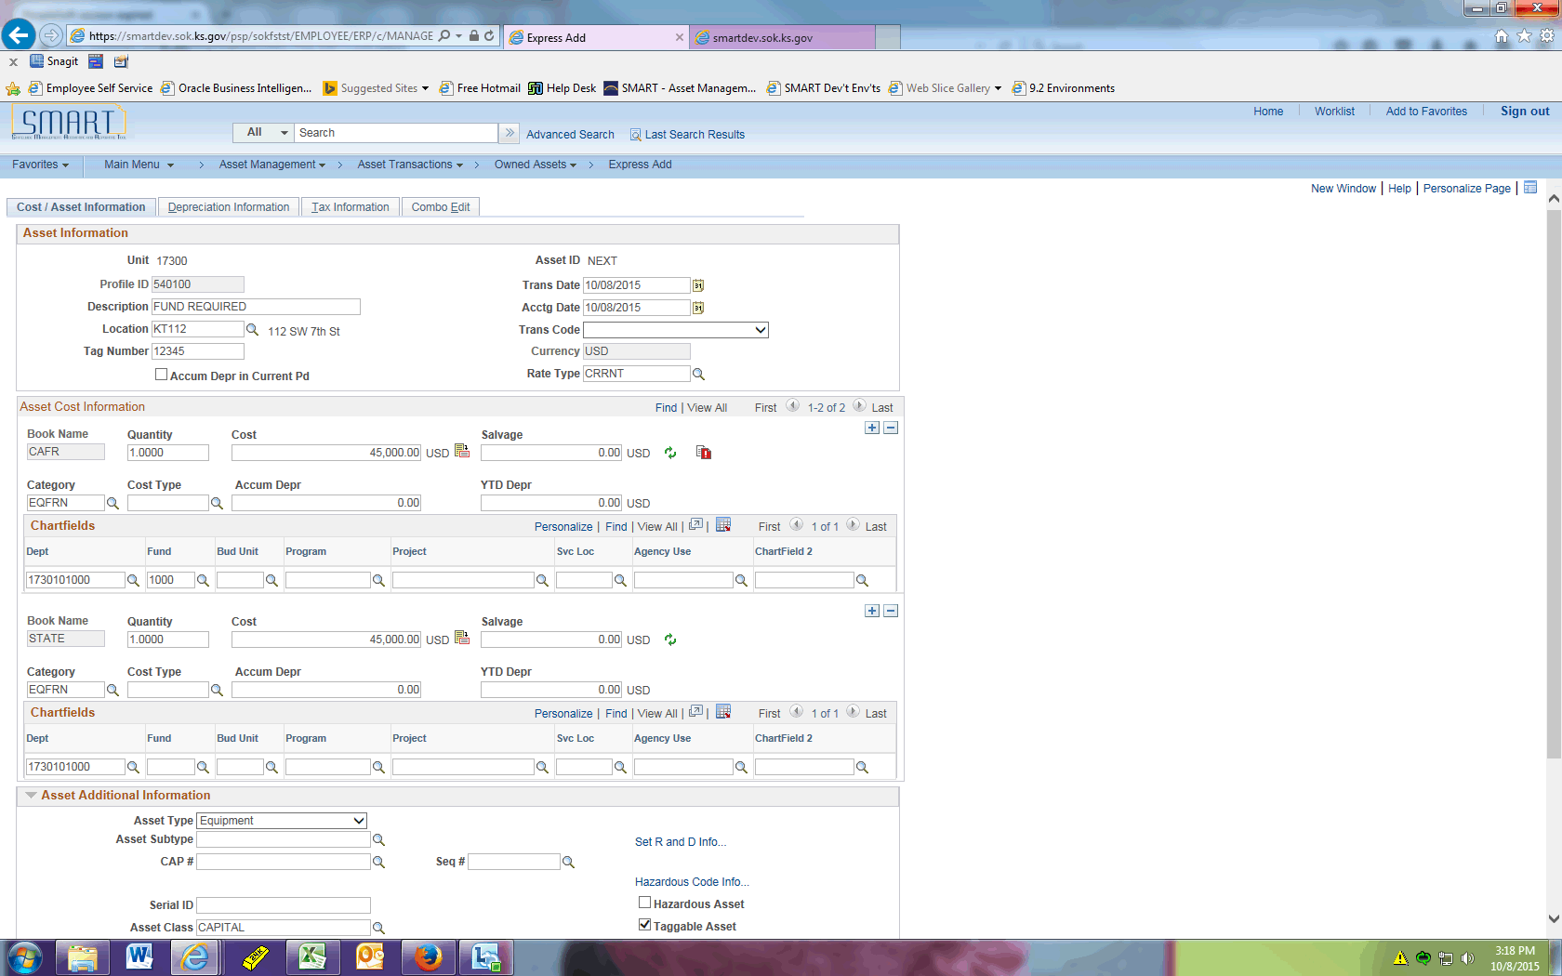

Step | Action
 | Enter the desired information into the Fund field for the STATE book. Enter "1000".
 | Click the Save button.
 | The asset was able to be saved after the Fund Code was entered on all books.
This concludes the 'AM - Fund Requirement for Capital Assets' topic. Thank you for taking this course.
End of Procedure.

