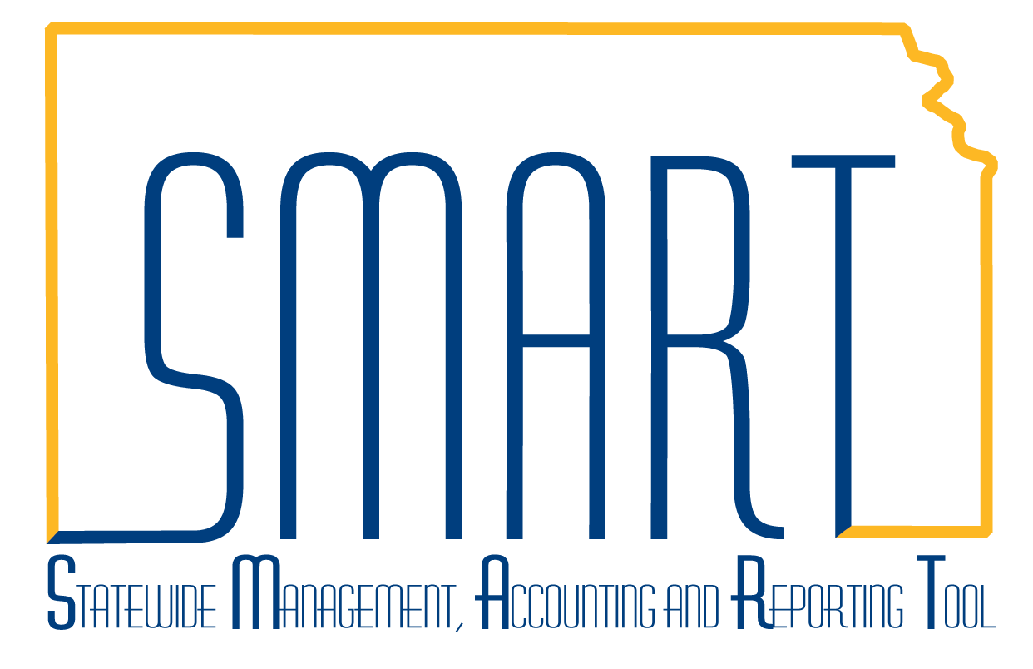
State of Kansas
Federal Draw Down Process
Statewide Management, Accounting and Reporting Tool

Date Created: |  | 2/15/2019
Version: |  | 1.3
Reason for Job aid:  DESCRIPTION OF PROCESS: Delivered functionality in SMART and custom queries (Sponsor Draw Down Report and KS_PC_NEW_BILLING_WKST_DTL) allow you to better manage your draw down process for reimbursable projects/grants. This job aid discusses the agency steps needed to perform your draw downs, including the use of Project Costing (PC), Customer Contracts (CA), Billing (BI), and Accounts Receivable (AR). |  | ROLES: Agency Projects Manager, Agency Customer Contract Manager, Agency Budget Processor, Agency Projects/Grants Reporter, Agency Billing Administrator, Agency Deposit Processor  The WorkCenters for Customer Contracts (CA), Grants (GM), Project Costing (PC), and Billing (BI) are useful to eliminate navigation steps and components can be accessed from a specific WorkCenter.  If interested in using the Grants Portal for tracking all data concerned with Grants, the full grant process must be used. Follow instructions for Adding Sponsors, How to Create a Grant, How to Submit a Grant Proposal, and How to Generate an Award located at the following link: http://www.smartweb.ks.gov/training/projects-grants/grants/grants---job-aids  Note: References are made to the specific job aids that provide more information on the particular tasks.  This job aid is structured to easily print processes, with breaks for Day 1 and Day 2, but more logically for processes not necessarily used each time a draw down is completed.
 | DAY 1
1. | As the Agency Projects Manager, create a Project. The How to Create a Project job aid can be accessed at the following link: http://www.smartweb.ks.gov/training/projects-grants/projects/projects---job-aids Also included at this link is a job aid on Project Types. | 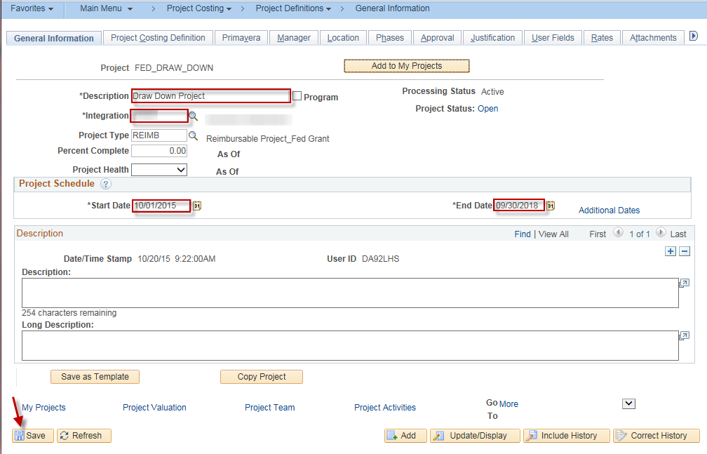
2. | Add an Activity to the Project. Instructions included in the How to Create a Project job aid. | 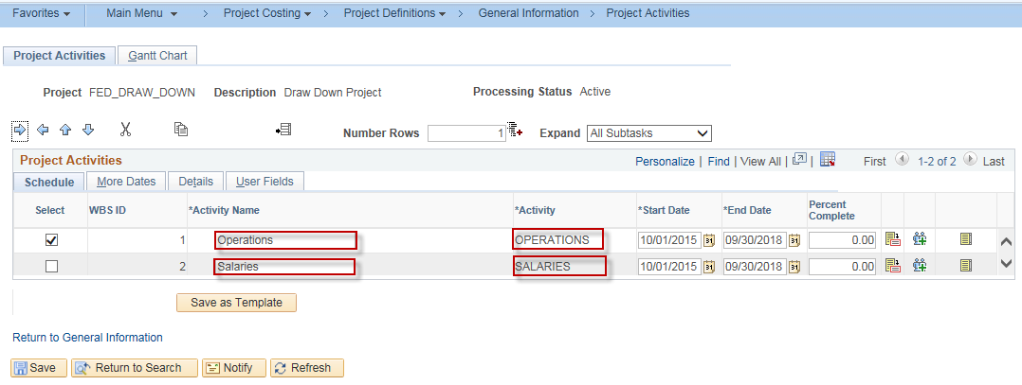
3. | As the Agency Customer Contracts Manager, create a Contract. Verify the Use Project Chartfields checkbox is checked on the Customer Contract. The How to Create a Customer Contract job aid provides complete instructions and can be accessed at the following link: http://www.smartweb.ks.gov/training/projects-grants/customer-contracts/customer-contracts---job-aids | 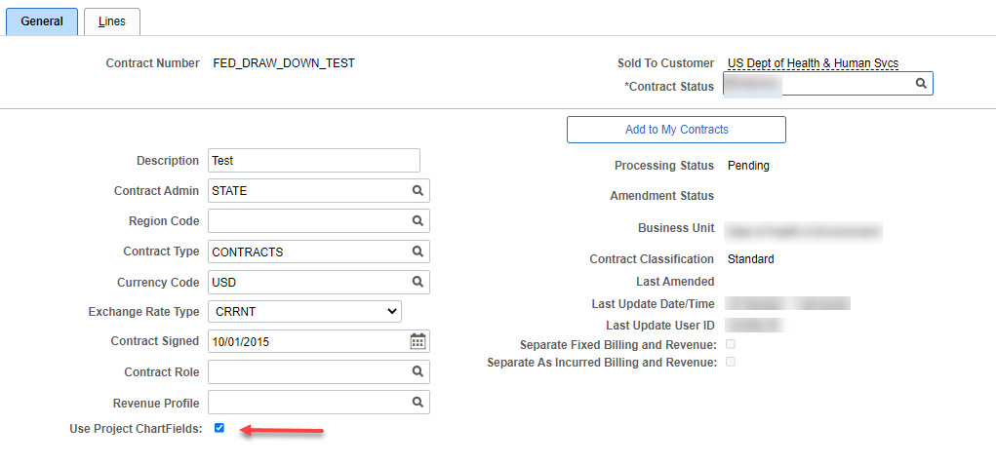  Note: If intending to use the Federal Financial Report for multiple grants, include the LOC ID on the Contract. As the Billing Limit is now entered differently since the upgrade, more information may be found in the job aid.
4. | Relate the Project and Activity to the rate-based product on the Contract. Click Save. | 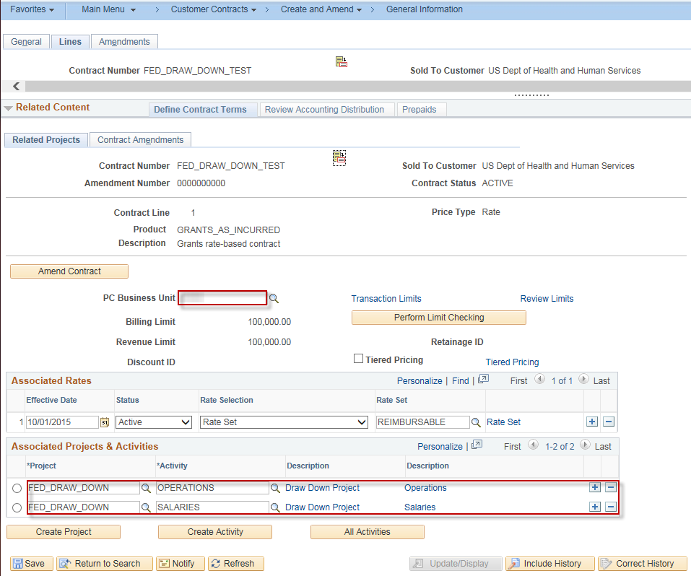
5. | Update the Accounting Distribution on the Contract. Verify or update the Effective Date as needed. Click Save. Verify the Valid checkbox is now checked by scrolling as far right as possible. | 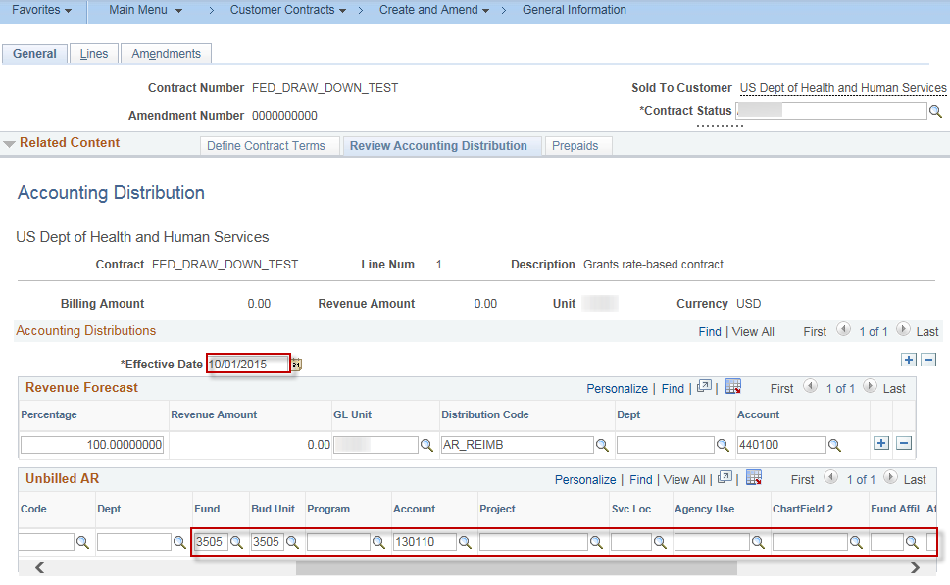
6. | Activate the Contract, by selecting Active for Contract Status. Click Save. | 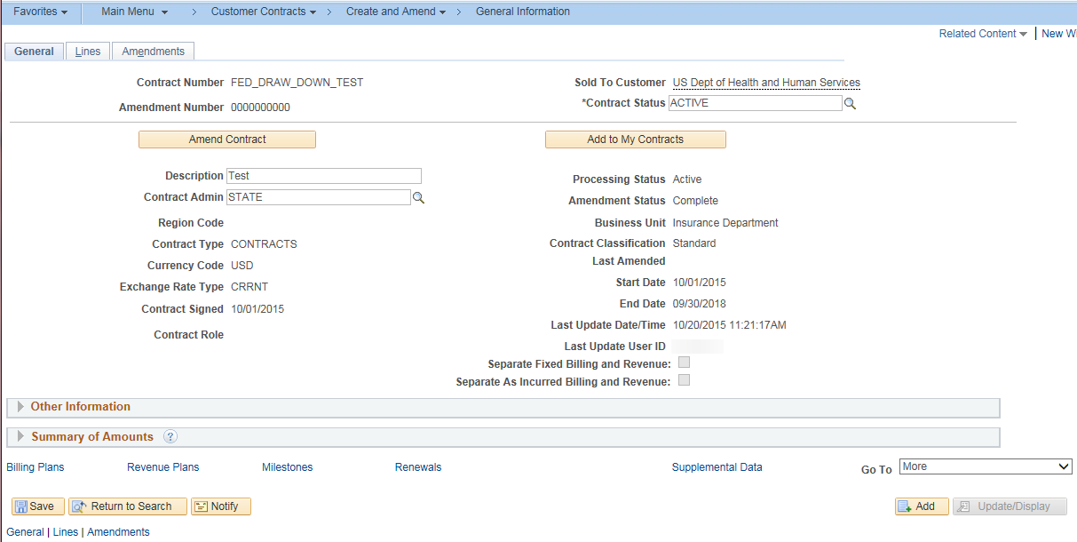
7. | As the Agency Budget Processor, add a project budget journal (if required). | 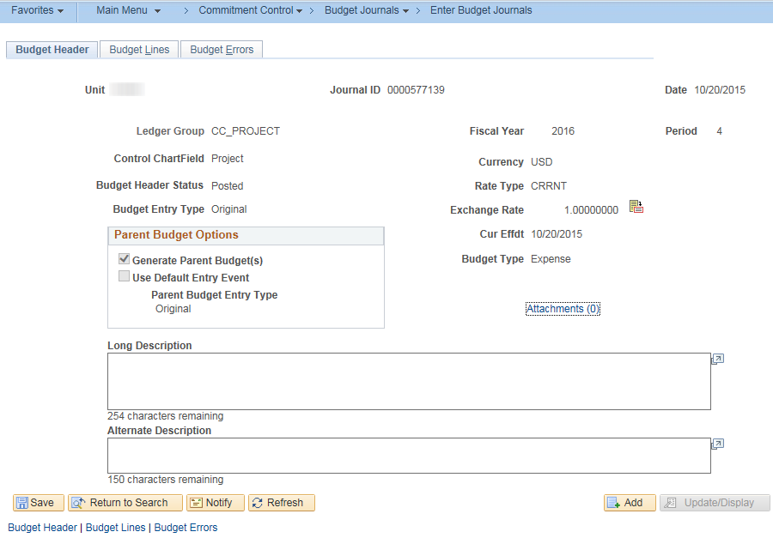  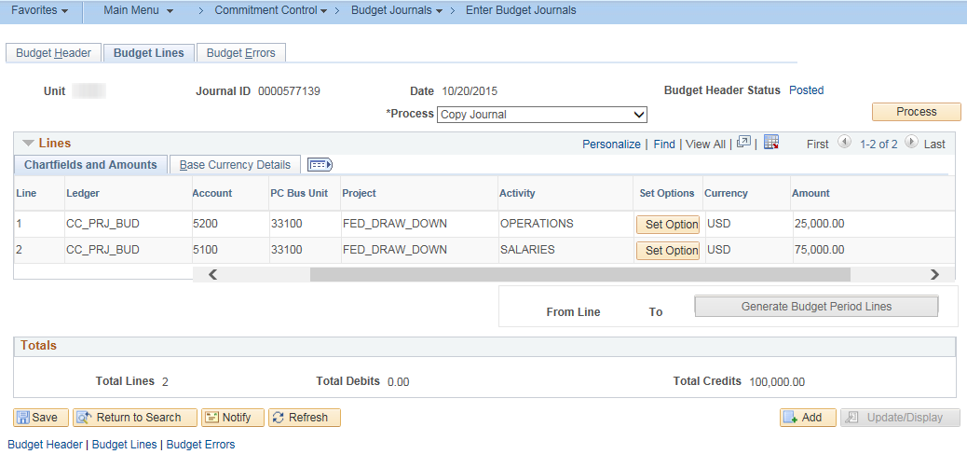
8. | Begin transacting in the system (i.e. enter a $15.00 transaction against the project)
9. | **IN NIGHTLY BATCH | All of the cost collection and billing/revenue processes will occur.
 | DAY 2
10. | Navigation: Projects and Grants Homepage > Project Costing > Transaction Definitions > Transaction List or Navigator > Project Costing > Transaction Definitions > Transaction List. As the Agency Projects Manager, review transactions against the project. Using the Analysis Group of ALL will pull in all rows.  The ACT (Actual Cost) row was created from the transaction entered online. The ACT row generated a BIL (Billable Amount) row since a rate-based contract line was tied to this Project/Activity.  Note: A BD1 (Budget) row would be from the project budget journal that was created if you entered a budget journal in Step 7. | 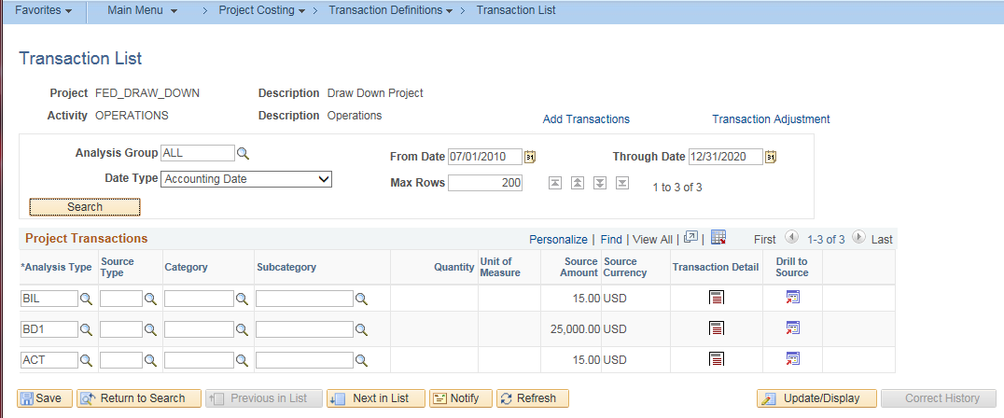
11. | As the Agency Projects/Grants Reporter, navigate to the custom Sponsor Draw Down Report to determine how much is needed to draw. Billing Homepage > Process Billing Worksheets > Non-Consol Invoice Processing > Sponsor Draw-Down Report or Navigator > Customer Contracts > Reports > Sponsor Draw-Down Report  On the Run Control page, enter the Transaction Beginning Date, Transaction Ending Date, PC Business Unit, Project ID (optional), and Activity ID (optional). The report can also be filtered based on Customer. Click Save, then click Run. | 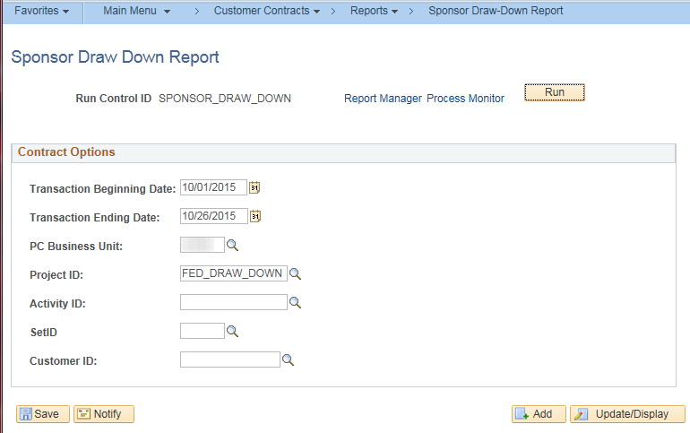
12. | Select the KPC00001 checkbox, and click OK. | 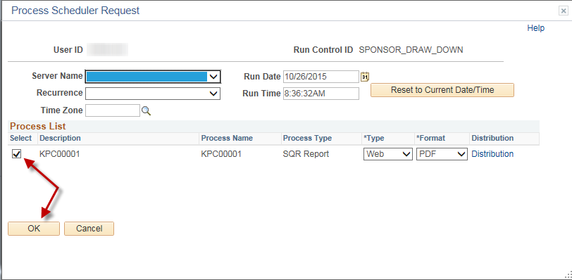
13. | Once the page updates, select the Process Monitor link. Click the Refresh button to update the progress of the report until a Run Status of Success and Distribution Status of Posted is shown. Click the Details link. | 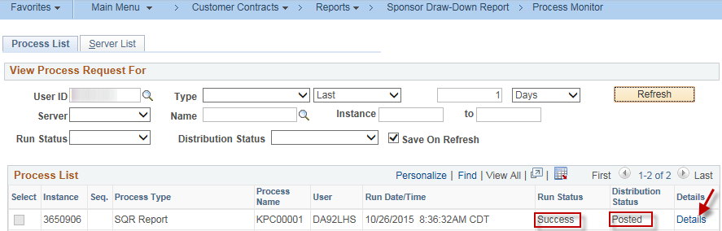
14. | Click the View Log/Trace link. | 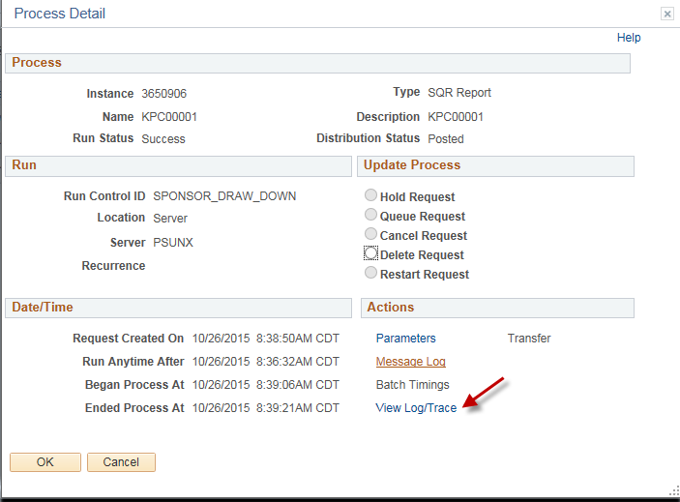
15. | Select the .CSV file generated. This is the report. | 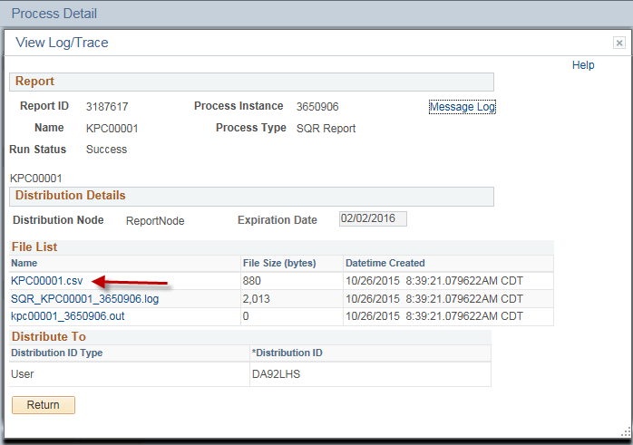
16. | The report should open in Excel, and the transactions that need drawn down are listed in the report. The Scheduled Amount is the amount that needs to be drawn down from the external system (in this example = $15.00).  NOTE: If this transaction originated from a voucher in AP, then a Voucher ID and Payment Date would be included in the report. You should use the Payment Date to determine when you should do the draw down. If the Payment Terms are NET30, and the payment is not due to the vendor for another 30 days, you should not complete your draw until closer to the Payment Date (CMIA standards). | 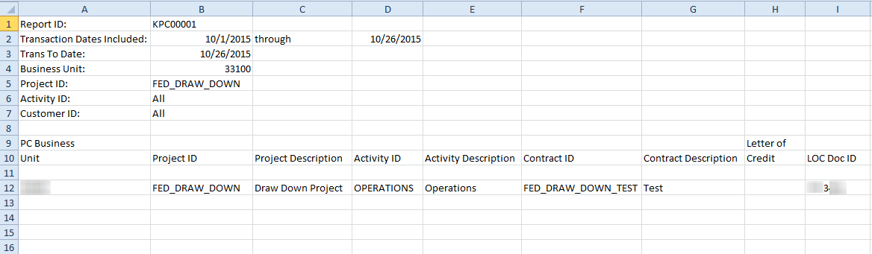  (Left screen)  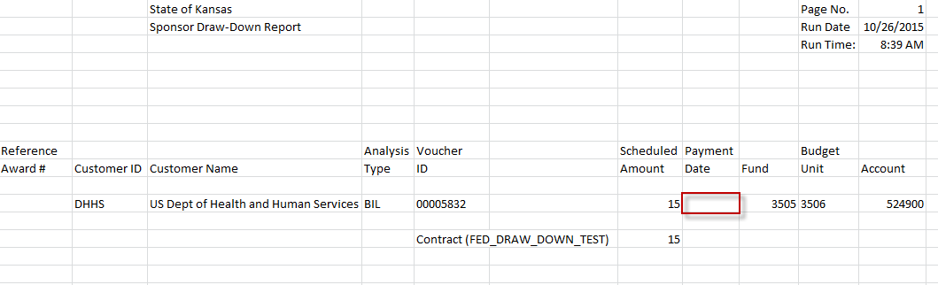  (Right screen)
17. | KS_PC_NEW_BILLING_WKST_DTL - A new Billing Worksheet Detail query has been created. The user can access the query in the BI WorkCenter or Billing homepage > Utilities tile > Query Viewer.. | 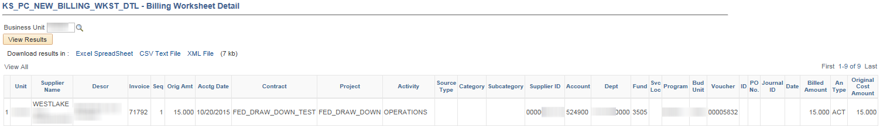
18. | As the Agency Customer Contracts Manager, review the Billing Worksheet. Navigation: Billing Homepage > Process Billing Worksheets > Non-Consol Invoice Processing > Update Billing Worksheet or Navigator > Billing > Manage Billing Worksheet > Update Billing Worksheet. Once you find the related bill, select the checkbox for the line and click Approve Now. | 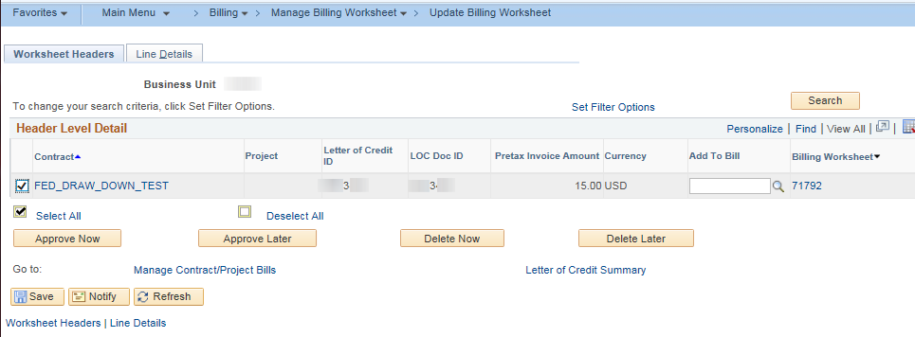
19. | Once approved, the Billing Worksheet will no longer be available for selection. | 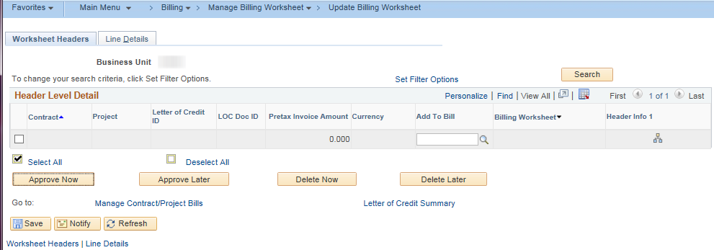
20. | As it moves through the Billing processes the Invoice number changes from the original BI invoice number to the AR invoice number. To locate the new AR invoice number that will be used in later steps, select the Review Contract/Project Bills in the Non-Consol Invoice Processing folder. The Business Unit will default, click the Search button to view results. | 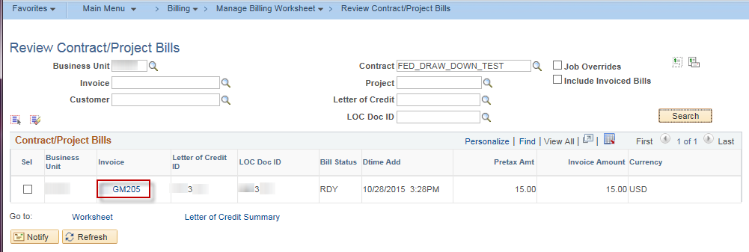  Note the Invoice number to be used later. This will have a bill status of RDY. If the invoice is listed on this screen, it is available for processing the next step.
21. | Navigation: Billing Homepage > Process Billing Worksheets > Non-Consol Invoice Processing > Finalize and Print Invoices, Add a New Value tab or Navigator > Billing > Generate Invoices > Non-Consolidated > Finalize and Print Invoices, Add a New Value tab. Enter a Run Control ID that is meaningful to the user.  Note: After the RC ID is created, the RC ID can be re-used each time a draw is completed, simply use the Find and Existing Value tab for future processing. | 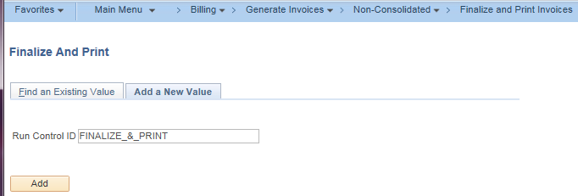
22. | Another place to find the invoice number is by clicking the icon to the right of the Run button.  Enter the parameters for the Finalize and Print process. Include the Invoice number noted previously in Step 20. After entering the From Business Unit, the To Business Unit will auto-fill, as will the To Invoice, once the From Invoice is entered. Click Save, then click Run.  Note: A range of invoice numbers may be entered. | 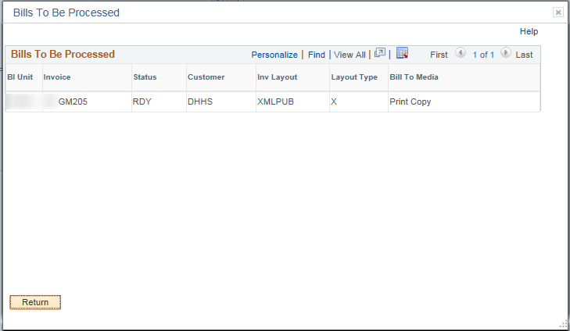  After clicking the icon, the above will display any invoices available, but does not give you any amount information.  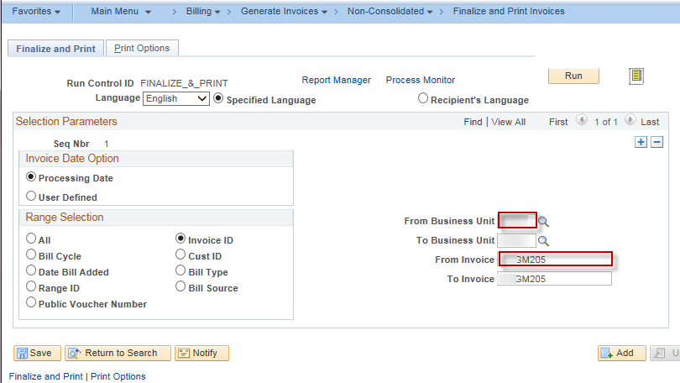
23. | Select Finalize and Print (Process Name: BIJOB01) and click OK. | 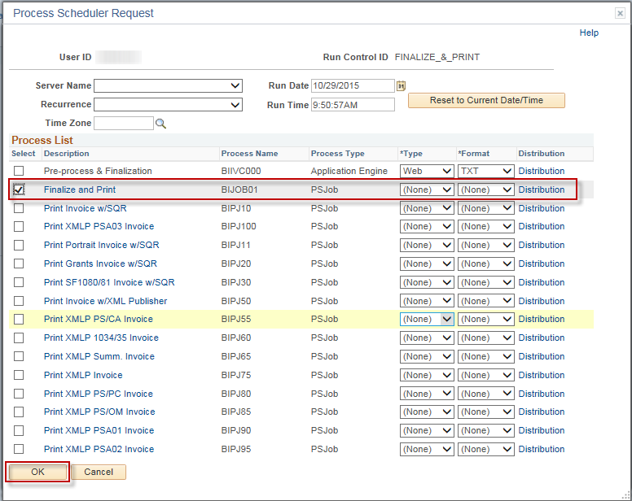
24. | Access the Process Monitor link to see progress of the job. When the job is complete, it will have a Run Status of Success and Distribution Status of Posted. | 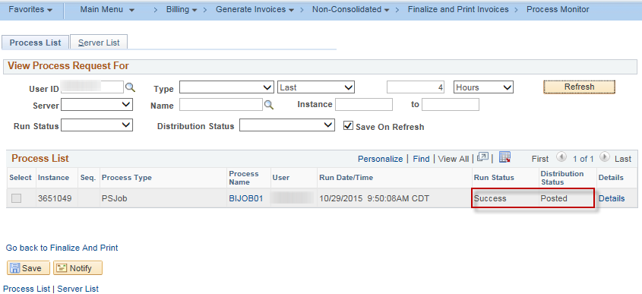
25. | **IN DAILY BATCH - After Finalize and Print is run, there will be a delay of approximately one hour so that the remainder of the BI/AR processes will run.
26. | **EXTERNAL TO SMART - Access your external draw down system and request your draw (this will not be tracked in SMART) in the amount of the billing worksheet.  Do not over-draw or under-draw, as this will cause the system to be out of balance.
27. | As the Agency Deposit Processor, create the Deposit. Navigation: Billing Homepage > Process Billing Worksheets > Create the Deposit > Create the Deposit > Add a New Value tab or Navigator > Accounts Receivable > Payments > Online Payments > Regular Deposit > Add a New Value tab. Enter the Business Unit for the Deposit and click Add. | 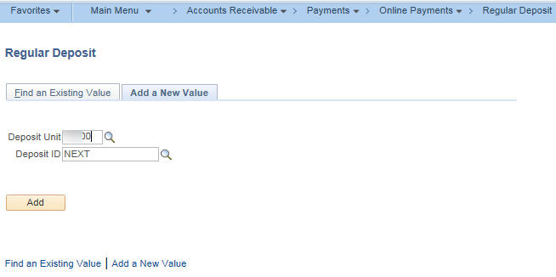
28. | On the Totals tab, enter the Deposit Type, Control Total Amount, and Control Count. Accept the defaults on all others. | 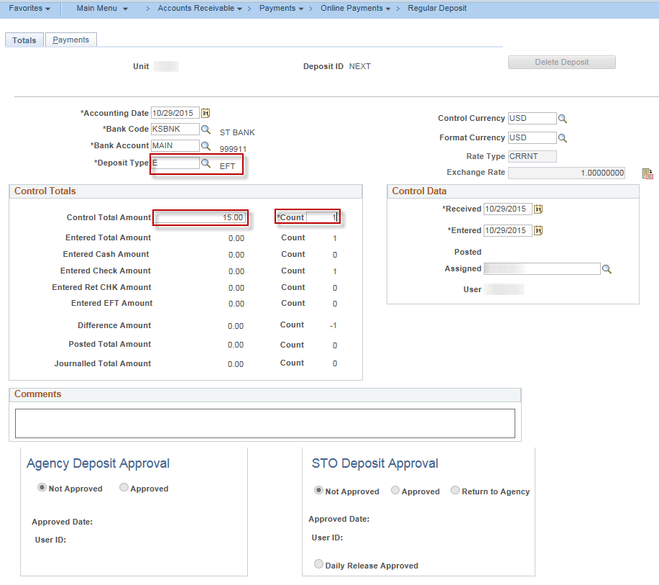
29. | On the Payments tab, enter the Payment ID, Amount, Payment Method, Customer ID, Qual Code (I), and Reference (invoice numbers noted in steps 20 or 22). Click Save.  Note: Best practice is to use the look up to locate the invoice numbers (Reference) to be processed to ensure the invoices have processed to this point. | 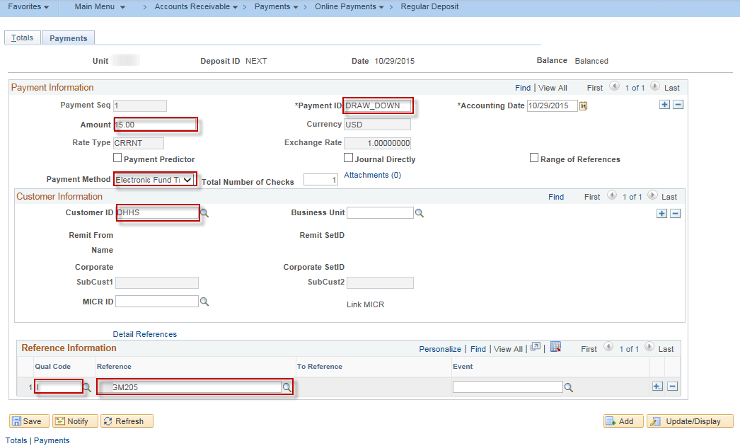
30. | Navigation: Billing Homepage > Process Billing Worksheets > Create the Deposit > Create Worksheet or Navigator > Accounts Receivable > Payments > Apply Payments > Create Worksheet. Create the Payment Worksheet for the Deposit by entering Deposit Unit and clicking Search. Select the Payment recently created. | 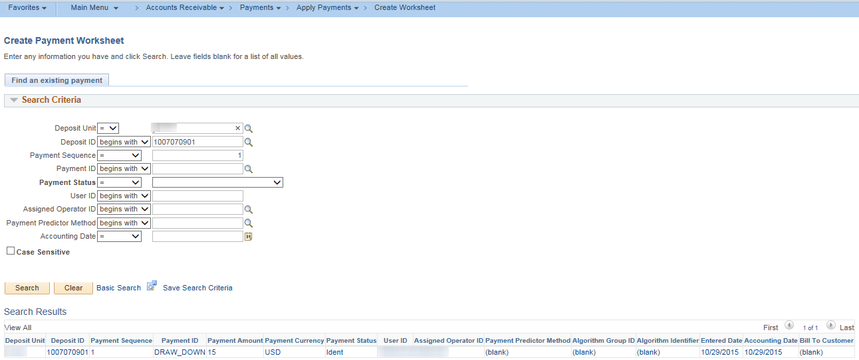
31. | Click the Build button on the Payment Worksheet. | 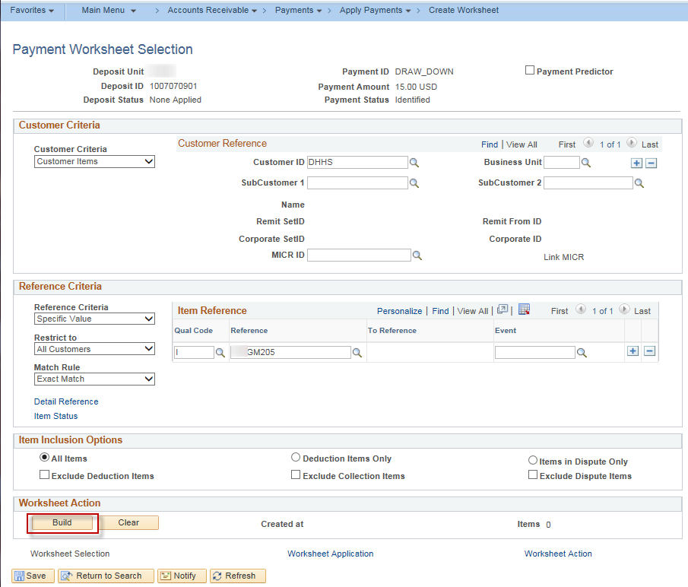
32. | On the Payment Worksheet Application, click the Sel checkbox next to the items to be processed. Click the Save button. Click the Worksheet Action link. | 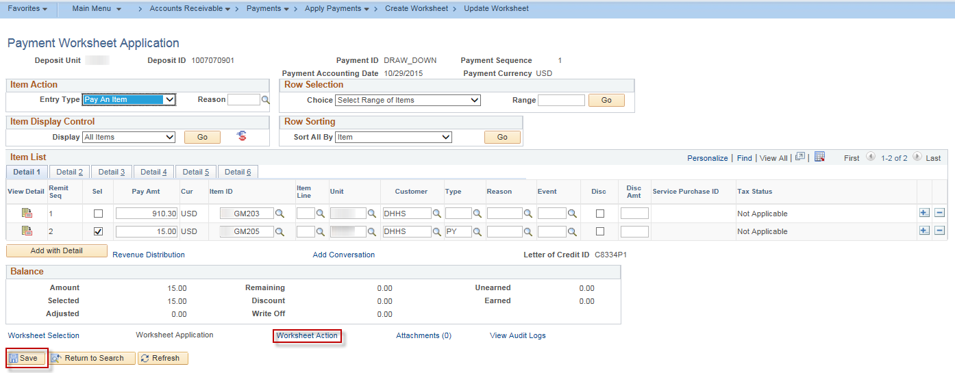
33. | Click the Create/Review Entries button to review the accounting entries. | 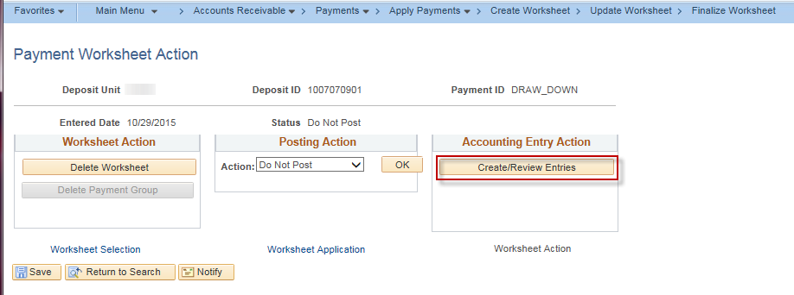
34. | If necessary, click the View All on the far right to see all lines of your deposit. Once reviewed, click the Return to Previous Panel button. | 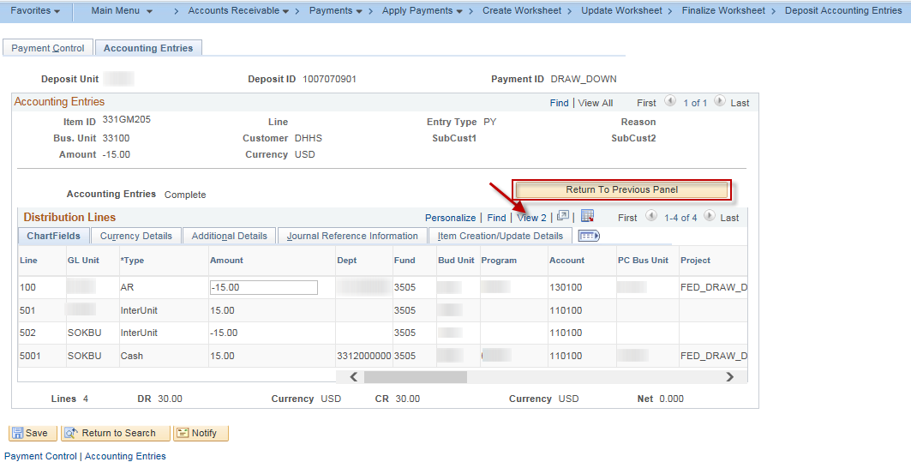
35. | Select Batch Standard for the Posting Action, click OK, then click Save. | 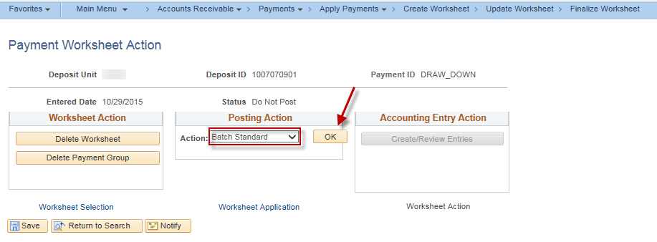
36. | While this is the end of the job aid instructions, depending on agency processes and SMART hourly processes, the deposit will require approval. The receipt of the funds will happen following normal agency AR processes.

