AM Tool 6 – Processing Asset Vouchers When Integration Began in Purchasing
04/17/2019
V.1.1
This document provides instruction on how to process a Voucher that contains asset data. These instructions are for agencies who begin asset integration in the Purchasing module by populating the Asset Management Business Unit and Profile ID fields on either the Requisition or Purchase Order.
Note this document does not cover every step to processing a Voucher; only the pertinent asset- related data is included. Additional instruction on processing a Voucher can be found in the Accounts Payable training documents.
Foundation Information
It is important to understand three basic asset concepts before processing an asset Voucher. All of these are defined in the Asset Management—The Basics Training Guide located on the SMART website under the Training page, Asset Management section.

- You should know the definition of ‘Asset’.
- You must have an understanding of Profile IDs.
- You must know the Capitalization Thresholds utilized by the State of Kansas.

There are two fields that trigger the integration: the AM Business Unit (your business unit) and the Profile ID. It is critical that the correct Profile ID is selected on these documents to prevent processing problems in the AM module.

Adjustments to existing asset costs (as in the case of Construction in Progress (CIP) assets) must come from the voucher only. The system assumes that Requisitions and PO's are for new assets.

Homepage Navigation: Accounts Payable>Vouchers>Add/Update>Regular Entry
Or
NavBar: Navigator>Accounts Payable>Vouchers>Add/Update>Regular Entry

Asset data is located on the Assets tab in the Distribution Lines Section under Invoice Lines. If the AM BU and Profile ID were entered on either the Requisition or Purchase Order and the Copy PO button or the Worksheet Copy Option dropdown is used to associate the Purchase Order to the Voucher, asset information will default into the Voucher.

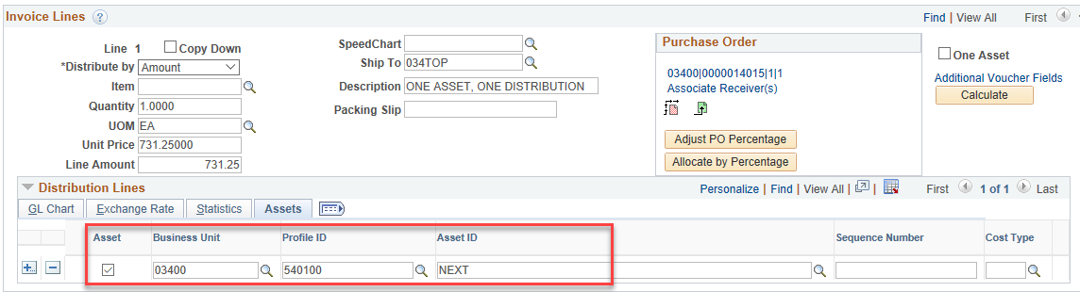

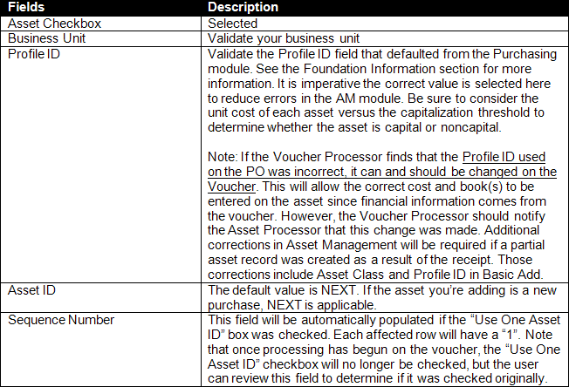

After the voucher is posted, the data will integrate into the Asset Management Loader Tables, where the Agency Asset Processor is responsible for reviewing and loading the data.

Items to Note Regarding Processing a Voucher with a Receipt

O If the receipt was serialized (i.e. the quantity was split out into individual asset lines), the total cost from the voucher will be split automatically between the assets that were created from the serialized receipt.

O If the ‘One Asset’ feature was selected on the receipt, the split-funding from the voucher will automatically integrate into AM.

O If the ‘One Asset’ feature was not used on the receipt and multiple Asset IDs were created erroneously, the voucher cost will be split between the created Asset IDs. This would have to be corrected manually in AM via adjustments to cost and/or quantity.

Items to Note Regarding Processing a Voucher With No Associated Receipt

O If there are multiple assets on the same Invoice Line (i.e. Quantity > 1.000), those lines will need to be split into individual assets by the Agency Asset Processor in the AM Loader Tables via Unitization.

O If the asset is split-funded, utilize the ‘One Asset’ checkbox. Split-funded assets should have a single Invoice Line with multiple Distribution Lines under each Invoice Line. This tells the system that all Distribution Lines within that Invoice Line are for the same asset. This creates one split-funded asset in AM. Only those lines with the AM BU and Profile ID will integrate forward into AM, so every applicable Distribution Line should be marked with the AM Business Unit and Profile ID.

- Note that the Sequence Number field on the Assets tab will be populated with a “1” on each funding line if the ‘One Asset’ box was checked. After processing has begun on the voucher, the ‘One Asset’ box will no longer be checked, but the Sequence Number field will validate that it was originally.

