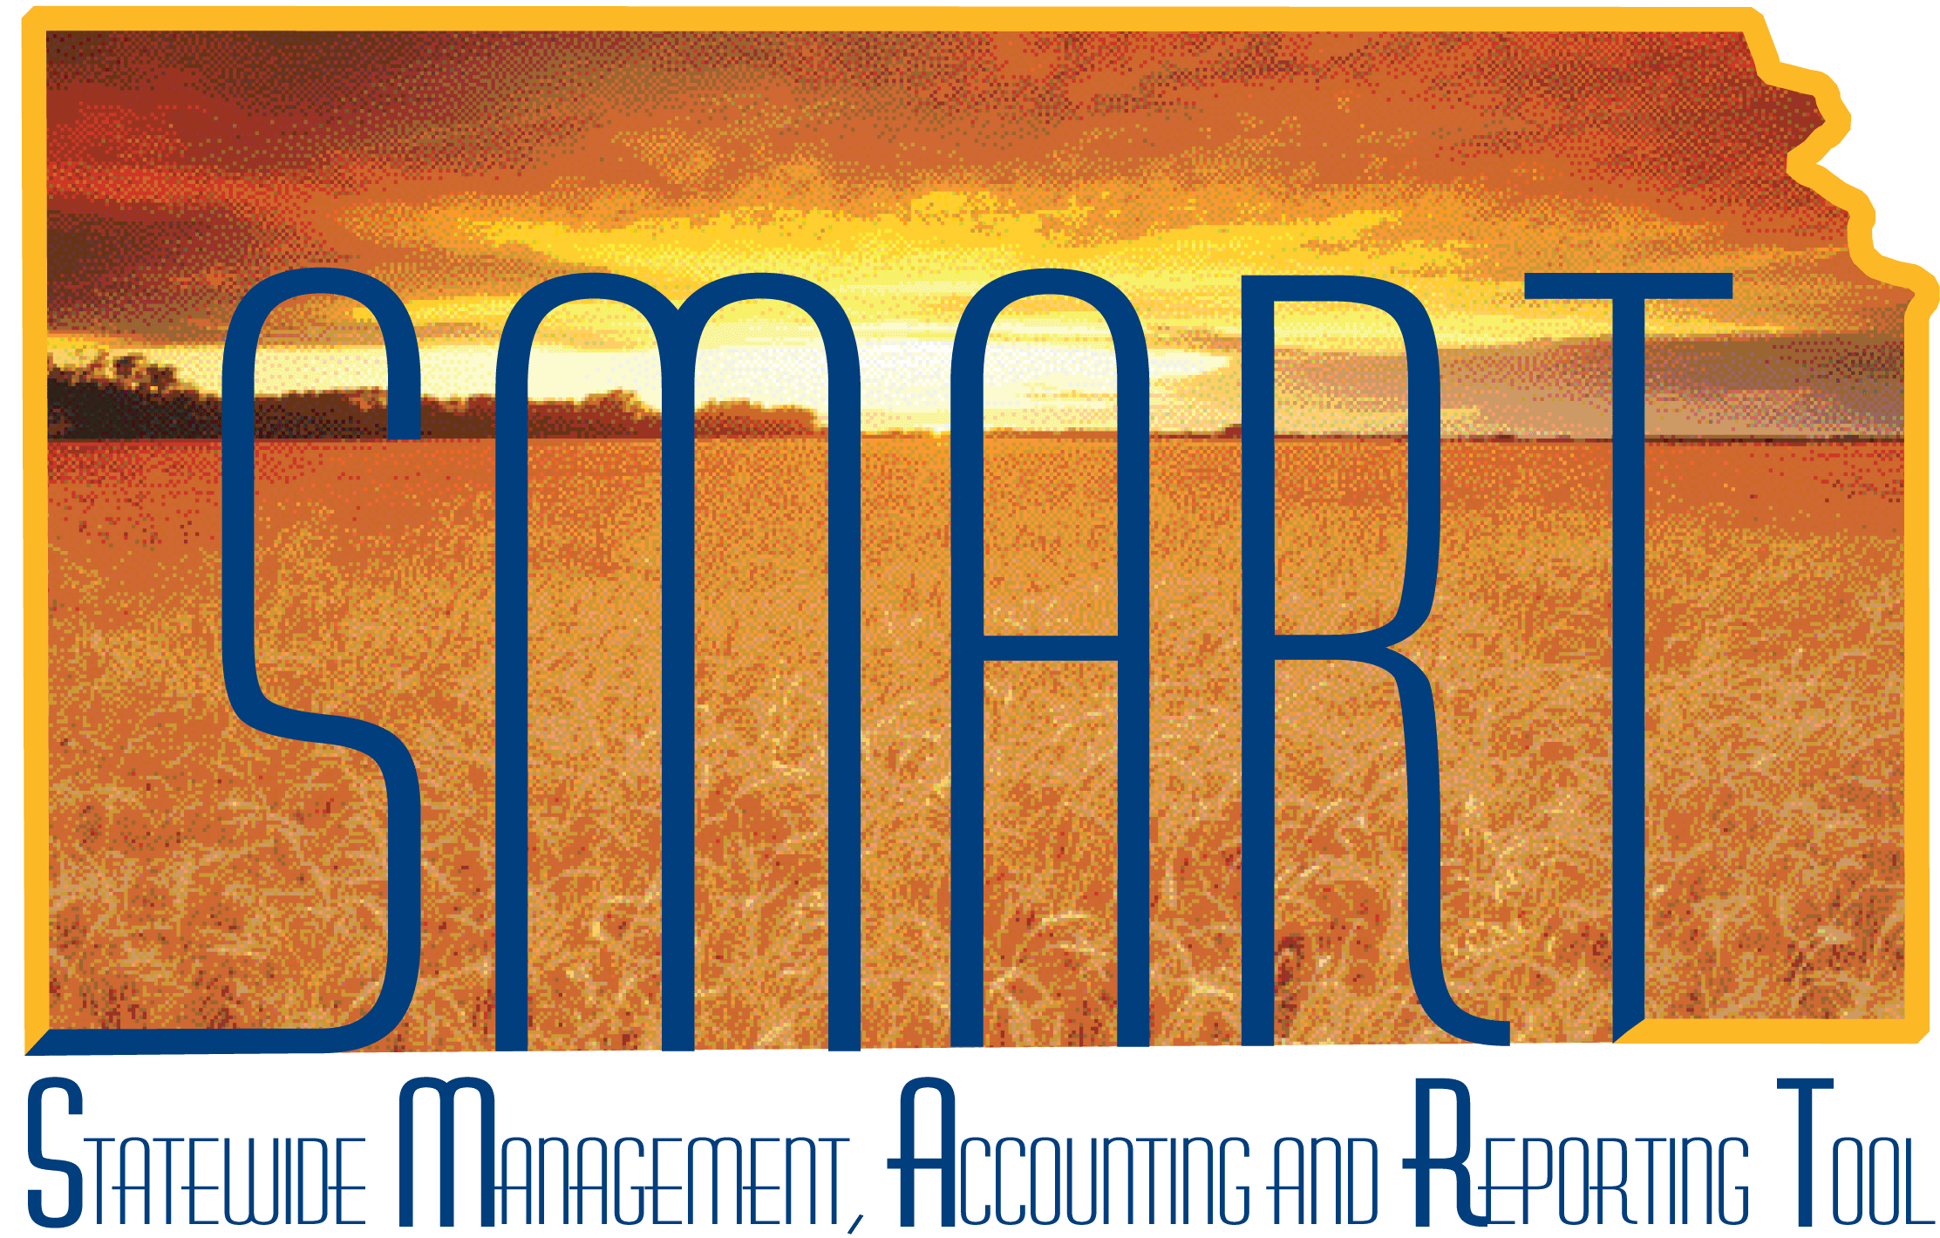
Training Guide – Purchasing
Entering Requisitions
State of Kansas

Applicable Role(s):
KPO_Agy_Requisitioner
Table of Contents
Key Terms 4
Key Concept 5
Structure OF A REQUISITION 5
Pre-Encumbrance versus encumbrance 6
Requisition Approval Workflow 6
Saving for Later 7
po auto sourcing 8
Sourcing Workbench 8
Key Agency Roles and Tasks 8
Entering Requisitions 9
Create Requisition – Requisition Settings page 9
Create Requisition page 13
FAVORITES LINK 14
Create a ‘Favorite’ 14
Using ‘Favorites’ 16
Create a ’Favorites Group’ 18
Delete from ’Favorites’ 21
Create a ‘Template’ 22
Use a ‘Template’ 24
WEB 28
Create requisition using the WEB section – Example: Staples Requisition 29
SPECIAL REQUEST link 34
Special Request – Special Item 34
Fixed Cost Service 44
Variable Cost Service 54
CHeckout - Review and Submit page 64
Prior Authorization Type 64
Add an attachment for a PA or for an RFQ (Request for Bid): 66
Line Details – Button and Page 70
Requisition Lines Section 76
Shipping Line Section 78
Modify A Shipping Address 79
Add a Shipping Line (multiple delivery locations) 81
Accounting Lines section 85
Use a SpeedChart 86
Add ‘Accounting Lines’ 89
Distribute By 92
Asset Information 95
Mass Change – link and Page 96
Budget Checking a Requisition 102
Saving a Requisition 104
Save for later 104
PREVIEW APPROVALS Page 105
Save and submit Button 106
Confirmation Page 107

Key Terms

Term | Brief Description of Term
Account Codes | The ChartField that categorizes the nature of a transaction as a specific type of revenue, expense, asset or liability
Budget checking | The process of comparing expenditure or revenue transactions against a defined budget
Category Code | The State of Kansas is using the United Nations Standard Products and Services Code (UNSPSC) as their category code listing. The UNSPSC is an industry standard list of products and services. Each product / service is assigned a specific number. In SMART, this number is used two (2) ways: 1) as a link to the Account Code and 2) as a reporting tool.
eProcurement | A SMART module that provides the ability to enter requisitions. Creating requisitions may be done from either the online catalog from which a Requisitioner can search for goods and services from various suppliers, or the Requisitioner is able to add a free-form (special request) item (if the item is not found in the online catalog), or a free-form (special request) service.
Favorite items | Frequently used items or services that are saved to a Requester’s profile
Items | A good or service purchased by the State of Kansas. SMART uses the term ‘Item’, such as ‘Item Description’, to describe a good or a service.
Purchase Order (PO) | Legally binding contractual agreement between a State Agency and a supplier to purchase goods or services from that supplier on a specific date; creates an encumbrance in SMART. (An encumbrance puts budget monies on hold so that the funds can NOT be spent on any other purchase for the Agency).
Requisition | Record of a request for goods or services by a Requester
Requester | The individual who requests goods or services to be entered into SMART by the Requisitioner.
Requisitioner | The individual that enters the requisition into SMART. The Requisitioner may also be the Requester on a requisition in SMART.
Schedule | The schedule defines when (due date) and where (shipping address) you want the goods and/or services delivered to. (In other words, Ship To Information)
PO Auto Sourcing | The PO Auto Sourcing process is a collection of processes in SMART that move data from the requisition, once the requisition is fully approved, to the PO Staging tables and finally generates a purchase order. This is done automatically by SMART every hour from 9 AM to 4 PM and once each evening Monday through Friday.
Speed Charts | A SpeedChart is an optional efficiency tool in SMART. Your Agency may, or may not, be using SpeedCharts in SMART. SpeedCharts allow your Agency to define specific funding and accounting distribution information associated with expenses and revenue within your Agency.  With the entry of a SpeedChart value, SMART automatically enters the pre-determined funding information associated with expenses or revenue.  For example, a SpeedChart allows your Agency to ‘split’ funding between different departments, programs, or funds.  SpeedCharts are Agency specific and Agency maintained. Please refer to your Agency for more information concerning SpeedCharts.
Supplier | A supplier is any person or company from which the State of Kansas purchases goods or services, including state agencies, sub recipients, and sub-grantees.

Key Concept
The State of Kansas uses the e-Procurement module in SMART to enter, submit, and approve Requisitions.

Structure OF A REQUISITION
Requisitions consist of four basic elements: Header, lines, schedules, and distributions. Each requisition has one header, which can have multiple lines. Each line can have multiple schedules, and each schedule can have multiple distributions.
- Header: The header provides a title for the requisition and indicates who (the Requester) is requesting the goods/services.
- Line: Each requisition line defines the item(s) or service(s) being purchased, and which Supplier the items are being purchased from. The line also contains the quantity being purchased, and the price being paid for the item(s) / service(s).
- Schedule: The schedule defines the due date and the shipping address for where you want the items/services delivered.
- Distribution: The distribution line(s) define the funding stream from which payment will be made for the specific item/service being requested. (i.e. which accounts, departments, funds, programs, and budget units should be charged for the purchase.)

Pre-Encumbrance versus encumbrance

There are a limited number of State agencies using the ‘pre-encumbrances’ option in SMART. For those Agencies using pre-encumbrances, a pre-encumbrance is created when a requisition is budget checked in SMART. For Agencies not using pre-encumbrances, the requisition bypasses budget checking and defaults the budget status as valid; however, no pre-encumbrance is created.

For those Agencies using pre-encumbrances, the pre-encumbrance is released after the requisition is sourced to a purchase order (PO).

Requisition Approval Workflow
The State of Kansas has set up a linear approval workflow process for the approval of Requisitions. SMART associates a ‘Supervisor’ (Approver), who is the individual that ‘Approves’ each ‘Requester’s’ requisitions. Each requisition ‘Approver’ is given the Agency Purchasing Approver (KPO_Agy_Purchasing_Approver) SMART security access role and may also have a ‘Supervisor’ assigned to them. There are several things to consider when setting up workflow for an Agency:
- Each ‘Requester’ must have at least one (1) person review their requisition(s); however, a requisition may go through multiple ‘Approvers’.
- Each ‘Requester’ or ‘Approver’ can have one (1) and only one (1) ‘Supervisor’ associated to their SMART User ID.
- It is recommended that agencies have no more than three (3) Approvers.
- It is recommended that the final ‘Approver’ of a requisition also be an Agency ‘Buyer’ so that corrections can be made on the requisition before it is sourced to a PO.
- The ‘Supervisor’ field for the final Approver should have their own SMART User ID applied.

Example of requisition workflow:
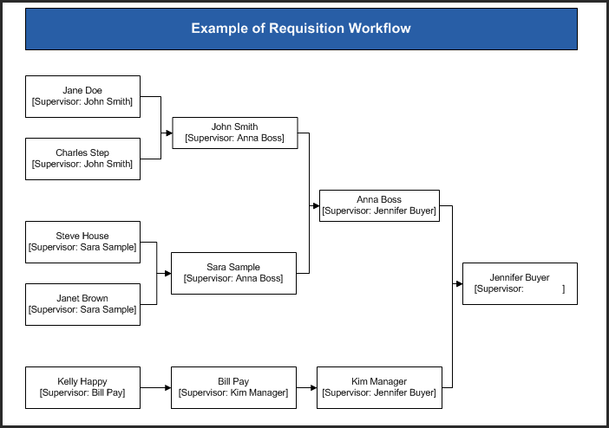

Saving for Later
A ‘Requisitioner’ can save a requisition without submitting the requisition for approval by selecting the ‘Save For Later’ button. If a Requisitioner saves the requisition before they are ready to submit the requisition for approval, they will need to use the ‘Manage Requisitions page > Edit Requisition’ function to locate the requisition and to complete it.
Hint: If you need to save a requisition BEFORE it is complete (submitted for approval), make a note of the ten-digit Requisition ID number (SMART assigns this number when the requisition is saved for the first time). That will make finding the requisition much easier on the Manage Requisitions page!

po auto sourcing
The PO Auto Sourcing process is a collection of batch processes in SMART that moves the data from Requisitions (in the e-Procurement module of SMART) to temporary PO Staging tables (viewed from the Sourcing Workbench in the Purchasing module), and finally generates a Purchase Order (in the Purchasing module of SMART). Typically Purchase Orders for the State of Kansas are generated through the PO Auto Sourcing batch process.

Sourcing Workbench
The Sourcing Workbench allows a Buyer to review the contents of the temporary staging tables before and after each step of the PO Auto-Sourcing batch processes. Requisition lines will appear on the ‘Sourcing Workbench’ if SMART is unable to create a Purchase Order (PO) with the information provided on the requisition. Typical issues preventing the creation of a PO are:
- Supplier ID is left blank on the requisition line.
- Contract associated to the requisition line is not valid for some reason.
Buyers: For more information regarding the Sourcing Workbench, please refer to the ‘Working Errors on the Sourcing Workbench’ training document, which is located on the SMART website at:

http://www.smartweb.ks.gov/training/purchasing#Purchase_Orders

Key Agency Roles and Tasks
The following roles are involved in the Requisition Process:
SMART User Role | Key Activities per Role – Processing Requisitions
Agency Requisitioner (KPO_Agy_Requisitioner) | Creates, edits, modifies, and cancels requisitions (up to the point of ‘Saving and ‘Submitting’ the requisition in the workflow process for approval).
Agency Requisition Administrator (KPO_Agy_Req_Administrator) | Maintains agency requisitions, manually closes requisitions which releases pre-encumbrances (applicable only to Agencies using pre-encumbrances)

Entering Requisitions
The purchasing process begins with someone from your agency indicating that an item or service needs to be purchased. For the purposes of this training guide, the individual asking for the item(s) or service(s) will be referred to as the ‘Requester’. The ‘Requester’ may, or may not, be the individual that actually logs into SMART and creates the requisition. For the purposes of this training material, the individual that logs into SMART and creates the requisition will be referred to as the ‘Requisitioner’.
(State of Kansas has a default requester ID that must be changed. Please refer to your agency’s business process regarding the value to enter in to the Requester field.)
SMART does NOT differentiate between ‘Requester’ and ‘Requisitioner’. This distinction is made in this training material to explain that the ‘Agency Requisitioner’ can enter requisitions for either themselves or on behalf of someone else within their Agency. Additionally, requisition approval workflow and the default values used in the requisition are based upon the ‘Requester’ information entered on the ‘Create Requisition –Requisition Settings’ page.

Create Requisition – Requisition Settings page
Fluid Navigation: From the SMART Homepage, select the ‘Requisitions & PCards’ homepage option under the homepage drop-down, and then select the ‘Create Requisitions’ tile:
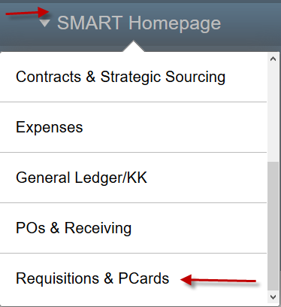 > 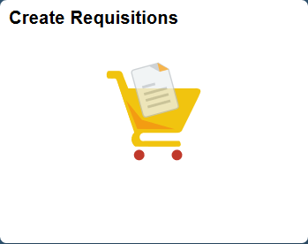

Classic Navigation: Select the ‘NavBar’ icon on the Navigation Bar, and then select the ‘Navigator’ icon, and then the ‘eProcurement’ and ‘Requisition’ links:
> 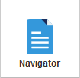> >

This opens the Requisition Settings’ page:
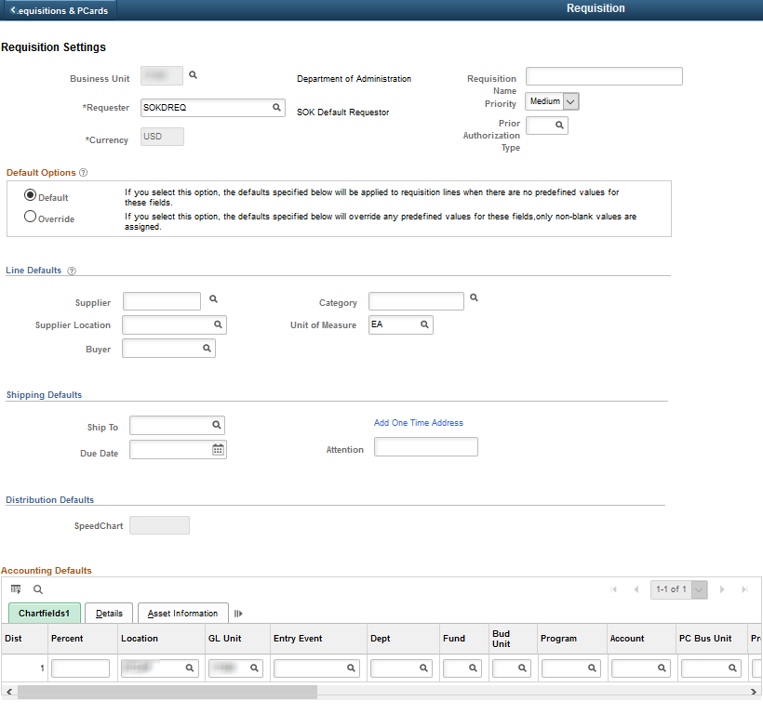
- The Requisitioner’s Business Unit automatically defaults into this page.
- State of Kansas has a default requester ID that must be changed. Enter the correct ‘Requester’s’ SMART User ID; this can be the Requisitioner’s ID or a ‘Requester’ in the agency. (Please refer to your agency’s business processes regarding the value to enter in to the Requester field).
The information entered on the rest of the page applies to the requisition as a whole. The Requisitioner enters the following values on this page:
Field | Description
Requisition Name | Enter an easily recognizable description for the requisition as a whole.  For example, your Agency may choose to enter the Supplier’s name, the item(s) being ordered, an internal Agency reference number, or even a specific event.  Note: If the Requisition Name field is left blank (empty), SMART will auto-populate the field with the assigned requisition number (when the requisition is saved).  Please refer to your Agency’s business process regarding what value / data to enter in the Requisition Name field.
Priority | A priority of ‘Medium’ is defaulted into this field. SMART does NOT use this value to manage approval workflow or any other process. Agencies may opt to use this field to manage internal workload or need.  Please refer to your Agency’s business process regarding the use of this field.
Prior Authorization Type | If attaching a prior authorization, please select the type from the search menu.
Default Options | If the ‘Requisitioner’ is creating a multiple line requisition (2 or more requisition lines – items/services to be purchased) AND one (1) or more of the following described values are shared across ALL requisition lines on the requisition, then the ‘Requisitioner’ should click the Override radio button and enter ‘Line Defaults’ section. Values entered in to the Line Defaults section will be applied to EVERY requisition line that is created on the requisition.
Supplier ID | Enter the ‘Supplier ID’. For workflow and delegated purchasing purposes, only supplier should be applied to each requisition.
Supplier Location | Enter the ‘Supplier Location’ (three-digit number).
Buyer | The ‘Buyer’ ID must be populated with the same Buyer ID on ALL requisition lines for the requisition to correctly source to a PO.  For most Agency Requisitioners, the ‘Buyer ID’ will be set-up as a default value and the ‘Requisitioner’ will NOT need to enter the Buyer ID on this page. However, if the ‘Requisitioner’ has not been set up with a default Buyer ID, enter the Buyer ID in the ‘Line Defaults’ section to easily apply the Buyer ID to ALL requisition lines.  For more information regarding Buyer ID’s, please refer to the ‘BYRDFLT Buyer ID’ training document, which is located on the SMART website at:  https://www.smartweb.ks.gov/training/purchasing#Purchase_Orders
Category | If ALL items/services being purchased on this requisition are using the same category code, use the ‘Line Defaults’ section to easily apply the same ‘Category Code’ to ALL requisition lines.
Unit of Measure (UOM) | UOM code is defaulted in as EA (each). If ALL goods/services being purchased on this requisition are using the same UOM, use the ‘Line Defaults’ section to easily apply the ‘Unit of Measure’ code to ALL requisition lines.
Ship To | The ‘Ship To’ value will default based upon the ‘Requester’ ID selected. If this value needs to be changed and the new value needs to be applied to ALL requisition lines, use the ‘Line Defaults’ section to easily apply the ‘Ship To’ code to ALL requisition lines.
Due Date | If ALL goods/services being purchased on this requisition have the same ‘Due Date’, use the ‘Line Defaults’ section to easily apply the ‘Due Date’ to ALL requisition lines.
Non-Defaulted Chartfield Values  (‘Non-Defaulted ChartField Values’ are any other fields on this page which do not have data pre-populated in them) | If ALL items/services being purchased on this requisition will use the same ‘Non-Defaulted Chartfield’ values, use the ‘Line Defaults’ section to easily apply the ‘Non-Defaulted Chartfield’ values to ALL requisition lines.  The pre-populated fields on the ‘Accounting Defaults – Chartfields tab’ are default values associated to the ‘Requester’ ID.  The default values can also be overridden for multiple requisition lines by using the ‘Mass Change’ button which is located on the ‘Checkout - Review and Submit’ page (and which is covered later in this training document).
All requisition lines created on the requisition, will inherit the values entered on the ‘Create Requisition – Requisition Settings’ page.
Note: For more information about the ‘Requisition Settings’ page, please refer to the training document ‘Tips for Requisition Settings Page’, located on the SMART website at:
https://www.smartweb.ks.gov/training/purchasing#Requisitions
If the Requisitioner chose to change information within the Line Defaults section of the ‘Requisition Settings’ page, they may select the ‘OK’ button at the bottom left of the page to navigate to ‘Create Requisition’ page.

Create Requisition page
The ‘Create Requisition’ page is used to enter the information about the item(s)/service(s) being requested. The ‘Requisitioner’ has a few choices for entering the item(s)/service(s) information:
- The Requisitioner can create ‘Favorites’ and then select from a favorites list.
- The Requisitioner can create ‘Templates’ and then select from a templates list.
- If a Supplier is set up as a ‘Direct Connect Supplier’, the Requisitioner can use the ‘Web’ to access that supplier’s catalog and pull item information into SMART. Currently, the State of Kansas has one (1) Direct Connect Supplier set up, Staples, for office supply purchases.
- The Requisitioner can directly enter information using a ‘Special Request’.

FAVORITES LINK
The Favorites link is a great efficiency tool provided in SMART for Requisitioners to use. The Favorites link provides a quick way to insert individual requisition lines for items or services in to a requisition.
What is a ‘Favorite’ item? A Favorite item may be created in SMART to save items or services which are purchased frequently AND whose price does NOT change on a regular basis.
Who creates Favorite items in SMART? The Requisitioner creating the requisition may elect to save an item or a service as a ‘Favorite’.
Note: The Requisitioner must set up a ‘Favorite’ before any items will appear on the ‘Favorites’ tab.
How are Favorite Items stored in SMART? Favorite items are stored by ‘Requester’ ID.
When a Requisitioner creates a NEW favorite item, the item is stored under the ‘Requester’s ID’
(the Requester is chosen on the ‘Specify Business Unit and Requester’ page when the requisition is first being created).
Lists of Favorites: All Requisitioners for your agency have access to the list of Favorite items for each ‘Requester’ within your agency. If the ‘Requisitioner’ enters requisitions for multiple ‘Requesters’, the list of ‘Favorites’ will change depending upon the ‘Requester ID’ entered.

Create a ‘Favorite’
The creation of a ‘Favorite’ takes place on the ‘Checkout - Review and Submit’ page. This page is discussed in depth later in this training document. At this point we will strictly look at the steps to set up a ‘Favorite’.
From the ‘Checkout - Review and Submit’ page:
- Select the item or service that is to become a ‘Favorite’ by selecting (clicking) the checkbox at the far-left side of the desired requisition line.
- Click the ‘Add to Favorites’ link:
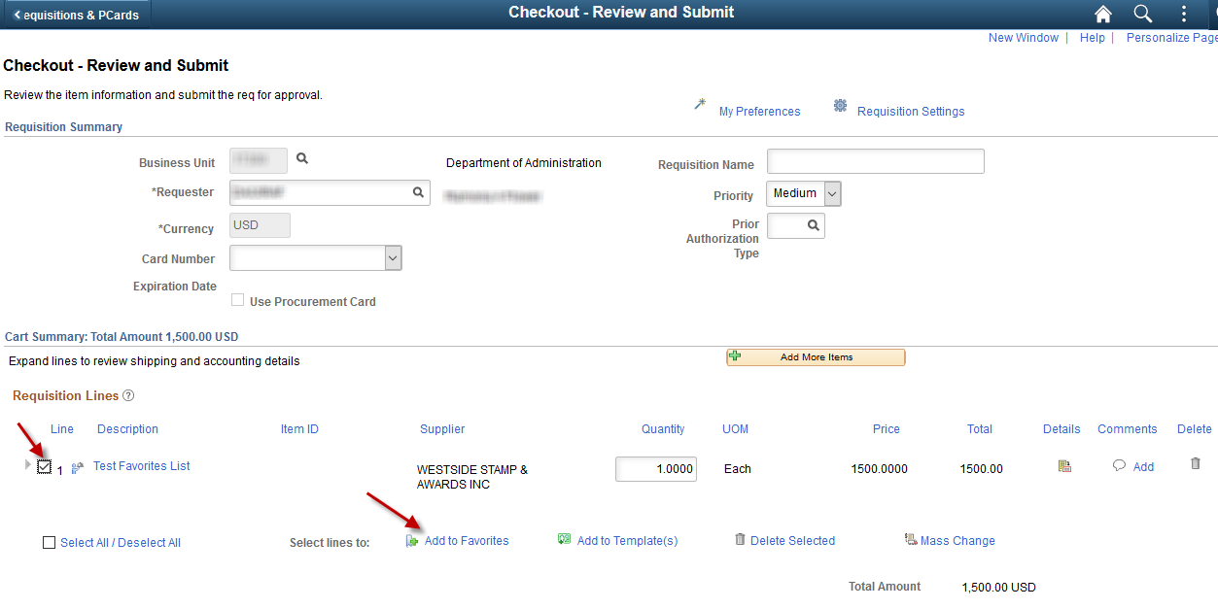
Note: The ‘Select All / Deselect All’ link can be checked if the Requisitioner wants ALL the requisition lines to be saved to the ‘Favorites’ list for the Requester.
- After clicking the ‘Add to Favorites’ link, the Requisitioner may see the following pop-up box, if so, select the ‘OK’ button. To view the ‘Favorite’ added, click on the ‘Add More Items’ button and then use the ‘Favorites’ link.
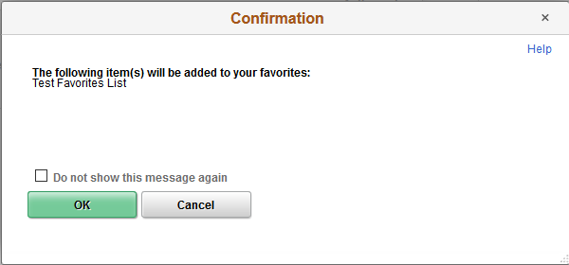

Using ‘Favorites’
- On the ‘Create Requisition’ page, select the ‘Favorites’ link
- Enter the Quantity to be purchased
- Click the ‘Add’ button:
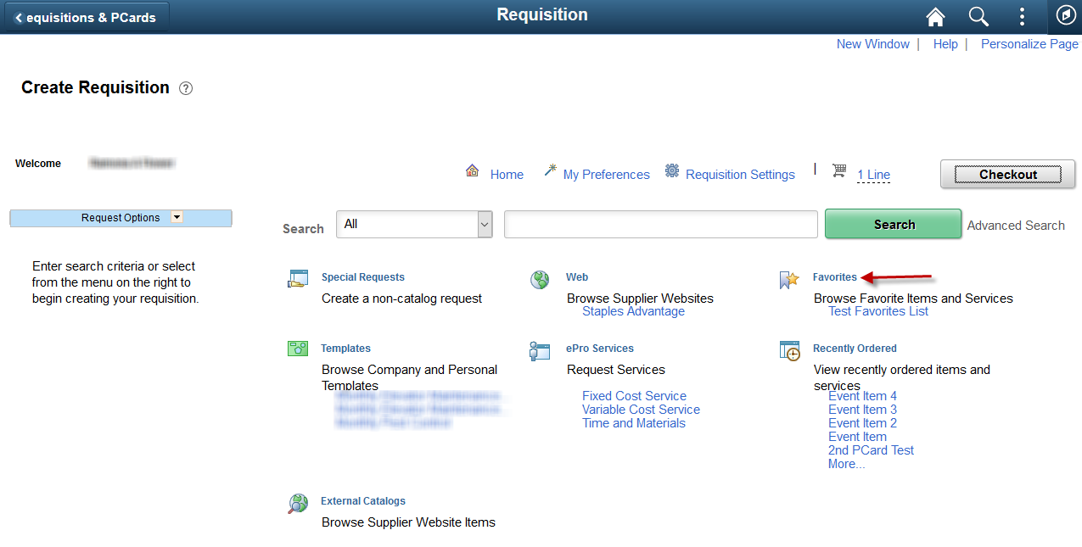
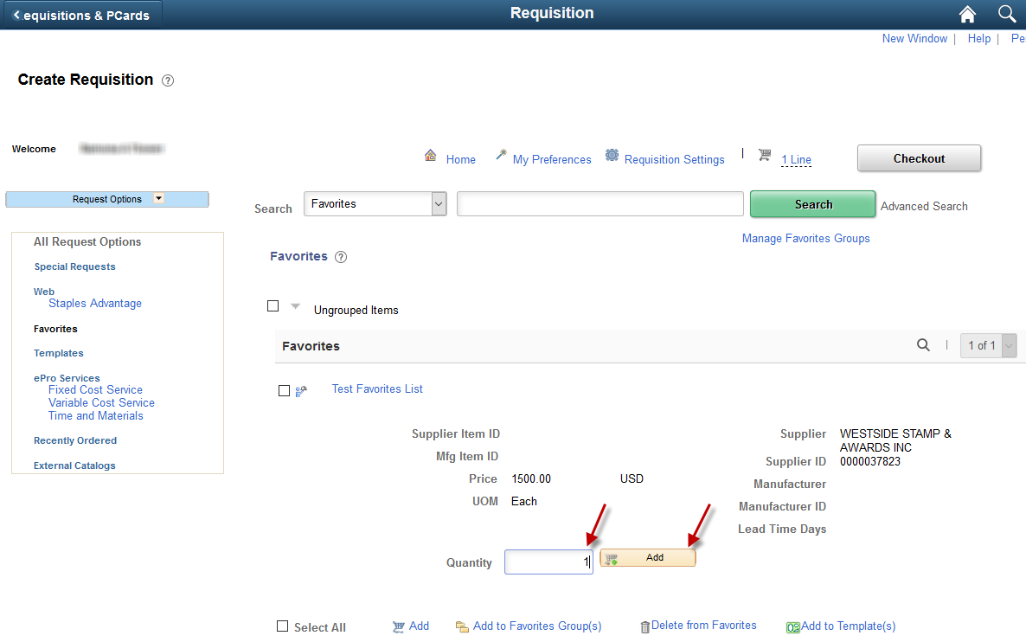
Clicking the ‘Add’ button, adds the item/service to the requisition. The item/service may be viewed in the ‘Requisition Lines’ section of the ‘Checkout - Review and Submit’ page:
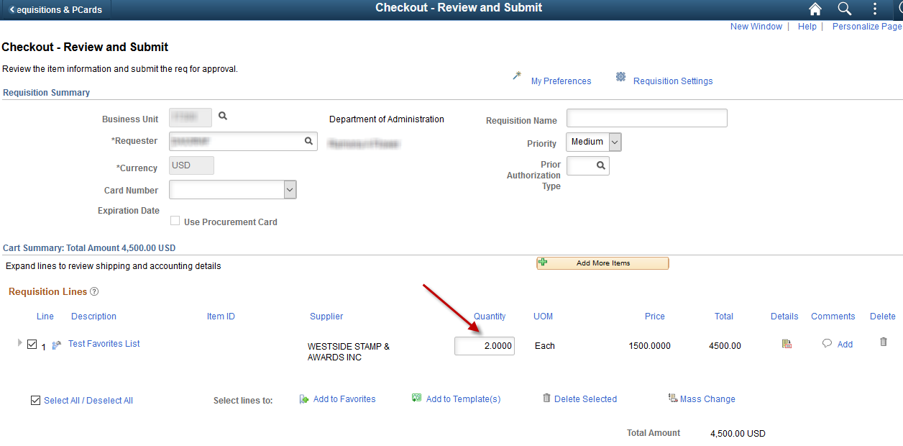

Create a ’Favorites Group’
If the Requisitioner uses ‘Favorites’ frequently, grouping items together in ‘Favorites Group(s)’ may be helpful for organization purposes.
- On the ‘Create Requisitions’ page, select the ‘Favorites’ link.
- Select the checkboxes for the items you wish to add to the Favorites Group that you are creating.
- Click the ‘Add to Favorites Group(s)’ link.
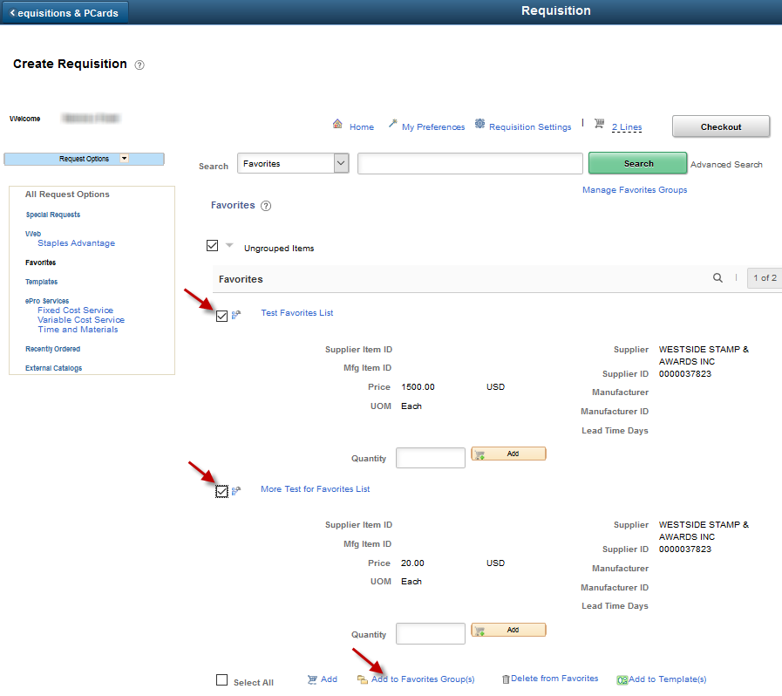
This opens the ‘Add Selected Items to Favorites Groups’ page (shown in below screenshot).
- Enter a ‘Group Name’.
- Enter a ‘Description’.
- Click the ‘OK’ button.
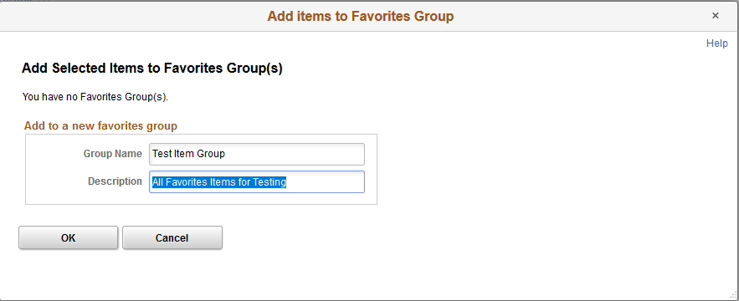
In this example, the ‘Favorite’ item that was selected is now displayed under the Favorite Group Name of ‘Test Item Group’:
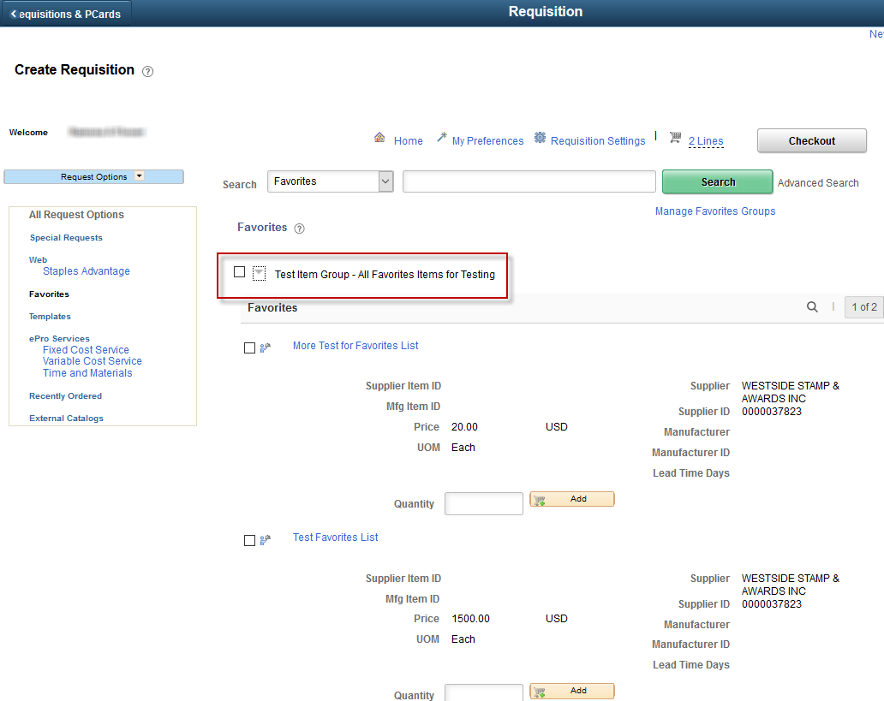
Note: A user can NOT edit ‘Favorites’ within the ‘Favorites’ section; however, the user can select the ‘Favorite’, enter edits which appear on the ‘Checkout - Review and Submit’ page. If a ‘Favorite’ is no longer valid the user can delete the ‘Favorite’ and save a new ‘Favorite’ with the correct information.

Delete from ’Favorites’
- On the ‘Create Requisitions’ page, select the ‘Favorites’ link.
- Select the checkboxes for the items you wish to delete from the Favorites Group that you are creating.
- Click the ‘Delete From Favorites’ button.
This page provides a quick way to insert a group of requisition lines for items/services that:
- Are purchased frequently
- The price does NOT change on a regular basis
and
- The quantity to be purchased does NOT change.
‘Templates’ are associated to the ‘Requester ID’ that is entered on the ‘Requisition Settings’ page. If the ‘Requisitioner’ enters requisitions for multiple ‘Requesters’, the list of ‘Templates’ will change depending upon the ‘Requester ID’ entered.
The Requisitioner must set up a ‘Template’ before any items will appear on the ‘Templates’.

Create a ‘Template’
The creation of a ‘Template’ takes place on the ‘Checkout - Review and Submit’ page. This page is discussed in depth later in this training document. At this point we will strictly look at the steps to create a ‘Template’.
From the ‘Checkout - Review and Submit’ page:
- Select the items and/or services that are to form the ‘Template’ by selecting (clicking) the line checkboxes at the far-left side of the desired requisition lines.
- Click the ‘Add to Template(s)’ link:

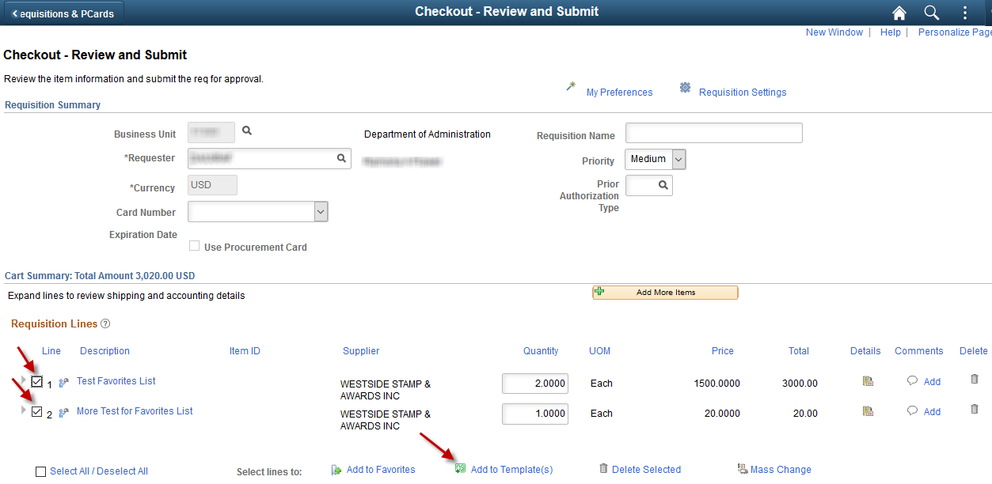
- Enter a ‘Template Name’.
- Enter a ‘Description’ for the Template.
- Click the ‘OK’ button:
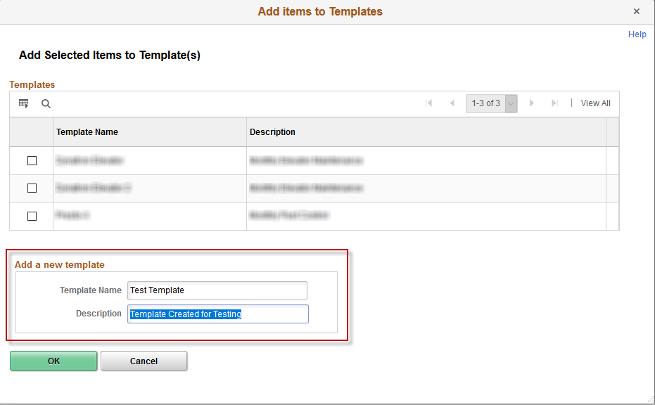

Use a ‘Template’
From the ‘Create Requisition’ page:
- Select the ‘Template’ link.
- Enter the Quantity to be purchased.
- Select the ‘Add’ button:
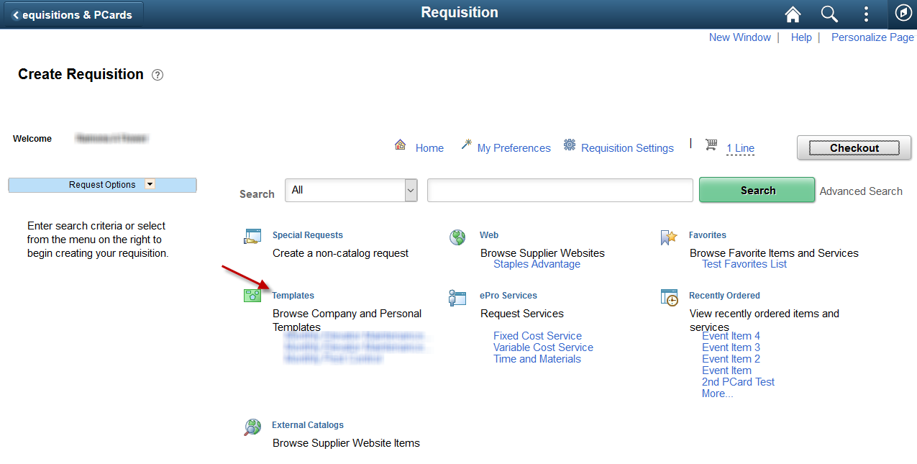
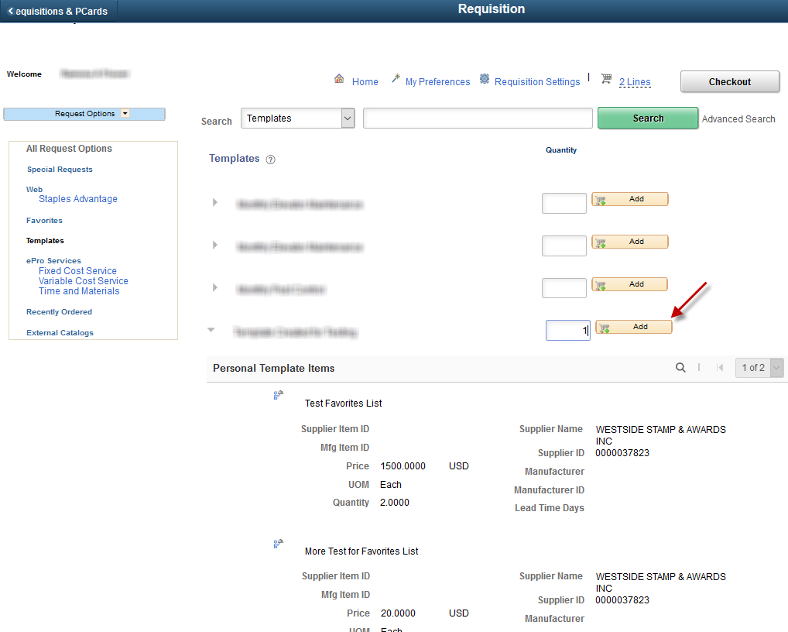
Clicking the ‘Add’ button, adds the items/services to the requisition. The items/services may be viewed in the ‘Requisition Lines’ section of the ‘Checkout - Review and Submit’ page (please refer to following screenshot).
It is important to know and understand that when a template is first created and saved, SMART saves the Quantity of the items/services within the Template.
When selecting the Template for use on future requisitions, SMART multiplies the Template Item Quantity by the Template Quantity.
Note: A user can NOT edit or delete ‘Templates’ within the ‘Templates’ link; however, the items can be edited from the ‘Checkout - Review and Submit’ page.
Note: If the Quantities are not correct they may be edited on the ‘Checkout - Review and Submit’ page of the requisition (please refer to following screenshot).
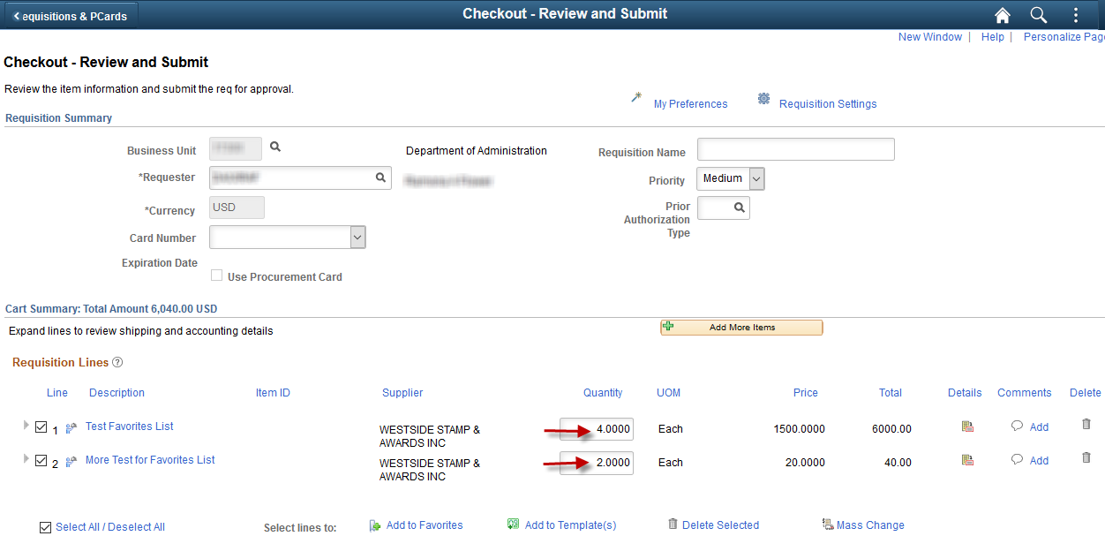

WEB
The ‘Web’ section is a specialized to allow Requisitioners to order items/services directly from selected suppliers.
For each supplier listed on the ‘Web’ section: Behind the scenes of SMART, a direct electronic connection has been built between the supplier’s website and SMART. This allows SMART and the supplier’s website to communicate item information directly with one another (hence the name ‘Direct Connect’). If a supplier has been set up as a Direct Connect Supplier, then requisitions should be created using the ‘Web’ option unless the Office of Procurement and Contracts specifically directs agencies not to.
At this time, only one supplier is set up as a ‘Web’ merchant for the State of Kansas. The supplier is ‘Staples Advantage’. The State of Kansas has a contract with ‘Staples Advantage’ for State agencies to purchase certain office supplies (a $35 minimum order for items is required).
The ‘Staples Advantage’ link on the ‘Web’ section allows a Requisitioner to click the link and navigate directly to the supplier’s website (online catalog).
Note – ‘Punch Out’: When you select the ‘Staples Advantage’ link from the ‘Web’ section, you are being navigated directly to Staples website. This navigation process is known as ‘punch out’.
Note - Supplier Website Issues’: If your agency experiences issues while working within the supplier’s website, it is NOT a SMART issue, it is a supplier’s website issue. Subsequently, you will need to contact the supplier directly for assistance. Please do NOT open a ManageEngine Service request.
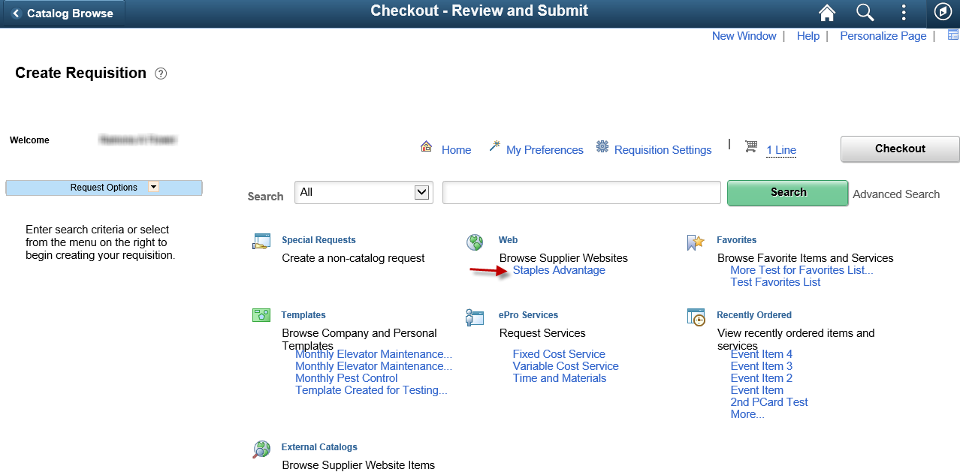

Create requisition using the WEB section – Example: Staples Requisition
In this example, the Requisitioner is ordering staples for their agency. The purpose of this example is to show you how to NAVIGATE on the Staples Advantage website and in SMART; each supplier website will look and function differently.
From the ‘Create Requisition’ page:
- Under the ‘Web’ section
- Click the ‘Staples Advantage’ link
- Clicking the ‘Staples Advantage’ link navigates the Requisitioner directly into the Staples Advantage website (online catalog).
- In the Search box at the top of the Staples Advantage website, enter a description of the item for which you are searching. In this example, the Requisitioner needs to order staples for their agency.
- Click the ‘Search’ button (this will return search results based on the description entered):
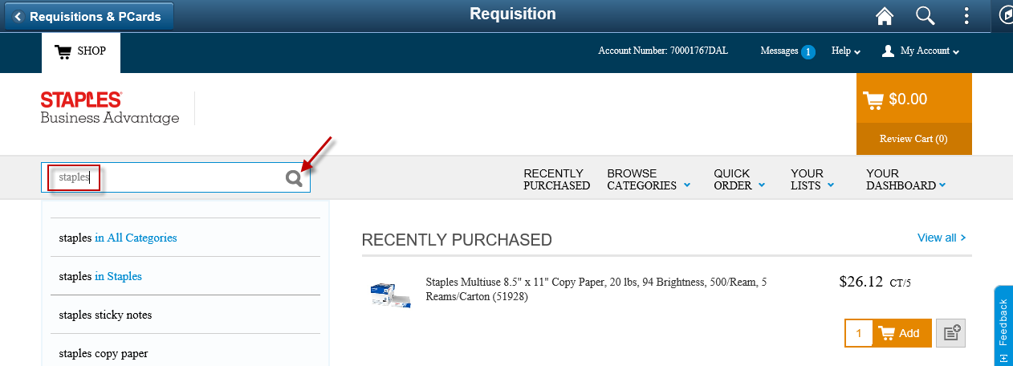
- Enter the Qty (quantity) you wish to order. (Note: Pay attention to Unit of Measure for items).
- Click the ‘Add to Cart’ button (this will display a shopping cart summary):
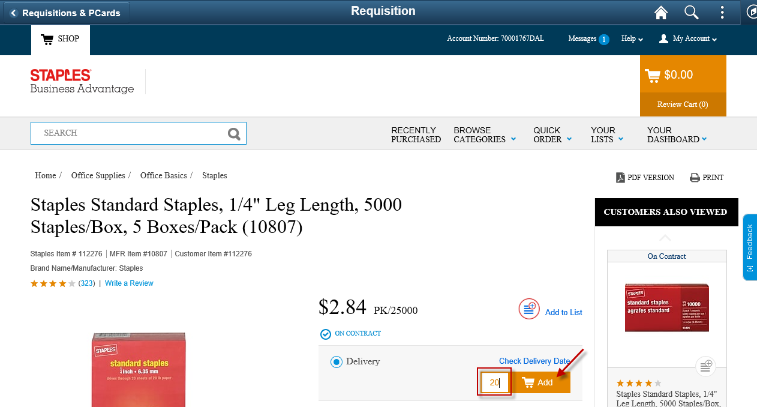

- You may select the continue shopping, or the ‘Review & Checkout’ button
- In this example, the Requisitioner is done selecting the items so they now click the ‘Review & Checkout’ button, as shown in the following screenshot.
(Please note that Staples Advantage require orders to have a minimum of a $35.00 total):
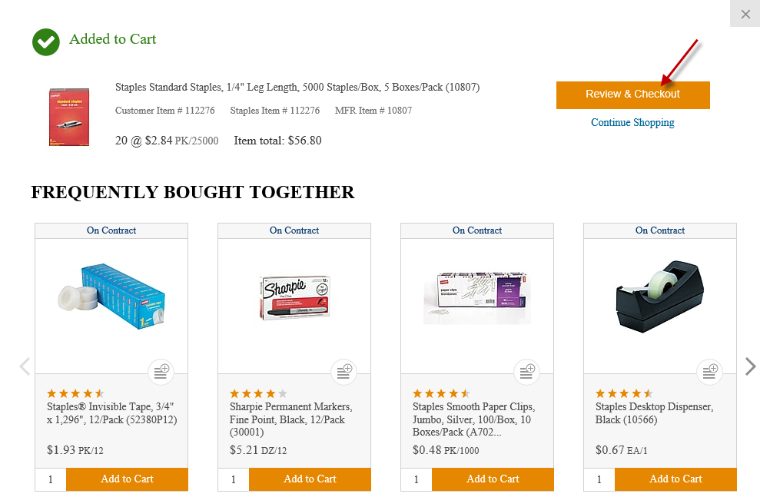
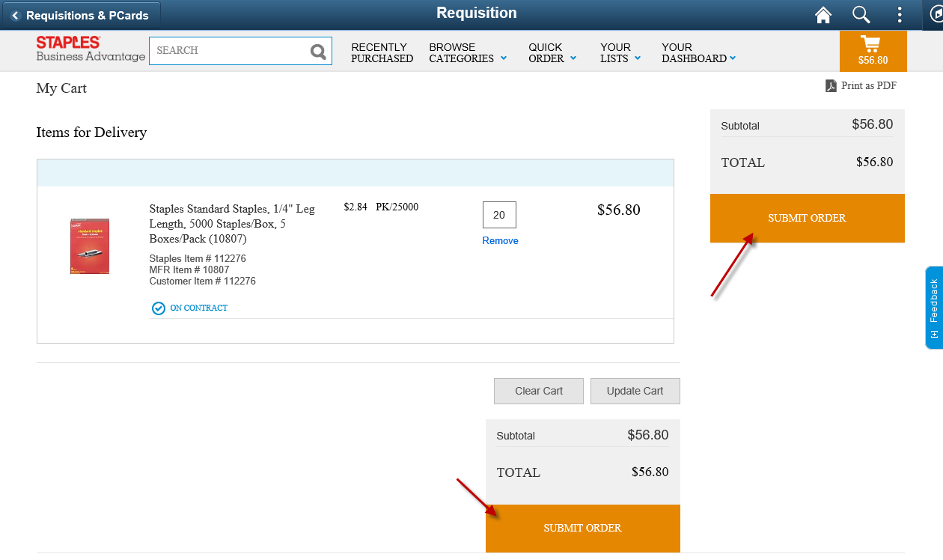
- Use the Shopping Cart Items page to review all items on the order. This is the last chance the Requisitioner has to change any items on the order before returning to SMART.
After all items have been reviewed and confirmed as correct, click the ‘Submit Order’ button.
Clicking the ‘Submit Order’ button on the Staples Advantage website, returns the Requisitioner to SMART. SMART brings the items from the Staples Advantage website into the requisition; to the Requisition Lines section of the ‘Checkout - Review and Submit’ page (as shown in the following screenshot):
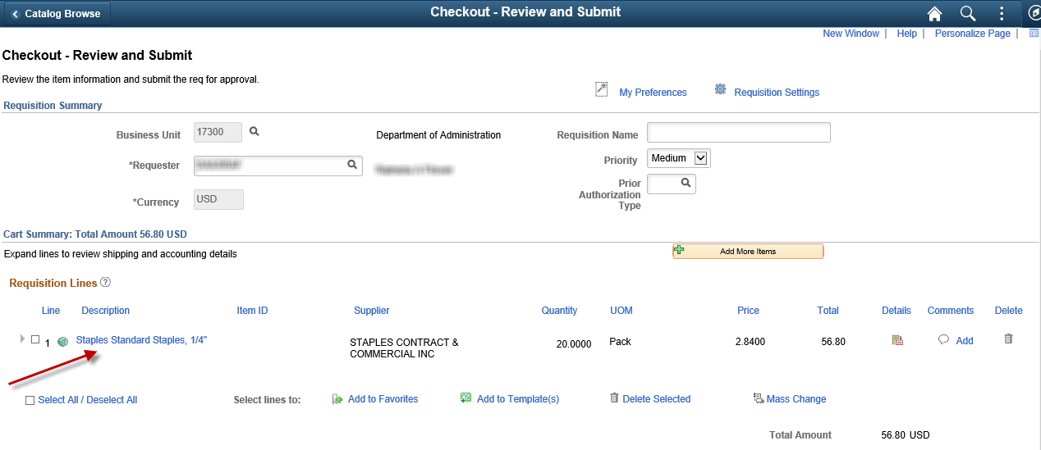
Note – Requisition Issues: If you experience issues with a Staples requisition in SMART, your agency’s Security Liaison should submit a Service Desk request.
For example, if you experience problems such as:
- you select the Direct Connect Supplier link and do not get to the supplier’s web site;
OR
- you check out from the supplier’s website and you are back to the ‘Create Requisition’ page when you experience the issues.
Note – Ship To Addresses: If your agency needs to change or add a Ship To address on a requisition, please have your agency’s Security Liaison submit a Service Desk request. Agencies - Please Do NOT send Ship To address changes/additions directly to a Direct Connect Supplier.
It is important that the Ship To addresses match between SMART and the supplier’s ordering system. The only way to accomplish this is for agencies to notify the SMART team (via a Service Desk request) containing the Ship To address changes/additions and allow the SMART team to notify the Direct Connect supplier.

SPECIAL REQUEST link
The ‘Special Requests’ link should be selected when the Requisitioner needs to manually enter the requisition lines.
For example, the Requisitioner needs to enter items that:
- Have not been saved to either Favorites or Templates
- Are not items ordered from a Direct Connect supplier using the Web
The Requisitioner has several options from which to choose under ‘Request Options’:
- Special Requests: Requisitioner needs to manually enter the requisition line information.
- Favorites
- Templates
- ePro Services - Fixed Cost Service: Request a one-time service for a flat fee.
- ePro Services - Variable Cost Service: Request a service for which the fee is based on the time worked.
- Recently Ordered
- External Catalogs

Note: ePro Services - Time and Materials, is not used by the State of Kansas so it will not be included in this documentation.

Special Request – Special Item
The ‘Special Requests’ option is the option that will be used most frequently.
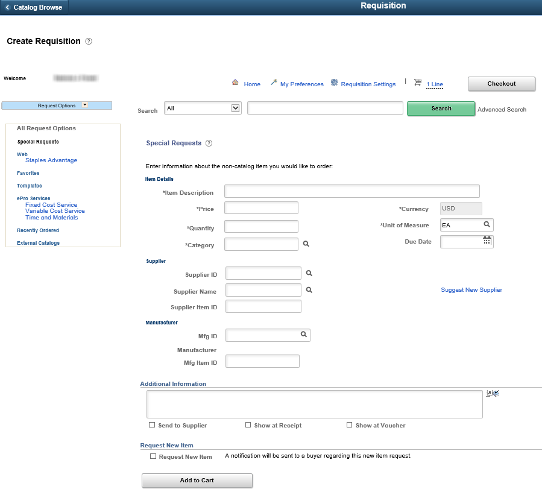
There are several values that need to be populated on the Special Requests page:
Field | Description
Item Description (Required) | Enter an Item Description of the good/service being purchased. A descriptive entry in this field will help with tracking the purchase through to the payment of the item. It will also help with future reporting and auditing efforts.
Price (Required) | Enter the Price per unit of measure.
Quantity (Required) | Enter the Quantity to be purchased. If a service is being purchased and the service will be paid by a dollar amount (i.e. 1st payment $100.00, 2nd payment $50.00, etc.) then enter one (1) as the quantity.
Unit of Measure (Required) | Enter the Unit of Measure. A list of possible options is provided by selecting the ‘Look Up’ icon. Some examples are: EA = Each, BX=Box, LOT = Lot, etc.
Category (Required) | The State of Kansas has purchased the UNSPSC listing to be used as the ‘Category’ codes within SMART. The UNSPSC is an industry standard classification that is used to classify all goods and services. By using a standardized classification for goods and services we can utilize the Category field for detailed good/service reporting provided that accurate category codes are selected during the requisition/PO processing.  The UNSPSC listing does NOT have Categories for all the goods/services that the State of Kansas uses. In the event there is no Category code that matches the good/service being ordered, the Requisitioner needs to select a code that most closely represents the good/service being purchased.  Click the ‘Look Up’ icon (Magnifying glass icon to the right of the Category field – this opens the ‘Look Up Category’ page). Enter a Description or partial description, then click the ‘Find’ button. SMART displays a list of ‘Category Codes’ that contain the description. Select the Category code that best fits the good/service being purchased (by clicking on the desired Category code link).  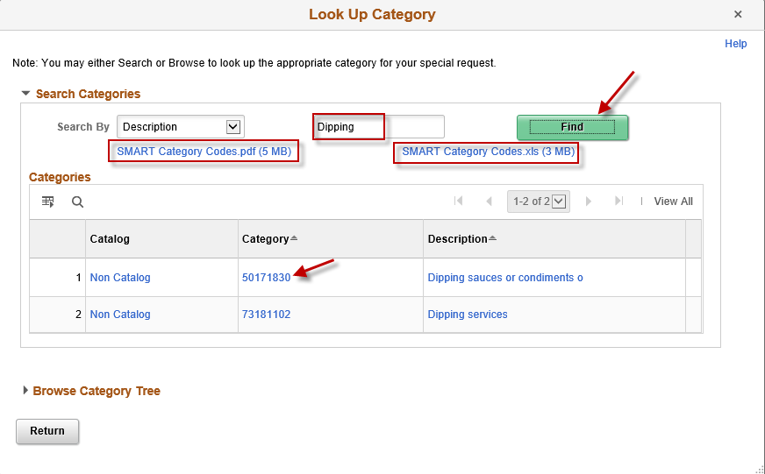  The State of Kansas has provided a complete listing of the ‘Category’ codes for use. The list of Category codes is located on the ‘Look Up Category’ page. To view the complete list of Category Codes, select either the .pdf or .xls SMART Category Codes links.  It is recommended that the Requisitioner select the .xls file so that they can use the ‘sort and filter’ capability within the Excel document.  The Requisitioner should save this file to their local computer drive. It is recommended that Requisitioners use this Excel document to make notes for themselves as to what Category codes are typically used by their agencies.  Note: Requisitioners should select specific, detailed, Category Codes – NOT the ‘All Items’ code. Selecting the ‘All Items’ Category Code results in incorrect reporting regarding State of Kansas purchasing activities.

Due Date (Recommended) | Enter a ‘Due Date’. The Due Date can be selected using the ‘Calendar’ icon. A pop-up Warning message will display in a dialog box when the requisition ‘Due Date’ is more than 30 days in the future. The pop-up message will not stop the requisition from further processing, it is strictly an informational message. If you encounter this informational message, click the ‘OK’ button to continue with the requisition.  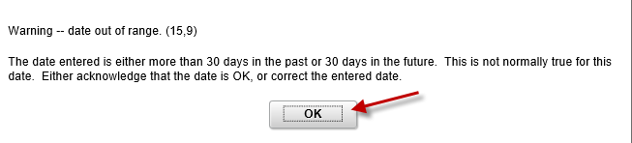  SMART does not require a ‘Due Date’ to be entered; however, the monthly close process uses the ‘Due Date’ to determine if a Requisition can be closed.  Note: Entering an accurate ‘Due Date’, will help prevent requisitions and POs from being closed prematurely.
Supplier ID (Recommended) | A ‘Supplier ID’ must be entered for the requisition to source to a PO.  SMART does not require a ‘Supplier ID’ to be entered; however, if the ‘Supplier ID’ is left blank the requisition will not source to a PO and will end up on the ‘Sourcing Workbench’.  Please refer to the ‘Working Errors on the Sourcing Workbench’ training document for additional information, which is located on the SMART at:  https://www.smartweb.ks.gov/training/purchasing#Purchase_Orders  When should the ‘Supplier ID’ be left blank? It is appropriate to leave the ‘Supplier ID’ blank if the requisition exceeds the Agencies delegated purchasing authority and needs to be put out for bid by the Office of Procurement and Contracts. (In this case the Requisitioner MUST select the ‘RFQ Required’ checkbox on the Line Details page for the requisition line. This information is covered later in this training document).
Supplier Item ID (Optional) | This is not a required field but can be very helpful in identifying the specific item using the supplier’s item identification number.
Additional Information (Optional) | The Additional Information field is a free text field. Information entered in this field becomes a requisition line comment and is sourced to the PO as a line comment.
Send to Supplier checkbox  (Optional) | Select the ‘Send to Supplier’ check box if the information should be included on the Purchase Order. The Requisition Line comment will source to the PO line which will then display under the line description on the dispatched Purchase Order:  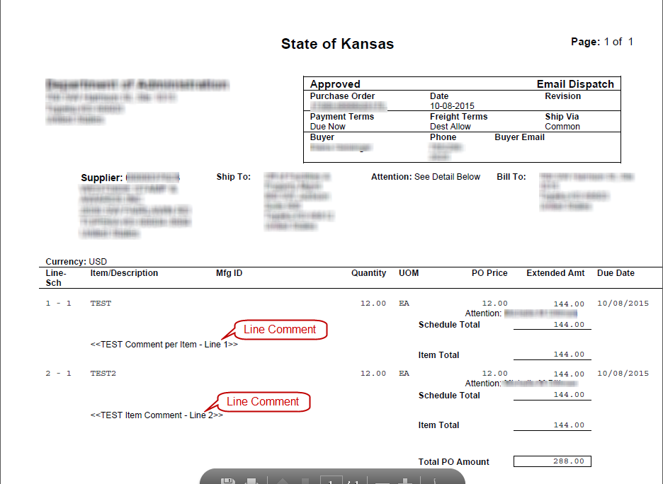

Show at Receipt checkbox  (Optional) | Select the ‘Show at Receipt’ check box if the information should be provided to the user that will receive the product. The comment is available from the ‘Receiving’ page; however, the comment is NOT readily apparent. The user creating the receipt would have to select the ‘Source Information’ tab from the ‘Receiving’ page to get to the PO Line comment:  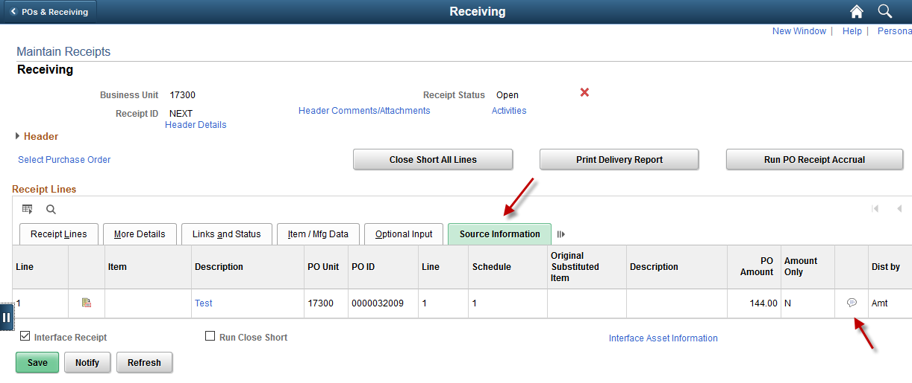
Show at Voucher checkbox  (Optional) | Select the ‘Show at Voucher’ check box if the information should be provided to the Voucher Processor. The comment is available from the ‘Voucher – Invoice Information (Tab)’ page; however, the comment is NOT readily apparent. The Voucher Processor would have to select the ‘Purchase Order & Receiver Info’ link from the ‘Voucher – Invoice Information (Tab)’ page and then expand the ‘PO/Receipt Comments’ section to get to the PO Line comment:  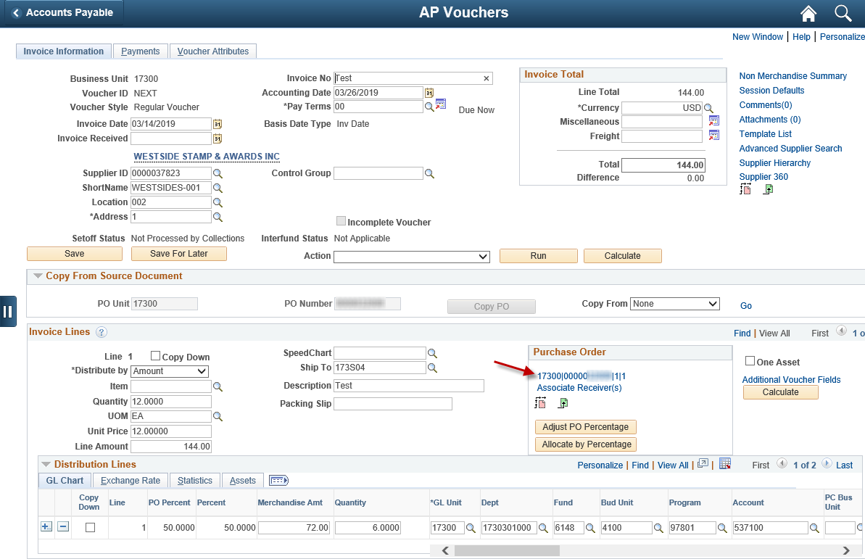  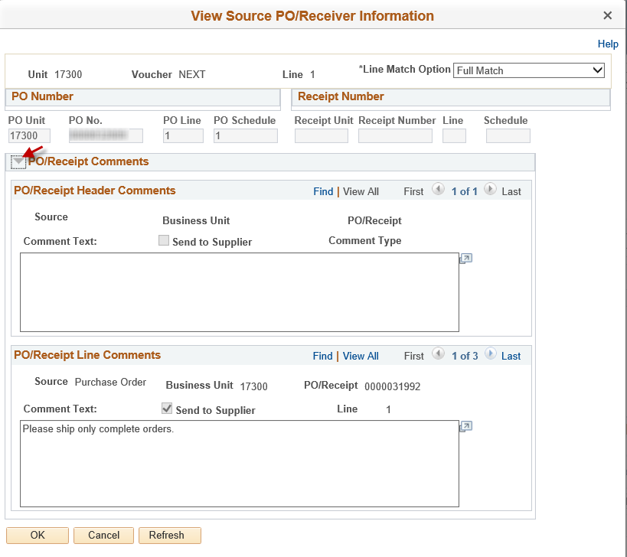
Once the information is entered, click the ‘Add to Cart’ button (located at the bottom left corner of the page):
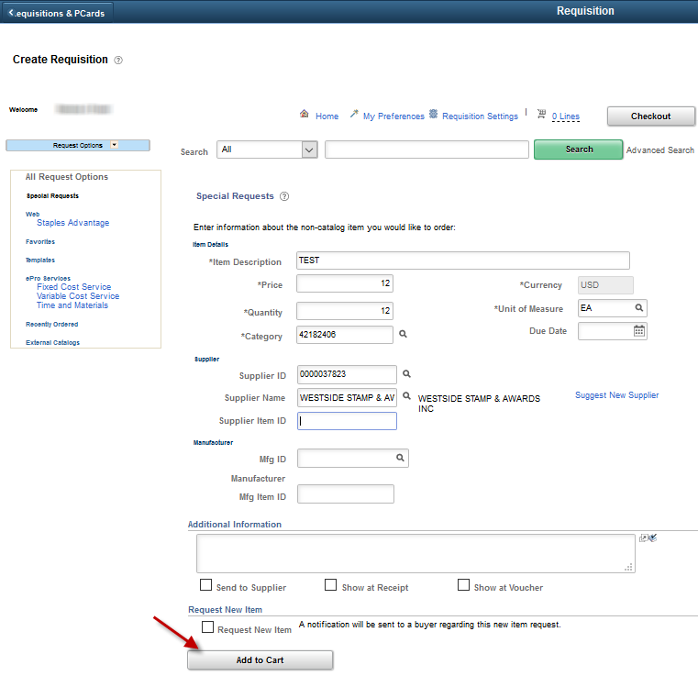
When the ‘Add to Cart’ button is clicked, SMART adds the item to the requisition line, and returns a blank ‘Special Requests’ page (so the Requisitioner can enter another good/service).
Once all the goods/services have been added on the Special Item form, click the ‘Checkout’ button at the top right corner of the ‘Create Requisition’ page:
Note: If no line items have been selected on the ‘Create Requisitions’ page, SMART will display a message on the ‘Checkout - Review and Submit’ page, advising that no requisitions lines are available.

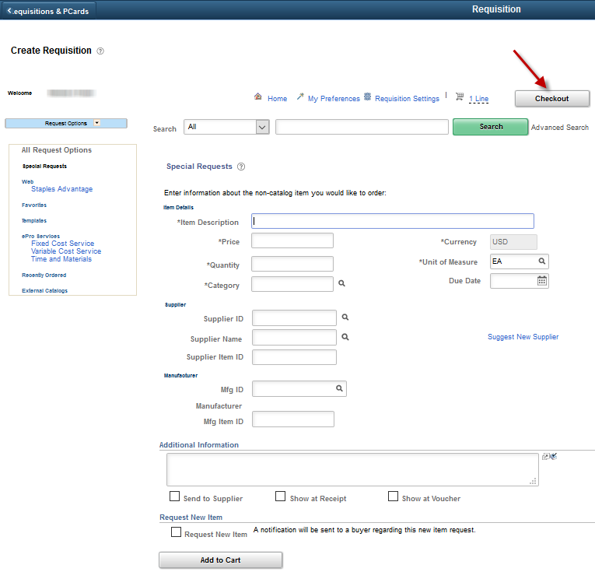

Fixed Cost Service
The ‘Fixed Cost Service’ option can be used when purchasing a service for which the pricing will not change.
For example, pest control services. Typically, pest control services have a fixed monthly cost per site, such as $100.00 per site / per month.
To create a requisition for a ‘Fixed Cost Service’ click the ‘Fixed Cost Service’ link on the Left menu:
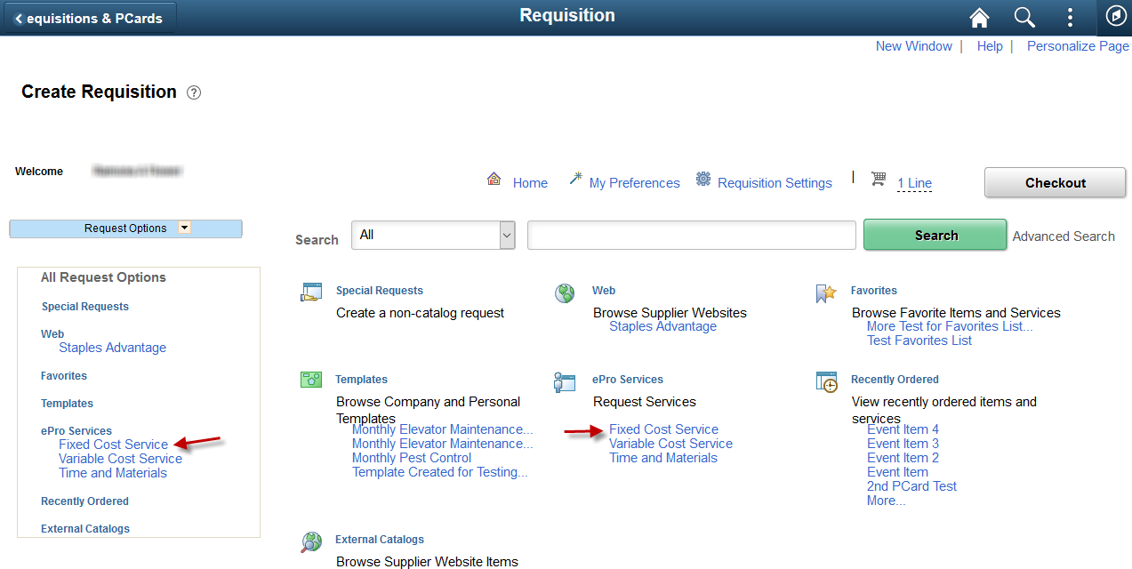

Clicking the ‘Fixed Cost Service’ link opens the ‘Fixed Cost Service’ page:
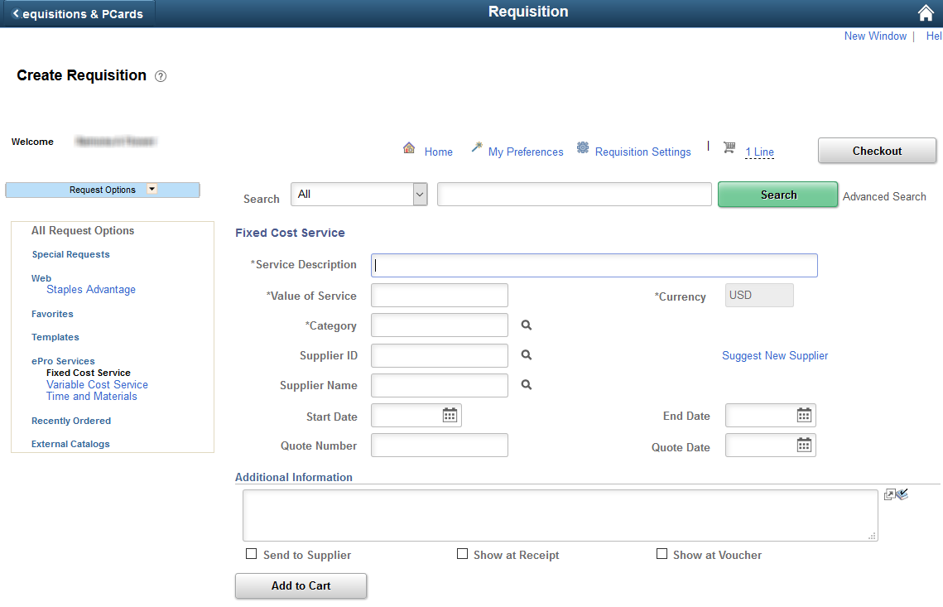
There are several values that need to be populated on the Fixed Cost Service page:
Field | Description
Service Description  (Required) | Enter a detailed Service Description for the service being requested.
Value of Service  (Required) | Enter the total cost for the service in the Value of Service field. For the example stated above, the ‘Value of Service’ would be ‘$1,200.00’ (the price for a full year of services).

Category  (Required) | The State of Kansas has purchased the UNSPSC listing to be used as the ‘Category’ codes within SMART. The UNSPSC is an industry standard classification that is used to classify all goods and services. By using a standardized classification for goods and services we can utilize the Category field for detailed good/service reporting provided that accurate category codes are selected during the requisition/PO processing.  The UNSPSC listing does NOT have Categories for all the goods/services that the State of Kansas uses. In the event there is no Category code that matches the good/service being ordered, the Requisitioner needs to select a code that most closely represents the good/service being purchased.  Click the ‘Look Up’ icon (Magnifying glass icon to the right of the Category field – this opens the ‘Look Up Category’ page). Enter a Description or partial description, then click the ‘Find’ button. SMART displays a list of ‘Category Codes’ that contain the description. Select the Category code that best fits the good/service being purchased (by clicking on the desired Category code link).  The State of Kansas has provided a complete listing of the ‘Category’ codes for use. The list of Category codes is located on the ‘Look Up Category’ page. To view the complete list of Category Codes, select either the .pdf or .xls SMART Category Codes links.  It is recommended that the Requisitioner select the .xls file so that they can use the ‘sort and filter’ capability within the Excel document.  The Requisitioner should save this file to their local computer drive. It is recommended that Requisitioners use this Excel document to make notes for themselves as to what Category codes are typically used by their agencies.  Note: Requisitioners should select specific, detailed, Category Codes – NOT the ‘All Items’ code. Selecting the ‘All Items’ Category Code results in incorrect reporting regarding State of Kansas purchasing activities.
Supplier ID  (Recommended) | A ‘Supplier ID’ must be entered for the requisition to source to a PO.  SMART does not require a ‘Supplier ID’ to be entered; however, if the ‘Supplier ID’ is left blank the requisition will not source to a PO and will end up on the ‘Sourcing Workbench’.  Please refer to the ‘Working Errors on the Sourcing Workbench’ training document for additional information, which is located on the SMART at:  https://www.smartweb.ks.gov/training/purchasing#Purchase_Orders  When should the ‘Supplier ID’ be left blank? It is appropriate to leave the ‘Supplier ID’ blank if the requisition exceeds the Agencies delegated purchasing authority and needs to be put out for bid by the Office of Procurement and Contracts. (In this case the Requisitioner MUST select the ‘RFQ Required’ checkbox on the Line Details page for the requisition line. This information is covered later in this training document).

Start Date and End Date  (Recommended) | Enter the Start Date and the End Date for the service. In the example shown above, the service would occur once a month for the period of one year: 07/01/2019 – 06/30/2020.  Note: The ‘End Date’ will appear on the requisition line, in the ‘Due Date’ field. The dates provided when completing this special request form will also appear at the requisition line level, in the line comments page. The requisition line comments are sourced to the subsequent PO line comments page.  SMART does not require an ‘End Date’ to be entered; however, the monthly close process uses the ‘Due Date’ to determine if a Requisition can be closed. Entering an accurate ‘End Date’, will help prevent requisitions and POs from being closed prematurely.
Quote Number  (Optional) | If you received a quote from the supplier, entering the quote number in the Quote Number field can be very useful for future tracking purposes.  Note: The Quote Number provided on this special request form appears at the requisition line level, in the line comments page. These comments will also be sourced to the subsequent PO line comments.
Quote Date  (Optional) | If you received a quote from the supplier, entering the quote date in the Quote Date field can be very useful for future tracking purposes.  Note: The Quote Date provided on this special request form appears at the requisition line level, in the line comments page. These comments will also be sourced to the subsequent PO line comments.
Send to Supplier checkbox  (Optional) | Select the ‘Send to Supplier’ check box if the information should be included on the Purchase Order. The Requisition Line comment will source to the PO line which will then display under the line description on the dispatched Purchase Order:
Show at Receipt checkbox  (Optional) | Select the ‘Show at Receipt’ check box if the information should be provided to the user that will receive the product. The comment is available from the ‘Receiving’ page; however, the comment is NOT readily apparent. The user creating the receipt would have to select the ‘Source Information’ tab from the ‘Receiving’ page to get to the PO Line comment:

Show at Voucher checkbox  (Optional) | Select the ‘Show at Voucher’ check box if the information should be provided to the Voucher Processor. The comment is available from the ‘Voucher – Invoice Information (Tab)’ page; however, the comment is NOT readily apparent. The Voucher Processor would have to select the ‘Purchase Order & Receiver Info’ link from the ‘Voucher – Invoice Information (Tab)’ page and then expand the ‘PO/Receipt Comments’ section to get to the PO Line comment:

Once the information is entered, click the ‘Add to Cart’ button (located at the bottom left corner of the page):
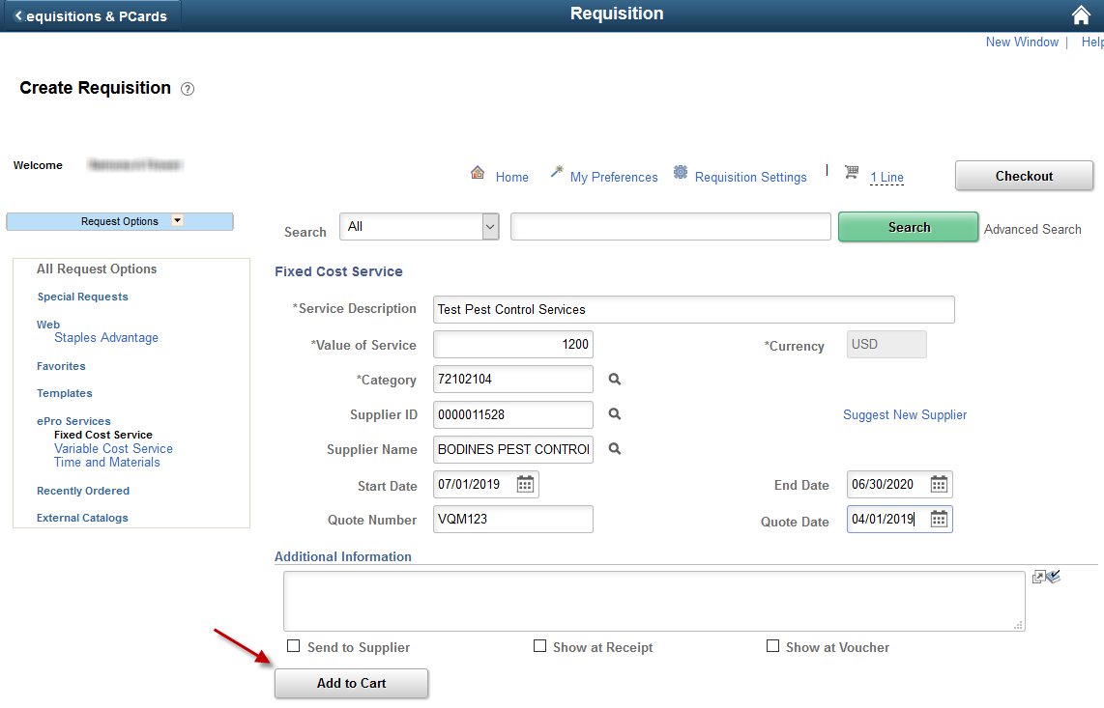
When the ‘Add to Cart’ button is clicked, SMART adds the service to the requisition line, and returns a blank ‘Fixed Cost Service’ page (so the Requisitioner can enter another service if desired).
Once all the goods/services have been added, select the ‘Checkout’ button at the top right corner of the ‘Create Requisition’ page:
Note: If no line items have been selected on the ‘Create Requisition’ page, SMART will display a message on the ‘Checkout - Review and Submit’ page, advising that no requisitions lines are available.

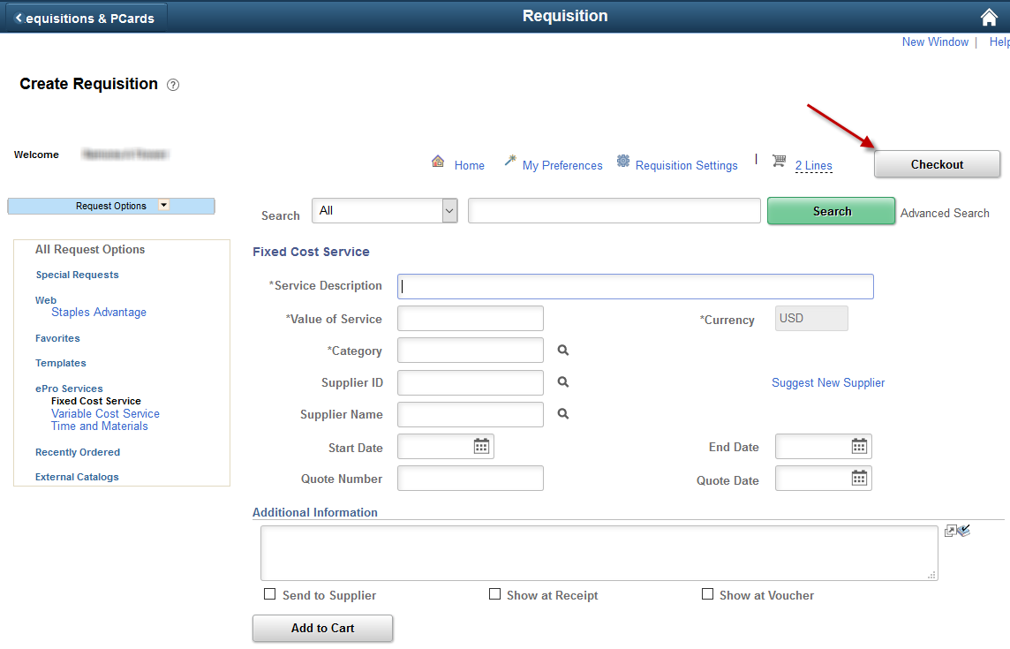
The ‘Checkout – Review and Submit’ page appears. Select the requisition lines that should be saved, and then click on the ‘Save and Submit’ or ‘Save for Later’ button at the bottom left-hand corner of the page.

Variable Cost Service
The ‘Variable Cost Service’ option can be used when purchasing a service for which the fee is based upon time worked.
For example, temporary staffing. Typically, temporary staffing has a fixed hourly rate, and the number of hours to be worked varies.
To create a requisition for a ‘Variable Cost Service’ click the ‘Variable Cost Service’ link:
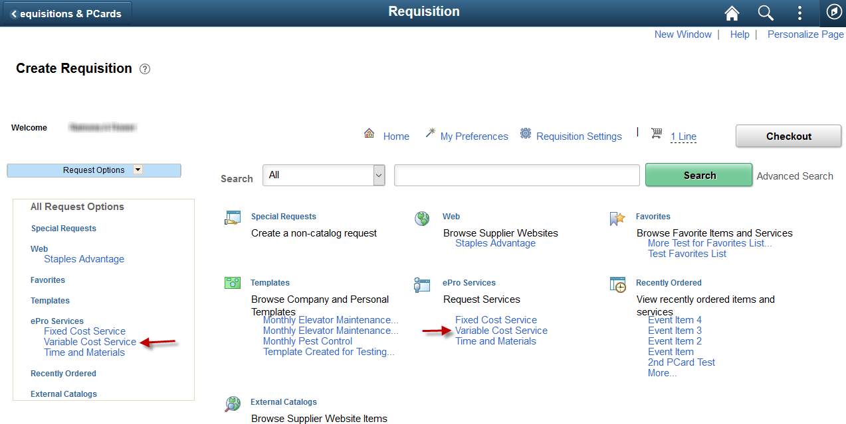

Clicking the ‘Variable Cost Service’ link opens the ‘Variable Cost Service’ page:
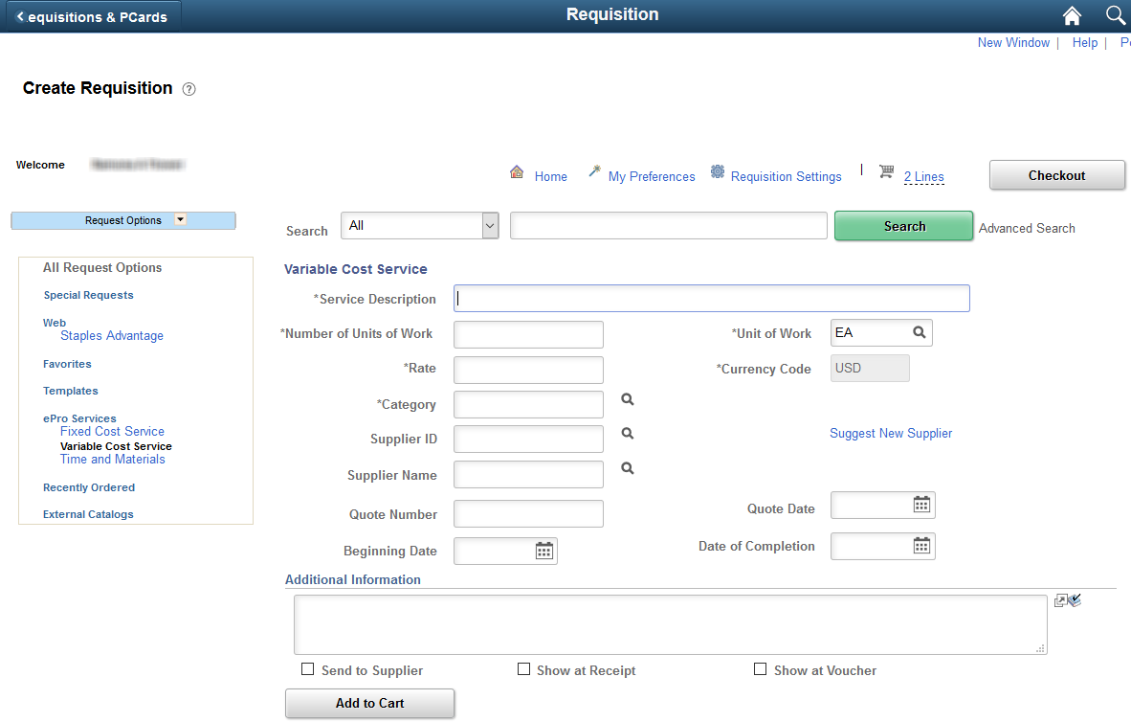
There are several values that need to be populated on the Variable Cost Service page:
Field | Description
Service Description  (Required) | Enter a detailed Service Description for the service being requested.
# of Units of Work  (Required) | Enter the number of units to be worked. For example, the number of hours to be worked.  If an exact number is not known at this time, enter an approximate value in this field.
Unit of Work  (Required) | Enter the units of work, i.e. how the work is to be charged to your agency. A list of possible options is provided by selecting the ‘Look Up’ icon. Examples: MHR = Man Hours, or SQF = Square Feet
Rate  (Required) | Enter the cost (amount) per unit of work in this field. Example: $25.00 per Man Hour (MHR)
Category  (Required) | The State of Kansas has purchased the UNSPSC listing to be used as the ‘Category’ codes within SMART. The UNSPSC is an industry standard classification that is used to classify all goods and services. By using a standardized classification for goods and services we can utilize the Category field for detailed good/service reporting provided that accurate category codes are selected during the requisition/PO processing.  The UNSPSC listing does NOT have Categories for all the goods/services that the State of Kansas uses. If there is no Category code that matches the item/service being ordered, the Requisitioner needs to select a code that most closely represents the good/service being purchased.  Click the ‘Look Up’ icon (Magnifying glass icon to the right of the Category field – this opens the ‘Look Up Category’ page). Enter a Description or partial description, then click the ‘Find’ button. SMART displays a list of ‘Category Codes’ that contain the description. Select the Category code that best fits the good/service being purchased (by clicking on the desired Category code link).  The State of Kansas has provided a complete listing of the ‘Category’ codes for use. The list of Category codes is located on the ‘Look Up Category’ page. To view the complete list of Category Codes, select either the .pdf or .xls SMART Category Codes links.  It is recommended that the Requisitioner select the .xls file so that they can use the ‘sort and filter’ capability within the Excel document.  The Requisitioner should save this file to their local computer drive. It is recommended that Requisitioners use this Excel document to make notes for themselves as to what Category codes are typically used by their agencies.  Note: Requisitioners should select specific, detailed, Category Codes – NOT the ‘All Items’ code. Selecting the ‘All Items’ Category Code results in incorrect reporting regarding State of Kansas purchasing activities.

Supplier ID  (Recommended) | A Supplier ID must be entered for the requisition to source to a PO.  SMART does not require a Supplier ID to be entered; however, if the Supplier ID is left blank the requisition will not source to a PO and will end up on the ‘Sourcing Work bench’.  Please refer to the ‘Working Errors on the Sourcing Workbench’ training document for additional information, which is located on the SMART at:  https://www.smartweb.ks.gov/training/purchasing#Purchase_Orders  When should the Supplier ID be left blank? It is appropriate to leave the ‘Supplier ID’ blank if the requisition exceeds the Agencies spending authority and needs to be put out for bid by the Office of Procurement and Contracts. (In this case the Requisitioner MUST select the ‘RFQ Required’ checkbox on the Line Details page for the requisition line or the Mass Change hyperlink. This information is covered later in this training document).
Quote Number  (Optional) | If you received a quote from the Supplier, entering the quote number in the Quote Number field can be very useful for future tracking purposes.  Note: The Quote Number provided on this special request form appears at the requisition line level, in the line comments page. These comments will also be sourced to the subsequent PO line comments.
Quote Date  (Optional) | If you received a quote from the Supplier, entering the quote date in the Quote Date field can be very useful for future tracking purposes.  Note: The Quote Date provided on this special request form appears at the requisition line level, in the line comments page. These comments will also be sourced to the subsequent PO line comments.
Beginning Date  (Recommended) | Enter the date that the service is to begin.  Note: The Beginning Date provided on this special request form appears at the requisition line level, in the line comments page. These comments will also be sourced to the subsequent PO line comments.

Date of Completion  (Recommended) | Enter the date that the service is to be completed.  Note: The ‘Date of Completion’ will appear on the requisition line, in the ‘Due Date’ field. The dates provided when completing this special request form will also appear at the requisition line level, in the line comments page. The requisition line comments are sourced to the subsequent PO line comments page.  SMART does not require a ‘Date of Completion’ to be entered; however, the monthly close process uses the ‘Due Date’ to determine if a Requisition can be closed. Entering an accurate ‘Date of Completion’, will help prevent requisitions and POs from being closed prematurely.
Send to Supplier checkbox  (Optional) | Select the ‘Send to Supplier’ check box if the information should be included on the Purchase Order. The Requisition Line comment will source to the PO line which will then display under the line description on the dispatched Purchase Order:
Show at Receipt checkbox  (Optional) | Select the ‘Show at Receipt’ check box if the information should be provided to the user that will receive the product. The comment is available from the ‘Receiving’ page; however, the comment is NOT readily apparent. The user creating the receipt would have to select the ‘Source Information’ tab from the ‘Receiving’ page to get to the PO Line comment:
Show at Voucher checkbox  (Optional) | Select the ‘Show at Voucher’ check box if the information should be provided to the Voucher Processor. The comment is available from the ‘Voucher – Invoice Information (Tab)’ page; however, the comment is NOT readily apparent. The Voucher Processor would have to select the ‘Purchase Order & Receiver Info’ link from the ‘Voucher – Invoice Information (Tab)’ page and then expand the ‘PO/Receipt Comments’ section to get to the PO Line comment:

Once the information is entered, click the ‘Add to Cart’ button (located at the bottom left corner of the page):

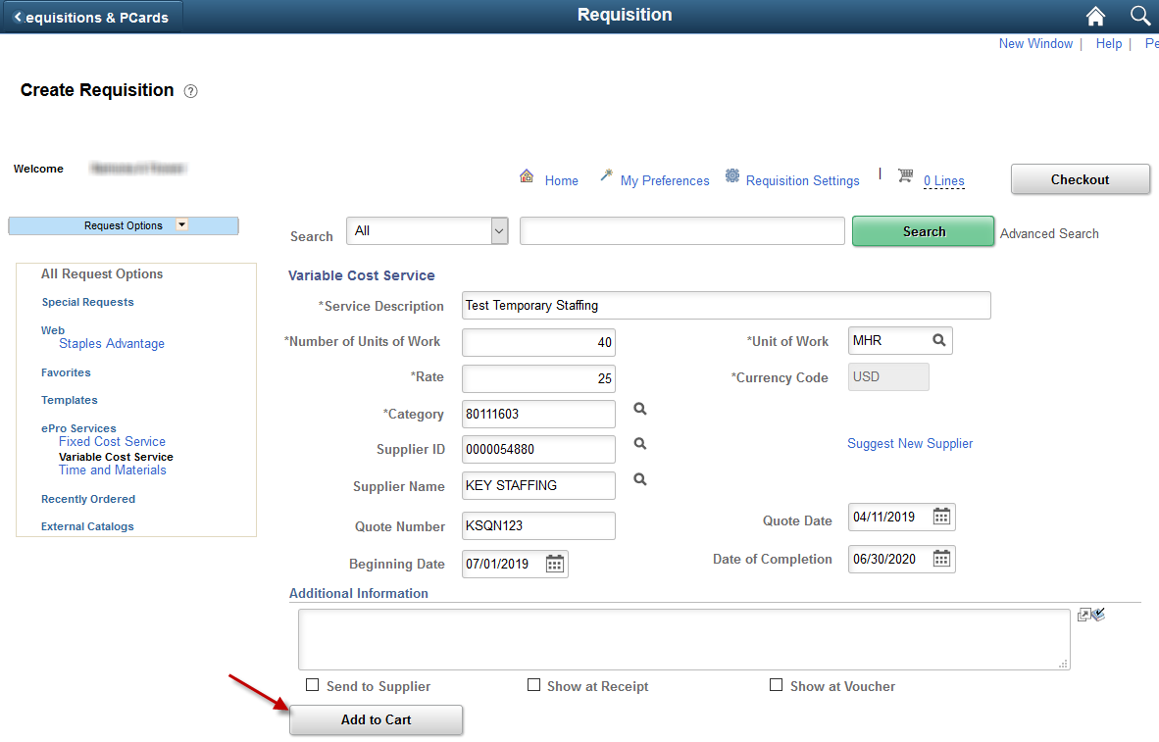
When the ‘Add to Cart’ button is clicked, SMART adds the service to the requisition line, and returns a blank ‘Variable Cost Service’ page (so the Requisitioner can enter another service if desired).
Once all the items/services have been added from Special Request tab, select the ‘Checkout’ button at the top right corner of the ‘Create Requisition’ page:
The ‘Checkout – Review and Submit’ page appears.
Note: If no line items have been selected on the ‘Create Requisition’ page, SMART will display a message on the ‘Checkout - Review and Submit’ page, advising that no requisitions lines are available.
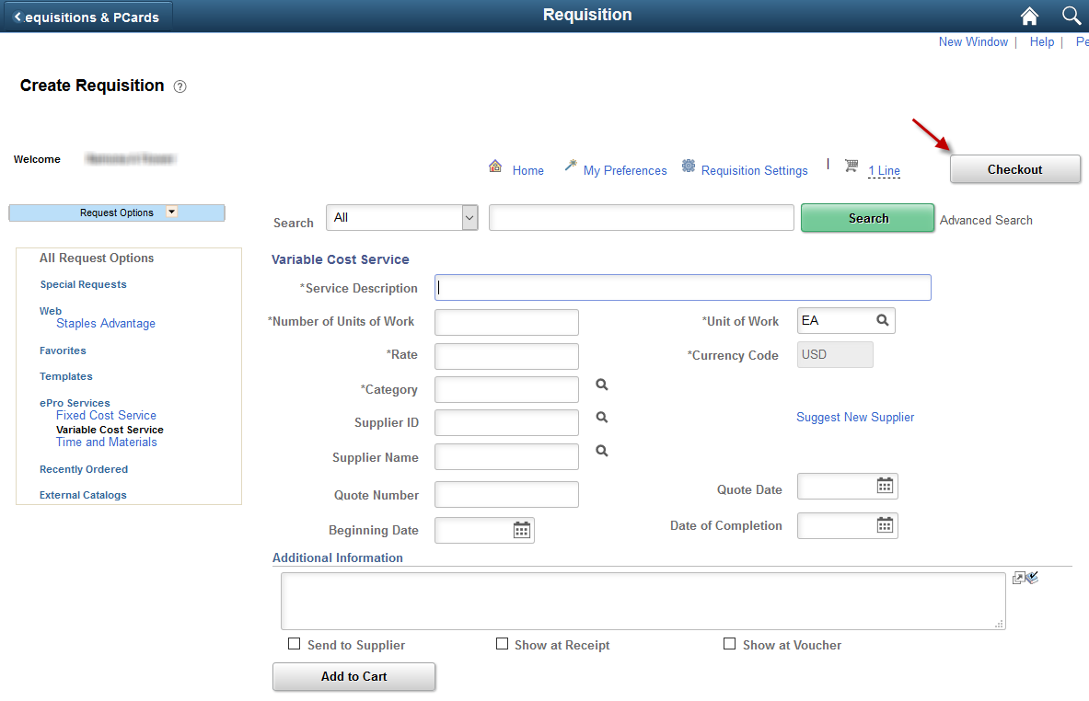
Note: For more information about the ‘Create Requisitions’ page, please refer to the ‘REQ TOOL 2 – Create Requisitions Request Options’ training document, located on the SMART Website at:
https://www.smartweb.ks.gov/training/purchasing#Requisitions

CHeckout - Review and Submit page
The ‘Checkout - Review and Submit’ page is where the financial information and the details of the requisition are captured and stored.

Prior Authorization Type
What is ‘Prior Authorization’? Agencies MUST submit a SMART Prior Authorization Requisition to the Office of Procurement and Contracts for procuring goods or services when:
- not on an established contract,
- above the agency’s Delegated Purchasing Authority, and
- the competitive bid process is not appropriate.

For complete Prior Authorization submission instructions please refer to ‘Purchasing Information Circular 11-03’: http://www.da.ks.gov/purch/11-03Circular.doc

If the good/service being requested meets the Prior Authorization criteria, the ‘Requisitioner’ needs to select the appropriate ‘Prior Authorization Type’ (PA) on the Checkout - Review and Submit page of the requisition:

Select the ‘Look Up’ icon to view and select from the listing of the available PA Type options:
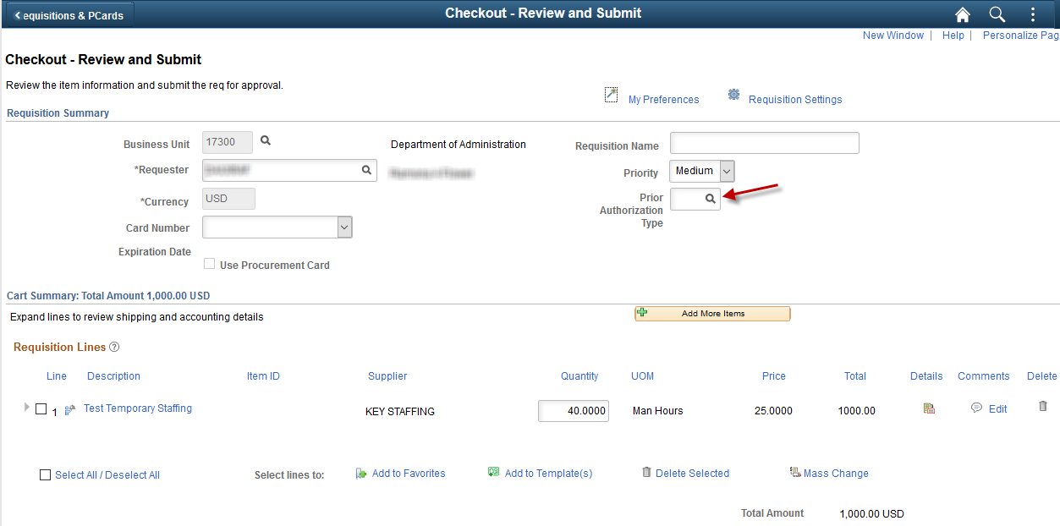

Clicking on the Look Up icon opens the Look Up Prior Authorization Type page:
The Requisitioner selects the appropriate PA type from the list of available options:
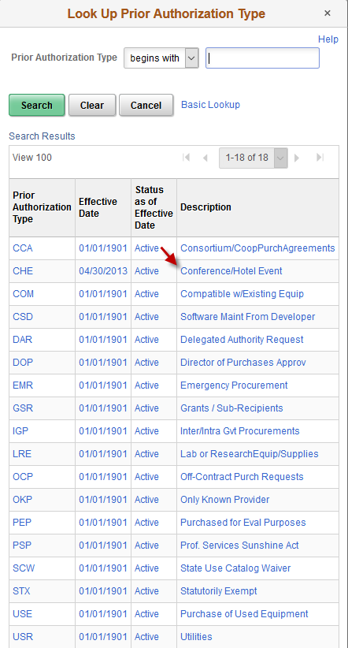

The PA type selected populates in to the Prior Authorization Type field, located at the top right corner of the ‘Checkout - Review and Submit’ page.

As a rule, the requisitions in SMART are not a document repository, therefore Requisitioners should NOT attach documents such as brochures or specifications to the requisition.

However, there are two exceptions:
- The requisition meets the Prior Authorization (PA) criteria. In this case, the Requisitioner needs to provide a completed Prior Authorization Request Form located on the Office of Procurement and Contracts website at:
https://admin.ks.gov/offices/procurement-and-contracts/procurement-training

The completed form is attached to the requisition at the requisition line level, using the Line Comments page.

- The requisition exceeds the agency’s Delegated Purchasing Authority and must be bid out by the Office of Procurement and Contracts. In this case, the Requisitioner needs to provide specifications to the Central Procurement Officer. This is done by attaching the additional Request for Bid (RFQ) information to the requisition - at the requisition line level, using the Line Comments page.

Add an attachment for a PA or for an RFQ (Request for Bid):

To attach the completed Prior Authorization Request form OR to attach specifications for the Office of Procurement and Contracts bid process at the requisition line level:

- Click the ‘Line Comments’ icon:
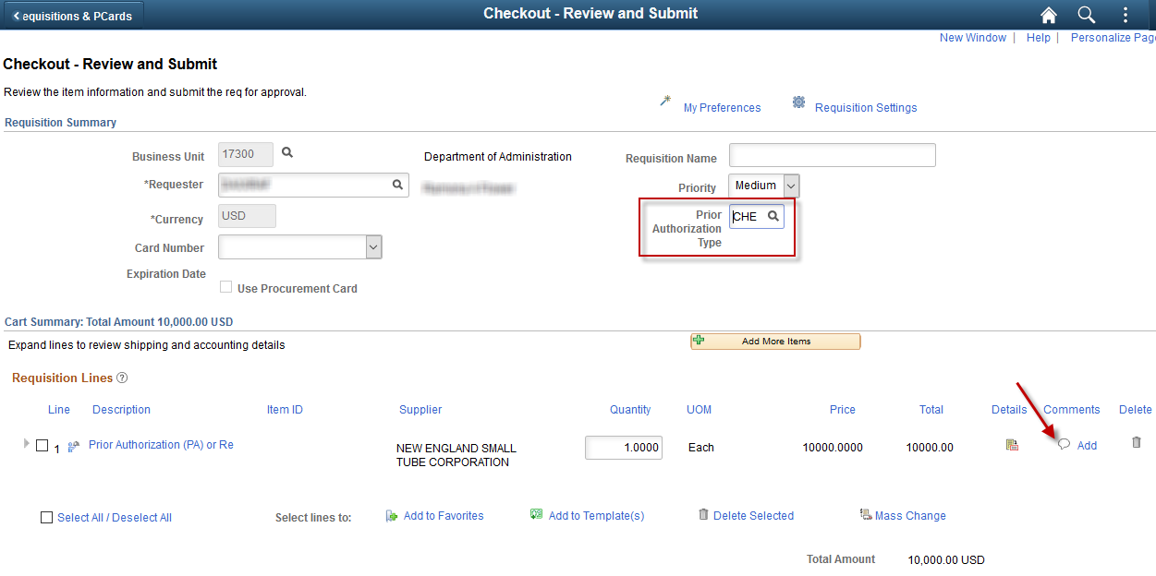

- Click the ‘Add Attachment’ button:
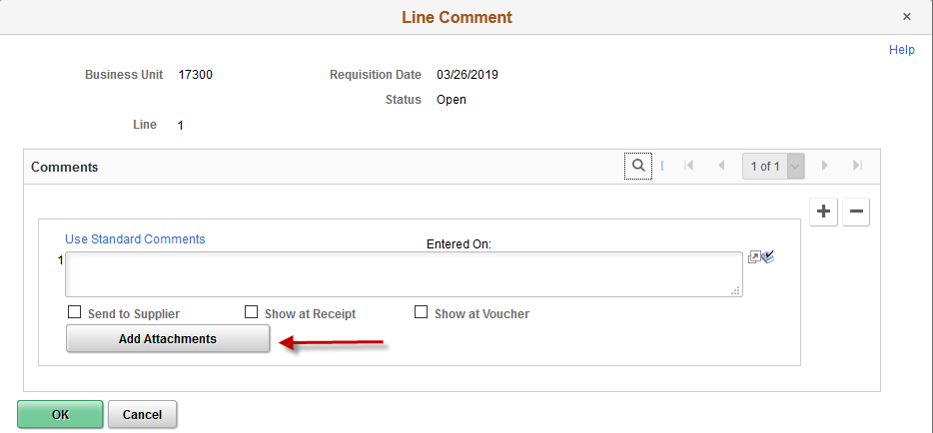
- Click the ‘Browse’ button:

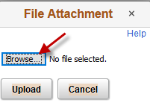

- Locate the document to be attached (i.e. the completed PA form OR the Specifications).

- Click the ‘Open’ button:

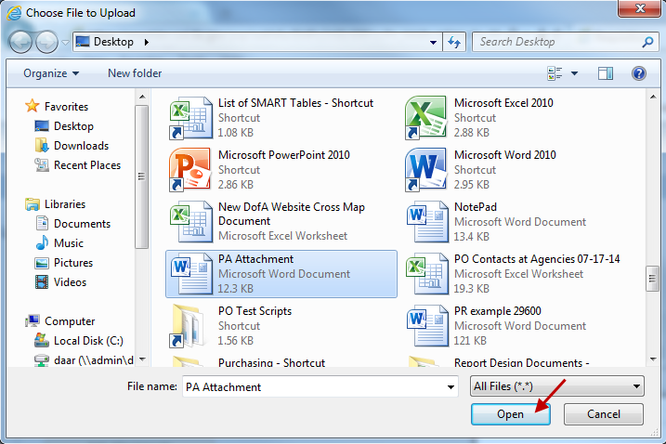

- Select the ‘Upload’ button:

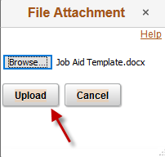
- The document is now attached to the requisition line level, in the Line Comments page:
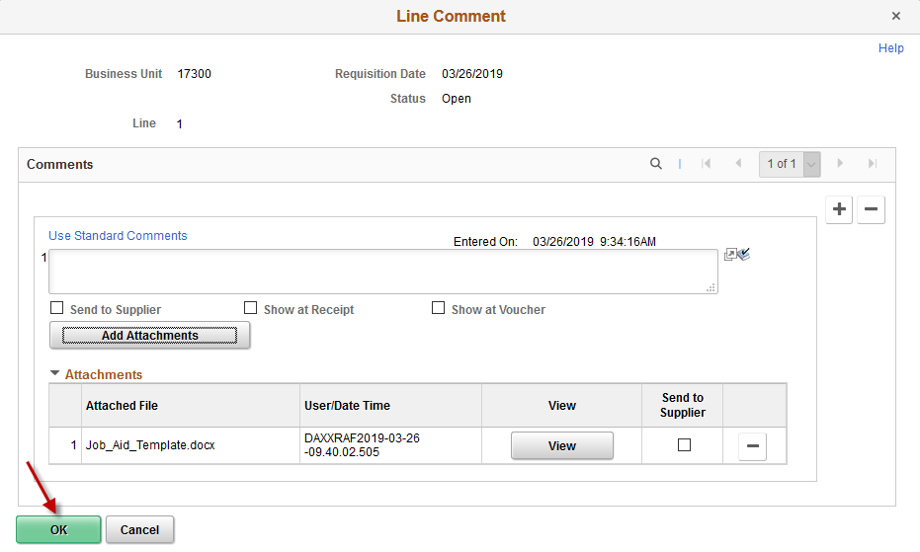
- Click the ‘OK’ button.
Note: For complete Prior Authorization submission instructions please refer to ‘Purchasing Information Circular 11-03’ located at: http://www.da.ks.gov/purch/11-03Circular.doc
Note: For an explanation of the Prior Authorization policy and a listing of all available codes and their definitions, please see the called ‘Prior Authorization Training Document’ on the Office of Procurement and Contracts website at:
http://admin.ks.gov/offices/procurement-and-contracts/procurement-training

Line Details – Button and Page
Click the ‘Line Details’ icon at the far-right side of the requisition line:

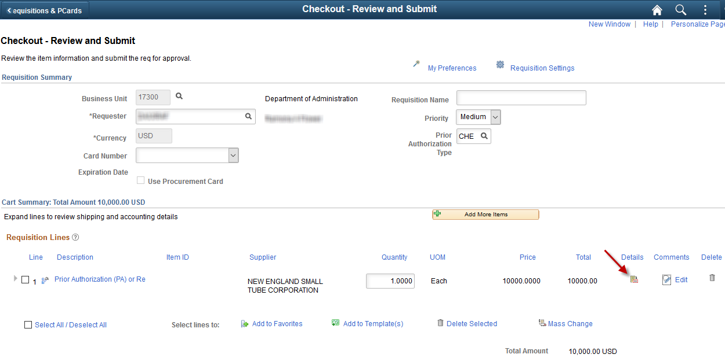

Clicking the ‘Line Details’ icon opens the Line Details page:
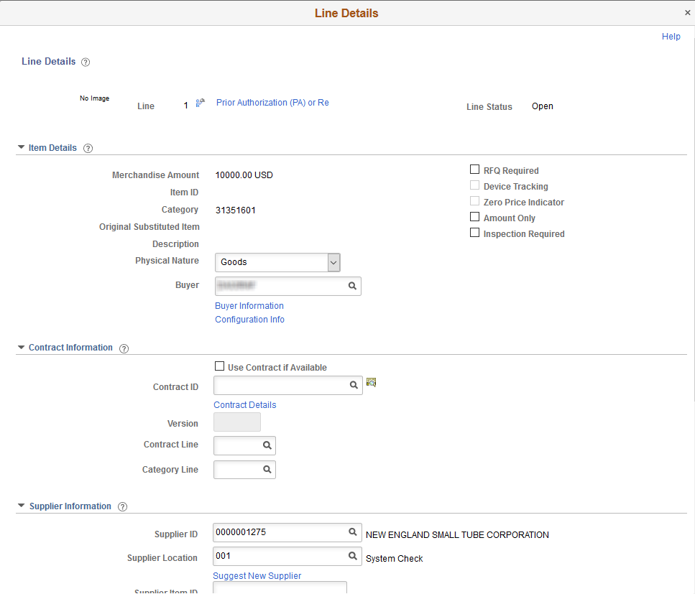
Many of the fields on the ‘Line Details’ page are populated with the information that the Requisitioner has already entered, OR defaulted values based upon the Requester’s user set up. There are several fields on the ‘Line Details’ page that the Requisitioner should review:
Field | Description
Buyer | If the Buyer field is blank or contains the incorrect Buyer ID, enter the correct Buyer ID in this field.  Note: The Buyer ID will default into the requisition line based upon the ‘Requisitioner’ set-up.  When the requisition is sourced to a PO, SMART will use a system wide Buyer ID default value of ‘BYRDFLT’, IF:  - the ‘Requisitioner’ does NOT have a default Buyer established and the Buyer field is blank; OR  - the requisition has different Buyers on different lines.  For additional information, please refer to the ‘BYRDFLT Buyer Id 9.2’ training document, located on the SMART website at:  https://www.smartweb.ks.gov/training/purchasing#Purchase_Orders
RFQ Required checkbox | Select the ‘RFQ Required’ checkbox, if the requisition exceeds the agency’s delegated purchasing authority, and the Office of Procurement and Contracts needs to bid out the goods/services.  Selecting the ‘RFQ Required’ checkbox prevents the ‘PO Auto Sourcing’ batch process from automatically picking up the requisition for sourcing to a PO and makes the requisition available for the creation of a Bid Event by the Office of Procurement and Contracts.  Note: If a requisition is to be bid out by the Office of Procurement and Contracts, the Supplier field must be left blank.  To apply the ‘RFQ Required’ checkbox to all lines, please see the Mass Change section later in this document.  If the Supplier field IS left blank and the ‘RFQ Required’ checkbox is NOT selected, the requisition will end up on the ‘Sourcing Workbench’.  For additional information, please refer to the ‘Working Errors on the Sourcing Workbench’ training document, located on the SMART website at:  https://www.smartweb.ks.gov/training/purchasing#Purchase_Orders
Amount Only checkbox | The Requisitioner needs to determine if the goods/services being requested will be vouchered / paid by ‘Amount’ or by ‘Quantity’.  If the goods/services will be vouchered / paid by a certain ‘Amount’ then the ‘Amount Only’ checkbox MUST be selected.  Example of when the ‘Amount Only’ check box SHOULD be selected:  Select the ‘Amount Only’ checkbox when purchasing a service where multiple payments will be made and the dollar amount for each payment may vary.  For example, with temporary staffing, typically, multiple payments are made over a period of time and the payments are based upon the number of hours worked which may vary from payment to payment.  Example of when the ‘Amount Only’ check box should NOT be selected: Do NOT select the ‘Amount Only’ checkbox when purchasing a specific number of goods that have a set price.  For example, a quantity of four (4) widgets at an amount of $2.00 per widget.  Note: When the ‘Amount Only’ checkbox is NOT selected, it is known as ‘Quantity’.
Contract ID | If the goods/services being requested are on a Contract, then the Requisitioner MUST enter the ‘Contract ID’ number into the ‘Contract ID’ field on the Requisition Line Details page.  To locate a ‘Contract ID’ number, click the ‘Look Up’ icon located to the right of the ‘Contract ID’ field in the ‘Contract Information’ section.  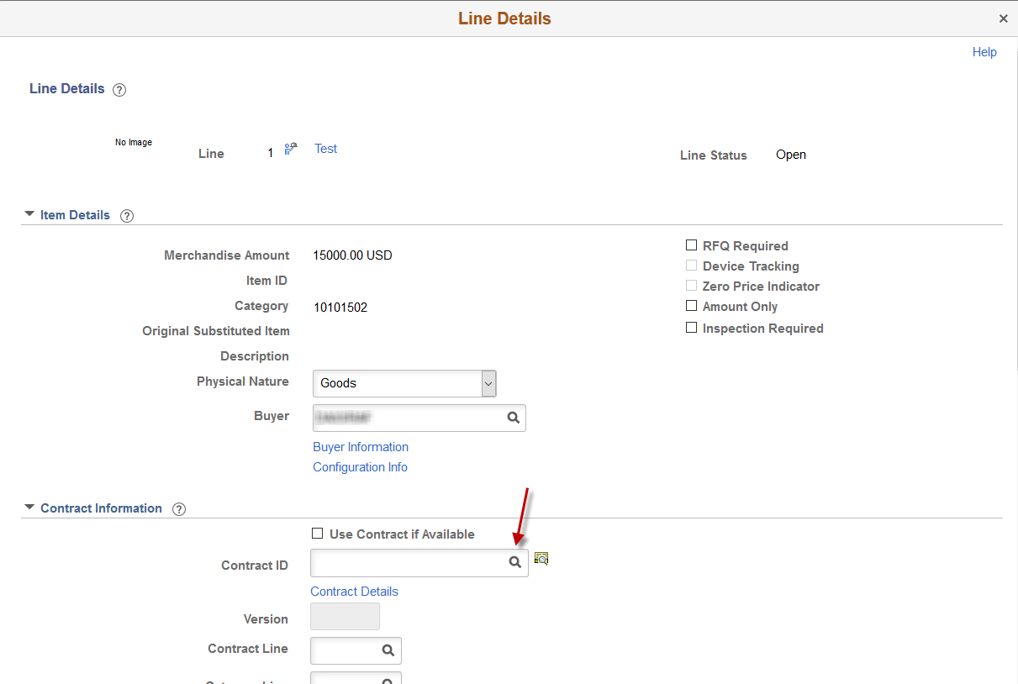  When you click on the ‘Look Up’ icon, SMART opens the ‘Look Up Contract ID’ page. Only contracts associated to the Supplier, not yet expired, and available to your agency will appear on the ‘Look Up Contract ID’ page. Review the list of available Contracts for the supplier, and select the appropriate ‘Contract ID’ by clicking on the Contract ID link:  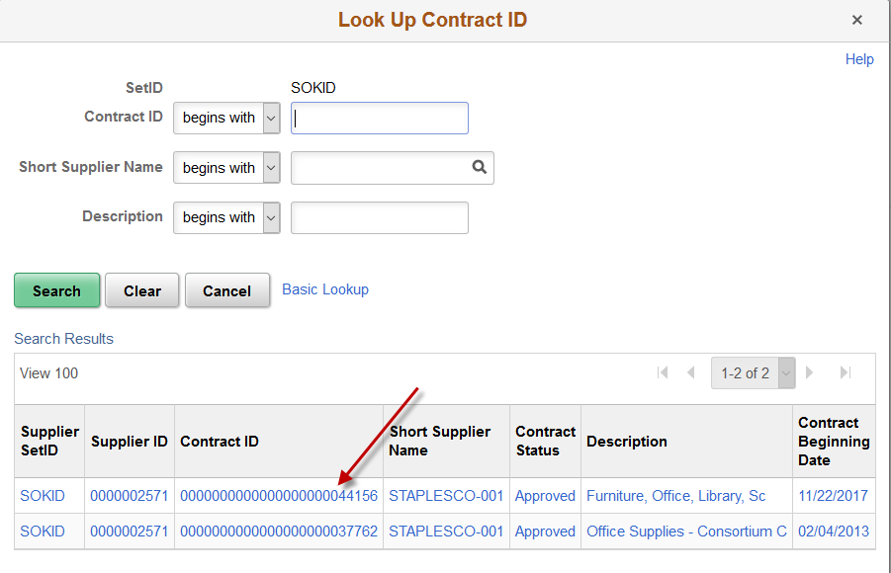  The Contract ID number will populate in to the Contract ID field:  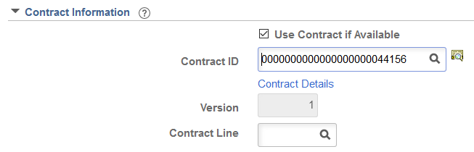  Note: The Contract ID MUST be populated on all requisition lines if the good/service is on a contract. Please see ‘Policy Manual 10,300 – Statewide Encumbrance Policy’ for more details.  To apply the Contract ID to all lines, please see the Mass Change section later in this document.  Note: If the Requisitioner is NOT sure of the correct Contract ID, they may navigate to the Office of Procurement and Contracts website for a listing of Contracts (located at): http://www.da.ks.gov/purch/Contracts/
Contract Line | Typically, the State of Kansas contracts do not have line numbers, and consequently this field will remain blank.

Requisition Lines Section
Many values displayed on the ‘Checkout - Review and Submit’ page in the Requisition Lines Section are default values based upon the ‘Requester’ information entered on the ‘Requisition Settings’ page. If this information is incorrect, the fields can and should be edited from the ‘Checkout - Review and Submit’ page.
The Requisition Lines section is where the Requisitioner enters ‘Shipping Line’ information (sources to the ‘PO - Schedule’ page) and ‘Accounting Lines’ containing the financial information (sources to the ‘PO – Distribution’ page).
To view the details for a line on the requisition, click the ‘Expand section’ button (located to the left of the line selection checkbox):

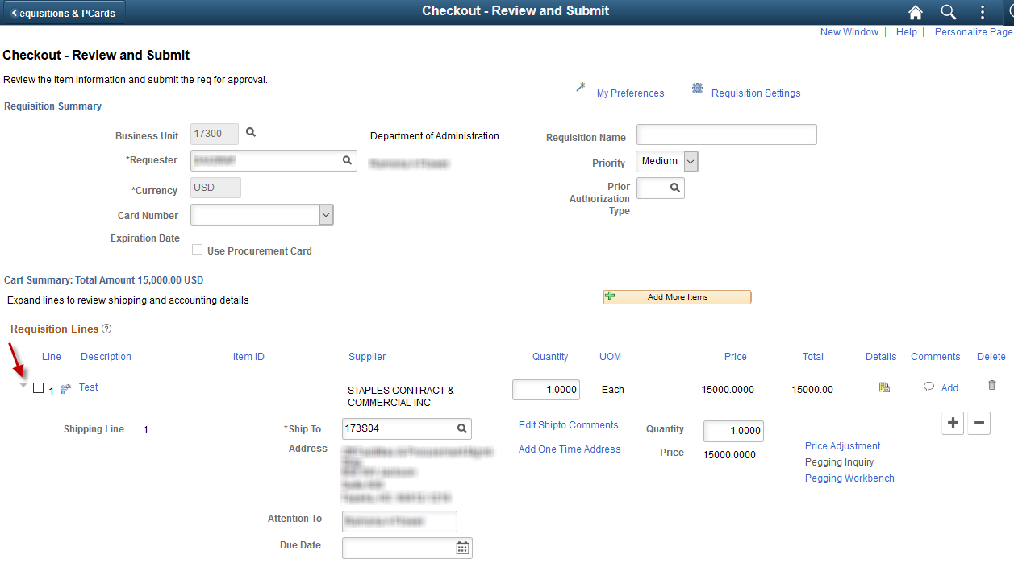

There are two (2) sections located under each requisition line:
- The first section is the ‘Shipping Line’ or (sources to the ‘PO - Schedule’ page) – which contains information such as: where the service is to be performed, or where the goods are to be delivered to.

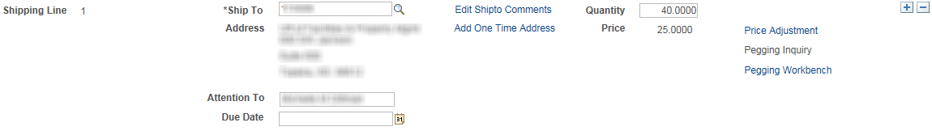

- The second section is the ‘Accounting Lines’ containing the financial information (sources to the ‘PO – Distribution’ page) – which contains the funding information associated with paying for this purchase and classifying the expense. This section contains the ‘ChartField’ information for the purchase.

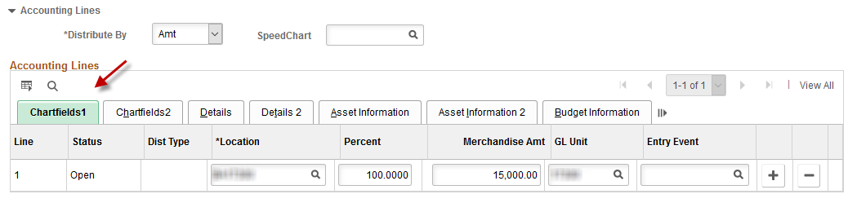
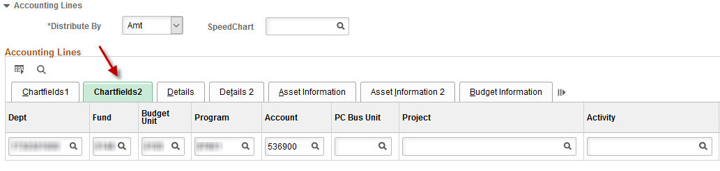

Shipping Line Section
The ‘Shipping Line’ section is where the Requisitioner indicates where the service is to be performed, or where the good(s) are to be delivered to. The ‘Shipping Line’ fields are:
Field | Description
Due Date | Populated based on information entered on the ‘Create Requisitions’ page.
Quantity | Populated based on information entered on the ‘Create Requisitions’ page.
Ship To | Defaulted based upon the ‘Requester’ selected on the ‘Specify Business Unit and Requester’ page.
Attention | Defaulted based upon the ‘Requester’ selected on the ‘Specify Business Unit and Requester’ page.  Note: There is nothing gained by changing the ‘Attention’ value; so, it is recommended to leave the default value. This field will default with the Requester name. The ‘Attention’ value will not flow forward to the Purchase Order and entering a different name in the ‘Attention’ field will not change workflow. Workflow is based upon the Requester ID entered on the ‘Specify Business Unit and Requester’ page.

Modify A Shipping Address
The Requisitioner can modify a shipping address if necessary using the ‘Add One Time Address’ link to navigate to the “Shipping Address’ page.
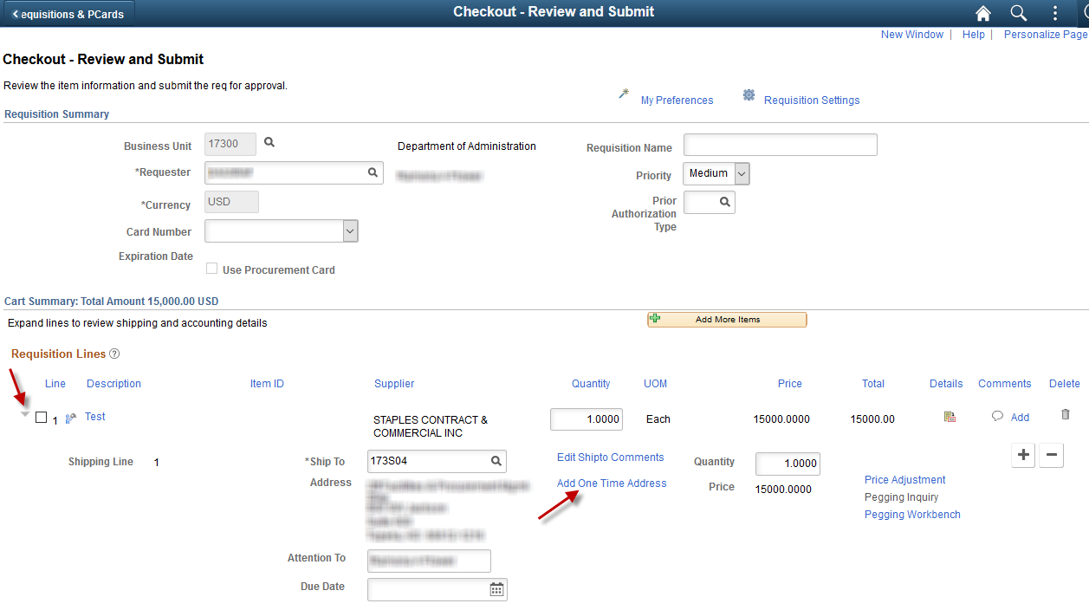
Note: To view the details for a line on the requisition, click the ‘Expand section’ button (located to the left of the line selection checkbox).

Use the ‘Shipping Address’ page to update the shipping address information for the requisition line. The ‘Shipping Address’ page is used to enter a shipping address that is not currently defined in SMART as a default “Ship To” location.

For example, a shipment to a construction site or other temporary location.
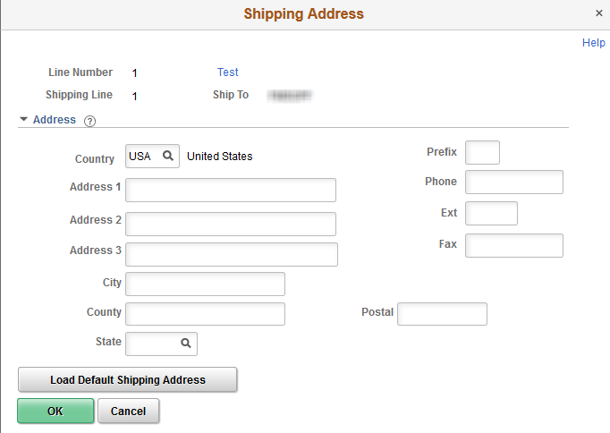

After an address is added there will be a ‘Edit Onetime Address’ icon hovering over the new Ship To address and the link will now say ‘Edit Onetime Address’.

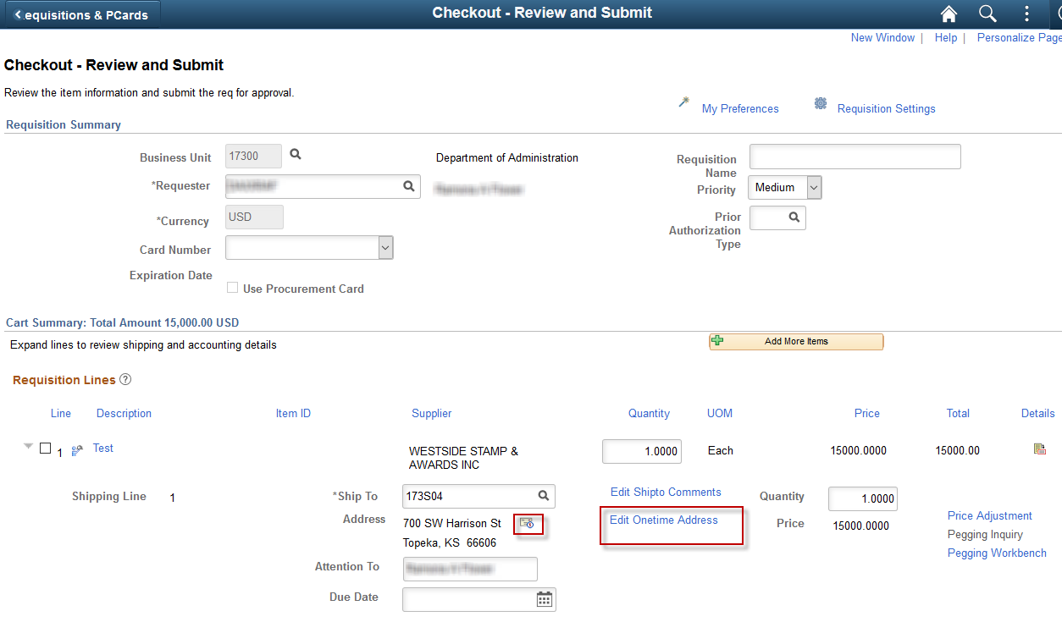
Note: The modified ‘Ship To’ address is added to the PO during the PO Auto Sourcing batch process.

Add a Shipping Line (multiple delivery locations)
Not all agencies are using the ‘Ship To’ multiple locations functionality in SMART. Please refer to your agency’s business process regarding the shipment of good(s) / service(s) for your agency.
A Requisitioner has the option to have products delivered to multiple ‘Ship To’ addresses.
For example, the Requisitioner needs to purchase a total of ‘10’ widgets for their agency. Three (3) of the widgets need to be delivered to a Topeka address for the agency, while the remaining seven (7) widgets need to be delivered to an Atchison address for the agency.
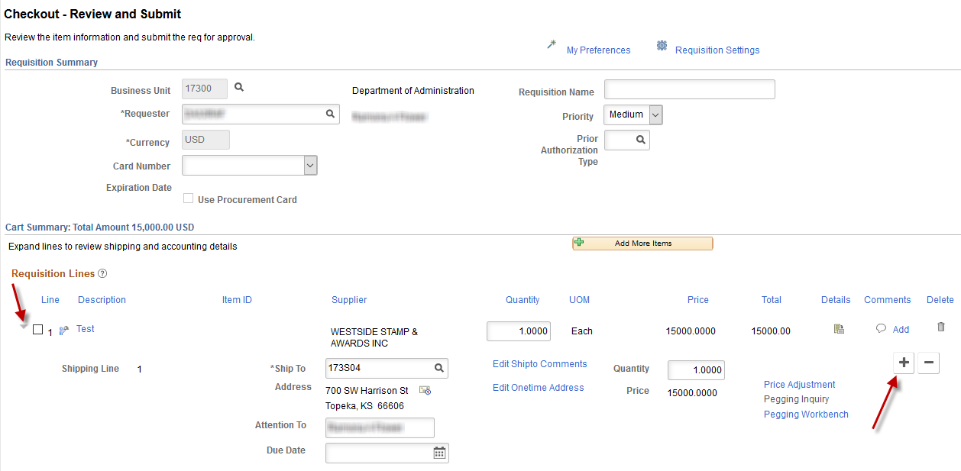
Note: To view the details for a line on the requisition, click the ‘Expand section’ button (located to the left of the line selection checkbox). In the Shipping section, click the plus sign button (+) on the far-right side of the Shipping Line:

There are several things that a Requisitioner will observe when adding a new Shipping Line to a requisition:
1) The new ‘Shipping Line(s)’ (Schedule) is displayed below the initial Shipping Line 1 (Shipping Line 2)
2) There are ‘Accounting Line(s)’ (Distribution) associated to each ‘Shipping Line’
3) The ‘Due Date’ fields are now blank (empty)
4) The ‘Quantity’ field is blank (empty) or a ‘0’ quantity on the new ‘Shipping Line(s)’ (Shipping Line 2)
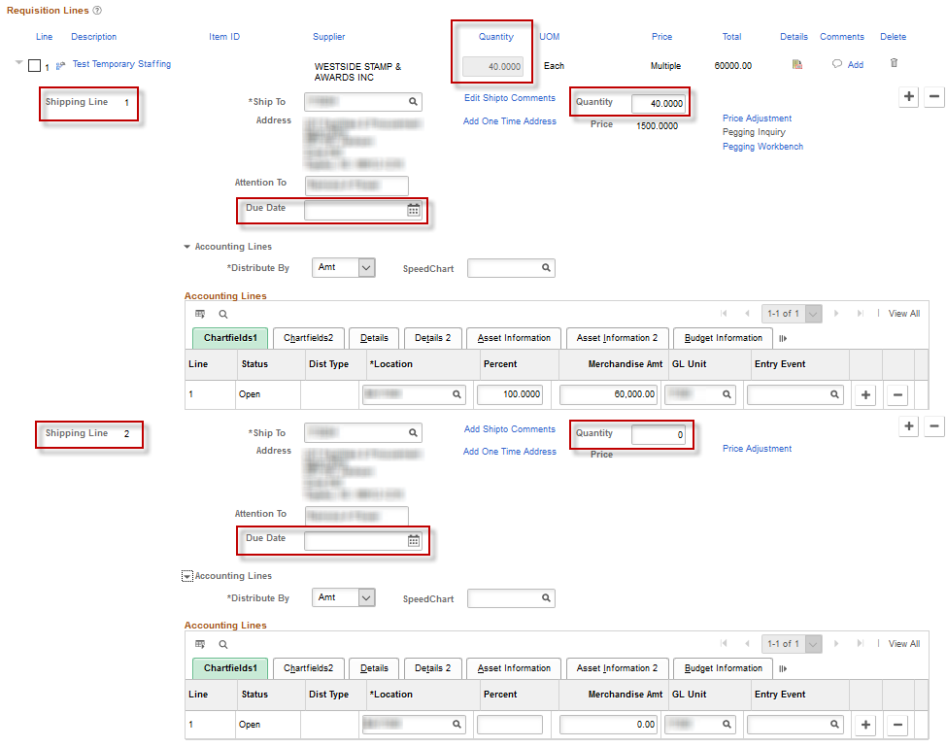

For the Shipping Lines: The Requisitioner will need to make the following changes:
Field | Description
Due Date | Enter a ‘Due Date’ for each ‘Shipping Line’; these may be different depending on the situation. For example, it may take an additional day to deliver to a non-Topeka address.
Quantity | Change the ‘Quantity’ on ‘Shipping Line 1’ and then enter the Quantities on each of the subsequent ‘Shipping Lines’. The Quantities for ALL shipping line Quantities added together MUST MATCH the total Quantity that is shown at the requisition line Quantity.  For example, the total requisition line Quantity is ‘10’ widgets. Therefore, the Quantities in ‘Shipping Line 1’ and ‘Shipping Line 2’ MUST ADD up to a total of ‘10’ widgets.
Ship To | Enter the correct ‘Ship To’ code (for each delivery location) on each Shipping Line. These ‘Ship To’ codes would typically be different from one another because; one ‘Ship To’ code is for the Topeka address, and the other ‘Ship To’ code is for the Atchison address.
Note: The information provided in the ‘Shipping Line’ section of the requisition is sourced to the Purchase Order (PO) as a ‘Schedule’. A PO refers to ‘Shipping Lines’ as ‘Schedules’.
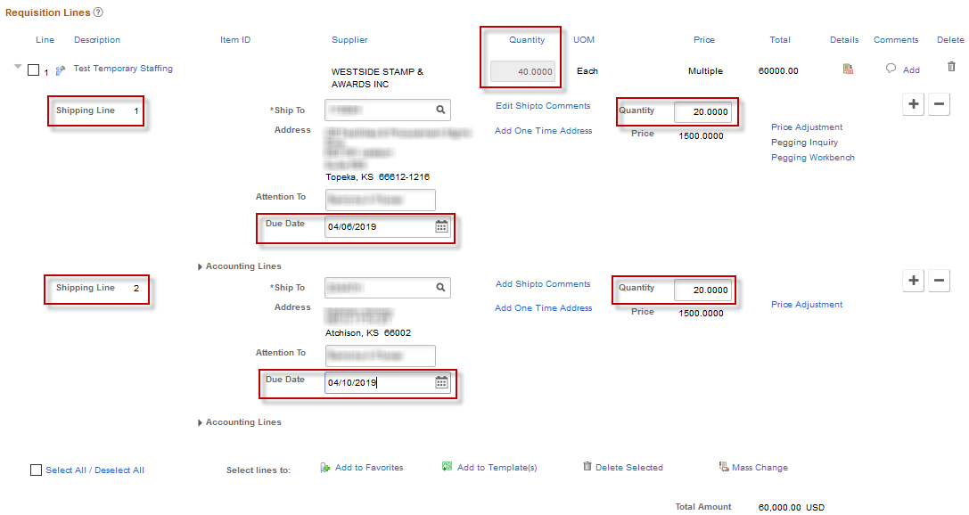

Accounting Lines section
The ‘Accounting Lines’ section of the requisition is where the Requisitioner indicates how the purchase is to be funded. This may be one (1) funding stream or multiple funding streams. The ‘Accounting Lines’ information defaults on each requisition line based upon the ‘Requester’ selected on the ‘Requisition Settings’ page. The funding streams set up as the Requester’s default may not be the correct funding stream for every purchase. Therefore, the Requisitioner needs to review the ‘Accounting Lines’ and validate that they are correct, or update the ‘Accounting Line’ values, (also referred to as ChartField values), if they are not correct.
It is important that the ‘Accounting Line’ information is as accurate as possible before the requisition is ‘Approved’ and sourced to a PO. The Purchasing and Accounts Payable functions in SMART are greatly impacted by the way the requisition ‘Accounting Lines’ are set up. For example, it can impact the creation and maintenance of PO’s and vouchers; and it can also impact the Budget and Expenditure ledgers for your agency.
Recommended best practice: If the Requisitioner is unsure of what ChartField information to use on a requisition, it is best that they consult with their agency’s budget/accounting staff prior to saving and submitting the requisition for approval. Please refer to your Agency’s business processes regarding the ChartField values that should be used for purchases.
The following fields are mandatory ChartField values – these ChartField values are required on every requisition line in SMART:
Field | Description
Dept | The Dept (Department) field is used to enter the appropriate ten-digit Department ID number.
Fund | The Fund field is used to enter the desired four-digit Agency Fund number.
Bud Unit | The Bud Unit (Budget Unit) field is used to enter the correct four-digit Budget Unit number.
Program | The Program field is used to enter the appropriate five-digit Agency Program number.

Account | The Account field is used to enter the correct six-digit Account Code number.  Note: On a requisition, the Account Code number should ALWAYS begin with a ‘5’, indicating an expense/cost for your Agency’s budget.  Note: There is a cross walk connection, behind the scenes, between the ‘Category’ codes and the ‘Account’ codes. If the correct ‘Category’ code is selected, there is a high probability that the ‘Account’ code will also be correct. However, there are exceptions, and the Requisitioner has the responsibility to change the ‘Account’ code on the ‘Accounting Lines’ section of the ‘Checkout - Review and Submit’ page to reflect the purchase, if necessary.  Please see ‘PM 7,002 – Uniform Expenditure Account Classification’ for directives regarding appropriate expenditure account codes on the Kansas Department of Administration website at:  https://www.admin.ks.gov/offices/chief-financial-officer/policy-manual  Please refer to your Agency’s business processes regarding the funding values that should be used for purchases.

Use a SpeedChart
Not all agencies are using the ‘SpeedChart’ functionality in SMART. Please refer to your agency’s business process regarding the use of ‘SpeedCharts’.
A ‘SpeedChart’ may be set up and used by an agency to provide efficiency in data entry of ChartField values and funding information. A ‘SpeedChart’ is a pre-defined combination of funding streams.
For example, say that every time your agency purchases ‘widgets’ the following funding streams are used to pay for them:
Percent | Dept | Fund | Budget Unit | Program
50 | 5650102020 | 1000 | 0303 | 01031
50 | 5650102020 | 2089 | 2020 | 01031
An agency can set up a “SpeedChart” for this combination of funding streams and give it a unique ID. SpeedCharts are stored in SMART by their unique ID. To make data entry faster and easier, and more efficient, the Requisitioner can select the desired ‘SpeedChart’ from the list, which immediately populates the desired funding information in to the Accounting Lines section (ChartFields) of the requisition.
Did you know? ‘SpeedCharts’ are not just used on requisitions in SMART, they can also be used on several other transactions within different modules.
For more information about ‘SpeedCharts’, please refer to the training document named ‘Enter and Maintain Speedcharts Job Aid’, located on the SMART website at:
https://www.smartweb.ks.gov/training/accounts-payable#Vouchers
How to use a SpeedChart: To help with data entry, a ‘SpeedChart’ can be selected from the ‘Checkout - Review and Submit’ page.
- Either enter the unique SpeedChart ID in to the ‘SpeedChart Key’ field, OR, select the ‘Look Up’ button.
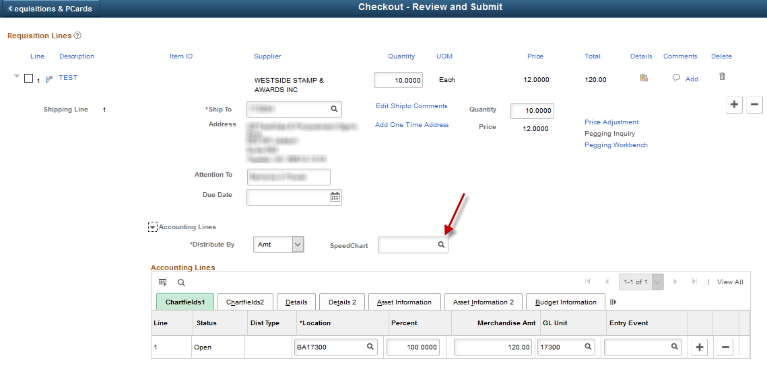

- Select the desired ‘SpeedChart’ Key link:
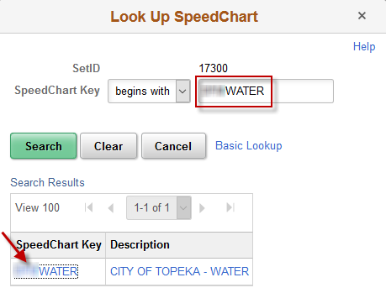
- SMART populates the funding streams associated with the chosen ‘SpeedChart’. This information is populated in to the Accounting Lines section, in the ChartFields (as shown in the following screenshot):
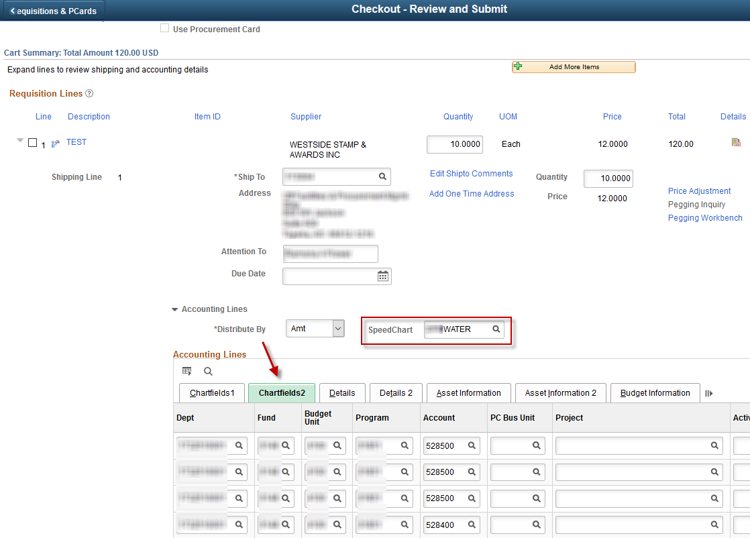
Requisition Line 1 began with one (1) ‘Accounting Line’. After the SpeedChart was applied, Requisition Line 1 now has multiple ‘Accounting Lines’ (because the SpeedChart was set up to split the one line of funding into multiple separate lines of funding).

Add ‘Accounting Lines’
Requisitioners have the ability to manually add ‘Accounting Lines’ if desired. In the Accounting Lines section, on the ‘ChartFields1’ tab:
Click the plus (+) sign button at the far-right side of the ‘Accounting Line’ to add a new line:
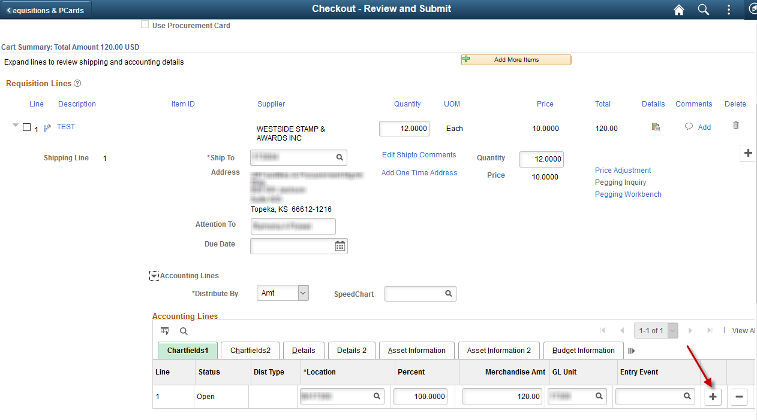

A new ‘Accounting Line’ will display with the Requester’s default information.

‘Chartfields1’:
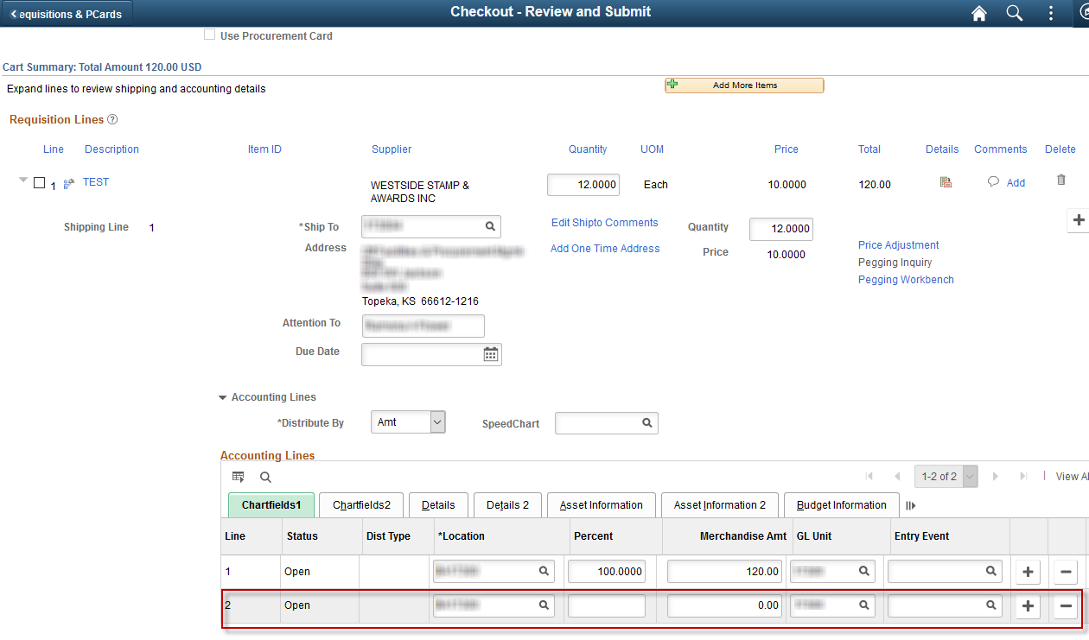
‘Chartfields2’:
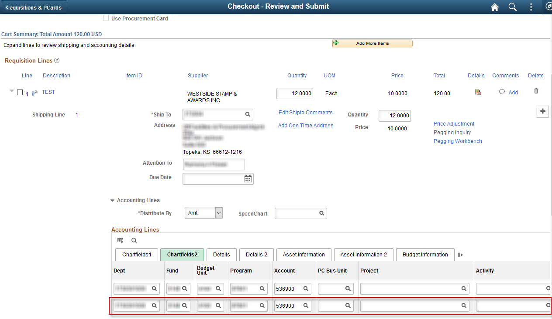
The Requisitioner needs to update the new ‘Accounting Line’ information.
The Requisitioner needs to enter the correct dollar amount, on the ‘Chartfields1’tab, to be associated to each ‘Accounting Line’. The total of the ‘Accounting Line’ Amounts must equal the ‘Total’ at the requisition line level.
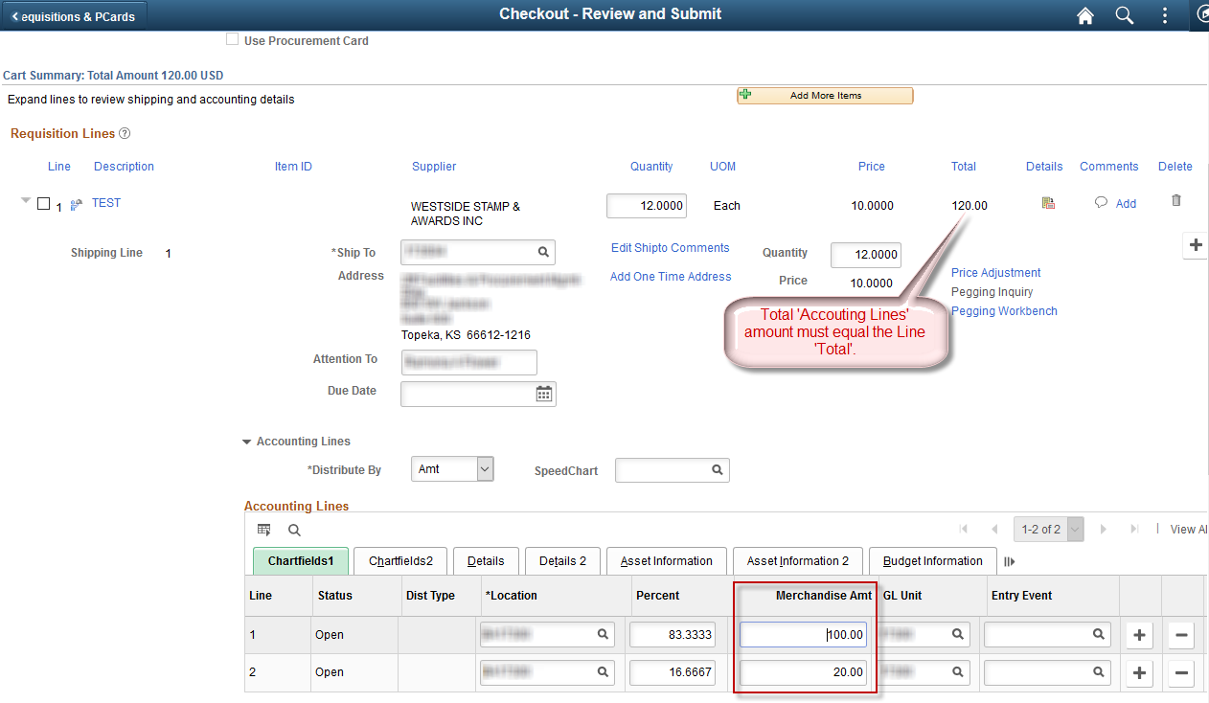

Distribute By
What is ‘Distribute By’? SMART allows a Requisitioner to indicate that a requisition line needs to be paid by ‘splitting’ the funding.
SMART allows for distribution line percentages to be applied to either the ‘Amount’ OR the ‘Quantity’. The Requisitioner needs to determine if there is more than one (1) funding stream used to pay for a purchase.
- If there is NOT more than one (1) funding stream paying for a purchase, then leave the ‘Distribute by’ option as the default value of ‘Amount’.
- If there IS more than one (1) funding stream paying for a purchase, then the Requisitioner needs to determine how the funding is to be applied to this purchase.
  - Will the funding be applied by ‘Quantity’ (Qty)?
For example, the requisition is for three (3) widgets:
- One (1) widget will be paid for out of the Chartfield combination of Fund 1000 / Budget Unit 6148.
- Two (2) widgets will be paid for out of the Chartfield combination of Fund 1700 / Budget Unit 0440.
  - Will the funding be applied by ‘Amount’ (Amt)?
For example, the requisition is for three (3) widgets and for a total amount of $30.00.
$10.50 will be paid out of the Chartfield combination of Fund 1000 / Budget Unit 6148.
$19.50 will be paid out of the Chartfield combination of Fund 1700 / Budget Unit 0440.
Note: The Requisitioner may need to consult with the agency’s budget/accounting staff to determine which ‘Distribute by’ option is appropriate for the purchase being made.

In the following screenshot, the ‘Distribute by’ option selected is ‘Amount’ (Amt); consequently, the requisition ‘Percent’ values are applied to the ‘Amount’ field:
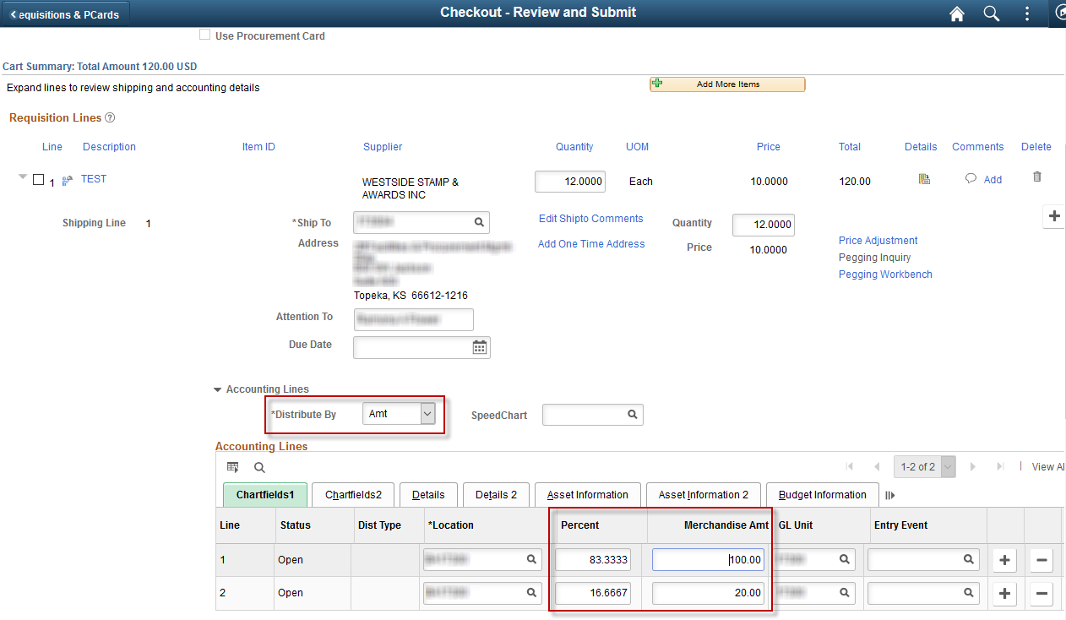

In the following screenshot, the ‘Distribute by’ option selected is ‘Quantity’ (Qty), therefore the requisition ‘Percent’ values are applied to the ‘Quantity’ value.

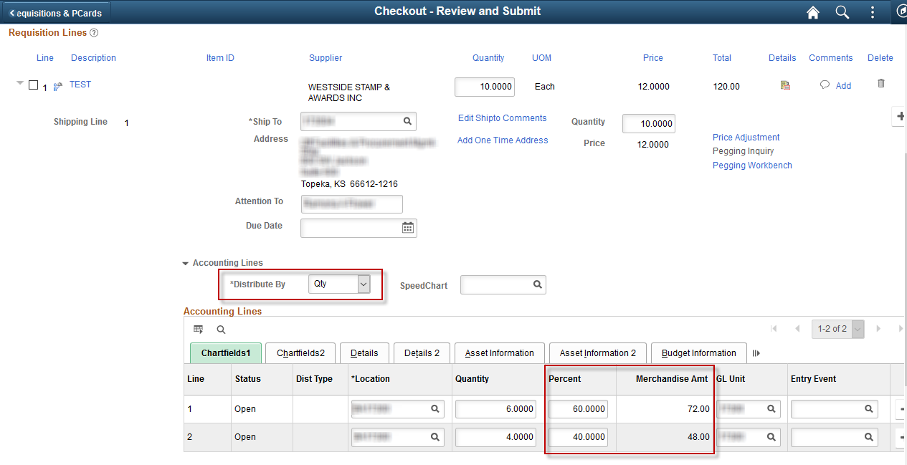
When the requisition lines are sourced to a PO the PO Distribution Lines mirror the requisition Accounting Lines. In this example, the requisition percentage value would be applied to the ‘Quantity’ when the PO is created.

Asset Information
If an item is to become a fixed asset item, use the ‘Asset Information’ tab to enter asset details for the item.
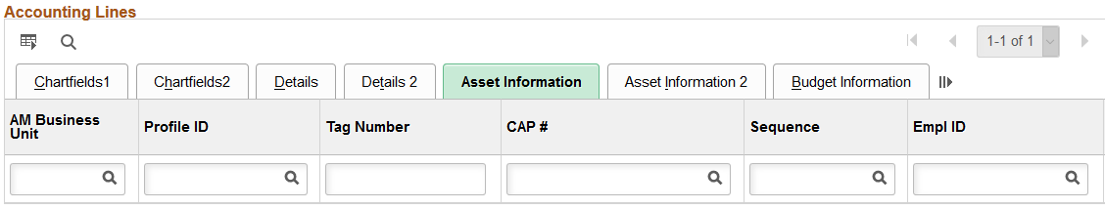
Note: It is State of Kansas business practice that any agency with assets that have a value of $5,000.00 or greater is required to use the Asset Management module in SMART.
For more information about asset management, please refer to the ‘PM 13,001 – Capital Asset Records’ policy manual located on the Kansas Department of Administration website at:
https://www.admin.ks.gov/offices/chief-financial-officer/policy-manual
Use the AM Business Unit field to enter an Asset Management business unit number to associate with the asset item.
If you consider an item to be an asset, you must populate both the ‘AM Business Unit’ field and the ‘Profile ID’ field. Both of these fields must contain data for the information to be passed through SMART into the Asset Management module.
The ‘Profile ID’ sets defaults for the asset such as asset class, asset type and depreciation rules in the Asset Management Module. The ‘Profile ID’ field becomes a required field whenever data is entered in the ‘AM Business Unit’ field.
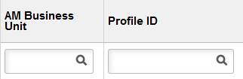
Note: If you enter data in the AM Business Unit field, you must also enter data in the Profile ID field. SMART will not allow you to progress forward until this is completed.
Enter the asset Tag Number if available, into the ‘Tag Number’ field.
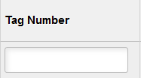
Note: When using asset tag numbers, you need to split the lines (add additional lines) using the + button. SMART allows only a Quantity of one on each line for which an asset tag number is being entered.

Mass Change – link and Page
The ‘Mass Change’ link allows the Requisitioner to quickly update multiple requisition lines through a single set of steps, rather than opening each individual requisition line and updating each line separately.
For example, there are two (2) Requisition Lines on the requisition. The ‘Account’ field is blank on both requisition lines. The same ‘Account’ value needs to be used for all ‘Accounting Lines’.
How to use the ‘Modify Line / Shipping / Accounting’ Link:
- Select the requisition lines by clicking the line selection checkboxes located to the left of the Requisition Line numbers.
Note: If there are several requisition lines, for example, 15 requisition lines, and the Requisitioner needs to apply the ‘Account’ code to only five (5) of the requisition lines; the Requisitioner is not required to select all 15 requisition lines they would only select the five (5) lines that need to be updated.
- Click the ‘Mass Change’ link at the bottom of the page.

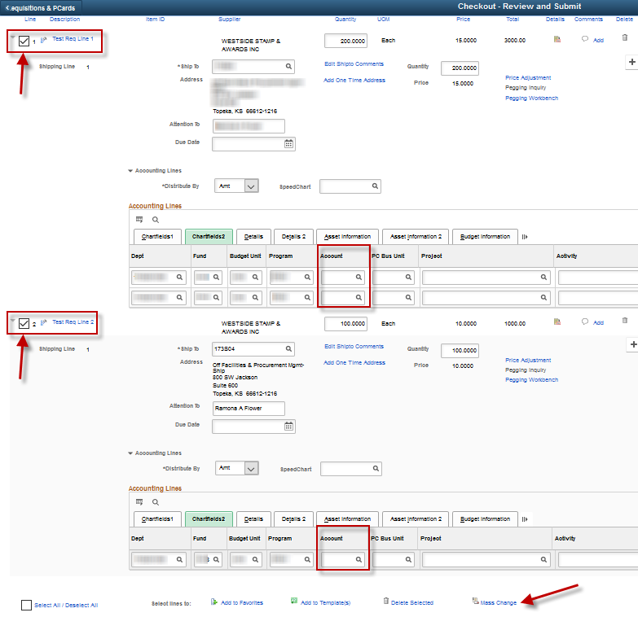
- Clicking the ‘Mass Change’ link opens the ‘Edit Lines / Shipping / Accounting for Selected Lines’ page. In the ‘Accounting Lines’ section, on the ‘Chartfields1’ tab, enter the Account code in to the ‘Account’ field.
Note: The ‘GL Unit’ field must be filled in to enter the Account code, otherwise the Account field cannot be edited.

Without ‘GL Unit’ provided:
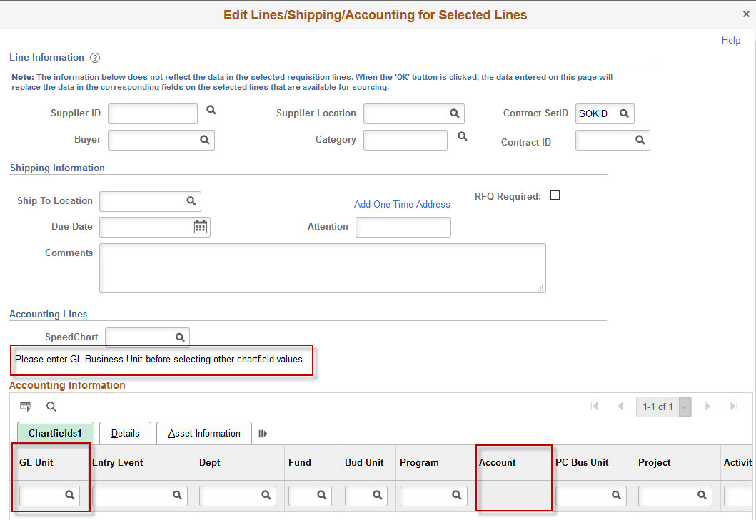

With ‘GL Unit’ provided:
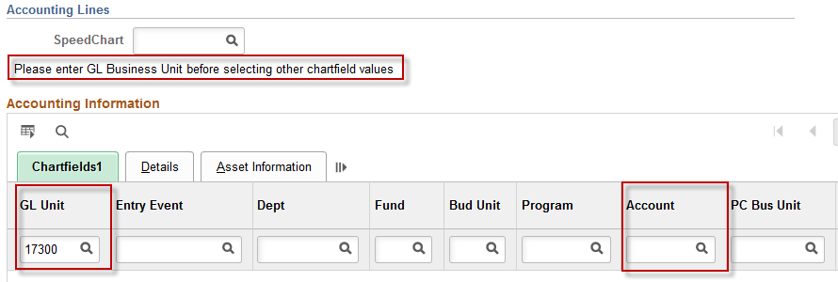
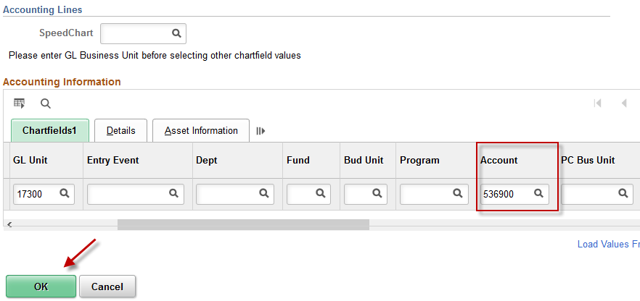

- Clicking the ‘OK’ button opens the ‘Distribution Change Options’ page.
There are three (3) options available on the ‘Distribution Change Options’ page:
- All Distribution Lines
- Matching Distribution Lines
- Replace Distribution Lines

- The ‘All Distribution Lines’ option is the one that will be selected most often, and it is the default option. Click the ‘OK’ button to accept the ‘All Distribution Lines’ option:
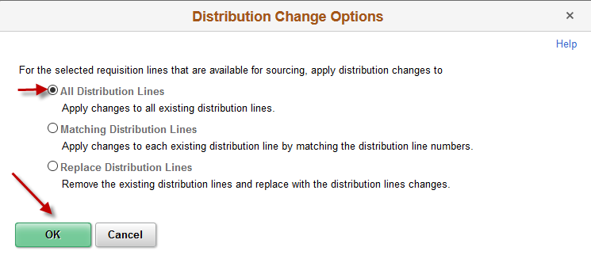

- Clicking the ‘OK’ button returns you to the ‘Checkout - Review and Submit’ page.
Notice that all Accounting Lines have now been populated with the Account code that was entered in the ‘Modify Line / Shipping / Accounting’ page (please refer to the screenshot on the following page):
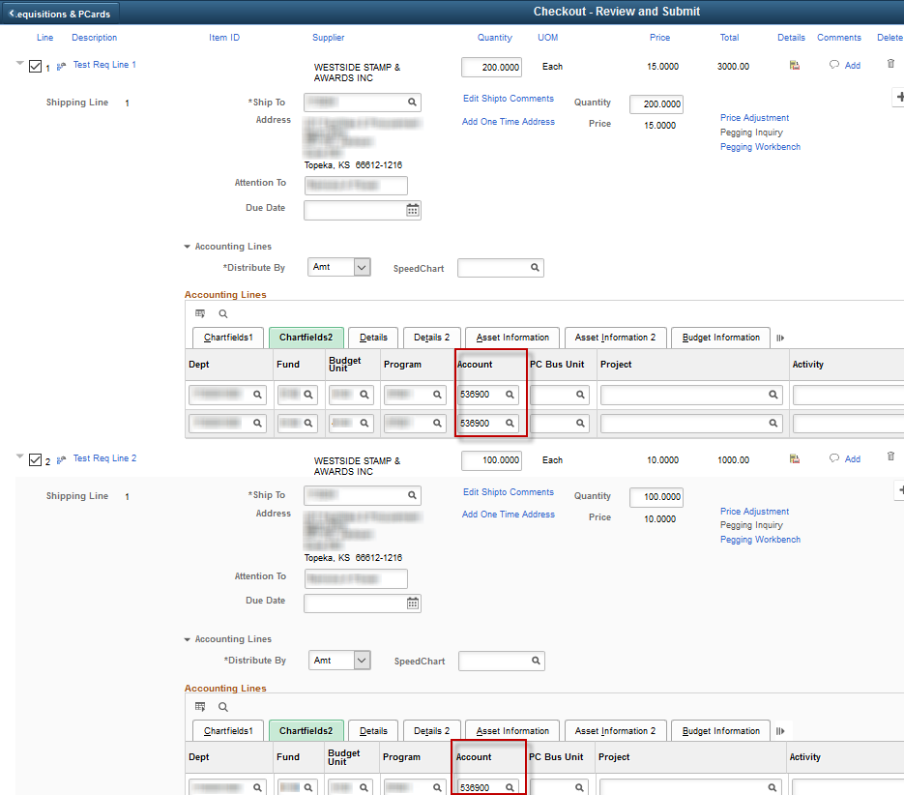
Note: The same process can be used to easily apply values in the following fields to multiple requisition lines:
- Supplier ID / Supplier Location
- Contract SetID / Contract ID
- RFQ Required Checkbox
- Buyer
- Category
- Ship To (Can also modify the Ship To and then apply to multiple requisition lines.)
- Due Date
- Chartfield values
Note: Default Chartfield values CAN be overwritten using the ‘Mass Change’ page or the ‘Requisition Settings’ page.
Note: There is nothing gained by changing the ‘Attention’ value; so, it is recommended to leave the default value. This field will default with the Requester name. The ‘Attention’ value will not flow forward to the Purchase Order and entering a different name in the ‘Attention’ field will not change workflow; the workflow is based upon the Requester ID entered on the ‘Specify Business Unit and Requester’ page.
Note: Before this page can be used to add contract IDs, the selected requisition lines must have Supplier IDs and the Supplier IDs must be the same for all selected requisition lines.
The Supplier ID and Contract ID cannot be applied at the same time. The Supplier ID can be applied to the selected requisition lines first and then the user can navigate back to the ‘Mass Change’ page to apply the contract ID.

Budget Checking a Requisition
The Requisitioner should NOT select the ‘Budget Check’ link. Budget checking is a batch process that occurs on an hourly basis between the hours of 9 AM to 4 PM, Monday through Friday, and once each evening, Monday through Friday. Requisitions that have been ‘Saved & Submit(ted)’ are picked up to be budget checked during the hourly and nightly batch processes.
A requisition must have a ‘Valid’ budget status (must have successfully passed Budget Checking) before it can be sourced to a Purchase Order. A ‘Valid’ budget status for requisitions means that the Chartfield Values are active, and the Chartfield Combinations are valid.

At the requisition level, budget checking does NOT validate available budget.
The Requisitioner will need to contact their budget/accounting staff if Chartfield values are inactive or if the Chartfield combinations are invalid.

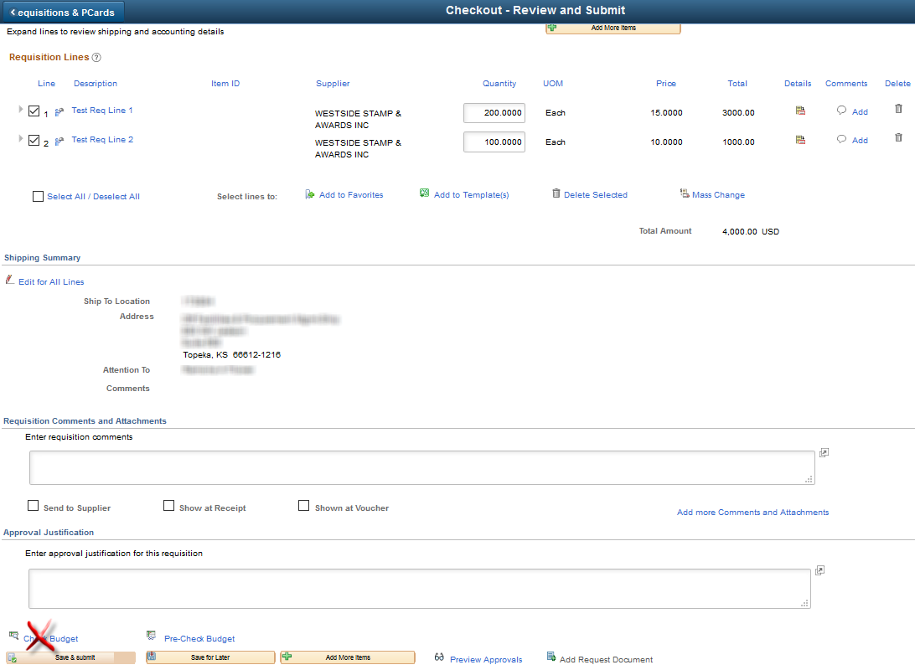

Saving a Requisition
A Requisitioner has two (2) options for “saving” a requisition:
1) ‘Save for Later’
2) ‘Save & submit’
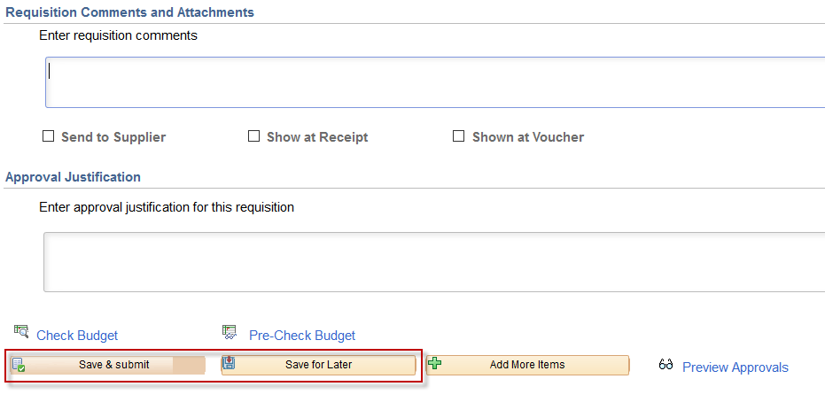

Save for later
The Requisitioner should click the ‘Save for Later’ link if they need to save the requisition, but the requisition is not ready to be reviewed or approved. It is not uncommon for a Requisitioner to be interrupted by a phone call or another task that requires them to redirect their attention. The requisition can be saved and returned to at a later time (via the ‘Manage Requisitions’ page). The requisition can be saved as many times as needed.
Once the ‘Save for Later’ option is selected the Requisitioner remains on the same page. The requisition has NOT been submitted for approvals. The Requisitioner can see this is true by clicking on the ‘Preview Approvals’ link and the below items are true:
1) The requisition Line status is ‘Initiated’
2) Supervisor Approval is ‘Not Routed’

PREVIEW APPROVALS Page
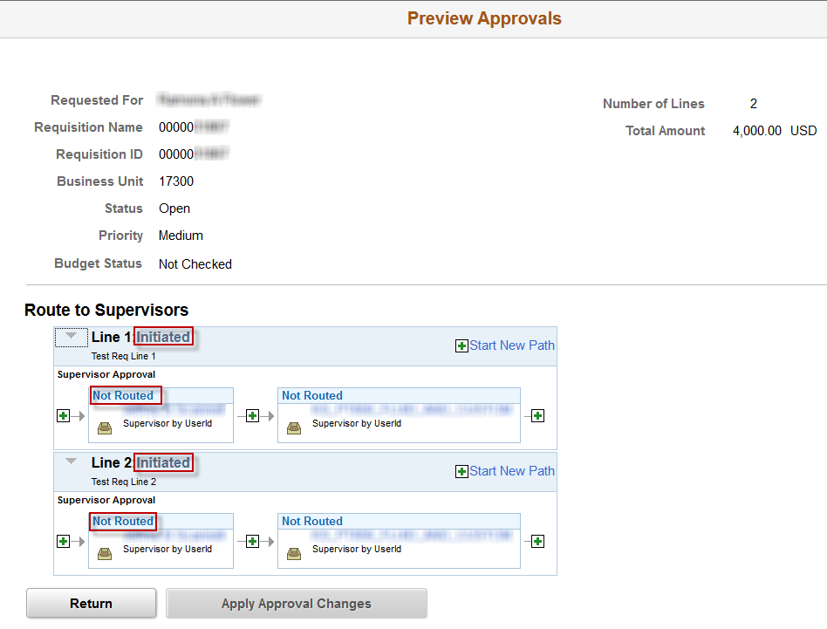

Note: There are rare occasions when the budget date needs to be changed on the requisition; this happens more frequently during the fiscal year end activities.
If the budget date needs to be changed on the requisition, select the ‘Save for Later’ link; and have your Agency Liaison submit a ManageEngine Request requesting that the budget date be changed.
For more information about requesting budget date changes, please refer to the training document ‘Budget Date Change Request’, located on the SMART website at:
https://www.smartweb.ks.gov/training/purchasing#Requisitions
After the budget date has been changed AND the Service Desk Request has been CLOSED, then the ‘Save and submit’ link should be clicked to submit the requisition in to the workflow process for approval.

Save and submit Button
The Requisitioner will select the ‘Save & submit’ link when all the information has been entered in to the requisition, and the requisition is ready to be reviewed and approved. Selecting the ‘Save & submit’ option initiates the requisition approval workflow.
Once the ‘Save & submit’ link is selected the Requisitioner will be sent to the ‘Confirmation’ page.
The requisition has entered the requisition approval workflow process, and the Requisitioner can see that this is true because:
- The Line status is ‘Pending’
- The 1st Supervisor Approval is ‘Pending’
Please refer to the screenshot on the following page.

Confirmation Page
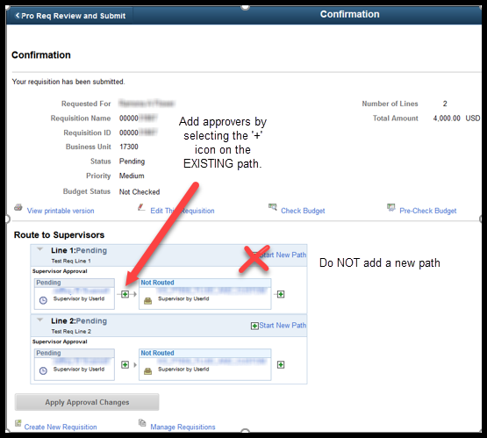
If an approver needs to be added as a one-off to requisition workflow, use the + icon in the existing approval path to insert the approver where needed. Adding a new path just creates a second line of approval that must be completed before the requisition lines approve and can source to a PO.
Note: If using the Look Up, be sure to select the 6-character USER ID and not the employee ID of the individual.

