
State of Kansas
Entering an AR (Pending Item) Deposit
Statewide Management, Accounting and Reporting Tool

Date Updated: |  | 3/18/2019
Version: |  | 2.0
Purpose: |  | Accounts Receivable Pending Item Deposits are payments that correspond to Customer Pending Items. They are referred to as Customer Deposits.  AR Deposit payments can be applied to multiple items for a single customer or multiple items for different customers.  There are three basic steps to completing an AR Deposit (Customer Deposit):  - Enter Payments – control totals and payment information  - Create and complete accounting entries using Payment Worksheets or Payment Predictor  - Deposit review and approval  This job aid provides the steps to complete an AR Deposit.  The roles required for processing AR Deposits are:  - KAR_Agy_Deposit_Processor  - KAR_Agy_Admin  - KAR_Agy_Maintainer
1. | Determine Deposit Type for AR Deposit | Deposit Types used for an AR Deposit  E – Electronic Payment  C – Customer Receipts  I – Initiating Interfund *  R – Reciprocating Interfund *  * I and R are used specifically for interfund deposits
2. | Determine Payment Method for AR Deposit | Payment Methods  Check – used with Deposit Type C  Cash – used with Deposit Type C  Electronic Fund Transfer – used with Deposit Type E  Returned Check – used with Deposit Type N
Navigation: |  | Accounts Receivable Homepage> Payments > Online Deposit Search/Entry > Regular Deposit > Add a New Value or Accounts Receivable > Payments > Online Payments > Regular Deposit > Add a New Value
3. | Totals  Deposit Type: Enter the Deposit Type identified in step 1. | 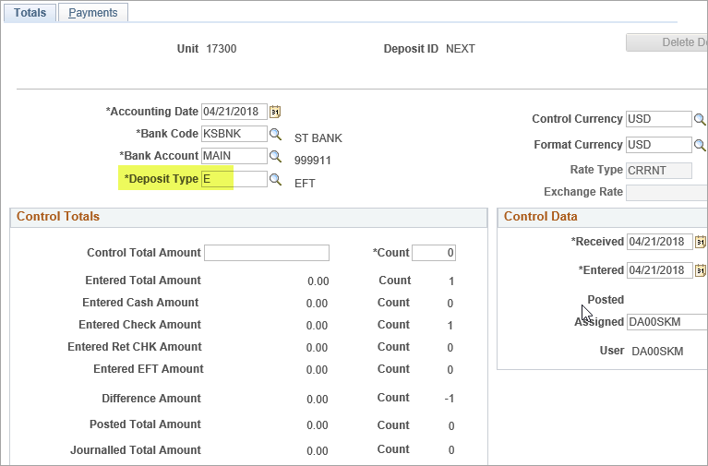
4. | Totals tab  Control Total Amount: Enter the total amount of all payments to be included in this deposit.  Count: Enter the total count of all payments (for example, number of checks), not the number of items or invoices being paid. | 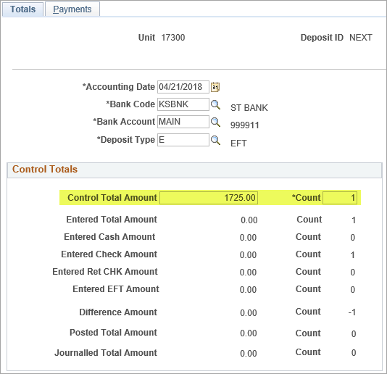
5. | Totals tab  Comments: 254-character field  As with other deposits, the State Treasurer requires a contact name and phone number be entered in this field.  Additional information can be entered as needed. | 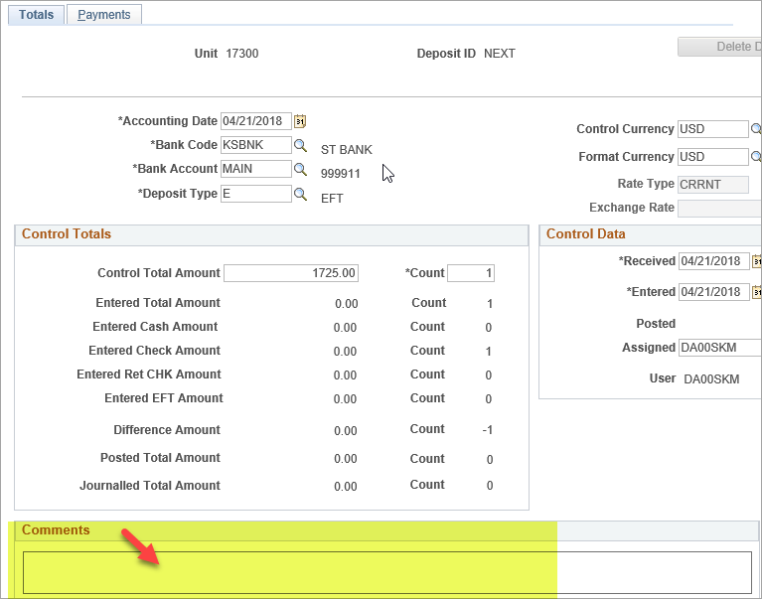
6. | Payments tab  Payment Seq: Sequence number is auto-assigned  Payment ID: Name or number entered to identify the payment (15 characters alpha/numeric)  Amount: Total amount of each payment (for example, amount of a check)  Payment Method: See step 2 for options | 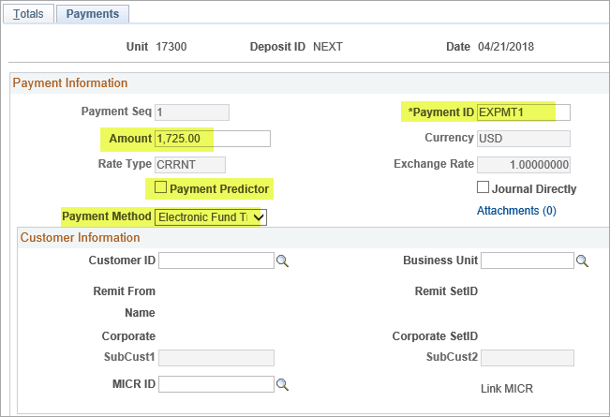  Payment Predictor: A system process used to match the payment to the Pending Item by Customer ID, Amount and Item ID. If any of these fields are not matched and accounting entries are not created, a payment worksheet must be used to apply the payment to the pending item.  In the example above, Payment Predictor is not selected.
7. | Payments - Customer Information  Customer ID: Enter the Customer ID making the payment. | 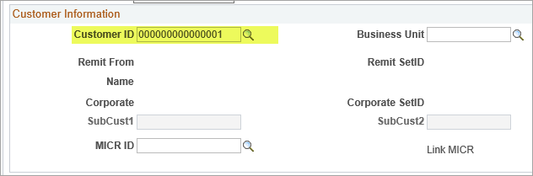
8. | Payments - Reference Information  Qual Code: Defaults to ‘I’ for Item  Reference: Enter the Item ID for the pending item matching this payment | 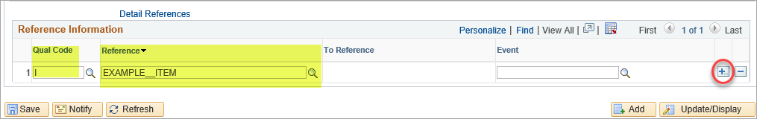  Note: One entry of the Item ID is used regardless of the number of lines/Reason Codes; however, if a payment (for example, a single check) covers more than one Item ID, each Item ID shall be entered. To add additional rows, click the blue ‘+’ button at the end of the row.
Repeat steps 6 - 8: |  | To add additional payments within a deposit, click the blue ‘+’ button on the Payments page, Payment Information section.  All payments within a deposit must be of the same Deposit Type.
9. | Totals - Control Totals  Verify the Entered Total Amount and Count matches the Control Total Amount and Count. The Difference Amount and Count should be zero.  Save. | 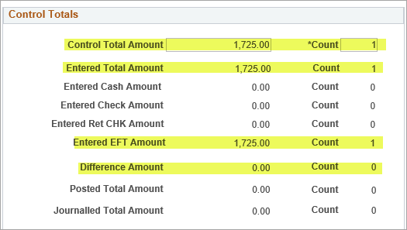
Apply Payments: |  | If Payment Predictor is not selected, a payment worksheet must be used to manually match the payment to the pending item.
10. | Payments - Payment Information  Select the Apply Payment link.  or  Follow the Navigation to search by Deposit Unit and Deposit ID | 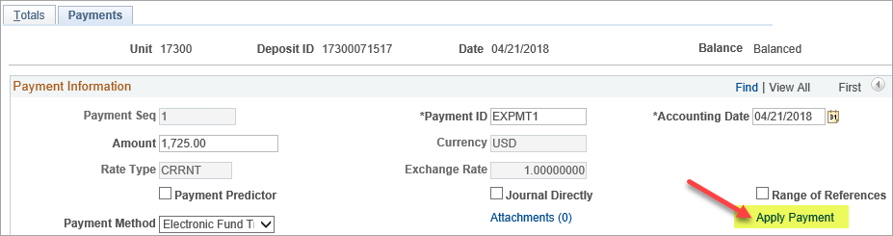
Navigation: |  | Accounts Receivable Homepage > Payments > Apply Payments > Create Worksheet or Nav Bar: Accounts Receivable > Payments > Apply Payments > Create Worksheet
11. | Payment Worksheet Selection  Customer ID: Verify the correct Customer ID is displayed  Worksheet Action: Select Build | 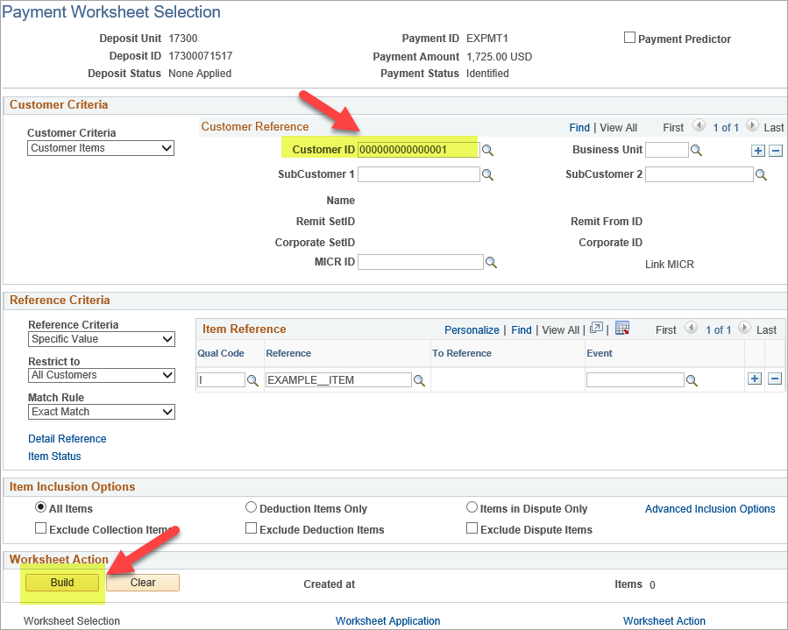
12. | Payment Worksheet Application  Item List: Verify that checkboxes are selected for applicable Item ID lines.  Note: In Item Display Control, select ‘Selected’ to only view selected lines.  Balance: Amount and Selected should be equal.  Select Worksheet Action | 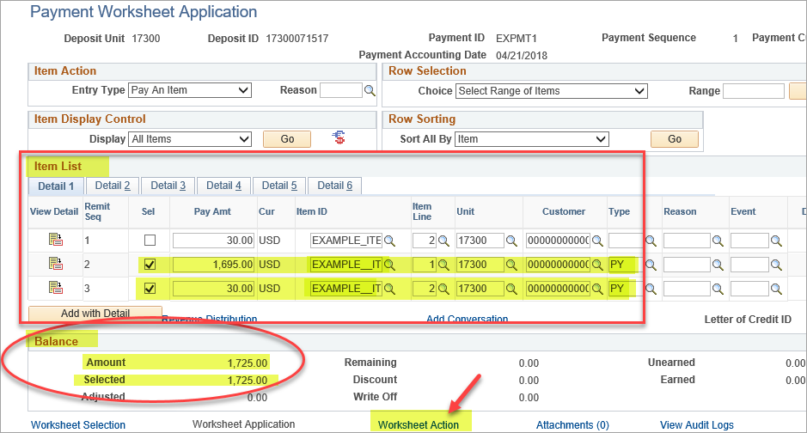
13. | Payment Worksheet Action  Accounting Entry Action: Select Create/Review Entries to create accounting entries.  Note: This step is not necessary to create the accounting entries. This is only for review, if desired. | 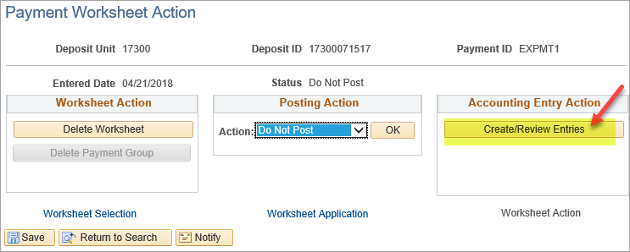
14. | Accounting Entries  Select View All in both the Accounting Entries section and the Distribution Lines section to view all accounting entries.  Payment accounting entries are created based on the original Pending Item accounting entries. Generally, Cash (110100) will be debited and the AR account (130100) will be credited.  Select Return to Previous Panel to return to Payment Worksheet Action | 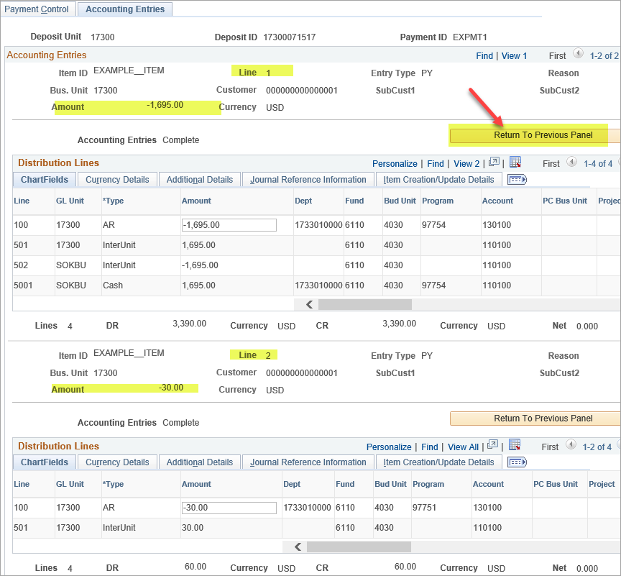
15. | Posting Action  Posting Action: Set Action to Batch Standard.  Click OK and Save. | 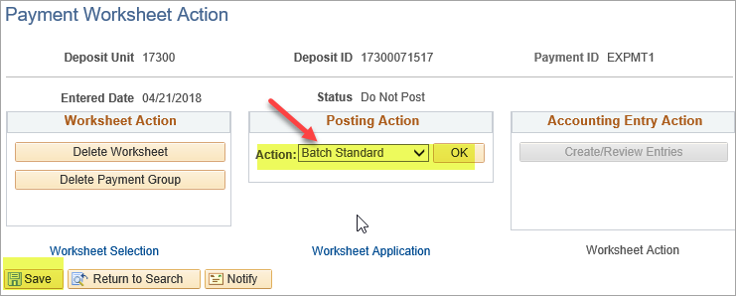  Note: This will post with the next hourly or nightly AR Update batch process.
Approve Deposit: |  | After the AR Update batch process is complete and the accounting entries have posted, the Accounting Entries page will be on the deposit.  If Payment Predictor was selected (step 6) and the process was successful, the Accounting Entries page will be on the deposit.  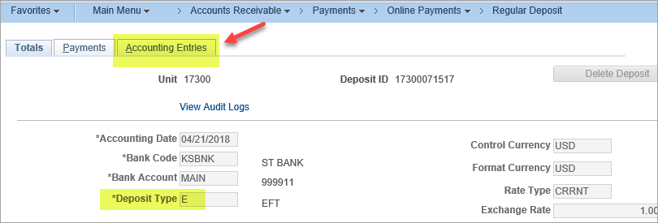
Navigation: |  | Accounts Receivable Homepage> Payments > Online Deposit Search/Entry > Regular Deposit > Find an Existing Value or Accounts Receivable > Payments > Online Payments > Regular Deposit > Find an Existing Value
16. | Follow the Navigation to search by Deposit Unit and Deposit ID  Review Accounting Entries and Payment Method | 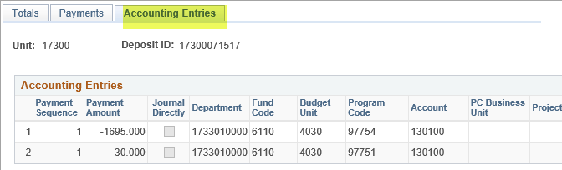  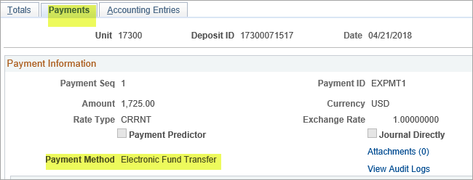
17. | Approve Deposit  Agency Deposit Approval:  Select Approved.  Save. | 

