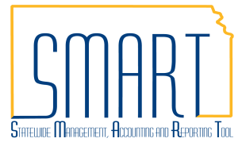
State of Kansas
Enter and Maintain SpeedCharts
Statewide Management, Accounting and Reporting Tool

Date Created: | 11/08/2010
Version: | 2.0
Last Updated: | 04/26/2017
Job Aid | The following Desk Aid instructs users on how to enter and maintain speedcharts.
SpeedCharts are able to be used in the following module areas:
- AP - Vouchers
- AP - Expenses
- AR – Direct Journal
- PO - Requisitions
- PO - Purchase Order
- PO - PCARD
 | SpeedCharts are not module specific and can be used in all of the modules listed. For adding PCARD SpeedCharts, please see the desk aid titled ‘Adding & Maintaining P-Card Holder Profiles’.
The following security role has ‘View Only’ access to SpeedCharts:
- KAR_AGY_ADMIN
The following security roles have access to add and update SpeedCharts:
- KAP_AGY_AP_MAINTAINER
- KAR_AGY_CONFIGURATOR

SpeedCharts Overview
- SpeedCharts are predefined chartfield combinations.
- SpeedCharts increase the efficiency of data entry by reducing the number of keystrokes required.
- SpeedChart codes can have single or multiple accounting distributions and are used by entering a code rather than individual chartfield combinations.
- SpeedCharts are not to be confused with Speed Types.
SpeedCharts - Effective Dating
- Upon creation, a SpeedChart is given an effective date.
- Users have the option of editing an existing speedchart or creating a new one.
- The accounting distribution on a SpeedChart can be changed as long as the new distribution is given a new effective date.
Create a new SpeedChart
- Navigate to Set Up Financials/Supply Chain>Product Related>Procurement Options>Management>SpeedChart.
- Enter SetID (Agency Business Unit) and ‘Add a New Value’.
- Enter SpeedChart Key (name of SpeedChart).
- Enter the Effective Date.
- Click ‘Add’.
 | 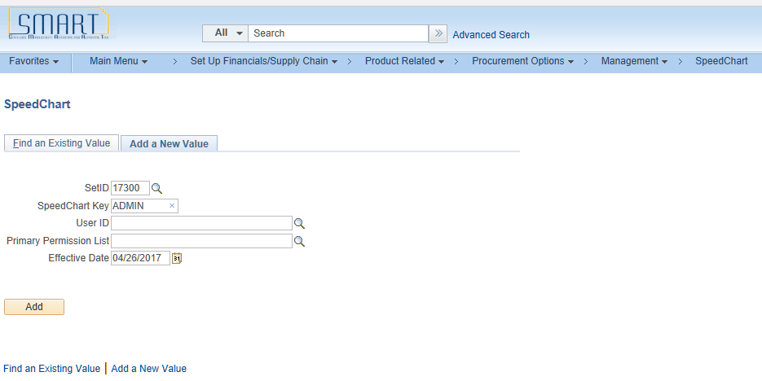
- Enter a Description.
- Select Security Option.
- Enter Percent and chartfields on line 1.
- Click the plus sign ‘+’ on the far right to add additional lines.
- Save.

Note: The total percentage must equal 100% in order to save the SpeedChart. Also, note that the speedchart can be saved without the required chartfields, but the chartfields will be required on the transaction.
 | 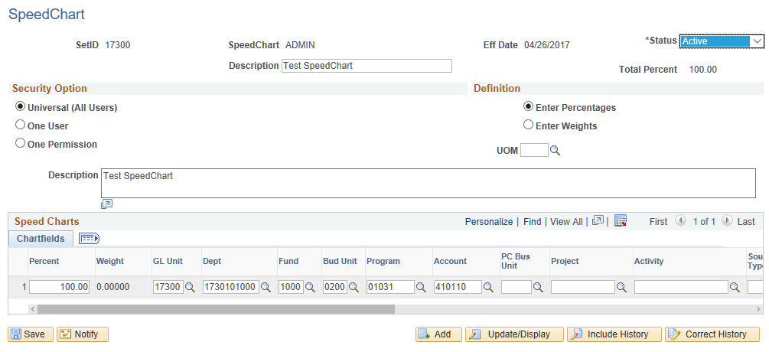
Edit an existing SpeedChart
- Navigate to Set Up Financials/Supply Chain>Product Related>Procurement Options>Management>SpeedChart.
- On the ‘Find an Existing Value’ tab, enter SetID (Agency Business Unit).
- Enter SpeedChart Key and ‘Search’.
- Select SpeedChart from Search Results list.
- Click the ‘Correct History’ button.
- Edit percentages or chartfields.
- Save.
 | 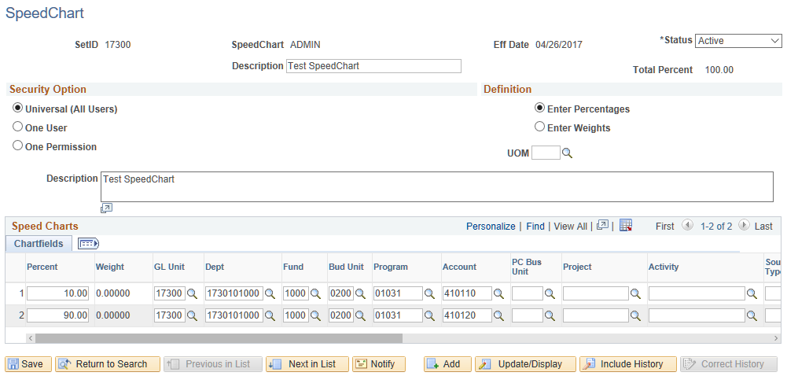
Inactivate a SpeedChart
- Navigate to Set Up Financials/Supply Chain>Product Related>Procurement Options>Management>SpeedChart.
- On the ‘Find an Existing Value’ tab, enter SetID (Agency Business Unit).
- Enter SpeedChart Key and ‘Search’.
- Select SpeedChart from Search Results list.
- Click the ‘Correct History’ button.
- Change the Status from ‘Active’ to ‘Inactive’
- Save.
 | 