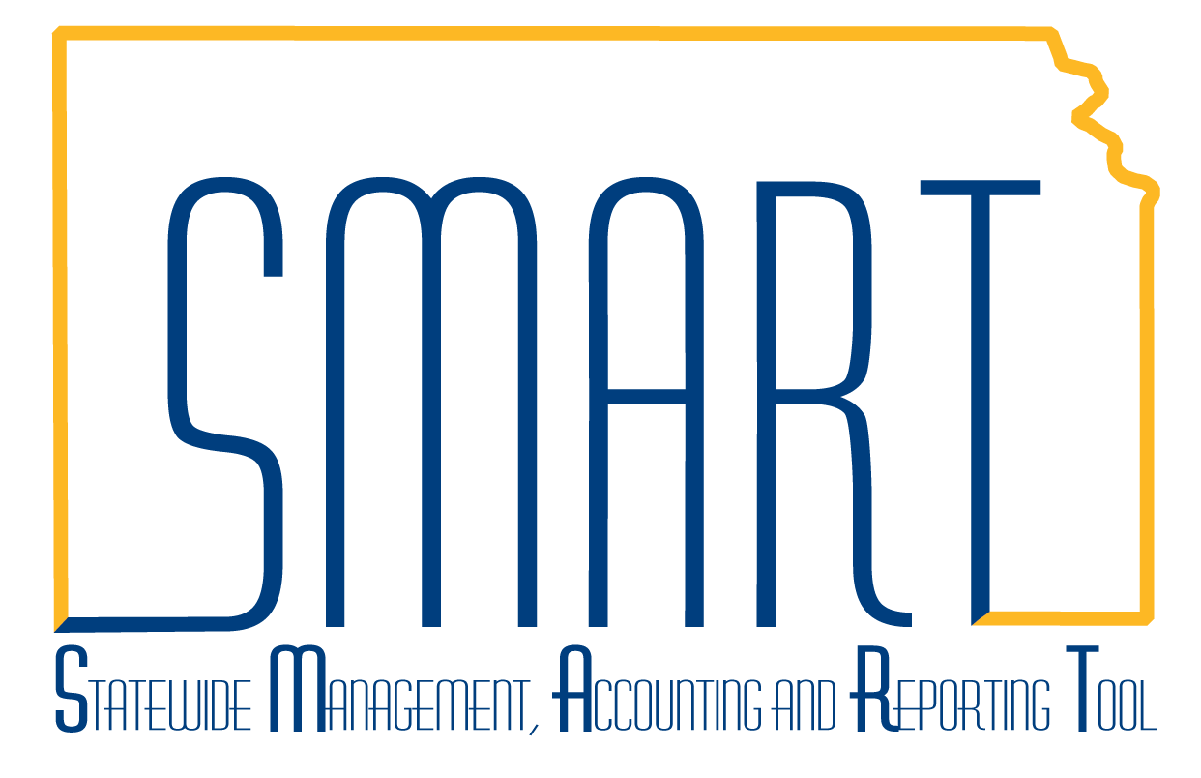
State of Kansas
High-Level Changes from 9.0 to 9.2 in Asset Management:
Enhanced Consolidation Improvements
Statewide Management, Accounting and Reporting Tool
Date Created: | 10/28/2015
Version: | 1.0
Last Updated Date:
Purpose: | This document highlights one of the changes between 9.0 and 9.2 in the Asset Management module.
Security: | - Role Security: The following roles are applicable:  Agency Asset Processor  BU Security: Business Unit Security is applied. Agencies will only have access to the assets in their Business Unit.
Procedure

Consolidation is required when multiple Interface Lines need to be combined together to create one asset. For example, if a piece of equipment is included in one Interface Line and freight for that equipment is included in a different Interface Line, these two lines can be combined to reflect the total cost of the asset.

There are enhanced search features in 9.2 for consolidation.

Step | Action
 | Click the Main Menu button.
 | Click the Asset Management menu.
 | Click the Send/Receive Information menu.
 | Click the Load Transactions menu.

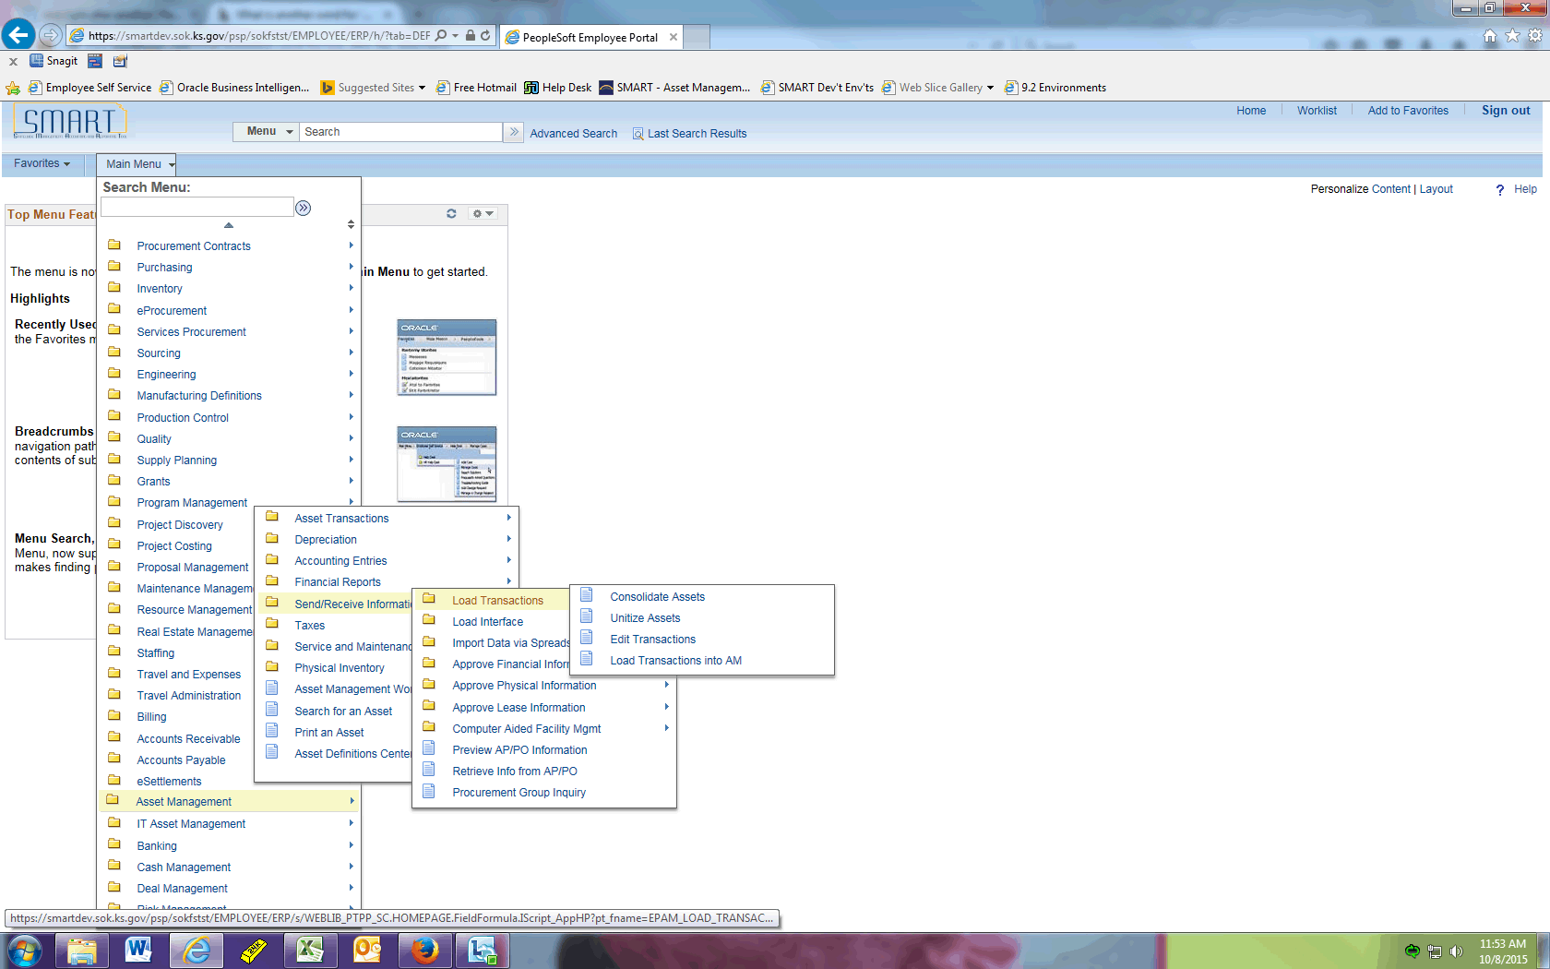

Step | Action
 | Click the Consolidate Assets menu.

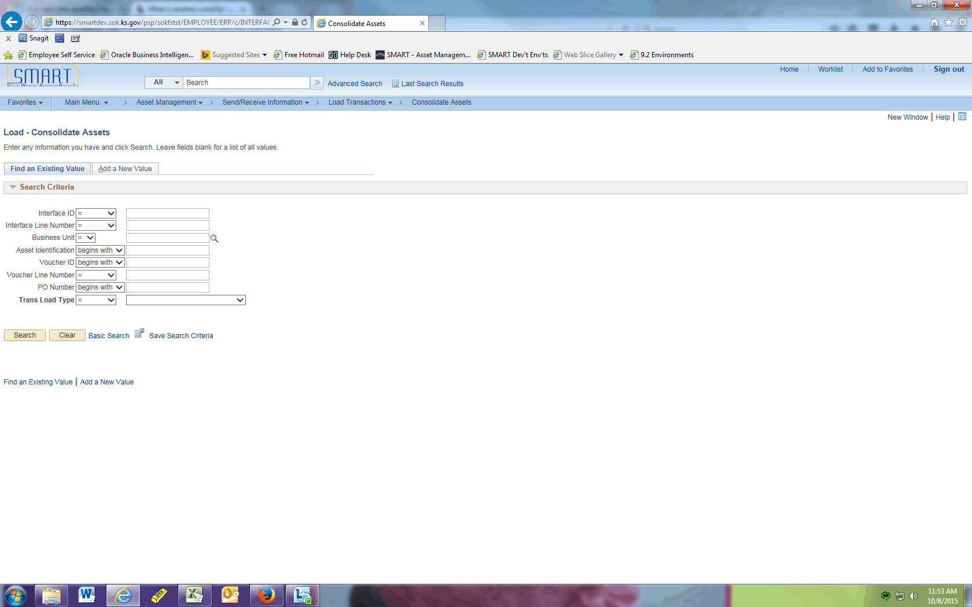

Step | Action
 | Click the Add a New Value tab.

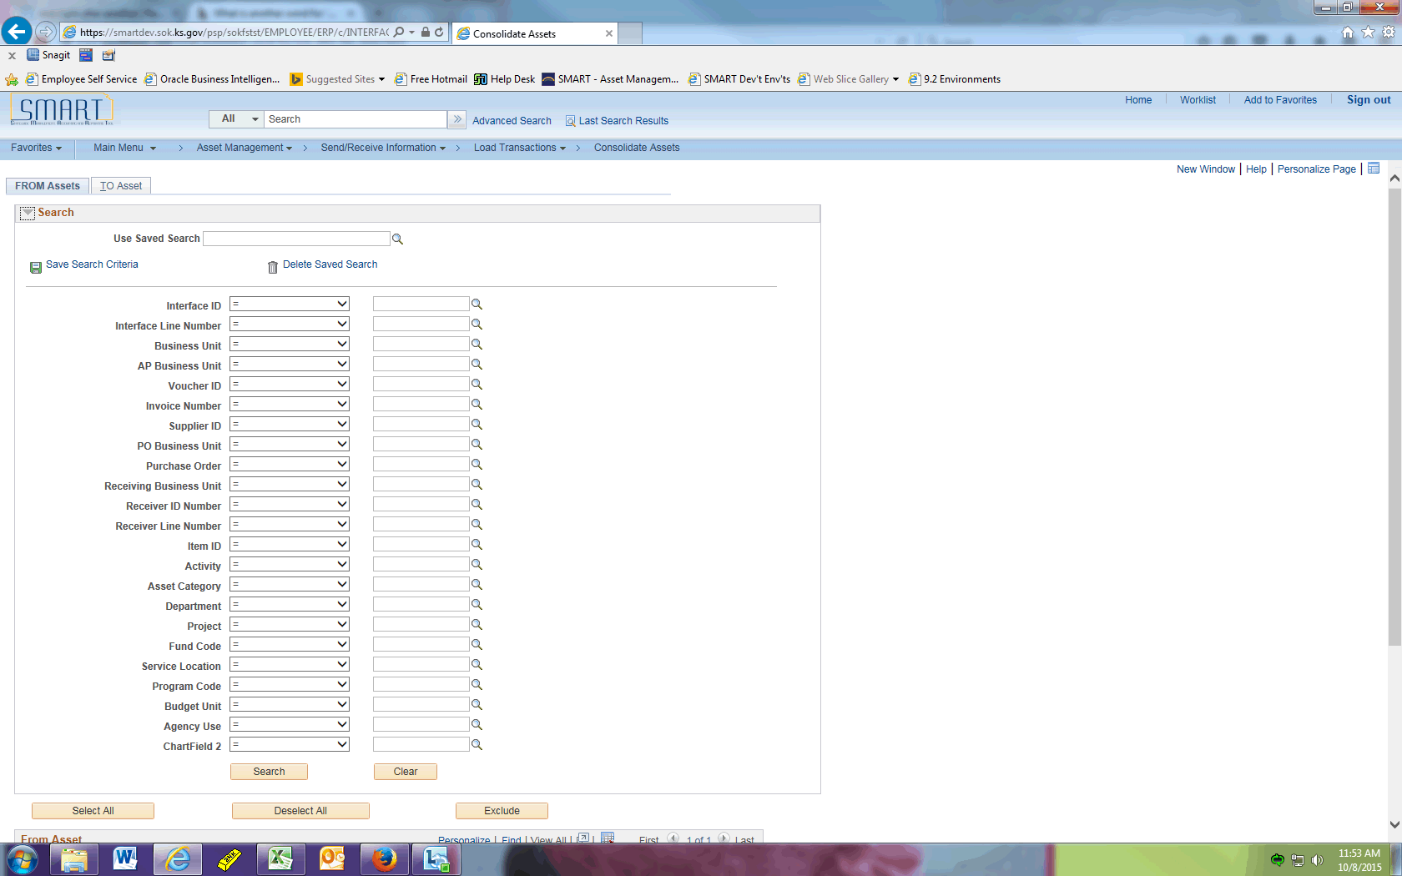

Step | Action
 | Notice how there are many more fields available to search by than what existed in 9.0. You can also populate several fields to refine your search results, whereas in 9.0 you could only search by one field at a time.
 | Enter the desired information into the Business Unit field. In this example, we are using "36500".
In this example, all lines under PO 0000002821 need to be added together. You could enter any other combination of fields in your search criteria.

Enter the desired information into the Purchase Order field. Enter "0000002821".

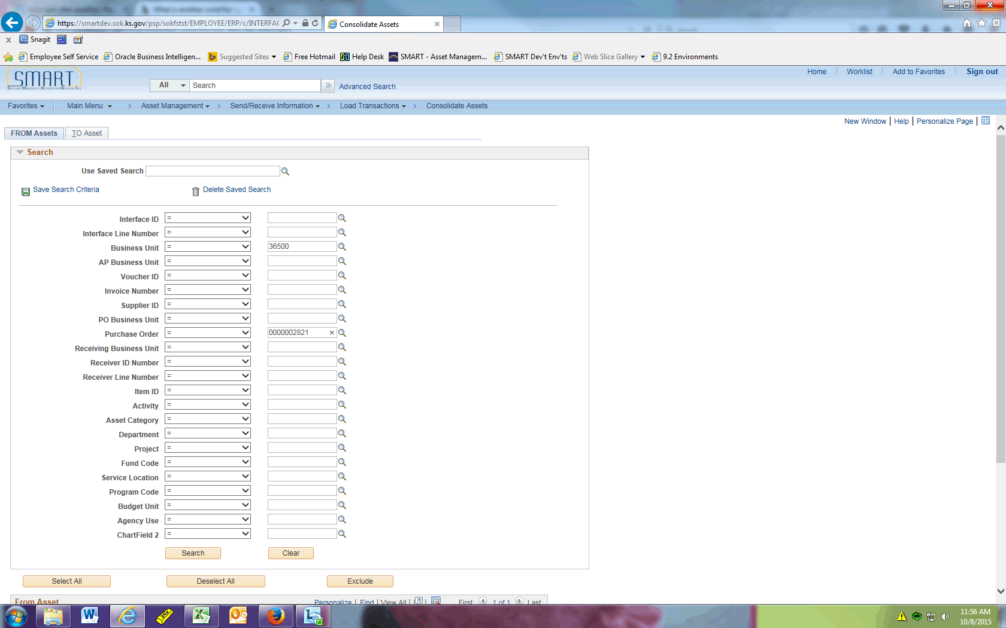

Step | Action
 | Click the Search button after entering all the Search Criteria you need.

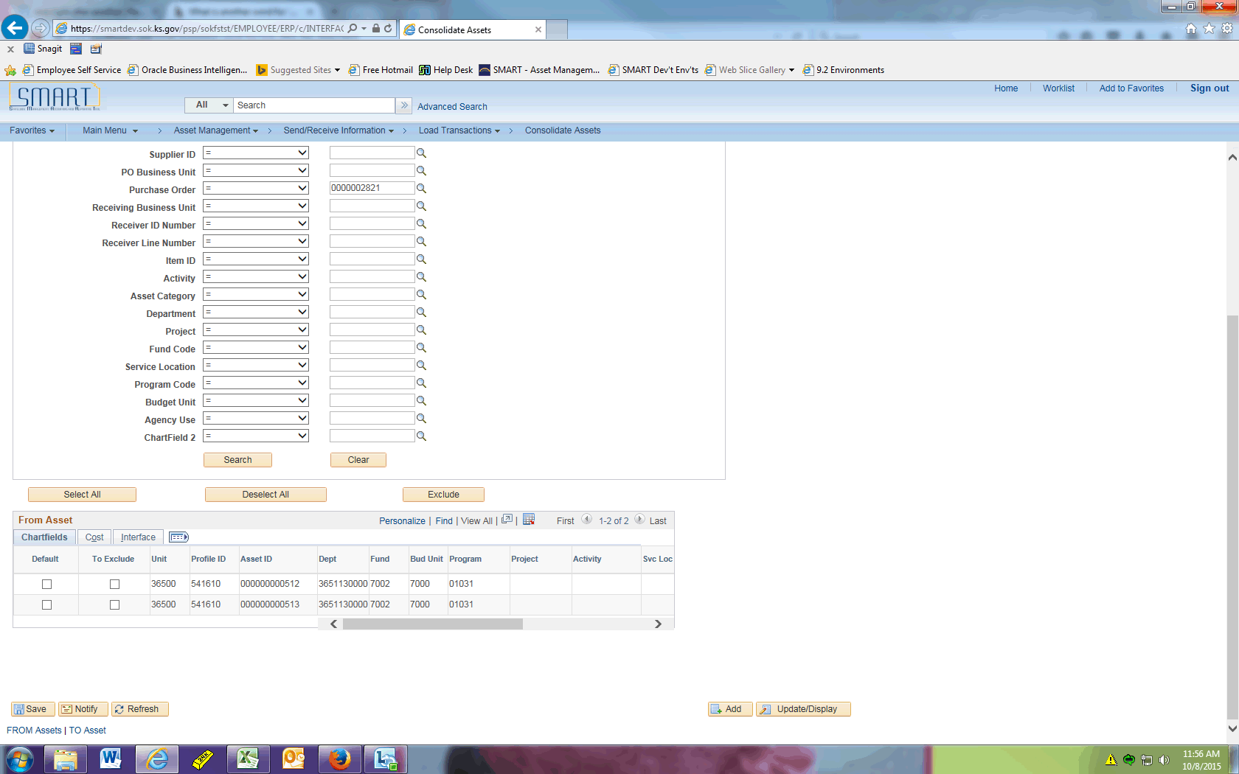

Step | Action
The Search Results return only those lines that meet your criteria. If there are any lines that you DO NOT want to include in your consolidation, be sure to click the To Exclude button for each of those rows.

Click the Show all columns button for additional details.

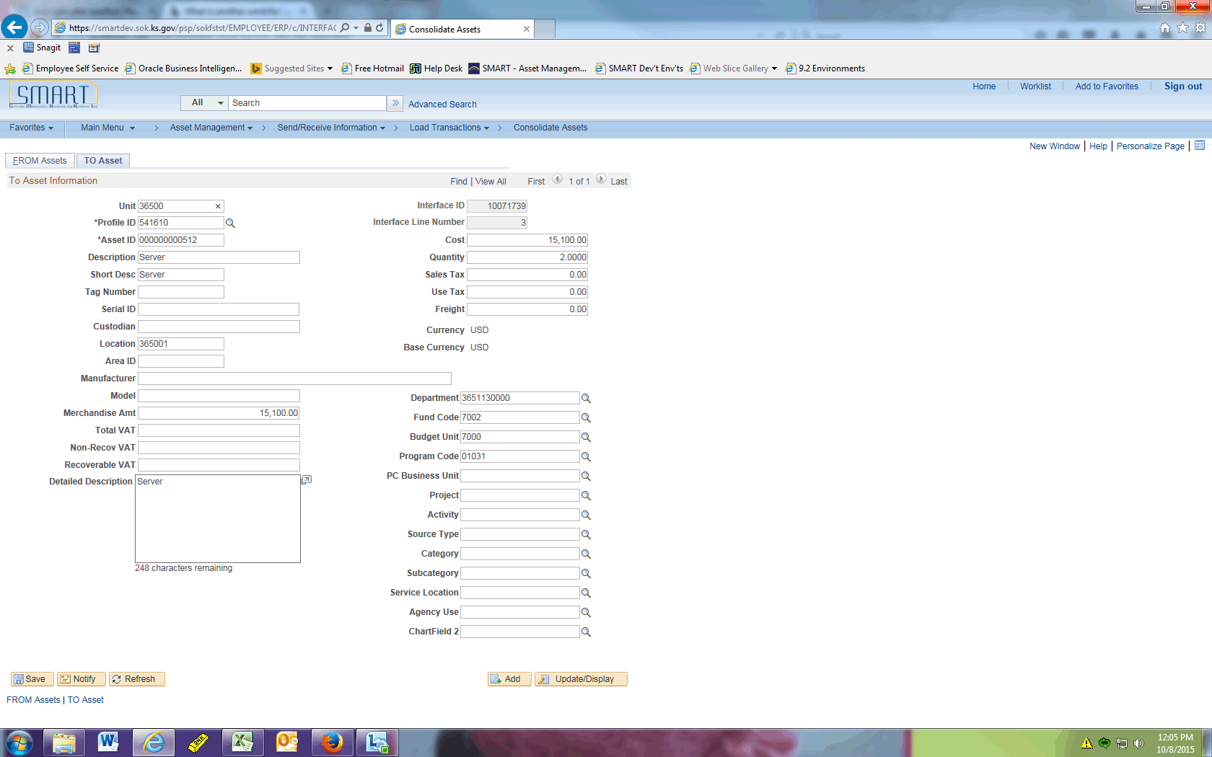

Step | Action
Click the TO Asset tab.

The costs and quantities are added together and will create one asset after saving and running the Transaction Loader process.

Typically, a user will change the quantity to 1.0000 on this page.
This completes the 'AM - Enhanced Consolidation Improvements' topic. Thank you for taking this course.
End of Procedure.

