State of Kansas
High-Level Changes from 9.0 to 9.2 in Asset Management:
Disposal Worksheet—Expanded Search Criteria
Statewide Management, Accounting and Reporting Tool
Date Created: | 10/28/2015
Version: | 1.0
Last Updated Date:
Purpose: | This document highlights one of the changes between 9.0 and 9.2 in the Asset Management module.
Security: | - Role Security: The following roles are applicable:  Agency Adjustment/Transfer/Retirement Processor  BU Security: Business Unit Security is applied. Agencies will only have access to the assets in their Business Unit.
Procedure

The Disposal Worksheet in 9.2 offers expanded search criteria to identify assets that need to be retired.

Like 9.0, this page should only be used when retiring a large number of assets at the same time. If a single retirement is needed, the Retire/Reinstate Asset page should be used instead.

In this example, we will be searching for equipment at a specific location.

Step | Action
 | Click the Asset Management menu.
 | Click the Asset Transactions menu.
 | Click the Asset Disposal menu.

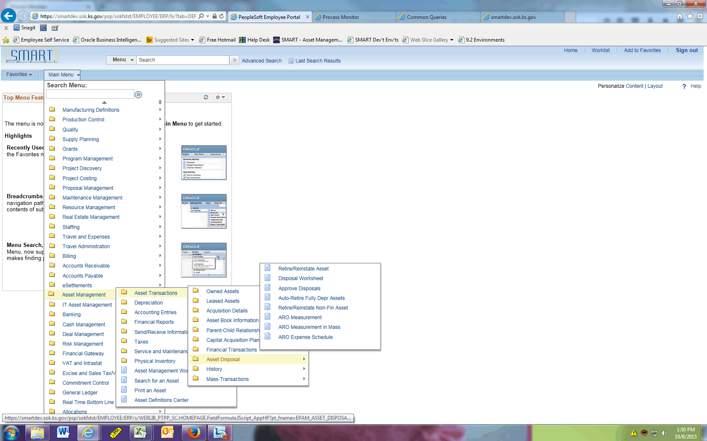

Step | Action
 | Click the Disposal Worksheet menu.

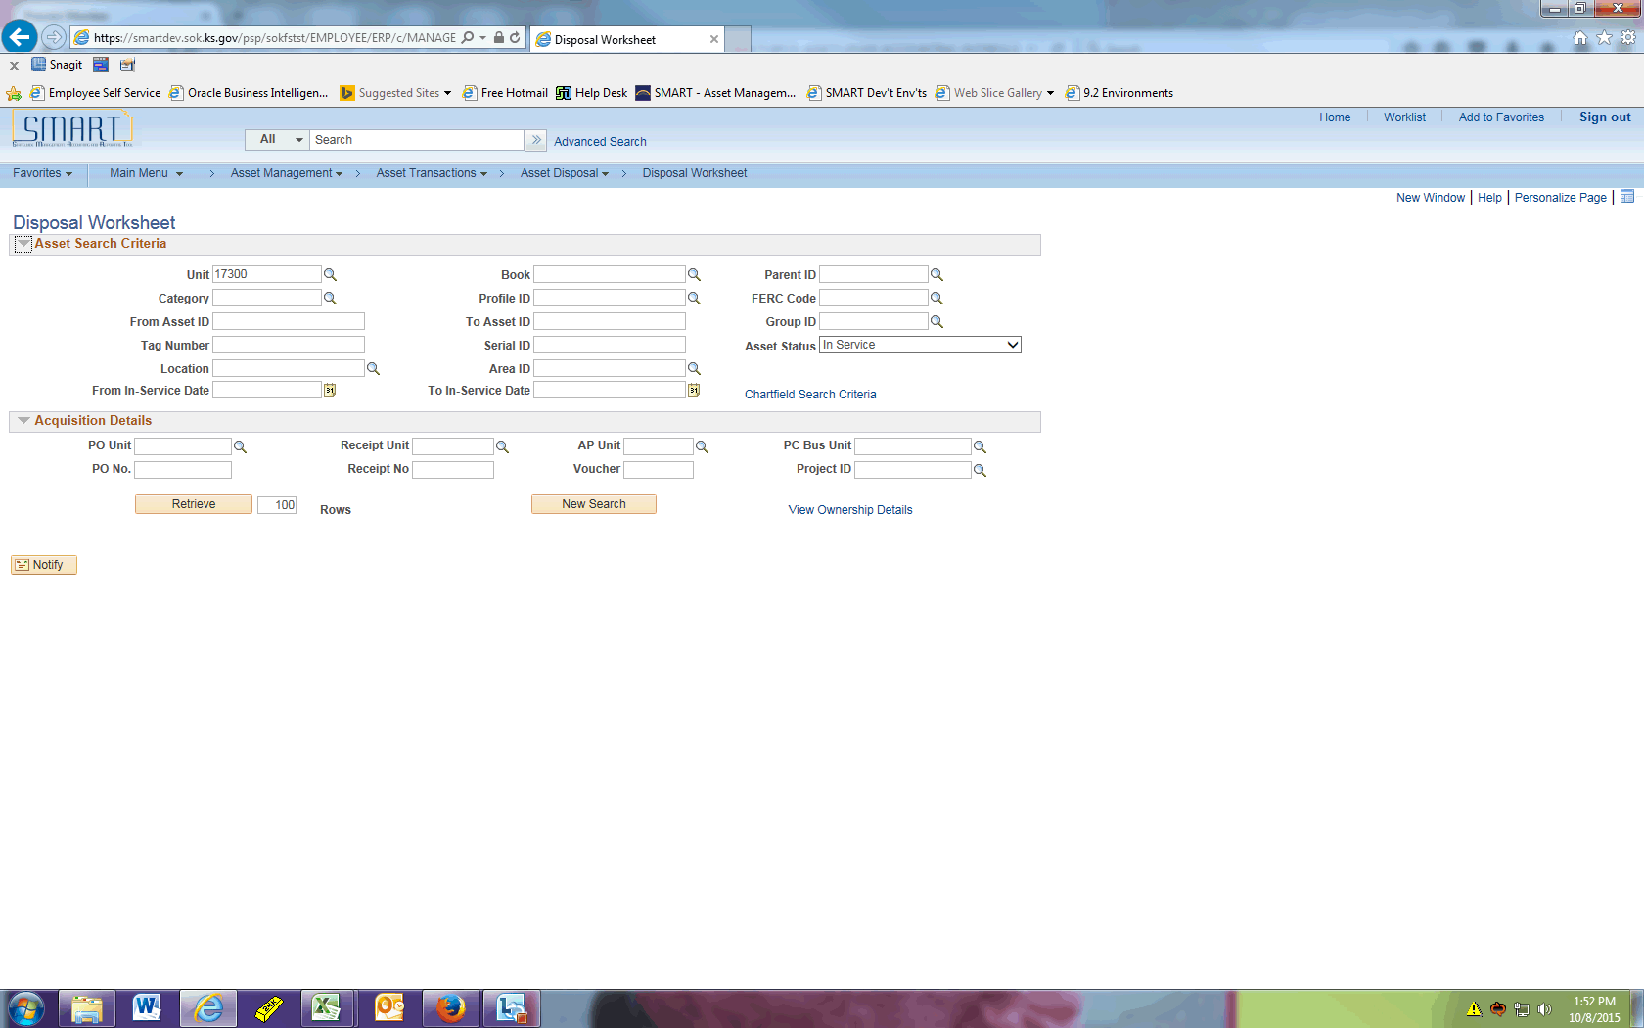

Step | Action
Recall in our example we're searching for equipment at a specific location.

Click the Category button.
 | Click the EQFRN link.
 | Click the Location button.
 | Enter the desired information into the Location Code field. Enter "KTLND".
 | Click the button.
 | Click the KTLND link.
 | Click the Retrieve button.

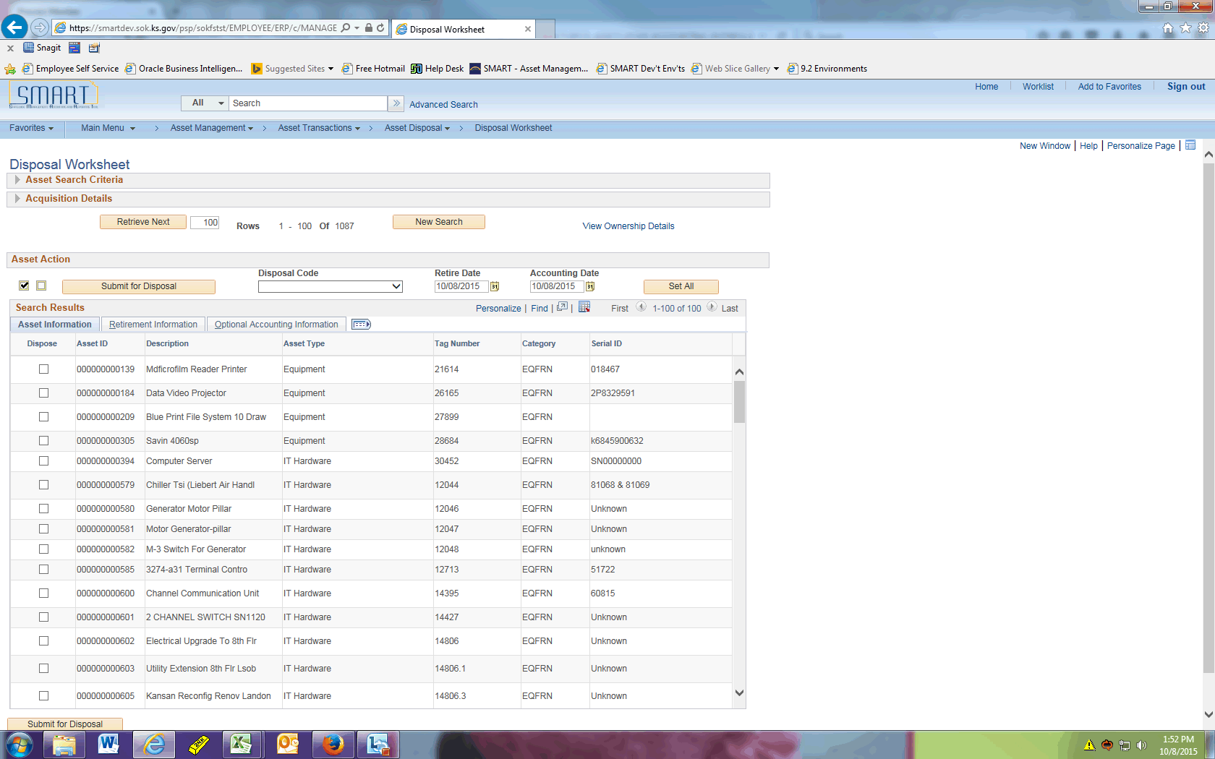

Step | Action
Click the Dispose option.

Continue to click the Dispose option until all assets to be retired have been selected.

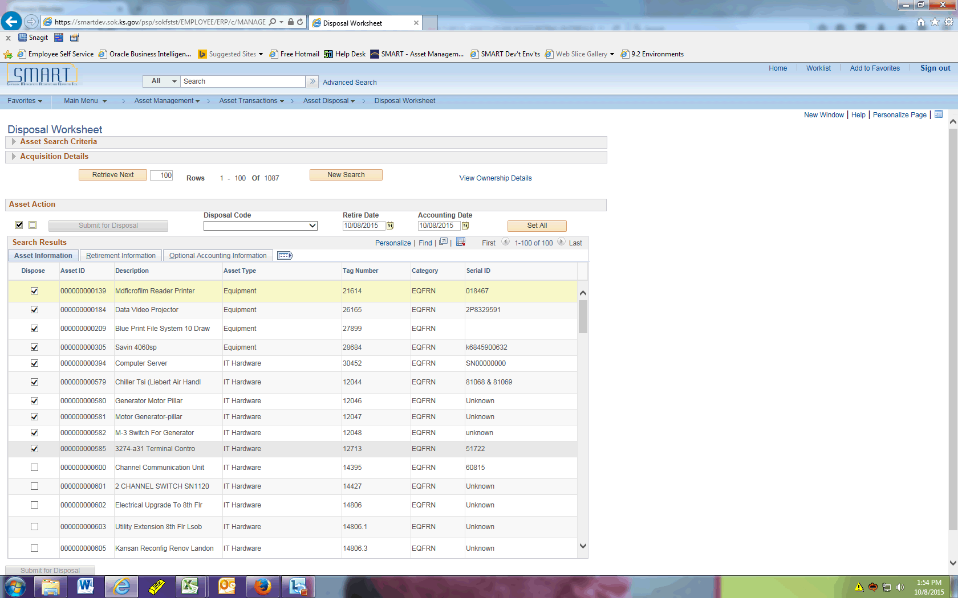

Step | Action
 | Click the Retirement Information object.

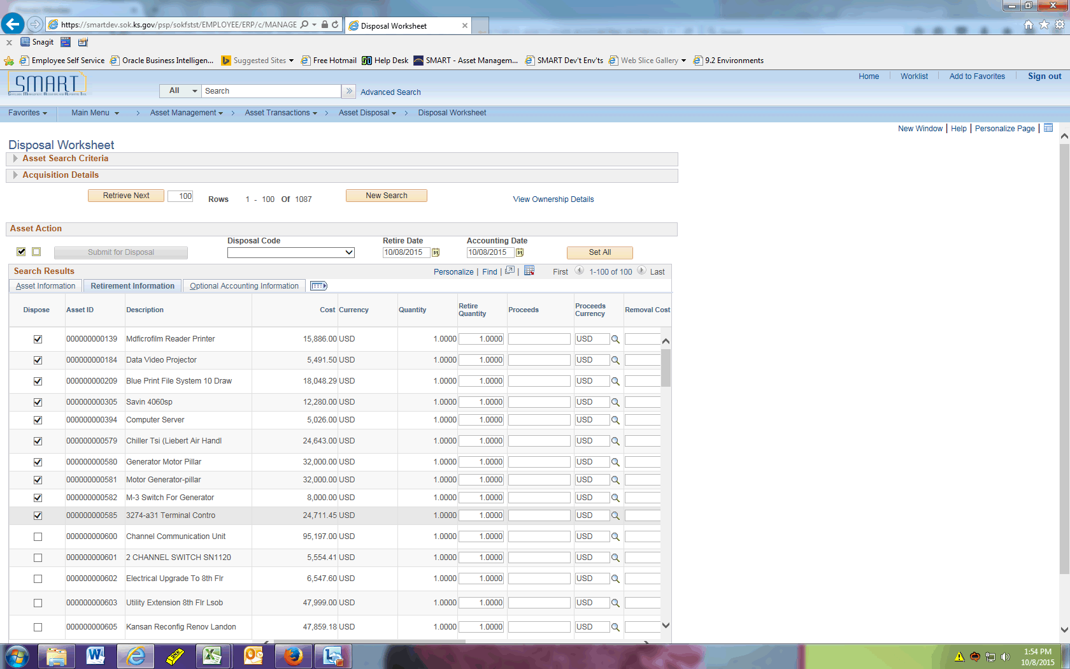

Step | Action
 | Enter any applicable Proceeds and Removal Costs.
 | Click the Submit for Disposal button.

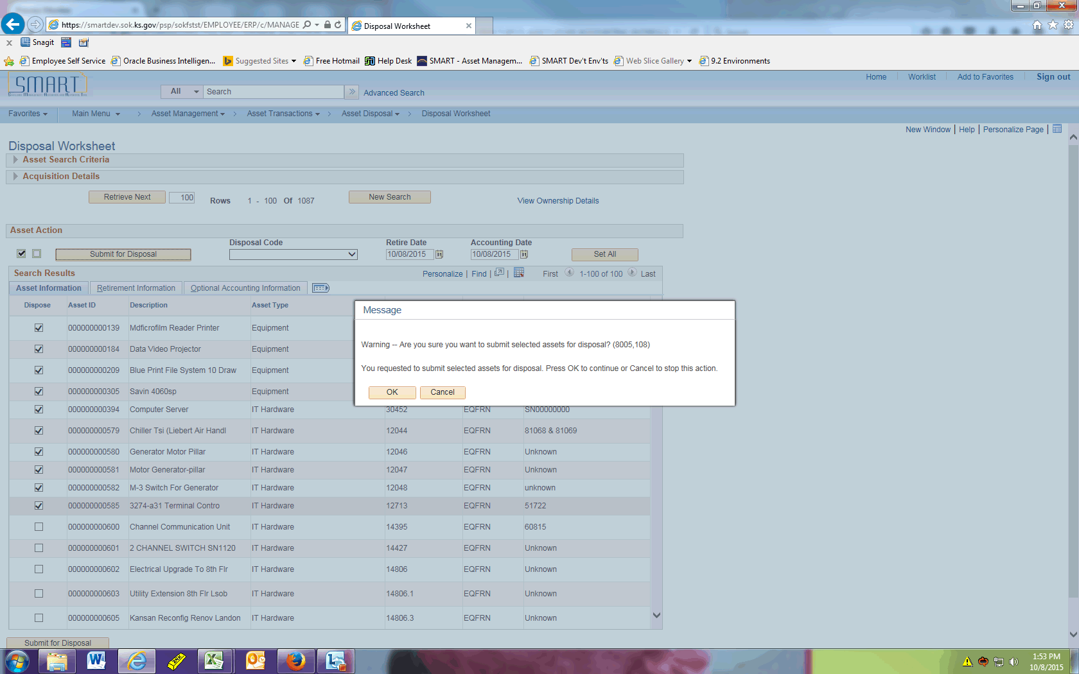

Step | Action
 | Click the button.
 | Submitting the assets for retirement via the Disposal Worksheet does not complete the retirement process. Next, determine the Interface ID associated with the retirements and run the Transaction Loader process.

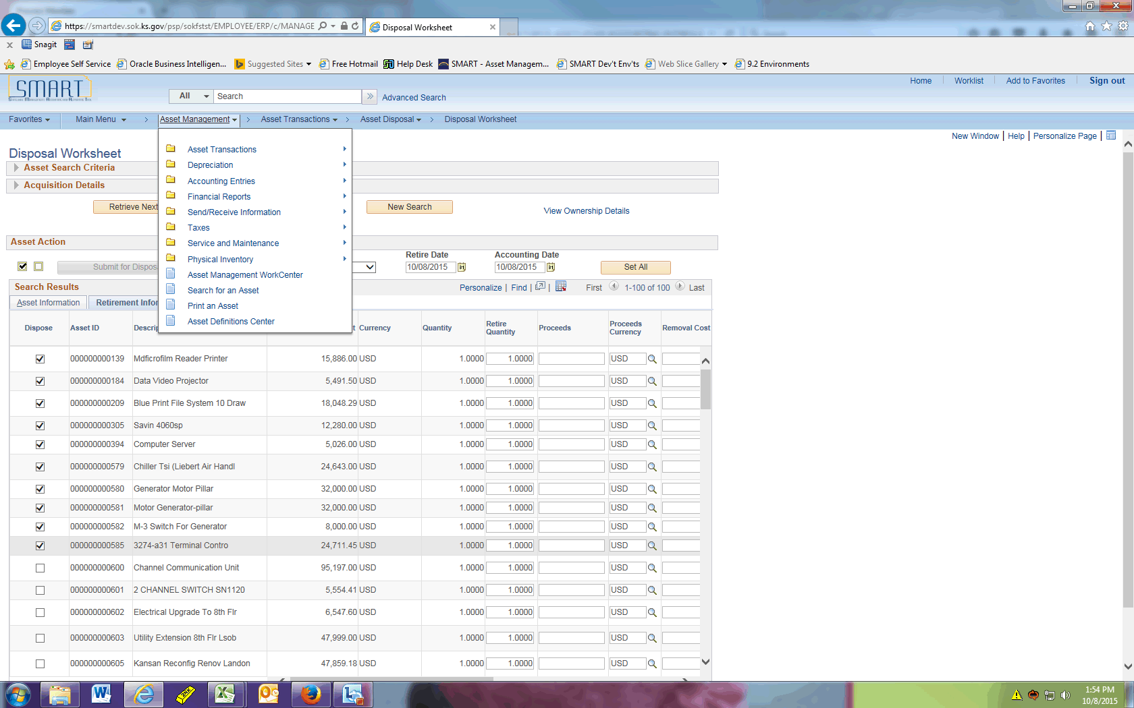

Step | Action
 | Click the Send/Receive Information menu.
 | Click the Approve Financial Information menu.

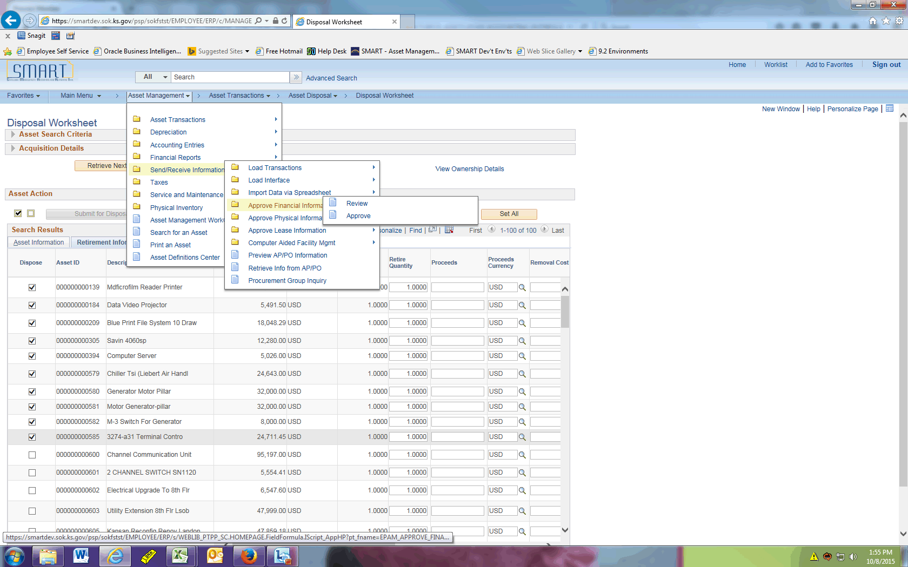

Step | Action
 | Click the Review menu.
 | Click the Asset Retirement list item.

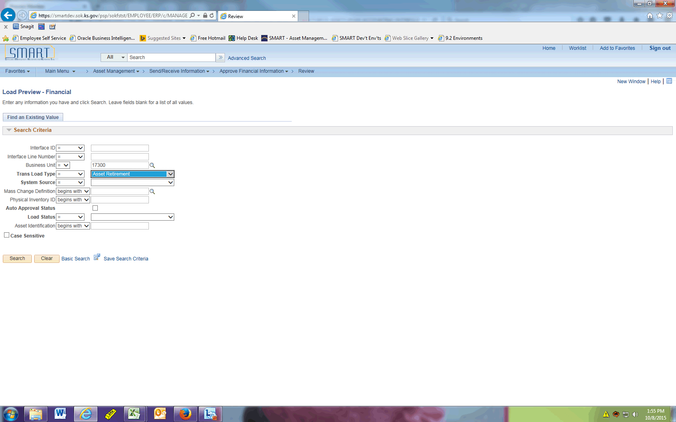

Step | Action
 | Click the Pending list item.
 | Click the Search button.

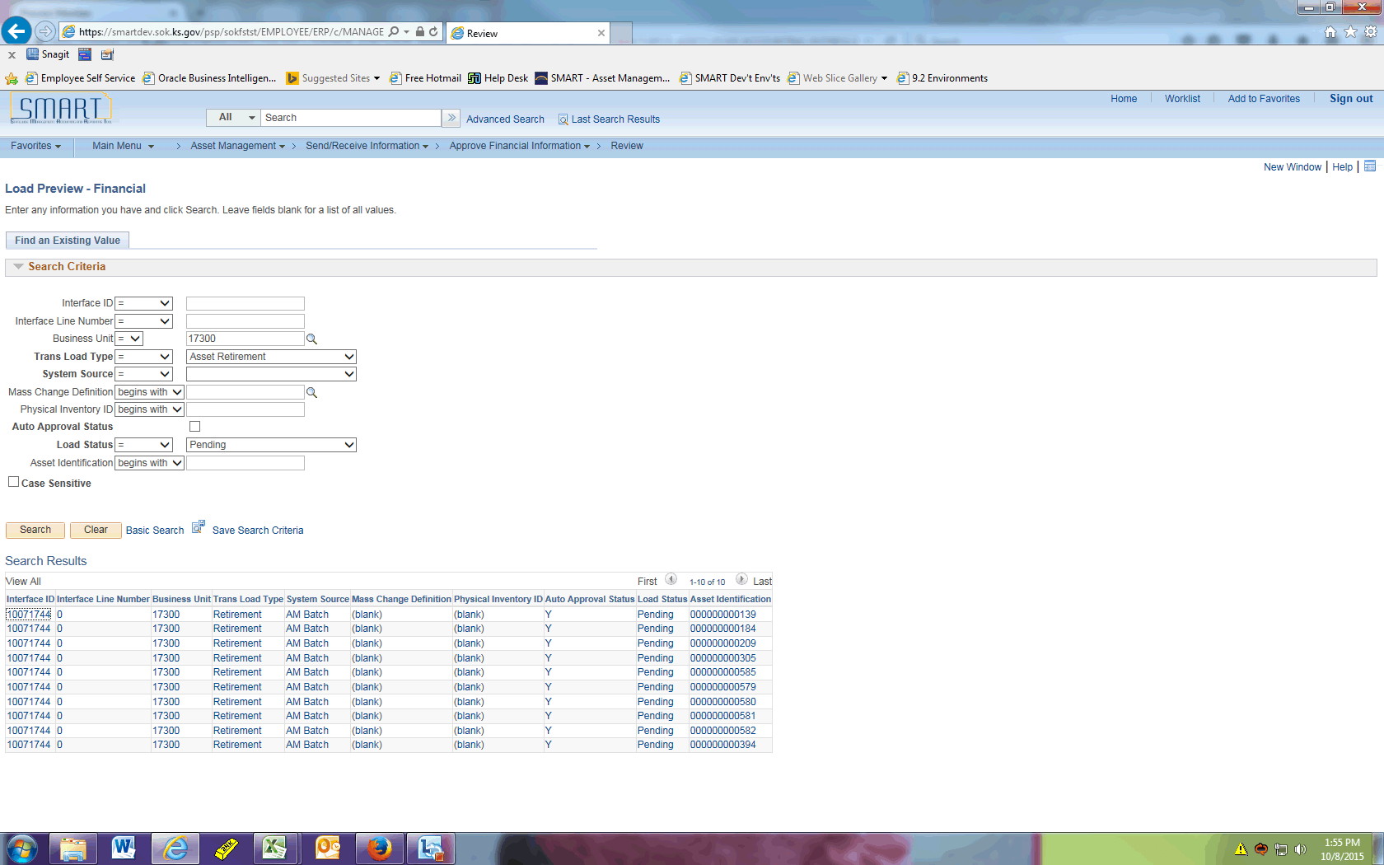

Step | Action
 | The list of assets just processed on the Disposal Worksheet should display. Take note of the Interface ID.

Step | Action
 | Click the Send/Receive Information button.
 | Click the Load Transactions menu.

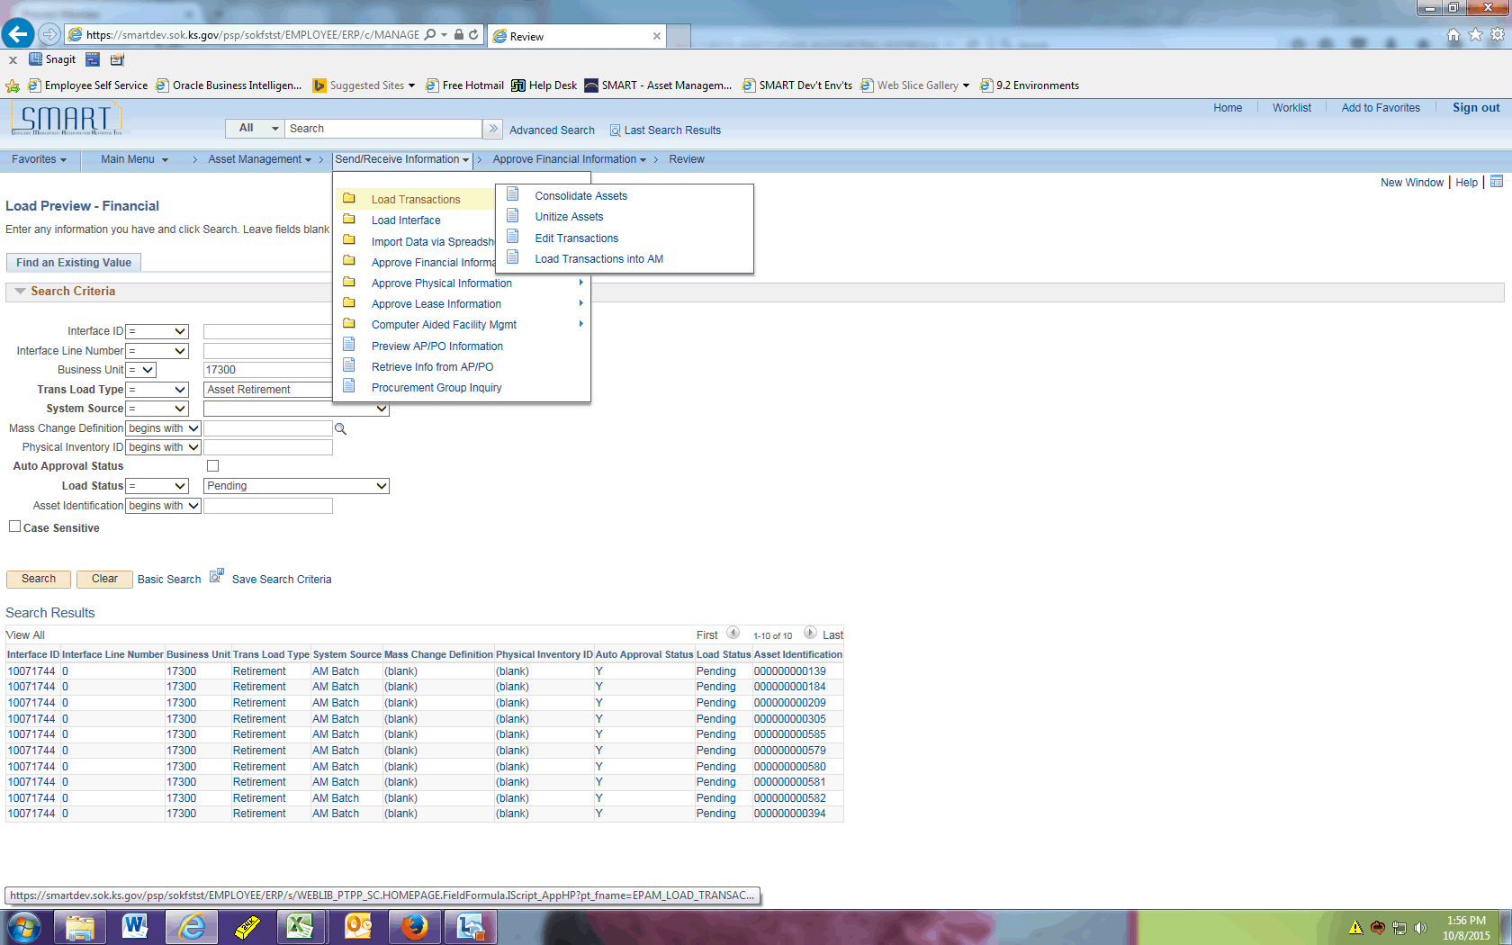

Step | Action
 | Click the Load Transactions into AM menu.
 | Enter the desired information into the begins with field. Enter "trans_loader".

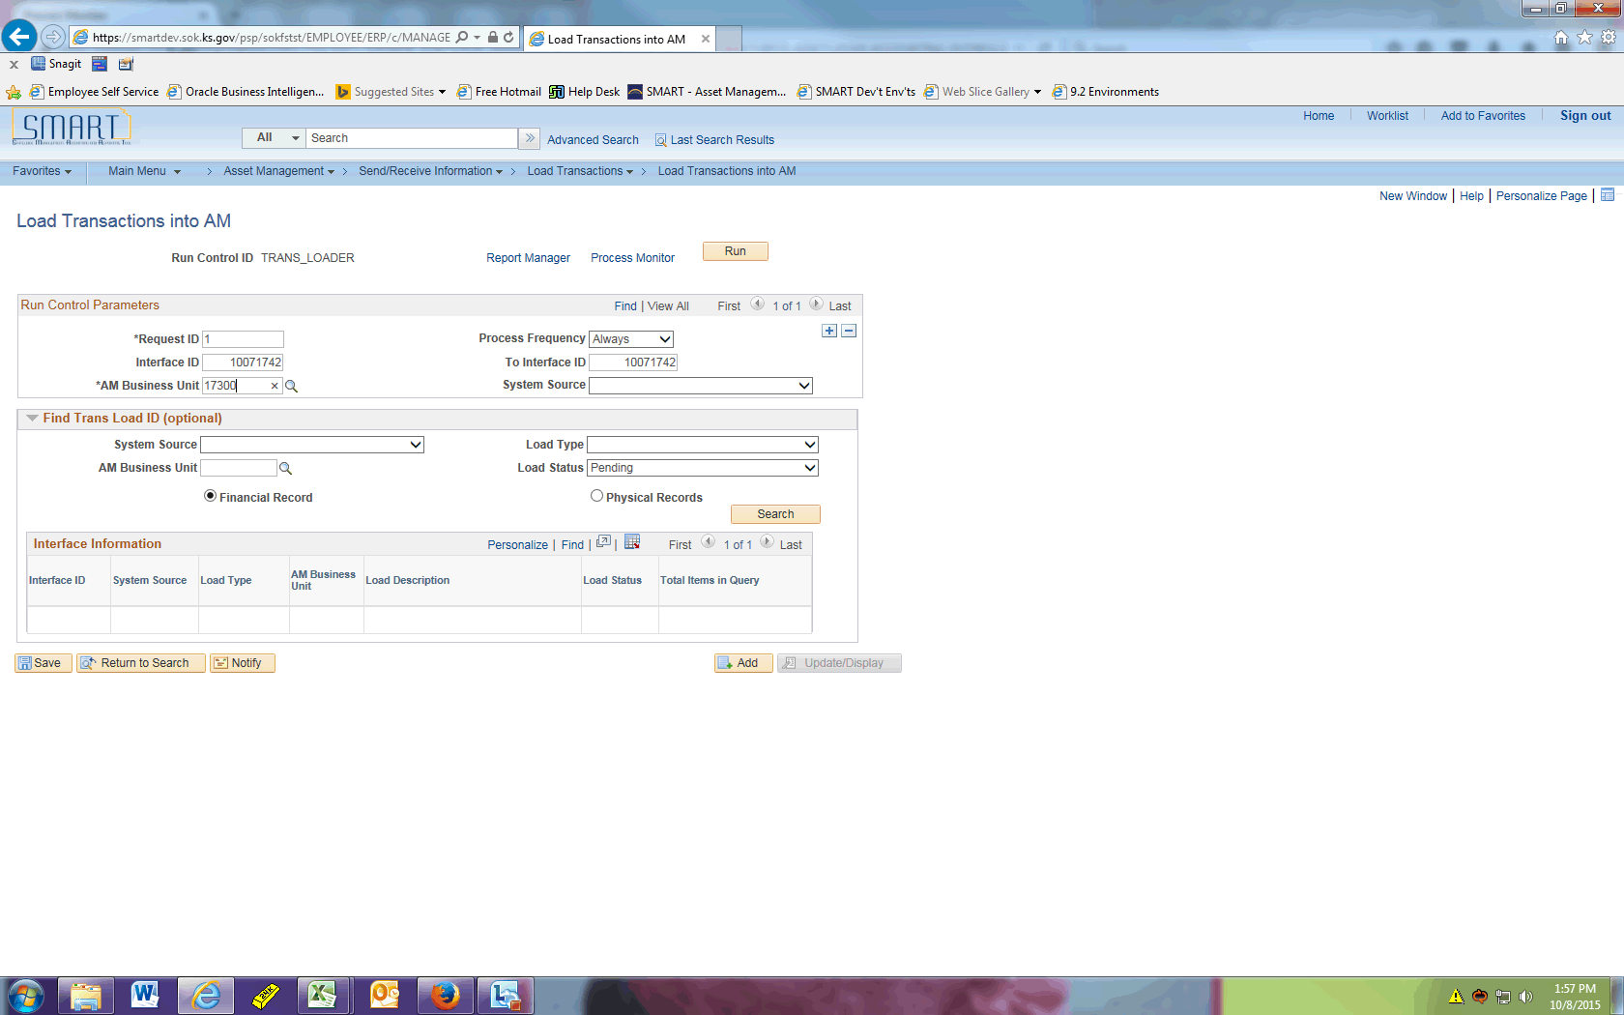

Step | Action
Enter the desired information into the Interface ID and AM Business Unit fields.
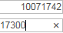

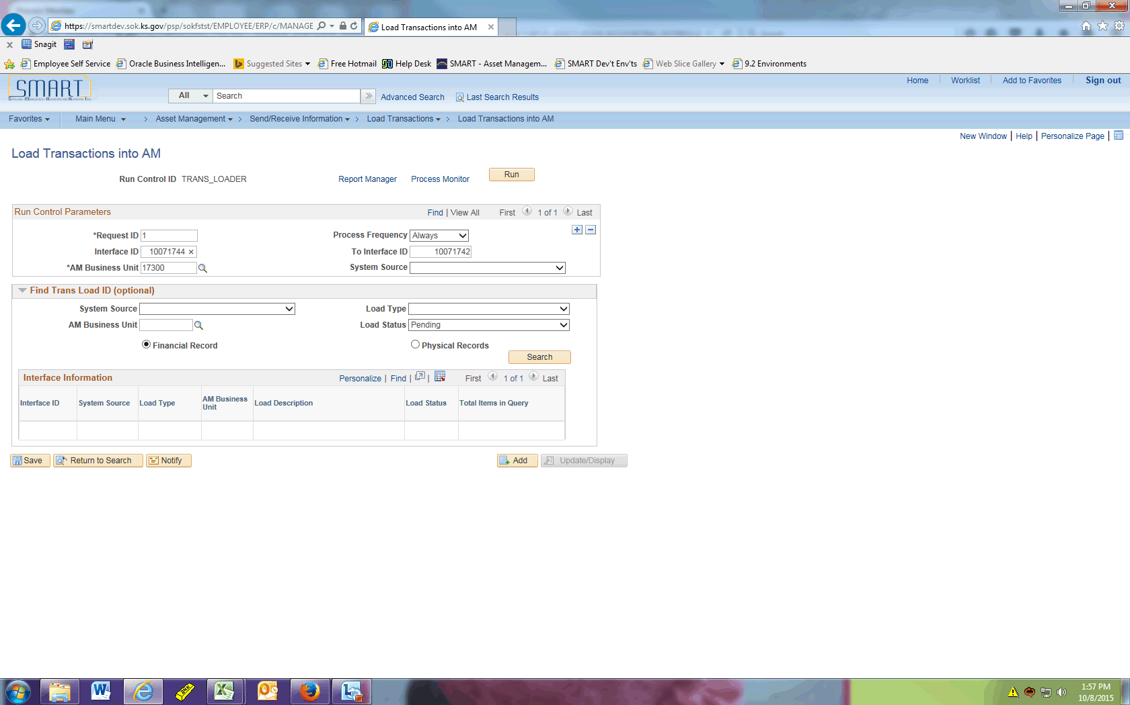

Step | Action
Click in the To Interface ID field.

The value entered in the Interface ID field will default in the To Interface ID field.
 | Click the Run button.

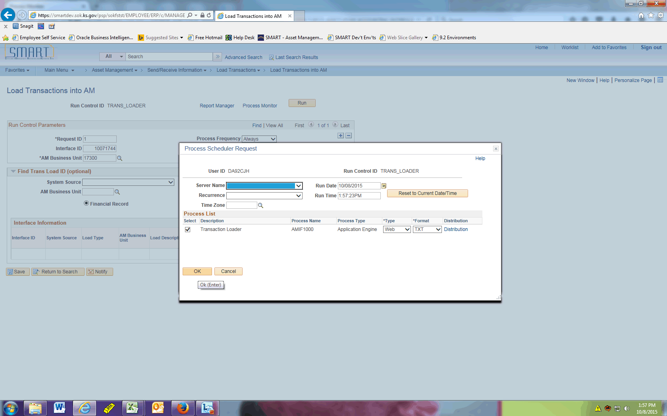

Step | Action
 | Click the OK button.
 | Click the Process Monitor link.
After AMIF1000 has completed, the assets have been successfully retired.

This concludes the 'AM - Disposal Worksheet--Expanded Search Criteria' topic. Thank you for taking this course.
End of Procedure.

