
State of Kansas
Cancel with No Reissue (DA-7)
Statewide Management, Accounting and Reporting Tool

Date Created: |  | 07.08.14
Version: |  | V.1.0.
PPM 11,961 Deletion |  | As of July 15, 2014, PPM 11,961 has been deleted from the website. The practice for cancelling checks has become more procedural rather than policy driven.  No additional documentation is to be sent to the Financial Systems Desk (i.e., paper checks or DA-6 form). If agency has paper check in hand, it is at their discretion on how they wish to retain this instrument. The DA-6 form attached to the Manage Engine Help Desk ticket will be sufficient documentation for Financial Systems Desk use.
Reason for Job aid |  | This job aid is to be used as reference for submitting the correct form to the Financial Systems Desk via Manage Engine Help Desk ticket.  Each form’s example will enable agency to determine which form best suits agency’s situation.
1. | Go to the Department of Administration website’s document center. | http://www.admin.ks.gov/resources/document-center
2. | There are three (3) separate forms that can be used.  Decide which form best suits the agency’s situation | 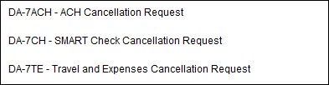
3. | After determining which form best suits agency’s need, download proper form and complete. | Each form has been created to be used as an example in assisting agency in correctly completing the proper form for their request.
4. | DA-7ACH – ACH Cancellation Request form.  This is to be researched before submitting cancel request form to Financial Systems Desk. | If funds have not been deposited into vendor’s bank (i.e., today is Monday and the funds are to be deposited to vendor’s bank on Tuesday), or if funds were inadvertently sent out to vendor (i.e., wrong vendor, wrong amount, etc.), agency will need to contact the State Treasurer’s Office (STO) to have the funds either deleted from bank file or returned before the Financial Systems Desk can cancel the payment.  The STO will need to have the following information before they are able to delete payment off of bank file before it goes out or to request funds be returned to the State:  Bank ABA/Routing Number:  Bank Name:  Account Name: (this will be vendor’s name)  Bank Account Number:  Dollar Amount:  Effective Date:  Agency should have the DA130 (Authorization for Electronic Deposit of Vendor Payment) in agency’s files for referencing. If agency does not have this form on file, agency will need to contact the Financial Systems Desk to retrieve this information for the STO to be able to either delete payment from bank file or to request return of funds.
4a. | DA-7ACH – ACH Cancellation Request form.  Once the payment has been verified deleted off of the bank file or funds returned, complete the DA-7ACH form. | 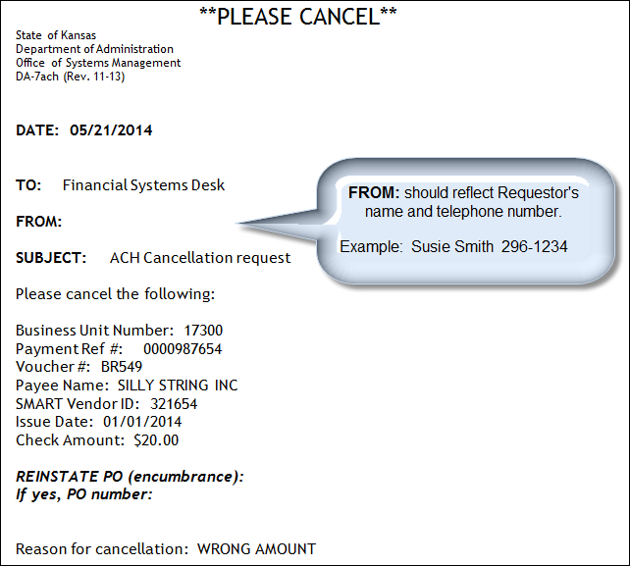
4b. | Pay close attention to the area regarding PO reinstatement. | If there is a PO attached to payment, you will need to advise the Financial Systems Desk if  (1) you need to have the PO reinstated  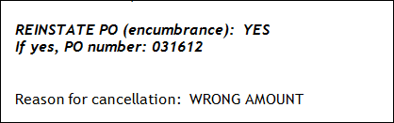  OR  (2) you do not need to have the PO reinstated  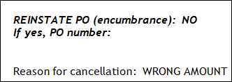  IF NOTHING IS INDICATED BY AGENCY, AND THE FINANICAL SYSTEMS DESK RECEIVES A MESSAGE REGARDING A PO, THE REQUEST WILL NOT BE PROCESSED UNTIL THE FINANCIAL SYSTEMS DESK RECEIVES AUTHORIZATION TO PROCEED - EITHER YES OR NO.  THIS WILL DELAY PROCESSING AGENCY’S REQUEST FOR CANCELLATION.
4c. | Submit completed form via Manage Engine Help Desk ticket. | https://dahelpdesk.ks.gov  NOTE: If you have unsure how to complete a Manage Engine Help Desk ticket, please refer to the Manage Engine – Job Aid “Creating a Vendor Service Desk Request “ job aid for further instructions.  Here is the link: http://smartweb.ks.gov/training/manageengine/creating-a-help-desk-ticket
4d. | Category, Subcategory, and Subject line | When entering a ticket for cancellation, please use the following:  Category: Financial Desk Inquiry  Subcategory: ACH Payment  Subject: DA7 – ACH cancellation  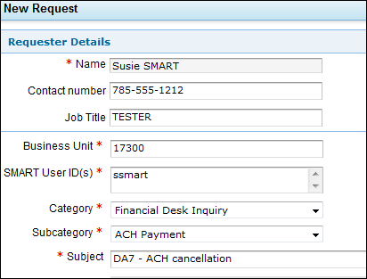
5. | DA-7CH – SMART Check Cancellation Request  Agency determines check was issued in error (i.e., wrong vendor, wrong amount, etc.).  Agency will need to complete the DA-7CH SMART check cancellation request form. | 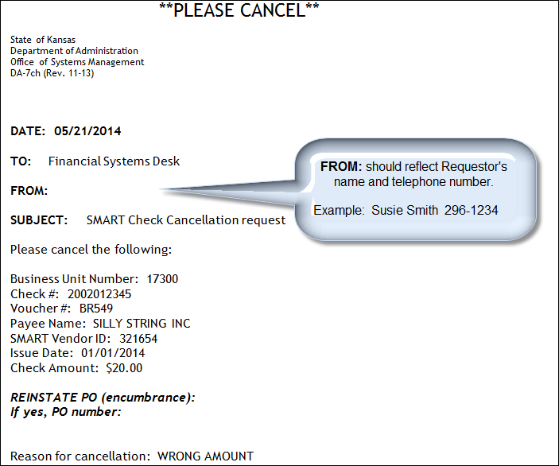
5a. | Pay close attention to the area regarding PO reinstatement. | If there is a PO attached to payment, you will need to advise the Financial Systems Desk if  (1) you need to have the PO reinstated  OR  (2) you do not need to have the PO reinstated  IF NOTHING IS INDICATED BY AGENCY, AND THE FINANICAL SYSTEMS DESK RECEIVES A MESSAGE REGARDING A PO, THE REQUEST WILL NOT BE PROCESSED UNTIL THE FINANCIAL SYSTEMS DESK RECEIVES AUTHORIZATION TO PROCEED - EITHER YES OR NO.  THIS WILL DELAY PROCESSING AGENCY’S REQUEST FOR CANCELLATION.
5b. | Submit completed form via Manage Engine Help Desk ticket. | https://dahelpdesk.ks.gov  NOTE: If you are unsure how to complete a Manage Engine Help Desk ticket, please refer to the Manage Engine – Job Aid “Creating a Vendor Service Desk Request “ job aid for further instructions.  Here is the link: http://smartweb.ks.gov/training/manageengine/creating-a-help-desk-ticket
5c. | Category, Subcategory, and Subject line | When entering a ticket for cancellation, please use the following:  Category: Financial Desk Inquiry  Subcategory: SMART Check Cancel Request  Subject: DA-7 Cancellation  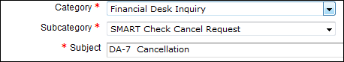
7. | DA-7TE – Travel and Expenses Cancellation Request form. | All Travel and Expense reimbursements are mandatory ACH payments effective October 1, 2010 (Info Circ 11-P-005).  Any alternate payment method is to be determined and authorized by agency.  In general, an agency will have been notified of funds returned by an email from the Financial Systems Desk (although this should not be considered the sole reason in cancelling a Travel and Expense payment). Here are a few reasons for cancelling a Travel and Expense payment:  (1) Agency determines payment was made to an employee in error  (2) Agency determines incorrect amount was paid  (3) Agency is unable to contact employee in order to update banking information
7a. | Download and complete the DA-7TE form | 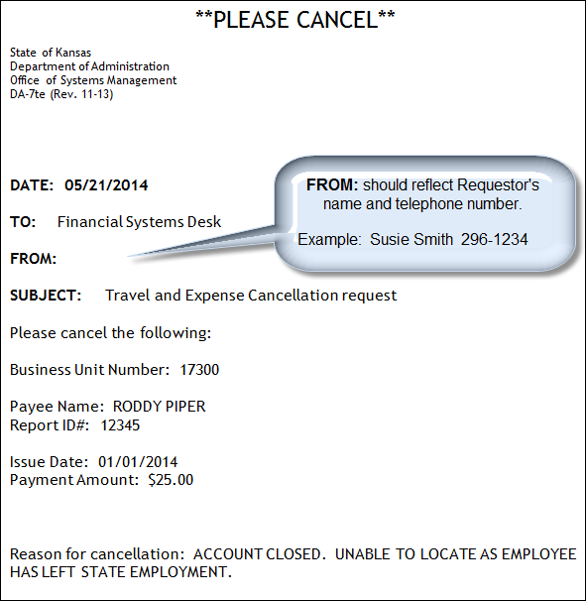
7b. | Submit completed form via Manage Engine Help Desk ticket. | https://dahelpdesk.ks.gov  NOTE: If you are unsure how to complete a Manage Engine Help Desk ticket, please refer to the Manage Engine – Job Aid “Creating a Vendor Service Desk Request “ job aid for further instructions.  Here is the link: http://smartweb.ks.gov/training/manageengine/creating-a-help-desk-ticket
7c. | Category, Subcategory, and Subject line | When entering a ticket for cancellation, please use the following:  Category: Financial Desk Inquiry  Subcategory: SMART Check Cancel Request  Subject: DA-7 Travel and Expense Cancellation  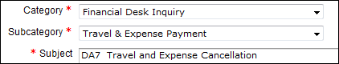
8. | Ticket closed – SUBJECT LINE | When the Financial Systems Desk has processed request, the ticket will be closed. Requestor will receive an email notifying of the ticket being closed.  A short statement will be noted in the subject line advising what was processed  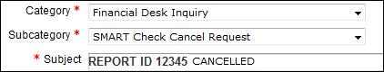  **NOTE: AS T&E cancellations are few, the verbiage might vary but the general information will be conveyed: the T&E payment was cancelled.**
9. | Ticket closed – RESOLUTION TAB | Agency is able to view the Resolution tab of the ticket to see when the ticket was closed as well as viewing any additional information which might not be in the Subject line.  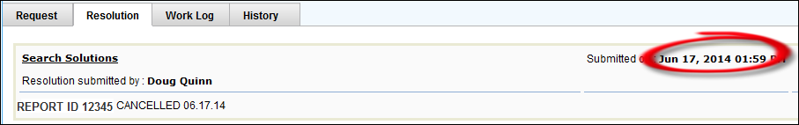  **NOTE: As T&E cancellations are few, the verbiage might vary but the general information will be conveyed: the T&E payment was cancelled.**

