The following Desk Aid instructs users how to locate Credit Card/E-Check EFT Deposits, including Credit Card fee charge and how to complete Deposit Adjustments for both.

- As often as daily, the State Treasurer’s Office will process EFT Deposits in SMART on behalf of Agencies for their Credit Card and E-Check revenue.

- The State Treasurer’s Office deposits these monies into ‘Credit Card Clearing Funds’ that have been designated for each Agency.

- The State Treasurer’s Office has created SpeedCharts under each Business Unit that receives Credit Card monies. These SpeedCharts are NOT to be modified or inactivated by the Agency.

- The naming convention for the SpeedChart is as follows: TRC##### or TRD#####. The ‘C’
indicated receiving monies, the ‘D’ indicates credit card fees. The last five numbers of the SpeedChart are the last five digits of the Merchant ID being used. So for example, TRC10511 would indicate monies being received for the Merchant ID ending in 10511. TRD10511 would indicate a fee was assessed for the Merchant ID ending in 10511.

- If an Agency has questions regarding their Credit Card/E-Check SpeedChart(s), please contact the
State Treasurer’s Office at (785) 296-3615.

- There is no automatic notification that a Credit Card Deposit has been processed in SMART. It is the Agency’s responsibility to search for and adjust these transactions daily.

- Each Agency is responsible for reconciling this Deposit with their Credit Card/E-Check transaction report.

- Credit Card fees will be charged to the ‘Credit Card Clearing Fund’ monthly.

- It is the Agency’s responsibility to move their monies out of the ‘Credit Card Clearing Fund’; this is done via Deposit Adjustment in SMART.

- Accounts and Reports uses the ‘STO Approval’ to approve Deposit Adjustments.

- Deposit ID and Payment ID for Agency initiated transactions are Agency assigned. The naming
convention used in this Desk Aid is encouraged for tracking purposes but is not required.

- The two Agency roles involved with this process are: KAR_AGY_DEPOSIT_PROCESSOR and KAR_AGY_ADMIN

Step 1: Search for Credit Card Deposit
Navigate to: Accounts Receivable Homepage>Payments>Online Deposits>Regular Deposit
or NavBar: Navigator>Accounts Receivable>Payments>Online Payments>Regular Deposit

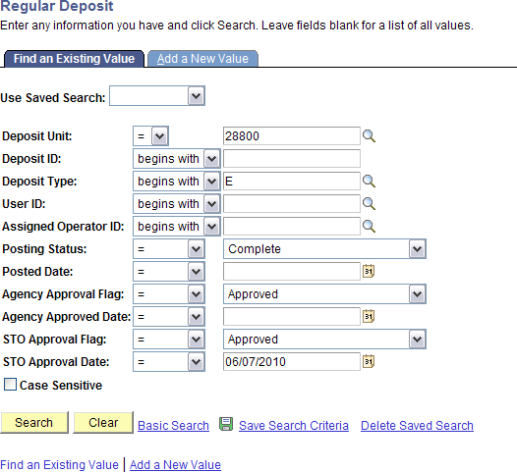
- Enter Business Unit.
- Deposit Type ‘E’.
- Posting Status ‘Complete’.
- Agency Approval Flag ‘Approved’.
- STO Approval Flag ‘Approved.
- STO Approval Date ‘Today’s Date’.

Step 2: Open Deposit – Totals Tab
  - The Deposit ID is the date/time the Deposit was created.
  - The ‘Assigned’ field is populated with ‘UC4’ (this identifies the transaction has been interfaced into SMART).
  - The Control Total Amount is the total of all Merchant ID Payments minus fees, if applicable.
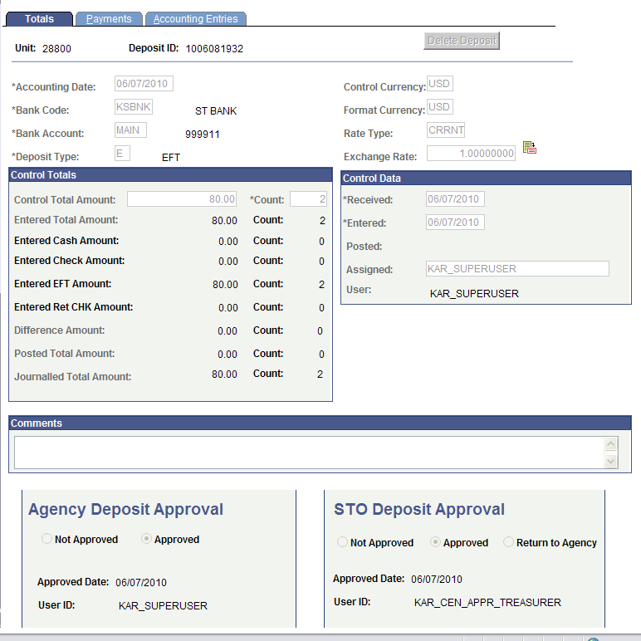
  - The Control Count is the total number of Merchant ID Payments reflected on the Deposit.

Step 3: Open Deposit – Payments Tab
    - Click the ‘View All’ link in the ‘Payment Information’ section. This will display all Payments for the Deposit.
    - Each Payment represents one Merchant ID; note that the Payment ID is the last 5 digits of the Merchant ID.
    - Note that Payment 2 is a negative amount; this is the credit card fee.
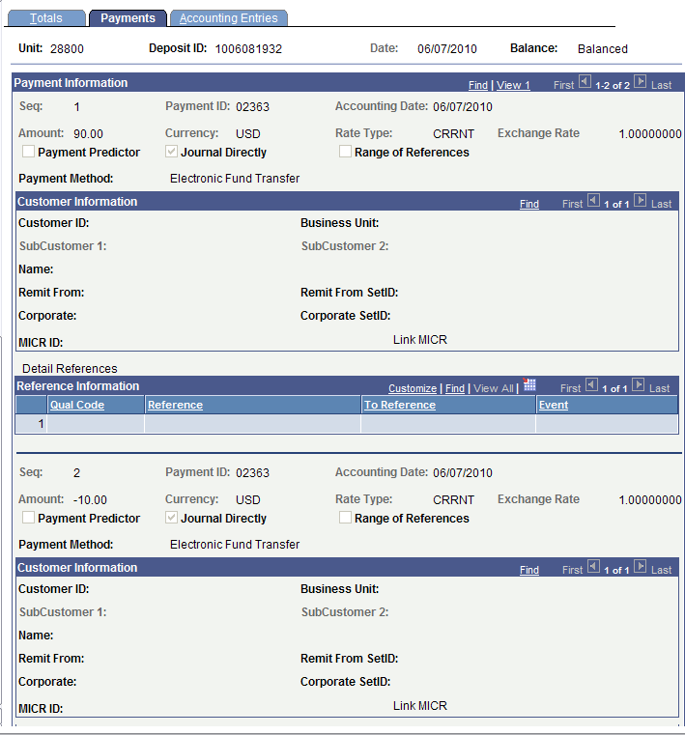

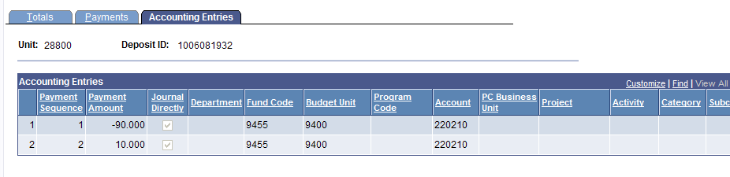

Step 3: Open Deposit – Accounting Entries Tab
    - Note that the Payment Amount(s) are negative.
    - Note that the Fee Amount(s) are positive.
    - Note that the ‘Department’ and ‘Program’ ChartFields are blank due to the ‘Account’ used.
    - Note that the ‘Account’ is ‘220210’.

Step 4: Create Deposit Adjustment – Totals Tab
- Note that the Deposit Type is ‘A’ – Adjustment.
- Note the that Control Total Amount is $0.00.
- Note that the Control Count is ‘4’. This is because for every one line being adjusted, two are created.
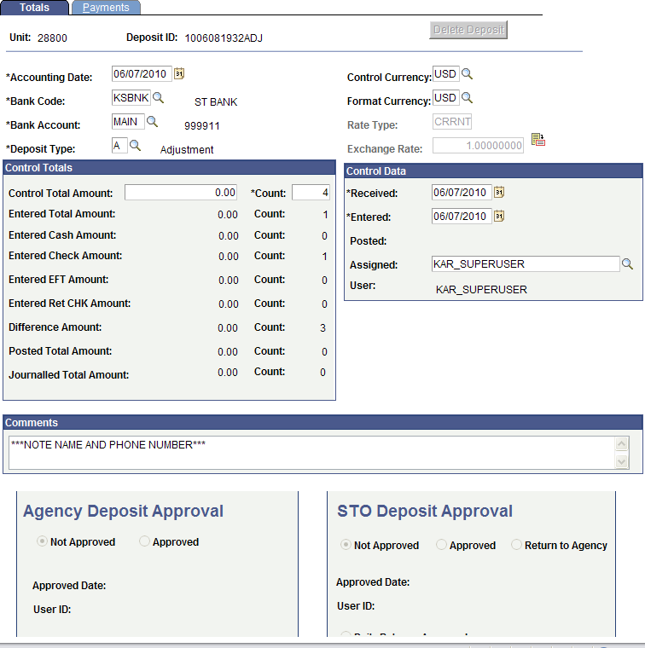
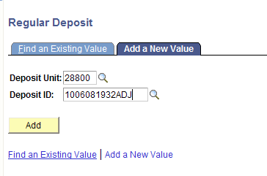
- Note that the Deposit ID is 1006081932ADJ (Original Deposit ID with ADJ added).

Step 4: Create Deposit Adjustment – Payments Tab
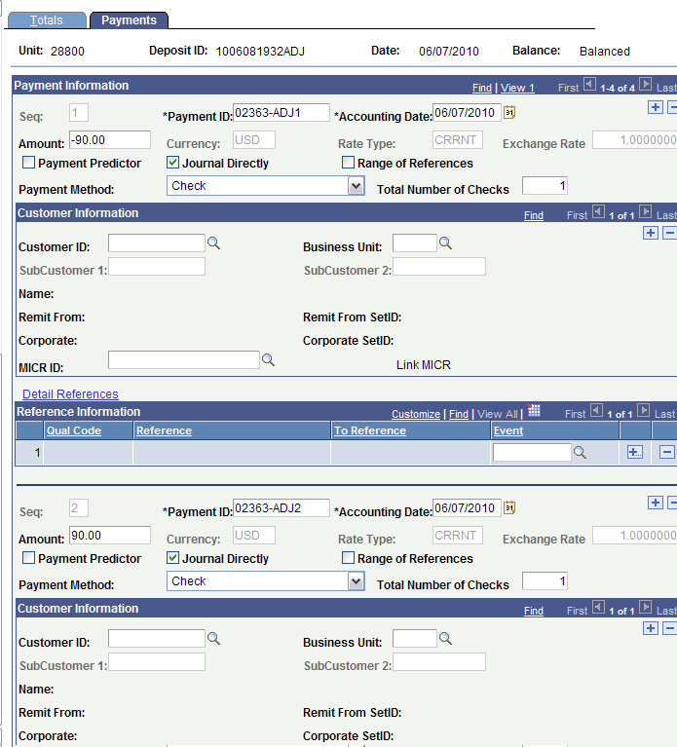
- Note that there are 4 payments. Payment ID ‘02363-ADJ1’ and ‘02363-ADJ2’ adjust the original Payment ID ‘02363’.

Step 4: Create Deposit Adjustment – Payments Tab
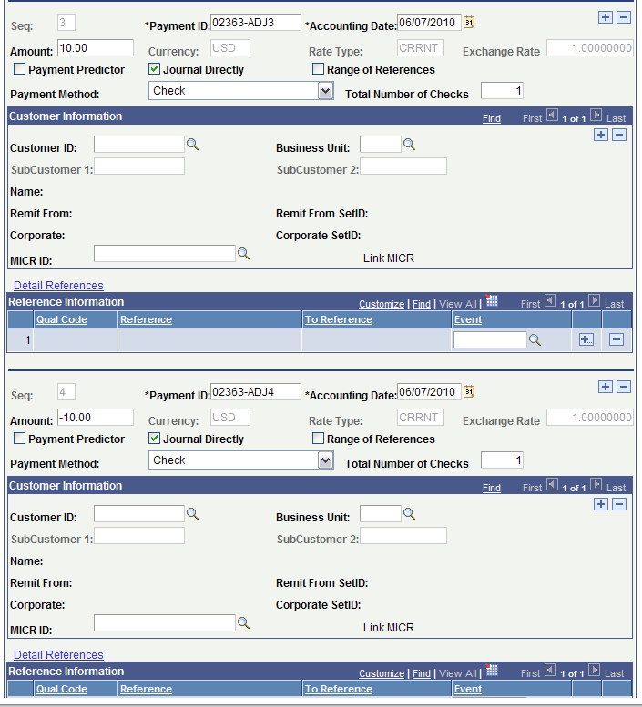
- Note that there are 4 payments. Payment ID ‘02363-ADJ3’ and ‘02363-ADJ4’ adjust the second Payment ID ‘02363’ (credit card fee).

Step 5: Create Accounting Entries
Navigate to: Accounts Receivable Homepage>Payments>Direct Journal Deposits>Create Accounting Entries
or
NavBar: Navigator>Accounts Receivable>Payments>Direct Journal Payments>Create Accounting Entries

- Locate Deposit
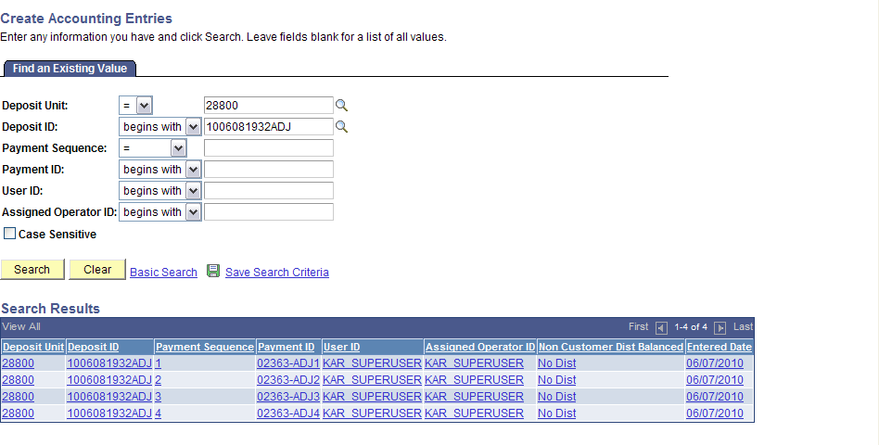

Step 5: Create Accounting Entries
- Create and Complete Accounting Entries for Payment Sequence 1: This accounting reverses the original accounting for Payment-1 02363. You can manually enter the accounting or use the SpeedChart associated to the Merchant ID. In this instance the SpeedChart would have been TRC02363.
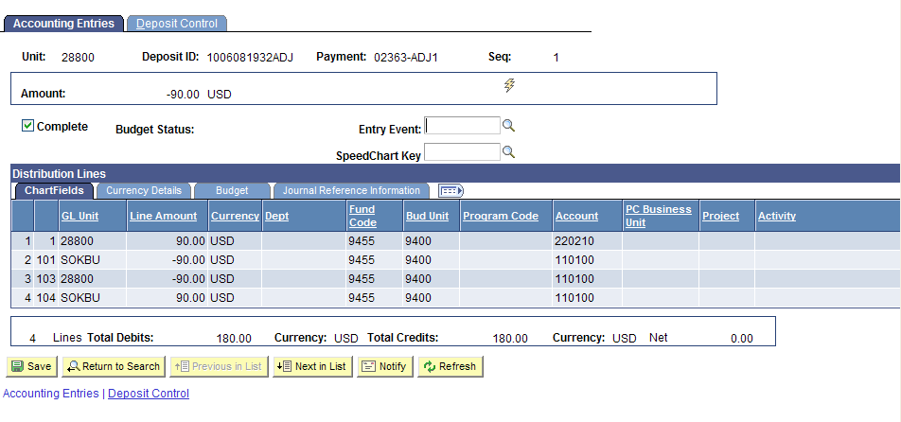

Step 5: Create Accounting Entries
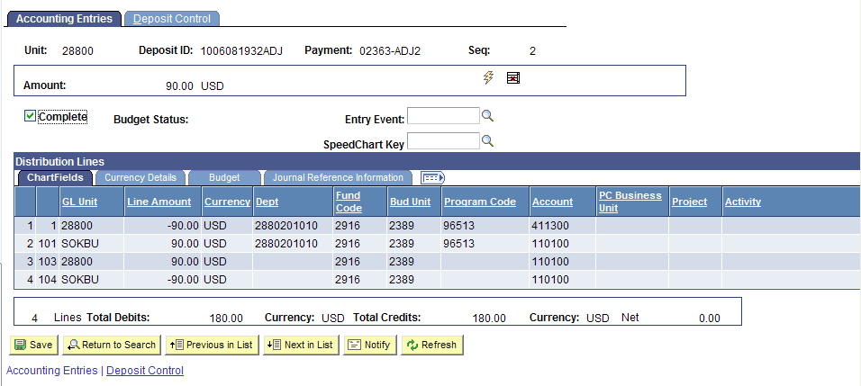
- Create and Complete Accounting Entries for Payment Sequence 2: This accounting places the money into the corrected accounting for Payment-2 02363.

Step 5: Create Accounting Entries
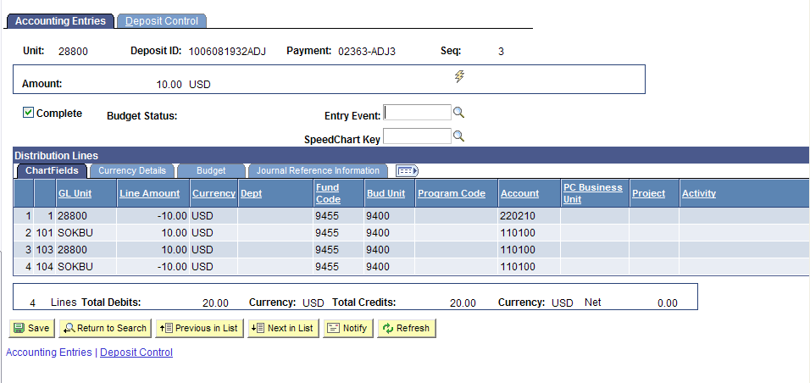
- Create and Complete Accounting Entries for Payment Sequence 3: This accounting reverses the original accounting for Payment-3 02363 (credit card fee). You can manually enter the accounting or use the SpeedChart associated to the Merchant ID. In this instance the SpeedChart would have been TRD02363.

Step 5: Create Accounting Entries
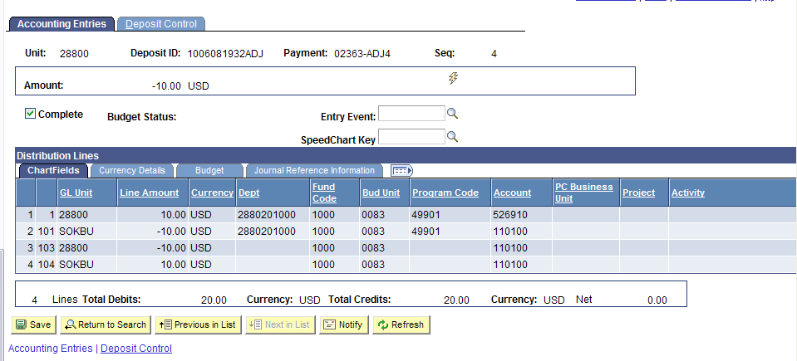
- Create and Complete Accounting Entries for Payment Sequence 4: This accounting places the money into the corrected accounting for Payment-4 02363 (credit card fee). Note that this must be account ‘526910’.

Step 6: Review and Agency Approve the Deposit
Navigate to: Accounts Receivable Homepage>Payments>Online Deposits>Regular Deposit
or NavBar: Navigator>Accounts Receivable>Payments>Online Payments>Regular Deposit

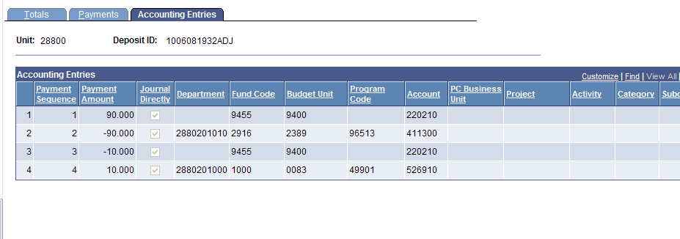
- Locate Deposit and Review Accounting

Step 6: Review and Agency Approve Deposit
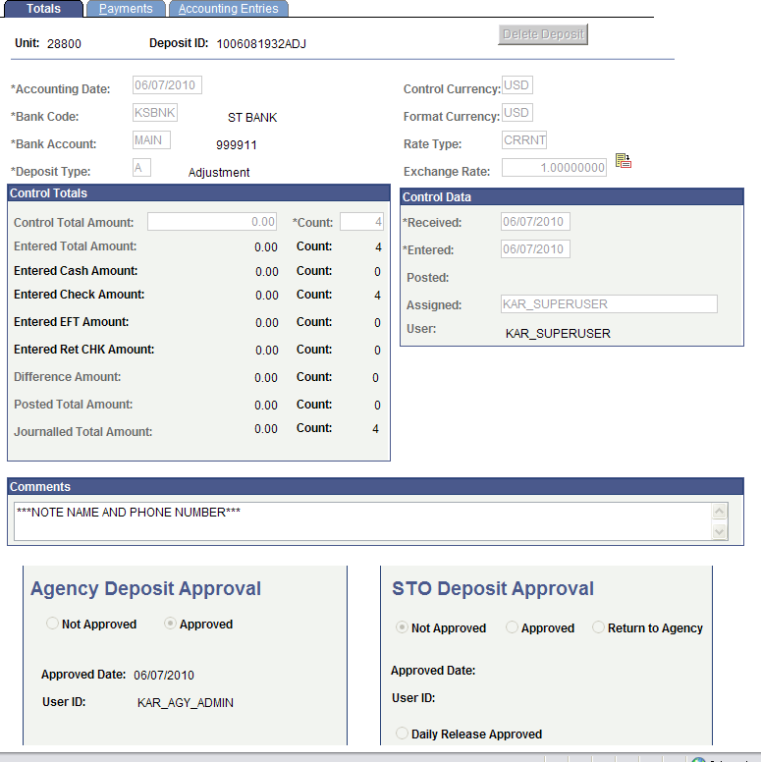
- Agency Approve Deposit

In the scenario shown in this job aid, an agency received a net of $80 from the Credit Card Deposit. The Deposit consisted of two payments, the first being money received ($90) and the second being the fee (-$10).

The money is moved from the original clearing accounting line into one Agency-defined accounting line. The Credit Card fee was also moved from the clearing accounting line into the Agency-defined accounting line.

An Agency may wish to distribute the one clearing accounting line into several Agency-defined accounting lines (deposit and/or fee). The first line of the adjustment must reverse the original clearing accounting line(s). All subsequent lines are Agency-defined accounting.

The original balance in the Credit Card Clearing Fund is $0.00. When the Treasurer completes the deposit:
  - Record the $90 as Revenue
  - Record the $10 as Expense

Adjustment 1 of 4: Reverses the $90 out of the Clearing Fund
Adjustment 2 of 4: Places the $90 in Agency-defined Accounting as Revenue Adjustment 3 of 4: Reverses the $10 fee out of the Clearing Fund
Adjustment 4 of 4: Places the $10 in Agency-defined Accounting as an Expense

The overall effect of this transaction is $90 in Revenue and $10 in Expense for Agency-defined Accounting.
The Credit Card Clearing Fund balance is back to $0.00.

