State of Kansas
Creating Requisitions Using
Grainger
Statewide Management, Accounting and Reporting Tool
Date Created: | 04/29/2022
Version: | 3.0
Last Updated Date: | 09/02/2022
Fluid Navigation | Begin by navigating to the Requisition Settings page using the Fluid homepages.  - Click the Requisitions & Pcards homepage link  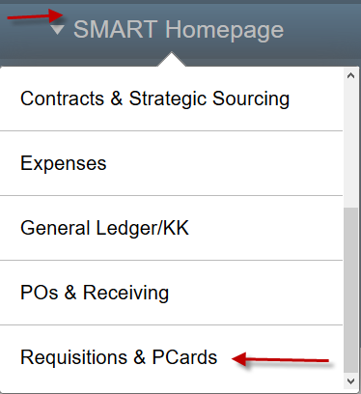
- Click the Create Requisitions tile
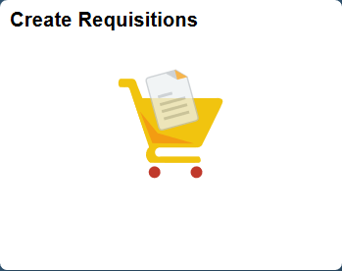
Classic Navigation | Or, begin by navigating to the Requisition Settings page using Classic navigation.  - Click the NavBar icon
- Click the Navigator icon
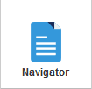

 |  | - Click the eProcurement link
 |  | - Click the Requisition link
Requisition Settings Page  Business Unit |  | The Business Unit search field defaults based on your agency number. Depending on your security level, you can accept the default or enter a different business unit number.
Requester |  | Use the Requester field to enter the SMART User ID for the Requester. You MUST replace the Default Requester ID with a valid SMART User ID.  Note: If you do not know the Requester’s SMART User ID, use the Lookup button (magnifying glass) to display a list of available values.
Requistion Name |  | Use the Requisition Name field to enter a requisition description, if desired.
Procurement Card |  | For the State of Kansas, SMART allows the procurement card information to be associated to the requisition if:  - The Requester holds a procurement card  - The Requisitioner enters the (procurement card holding) Requester’s SMART User ID in the Requester field when creating the requisition  Note: All suppliers are now setup to accept PCards. Grainger accepts PCards as a payment method.  If a Requester holds more than one procurement card for the State of Kansas, use the Card Number drop-down list to choose the correct procurement card number.  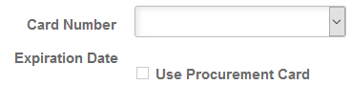  For security purposes, SMART encrypts the procurement card number allowing the Requisitioner to view only the last four digits.  Once a card is assigned, the expiration date will auto fill and the Use Procurement Card checkbox will be checked.  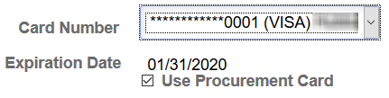  If the Requester was set up to use a procurement card as the default payment method on requistions, SMART automatically defaults procurement card information on every requisition that is created using that Requester. If necessary, change the procurement card number to the correct card number using the Card Number drop-down list.  If you are creating a requisition that should not be paid with a procurement card, simply remove the default selection in the Use Procurement Card check box by clicking in the check box. Deselecting the Use Procurement Card check box removes the Requester’s procurement card information from the Requisition.
Buyer |  | Use the Buyer field to assign a buyer to a requisition. Buyer is required and can be entered here for all lines or can be entered on the Review and Submit page per line. The Buyer will also default based on what has been associated to the Requisitioner ID when the Requistion Settings page is confirmed.  Note: If you do not know the Buyer ID, use the Lookup button (magnifying glass) to display a list of availabe values.
Remaining Fields |  | The remaining fields on the Requisition Settings page may remain blank.  However, since your requisition is for Grainger, and could have multiple lines with one or more of the same chartfields, it may be in your best interest to fill in some additional fields before continuing.  Note: Prior Authorization Type and Category should NOT be used on a Grainger Requisition. The Unit of Measure will always be EA (each). You can enter EA as the default UOM or leave blank.
Supplier |  | Do not apply a Supplier! The supplier information will autopopulate when you punchout to the supplier website.  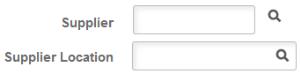  Note: It is important to let the information autopopulate as only one supplier location is actually setup to transmit a Purchase Order via EDX (Electronic Data Exchange) via Intergration Broker. If the Supplier is manually applied, a Location has to be selected at that time and it may not be the right one. If the wrong Location is selected, there is no indicator when the PO dispatches. It will look like it has gone via EDX, but will never actually reach the supplier.
Ship To |  | The Ship To address will default in values associated to the Requester ID when the Requistion Settings page is confirmed. This can be modified here or on the Review & Submit page.  Note: If you do not know the Ship To, use the Lookup button (magnifying glass) to display a list of availabe values.
Override |  | To apply changes to defaulted fields, such as the Ship To and Chartfields, with the field settings you define here click the Override radio button.  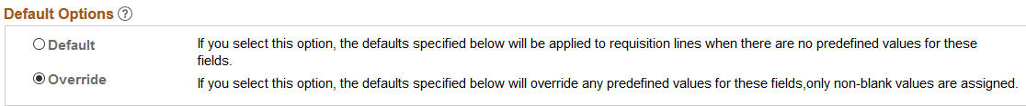
Asset Information |  | Use the Asset Information tab on this page if all lines for the requisition will have the same asset information. This can be modified on the Review & Submit page.  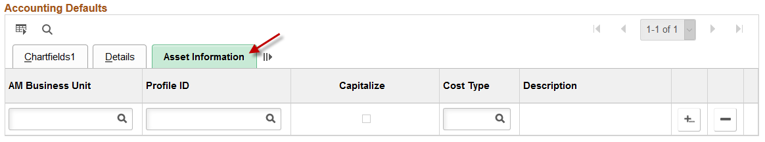  Note: It is State of Kansas business practice that any agency asset that has a value of $5000 or greater is required to use the Asset Management module in SMART (PM 13,001 – Capital Asset Records https://admin.ks.gov/media/documents/13001capitalassetrecords_BD2FAD99A7493.docx.
Apply Requisition Settings |  | To add items or services to the requisition, scroll to the bottom and click ‘OK’. Clicking the OK button progresses you to the Create Requisition page.  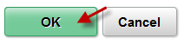
Chartfield Defaults |  | A pop-up box will appear, advising of the default values associated with the entered Requester ID. Click Yes through this message.  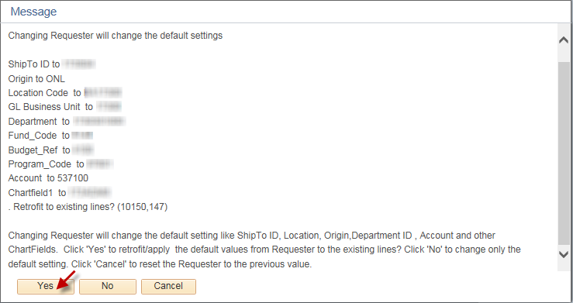
Requisition Page  Grainger Punch Out | Use the Grainger link to open the Grainger online web catalog within SMART. Use the supplier’s online catalog to locate items for ordering.  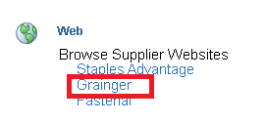  Note: Expect a one-time delay of 3-5 days on initial order if you do not have an existing Grainger account.

Grainger’s Website
First Time User Punchout | The first time a user accesses Grainger they will be required to register with their First Name, Last Name and Phone Number. The email address will already be populated and just needs to be confirmed.  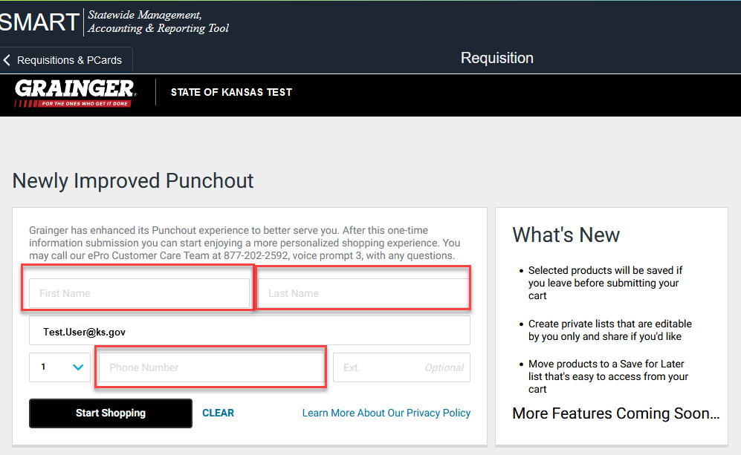  NOTE: It is a one-time requirement to enter this information. After initial punchout, the system will be able to log into the Grainger account via the standard SMART punchout process.
Locating Items | Use the Search field to locate needed items.
Adding Items to Order | Select the desired quantity of the item and click the Add to Cart button, which will add item(s) to to the shopping cart.  Note: It is important to notice that the shopping cart does NOT reflect the total quantity of items ordered. Instead, the shopping cart reflects the number of different items ordered.
Continue Shopping | Additional items can be added by selecting the Continue Shopping button on the Added to Cart page.
Checkout | Once all desired items have been added to the shopping cart, select Review & Checkout on the Added to Cart page.
Delivery Method Options | Grainger offers 2 Delivery Methods:  Shipping – Order shipped to the Ship-to location(s) associated to the requisition  Pickup – Allows a user to see if the product is available for them to pickup the order directly. Grainger also refers to this as WillCall
Pickup | Select Pickup as the Delivery Method and look up your local branch by entering in your Zip Code.  Note: Pickup is only available in certain locations.
Contact Information  (Optional) | Enter your contact information.
Submit Order | Use the My Products page to review the items before clicking the Submit Cart and then the Yes button to transfer the item information from the vendor catalog to the requisition in SMART, which returns the user to the Checkout – Review and Submit page.

Returned to SMART Requisitions
Checkout – Review and Submit | Use the Checkout – Review and Submit page to review and edit the requisition details, prior to saving and submitting the requisition into the SMART workflow process for approval.  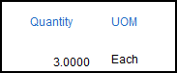  Note: Notice that the Quantity and UOM fields are not editable. When creating a requisition using a web catalog, the functionality of the Direct Connect interface with the supplier locks these fields down, preventing changes or edits.
Quantity Edits | To edit the Quantity for a web catalog requisition line, there are two options:  - Exit the existing requisition (do not save), and create a new requisition.  - Delete the line on the existing requisition, go back to the supplier’s website (click on the Add More Items button and then reuse the Grainger link) and re-enter the item and the correct quantity.
Noteworthy | It is important to know for the Grainger Web Catalog (Direct Connect) requisitions:  - The Ship To location code or Shipping Address can be modified on the requisition lines.  - A single requisition line CANNOT be split into multiple Ship To locations.  - Grainger catalog is associated to category codes and will default in their corresponding account code. However, it is the responsibility of the agency to ensure the correct acccount code for the purchase is used.
Line Details –  Contract | Important: Depending on the purchase, Grainger could be a Statewide Mandatory or Statewide Optional Use supplier. Be sure to check the contracts on the Kansas eSupplier Public Portal. The appropriate contract should be associated to every line of a Grainger requisition. Please see ‘Policy Manual 10,300 – Statewide Encumbrance Policy’ for more details.  To review the line detail information, use the Line Details icon to open the Line Details page, where line detail information, such as adding a Contract may be edited as necessary.  Use the Contract ID field to enter the Contract ID number if applicable to your requisition. If you do not know the Contract ID number, use the Lookup button (magnifying glass) to view and select from the available list of Contract ID numbers.  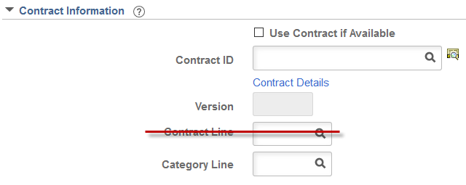  Note: The State of Kansas is not using the Contract Line field for requisitions. Please do not enter data in the Contract Line field for a requisition.
Mass Change | The Mass Change link can be used to add or change the Buyer, Category, Chartfield information, but most especially the Contract ID for Grainger and other contract suppliers to any one line, multiple lines, or all lines.  Note: Only the Requisition lines that have been selected by checking the box to the left of their line information or using the Select All / Deselect All link, will be affected by the changes/additions completed on the Mass Change link.  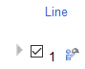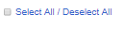
Save for Later | The save, preview, and submit requisition functions are located at the bottom of the page. Use the right scrollbar to navigate to the bottom of the page, if necessary.  Note: Budget checking in SMART is performed by an hourly batch process. Therefore, you do not need to use the Check Budget icon on the Review and Submit page of the requisition.  Use the Save for Later button to save the requisition for later use. When you click the Save for Later button, SMART will stay on the Review and Submit page.  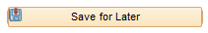  Note: It is important to know that the Save for Later button does not submit the requisition into the SMART approval workflow process. Using the Save for Later button enables you to save the requisition for later use, and access it again from Manage Requisitions, without entering the requisition into the SMART workflow approval process.
Save & Submit | The Save & Submit button is used to save the requisition, and submit it for approval, sourcing and dispatching to the supplier.  Note: If you enter invalid ChartField values or ChartField combinations on the requisition, you will receive an error message when you try to save the requisition. If you receive an error message, correct the entry of ChartField values on the requisition and save the requisition.  The requisition remains editable while the requisition status is “Open” or “Pending”. When you click the Save & Submit button, SMART displays the Confirmation page to inform you that the request has been successfully saved and submitted into workflow for approval. The Confirmation page provides summarized information about the request, including the requisition ID and total price.
Note: If the purchase order has been dispatched and a change is required, contact your Grainger representative. Change orders entered in SMART will not be processed by Grainger electronically.
Optional Grainger Managed Functionality
KeepStock Items – Optional functionality that can assist agencies with inventory management.
Grainger’s KeepStock Inventory Management Solutions helps agencies better understand their inventory and reduces the costs to manage it. Grainger’s solutions can enable multiple cost-savings opportunities around the State of Kansas’s process, inventory, and product. Today Grainger helps over 12,000 customer facilities manage over 14 million storage areas. The KeepStock portfolio provides Digital/CMI, Replenish, Vending, Onsite, and Managed options. If your agency is interested in the KeepStock feature, please contact your Grainger representative.

Using KeepStock for an Order | If using KeepStock, navigate to the Account menu and click on KeepStock Pending Orders.  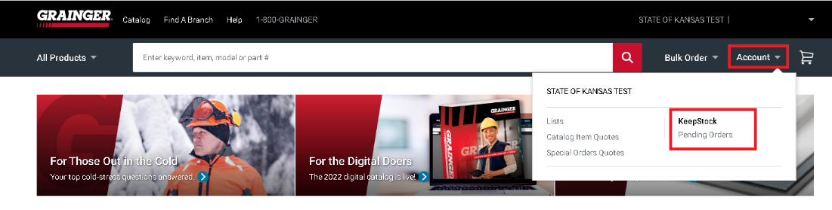  Enter KeepStock scan number and click on Search and click on Click Add To Cart.  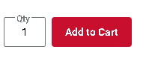
Optional User List Functionality
User Lists – Optional functionality that can assist with requesting repetitive items.
User Lists | To create a user list, navigate to the Account menu and click on Lists.
Create New List | Click on Create New List
Share this list | Enter a list name and list description.  To share the list, enable the Share this list box.  Click on .
Add Items to List | Enter the Item #, click on .  Click on .
Add List to Cart | Click on to add the item to your cart.
Continue Shopping or View | Click Continue Shopping or View Cart
Delete List | To delete a list, select Account and Lists.  Click on Delete List  Click on Delete List.
Confirm Deletion | Click on to confirm list deletion.

