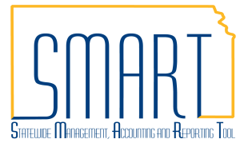
State of Kansas
Creating Requisitions Using
Fastenal
Statewide Management, Accounting and Reporting Tool
Date Created: | 06/10/2022
Version: | 3.0
Last Updated Date: | 09/02/2022
Fluid Navigation | Begin by navigating to the Requisition Settings page using the Fluid homepages.  - Click the Requisitions & Pcards homepage link  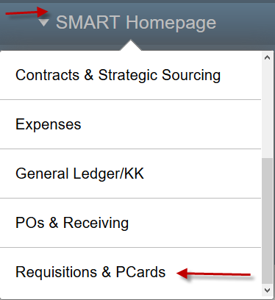
- Click the Create Requisitions tile
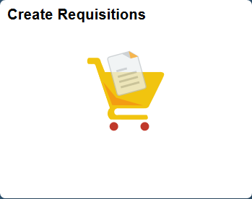
Classic Navigation | Or, begin by navigating to the Requisition Settings page using Classic navigation.  - Click the NavBar icon
- Click the Navigator icon
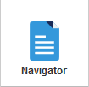

 |  | - Click the eProcurement link
 |  | - Click the Requisition link
Requisition Settings Page  Business Unit |  | The Business Unit search field defaults based on your agency number. Depending on your security level, you can accept the default or enter a different business unit number.
Requester |  | Use the Requester field to enter the SMART User ID for the Requester. You MUST replace the Default Requester ID with a valid SMART User ID.  Note: If you do not know the Requester’s SMART User ID, use the Lookup button (magnifying glass) to display a list of available values.
Requistion Name |  | Use the Requisition Name field to enter a requisition description, if desired.
Procurement Card |  | For the State of Kansas, SMART allows the procurement card information to be associated to the requisition if:  - The Requester holds a procurement card  - The Requisitioner enters the (procurement card holding) Requester’s SMART User ID in the Requester field when creating the requisition  Note: All suppliers are now setup to accept PCards, including Fastenal.  If a Requester holds more than one procurement card for the State of Kansas, use the Card Number drop-down list to choose the correct procurement card number.  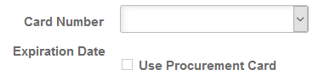  For security purposes, SMART encrypts the procurement card number allowing the Requisitioner to view only the last four digits.  Once a card is assigned, the expiration date will auto fill and the Use Procurement Card checkbox will be checked.  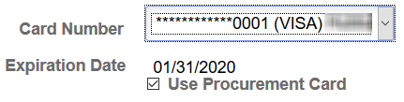  If the Requester was set up to use a procurement card as the default payment method on requistions, SMART automatically defaults procurement card information on every requisition that is created using that Requester. If necessary, change the procurement card number to the correct card number using the Card Number drop-down list.  If you are creating a requisition that should not be paid with a procurement card, simply remove the default selection in the Use Procurement Card check box by clicking in the check box. Deselecting the Use Procurement Card check box removes the Requester’s procurement card information from the Requisition.
Buyer |  | Use the Buyer field to assign a buyer to a requisition. Buyer is required and can be entered here for all lines or can be entered on the Review and Submit page per line. The Buyer will also default based on what has been associated to the Requisitioner ID when the Requistion Settings page is confirmed.  Note: If you do not know the Buyer ID, use the Lookup button (magnifying glass) to display a list of availabe values.
Remaining Fields |  | The remaining fields on the Requisition Settings page may remain blank.  However, since your requisition is for Fastenal, and could have multiple lines with one or more of the same chartfields, it may be in your best interest to fill in some additional fields before continuing.  Note: Prior Authorization Type and Category should NOT be used on a Fastenal Requisition.  The Unit of Measure will always be EA (each). You can enter EA as the default UOM or leave blank.
Supplier |  | Do not apply a Supplier! The supplier information will autopopulate when you punchout to the supplier website.  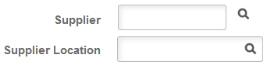  Note: It is important to let the information autopopulate as only one supplier location is actually setup to transmit a Purchase Order via EDX (Electronic Data Exchange) via Intergration Broker. If the Supplier is manually applied, a Location has to be selected at that time and it may not be the right one. If the wrong Location is selected, there is no indicator when the PO dispatches. It will look like it has gone via EDX, but will never actually reach the supplier.
Ship To |  | The Ship To address will default in values associated to the Requester ID when the Requistion Settings page is confirmed. This can be modified here or on the Review & Submit page.  Note: If you do not know the Ship To, use the Lookup button (magnifying glass) to display a list of availabe values.
Override |  | To apply changes to defaulted fields, such as the Ship To and Chartfields, with the field settings you define here, click the Override radio button.  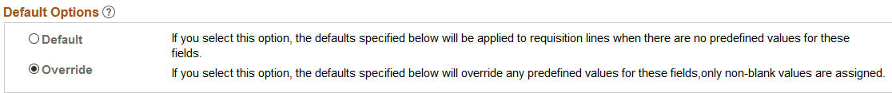
Asset Information |  | Use the Asset Information tab on this page if all lines for the requisition will have the same asset information. This can be modified on the Review & Submit page.  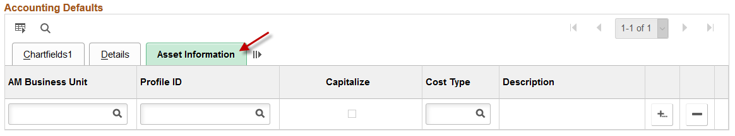  Note: It is State of Kansas business practice that any agency asset that has a value of $5000 or greater is required to use the Asset Management module in SMART (PM 13,001 – Capital Asset Records https://admin.ks.gov/media/documents/13001capitalassetrecords_BD2FAD99A7493.docx.
Apply Requisition Settings |  | To add items to the requisition, scroll to the bottom and click ‘OK’. Clicking the OK button progresses you to the Create Requisition page.
Chartfield Defaults |  | A pop-up box will appear, advising of the default values associated with the entered Requester ID. Click Yes through this message.  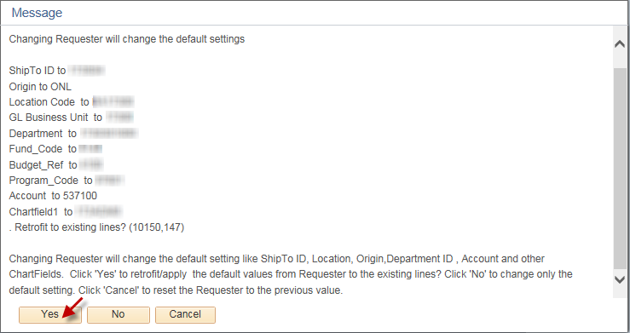
Requisition Page  Fastenal Punchout | Use the Fastenal link to open the Fastenal online web catalog within SMART. Use the supplier’s online catalog to locate items for ordering.  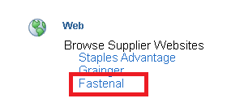

Fastenal’s Website
Locating Items | Use the Browse Products field to locate needed items.
Adding Items to Order | Select the desired quantity of the item and click Add, which will add item(s) to to the shopping cart.  Note: It is important to notice that the shopping cart does NOT reflect the total quantity of items ordered. Instead, the shopping cart reflects the number of different items ordered.
Continue Shopping | Additional items can be added by using the Browse Products field.
Submit Order | Use the Shopping Cart page to review the items before clicking Check Out and then the Complete Checkout button to transfer the item information from the vendor catalog to the requisition in SMART, which returns the user to the Checkout – Review and Submit page.

Returned to SMART Requisitions
Checkout – Review and Submit | Use the Checkout – Review and Submit page to review and edit the requisition details, prior to saving and submitting the requisition into the SMART workflow process for approval.  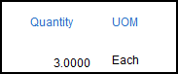  Note: Notice that the Quantity and UOM fields are not editable. When creating a requisition using a web catalog, the functionality of the Direct Connect interface with the supplier locks these fields down, preventing changes or edits.
Quantity Edits | To edit the Quantity for a web catalog requisition line, there are two options:  - Exit the existing requisition (do not save), and create a new requisition.  - Delete the line on the existing requisition, go back to the supplier’s website (click on the Add More Items button and then reuse the Fastenal Punchout link and re-enter the item and the correct quantity.
Noteworthy | It is important to know for the Fastenal Web Catalog (Direct Connect) requisitions:  - The Ship To location code or Shipping Address can be modified on the requisition lines.  - A single requisition line CANNOT be split into multiple Ship To locations.  - Fastenal catalog is associated to category codes and will default in their corresponding account code. However, it is the responsibility of the agency to ensure the correct acccount code for the purchase is used.
Line Details –  Contract | Important: Fastenal is an Statewide Optional Use supplier. Be sure review the contract on the Kansas eSupplier Public Portal. If appropriate, the contract should be associated to every line of a Fastenal requisition. Please see ‘Policy Manual 10,300 – Statewide Encumbrance Policy’ for more details.  To review the line detail information, use the Line Details icon to open the Line Details page, where line detail information, such as adding a Contract may be edited as necessary.  Use the Contract ID field to enter the Contract ID number if applicable to your requisition. If you do not know the Contract ID number, use the Lookup button (magnifying glass) to view and select from the available list of Contract ID numbers.  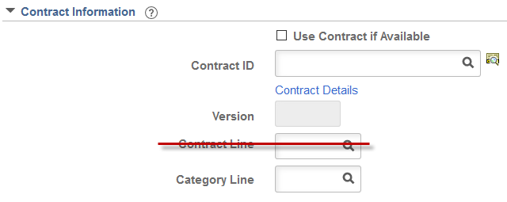  Note: The State of Kansas is not using the Contract Line field for requisitions. Please do not enter data in the Contract Line field for a requisition.
Mass Change | The Mass Change link can be used to add or change the Buyer, Category, Chartfield information, etc. to any one line, multiple lines, or all lines.  Note: Only the Requisition lines that have been selected by checking the box to the left of their line information or using the Select All / Deselect All link, will be affected by the changes/additions completed on the Mass Change link.  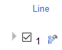
Save for Later | The save, preview, and submit requisition functions are located at the bottom of the page. Use the right scrollbar to navigate to the bottom of the page, if necessary.  Note: Budget checking in SMART is performed by an hourly batch process. Therefore, you do not need to use the Check Budget icon on the Review and Submit page of the requisition.  Use the Save for Later button to save the requisition for later use. When you click the Save for Later button, SMART will stay on the Review and Submit page.  Note: It is important to know that the Save for Later button does not submit the requisition into the SMART approval workflow process. Using the Save for Later button enables you to save the requisition for later use, and access it again from Manage Requisitions, without entering the requisition into the SMART workflow approval process.
Save & Submit | The Save & Submit button is used to save the requisition, and submit it for approval, sourcing and dispatching to the supplier.  Note: If you enter invalid ChartField values or ChartField combinations on the requisition, you will receive an error message when you try to save the requisition. If you receive an error message, correct the entry of ChartField values on the requisition and save the requisition.  The requisition remains editable while the requisition status is “Open” or “Pending”. When you click the Save & Submit button, SMART displays the Confirmation page to inform you that the request has been successfully saved and submitted into workflow for approval. The Confirmation page provides summarized information about the request, including the requisition ID and total price.
Note: If the purchase order has been dispatched and a change is required, contact your Fastenal representative. Change orders entered in SMART will not be processed by Fastenal electronically.
Optional New Order Template Functionality
New Order Template – Optional functionality that can assist with requesting repetitive items.

New Order Template | To create a New Order Template, expand the ADD TO CART menu and click on New Order Template.
Template Information | Enter a Template Name, Template Description and Click on Submit.
Using Order Templates | Click on Order Templates.
Add to Cart | Click Add to Cart.  .

