Training Guide – Billing
Creating and Processing Billing

State of Kansas

Applicable Role(s): Billing Administrator, Billing Processor and Central BI Configurator

TABLE OF CONTENTS

Billing Overview 4
4
End-to-End Billing Process 5
Billing Roles 5
Entering Bills Online 6
6
Online Bill Entry 6
Revenue Distribution Codes 18
Enter Express Bills 18
Updating Bills 18
Copying Bills 20
20
Copying Bills Overview 20
Enter and Copy an Existing Bill 21
Define Copy Group Header and Detail 24
Run Bill Copying Group Process 27
Create Recurring Bills 30
30
Creating Bill Templates 30
Running the Generate Recurring Bills Process 32
Managing Installment Bills 33
33
Entering an Installment Bill 33
Building an Installment Bill Schedule 33
Running the Generate Installment Bill Process 37
Researching Bills 39
39
Researching Bills Overview 39
Researching Non-Invoiced Bill Lines 39
Researching Non-Invoiced Bills 40
Processing Pro Formas and Reconciling Non-Invoiced Bills 41
41
Process Pro Formas 41

Billing Overview

SMART Billing offers real-time receivable and billing visibility, tracking and control for reporting and financial data. The streamlined approach enables users to bill customers quickly and efficiently. The complete integration of Billing with other SMART modules allows for the reduction of duplicate entries and manual processing.

Key Terms

- Standard Bill – A bill that is created by manual, online entry using the Standard Billing pages defined by Frequency as Once, Onetime bills, Installment bills, or Recurring bills; also known as a regular bill.
- Express Bill – The process of entering bills online quickly by adding or cloning existing bill lines in bulk
- Interface Bill – A bill that is automatically created from data interfacing from Project Costing
- Bill Type – A category of activity that should be grouped together on a particular bill
- Bill by Identifier – This is also known as the Bill Type Identifier (Bill Type). SMART Billing uses the bill-by ID to define how to group billing activity on invoices when it is added to a bill through data interfacing from Project Costing. A bill-by ID that you define can appear as the default at the customer, bill source, bill type, and business unit levels.
- Revenue Distribution Code – Codes used to simplify the process generating accounting entries by defining a valid combination of ChartField values
- Open Item – Amounts that are billed to a customer but are not yet paid

End-to-End Billing Process
Figure 1. Billing Lifecycle Process

Billing Roles
Role | Description
Billing Administrator | This role is responsible for setting bills to "ready" status and running the process to finalize invoices, as needed. This role also maintains agency-configured values in the Billing module.
Billing Processor | This role is responsible for creating new standard invoices and Pro Formas, copy single or groups of bills, reprint and review invoices, setting up and modifying installment schedules, creating new consolidated invoices, and printing invoices.
Central BI Configurator | This role is responsible for maintaining centrally controlled BI configuration values such as Remit To Addresses and Billing Sources.
Table 1. Billing Roles and Role Descriptions

Entering Bills Online

Online Bill Entry
**If Billing has not been utilized by an agency since implementation, configuration should be updated before proceeding with Online Billing. Enter a Service Desk ticket for configuration changes.

- In order to conduct business with customers, information needs to be tracked about including general and processing information and roles and correspondence options.
- Online bill entry enables you to enter bills manually into SMART. Each bill that you enter must have a header and at least one line.
- The order of page data entry is as follows: Header – Info 1, Line – Info 1, Line – Info 2, and Acct. Rev Distribution page.

Bill Header: The bill header contains valuable information, such as the bill source, the bill type, the customer information, and payment terms. It also includes receivable information and any additional internal or printed notes that need to be included for the bill.
  - Where the bill came from
  - Where the bill is going
  - When the bill is sent to the customer
  - The frequency of the bill

Note: Header Info 1 is general information and Header Info 2 is additional information. This information is added when entering a regular bill.

Page Name | Navigation
Header –Info 1 | Billing Homepage > Online Billing > Create Invoices > Standard Billing > Header-Info 1
 | NavBar
Header –Info 1 | Navigator > Billing > Maintain Bills > Standard Billing > Header-Info 1
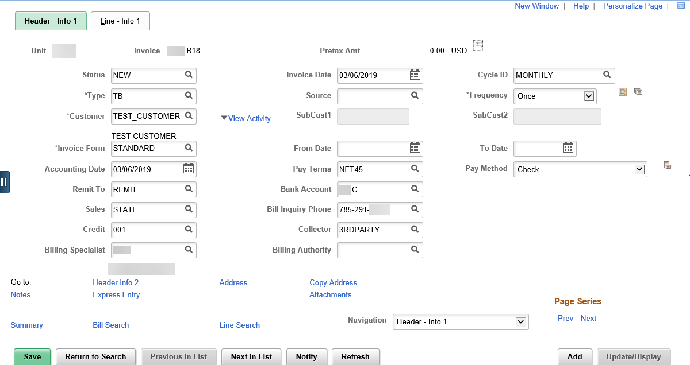
Figure 2. Header-Info 1 Page
Field | Description
Status | Status is usually defined as NEW, RDY, and INV to name a few of the options. Invoiced means that an invoice has been printed and an invoice number has been assigned. A non-invoiced bill is one that has not been printed. Bills are always created with a status of NEW and moved to RDY when they are ready to be invoiced. The change from NEW to RDY must be done by the user.
Invoice Date | Use this field to enter the invoice date. This can be a past, current, or future date.
Type | This field is also known as the Bill by Identifier and the Bill Type Identifier. Use this field to group billing. This field is agency specific. The SOK uses (Grants Management) GM for bills that are interfaced from Project Costing.
Bill Source | SOK is only using Online or Contracts for Bill Source
Frequency | Use this field to define the bill as either a Recurring, Installment or Once bill. The default is Once.
Customer | Use this field to enter the customer number if it was not entered on the Bill Entry > Add New Value page
Cycle ID | This field is also known as Bill Cycle. This field is defaulted from the Bill Type and can be overwritten.
Invoice Form | The SOK only uses one type of Invoice Form, STANDARD
From Date/To Date | These fields are service dates, and are used as information on the bill/invoice only
Pay Terms | Use this field to enter bill payment terms.
Pay Method | Use this field to enter the payment method, for informational purposes only. SMART searches the customer record for a default payment method. If one is not found, SMART does not populate this field. This field can be overwritten. The SOK values for payment methods are: CSH (cash), CHK (check), and EFT (electronic fund transfer).
Remit To | The SOK only uses REMIT for this field.
Bank Account | Use this field to select the Remit To Account. Each billing agency has one or more remit accounts. The account chosen on the bill determines what remit address is printed on the invoice. An example would be 173A or 173B. Agencies are responsible for differentiating between accounts if there is more than one.
Accounting Date | Use this field to enter the current SMART system date
Account | This field defaults from accounting set-up and should not be changed.
Sales | This field will default to STATE
Bill Inquiry Phone | Use this field to enter the phone number for the customer to call if there are questions regarding the bill. This field defaults from the Bill Type, but can be overwritten. This information is printed on the invoice.
Credit | The SOK uses 001 for this field
Collect | Use this field to enter collection information. The SOK values are 3RDPARTY and SETOFF.
Biller | Use this field to enter the Billing Specialist information that is assigned to the customer. This field defaults from the Bill Type and can be overwritten.
Table 2. Header - Info 1 Page Elements

Line –Info 1 Page:
Use this page to enter bill line general data and the bill Identifier. Identifiers are created with an association with distribution codes.
Page Name | Navigation
Line – Info 1 Page | Billing Homepage > Online Billing > Create Invoices > Standard Billing > Line – Info 1
 | NavBar
Line – Info 1 Page | Navigator > Billing > Maintain Bills > Standard Billing > > Line – Info 1

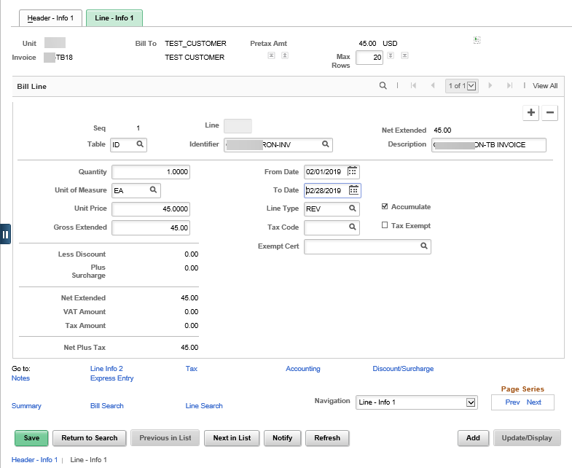
Figure 3. Line-Info 1 Page

Field | Description
Table | The value selected for Table determines what Identifier values are available. The SOK only uses the ID (PS/Billing Charge ID) value.  Note: If the Table field is left blank, agencies can enter a one-time only identifier and description
Identifier | This code is used to bill for an item that is not usually classified as a product by normal business standards. By selecting an Identifier, the following fields default, Description, UOM, List Price, and Distribution Code. (List Price and Distribution Code are optional on the Identifier set up, so some Identifiers may not have these values. All fields related to Identifier can be overwritten.
Description | This field defaults from the Identifier
Quantity | Use this field to enter the quantity of the goods or services.
Line Type | This field is a default value and will always be REV
UOM | This field defaults from the Identifier
From/Through Date | Use these fields to indicate the start/end date of the billing activity that the corresponding invoice covers
Unit Price | This field defaults based on the Quantity and the Identifier fields if a List Price was associated with an Identifier. This field can be overwritten.
Gross Extended | This field defaults based on values in the Quantity and Unit Price fields
Table 3. Line-Info 1 Page Elements

Line-Info 2 Page:
Use this page to enter an entry type and reason code that relates to the distribution code. When bills move into Accounts Receivable, all billing distribution codes are no longer available. The only way to verify the accounting information in AR on a bill is to view the bills Entry Type and Reason Codes.
Page Name | Navigation
Line-Info 2 | Billing Homepage > Online Billing > Create Invoices > Standard Billing > Navigation drop-down > Line-Info 2
 | NavBar
Line-Info 2 | Navigator > Billing > Maintain Bills > Standard Billing > Navigation drop-down > Line-Info 2

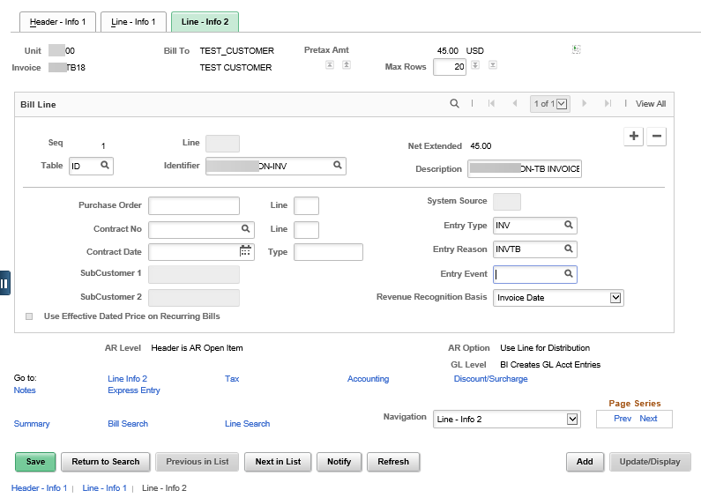
Figure 4. Line - Info 2 Page

Field | Description
Entry Type | Use this field to categorize the pending items that create items in SMART. Entry Types must be selected on a bill line because this value moves into Accounts Receivable. Entering the Entry Type does not create accounting entries, but when reviewing the item in Accounts Receivable, there is no way to easily identify what accounting line was created if there is no Entry Type on the bill. Entry types for SOK Billing are INV (Invoice) and IF (InterFunds).
Entry Reason | Use this field to categorize different uses for a single entry type. Entry Reasons alone or in association with Entry Types do not create accounting entries, but when reviewing the item in Accounts Receivable, there is no way to easily identify what accounting line was created if there is no Entry Reason on the bill.
Table 4: Line –Info 2 Page Elements

Acctg – Rev Distribution Page:
Use this page to view/enter/update bill line accounting information.
Page Name | Navigation
Acctg-Rev Distribution Page | Billing Homepage > Online Billing > Create Invoices > Standard Billing > Navigation drop-down > Acctg –Rev Distribution
 | NavBar
Acctg-Rev Distribution Page | Navigator > Billing > Maintain Bills > Standard Billing > > Header – Info 1 > Navigation drop-down > Acctg –Rev Distribution

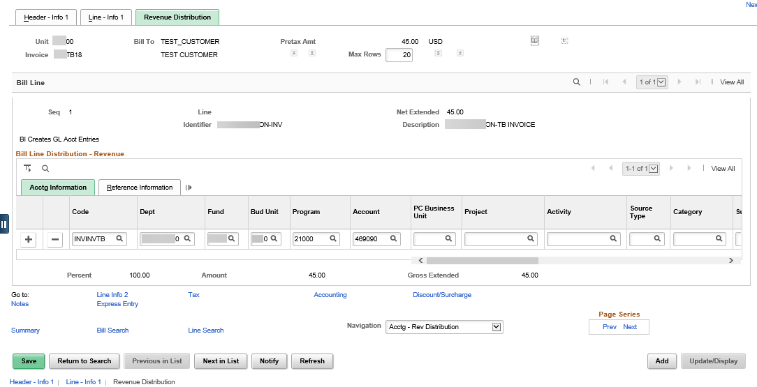
Figure 5. Acctg-Rev Distribution Page
Field | Description
Code (Revenue Distribution Code) | Revenue Distribution Codes are the combination of Entry Type and Reason Codes. If a Revenue Distribution Code does not auto-populate, then it is not associated with the selected Identifier. Agencies have the ability to change/enter the Revenue Distribution Code. However, if your agency is continually using a Revenue Distribution Code that is not associated with an Identifier, then it is in the agencies best interest to contact their AR Configurator to add the necessary Revenue Distribution Code to the Identifier.  Note: If the Revenue Distribution Code is changed, you MUST update the related Entry Type and Reason Code.
ChartFields for SOK | Use these fields to update Accounts Receivable Distribution codes, if necessary.  Note: Multiple Distribution Codes can be used per Bill Line, based off percent. However, the only ChartField that can be different is the Account. If a bill line needs to be split by ChartFields other than the Account, one line must be entered per Distribution Code.
Table 5. Acctg-Rev Distribution Page Elements

Note Pages:
SMART allows users to incorporate notes on bill headers and/or bill lines that can be seen on the customer invoice, or used for internal agency use only. There are two different types of notes, Standard and Free form.

Standard notes are notes that are generally used repeatedly on customers or specific invoices. For example, a standard note, within the note type of ADJUST, might state, “Please note that an adjustment has been made to your account to reflect the proper balance.”

Note: Standard notes must be associated with a note type. Some standard notes are predefined in SMART. Agencies can also create and maintain standard notes. Free-form notes are generally notes that are customer or scenario specific.

Header Note Page
Use this page to enter header notes.

Page Name | Navigation
Header Note | Billing Homepage > Online Billing > Create Invoices > Standard Billing > Header – Info 1 > Navigation drop-down > Header – Note
 | NavBar
Header Note | Navigator > Billing > Maintain Bills > Standard Billing > Header – Info 1 > Navigation drop-down > Header – Note

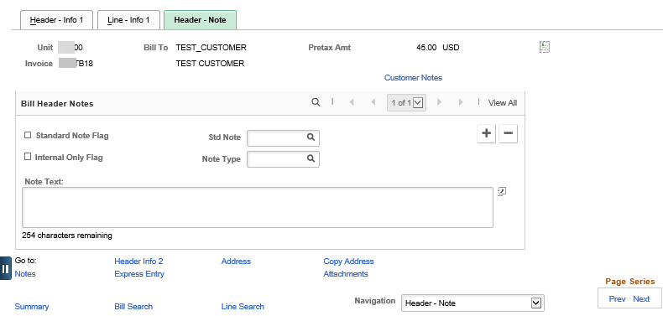
Figure 6. Header Note Page
Field | Description
Standard Note Flag | Use this check box to indicate the note is a standard note that the customer can see on the invoice
Std Note | Use this field to select the note as a Standard Note. Standard Notes are categorized in the Note Type field.
Internal Only Flag | Use this check box to indicate the note is for internal use only, and is not be seen by the customer
Note Type | Use this field to categorize/group notes. These can be standard notes or one-time only for a specific bill. Note types do not print on a specific invoice. Categorizing notes using note types allows for simpler searching for a specific note.
Note Text | This field is used for the auto-population of the Standard Note, or for Free-form notes.  Note: If a standard note is used, agencies can include further description here.
Table 6. Header Note Page Elements

Line Note Page
Use this page to enter line notes.

Page Name | Navigation
Line Note | Billing Homepage > Online Billing > Create Invoices > Standard Billing > Header – Info 1 > Navigation drop-down > Line – Note
 | NavBar
Line Note | Navigator > Billing > Maintain Bills > Standard Billing > Header – Info 1 > Navigation drop-down > Line – Note

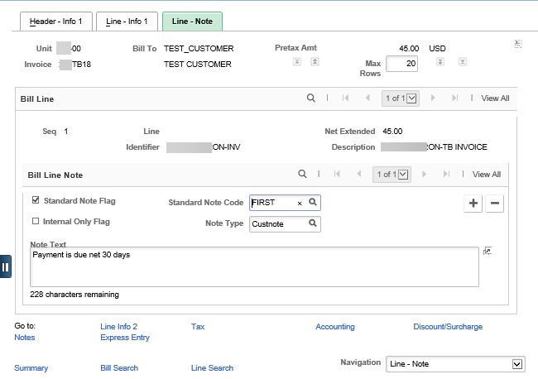Figure 7. Line Note Page

Revenue Distribution Codes
- Revenue distribution codes are set up and used in SMART Billing to generate a combination of ChartFields for funding
- These codes default from the Identifier and can be overwritten on the bill when necessary
- Distribution codes are created based directly on entry type and reason codes. If a distribution code is not selected, but entry type and reason codes are, ChartFields are NOT populated. Entry types and reason codes must be selected so that a record of distribution information can be found in Accounts Receivable.
- There may be situations when modifications to the ChartField information are necessary. This can be done by selecting a different distribution code. If a different distribution code is selected all ChartField information is removed, and new ChartField information is populated. You can change ChartFields within the defaults

Enter Express Bills

**Express Bills are not encouraged. For large numbers of bills and lines, there is now the Billing Worksheet Upload that is encouraged. Submit a Service Desk ticket for more information.

- SMART Express Billing combines the standard bill entry pages to reduce the number of pages that you need to access when entering bills online. Express billing enables you to:
  - Enter bills online quickly, especially when you have a large number of lines per bill
  - Add and clone existing bill lines in bulk
- When entering data on the Add New Value page for Express Billing, SMART auto-populates the necessary information on the Header-Primary page. It is best practice to verify that the information is correct before continuing to enter information on the Line List page.
Page Name | Navigation
Line List Page | Billing > Maintain Bills > Express Billing > Line List
 | NavBar
Line List Page | Navigator > Billing > Maintain Bills > Express Billing > Line List

Updating Bills
- SMART Billing provides bill header data and bill line data online for inquiry, regardless of the bill status
- When updating bills, it is best practice to change the bill status to HOLD (HLD) while making changes to the bill
- End users cannot update bills with a bill status of INV. A rebill must be created. Rebills and other adjustments will be covered in AR354, Advanced Billing Process

Copying Bills

Copying Bills Overview

Copying Individual Bills
- There may be situations when you need to enter a bill that is very similar to an existing bill. You can choose to copy the existing bill and update this bill as necessary. Copying bills can save data entry time and minimize the potential for errors.
- You can copy any bill regardless of its status. When you copy a bill, all bill information including notes and accounting distribution is copied from the original bill. The only information that does not copy from the original bill is the bill status, the invoice date, and the invoice number.
- When you copy a bill, the new bill is created with a status of NEW and a blank invoice date. The current system date is specified as the date on which the bill was created. After a bill has been copied, you can edit any field.
Copying Groups of Bills
- You can define a group of bills to be copied together. In doing so, you must define a copy group header for each group of bills to be copied together. After you have defined the copy group header, you attach and use the bills as copy templates. You can assign as many bills as required to a copy group header. You must also assign the beginning date, ending date, and the new bill status to the copy group detail.
- You can choose any bill to be used as a copy template, regardless of the status. All bill information, including notes and accounting distribution is copied from the original bill. The only information that does not copy from the original bill is the bill status, invoice date, and invoice number. The new bill is created with the status designated by the copy detail, a blank invoice date, and the current system date as the bill-added date. You can edit any field on the newly created bill, if necessary.
- You can copy the same copy group an unlimited number of times within the date range defined. When using a copy group, you are not required to copy all the templates in the group. Instead, you can select which templates are to be copied.
- When you use a copy group for copying, the invoice number is set by default to NEXT. However, you can override the default and manually assign the invoice number (at the agency’s discretion). For example, suppose your company leases office space in a building. Each tenant's monthly rent is set up as a recurring bill because the monthly rent is a predefined amount for the term of the lease. In addition to the building space, you provide each tenant with cleaning services, which are billed on an "as used" basis. To save data entry time, you can set up a template for each tenant's cleaning service charges as a copy group. Each month, you can select the templates for the tenants who have used the cleaning service. After the manually run copy group process is completed, the bills are ready to finalize and print.
- To copy groups of bills together in a group, you need to:
  - Define the copy group header information
  - Assign bills to the copy groups
  - Define the copy group details
  - Run the Bill Copy Group process (BICPYGRP)
Figure 9. Copying Groups of Bills Process

Enter and Copy an Existing Bill
Copy Single Bill Page:
Use this page to copy the information of an existing bill to a new bill.
Page Name | Navigation
Copy Single Bill | Billing Homepage > Online Billing > Create Invoices > Copy Single Bill > Enter Invoice Number to copy
 | NavBar
Copy Single Bill | Navigator > Billing > Maintain Bills > Copy Single Bill > Enter Invoice Number to copy

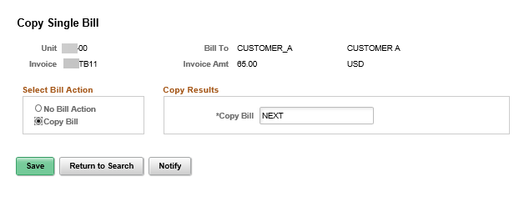
Figure 10. Copy Single Bill Page

Header – Info1 Page:
Use this page to access and review bill header general information.

Page Name | Navigation
Header – Info 1 | Billing Homepage > Online Billing > Create Invoices > Copy Single Bill > Go To Bill Header – Gen. Info Link
 | NavBar
Header – Info 1 | Navigator > Billing > Maintain Bills > Copy Single Bill > Go To Bill Header – Gen. Info Link

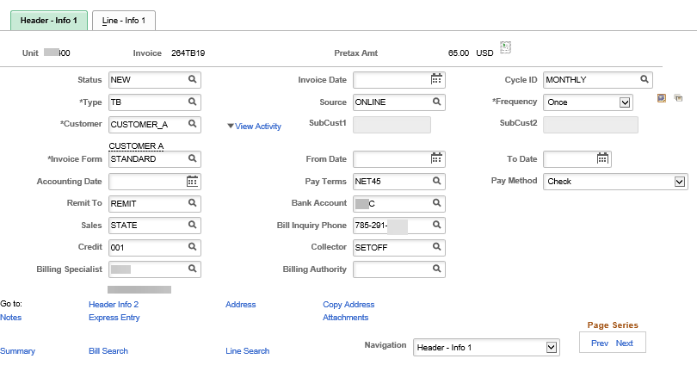
Figure 11. Header - Info 1 Page

Line – Info 1 Page:
Use this field to enter bill line general data.

Page Name | Navigation
Line – Info 1 | Billing Homepage > Online Billing > Create Invoices > Copy Single Bill > Go To Bill Header – Gen. Info Link > Line – Info 1
 | NavBar
Line – Info 1 | Navigator > Billing > Maintain Bills > Copy Single Bill > Go To Bill Header – Gen. Info Link > Line – Info 1

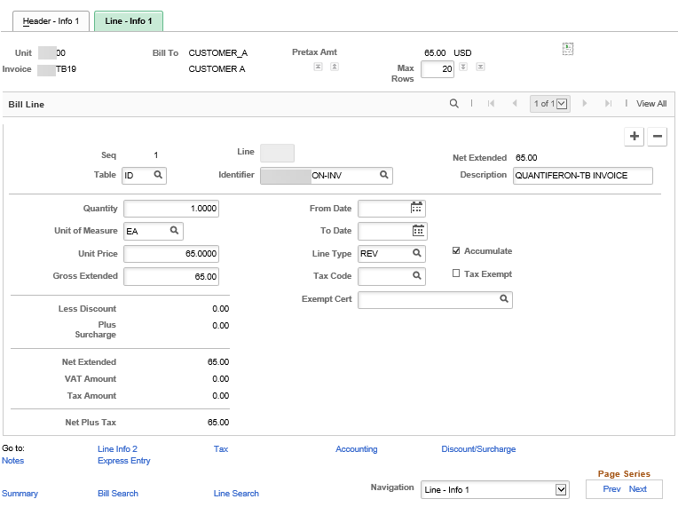
Figure 12. Line - Info 1 Page

Define Copy Group Header and Detail
Copy Group Header Page:
Use this page to define copy group header information. This is the first required step to define groups of bills to be copied together in a batch. This utility is useful if you have bills that you invoice each month and only a small portion of the information changes.

Page Name | Navigation
Copy Group Header | Billing Homepage > Online Billing > Create Invoices > Define Bill Copy Group
 | NavBar
Copy Group Header | Navigator > Billing > Maintain Bills > Define Bill Copy Group

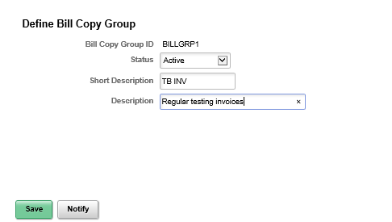
Figure 13. Copy Group Header Page

Field | Description
Status | Use this field to select the bill status of Inactive or Active
Table 7. Copy Group Header Page Elements

Define Copy Group Detail Page:
Use this page to assign bills to appropriate copy groups. This is the second required step when defining groups of bills to be copied together in a batch.

Page Name | Navigation
Define Copy Group Detail | Billing Homepage > Online Billing > Create Invoices > Define Copy Group Details
 | NavBar
Define Copy Group Detail | Navigator > Billing > Maintain Bills > Define Copy Group Details

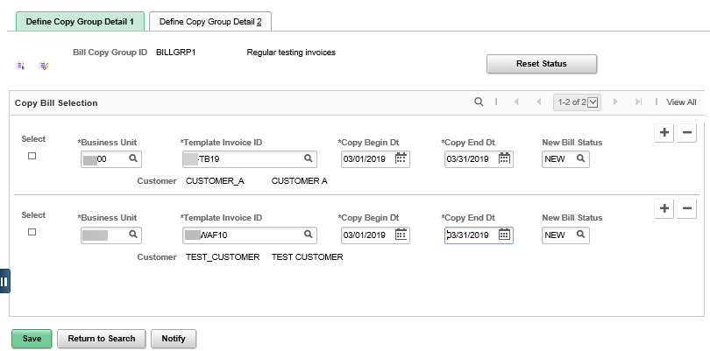
Figure 14. Define Copy Group Detail 1 Page
Field | Description
Select All | Use this icon to select all invoices to copy
Deselect All Invoices | Use this icon to deselect all invoices to copy
Template Invoice ID | Use this field to enter the invoice number to be copied
Copy Begin Dt /Copy End Dt | These fields represent the start and end copy dates for this template. When you initiate the copy bill group process, the system determines if the run date is within these copy dates.
New Bill Status | Use this field to enter the status that is assigned to the new bill; HLD (Hold) or NEW
Table 8. Define Copy Group Detail 1 Page Elements
Define Copy Group Detail 2 Page:
Use this page to define copy group details. This is the third required step when defining groups of bills to be copied together in a batch. After running the Copy Group of Bills process, return to this page to verify invoice numbers or process error details.

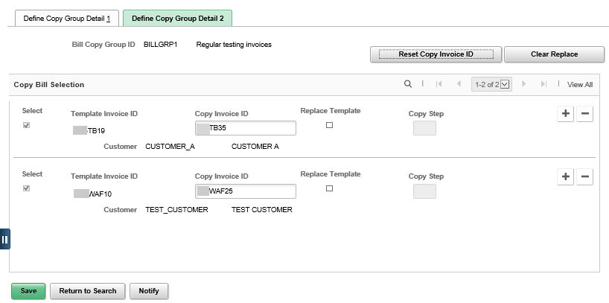
Figure 15. Define Copy Group Detail 2 Page
Field | Description
Reset Copy Invoice ID | Use this button to reset all of the copy invoice IDs to NEXT. Before running the process again, reset the copy invoice IDs. Otherwise, the system attempts to reassign the old invoice IDs to the new bills and an error occurs.
Clear Replace | Use this button to clear the Replace Template check boxes for the entire group
Copy Invoice ID | Use this field to define the invoice number of the new bill. The default field value is NEXT. It is best practice to leave the default value, but if you have authorization, you can override this default with any number if that number is not a duplicate of an existing invoice.
Replace Template | Use this checkbox to make the bill the “template” from which you copy when making changes to the original bill and want to keep those changes every time you copy bills. The copy is identical to the template. You can use either the original bill or the new copy as the template. You can change the resulting copy through bill entry. For example, you can add lines, alter amounts and dates, or modify header and line notes on the bill that you just created through the copy process. In addition, you can incorporate all changes into the new template to include the modifications that you make to this bill (which is now the new template in the copy group) in any subsequent copy processes.  Select the Replace Template check box in conjunction with bill status change. If you do not select this option, the templates do not change and SMART uses the old version the next time that you run the copy process.
Copy Step | This field displays the status of the last copy bill group run
Table 9. Define Copy Group Detail 2 Page Elements

Run Bill Copying Group Process
After you have defined a copy group header and assigned bills, run the bill copy group process to produce bills identical to the template bills. This is the fourth required step to copy a bill group.

Run Bill Copy Group Page:
Use this page to process the group of bills you wish to copy.
Page Name | Navigation
Run Bill Copy Group Page | Billing Homepage > Online Billing > Create Invoices > Copy Bill Group
 | NavBar
Run Bill Copy Group Page | Navigator > Billing > Maintain Bills > Copy Bill Group

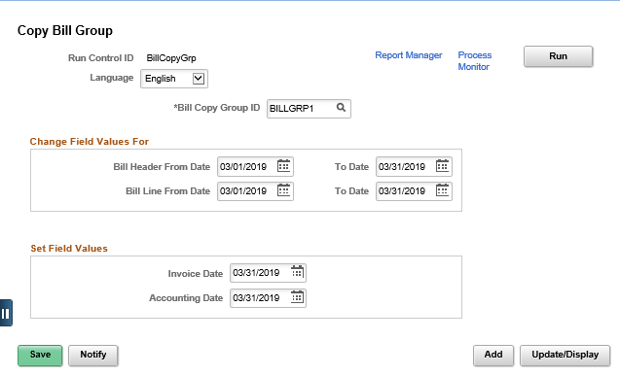
Figure 16. Run Bill Copy Group Page
Field | Description
Bill Copy Group ID | This field is the Copy Group ID that was created on the Define Copy Group page
Bill Header From /To Date | Use these fields to create new To and From header dates
Bill Line From/To Date | Use this field to enter new To and From bill dates
Invoice Date | Use this field to enter the invoice date. This can be a past, current, or future date.
RUN button | Click to start the Copy Group Process BICPYGRP
Table 10. Run Bill Copy Group Page Elements

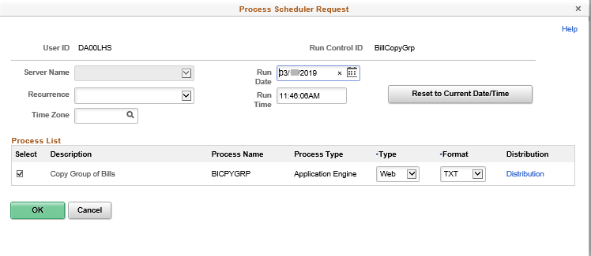
Figure 17. Process Scheduler Request Page
Click the OK button to return to the Run Bill Copy Group page. Click the Process Monitor button. When Run Status is Success and Distribution Status Posted, the bills have been copied.

Create Recurring Bills

**The following section has not been tested extensively with the latest upgrades. If interested in this functionality, please submit a Service Desk ticket.

Creating Bill Templates
- To create a recurring bill template, enter a new bill that specifies a billing cycle ID with recurring bill parameters, set Recurring as the frequency, and complete the Recurring Bill Schedule page
- Recurring bills are created, according to the defined schedule established when the Recurring Bill Generation process is run
- Recurring bills cannot be created until the recurring bill template is set to the status of RDY

Page Name | Navigation
Recurring Bill Schedule | Navigator > Billing > Maintain Bills > Recurring Bill Schedule

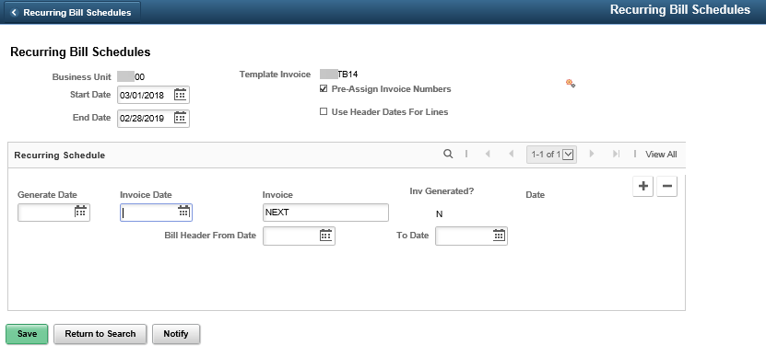
Figure 18. Recurring Bill Schedule Page
Field | Description
Template Invoice | This is the number from the invoice you are using as a template. SMART auto-generates the number when the original bill was created.
Start Date | Use this field to enter the start date of the recurring bill schedule
End Date | Use this field to enter the ending date of the recurring bill schedule
Pre-Assign Invoice Numbers | Select this field if you want SMART to pre-assign invoice numbers in a recurring schedule
Use Header Dates for Lines | Select this checkbox to use the bill header From and To Dates on the bill lines (for invoices that have not been generated). Do not select if you prefer the line From and To Dates to appear by default from the recurring bill template.
Generate Rev. Rec. Schedule | Use this icon to generate a recurring bill schedule, or to regenerate if changes were made
Recurring Schedule Section | The recurring bill schedule is shown once you generate the schedule
Generate Date | This field is auto-populated based on the billing cycle selected on the Header – Info 1 page once the Generate Rev. Rec. Schedule is run
Invoice Date | This field is auto-populated based on the billing cycle selected on the Header – Info 1 page once the Generate Rev. Rec. Schedule is run
Invoice | When generating the invoice, SMART uses the value in this field as the invoice ID. If the invoice value is Next, SMART assigns the next available invoice number in the sequence once that invoice is generated. If Pre-Assign Invoice Number is selected, SMART assigns all of the invoice numbers to the recurring bills when you save the page.
Inv. Generated | This indicates whether SMART generated the invoice for the corresponding line. If the indicator is Y (yes), the date on which the invoice was generated appears under Date.
Table 11. Recurring Bill Schedule Page Elements

Running the Generate Recurring Bills Process
- Generate recurring bills after the bill template with bill schedule is created. The bill template also needs to be set to RDY. Recurring bills are created when the Generate Recurring Bills process is run.
Generate Recurring Bills Page:
Use this page to generate recurring bills.

Page Name | Navigation
Generate Recurring Bills | Navigator > Billing > Maintain Bills > Create Recurring Bills

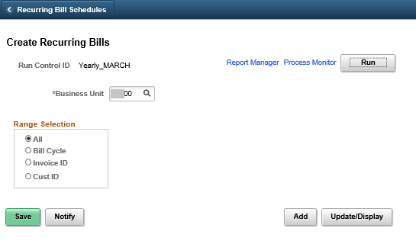
Figure 19. Recurring Bill Schedule Page
Field | Description
Business Unit | Use this field to enter your agency specific business unit. You must enter a business unit.
Range Selection | Use this selection area to choose the range of bills based on Bill Cycle, Invoice ID, Customer ID, or all the above. It is best practice to use Invoice ID so one division of an agency does not accidentally create a recurring bill for another division of that agency who might not be ready to create their own recurring bills.
Table 12. Recurring Bill Schedule Page Elements

Managing Installment Bills

**The following section has not been tested extensively with the latest upgrades. If interested in this functionality, please submit a Service Desk ticket.

Entering an Installment Bill
- Each installment-billing invoice carries its own information for accounting. SMART copies the default information from the template for installment billing invoices to the individual installment invoices. This means that Standard Bill must be saved with a Frequency of Installment.

Building an Installment Bill Schedule
- SMART Billing enables to build a schedule for installment bills. You can customize the schedule based on your customer's requirements. Tasks in building a schedule include:
  - Adding billing terms applied to the installment bills
  - Generating a bill schedule based on an installment bill plan
- After an installment bill is created, the bill status must be changed to RDY to allow for processing (this is done on the Header-Info 1 page)
Installment Bill Terms Page:
Use this page to select installment-billing plans.

Page Name | Navigation
Installment Bill Terms | Navigator > Billing > Maintain Bills > Installment Bill Schedule

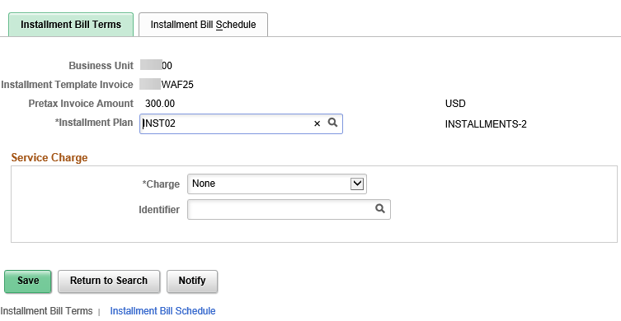
Figure 20. Installment Bill Terms Page

Field | Description
Installment Plan | Use this field to identify a predefined plan
Table 13. Installment Bill Terms Page Elements
Installment Bill Schedule Page:
Use this page to create schedules based on the installment billing plan and bill cycle parameters.

Page Name | Navigation
Installment Bill Schedule | Navigator > Billing > Maintain Bills > Standard Billing > Installment Bill Schedule Link > Installment Bill Schedule

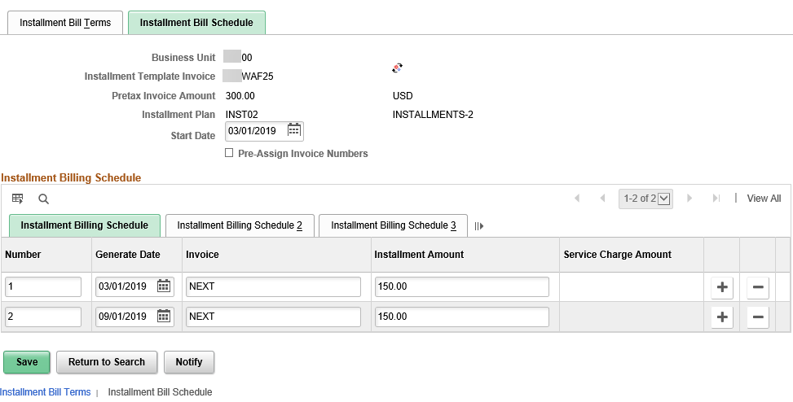
Figure 21. Installment Bill Schedule Page
Field | Description
Start Date | Use this field to enter the date from which the installment bill schedule is effective
Pre Assign Invoice Numbers | Select this check box to have SMART assign all of the invoice numbers to the installment bills when you save the page. Clear this check box to have SMART assign invoice numbers when you generate installment bills.
Generate Installment Bill Schedule | Use this button to generate the installment bill schedule for percentage installments or equal installments plans. If you change any of the schedule information on this page, the Generate Installment Bill Schedule button name changes to Regenerate Installment Bill Schedule. Regenerating an installment bill schedule deletes and replaces any lines for which installment bills have not already been generated.
Number | This is an auto-populated field that holds the number of the installment bill in sequential order. This field cannot be changed or updated.
Generate Date | Use this field to enter the date on which you want the system to generate the invoices. The system generates only installment bills with a generate date that is equal to or earlier than the current date. However, if you choose to Generate an Installment Bill Schedule, SMART auto populates the generate date.
Installment Amount | This field is auto populated by SMART with the pre-defined bill amount. This field cannot be changed or updated
Table 14. Installment Bill Schedule Page Elements
Installment Billing Schedule Tab Expanded:
This tab displays the bill schedule generated for the installment bill.
Page Name | Navigation
Installment Billing Schedule Tab Expanded | Navigator > Billing > Maintain Bills > Standard Billing > Installment Bill Schedule Link > Installment Bill Schedule

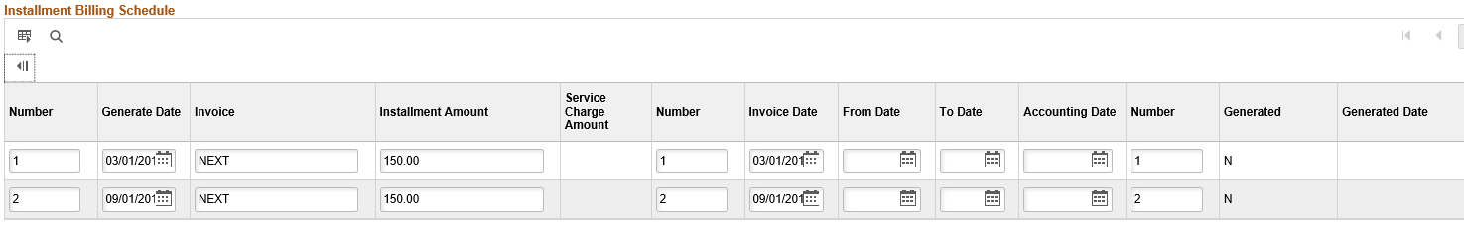
Figure 22. Installment Billing Schedule Tab Expanded
Installment Billing Schedule 2 Tab Expanded:
This tab displays the invoice date, and the accounting date, once the invoice has been posted to the GL.

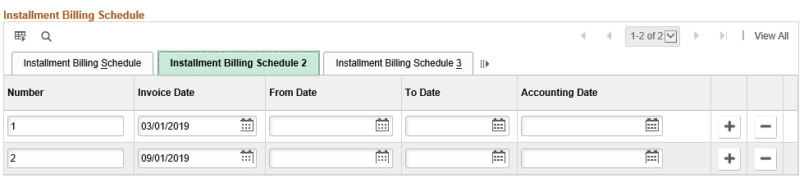
Figure 23. Installment Billing Schedule 2 Tab
Installment Billing Schedule 3 Tab Expanded:
This tab displays the date the actual invoice is generated. If the invoice has been generated, you can select the View Header Details button to navigate directly to the bill header.

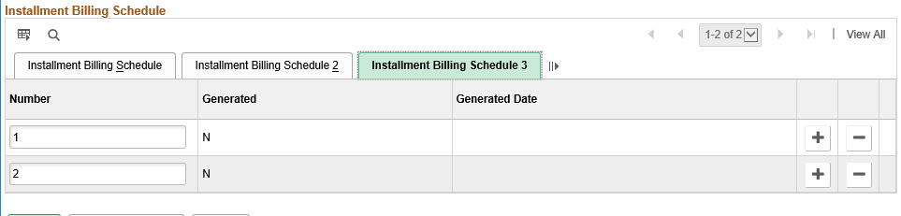
Figure 24. Installment Billing Schedule 3 Tab

Running the Generate Installment Bill Process
- You can generate installment bills after the bill template and the bill schedule are defined. You also need to ensure that the status of the installment bill template is set to RDY (Ready).
  - Installment bills are created when you run the Generate Installment Bills process. The Generate Installment Bills process enables you to generate recurring bills according to billing cycle ID, invoice ID, or customer ID.
- After the process has been run to success, return to the installment bill schedule page to verify on the Installment Billing Schedule 3 tab that the invoices have been generated (Y)

Generate Installments Page:
Use this page to enter the request parameters. These parameters are used to define the processing rules and data to be included when the process is run.

Page Name | Navigation
Generate Installments | Navigator > Billing > Maintain Bills > Create Installment Bills

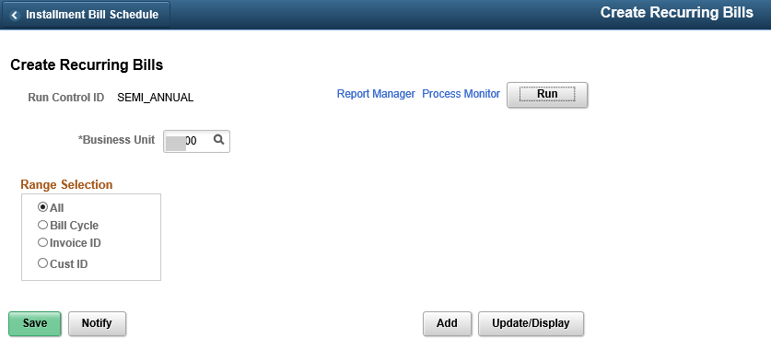
Figure 25. Generate Installments Page

Researching Bills

Researching Bills Overview
- SMART Billing enables you to search for bills by specifying criteria. You can search for a single bill, a group of bills, a single bill line, or a group of bill lines.
- Bill Not Invoiced and Lines Not Invoiced pages enable you to search for bills and lines not invoiced. These pages provide links to the pages you to modify information.
- You can also use the Bills Invoiced and Lines Invoiced pages to search for any bill or bill lines, regardless of status. With these pages, you can only view bill and bill line information.

Researching Non-Invoiced Bill Lines
- SMART enables you to search for bills and bill lines based on a search criterion. When searching for a non-invoiced bill line, you can review and update information.

Bill Line Search:
Use this page to search for any non-invoiced bill lines.

Page Name | Navigation
Bill Line Search | Billing Homepage > Online Billing > Search for Bills > Lines Not Invoiced
 | NavBar
Bill Line Search | Navigator > Billing > Locate Bills > Bills Not Invoiced

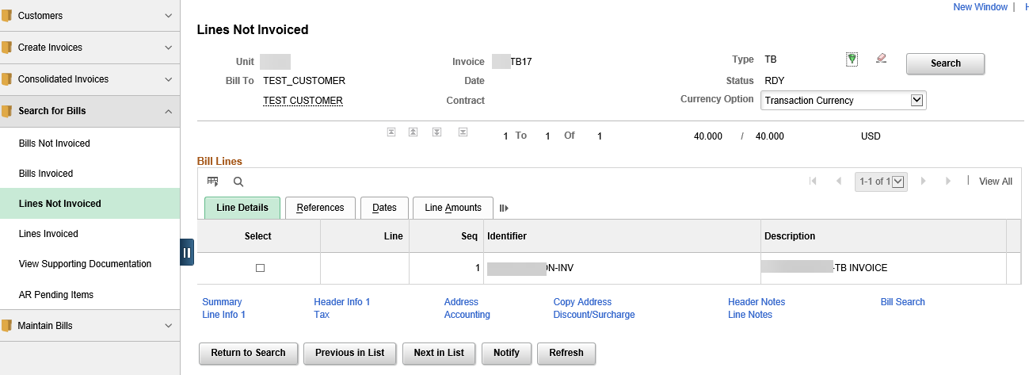
Figure 26. Bill Line Search Page

Researching Non-Invoiced Bills
- In SMART Billing, you can search for bills by specifying a search criterion. This enables you to review only those bills that meet your requirements. When searching for a non-invoiced bill, you can review and update information.

Bill Summary Info Page:
Use this page to review bill summary information.

Page Name | Navigation
Bill Summary Info | Billing > Online Bills > Manage Bills > Review Billing Info Summary
 | NavBar
Bill Summary Info | Navigator > Billing > Locate Bills > Bills Not Invoiced > Bill Selection > Summary Link

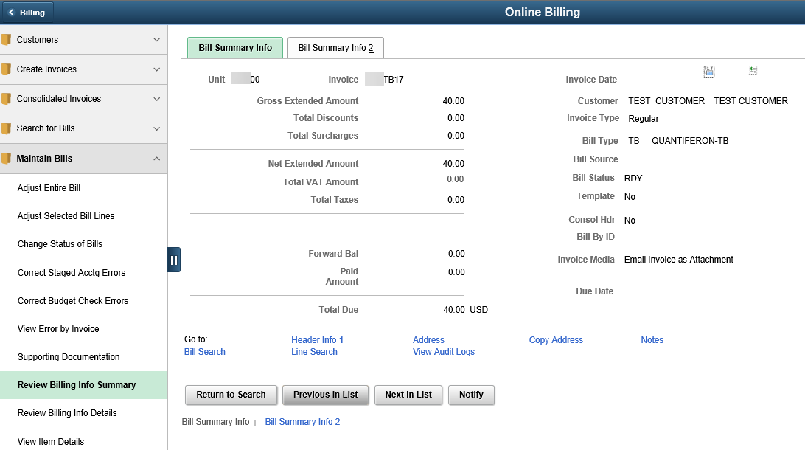
Figure 27. Bill Summary Info Page

Processing Pro Formas and Reconciling Non-Invoiced Bills

Process Pro Formas

- A Pro Forma is a preview of Billing invoice that can still be modified
- A Pro Forma is identical to an invoice except for two things: the word "Pro Forma" appears at the top of the page instead of "Invoice," and the estimated due date is printed instead of the actual due date. You can generate a Pro Forma before or after bills are in the RDY state, since you are producing a "sample" invoice. Printing Pro Formas enables you to review and correct errors before bills are invoiced.
- A Pro Forma may also be generated from the Standard Billing entry page. At the upper right, clicking the icon will generate a Pro Forma invoice.
Page Name | Navigation
Non-Consolidated Pro Forma | Billing Homepage > Create Invoices > Print Pro Forma
 | NavBar
Non-Consolidated Pro Forma | Navigator > Billing > Generate Invoices > Non-Consolidated > Print Pro Forma

The first time you generate a Pro Forma invoice, you will “Add a New Value” to create a Run Control ID. You can reuse the Run Control ID for future Pro Formas.

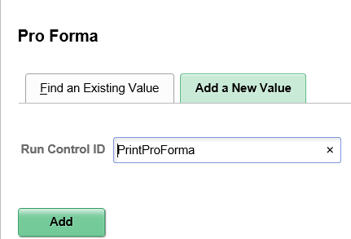
Figure 28. Pro Forma – Add a New Value Page
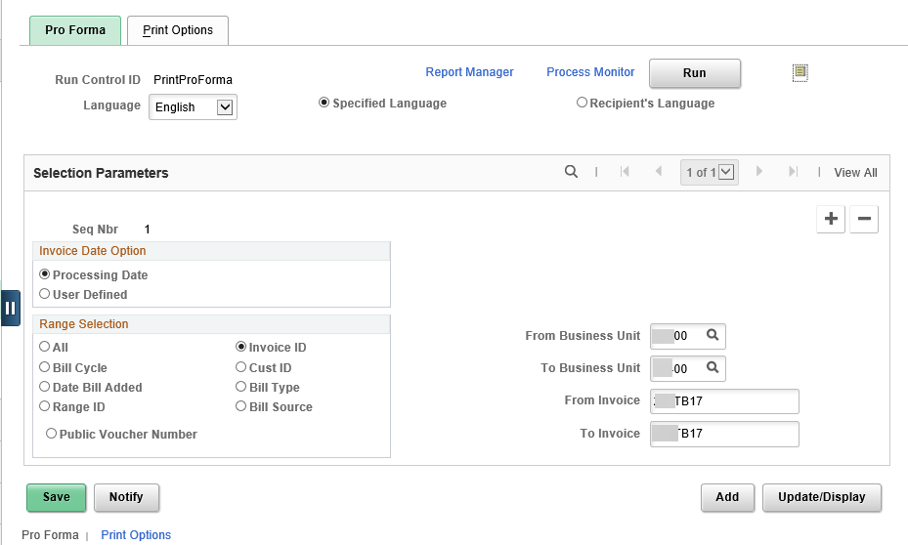
Figure 29. Pro Forma Page
Field | Description
Range Selection | Use this field to select the range type.
From/To Invoice | Use this field to enter the From and To Invoice Numbers for the Pro Formas you wish to process and print
Bills To Be Processed Icon | Use this icon to view and verify the listing of bills to be processed as part of the pro-forma process. This should be done after all the parameters have been entered.
Run Button | Click to run the Pro Forma process
Table 15. Pro Forma Page Elements
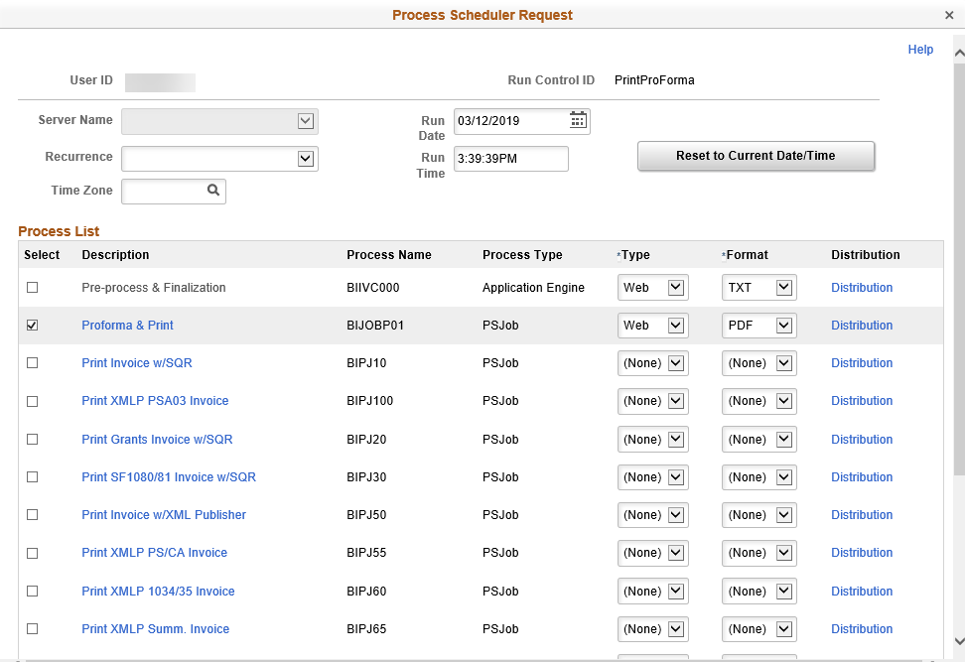 Figure 30. Process Scheduler Request Page
Field | Description
Server Name | Select server
Select | Click to select process
Description | Proforma & Print describes Process Name
Process Name | Process Name for Proforma & Print is BIJOBP01
Type | Select Web from drop down list
Format | Select PDF from drop down list
Click the OK button after completing the above fields

Clicking OK on the Process List page returns you to the Pro Forma Page. The next step is to click the Process Monitor link to access the Process List page.
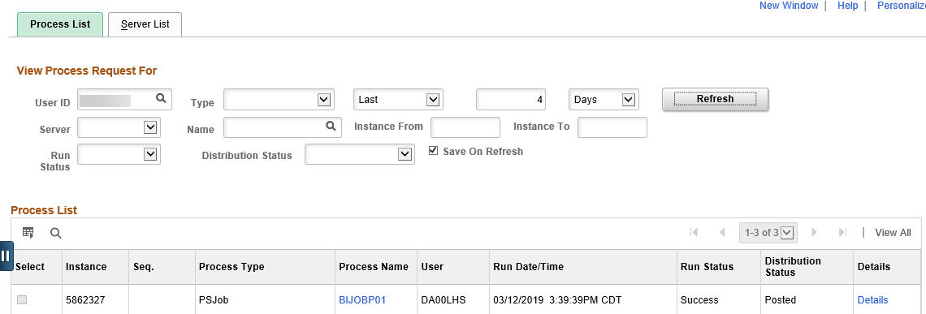Figure 31. Process List Page
Field | Description
Refresh button | Click until Run Status is “Success” and Distribution Status is “Posted”
Instance | Number created for each process request
Process Name | Process Name for Proforma & Print is BIJOBP01
Click the Process Name BIJOBP01 link for your process instance
Click the Go Back to Pro Form link at the bottom on the Process Scheduler page. Select the Report Manager link at the top of the page. Select the BIXPRNT00 pdf file hyperlink.
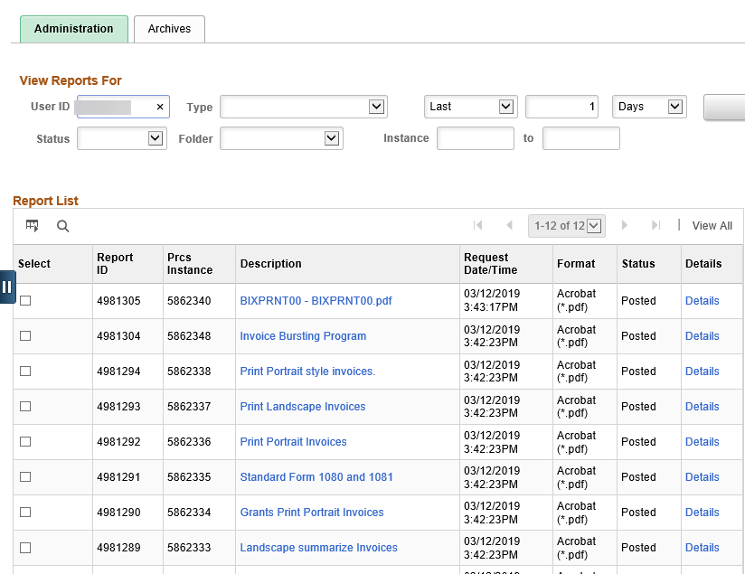
Figure 32. Report Manager Page

