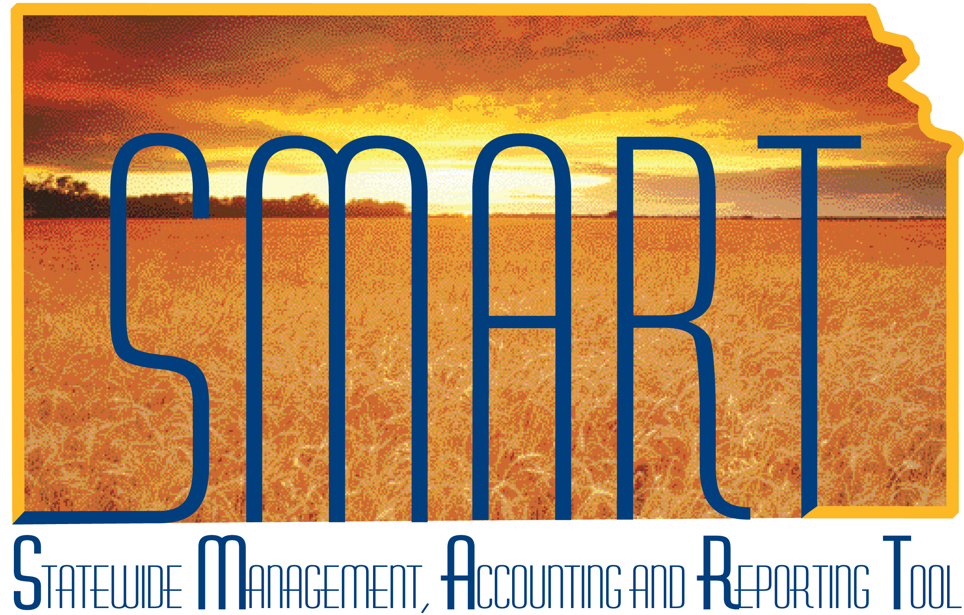

Training Guide – Accounts Receivable
Creating and Maintaining Receivables

State of Kansas

Applicable Role(s): AR Agency Administrator, AR Configurator, AR Maintainer and Pending Item Processor

Table of Contents
Introduction to Receivables 3
Receivables Process 4
Accounts Receivable Roles 5
Entering and Reviewing Receivables 5
Working with Pending Items 5
Updating Pending Items 11
Maintaining and Updating Receivables 12
Changing Item Pay Terms 12
Multi-Item Update 13
Maintenance Worksheets 14
Unposting Item Groups 19
Transferring Receivables 20
Using Worksheet Actions 20
Account Aging and Communication 23
Aging Summary Report 23
Processing and Printing Customer Statements 25
Processing and Printing Dunning Letters 26
Collections and Exceptions Management 27
Analyzing Customer Accounts 27
Viewing Customer History 27
Customer Account Overview 28
Viewing Item Groups 35
Disputing Items and Adding a Conversation 36

Introduction to Receivables

A receivable is an expectation to receive payment for goods or services. PeopleSoft Receivables distinguishes between pending items (entered into SMART, but not yet posted) and items (posted receivables). Pending items are amounts that are billed to a customer, but not paid. Receivables items are maintained using maintenance worksheets.

Key Terms:
- Receivable – An expectation to receive payment for goods or services sold
- Item Entry – Entering invoices, debit memos and credit memos
- Customer – Entity that receives or consumes goods or services
- Aging –The time that has passed since customers were billed or a pending item was established
- Batch Processing – The process of running a series of programs or “jobs” in the system without the need for user action
- Posting – An automated process of creating and recording accounting entries in SMART
- Posting Statuses
  - Not Posted
  - Errors
  - Complete
- AR Update – The posting process in SMART Receivables related to pending items. Pending items can be entered online, created by your billing interface, created during payment processing or during item maintenance activities. AR Update runs hourly.
Receivables Process 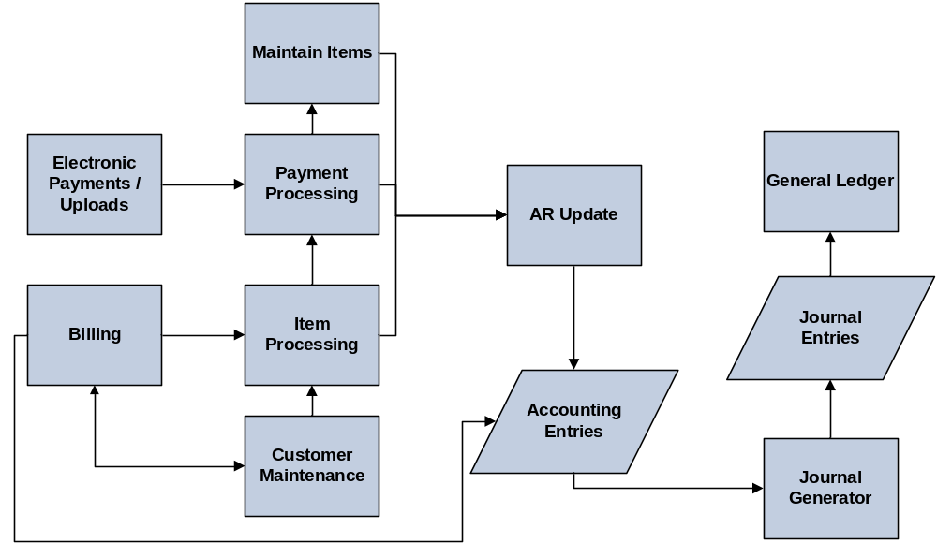
End-to-End Accounts Receivable and Billing Process

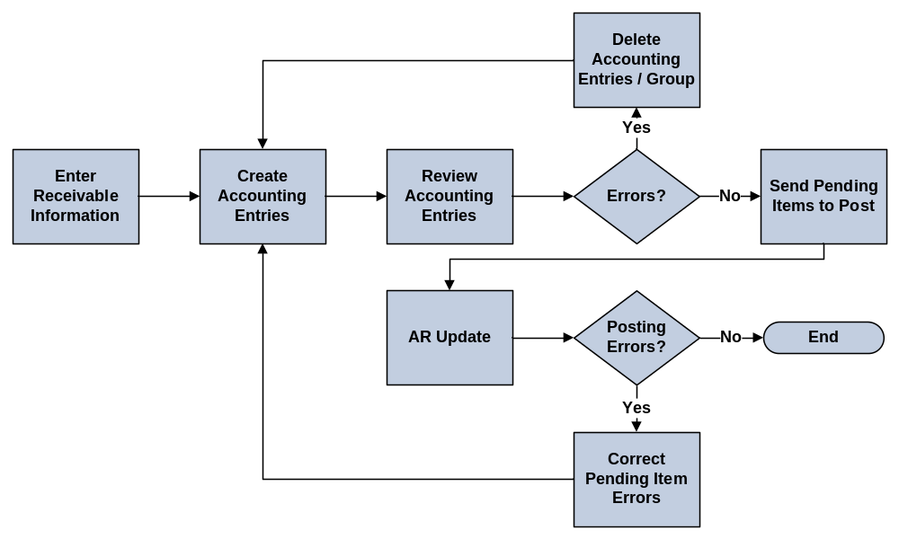
Receivables Lifecycle Process

Accounts Receivable Roles
Role | Description
AR Agency Administrator | Responsible for approving agency deposits in addition to creating and updating customers and customer information.
AR Configurator | Responsible for setting up and maintaining values that are used for some AR fields, such as payment terms an aging categories. Also has the ability to correct history for effective dated rows.
AR Maintainer | Responsible for reviewing and maintaining Accounts Receivable information, including customer, contact, deposit, item and payment information.
Pending Item Processor | Responsible for creating pending items, credit and debit memos. Also views customer, payment and deposit information.

Entering and Reviewing Receivables

Working with Pending Items
- Pending Items – Amounts that have been billed to a customer but not paid. Pending items can be entered in two ways, manually as online items or received as external items from SMART Billing.
- Create Accounting Entries and Setting Them to Post – The posting process in SMART Receivables is known as AR Update. When you post items in SMART Receivables, SMART processes groups of pending items to update a customer’s account and creates balanced, valid accounting entries. These accounting entries are then passed to the General Ledger by a process called the Journal Generator.

Group Control Page:
Use this page to enter the control totals, currency, group type, origin ID and the status of the item group.

Page Name | Navigation
Group Control | Accounts Receivable > Pending Items > Online Items > Group Entry > Add New Value > Group Control

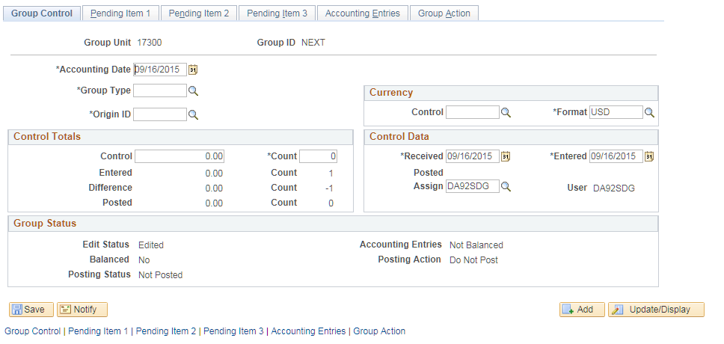

Fields | Description
Accounting Date | This is the current SMART system date
Group Type | For online pending item entry, Group Type is always B.
Origin ID | This field indicates whether the group was entered online (OBILL) or from an external billing source (PS BI)
Control Currency | The State of Kansas is only using USD
Format Currency | The State of Kansas is only using USD. This defaults when a new group is created.
Control Amount | Use this field to enter the total amount of the pending item(s)
Count | Use this field to enter the number of pending item rows
Group Control Page Elements

Pending Item 1 Page:
Use this page to enter the item information, payment terms and any other reference information for each item in the group.

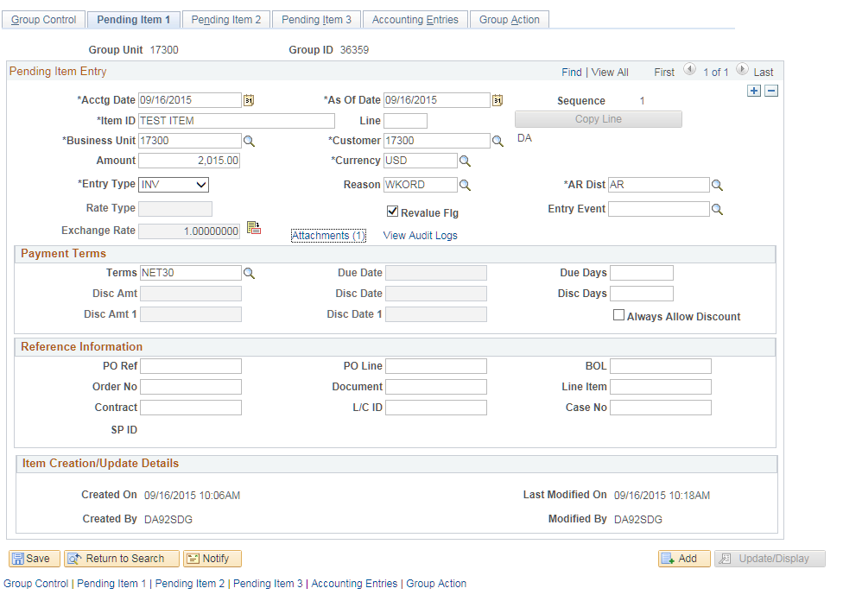

Fields | Description
As Of Date | Use this field to enter a date for the pending item. Usually the same as the accounting date. This date plus payment terms equals the due date.
Item ID | A name/number that identifies the pending item. This can also be the invoice ID if the item is from Billing.
Business Unit  Page 15  - Reference Job Aid: Entry Types  - Highlight note about Entry Type/Reason Code combination | This field defaults from the Group Control Page.
Customer | The customer number established by the Agency.
Amount | Amount of the pending item(s) in that row.
Currency | The State of Kansas is using only USD.
Entry Type | Every receivable transaction that is entered or generated by SMART must have an Entry Type associated with it. The SOK Entry Types for Pending Item Entry are Invoice (INV), Credit Memo (CR), Debit Memo (DR), InterFund (IF), InterFund Credit Memo (IFCR) and InterFund Debit Memo (IFDR).  Note: The Entry Type/Reason Code combination creates funding.
Reason Code | All Pending Items require Reason Codes. Reason Codes (entry reasons) allow ChartFields to be defined for each entry type. Multiple entry reasons can be assigned to a single entry type. Reason codes can be used for Invoices, debit memos, credit memos and Interfunds. Reason Codes are agency specific. The AR Configurator in each agency can update reason codes.  Note: The Entry Type/Reason Code combination creates funding.
Attachments | Use this link to attach pending item documents. To add an attachment, click on the ‘Attachments’ hyperlink. Click the ‘Add Attachments’ button. Click Browse and find the attachment that should be added to this customer and pending item by clicking once on the file. Click ‘Open’. Click the ‘Upload’ button. Enter a description for the file attachment and click the Internal checkbox. Click ‘OK’. The Attachments hyperlink has a number next to it indicating the number of attachments to this pending item. Click ‘Save’.
Terms | This field value defaults from the Customer record but can be overwritten.
Reference Information Section | Optional field to enter additional information if applicable.
AR Distribution | This code defaults. It is used by SMART to generate the offsetting accounting lines for the pending item. The code is controlled by Central and should not be changed.
Pending Item 1 Page Elements

Pending Item 2 Page:
Use this page to record that an item is in dispute or collections. The information is for reference only. It does not generate any action.

Correspondence or personnel information from the Customer record is also displayed. SOK does not use Cash Forecasting.

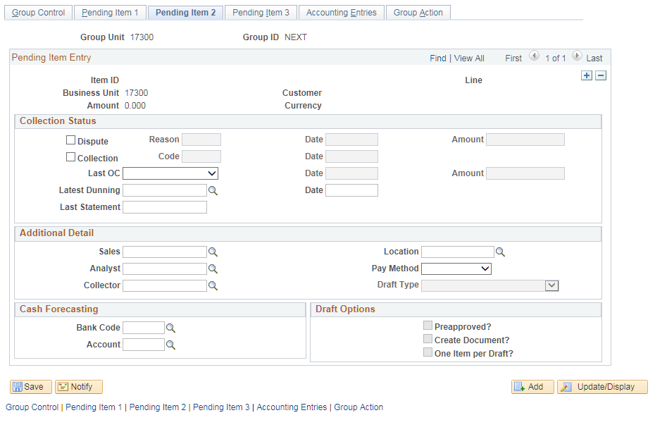
Pending Item 2 Page
Fields | Description
Dispute | Use this field to mark that the item is in dispute.
Dispute Reason | This field becomes available after the item has been marked for Dispute.
Collection | Use this field to mark that the item is in collection.
Bank Code | The State of Kansas uses only one bank code: KSBNK
Account | The State of Kansas uses only one account: MAIN
Pending Item 3 Page Elements
Pending Item 3 Page:
You can see only consolidated invoices that originated in SMART Billing (PS BI).
State of Kansas is not utilizing the User Defined areas so this page is seldom used.
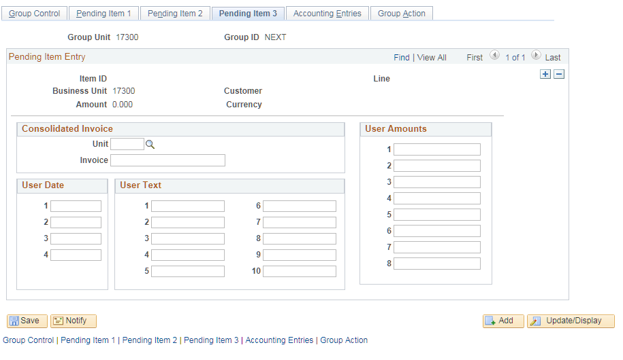

Fields | Description
Unit | Same as the Business Unit
Invoice | Shows the corresponding invoice name/number
Pending Item 3 Page Elements
Accounting Entries Page:

This page can be used to create accounting entries for each item in the group.

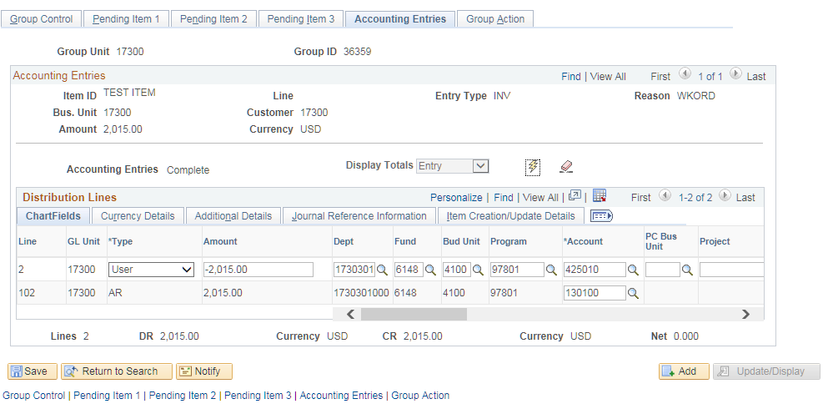
Accounting Entries Page

Fields | Description
Create | Click the Create icon to have the system create accounting entries for one pending item row at a time. After you click the Create icon, the accounting entries appear in the grid at the bottom of the page.
Accounting Entry Page Elements
Group Action Page:
Use this page to:
Create online accounting entries for entire group rather than individually for each item.
Delete accounting entries for an entire group.
Delete the entire group.
Verify that a group is balanced.
Set Posting Action (group will not post until Status indicates “Batch Standard”).

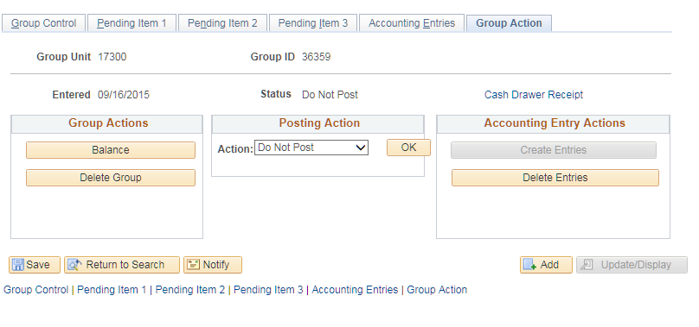

Fields | Description | Meaning
Group Actions | Balance | Verify that Group is Balanced
Group Actions | Delete Group | Click to delete entire Group
Posting Action | Batch Standard | This option flags the Group for posting the next time AR Update runs
Posting Action | Do Not Post | This option acts like a save function and does not flag the group to be picked up by AR Update.
Group Action Page Elements

Updating Pending Items
- You have the ability to update pending items before the group is picked up in AR Update. You must set the posting status to Do Not Post before you can update the data.
- After you have updated the data, change the posting status back to Batch Standard.

Maintaining and Updating Receivables

Key Terms:
- Payment Terms – how many days before the customer is required to make payment. Payment terms plus invoice date equals due date.
- Maintenance Worksheets –a workspace in SMART for offsetting, writing-off or adjusting posted items, refunding an item with a credit balance.

Change Item Pay Terms
- Item Due Date – SMART enables you to modify the payment terms of an item. Changing payment terms will change the Item Due Date.

Detail 1 Page

Use this page to change payment options for an item or put an item in dispute or collections.

Page Name | Navigation
Detail 1 | Accounts Receivable Homepage > Customers and Accounts > Item Information > View/Update Item Details  Or  NavBar: Navigator > Accounts Receivable > Customer Accounts > Item Information > View/Update Item Details

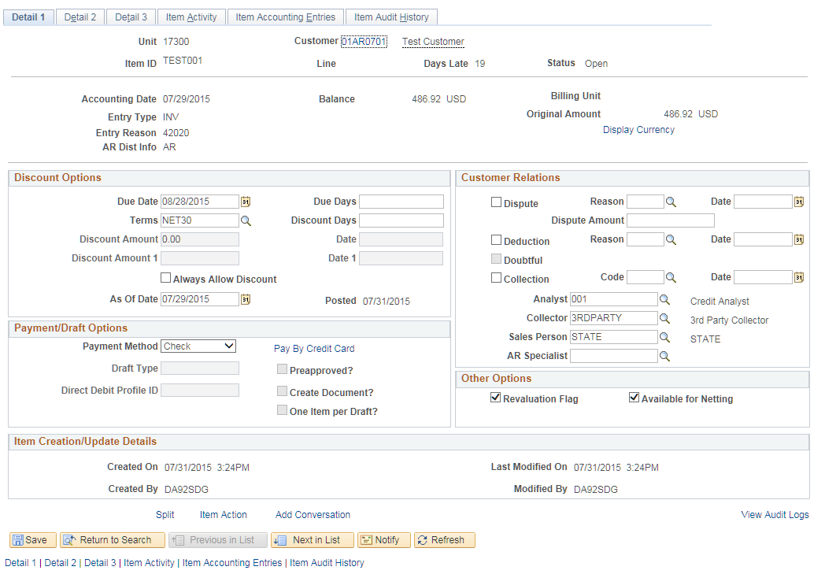

Fields | Description
Due Date | This field shows the new item due date based on the change in the payment terms.
Terms | Use this field to select a payment term that defines the due date.

Maintenance Worksheets
- Cleaning Up Accounts – A maintenance worksheet is a workspace in SMART for offsetting items, write-offs or adjustments to clean up posted items. You can use maintenance worksheets to refund an item with a credit balance or to create a new refund item for a credit remaining from maintenance tasks.
- Debit and Credit Memos – In SMART Receivables, maintenance items can be credit or debit memos, invoices, adjustments, on-account payments or prepayments.
  - Credit and Debit memos must be created as new pending items. These pending items are not available on the Maintenance Worksheet until AR Update has successfully run.
- Item Accounting Entries – SMART enables you to create online accounting entries for maintenance worksheet transactions. You can review these entries on the Accounting Entries page before they are processed in the background. The only accounting entries you can edit online for items on a worksheet are those that are user-defined for write-offs. Accounting entries for matched items are system-defined and therefore not editable.
Worksheet Selection Page:
Use this page to specify customer and item information that should appear on the worksheet. You can specify customer criteria, a reference criterion or a combination of customer and reference criteria. You can select a range of item IDs and a single customer ID as your search criterion. You can also select all items for a customer without narrowing your search to the selected item IDs. SMART uses criteria information to retrieve all items matching the selection criteria when the worksheet is built.

Page Name | Navigation
Detail 1 | Accounts Receivable Homepage > Receivables Maintenance > Create Worksheet > Add a New Value  Or  NavBar: Navigator > Accounts Receivable > Receivables Maintenance > Maintenance Worksheet > Create Worksheet > Add a New Value

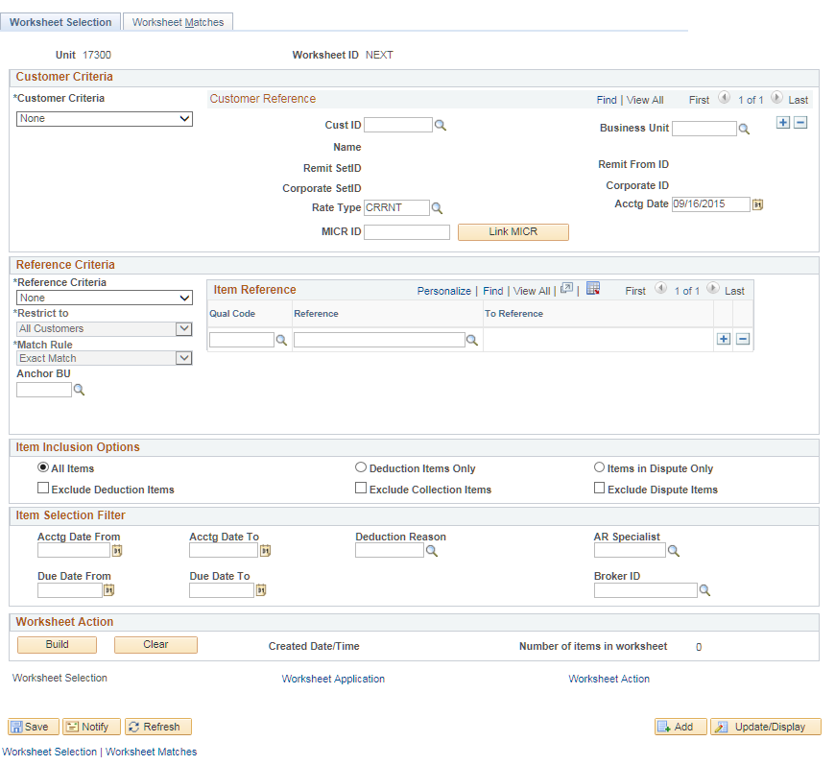

Fields | Description
Cust ID | Use this field to enter the customer ID
Business Unit | Should default to agency number
Reference Criteria | Specify whether you will use a Specific Value, None or a Range of References. If you select either Range of References or Specific Value, you enter information in the Item Reference fields.

Worksheet Application Page:
This page will appear after clicking the Build button. Use this page to match or settle open items. The Net amount of all credits and debits must be zero for the worksheet to balance and post.

Page Name | Navigation
Worksheet Application | Accounts Receivable Homepage > Receivables Maintenance > Create Worksheet > Add New Value > Build button  Or  NavBar: Navigator > Accounts Receivable > Receivables Maintenance > Maintenance Worksheet > Create Worksheet > Add New Value > Build button

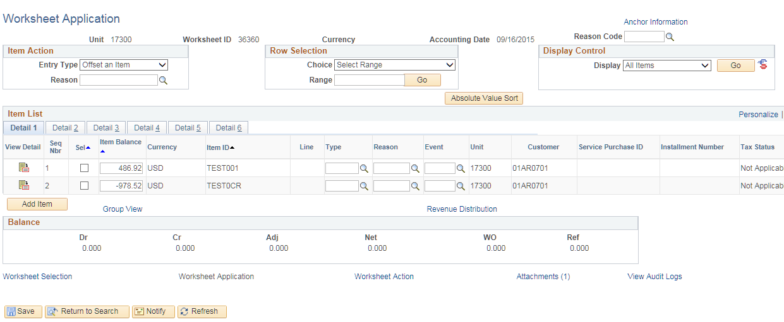

Fields | Description
Sel. Check Box | Select the item(s) you wish to update
Absolute Value Sort | This sort feature enables the user to more easily match debit and credit amounts. Click this button to sort items by the absolute value of the item balance amount..
Item ID | When adding a new item to the worksheet to balance the worksheet, enter the item ID plus the appropriate suffix:  XXX-DR, XXX-CR, or XXX-New.
Entry Type | This field defines how SMART assigns Entry Types (write-offs, payment on account) and Entry Reasons to pending items that are being paid or maintained. Automatic Entry Types are used on worksheets (payment, maintenance and transfer). The combination of Automatic Entry Types and Reason Codes provide the distribution line for each pending item that is entered in SMART.
Attachments | Use this link to attach item maintenance documentation. To add an attachment, click on the ‘Attachments’ hyperlink. Click the ‘Add Attachments’ button. Click Browse and find the attachment that should be added to this maintenance item by clicking once on the file. Click ‘Open’. Click the ‘Upload’ button. Enter a description for the file attachment and click the Internal checkbox. Click ‘OK’. The Attachments hyperlink has a number next to it indicating the number of attachments to this maintenance item. Click ‘Save’.
Worksheet Application Page Elements

Worksheet Action Page:
Use this page to select a posting action for the worksheet or to create and review accounting entries. This page enables you to delete a worksheet, create accounting entries online or delete all accounting entries for the worksheet.
Page Name | Navigation
Worksheet Action | Accounts Receivable Homepage> Receivables Maintenance > Create Worksheet > Add New Value > Build > Worksheet Action Link  Or  NavBar: Navigator > Accounts Receivable > Receivables Maintenance > Maintenance Worksheet > Create Worksheet > Add New Value > Build > Worksheet Action Link

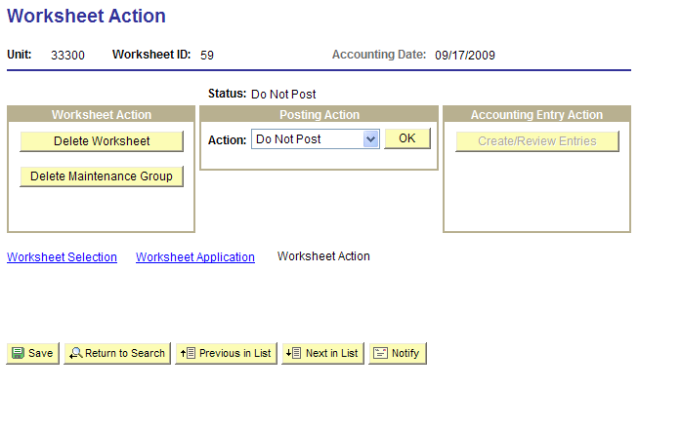

Accounting Entries Page:
Use this page to review/create accounting entries for one item at a time. Accounting entries must be created before selecting a posting action.
Page Name | Navigation
Accounting Entries Page | Accounts Receivable Homepage> Receivables Maintenance > Create Worksheet > Add New Value > Build > Worksheet Action Link > Create/Review Entries  Or  NavBar: Navigator > Accounts Receivable > Receivables Maintenance > Maintenance Worksheet > Create Worksheet > Add New Value > Build > Worksheet Action Link > Create/Review Entries

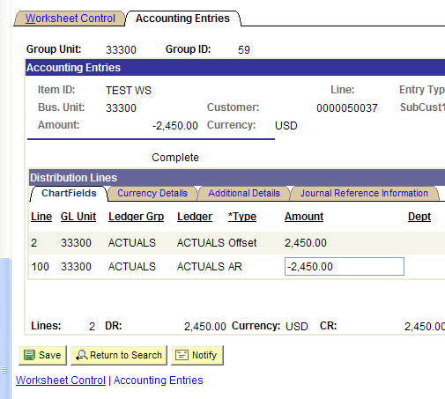

Worksheet Action Page:
Use this page to set Status of the maintenance worksheet to Batch Standard.

Unposting Item Groups
- Only Central has the security to Unpost Groups. Submit a Help Desk Request when Unposting is needed.
- Groups can be Unposted if AR Update has successfully processed them. Unposting creates a new group that is the exact opposite (reversal) of the original group. The unpost group creates a new unpost item activity and new accounting entries for each item that it is unposting.
- After AR Update has run and the unposting is successful, the available item(s) cannot be located for “matching”. You are able to view them when you view all pending items but you are not able to update the item(s).
NOTE: You will be able to make changes to the group if AR Update has not run. In that case, change the posting action on the Worksheet Action page from Batch Standard to Do Not Post. Make the changes, then reset to Batch Standard.

Transferring Receivables

Using Worksheet Actions
- Building a Transfer Worksheet:
  - A transfer worksheet is a workspace in SMART for transferring an open item from one customer to another. You can access only those open items that have been posted.
  - Customers must be in the same business unit for transferring receivables
- Updating Data on a Transfer Worksheet:
  - You can add or change items on a transfer worksheet. In addition, you can enter general or specific customer and item criteria depending on the scope of information you want on the worksheet.
- Using Transfer Worksheet Actions:
  - You can select a posting option for the transfer worksheet depending on your requirements
Note: You cannot transfer pending items on a transfer worksheet from one business unit to another.
Note: If this process is done correctly, the FROM customer will not have the item in their customer items anymore and it will be transferred to the new TO customer.

Transfer Selection:
Use this page to create a new worksheet, modify an existing one and select items to include in the worksheet. When transferring receivables, this is the page where you put the customer ID that the item is coming FROM.

Page Name | Navigation
Transfer Selection | NavBar: Navigator > Accounts Receivable > Receivables Maintenance > Transfer Worksheet > Create Worksheet

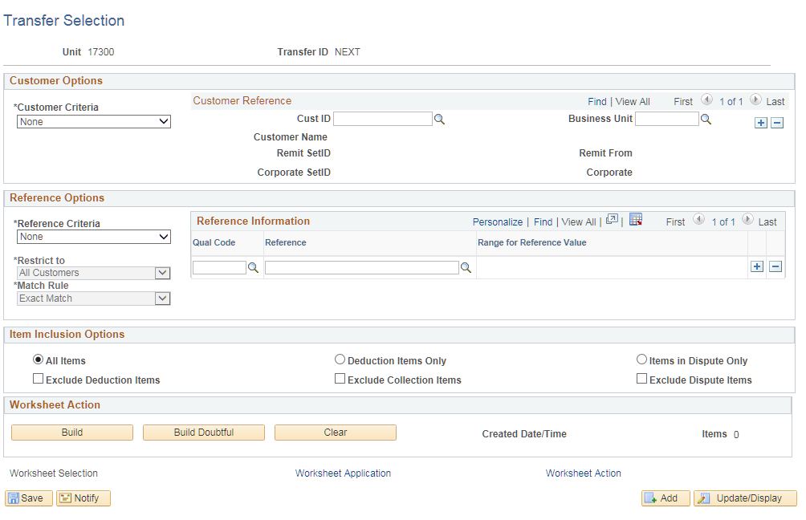

Enter required information then click the Build button.

Worksheet 1 Page:
Use this page to indicate the TO customer that receives the items. Notice the action used to post a Transfer worksheet is the same process used to post Maintenance Worksheets.
Page Name | Navigation
Worksheet 1 | NavBar: Navigator > Accounts Receivable > Receivables Maintenance > Transfer Worksheet > Create Worksheet > Worksheet Application Link

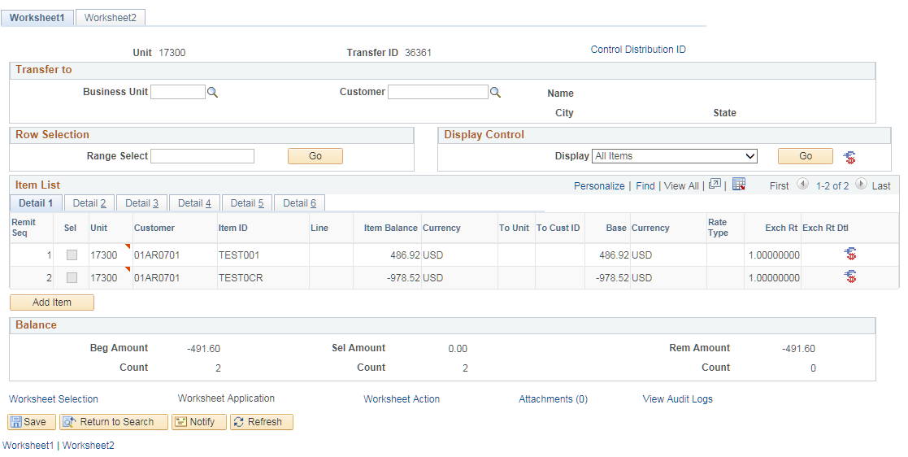

Account Aging and Communication

Key Terms:

- Aging –The time that has passed since customers were billed or a pending item was established
- Dunning – The process of methodically communicating with customers regarding overdue payments to ensure the collection of accounts receivable
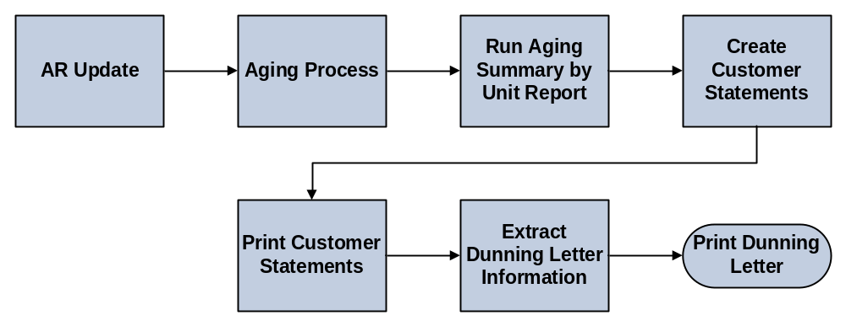
End-to-End Aging and Dunning Process

Aging Summary Report
- The Aging process updates summary aging information that appears on various inquiry pages. Agencies rely on aging to identify delinquent accounts and to assess possible cash flow issues.
- The Aging Process is a Central function and runs once a month for the entire State. There is no user action required for the Aging Process.
- Each agency can run the Aging Summary by Unit Report based on the results of the monthly Central run.
- The Aging process also updates the Due and High Due history IDs
  - High Due history ID – is the highest amount the customer has ever owed the agency. This allows agencies to determine the risk level of customer.
  - Due – is the current amount past due

Aging Summary by Unit Page:
Use this page to define the run parameters for the Aging Summary by Unit report. Use the report to see aged open balances for every customer in your business unit.

Page Name | Navigation
Aging Summary By Unit | Accounts Receivable Homepage > AR Reports > Aging Reports > Aging Summary by Unit Rpt  Or  NavBar: Navigator > Accounts Receivable > Receivables Analysis > Aging > Aging Summary by Unit Rpt

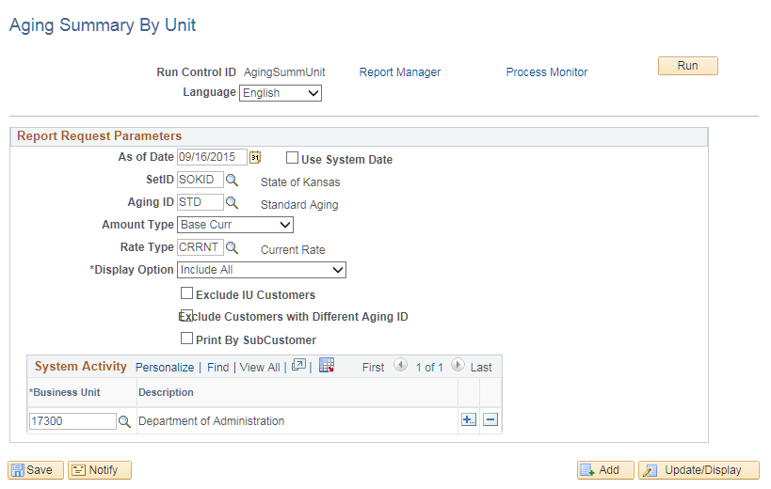
Fields | Description
As of Date | Enter the date you want the report “aged” to. Usually current date.
Set ID | This field must indicate the shared Set ID of SOKID. Do Not leave this field blank.
Aging ID | This field must indicate the SOK Aging ID of STD.
Amount Type | Leave this field at Base Currency.
Rate Type | The SOK uses only one rate type, CRRNT. Can leave blank.
Display Option | Use this field to select from the following: Collections Only, Disputes Only and Include All. Include All is the default and gives a more comprehensive report.
Business Unit | Use this field to enter your agency specific business unit. Do not leave this field blank.
Aging Summary by Unit Page Field Descriptions

Processing and Printing Customer Statements
- SMART enables you to generate customer statements on a regular schedule for many customers or a single statement for only one customer.
- Customer statements are based on current customer balances and open item information, which are updated by the AR Update process.
- Printing customer statements is an optional process and should be based on agency specific scenarios.
- A printed statement showing outstanding items can be a diplomatic reminder to customers whose payments are slightly overdue.
Statements Parameters Page:
Use this page to define the run parameters for the Customer Statements.
Page Name | Navigation
Statements Parameters | NavBar: Navigator > Accounts Receivable > Customer Interactions > Statements > Create Customer Statements (create a Run Control ID)

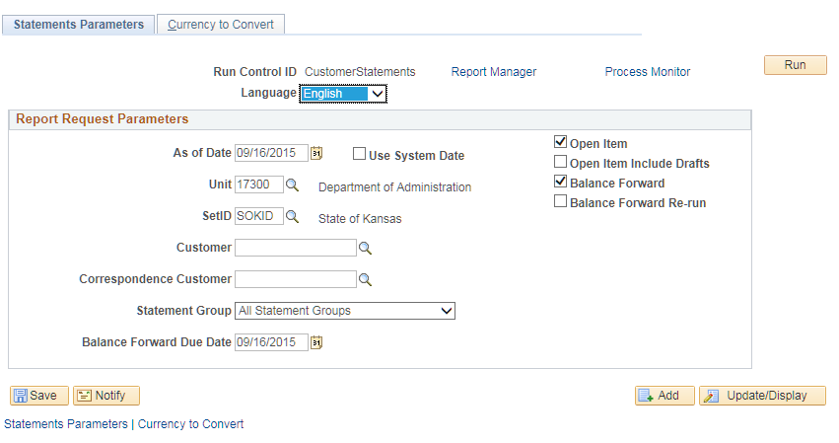

Processing and Printing Dunning Letters
- SMART Receivables uses Dunning letters to alert customers of their overdue items and expedite the collection of outstanding accounts receivable.
- The Dunning letter shows what items make up their balance and the age of the items in their account.
- To generate Dunning letters for specific customers, you need to run a single, two-step process.
Note: Printing Dunning letters is optional and should be based on agency specific scenarios.

Dunning Letters Parameters Page:
Use this page to specify the extract parameters and run the AR Dunning process or the Dunning Letters multi-process job.
Page Name | Navigation
Dunning Letters Parameters Page | NavBar: Navigator > Accounts Receivable > Customer Interactions > Dunning Letters > Extract Dunning Letter Info

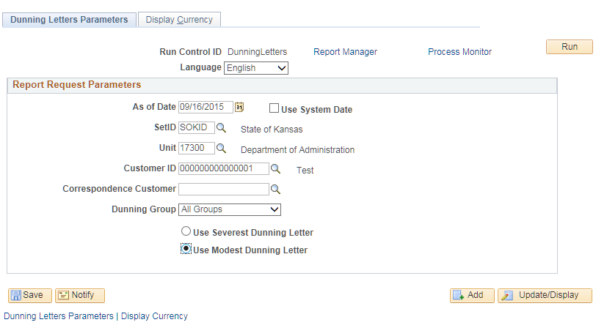

Fields | Description
Dunning Letter | There are two types of Dunning Letters- Severe or Modest. Agencies have the ability to choose between the letter types for agency/customer specific scenarios.
Dunning Letters Parameters Page Elements

Collections and Exceptions Management

Analyzing Customer Accounts
- Analyzing individual customer accounts is the process of determining how well customers maintain their accounts. You use customer analysis to make decisions about an agency’s accounts receivable and collection policies, facilitate planning and budgeting and help minimize the agency’s exposure to bad debt.
- After customer accounts are established and activity begins, invoices are posted and payments are made on the invoices. Customer accounts are then analyzed to verify that they have a good history of invoice payment. You may also want to know about the most recent activity and any previous conversations with the customer.
- When analyzing customer accounts you have the ability to view items in groups or individually (single). When viewing those items, SMART allows you to analyze many different types of information. Some examples are
    - Accounting Entries
    - Disputes
    - Collections
    - Payment History
    - Due Dates

Viewing Customer History
Customer History Page:

Page Name | Navigation
Customer History | NavBar: Navigator > Accounts Receivable > Customer Accounts > Customer Information > Customer History

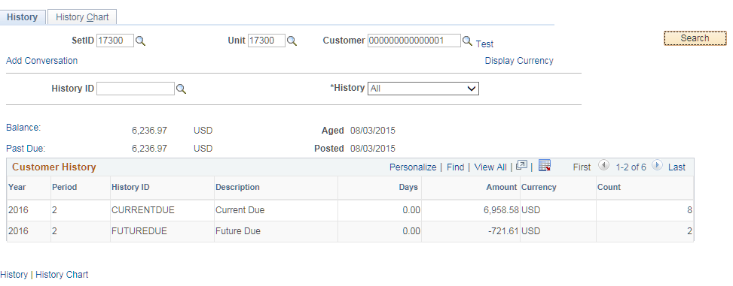

Fields | Description
SetID | Should default to agency number
Customer | Enter customer number or choose from list
History ID | Use this field to restrict the type of customer history you wish to review. Leave blank to get all history.
History | Only choices are All or Most Recent

Customer Account Overview
Account Overview Component:
Use this page to view various customer balances, the most recent item and payment activity and summarized aging information. Click links to view detailed information such as customer items, item statuses, item activity, accounting entries and dispute status.
Page Name | Navigation
Account Overview | Accounts Receivable Homepage > Customers and Accounts > Customer Accounts > Account Overview  Or  NavBar: Navigator > Accounts Receivable > Customer Accounts > Customer Information > Account Overview
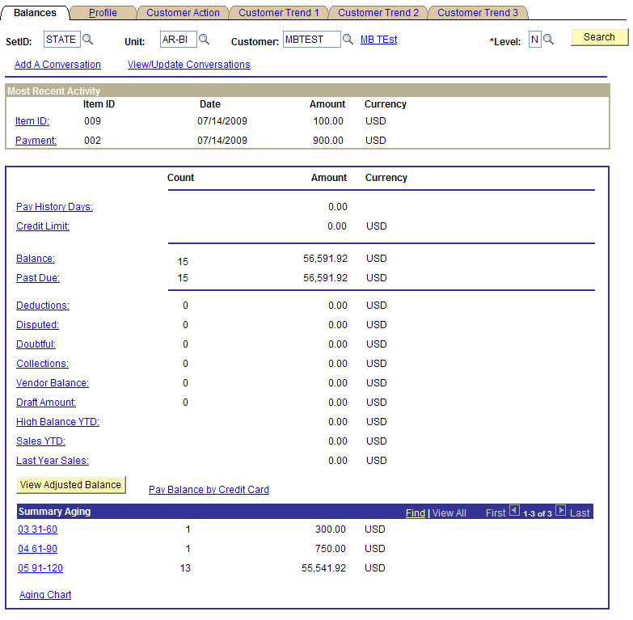
Item List Page:
By selecting the Item List link on the Profile page of the Account Overview component, you can view customer profile information and use links to view in-progress payments and outstanding items (Open/Closed/Dispute/Collections). This page also allows you to select the individual accounting entries or single items for review/update.
By selecting Closed from the Status drop-down, you can refine your search for payments. Closed items are items that have been paid or applied on a worksheet.
By looking at the entry type, you can see the action taken on the item, which could be a Payment (PY) Debit (DR), or a Credit (CR).
Page Name | Navigation
Item List | Accounts Receivable Homepage > Customers and Accounts > Customer Accounts > Account Overview > Profile > Item List Link  Or  NavBar: Navigator > Accounts Receivable > Customer Accounts > Customer Information > Account Overview > Profile > Item List Link

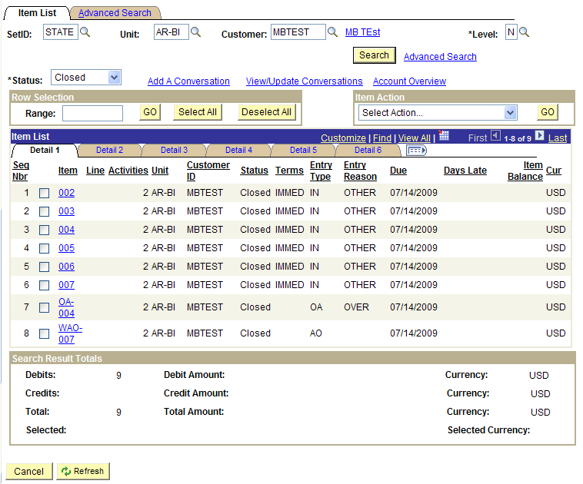

Item Detail Component:
Use this page to change payment options for an item or put an item in dispute or collections.
Page Name | Navigation
Detail 1 Component | Accounts Receivable Homepage > Customers and Accounts > Customer Accounts > Account Overview > Profile > Item List Link > Item Link  Or  NavBar: Navigator > Accounts Receivable > Customer Accounts > Customer Information > Account Overview > Profile > Item List Link > Item Link

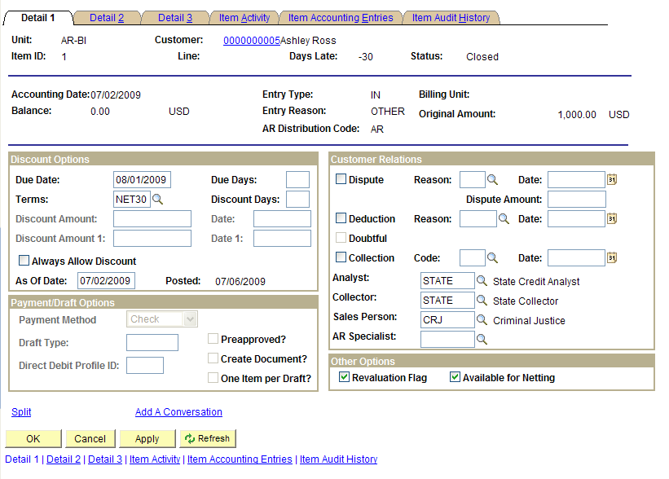

Item Activity Page:
Use this page to review all activity records for an item, including payments against an item.

Page Name | Navigation
Item Activity | Accounts Receivable Homepage > Customers and Accounts > Customer Accounts > Account Overview > Profile > Item List Link > Item Link > Item Activity Tab  Or  NavBar: Navigator > Accounts Receivable > Customer Accounts > Customer Information > Account Overview > Profile > Item List Link > Item Link > Item Activity Tab

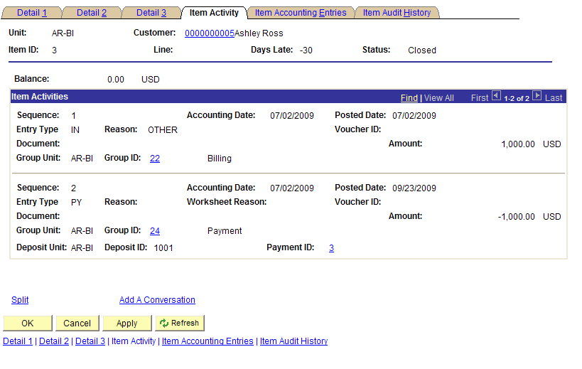

Item Activity from a Payment Page:

Selecting the Payment ID link takes you to the Item Activity from a Payment page in a new window. This page reviews all items paid by a single payment.

Page Name | Navigation
Item Activity From A Payment | Item Activity Tab > Payment ID link > New Window

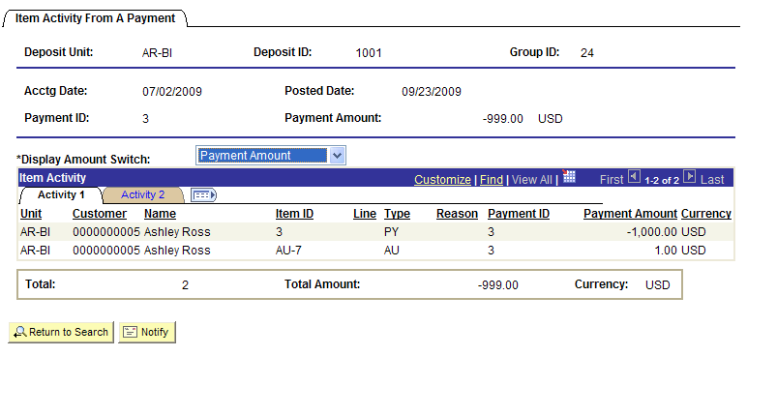

Item Accounting Entries Page:
Use this page to view the accounting entries for each item activity.
Page Name | Navigation
Item Accounting Entries | Close New Window > Item Accounting Entries Tab

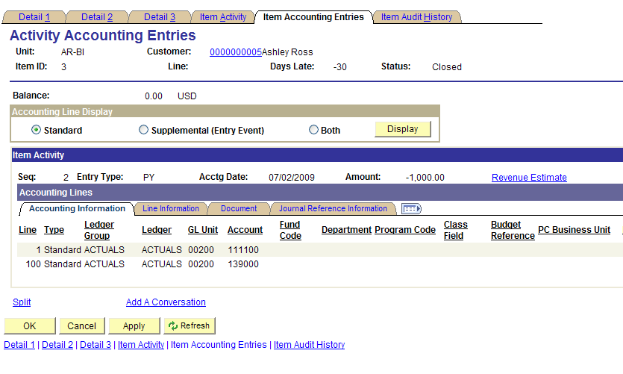

Viewing Item Groups
- Group – During customer analysis, questionable accounts and/or items may be found. In order to resolve these questions, you must research detailed information. There are single documents that can have multiple items attached to them. For example, one check can pay many invoices, one purchase order can be attached to several invoices, or one sales order can have multiple shipments and invoices. You may need to research groups of items that relate to one another.
Item Activity from a Group Page
Use this page to view activity for all items in a group.
Page Name | Navigation
Item Activity From A Group | Accounts Receivable Homepage > Customers and Accounts > Item Information > Item Activity From A Group  Or  NavBar: Navigator > Accounts Receivable > Customer Accounts > Item Information > Item Activity From A Group
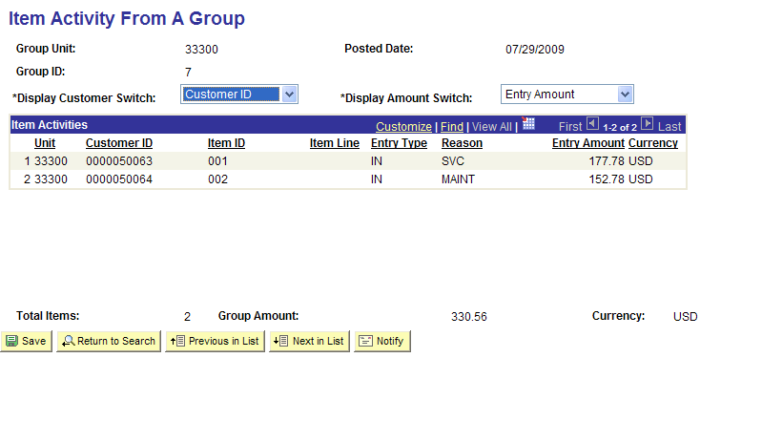

Disputing Items and Adding a Conversation
- SMART Receivables enables you to put items in dispute based on internal agency notification or from customer notification.
Detail 1 Page:
Use this page to change payment options for an item, put an item in dispute or collections, mark an item as a deduction and assign item owners.
Page Name | Navigation
View/Update Item Details | Accounts Receivable Homepage > Customers and Accounts > Item Information > View/Update Item Details  Or  NavBar: Navigator > Accounts Receivable > Customer Accounts > Item Information > View/Update Item Details
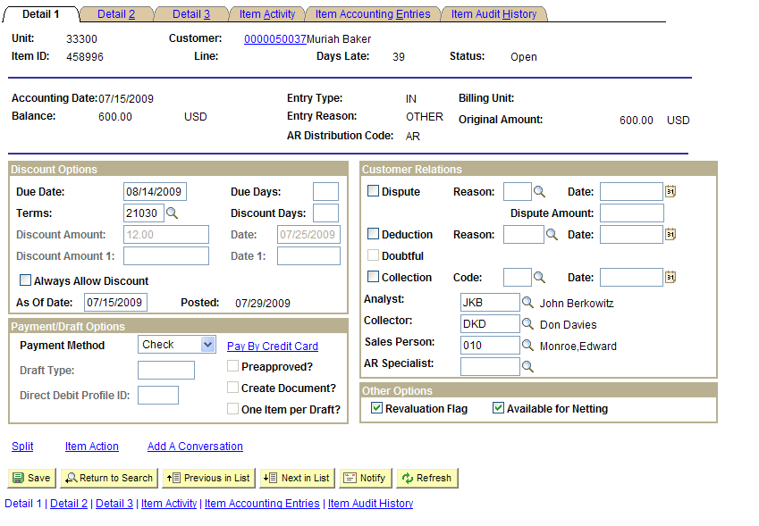

Fields | Description
Dispute | Select this box to put the item in dispute
Reason | Use this field to enter the dispute reason
Dispute Amount | Use this filed to enter the disputed amount
View/Update Item Details Page Elements

Conversations Page:
This page allows you to add or view conversation entries for the item. This information will be available for agency personnel to view. A conversation can be entered for any purpose, not just disputes. If you mark an item for dispute, the conversation comment should be detailed.
Page Name | Navigation
Conversations | Accounts Receivable Homepage > Customers and Accounts > Item Information > View/Update Item Details > Add a Conversation Link  Or  NavBar: Navigator > Accounts Receivable > Customer Accounts > Item Information > View/Update Item Details > Add a Conversation Link

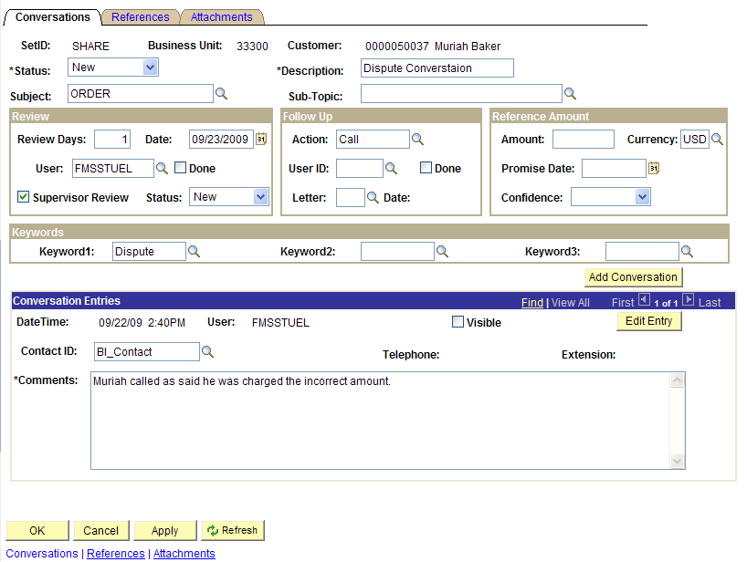

Fields | Description
Status | Use this field to select the status of the conversation: New, Open, or Closed
Description | Use this field to enter the description of the conversation
Subject | Use this field to select from the following conversation subjects: Delayed Payment, Payment, Questions, or Order
Review Days | You can enter a specified number of days. This is information only. No auto reminder is triggered.
Supervisor Review | Select this checkbox if supervisor review is necessary. The system assigns the supervisor associated with the user profile for the individual to review the conversation.
Action | Select the type of follow-up action for the customer
Keyword | Use this field to enter a keyword that would classify the type of comment and assist in a future search.
Contact ID | Use this field to enter the customer contact information to record with whom you spoke
Comments | Use this field to enter the text that you want to record for the conversation
Conversations Page Elements
References Page:
Use this page to link a conversation with a reference, such as an invoice, purchase order, or receivables item.
Page Name | Navigation
References | Accounts Receivable Homepage> Customers and Accounts > Item Information > View/Update Item Details > Add a Conversation Link > References Tab  Or  NavBar: Navigator > Accounts Receivable > Customer Accounts > Item Information > View/Update Item Details > Add a Conversation Link > References Tab

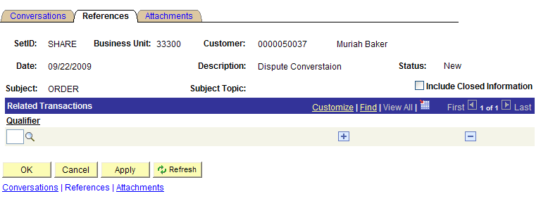
References Page
Field | Description
Include Closed Information | Use this field to associate closed items in Receivables with the conversation.
References Page Field Description
Attachments Page:
Use the Attachments page to Browse and add an attachment if applicable.

Page Name | Navigation
Attachments | Accounts Receivable Homepage > Customers and Accounts > Item Information > View/Update Item Details > Add a Conversation Link > Attachments Tab  Or  NavBar: Navigator > Accounts Receivable > Customer Accounts > Item Information > View/Update Item Details > Add a Conversation Link > Attachments Tab

